**2Roba project**

Technical white paper

Authors: Severyn Tsiapka

Published: May 2018

Applies to: 2Roba project

**Getting Started with 2Roba project**

**1.** How to start working with Arduino Uno and differently modules.

1.1 Info about all modules, what we use in our project

1.2 Connection scheme Arduino + modules

**2.** How to write a program to manage a project

1.1 Welcome to Arduino Ide

1.2 Algorithms diagram

1.3 Programs for controlling modules

**How to start working with Arduino Uno and differently modules.**

In our project we use to many different modules, so here u can read small info about they.

1) The most important is Arduino Uno. It’s a small computer, which controls all process and it is the basis of the project.

2) Next important part of our project is ultrasound module, which we use for the calculation distance to obstacle.

3) Out robot have two motor reducer, which controls two wheels. We use this motor for change a direction and speed.

4) Mp-3 we use to voice the command that will be executed.

5) Also, we use a small stepper motor to rotate the ultrasonic module.

**Connection scheme Arduino + modules**

1)Bluetooth module conection.

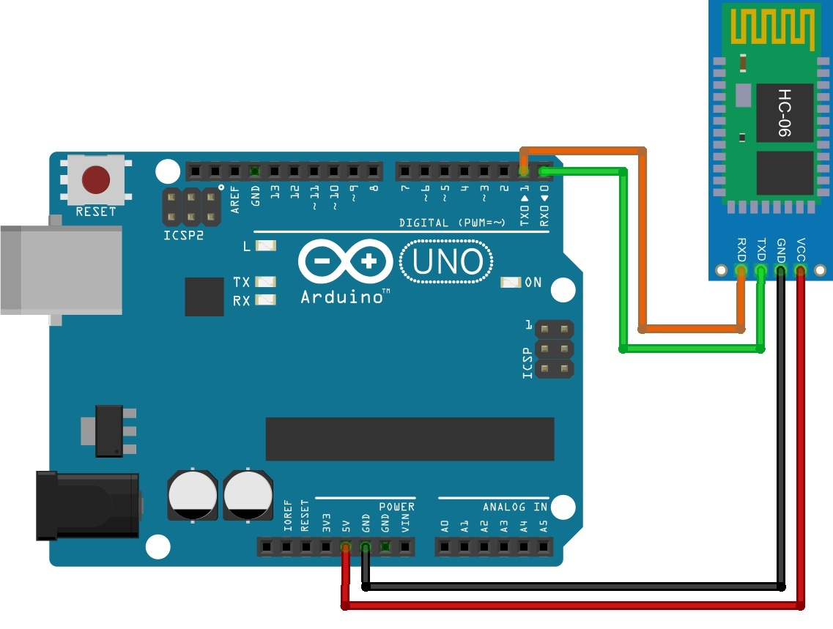

2)Ultrasonic module connection.

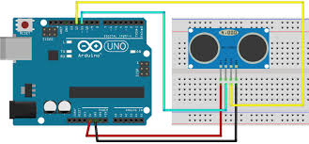

3) DFplayer mp3 module connection.

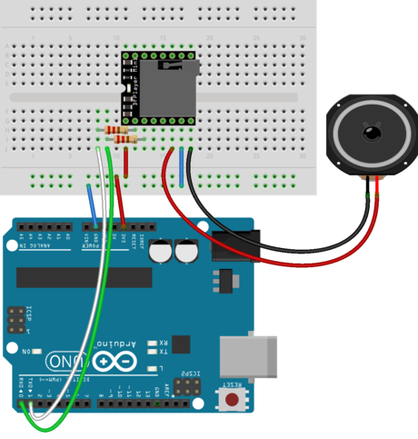

4) Motor driver connection + two motors.

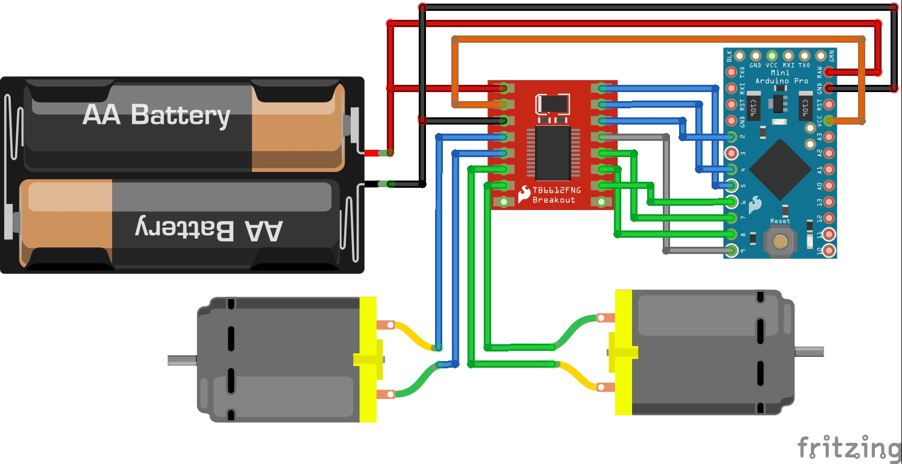

5) Servo motor connection.

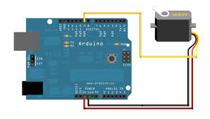

**How to write a program to manage a project**

**1) Welcome to Arduino ide**

Arduino Ide is the most popular environment for programmer on Arduino.

So u need download this program, if u want to write programm.

<https://www.arduino.cc/en/Main/Software>

**3)** **Algorithms diagram**

This diagram will show you, how our project work.

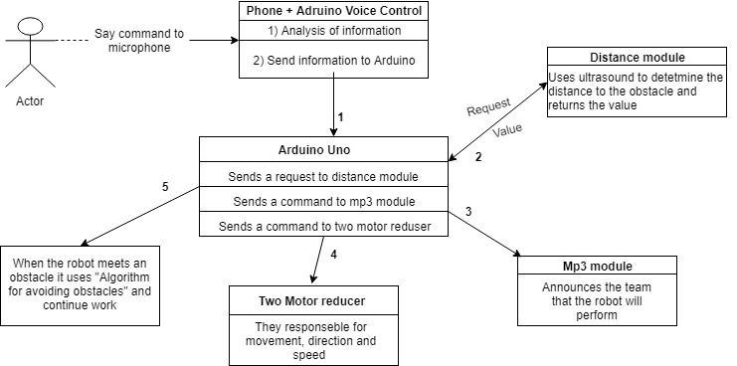

**3) Algorithm “for avoiding obstaclse”**

Robot is moving as close to the obstale as possible, examines left and right side and chooses to turn the side, that removes it from obstacle. Robot is mowing this way until distance between it and the obstacle increases, which means, that robot is on the edge of the obstacle, if it has regular shape. Then execution of this algorithm repears 2 more times.



Check: This function returns the value to which side you want to move.



Move: This function is responsible for the start and end of the movement.



Turn: This function is responsible for turning.



Fullstop: This function is responsible for the complete stop of the algorithm.



MoveMotorForward: This functions is responsible for moving the motor forward.



MoveMotorBackward: This functions is responsible for moving the motor backward.



Our code is free to use, so you can find if here:

https://github.com/MaxShavarsky/Arduino_Voice_Control_-2Roba-/tree/master/Codes