Part1
Module | Timing | Critical path
a) 10-bit number bitwise AND | 0.05 | Input i -> output i
b) 3:2 adder with “&”, “|”, “^”, “~” | 0.18 | Input b -> output carry
c) 3:2 adder with “+” | 0.18 | Input b -> output carry
d) 10-bit adder with “+” | 0.92 | Input a[0] -> sum[9]
e) 29 6-bit adder with “+” | 1.12 | Input in24[0] -> sum[5]
f) 6-input adder from hw1/part6 | 0.88 | Input d[2] -> out[5]
g) 8-bit x 8-bit multiplier | 1.48 | Input b[2] -> out[14]
h) 16-bit x 16-bit multiplier | 3.21 | Input a[1] -> out[31]

Circuit for module b:
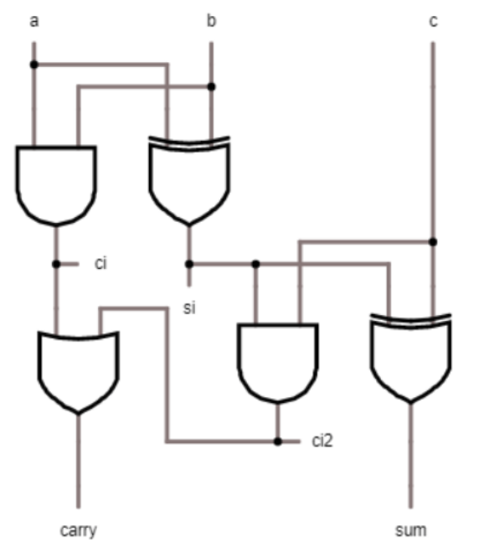

Part2

Part 3

Part 4

