# Problem 1

## Result

Total sum for +0.5 - +100.00 = 605

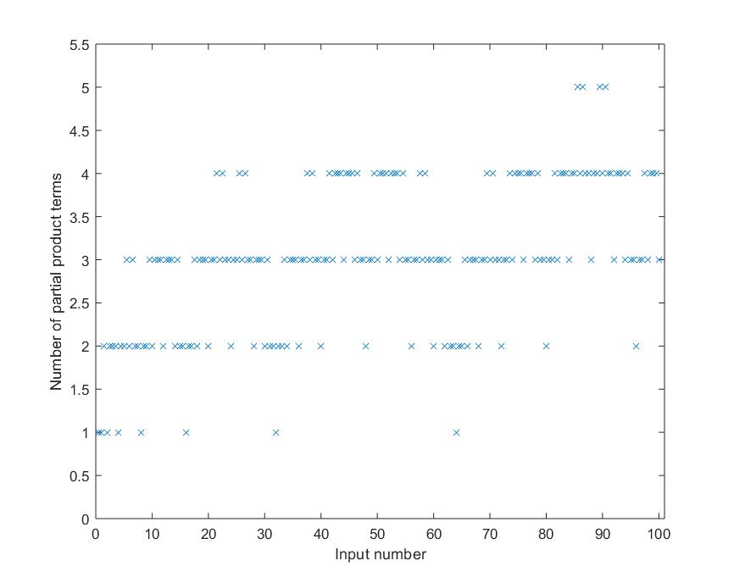

## numppterms.m

function [mpp] = numppterms(num)

mpp = 0;

rem = num;

while (rem ~= 0 && mpp < 10)

for i = -1:10

if 2^i >= abs(rem)

mpp = mpp + 1;

if (2^i - abs(rem) < abs(rem) - 2^(i-1))

rem = abs(rem) - 2^i;

else

rem = abs(rem) - 2^(i-1);

end

break;

end

end

end

end

# Problem 2

## Matlab output for unscaled coefficients

Scale 1.000000 Using coefficients [ 17 -90 241 902 241 -90 17]

coef #1 17, 2 partial products

coef #2 -90, 4 partial products

coef #3 241, 3 partial products

coef #4 902, 4 partial products

coef #5 241, 3 partial products

coef #6 -90, 4 partial products

coef #7 17, 2 partial products

In total, need 22 partial products

## Matlab output for scaled coefficients

Scale 0.532000 Using coefficients [ 9 -48 128 480 128 -48 9]

coef #1 9, 2 partial products

coef #2 -48, 2 partial products

coef #3 128, 1 partial products

coef #4 480, 2 partial products

coef #5 128, 1 partial products

coef #6 -48, 2 partial products

coef #7 9, 2 partial products

In total, need 12 partial products

## Matlab code

clear;

addpath('../part1/') %add numppterms

%fir

%coef = [17 -90 241 902 241 -90 17]

%pps 2 4 3 4 3 4 2

% +16 -64 +256 +1024 +256 -64 +16

% +1 -32 -16 -128 -16 -32 +1

% +4 -1 +4 -1 +4

% +2 -2 +2

%original coefficients

coef = [17 -90 241 902 241 -90 17];

%scaling factor

%scale = 1;

scale = 0.532; %12 pps, coef_r will be [9 -48 128 480 128 -48 9]

%rounded coedficients

coef_r = round( coef * scale );

fprintf("Scale %f Using coefficients [", scale);

fprintf(" %d", coef_r);

fprintf("]\n");

%total number of partial products for FIR

total = 0;

%calculation

for fircoef = 1:7

total = total + numppterms(coef_r(fircoef));

fprintf("coef #%d %d, %d partial products\n", fircoef, coef_r(fircoef), numppterms(coef_r(fircoef)));

end

fprintf("In total, need %d partial products\n", total);

## Bogus plot

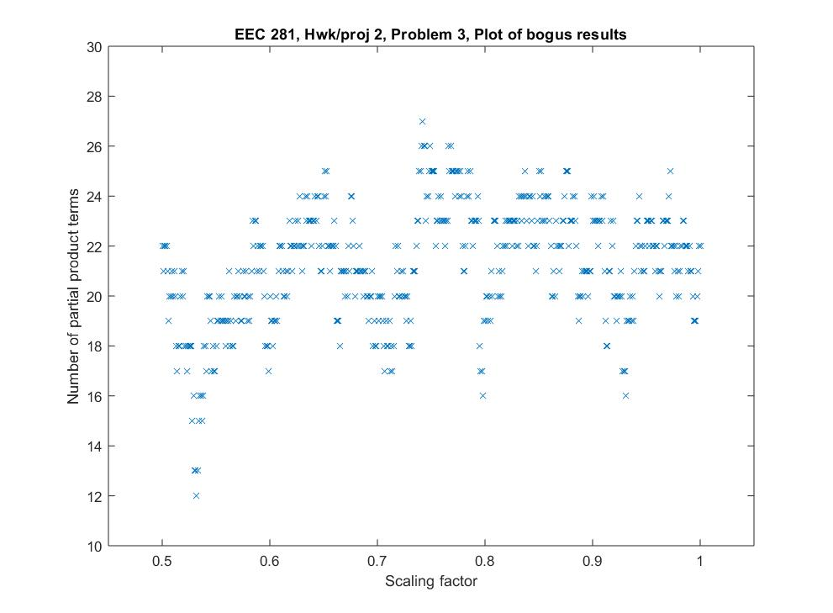

## Dot diagram

[ ] – 4:2 adder, [ ] – 3:2 adder, [ ] – half adder, ”.” – signal, “~” – inverted signal, “s” – sign extend, ark – right-to-left signal copy to reduce number of adders due to same inputs.

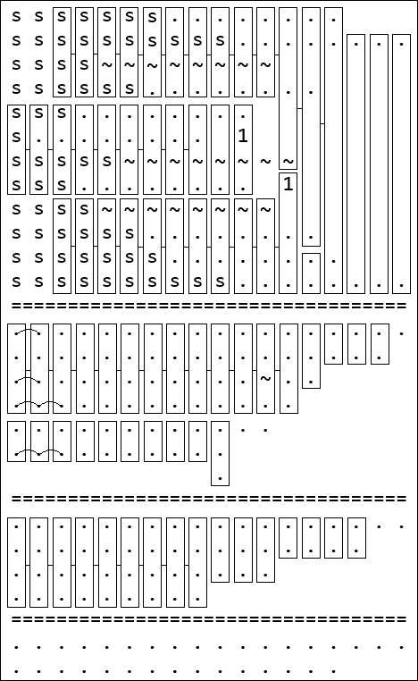

# Problem 3

## Part 1

|  |  |
| --- | --- |
| Clock period | Total cell area |
| 4ns | 345.268 |
| 2ns | 345.268 |
| 20ns | 345.268 |

Top-level diagram:

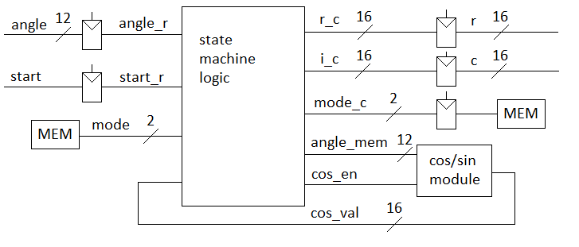

“cos/sin module” diagram:

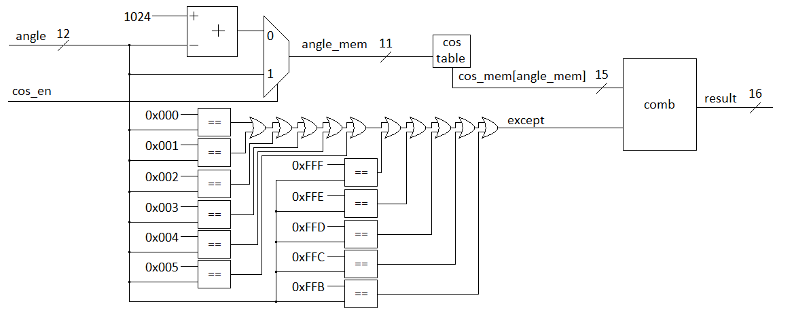

“comb” module diagram (applies exception for result):

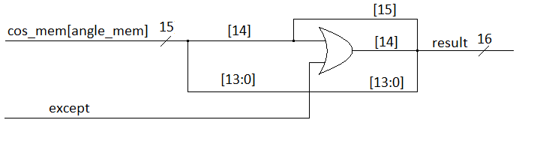

Energy_diff / Energy_data0 = 10*log(0.000002/4096.020943) = -83.11dB

Difff.m output:

max(data0-data1) = +0.000031 +0.000031i = +3.05034e-05 +3.05034e-05i

min(data0-data1) = -0.000031 -0.000031i = -3.05034e-05 -3.05034e-05i

max(data0/data1) = -Inf -Infi

min(data0/data1) = +Inf +Infi

approx separated mean(data0/data1) = +0.999508+ +0.999508i

Energy_data0 = 4096.020943

Energy_diff = 0.000002

Energy_data0/Energy_diff = 1653952521.828711 = 92.185230dB

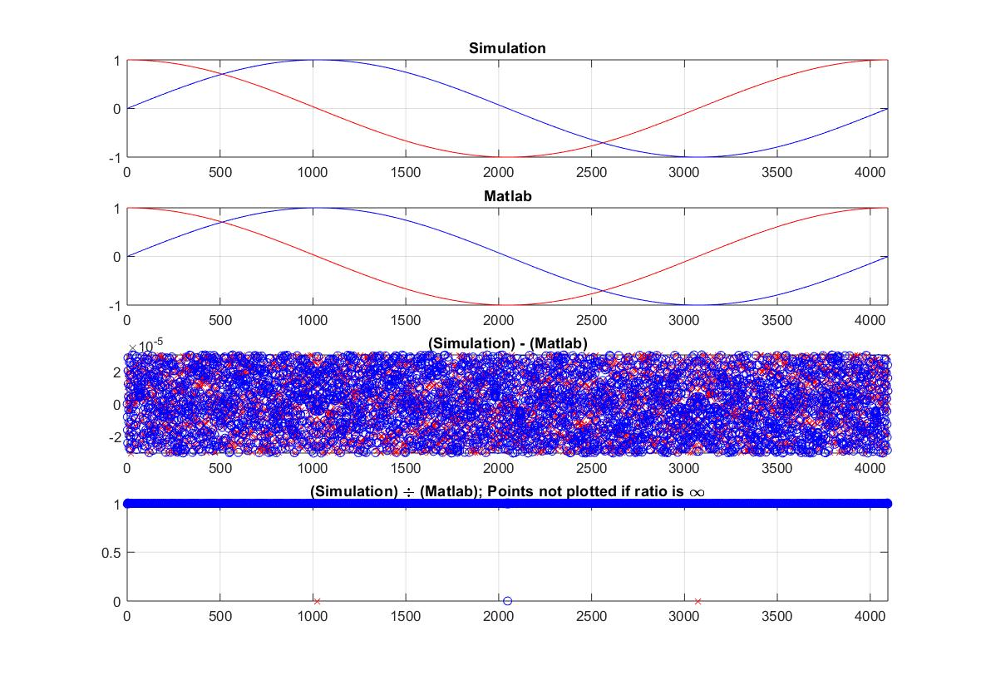

### Code compl.v:

/*

Top level for complex number generator

*/

`timescale 1ns/10ps

module compl(

input [11:0] angle,

input start,

input clk,

input reset,

output reg [15:0] r,

output reg [15:0] i

);

parameter IDLE = 2'b00;

parameter COS = 2'b01;

parameter SIN = 2'b10;

reg [1:0] mode, mode_c;

reg [11:0] angle_mem, angle_r;

reg [15:0] r_c, i_c;

wire [15:0] cos_val;

reg cos_en, start_r;

initial begin

mode = IDLE;

mode_c = IDLE;

angle_mem = 12'b0000_0000_0000;

// angle_r = 12'b0000_0000_0000;

r_c = 16'b0000_0000_0000_0000;

i_c = 16'b0000_0000_0000_0000;

cos_en = 1'b0;

// start_r = 1'b0;

end

cos cos_mem (.angle (angle_r), .cos_en(cos_en), .result(cos_val));

//State Machine

always @(angle_r or start_r or mode) begin

mode_c = mode;

case(mode)

IDLE: begin

if (start_r == 1'b1) begin

mode_c = COS;

cos_en = mode_c[0];

angle_mem = angle_r;

end

end

COS: begin

r_c = cos_val;

mode_c = SIN;

cos_en = mode_c[0];

end

SIN: begin

i_c = cos_val;

mode_c = IDLE;

end

default: begin

mode_c = IDLE;

end

endcase

end

//output FFlop

always @(posedge clk or posedge reset) begin

if (reset == 1'b1) begin

r <= #1 16'b0000_0000_0000_0000;

i <= #1 16'b0000_0000_0000_0000;

mode <= #1 IDLE;

angle_r <= #1 12'b0000_0000_0000;

start_r <= #1 1'b0;

end else begin

r <= #1 r_c;

i <= #1 i_c;

mode <= #1 mode_c;

angle_r <= #1 angle;

start_r <= #1 start;

end

end

endmodule

### Code cos.v

//cos function lookup table

//full precision for angle [0 .. 360) degrees

`timescale 1ns/10ps

module cos(

input cos_en,

input [11:0] angle,

output reg [15:0] result

);

reg except;

reg [14:0] cos_mem [4095:0];

reg [11:0] angle_mem;

initial begin

result = 16'b0000_0000_0000_0000;

//load values to memory

cos_mem[12'b000000000000] = 15'b000000000000000;

cos_mem[12'b000000000001] = 15'b000000000000000;

cos_mem[12'b000000000010] = 15'b000000000000000;

cos_mem[12'b000000000011] = 15'b000000000000000;

cos_mem[12'b000000000100] = 15'b000000000000000;

cos_mem[12'b000000000101] = 15'b000000000000000;

cos_mem[12'b000000000110] = 15'b011111111111111;

cos_mem[12'b000000000111] = 15'b011111111111111;

cos_mem[12'b000000001000] = 15'b011111111111111;

cos_mem[12'b000000001001] = 15'b011111111111110;

cos_mem[12'b000000001010] = 15'b011111111111110;

cos_mem[12'b000000001011] = 15'b011111111111110;

cos_mem[12'b000000001100] = 15'b011111111111101;

cos_mem[12'b000000001101] = 15'b011111111111101;

cos_mem[12'b000000001110] = 15'b011111111111100;

cos_mem[12'b000000001111] = 15'b011111111111100;

//<Many lines removed>

cos_mem[12'b111111110001] = 15'b011111111111100;

cos_mem[12'b111111110010] = 15'b011111111111100;

cos_mem[12'b111111110011] = 15'b011111111111101;

cos_mem[12'b111111110100] = 15'b011111111111101;

cos_mem[12'b111111110101] = 15'b011111111111110;

cos_mem[12'b111111110110] = 15'b011111111111110;

cos_mem[12'b111111110111] = 15'b011111111111110;

cos_mem[12'b111111111000] = 15'b011111111111111;

cos_mem[12'b111111111001] = 15'b011111111111111;

cos_mem[12'b111111111010] = 15'b011111111111111;

cos_mem[12'b111111111011] = 15'b000000000000000;

cos_mem[12'b111111111100] = 15'b000000000000000;

cos_mem[12'b111111111101] = 15'b000000000000000;

cos_mem[12'b111111111110] = 15'b000000000000000;

cos_mem[12'b111111111111] = 15'b000000000000000;

end

always @(angle or cos_en) begin

//cos/sin selection

if (cos_en == 1'b1)

//compute cos(angle)

angle_mem = angle;

else

//compute sin(angle) = cos (pi/2 - angle)

angle_mem = 12'b0100_0000_0000 - angle;

//exception (when need to return == +1.0)

except = (angle_mem == 12'b0000_0000_0000);

except = except || (angle_mem == 12'b0000_0000_0001);

except = except || (angle_mem == 12'b0000_0000_0010);

except = except || (angle_mem == 12'b0000_0000_0011);

except = except || (angle_mem == 12'b0000_0000_0100);

except = except || (angle_mem == 12'b0000_0000_0101);

except = except || (angle_mem == 12'b1111_1111_1011);

except = except || (angle_mem == 12'b1111_1111_1100);

except = except || (angle_mem == 12'b1111_1111_1101);

except = except || (angle_mem == 12'b1111_1111_1111);

except = except || (angle_mem == 12'b1111_1111_1110);

//output

result = {cos_mem[angle_mem][14], cos_mem[angle_mem][14] | except, cos_mem[angle_mem][13:0]};

end

endmodule

## Part 2

|  |  |
| --- | --- |
| Clock period | Total cell area |
| 4ns | 345.268 |
| 2ns | 345.268 |
| 20ns | 345.268 |

Top-level design is the same as in part 1.

“cos/sin module” diagram:

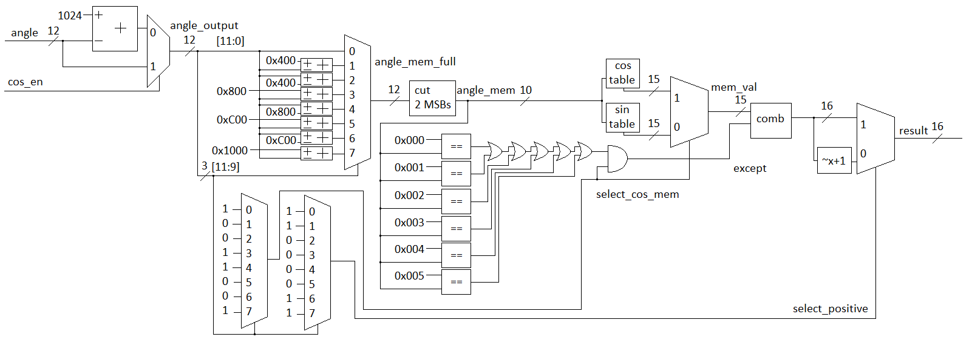

“Comb” module is the same as in part 1.

Energy_diff / Energy_data0 = 10*log(0.000002/4096.020943) = -83.113dB

Difff.m output:

max(data0-data1) = +0.000031 +0.000031i = +3.05034e-05 +3.05034e-05i

min(data0-data1) = -0.000031 -0.000031i = -3.05034e-05 -3.05034e-05i

max(data0/data1) = -Inf -Infi

min(data0/data1) = +Inf +Infi

approx separated mean(data0/data1) = +0.999508+ +0.999508i

Energy_data0 = 4096.020943

Energy_diff = 0.000002

Energy_data0/Energy_diff = 1653952521.828711 = 92.185230dB

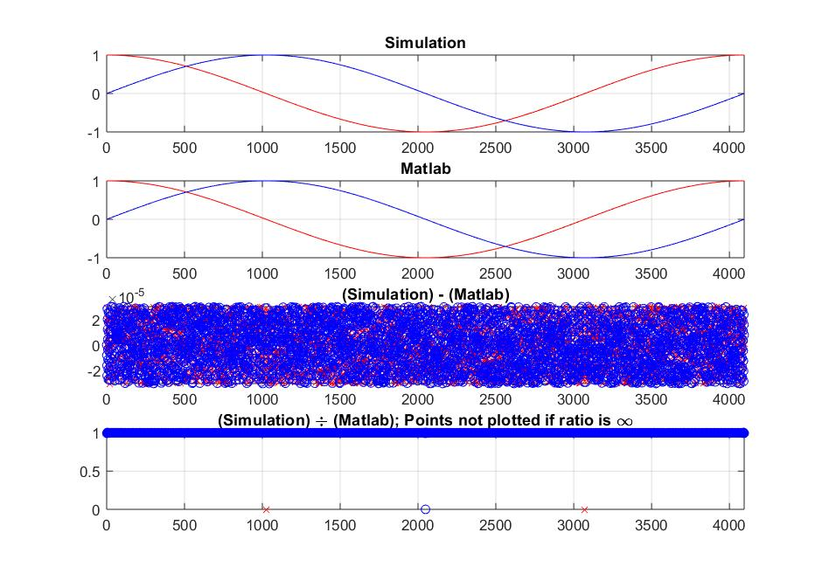

### Code compl.v

/*

Top level for complex number generator

*/

`timescale 1ns/10ps

module compl(

input [11:0] angle,

input start,

input clk,

input reset,

output reg [15:0] r,

output reg [15:0] i

);

parameter IDLE = 2'b00;

parameter COS = 2'b01;

parameter SIN = 2'b10;

reg [1:0] mode, mode_c;

reg [11:0] angle_mem, angle_r;

reg [15:0] r_c, i_c;

wire [15:0] cos_val;

reg cos_en, start_r;

initial begin

mode = IDLE;

mode_c = IDLE;

angle_mem = 12'b0000_0000_0000;

// angle_r = 12'b0000_0000_0000;

r_c = 16'b0000_0000_0000_0000;

i_c = 16'b0000_0000_0000_0000;

cos_en = 1'b0;

// start_r = 1'b0;

end

cos cos_mem (.angle (angle_r), .cos_en(cos_en), .result(cos_val));

//State Machine

always @(angle_r or start_r or mode) begin

mode_c = mode;

case(mode)

IDLE: begin

if (start_r == 1'b1) begin

mode_c = COS;

cos_en = mode_c[0];

angle_mem = angle_r;

end

end

COS: begin

r_c = cos_val;

mode_c = SIN;

cos_en = mode_c[0];

end

SIN: begin

i_c = cos_val;

mode_c = IDLE;

end

default: begin

mode_c = IDLE;

end

endcase

end

//output FFlop

always @(posedge clk or posedge reset) begin

if (reset == 1'b1) begin

r <= #1 16'b0000_0000_0000_0000;

i <= #1 16'b0000_0000_0000_0000;

mode <= #1 IDLE;

angle_r <= #1 12'b0000_0000_0000;

start_r <= #1 1'b0;

end else begin

r <= #1 r_c;

i <= #1 i_c;

mode <= #1 mode_c;

angle_r <= #1 angle;

start_r <= #1 start;

end

end

endmodule

### Code cos.v

//cos function lookup table

//full precision and [0 .. 45) degrees

`timescale 1ns/10ps

module cos(

input cos_en,

input [11:0] angle, //full angle

output reg [15:0] result

);

reg except;

reg [14:0] cos_mem [512:0];

reg [14:0] sin_mem [512:0];

reg [9:0] angle_mem; //memory address

//logic variables

reg select_cos_mem;

reg select_positive;

reg [11:0] angle_output, angle_mem_full;

reg [14:0] mem_val;

initial begin

//defaults

result = 16'b0000_0000_0000_0000;

mem_val = 15'b000_0000_0000_0000;

angle_output = 12'b0000_0000_0000;

angle_mem_full = 12'b0000_0000_0000;

select_cos_mem = 1'b0;

select_positive = 1'b1;

//load values to memory;

cos_mem[10'b0000000000] = 15'b000000000000000; sin_mem[10'b0000000000] = 15'b000000000000000;

cos_mem[10'b0000000001] = 15'b000000000000000; sin_mem[10'b0000000001] = 15'b000000000011001;

cos_mem[10'b0000000010] = 15'b000000000000000; sin_mem[10'b0000000010] = 15'b000000000110010;

cos_mem[10'b0000000011] = 15'b000000000000000; sin_mem[10'b0000000011] = 15'b000000001001011;

cos_mem[10'b0000000100] = 15'b000000000000000; sin_mem[10'b0000000100] = 15'b000000001100101;

cos_mem[10'b0000000101] = 15'b000000000000000; sin_mem[10'b0000000101] = 15'b000000001111110;

cos_mem[10'b0000000110] = 15'b011111111111111; sin_mem[10'b0000000110] = 15'b000000010010111;

cos_mem[10'b0000000111] = 15'b011111111111111; sin_mem[10'b0000000111] = 15'b000000010110000;

cos_mem[10'b0000001000] = 15'b011111111111111; sin_mem[10'b0000001000] = 15'b000000011001001;

cos_mem[10'b0000001001] = 15'b011111111111110; sin_mem[10'b0000001001] = 15'b000000011100010;

cos_mem[10'b0000001010] = 15'b011111111111110; sin_mem[10'b0000001010] = 15'b000000011111011;

cos_mem[10'b0000001011] = 15'b011111111111110; sin_mem[10'b0000001011] = 15'b000000100010100;

cos_mem[10'b0000001100] = 15'b011111111111101; sin_mem[10'b0000001100] = 15'b000000100101110;

cos_mem[10'b0000001101] = 15'b011111111111101; sin_mem[10'b0000001101] = 15'b000000101000111;

cos_mem[10'b0000001110] = 15'b011111111111100; sin_mem[10'b0000001110] = 15'b000000101100000;

//<Many lines removed>

cos_mem[10'b0111110010] = 15'b010111000110111; sin_mem[10'b0111110010] = 15'b010110001000110;

cos_mem[10'b0111110011] = 15'b010111000100110; sin_mem[10'b0111110011] = 15'b010110001011000;

cos_mem[10'b0111110100] = 15'b010111000010101; sin_mem[10'b0111110100] = 15'b010110001101010;

cos_mem[10'b0111110101] = 15'b010111000000011; sin_mem[10'b0111110101] = 15'b010110001111100;

cos_mem[10'b0111110110] = 15'b010110111110010; sin_mem[10'b0111110110] = 15'b010110010001110;

cos_mem[10'b0111110111] = 15'b010110111100000; sin_mem[10'b0111110111] = 15'b010110010100000;

cos_mem[10'b0111111000] = 15'b010110111001111; sin_mem[10'b0111111000] = 15'b010110010110010;

cos_mem[10'b0111111001] = 15'b010110110111101; sin_mem[10'b0111111001] = 15'b010110011000100;

cos_mem[10'b0111111010] = 15'b010110110101011; sin_mem[10'b0111111010] = 15'b010110011010110;

cos_mem[10'b0111111011] = 15'b010110110011010; sin_mem[10'b0111111011] = 15'b010110011101000;

cos_mem[10'b0111111100] = 15'b010110110001000; sin_mem[10'b0111111100] = 15'b010110011111010;

cos_mem[10'b0111111101] = 15'b010110101110110; sin_mem[10'b0111111101] = 15'b010110100001100;

cos_mem[10'b0111111110] = 15'b010110101100101; sin_mem[10'b0111111110] = 15'b010110100011110;

cos_mem[10'b0111111111] = 15'b010110101010011; sin_mem[10'b0111111111] = 15'b010110100101111;

cos_mem[10'b1000000000] = 15'b010110101000001; sin_mem[10'b1000000000] = 15'b010110101000001;

end

always @(angle or cos_en) begin

//cos/sin selection for output

if (cos_en == 1'b1)

//compute cos(angle)

angle_output = angle;

else

//compute sin(angle) = cos (pi/2 - angle)

angle_output = 11'b100_0000_0000 - angle;

//choose cos/sin mem bank

case (angle_output[11:9])

3'b000: begin //0 - 45

angle_mem_full = angle_output;

select_cos_mem = 1'b1;

select_positive = 1'b1;

end

3'b001: begin //45 - 90

angle_mem_full = 12'h400 - angle_output;

select_cos_mem = 1'b0;

select_positive = 1'b1;

end

3'b010: begin //90 - 135

angle_mem_full = angle_output[9:0] - 12'h400;

select_cos_mem = 1'b0;

select_positive = 1'b0;

end

3'b011: begin //135 - 180

angle_mem_full = 12'h800 - angle_output;

select_cos_mem = 1'b1;

select_positive = 1'b0;

end

3'b100: begin //180 - 225

angle_mem_full = angle_output - 12'h800;

select_cos_mem = 1'b1;

select_positive = 1'b0;

end

3'b101: begin //225 - 270

angle_mem_full = 12'hC00 - angle_output;

select_cos_mem = 1'b0;

select_positive = 1'b0;

end

3'b110: begin //270 - 315

angle_mem_full = angle_output - 12'hC00;

select_cos_mem = 1'b0;

select_positive = 1'b1;

end

3'b111: begin //315 - 360

angle_mem_full = 13'h1000 - angle_output;

select_cos_mem = 1'b1;

select_positive = 1'b1;

end

endcase

//exception (when need to return +1.0)

angle_mem = angle_mem_full[9:0];

except = (angle_mem == 10'b00_0000_0000);

except = except || (angle_mem == 10'b00_0000_0001);

except = except || (angle_mem == 10'b00_0000_0010);

except = except || (angle_mem == 10'b00_0000_0011);

except = except || (angle_mem == 10'b00_0000_0100);

except = except || (angle_mem == 10'b00_0000_0101);

//except only work for cos bank near angle 0

except = except & select_cos_mem;

//read memory

if (select_cos_mem == 1'b1) begin

mem_val = cos_mem[angle_mem];

end else begin

mem_val = sin_mem[angle_mem];

end

//make output

if (select_positive == 1'b1) begin

result = {mem_val[14], mem_val[14] | except, mem_val[13:0]};

end else begin

result = -{mem_val[14], mem_val[14] | except, mem_val[13:0]};

end

end

endmodule

## Part 3

|  |  |
| --- | --- |
| Clock period | Total cell area |
| 4ns | 345.268 |
| 2ns | 345.268 |
| 20ns | 345.268 |

Top –level diagram is the same as in part 1 and 2.

Cos/sin module:

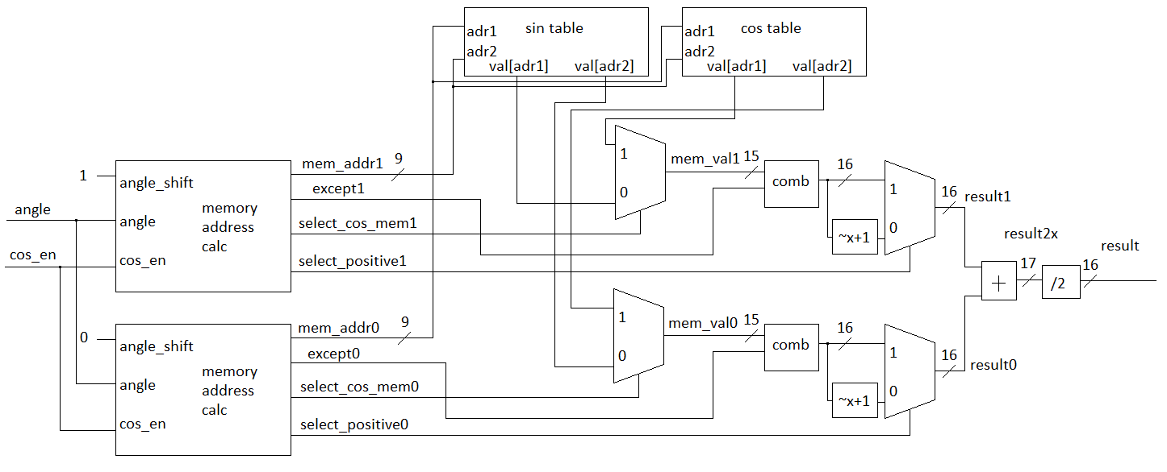

Memory address module:

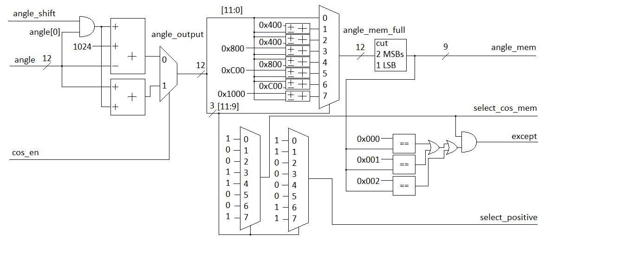

Energy_diff / Energy_data0 = 10*log(0.002413/4096.016469) = -62.298dB

Difff.m output:

max(data0-data1) = +0.001554 +0.001554i = +0.00155412 +0.00155412i

min(data0-data1) = -0.001554 -0.001554i = -0.00155412 -0.00155412i

max(data0/data1) = -Inf -Infi

min(data0/data1) = +Inf +Infi

approx separated mean(data0/data1) = +0.997796+ +0.997796i

Energy_data0 = 4096.016469

Energy_diff = 0.002413

Energy_data0/Energy_diff = 1697518.136491 = 62.298144dB

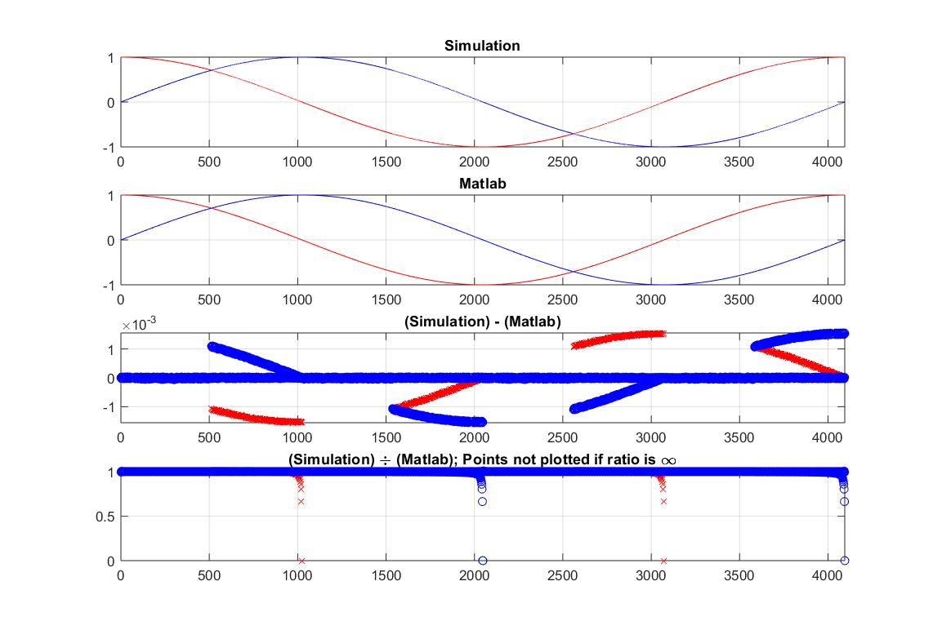

### Code compl.v

/*

Top level for complex number generator

*/

`timescale 1ns/10ps

module compl(

input [11:0] angle,

input start,

input clk,

input reset,

output reg [15:0] r,

output reg [15:0] i

);

parameter IDLE = 2'b00;

parameter COS = 2'b01;

parameter SIN = 2'b10;

reg [1:0] mode, mode_c;

reg [11:0] angle_mem, angle_r;

reg [15:0] r_c, i_c;

wire [15:0] cos_val;

reg cos_en, start_r;

initial begin

mode = IDLE;

mode_c = IDLE;

angle_mem = 12'b0000_0000_0000;

// angle_r = 12'b0000_0000_0000;

r_c = 16'b0000_0000_0000_0000;

i_c = 16'b0000_0000_0000_0000;

cos_en = 1'b0;

// start_r = 1'b0;

end

cos cos_mem (.angle (angle_r), .cos_en(cos_en), .result(cos_val));

//State Machine

always @(angle_r or start_r or mode) begin

mode_c = mode;

case(mode)

IDLE: begin

if (start_r == 1'b1) begin

mode_c = COS;

cos_en = mode_c[0];

angle_mem = angle_r;

end

end

COS: begin

r_c = cos_val;

mode_c = SIN;

cos_en = mode_c[0];

end

SIN: begin

i_c = cos_val;

mode_c = IDLE;

end

default: begin

mode_c = IDLE;

end

endcase

end

//output FFlop

always @(posedge clk or posedge reset) begin

if (reset == 1'b1) begin

r <= #1 16'b0000_0000_0000_0000;

i <= #1 16'b0000_0000_0000_0000;

mode <= #1 IDLE;

angle_r <= #1 12'b0000_0000_0000;

start_r <= #1 1'b0;

end else begin

r <= #1 r_c;

i <= #1 i_c;

mode <= #1 mode_c;

angle_r <= #1 angle;

start_r <= #1 start;

end

end

endmodule

### Code cos.v

//cos function lookup table

//full precision and [0 .. 45) degrees

`timescale 1ns/10ps

module addr_selector(

input [11:0] angle,

input angle_shift,

input cos_en,

output reg [8:0] mem_address,

output reg do_except,

output reg select_cos_mem,

output reg select_positive

);

//logic variables

reg [11:0] angle_output, angle_mem_full;

always @(angle or cos_en) begin

//cos/sin selection for output

if (cos_en == 1'b1)

//compute cos(angle)

angle_output = angle + angle[0]*angle_shift;

else

//compute sin(angle) = cos (pi/2 - angle)

angle_output = 11'b100_0000_0000 - angle - angle[0]*angle_shift;

//choose cos/sin mem bank

case (angle_output[11:9])

3'b000: begin //0 - 45

angle_mem_full = angle_output;

select_cos_mem = 1'b1;

select_positive = 1'b1;

end

3'b001: begin //45 - 90

angle_mem_full = 12'h400 - angle_output;

select_cos_mem = 1'b0;

select_positive = 1'b1;

end

3'b010: begin //90 - 135

angle_mem_full = angle_output[9:0] - 12'h400;

select_cos_mem = 1'b0;

select_positive = 1'b0;

end

3'b011: begin //135 - 180

angle_mem_full = 12'h800 - angle_output;

select_cos_mem = 1'b1;

select_positive = 1'b0;

end

3'b100: begin //180 - 225

angle_mem_full = angle_output - 12'h800;

select_cos_mem = 1'b1;

select_positive = 1'b0;

end

3'b101: begin //225 - 270

angle_mem_full = 12'hC00 - angle_output;

select_cos_mem = 1'b0;

select_positive = 1'b0;

end

3'b110: begin //270 - 315

angle_mem_full = angle_output - 12'hC00;

select_cos_mem = 1'b0;

select_positive = 1'b1;

end

3'b111: begin //315 - 360

angle_mem_full = 13'h1000 - angle_output;

select_cos_mem = 1'b1;

select_positive = 1'b1;

end

endcase

//exception (when need to return +1.0)

mem_address = angle_mem_full[9:1];

do_except = (mem_address == 10'b00_0000_0000);

do_except = do_except || (mem_address == 10'b00_0000_0001);

do_except = do_except || (mem_address == 10'b00_0000_0010);

//except only work for cos bank near angle 0

do_except = do_except & select_cos_mem;

end

endmodule

//////////////////////////////////////////////////////////////////

module cos(

input cos_en,

input [11:0] angle,

output reg [15:0] result

);

reg [15:0] result0, result1;

reg [16:0] result2x;

reg [14:0] cos_mem [256:0];

reg [14:0] sin_mem [256:0];

reg [14:0] mem_val0, mem_val1;

wire [8:0] mem_adr0, mem_adr1;

wire select_cos_mem0, select_cos_mem1, select_positive0, select_positive1, except0, except1;

initial begin

//defaults

result = 16'b0000_0000_0000_0000;

mem_val0 = 15'b000_0000_0000_0000;

mem_val1 = 15'b000_0000_0000_0000;

//load values to memory;

cos_mem[9'b000000000] = 15'b000000000000000; sin_mem[9'b000000000] = 15'b000000000000000;

cos_mem[9'b000000001] = 15'b000000000000000; sin_mem[9'b000000001] = 15'b000000000110010;

cos_mem[9'b000000010] = 15'b000000000000000; sin_mem[9'b000000010] = 15'b000000001100101;

cos_mem[9'b000000011] = 15'b011111111111111; sin_mem[9'b000000011] = 15'b000000010010111;

cos_mem[9'b000000100] = 15'b011111111111111; sin_mem[9'b000000100] = 15'b000000011001001;

cos_mem[9'b000000101] = 15'b011111111111110; sin_mem[9'b000000101] = 15'b000000011111011;

cos_mem[9'b000000110] = 15'b011111111111101; sin_mem[9'b000000110] = 15'b000000100101110;

cos_mem[9'b000000111] = 15'b011111111111100; sin_mem[9'b000000111] = 15'b000000101100000;

cos_mem[9'b000001000] = 15'b011111111111011; sin_mem[9'b000001000] = 15'b000000110010010;

cos_mem[9'b000001001] = 15'b011111111111010; sin_mem[9'b000001001] = 15'b000000111000100;

cos_mem[9'b000001010] = 15'b011111111111000; sin_mem[9'b000001010] = 15'b000000111110111;

cos_mem[9'b000001011] = 15'b011111111110111; sin_mem[9'b000001011] = 15'b000001000101001;

cos_mem[9'b000001100] = 15'b011111111110101; sin_mem[9'b000001100] = 15'b000001001011011;

cos_mem[9'b000001101] = 15'b011111111110011; sin_mem[9'b000001101] = 15'b000001010001101;

cos_mem[9'b000001110] = 15'b011111111110001; sin_mem[9'b000001110] = 15'b000001011000000;

//<Many lines removed>

cos_mem[9'b011110010] = 15'b010111100101000; sin_mem[9'b011110010] = 15'b010101101000101;

cos_mem[9'b011110011] = 15'b010111100000110; sin_mem[9'b011110011] = 15'b010101101101010;

cos_mem[9'b011110100] = 15'b010111011100100; sin_mem[9'b011110100] = 15'b010101110001111;

cos_mem[9'b011110101] = 15'b010111011000010; sin_mem[9'b011110101] = 15'b010101110110100;

cos_mem[9'b011110110] = 15'b010111010011111; sin_mem[9'b011110110] = 15'b010101111011000;

cos_mem[9'b011110111] = 15'b010111001111101; sin_mem[9'b011110111] = 15'b010101111111101;

cos_mem[9'b011111000] = 15'b010111001011010; sin_mem[9'b011111000] = 15'b010110000100001;

cos_mem[9'b011111001] = 15'b010111000110111; sin_mem[9'b011111001] = 15'b010110001000110;

cos_mem[9'b011111010] = 15'b010111000010101; sin_mem[9'b011111010] = 15'b010110001101010;

cos_mem[9'b011111011] = 15'b010110111110010; sin_mem[9'b011111011] = 15'b010110010001110;

cos_mem[9'b011111100] = 15'b010110111001111; sin_mem[9'b011111100] = 15'b010110010110010;

cos_mem[9'b011111101] = 15'b010110110101011; sin_mem[9'b011111101] = 15'b010110011010110;

cos_mem[9'b011111110] = 15'b010110110001000; sin_mem[9'b011111110] = 15'b010110011111010;

cos_mem[9'b011111111] = 15'b010110101100101; sin_mem[9'b011111111] = 15'b010110100011110;

cos_mem[9'b100000000] = 15'b010110101000001; sin_mem[9'b100000000] = 15'b010110101000001;

end

//address calculation for bottom value

addr_selector ADS0 (

.angle (angle),

.angle_shift (1'b0),

.cos_en (cos_en),

.mem_address (mem_adr0),

.do_except (except0),

.select_cos_mem (select_cos_mem0),

.select_positive (select_positive0)

);

//address calculation for upper value

addr_selector ADS1 (

.angle (angle),

.angle_shift (1'b1),

.cos_en (cos_en),

.mem_address (mem_adr1),

.do_except (except1),

.select_cos_mem (select_cos_mem1),

.select_positive (select_positive1)

);

//calculate upper value

always @(mem_adr1 or mem_adr1 or select_cos_mem1 or select_positive1) begin

//read memory

if (select_cos_mem1 == 1'b1) begin

mem_val1 = cos_mem[mem_adr1];

end else begin

mem_val1 = sin_mem[mem_adr1];

end

if (select_positive1 == 1'b1) begin

result1 = {mem_val1[14], mem_val1[14] | except1, mem_val1[13:0]};

end else begin

result1 = -{mem_val1[14], mem_val1[14] | except1, mem_val1[13:0]};

end

end

//calculate bottom value

always @(mem_adr0 or mem_adr0 or select_cos_mem0 or select_positive0) begin

//read memory

if (select_cos_mem0 == 1'b1) begin

mem_val0 = cos_mem[mem_adr0];

end else begin

mem_val0 = sin_mem[mem_adr0];

end

if (select_positive0 == 1'b1) begin

result0 = {mem_val0[14], mem_val0[14] | except0, mem_val0[13:0]};

end else begin

result0 = -{mem_val0[14], mem_val0[14] | except0, mem_val0[13:0]};

end

end

//write output

always @(result1 or result0) begin

result2x = {result1[15], result1} + {result0[15], result0};

result = result2x[16:1]; //devide by 2

end

endmodule