GUI Layout Toolbox Bash Tasks

# Boxes

* Columns 1, 2 and 4 are variable width; 1 is twice as wide as 2 and 4
* Column 4 is fixed width (100 px)
* Vertical divider on the right is draggable

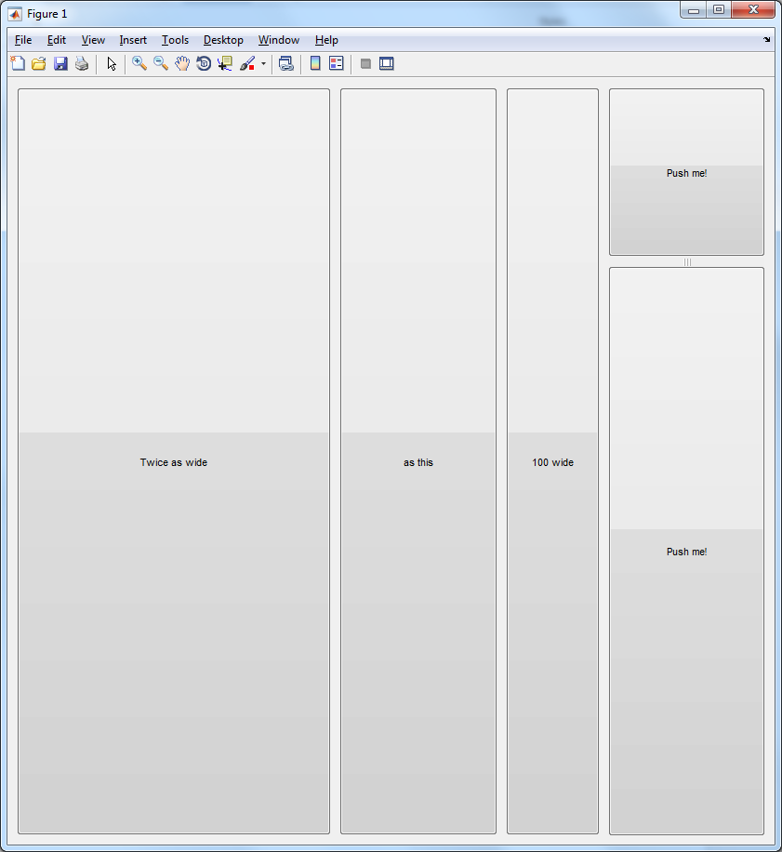

# Grids

Create a checkerboard of buttons in a uix.Grid.

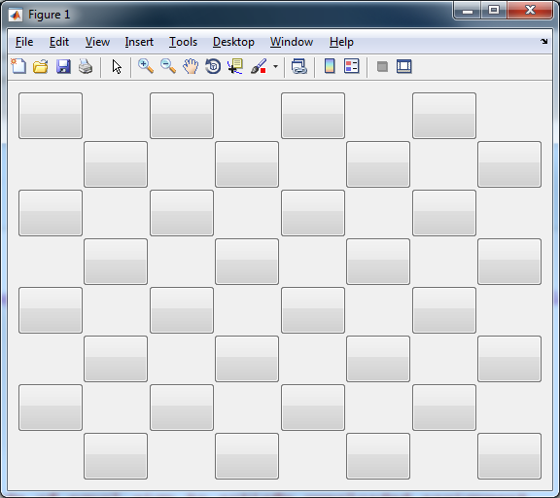

# Axes

Create a figure with three elements:

* A listbox 100 px wide in the top left
* Axes with peaks in the top right
* An inactive edit box at the bottom

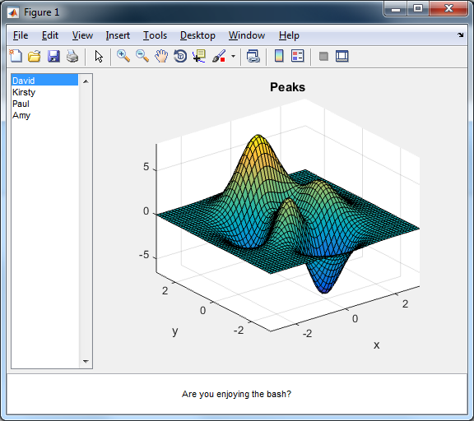

# Tabs

Place the above in a group of tabs. Try both a uitabgroup and a uix.TabPanel.

For extra credit, set up a callback so that a message is shown in the command window when tab selection changes… something like “Changed selection from 2 to 3”.

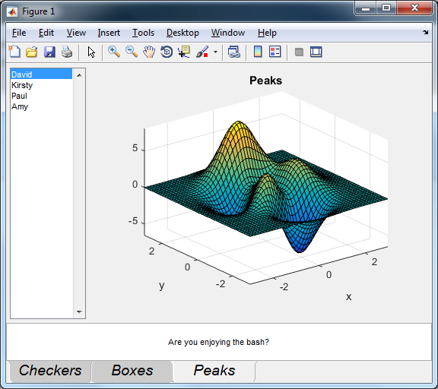

# Miscellaneous

* Experiment with flexible boxes and grids. Does the cursor change as you expect when you hover over a divider?
* Try docking and undocking your figure windows. Any issues?
* Try setting minimum widths and heights on boxes and grids and checking the container resize behaviour.

# Shipping demo

* Bring up the help, doc -classic.
* Navigate to GUI Layout Toolbox > User Guide > 8. A complete example.
* Run demoBrowser.m. Have a play.

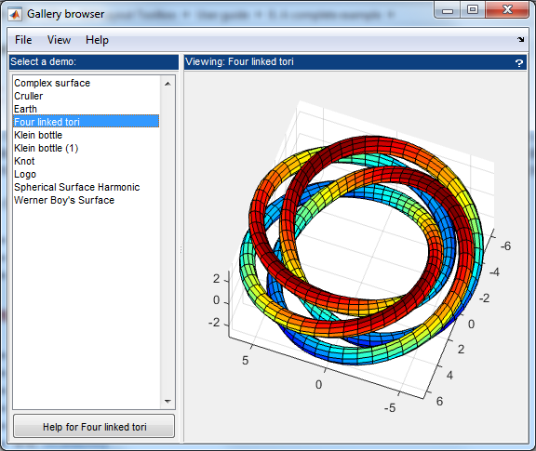

# Bugs

Please geck to component “Consulting Projects”, subcomponent “GUI Layout Toolbox”.