Household and Environmental Drivers of Gut Microbiome Variation in Ethiopian School Children
OR
Hygienic Habits and Household Variables Alter Gut Diversity and
Composition in Ethiopian School Children
Max Warriner  Colgate University  Department of Mathematics mwarriner@colgate.edu | Bineyam Taye  Colgate University  Department of Biology btaye@colgate.edu

Abstract

Background
The effects and associations between environmental, socioeconomic, clinical, and lifestyle factors and the gut microbiome remain understudied in non-western populations. Different living conditions and attitudes towards hygiene practices affect different populations differently. To explore this, household and environmental factors were tested for variations in the gut microbiome of Ethiopian Schoolchildren.

Methods
Stool samples from 138 Ethiopian schoolchildren (aged 6-17) living in Jimma Town, Ethiopia, were collected and sequenced using 16s rRna targeted amplicon sequencing to identify the composition of the microbiome. The guardians of the children filled out the accompanying questionnaire.

Results
Lifestyle factors such as hand-washing soap usage were found to significantly (p < 0.05) alter gut microbiome alpha diversity and abundance of certain genera of microorganisms. Socioeconomic and clinical factors such as kitchen floor material and deworming pills were found to significantly affect gut composition in beta diversity testing.

Conclusions
These exploratory identifications of non-physiological factors such as hand-washing habits and kitchen floor material influencing the gut microbiome can serve as references for future controlled experiments testing causal relationships.

Introduction
Study of the human gut-microbiome aims to characterize and analyze the relationship between the human host and the population of microorganisms inhabiting its gastrointestinal (GI) system. Primary interest is of the hundreds of billions of, mostly anaerobic, bacteria, unicellular eukaryotes, and other microorganisms in the human colon (Khalil et al., 2024). Humans and their microbiota form a symbiotic relationship that, for humans, extends the genomic capabilities of their GI system, aiding in digestion, immune function, metabolite synthesis, communicating with the nervous system through the gut-brain axis, and much more (Khalil et al., 2024).
Non-genetic factors account for roughly 20% of inter-human gut microbiome variation (Zhernakova et al., 2016). Common factors studied include diet, air pollutants, pet ownership, and smoking, as done in a large analysis of a Dutch population by Gacesa et al. African populations are underrepresented in human gut microbiome research, let alone for non-genetic factors(Ayeni et al., 2022). Most studies in this area focus on differences between urban and rural populations like in Nigeria (Ayeni et al., 2018), Tanzania (Pyuza et al., 2025), and South Africa (Ramaboli et al., 2024), instead of what underlying differences might be having an effect.
Household conditions vary across Africa and Ethiopia more specifically. In the Oromia region, containing Jimma Town, 12.6% of the population have access to improved toilet facilities, 61.5% to unimproved facilities, and 25.9% perform open defecation (Institute & Icf, 2021). This difference is exacerbated by wealth quintile (Institute & Icf, 2021). Microbes have been shown to be transmitted through the air via substrates such as pollen and dust, and the biodiversity of the area can affect that transmission (Hanski et al., 2012).
The effects of hygienic habits on the gut microbiome are not well known. Monira et al. found that, in a small sample, a hand-washing program altered the abundance of certain gut bacteria relating to Cholera infection. Hand-washing is not ubiquitous in Ethiopian children despite knowledge of its benefits (Berhanu et al., 2022). Around half of children in Southern Ethiopia wash their hands before eating a meal, with most only using water instead of with soap (Berhanu et al., 2022). Hand-washing was more likely among older children, urban children, children with parents who were educators or health professionals, and unsurprisingly, those with more readily available access to hand-washing facilities (Berhanu et al., 2022).
In this cross-sectional study of 138 Ethiopian schoolchildren, we replicate previously found associations between gut microbiome diversity and age & weight, whilst also uncovering novel factors of gut microbiome composition such as soap use when hand washing and kitchen floor
material.

Methods
Study methods have been articulated more precisely in previous studies [40]. Below is a more concise description of the methods.

Ethics Statement
The study was approved by the Institutional Review Boards (IRBs) of Colgate University, Hamilton, NY, USA (IRB Reference number: FR-S20-03/20) and Jimma University Institute of Health, Ethiopia (IRB Reference number: IHRPGD/786/20). Written or fingerprint consent was obtained for each child’s parents or legal guardian. Children were informed of their right to leave the study at any point with no consequences. All confidential information on participating children has been kept in password-protected electronic files.

Study Design
The data presented in this study are one part of a larger, longitudinal & cross-sectional study analyzing the before-and-after effects of mass deworming protocols on the gut microbiome characteristics of Ethiopian Schoolchildren (Taye et al., 2024). Fecal samples were collected pre- and post-anti-helminthic treatment. Analyzed here are only the pre-treatment samples alongside personal information collected in the questionnaire regarding socioeconomic status, lifestyle habits, and environmental conditions.

Study Setting and Context
A detailed map was created for a previous study (Russel et al., 2023). Data was collected on children from ten primary schools in Jimma Town, Ethiopia. Jimma Town is a city of approximately 200,000 people (Service, 2007) and is 352 km from the capital city of Addis Ababa. The town sits 1.7km above sea level with a climate varying from dry to tropical. Jimma Town was chosen due to the prevalence of soil transmitted helminth infection in the area, the primary metric of another study (Taye et al., 2024). Many households do not have access to clean potable water, and sanitation levels vary between households.

Study Population
The original cohort of 1036 students has been described previously (Russel et al., 2023). Of those students, 140 were randomly sampled to be included in the analysis and narrowed down to 138 after exclusion of insufficient samples. A previous test showed no significant difference between characteristics of those included and those excluded from the sample (Taye et al., 2024).

Measurement and Data Collection

Questionnaire
Each of the children had a guardian fill out a questionnaire form to collect demographic, environmental, lifestyle, clinical, and socioeconomic factors. Demographic questions included sex, age, weight, mode of delivery, etc. Environmental and lifestyle questions included kitchen and house materials, cleanliness of latrine, bathing location, etc. Clinical factors included vaccination status, current or recent illness, BCG scar, etc. Finally, socioeconomic factors included location of residence, household technology, parental education status, etc.

Fecal sample collection
Fecal samples were initially collected in leak-proof plastic containers before being split in half, one half for detection of parasites, the other for microbiome sequencing. Samples for microbiome sequencing were put in Norgen Stool Nucleic Acid Collection and Preservation Tubes (Norgen Biotek Corp) and then sent to Jimma University where they were frozen within 2 hours. Lastly, those tubes were delivered to Colgate University where they were held at -80°C prior to sequencing.

DNA extraction, library preparation, and sequencing
One smaller portion, up to 250 mg, was taken from the fecal samples to be thawed for extraction. DNA extraction was performed with the DNeasy PowerSoil Pro kit (Qiagen, Germany) according to the manufacturer’s instructions. Homogenization was performed using the Beadbeater (BioSpec, Inc. OK, USA) with two 30-second pulses at 4°C. Isolated DNA purity and concentration was tested with the NanoDrop One (ThermoFisher Scientific, MA, USA). DNA integrity was tested by resolving DNA extracts on a 0.8% agarose gel by electrophoresis, afterwards this was visualized with ethidium bromide staining. Microbial DNA extraction was done by PCR amplification of the
16s rRNA V4 variable region using the primers 515F-Y and 806R according to Earth Microbiome Project (EMP) protocols (earthmicrobiome.org/protocols-and-standards/16s). After this initial extraction, DNA samples were stored again at -80°C before being shipped to MR DNA molecular laboratory (MR DNA, TX, USA) for sequencing on the Illumina MiSeq platform following standard Illumina protocol. The raw FASTQ sequence data was demultiplexed using FASTQ Splitter 64 bit
v19.07.10.

Amplicon sequencing reads processing
Sequence data was assessed for quality with FastQC (Andrews et al., 2010). Sequences with low quality (quality score < 20) or reads shorter than 50 base pairs were trimmed with Trimmomatic v.39. ASVs were generated using DADA2 (Version 1.26) (Callahan et al., 2016) and R (Version 4.2.2) (Team, 2025) following the ‘DADA2 Pipeline Tutorial (1.10) methodology. The software Cutadapt (Martin, 2011) was used to remove adapter sequences. A sample inference algorithm was applied after dereplicating identical reads. Classification of filtered, high-quality sequence reads was performed with the SILVA (SILVAv138) (Quast et al., 2013) reference database after chimeras were removed and paired reads were merged. Contaminant sequences from archaea, mitochondria, and chloroplast were removed before calculating abundance on the newly filtered dataset.

Statistical analysis
All statistical analysis was done in R (version 4.5.1)(Team, 2025). Data was rare-fyed to 20,000 read sampling depth without replacement. Data cleaning and analysis was done with tidyverse (Wickham et al., 2019). Plotting of data was done with ggplot2 (Wickham, 2016). Handling of microbiome features was done with phyloseq (McMurdie & Holmes, 2013). When performed, p-value adjustments were done according to the Benjamini-Hochberg method for controlling for false discovery rate (Benjamini & Hochberg, 1995).

Alpha Diversity
Estimations of alpha diversity were done with the Shannon (Shannon, 1948) and Chao1 (Chao, 1984) biodiversity indices. Tests of alpha diversity were done with Wilcoxon signed-rank tests for equality of medians (Woolson, 2008) in the two sample case. K-sample cases were done with the Kruskal-Wallis test of equality of medians (McKight & Najab, 2010). Effect size calculations were done with η² from the effectsize R package (Ben-Shachar et al., 2020).

Beta Diversity
To test differences in gut microbiome composition across groups, also known as beta diversity, we used the Permutational Multivariate Analysis of Variance (PERMANOVA) test from the vegan package (Oksanen et al., 2025), plotting the results on a PCA plot with the MicrobiotaProcess package (Xu et al., 2023).

Differential Abundance
To test differences in the abundance of genera among differing groups, we used a Wilcoxon signed-rank test for equality of medians (Woolson, 2008) with the Benjamini-Hochberg method of adjusting p-values (Benjamini & Hochberg, 1995). Effect size and p-value calculations were done with the Maaslin2 package (Mallick et al., 2020).

Results
For this study, we wanted to test whether any socioeconomic, demographic, environmental, and other lifestyle characteristics impacted the gut microbiome of Ethiopian children in our sample. To best answer this, a comprehensive survey was completed by a guardian of each child that included various characteristics about their life. Then, a fecal sample taken from each child was analyzed to profile their gut microbiome composition. From this, we can test if differences from child-to-child affect various measures of the gut microbiome.

Alpha Diversity
We found that alpha diversity, a measure of individual gut diversity, was greater in children who reported that they only sometimes used soap rather than always after using the toilet (Chao1: p = 0.0248, η² = 0.032, Shannon: p = 0.0065, η² = 0.051) (Figure 1).
Furthermore, when comparing children across frequencies of using the school latrine, differing levels of school latrine use had significantly different levels of Chao1 diversity in a Kruskal-Wallis test of equality of medians (p = 0.0402, η² = 0.033) (Figure 2). Comparisons across Shannon
diversity did not meet traditional levels of statistical significance.
We also compared children older than 12 years old to children 12 years old or younger, and found that children older than 12 years old had significantly higher Chao1 diversity (p = 0.0340, η² = 0.026) and marginally higher Shannon diversity (p = 0.0806, η² = 0.015) than children 12 years old (Figure 3).
Lastly, we compared children across two groups of weight. We found that children who weighed 40 kg or more had significantly greater Chao1 diversity (p = 0.0177, η² = 0.034) and marginally greater Shannon diversity (p = 0.0836, η² = 0.015) than children weighing less than 40 kg (Figure
4).

Beta Diversity
When testing differences in group gut microbiota composition, we found Beta diversity differences among the groups of children who had cement versus dust kitchen floors among Jaccard (p = 0.003, R² = 0.013) and Bray-Curtis (p = 0.007, R² = 0.016) distance metrics (Figure 5).

Differential Abundance
We tested the abundance of genera of bacteria across socioeconomic, environmental, and lifestyle factors with a Wilcoxon signed rank test for equality of medians.
We found two differentially abundant genera among children who always used soap after using a latrine/toilet versus children who never/sometimes used soap after using a latrine/toilet: Elusimicrobium (β = 3.054, p = 0.0004, q = 0.059) and Prevotella (β = 2.491, p = 0.0002, q = 0.059)
(Figure 6).
We found that three genera were significantly different (p < 0.05) among children who always/sometimes used the school latrine versus those who never did with p < 0.05 and adjusted p < 0.015: Blautia (β = 0.671, p = 0.0035, q = 0.143), Elusimicrobium (β = −2.821, p = 0.0014, q = 0.108), and Paludicola (β = −1.614, p = 0.0026, q = 0.124) (Figure 7).
Lastly, we also found differentially abundant genera among children who had cement versus dust/mud kitchen floors: Lachnoclostridium (β = −0.811, p = 0.0007, q = 0.097) and Prevotella 9 (β = 1.621, p = 0.0007, q = 0.097) (Figure 8).

Figures

Alpha Diversity
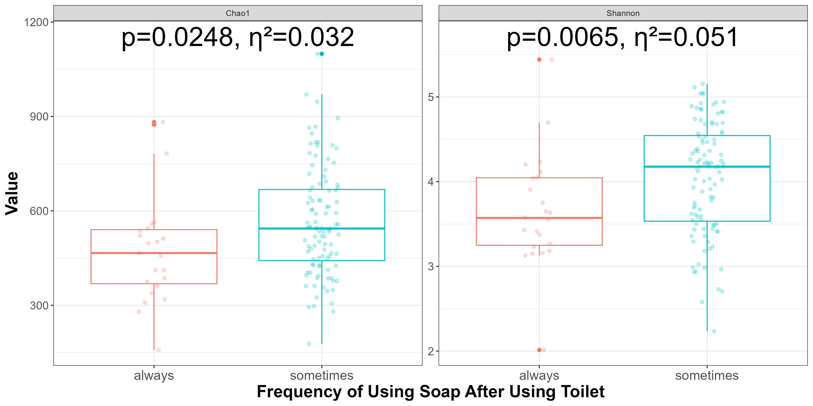
Figure 1: We calculated two metrics of alpha diversity for each child: Shannon and Chao1. The Shannon metric quantifies abundance and evenness of species in an ecosystem as a measure of diversity. Chao1 is an estimate of total species using singletons to infer unobserved species. Hypothesis testing values were done with a Wilcoxon signed rank test for equality of medians, a non-parametric alternative to a two-sample t-test. Across both metrics, the group of children that used soap only sometimes after using a latrine (toilet) had statistically higher levels of alpha diversity for Chao1 diversity (p = 0.0248, η² = 0.032) and Shannon diversity (p = 0.0065, η² = 0.051)
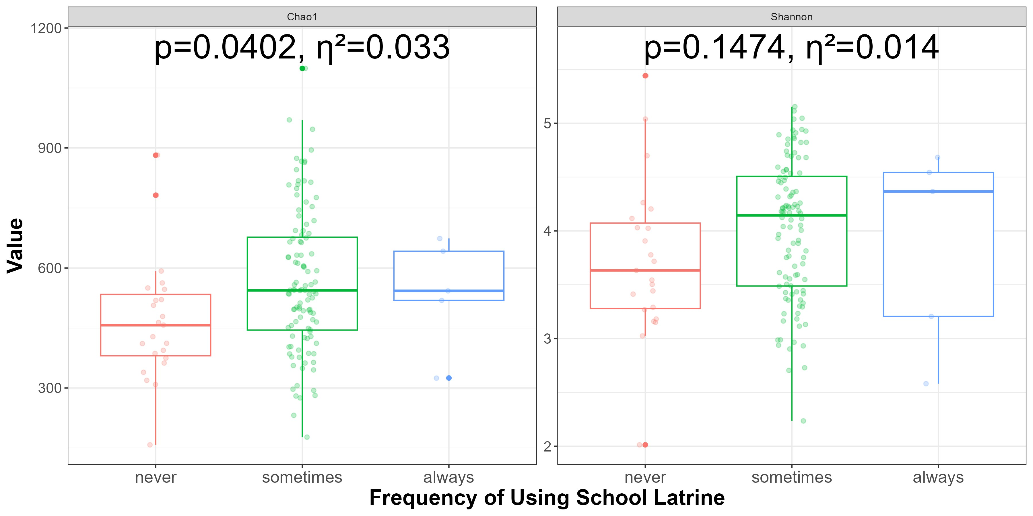
Figure 2: We compared two measures of alpha diversity (Shannon & Chao1) for children across different frequencies of using their school latrine using a Kruskal-Wallis test for equality of medians. Chao1 diversity was significantly different across frequency of using a school latrine (p = 0.0402, η² = 0.033). Differences in Shannon diversity did not reach traditional levels of statistical significance.
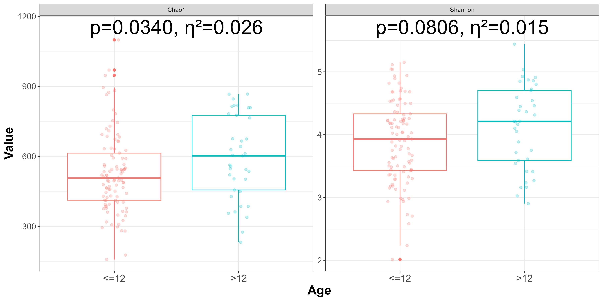
Figure 3: When comparing alpha diversity (Chao1 & Shannon) between children in different age groups, we found in a Wilcoxon signed rank test of equality of medians, that children older than 12 had significantly higher Chao1 diversity (p = 0.0340, η² = 0.026) and marginally higher (p = 0.0806, η² = 0.015) Shannon diversity.
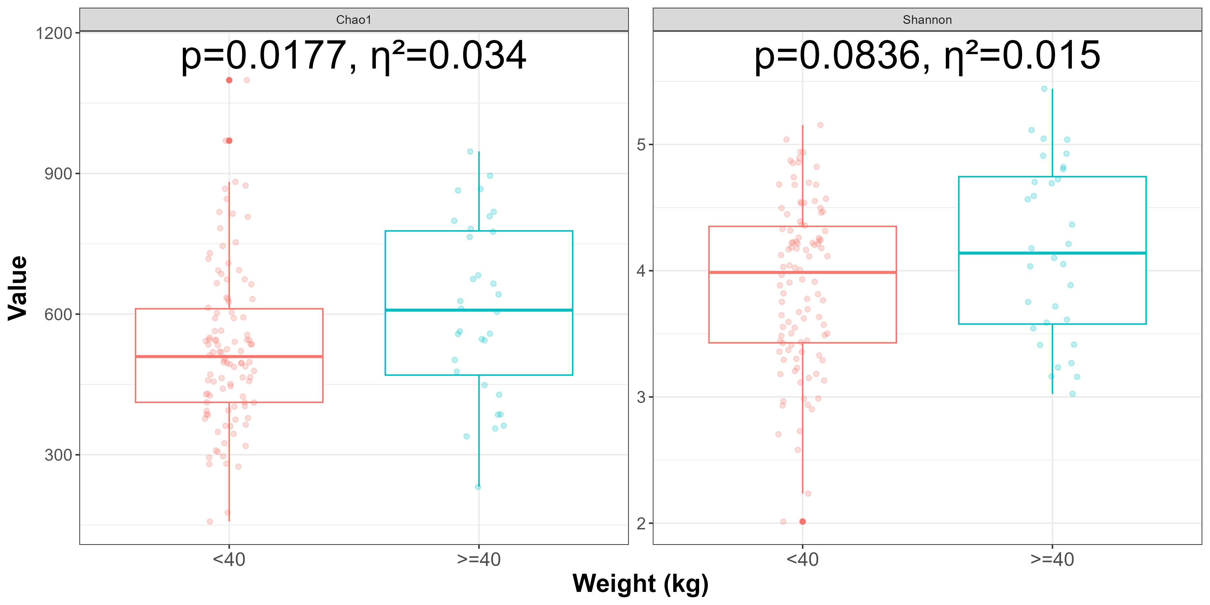
Figure 4: We tested two different measures of alpha diversity (Shannon & Chao1) for children in two different weight groups. Children heavier than or equal to 40 kg had significantly greater Chao1 diversity (p = 0.0177, η² = 0.034) and marginally greater Shannon diversity (p = 0.0836, η² = 0.015).

Beta Diversity
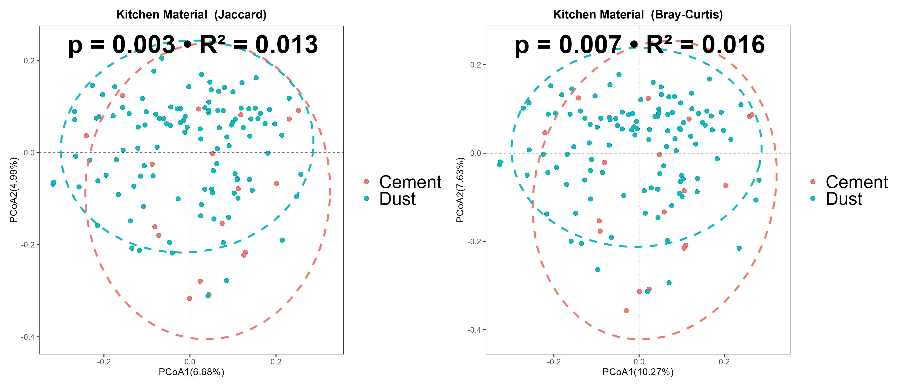
Figure 5: We calculated the beta diversity between groups of children who had kitchens made of dust/mud or cement. Beta diversity measures the difference in species composition between different groups and then plotted each group on a PCoA plot. A PCoA plot uses ordination to place an individual microbiome along two axes, with each axis representing a percentage of variation in diversity accounted for. The groups are then outlined with a 95% confidence interval ellipse. A PERMANOVA test of centroids and dispersion of the ellipses was used to assess differences in beta diversity between the two groups across two distance metrics (Jaccard & Bray-Curtis). Both distance metrics gave statistically significant beta diversity differences between the two groups (Jaccard: p = 0.003, R² = 0.013, Bray-Curtis: p = 0.007, R² = 0.016).

Differential Abundance
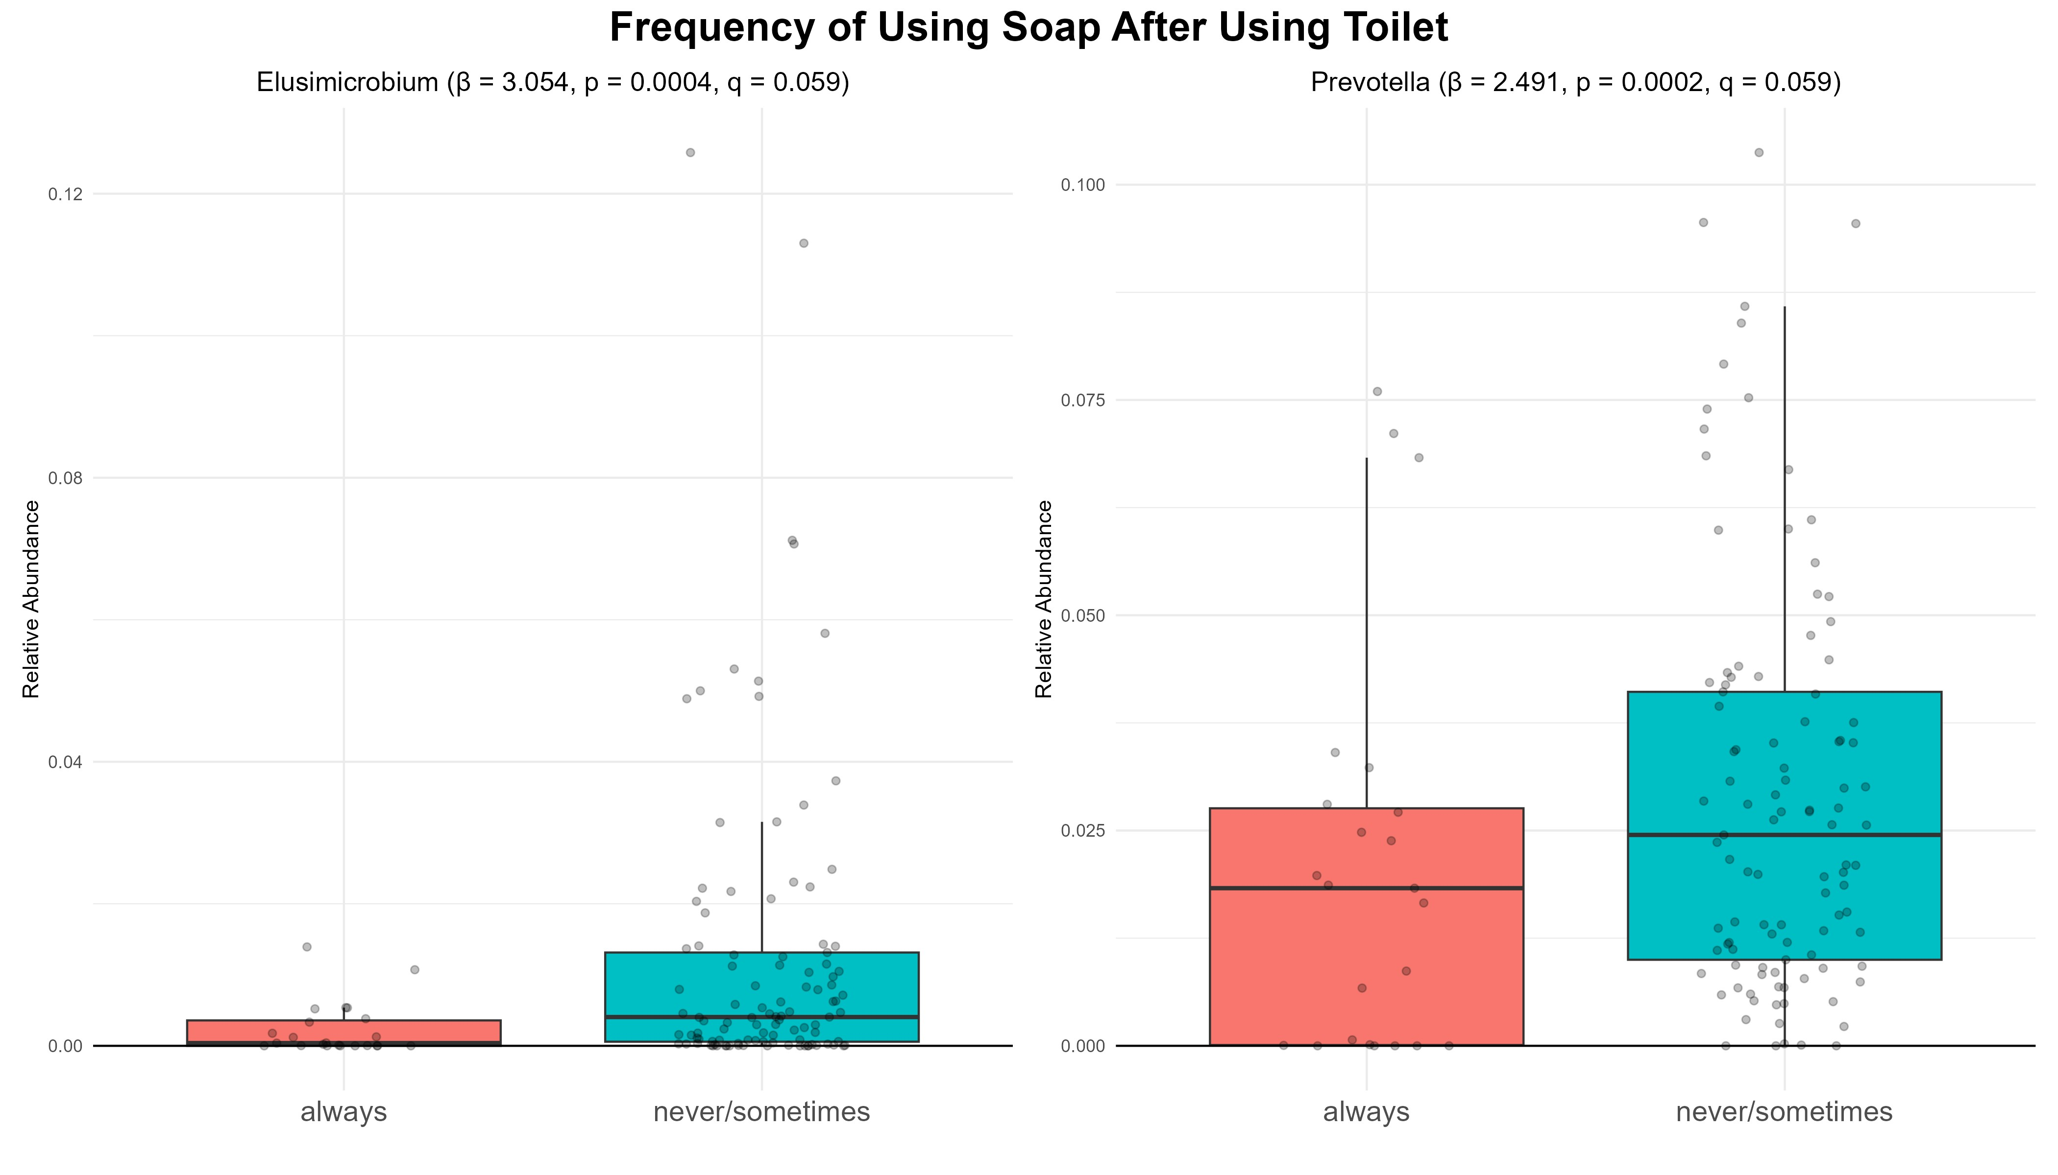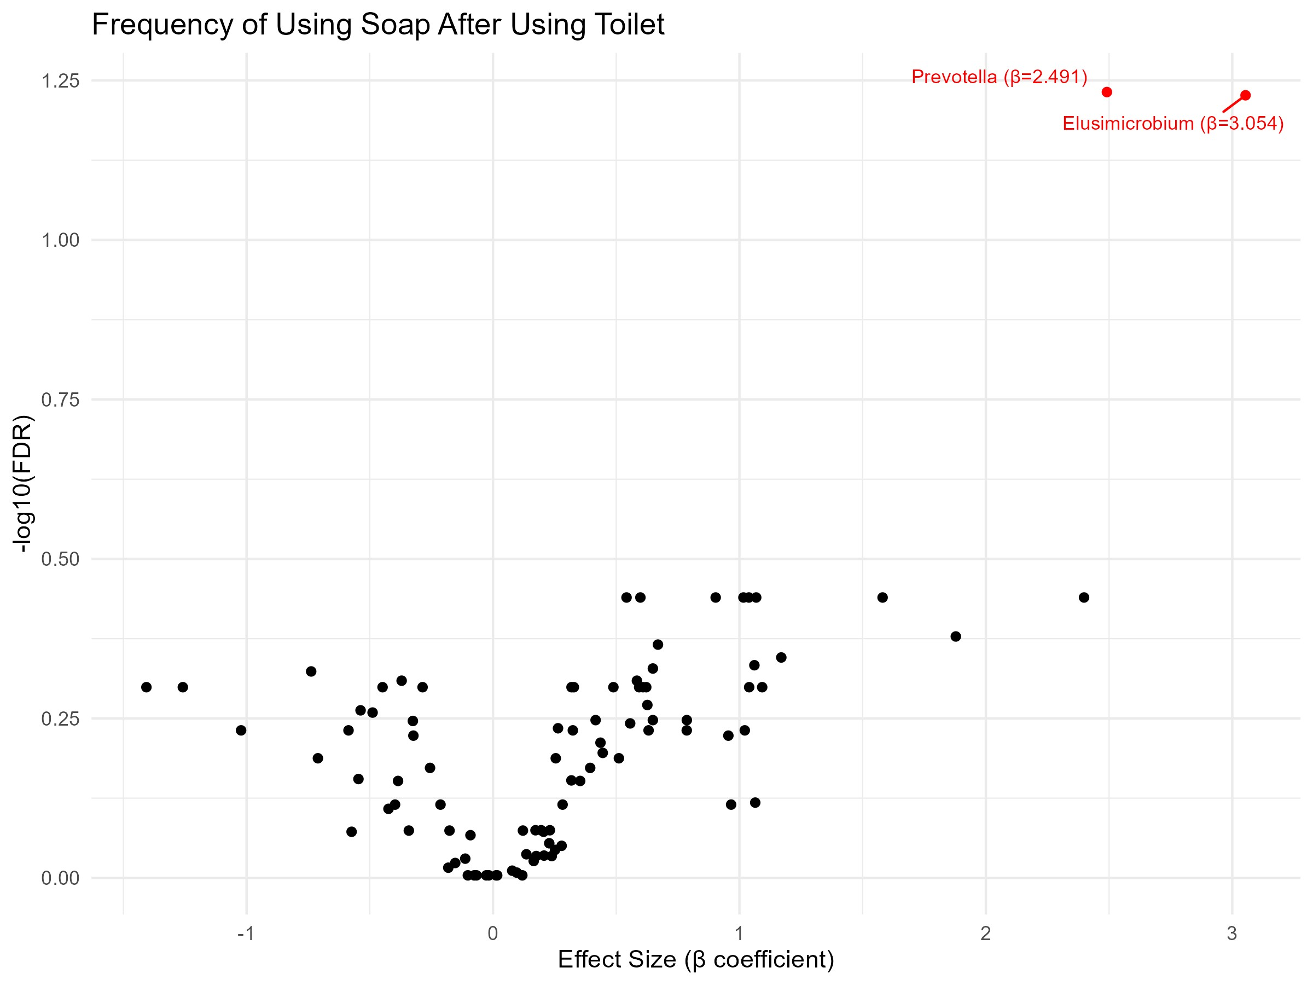
Figure 6: We performed Wilcoxon signed rank tests for equality of medians to test differential abundance of genera for children who always use soap after using a toilet versus children who sometimes/never use soap after using a toilet. Two genera were recognized as having the greatest differential abundance. We found that children who sometimes/never used soap after using a toilet had significantly greater abundance of Elusimicrobium (β = 3.054, p = 0.0004, q = 0.059) than children who always used soap. Also, children who sometimes/never used soap after using a toilet had significantly greater abundance of Prevotella (β = 2.491 p = 0.0002, q = 0.059). Both genera were only marginally significant after Benjamini-Hochberg p-value adjustment. On the right is the two genera highlighted on a volcano plot showing differential abundance effect size (x-axis) and p-value (y-axis, higher = lower p-value).
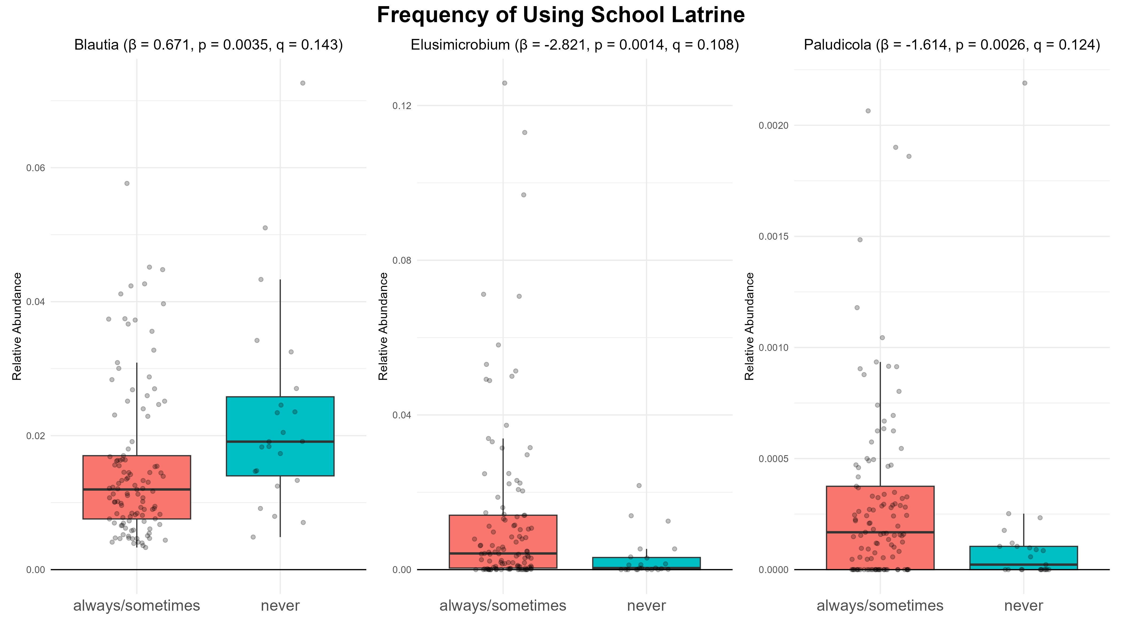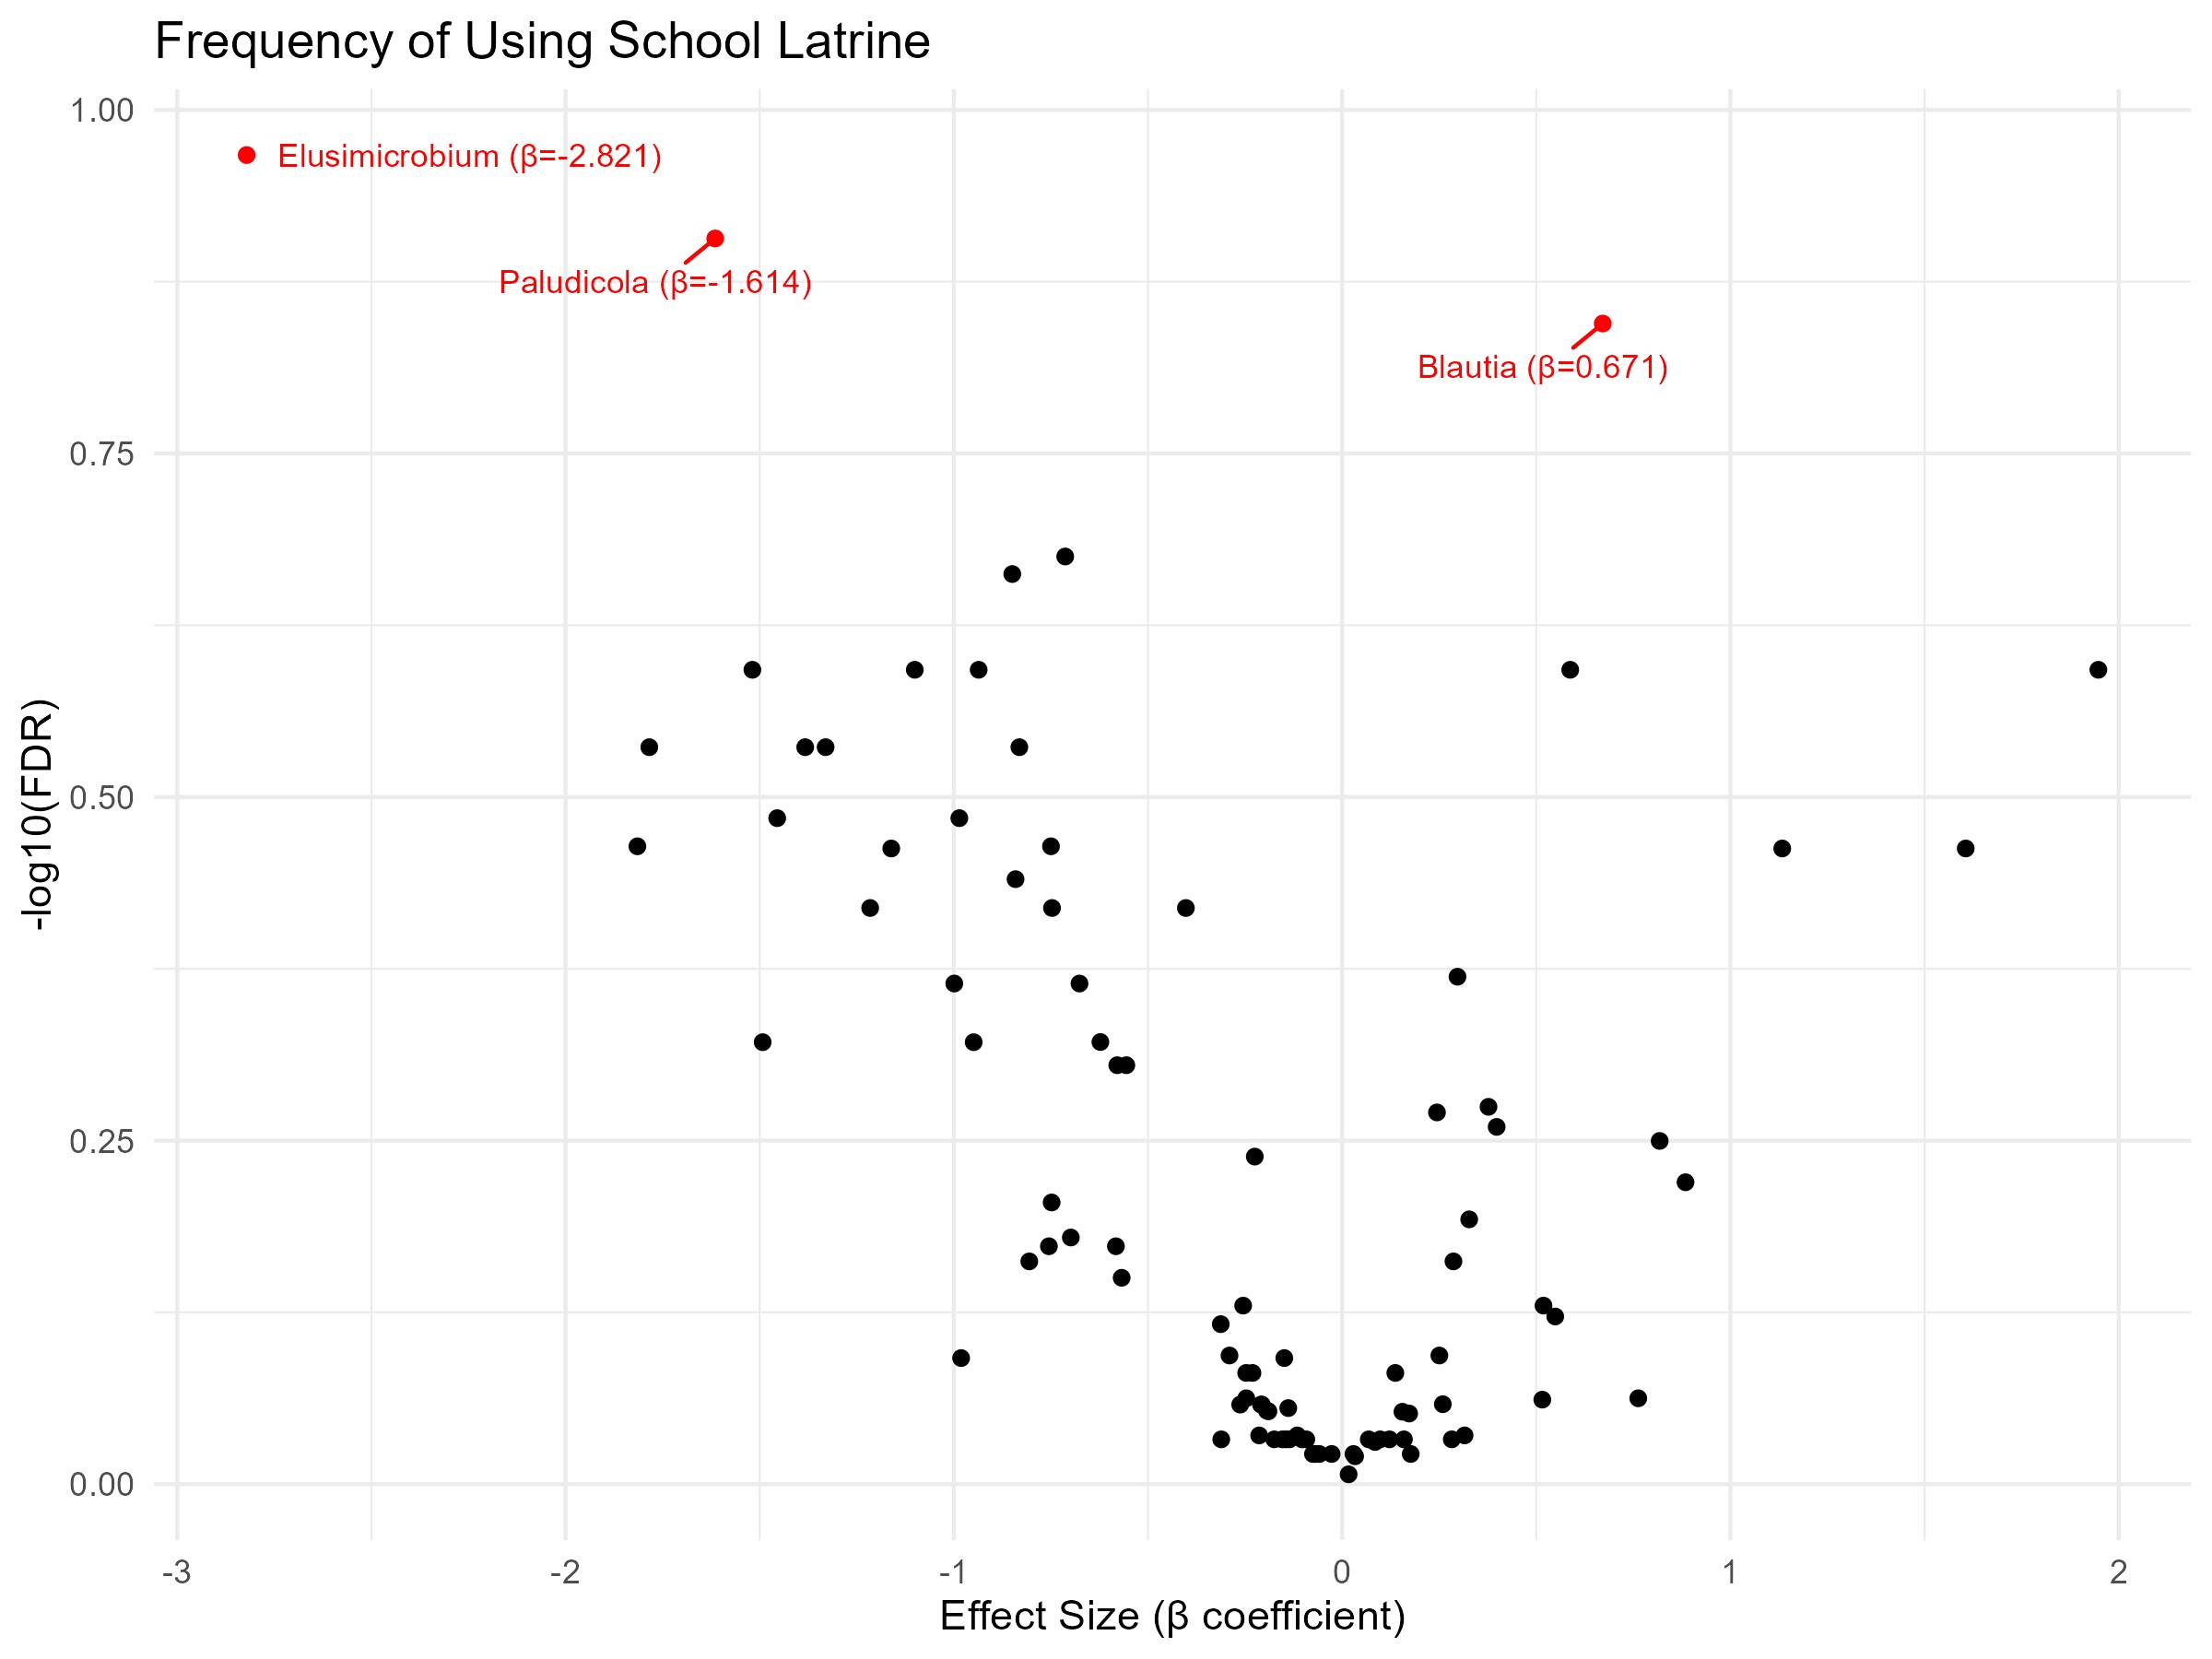
Figure 7: We performed a Wilcoxon signed rank test of equality of medians on the abundance of genera between children who never used the school latrine versus sometimes/always using the school latrine. Genera with Benjamini-Hochberg adjusted p-values < 0.15 were filtered down to 3 differentially abundant genera. Children who never used the school latrine compared to children who sometimes/always used the school latrine had higher abundance of Bluatia (β = 0.671, p = 0.003, q = 0.143), lower abundance of Elusimicrobiom (β = −2.821, p = 0.001, q = 0.108), and lower abundance of Paludicola (β = −1.614, p = 0.003, q = 0.124). None of the values remained statistically significant after adjustment. Also shown on the right is a volcano plot of each genera plotted according to their differential abundance effect size (x-axis), and their p-value (y-axis, higher
= lower p-value)
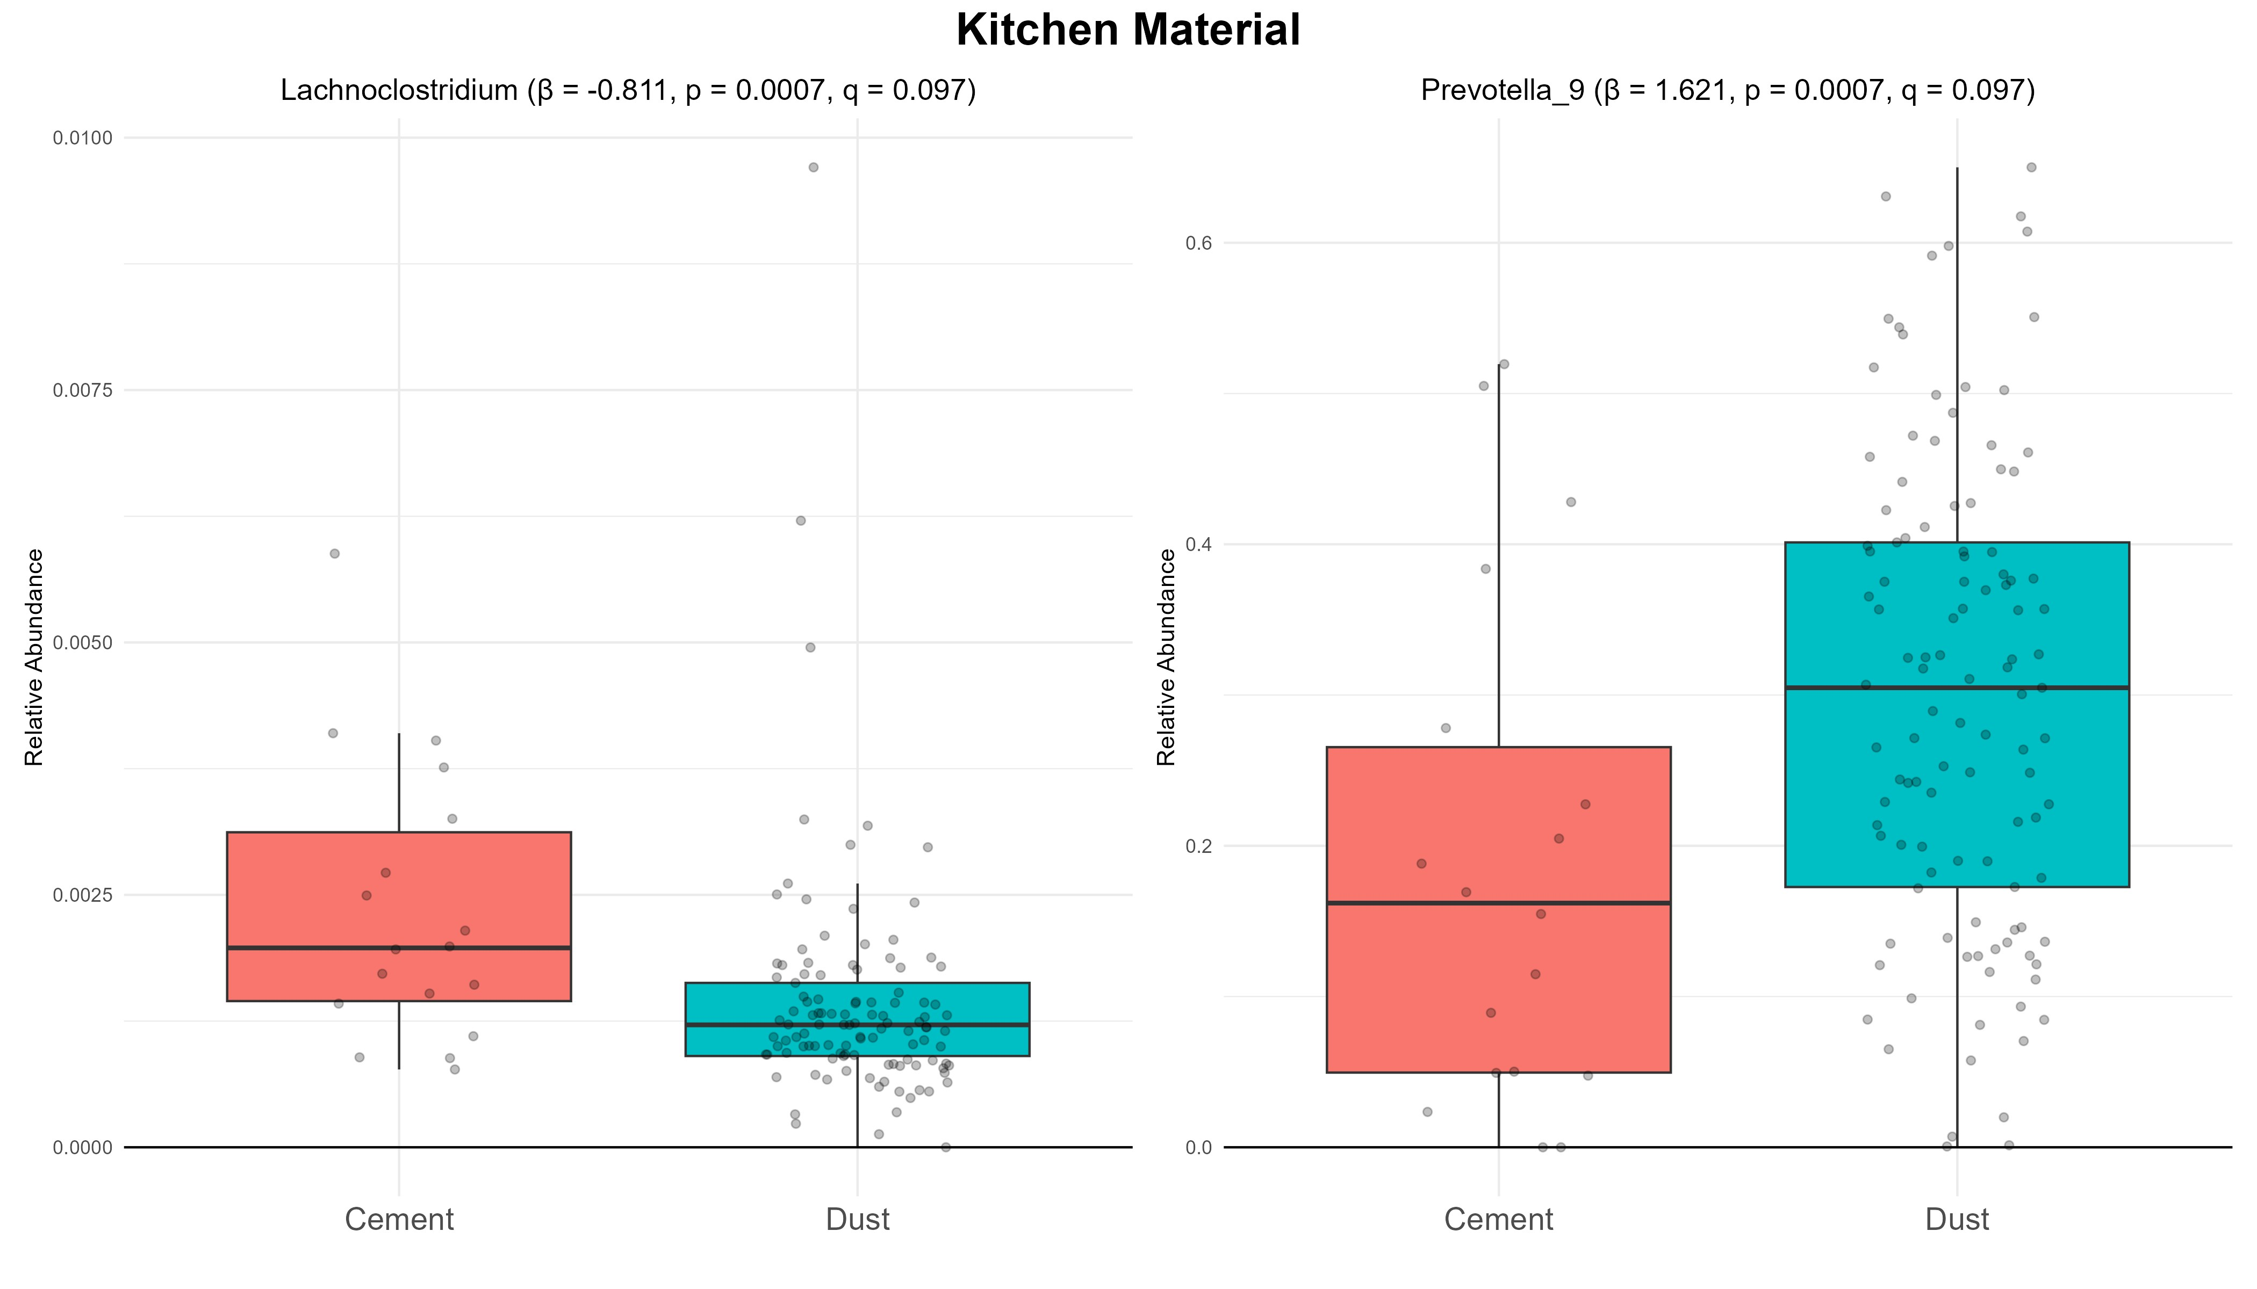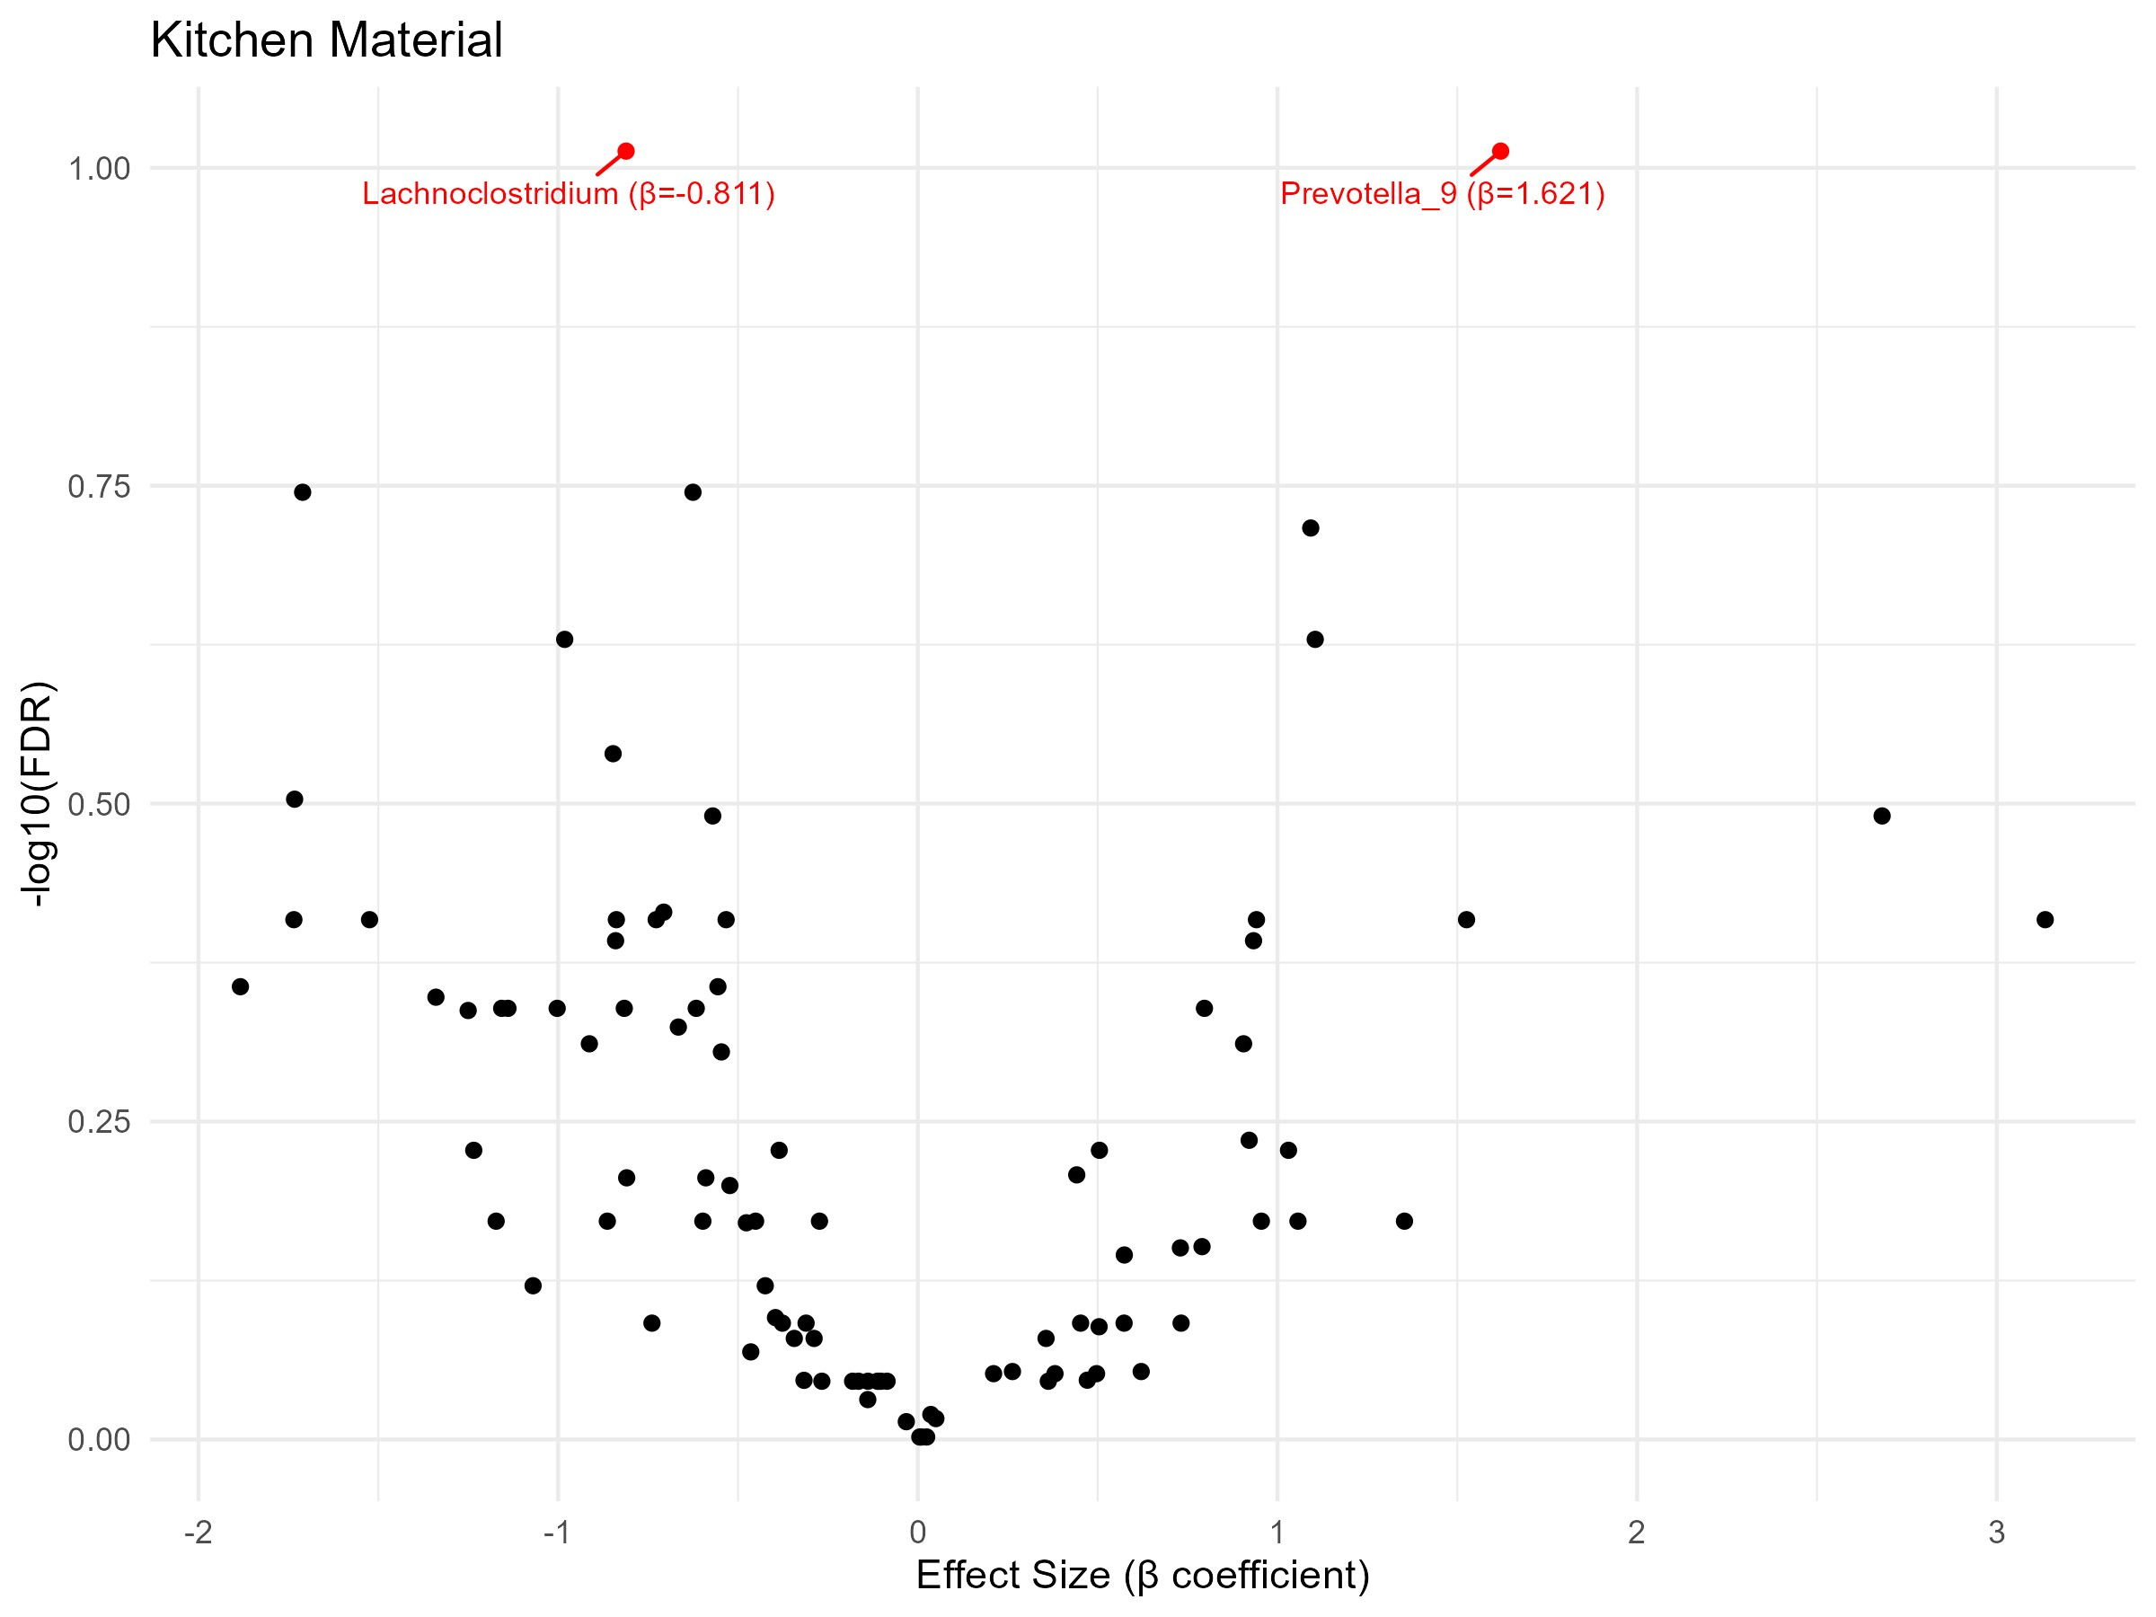
Figure 8: When comparing children with cement versus dust/mud floors in their kitchen, 2 differentially abundant genera were filtered with Benjamini-Hochberg adjusted p-values after performing a Wilcoxon signed rank test for equality of medians. Children with kitchen cement floors had significantly higher abundance of Lachnoclostridium (β = −0.811, p = 0.001, q = 0.097) than children with dust/mud kitchen floors. Conversely, children with dust/mud kitchen floors had significantly higher abundance of Prevotella 9 (β = 1.621 p = 0.001, q = 0.097) than children with cement kitchen floors. Both genera were only marginally significant after adjustment. Also on the right is a volcano plot specifically noting the two differentially abundant genera in comparison to the effect sizes and p-values of the other genera.

Discussion
This cross-sectional study of household and environmental factors that affect the gut microbiomes of Ethiopian children adds novel analysis to an understudied avenue of microbiome research in an understudied population. We observe a novel trend in increasing gut diversity and differing gut composition associated with less traditionally hygienic lifestyle habits and living conditions.
We found statistically significant increases in alpha diversity in children who reported not using soap as frequently as other children after using the latrine (toilet), as well as significant increases in the abundance of Elusimicrobium & Prevotella before adjustment. A small study of in humans associated decreases in Elusimicrobium with type II diabetes (Almugadam et al., 2020), and overall, Elusimicrobium is considered beneficial bacteria in the human gut (Shi et al., 2017), and our analysis shows a consistent low abundance of Elusimicrobium in children who always washed their hands with soap after using the toilet. Literature is mixed on the associations with Prevotella (Chen et al., 2026). Depending on the study, increased abundance of Prevotella is associated with oral inflammation, obesity, and immune diseases. However, decreased abundance of Prevotella is also associated with Crohn’s disease (Chen et al., 2026). These mixed results highlight the importance of species and strain level analysis in gut microbiome research.
In addition, we see a higher frequency of using the school latrine associated with greater intestinal diversity, though only in the Chao1 metric, as well as decreased abundance in Blautia, and increased abundance of Elusimicrobium & Paludicola. Differential abundance results did not survive statistical adjustment. Many studies have been conducted on the link between Blautia and obesity, with a meta-analysis concluding mostly inverse correlations and a potential mechanism of Blautia in alleviating obesity, but more research is needed (Chanda et al., 2024). Other human studies have shown lower abundances of Blautia in people with liver disease (Chen et al., 2021) and Parkinson’s (Guo et al., 2022). Lastly, less is known about the Paludicola genus. Greater abundance of Paludicola in humans has been found to be associated with healthy aging measures (Ramos et al., 2026) and healthy diet (Yang et al., 2023), but also Hidradenitis suppurativa disease (Lelonek et al., 2025) and Kawasaki disease (Yang et al., 2025). In total, the direction of positive/negative health associations with frequency of school latrine usage is mixed in our sample.
Often found among rural families, children living in a house with a dust kitchen floor had significantly different gut compositions than children in a house with a cement kitchen floor, specifically there was found to be a significant decrease in Lachnoclostridium & and a significant increase in Prevotella-9 before adjustment. Lachnoclostridium is typically enriched in people with negative health outcomes, such as colorectal polyps (Grion et al., 2024), atherosclerosis (Cai et al., 2022), and adenoma (Liang et al., 2020). For Prevotella 9, a reduction in the genera is most often associated with negative health outcomes like type-II diabetes (Wang et al., 2024), Crohn’s disease (Hu et al., 2022), Parkinson’s disease (Jin et al., 2019), but not always, as in the case of rheumatoid arthritis (Wu et al., 2025). It is surprising to see the differences in abundance across kitchen floor material aligned in their association with negative health outcomes and cement kitchen floors, as those are associated with factors indicating a higher economic status in our dataset, like maternal education status and having a television in the household.
In Ethiopia, almost all rural households, and even half of urban households have earth, sand, or dung floors (Institute & Icf, 2021). There’s a lack of research characterizing effects of floor type in Africa on people in the household. Mills et al. find household floor contaminants like animal and pet feces having discernible effects on the gut microbiome (Mills et al., 2023). To our knowledge, there is no current study on the association between the gut microbiome and floor material. Of course, floor material is highly correlated with factors relating to socioeconomic status, lifestyle factors, and other covariates. However, in our analysis, floor material stood out compared to those variables in differences in microbiome diversity and composition.

References

Almugadam, B. S., Liu, Y., Chen, S.-m., Wang, C.-h., Shao, C.-y., Ren, B.-w., & Tang, L. (2020). Alterations of Gut Microbiota in Type 2 Diabetes Individuals and the Confounding Effect of Antidiabetic Agents. Journal of Diabetes Research, 2020, 7253978. https://doi.org/10.1155/2020/7253978
Andrews, S., Krueger, F., Segonds-Pichon, A., Biggins, L., Krueger, C., & Wingett, S. (2010). {FastQC}: A Quality Control Tool for High Throughput Sequence Data. In Babraham Bioinformatics, Babraham Institute.
Ayeni, F. A., Biagi, E., Rampelli, S., Fiori, J., Soverini, M., Audu, H. J., Cristino, S., Caporali, L., Schnorr, S. L., Carelli, V., Brigidi, P., Candela, M., & Turroni, S. (2018). Infant and Adult Gut Microbiome and Metabolome in Rural Bassa and Urban Settlers from Nigeria. Cell Reports, 23(10), 3056-3067. https://doi.org/10.1016/j.celrep.2018.05.018
Ayeni, K. I., Berry, D., Wisgrill, L., Warth, B., & Ezekiel, C. N. (2022). Early-life chemical exposome and gut microbiome development: African research perspectives within a global environmental health context. Trends in Microbiology, 30(11), 1084-1100. https://doi.org/10.1016/j.tim.2022.05.008
Ben-Shachar, M. S., Lüdecke, D., & Makowski, D. (2020). {e}ffectsize: Estimation of Effect Size Indices and Standardized Parameters. Journal of Open Source Software, 5(56), 2815. https://doi.org/10.21105/joss.02815
Benjamini, Y., & Hochberg, Y. (1995). Controlling the False Discovery Rate: A Practical and Powerful Approach to Multiple Testing. Journal of the Royal Statistical Society. Series B (Methodological), 57(1), 289-300. http://www.jstor.org/stable/2346101
Berhanu, A., Mengistu, D. A., Temesgen, L. M., Mulat, S., Dirirsa, G., Alemu, F. K., Mangasha, A. E., Gobena, T., & Geremew, A. (2022). Hand washing practice among public primary school children and associated factors in Harar town, eastern Ethiopia: An institution-based cross-sectional study. Frontiers in Public Health, Volume 10 - 2022. https://doi.org/10.3389/fpubh.2022.975507
Cai, Y.-Y., Huang, F.-Q., Lao, X., Lu, Y., Gao, X., Alolga, R. N., Yin, K., Zhou, X., Wang, Y., Liu, B., Shang, J., Qi, L.-W., & Li, J. (2022). Integrated metagenomics identifies a crucial role for trimethylamine-producing {\textit{Lachnoclostridium}} in promoting atherosclerosis. npj Biofilms and Microbiomes, 8, 11. https://doi.org/10.1038/s41522-022-00273-4
Callahan, B. J., McMurdie, P. J., Rosen, M. J., Han, A. W., Johnson, A. J. A., & Holmes, S. P. (2016). {DADA2}: High-Resolution Sample Inference from {Illumina} Amplicon Data. Nature Methods, 13(7), 581-583. https://doi.org/10.1038/nmeth.3869
Chanda, W., Jiang, H., & Liu, S.-J. (2024). The Ambiguous Correlation of {Blautia} with Obesity: A Systematic Review. Microorganisms, 12(9), 1768. https://doi.org/10.3390/microorganisms12091768
Chao, A. (1984). Nonparametric Estimation of the Number of Classes in a Population. Scandinavian Journal of Statistics, 11(4), 265-270. http://www.jstor.org/stable/4615964
Chen, H., Bai, J., Ta, X., Yu, J., & Wang, C. (2026). Effects of enteric Prevotella on host health and disease: An overview of its double-edged roles and future perspectives. Journal of Future Foods. https://doi.org/10.1016/j.jfutfo.2026.01.008
Chen, T., Ding, R., Chen, X., Lu, Y., Shi, J., Lü, Y., Tang, B., Zhang, W., Ye, C., Yuan, M., & Yang, Z. (2021). Firmicutes and {Blautia} in gut microbiota lessened in chronic liver diseases and hepatocellular carcinoma patients: a pilot study. Bioengineered, 12(1), 8233-8246. https://doi.org/10.1080/21655979.2021.1982273
Grion, B. A. R., Fonseca, P. L. C., Kato, R. B., Yupanqui Garca, G. J., Vaz, A. B. M., Nafra Jimnez, B., Lapitz Dambolenea, A., Garcia-Etxebarria, K., Brenig, B., Azevedo, V., Bujanda, L., Banales, J. M., & Ges-Neto, A. (2024). Identification of taxonomic changes in the fecal bacteriome associated with colorectal polyps and cancer: potential biomarkers for early diagnosis. Frontiers in Microbiology, 14, 1292490. https://doi.org/10.3389/fmicb.2023.1292490
Guo, X., Tang, P., Hou, C., Chong, L., Zhang, X., Liu, P., Chen, L., Liu, Y., Zhang, L., & Li, R. (2022). Integrated Microbiome and Host Transcriptome Profiles Link {Parkinson's Disease} to {Blautia} Genus: Evidence From Feces, Blood, and Brain. Frontiers in Microbiology, 13, 875101. https://doi.org/10.3389/fmicb.2022.875101
Hanski, I., von Hertzen, L., Fyhrquist, N., Koskinen, K., Torppa, K., Laatikainen, T., Karisola, P., Auvinen, P., Paulin, L., Mäkelä, M. J., Vartiainen, E., Kosunen, T. U., Alenius, H., & Haahtela, T. (2012). Environmental biodiversity, human microbiota, and allergy are interrelated. Proceedings of the National Academy of Sciences, 109(21), 8334-8339. https://doi.org/10.1073/pnas.1205624109
Hu, J., Cheng, S., Yao, J., Lin, X., Li, Y., Wang, W., Weng, J., Zou, Y., Zhu, L., & Zhi, M. (2022). Correlation between altered gut microbiota and elevated inflammation markers in patients with Crohn's disease. Frontiers in Immunology, 13, 947313. https://doi.org/10.3389/fimmu.2022.947313
Institute, E. P. H., & Icf. (2021). Ethiopia Mini Demographic and Health Survey 2019: Final Report. https://dhsprogram.com/pubs/pdf/FR363/FR363.pdf
Jin, M., Li, J., Liu, F., Lyu, N., Wang, K., Wang, L., Liang, S., Tao, H., Zhu, B., & Alkasir, R. (2019). Analysis of the Gut Microflora in Patients With Parkinson's Disease. Frontiers in Neuroscience, 13, 1184. https://doi.org/10.3389/fnins.2019.01184
Khalil, M., Di Ciaula, A., Mahdi, L., Jaber, N., Di Palo, D. M., Graziani, A., Baffy, G., & Portincasa, P. (2024). Unraveling the Role of the Human Gut Microbiome in Health and Diseases. Microorganisms, 12(11). https://doi.org/10.3390/microorganisms12112333
Lelonek, E., Krajewski, P. K., & Szepietowski, J. C. (2025). Gut Microbiome Correlations in Hidradenitis Suppurativa Patients. Journal of Clinical Medicine, 14(14), 5074. https://doi.org/10.3390/jcm14145074
Liang, J. Q., Li, T., Nakatsu, G., Chen, Y.-X., Yau, T. O., Chu, E., Wong, S., Szeto, C. H., Ng, S. C., Chan, F. K. L., Fang, J.-Y., Sung, J. J. Y., & Yu, J. (2020). A novel faecal {Lachnoclostridium} marker for the non-invasive diagnosis of colorectal adenoma and cancer. Gut, 69(7), 1248-1257. https://doi.org/10.1136/gutjnl-2019-318532
Mallick, H., Rahnavard, A., & McIver, L. J. (2020). MaAsLin 2: Multivariable Association in Population-scale Meta-omics Studies. http://huttenhower.sph.harvard.edu/maaslin2
Martin, M. (2011). Cutadapt Removes Adapter Sequences from High-Throughput Sequencing Reads. EMBnet.journal, 17(1), 10-12. https://doi.org/10.14806/ej.17.1.200
McKight, P. E., & Najab, J. (2010). Kruskal-Wallis Test. In The Corsini Encyclopedia of Psychology (pp. 1-1). John Wiley & Sons, Ltd. https://doi.org/10.1002/9780470479216.corpsy0491
McMurdie, P. J., & Holmes, S. (2013). phyloseq: An R package for reproducible interactive analysis and graphics of microbiome census data. PLoS ONE, 8(4), e61217. http://dx.plos.org/10.1371/journal.pone.0061217
Mills, M., Lee, S., Piperata, B. A., Garabed, R., Choi, B., & Lee, J. (2023). Household environment and animal fecal contamination are critical modifiers of the gut microbiome and resistome in young children from rural {Nicaragua}. Microbiome, 11(1), 207. https://doi.org/10.1186/s40168-023-01636-5
Oksanen, J., Simpson, G. L., Blanchet, F. G., Kindt, R., Legendre, P., Minchin, P. R., O'Hara, R. B., Solymos, P., Stevens, M. H. H., Szoecs, E., Wagner, H., Barbour, M., Bedward, M., Bolker, B., Borcard, D., Borman, T., Carvalho, G., Chirico, M., Caceres, M.,…Weedon, J. (2025). vegan: Community Ecology Package. https://CRAN.R-project.org/package=vegan
Pyuza, J. J., van Dorst, M. M. A. R., Barnett, D., Stam, K., Manurung, M., Wammes, L., König, M., Kruize, Y., Andongolile, N., Ngowi, A., Shao, E. R., Kullaya, V. I., Mremi, A., Hogendoorn, P. C. W., Msuya, S. E., Jochems, S. P., Penders, J., Yazdanbakhsh, M., & de Steenhuijsen Piters, W. A. A. (2025). Tanzanian gut microbiota profiles linked to high but rapidly waning yellow fever antibody titers. npj Biofilms and Microbiomes, 11(1), 110. https://doi.org/10.1038/s41522-025-00687-w
Quast, C., Pruesse, E., Yilmaz, P., Gerken, J., Schweer, T., Yarza, P., Peplies, J., & Glöckner, F. O. (2013). The SILVA ribosomal RNA gene database project: improved data processing and web-based tools. Nucleic Acids Research, 41(D1), D590-D596. https://doi.org/10.1093/nar/gks1219
Ramaboli, M. C., Ocvirk, S., Khan Mirzaei, M., Eberhart, B. L., Valdivia-Garcia, M., Metwaly, A., Neuhaus, K., Barker, G., Ru, J., Nesengani, L. T., Mahdi-Joest, D., Wilson, A. S., Joni, S. K., Layman, D. C., Zheng, J., Mandal, R., Chen, Q., Perez, M. R., Fortuin, S.,…O'Keefe, S. J. D. (2024). Diet changes due to urbanization in South Africa are linked to microbiome and metabolome signatures of Westernization and colorectal cancer. Nature Communications, 15(1), 3379. https://doi.org/10.1038/s41467-024-46265-0
Ramos, C., Hunter, K., Walton, G. E., Whitham, A., Camp, N., Poveda, C., Gibson, G. R., Hough, J., & Magistro, D. (2026). Associations Between the Gut Microbiota and Physical Activity, Sedentary Behaviour and Physical Function in Community-Dwelling Older Adults. Journal of Aging Research, 2026, 8981398. https://doi.org/10.1155/jare/8981398
Russel, W. A., Perry, J., Bonzani, C., Dontino, A., Mekonnen, Z., Ay, A., & Taye, B. (2023). Feature selection and association rule learning identify risk factors of malnutrition among Ethiopian schoolchildren. Frontiers in Epidemiology, Volume 3 - 2023. https://doi.org/10.3389/fepid.2023.1150619
Service, E. S. (2007). Population and Housing Census 2007: National Statistical Report. https://ess.gov.et/download/population-and-housing-census-2007-national_statistical/
Shannon, C. E. (1948). A Mathematical Theory of Communication.
Shi, D., Lv, L., Fang, D., Wu, W., Hu, C., Xu, L., Chen, Y., Guo, J., Hu, X., Li, A., Guo, F., Ye, J., Li, Y., Andayani, D., & Li, L. (2017). Administration of {\textit{Lactobacillus salivarius}} {LI01} or {\textit{Pediococcus pentosaceus}} {LI05} prevents {CCl4}-induced liver cirrhosis by protecting the intestinal barrier in rats. Scientific Reports, 7, 6927. https://doi.org/10.1038/s41598-017-07091-1
Taye, B., Mekonnen, Z., Belanger, K. D., & Davenport, E. R. (2024). Gut-microbiome profiles among Soil-transmitted helminths (STHs) infected Ethiopian children enrolled in the school-based mass deworming program. PLoS Neglected Tropical Diseases, 18(10), e0012485. https://doi.org/10.1371/journal.pntd.0012485
Team, R. C. (2025). R: A Language and Environment for Statistical Computing. https://www.R-project.org/
Wang, X., Guo, Q., Liu, Z., Wang, Y., Cao, C., Jin, L., Li, C., Xiao, J., & Zhao, W. (2024). Alterations in the Gut Microbiota Composition in Obesity with and without Type 2 Diabetes: A Pilot Study. Diabetes, Metabolic Syndrome and Obesity: Targets and Therapy, 17, 3965-3974. https://doi.org/10.2147/DMSO.S477494
Wickham, H. (2016). ggplot2: Elegant Graphics for Data Analysis. Springer-Verlag New York. https://ggplot2.tidyverse.org
Wickham, H., Averick, M., Bryan, J., Chang, W., McGowan, L. D. A., François, R., Grolemund, G., Hayes, A., Henry, L., Hester, J., Kuhn, M., Pedersen, T. L., Miller, E., Bache, S. M., Müller, K., Ooms, J., Robinson, D., Seidel, D. P., Spinu, V.,…Yutani, H. (2019). Welcome to the {tidyverse}. Journal of Open Source Software, 4(43), 1686. https://doi.org/10.21105/joss.01686
Woolson, R. F. (2008). Wilcoxon Signed-Rank Test. In Wiley Encyclopedia of Clinical Trials (pp. 1-3). John Wiley & Sons, Ltd. https://doi.org/10.1002/9780471462422.eoct979
Wu, J., Peng, Y., Tian, R., Yu, H., Hu, H., Huang, Q., Xu, Y., Liu, L., & Pan, H. (2025). Investigating Correlation Between Gut Microbiota and Rheumatoid Arthritis Subtypes by Mendelian Randomization. Pathogens, 14(4), 385. https://doi.org/10.3390/pathogens14040385
Xu, S., Zhan, L., Tang, W., Wang, Q., Dai, Z., Zhou, L., Feng, T., Chen, M., Wu, T., Hu, E., & Yu, G. (2023). MicrobiotaProcess: A comprehensive R package for deep mining microbiome. The Innovation, 4, 100388. https://doi.org/10.1016/j.xinn.2023.100388
Yang, J., Lee, R., Schulz, Z., Hsu, A., Pai, J., Yang, S., Henning, S. M., Huang, J., Jacobs, J. P., Heber, D., & Li, Z. (2023). Mixed Nuts as Healthy Snacks: Effect on Tryptophan Metabolism and Cardiovascular Risk Factors. Nutrients, 15(3), 569. https://doi.org/10.3390/nu15030569
Yang, Q., Tang, W., Ren, J., Li, M., & Zhao, C. (2025). Unveiling the gut-heart potential connection: microbiota's role in Kawasaki disease and coronary artery lesions. Frontiers in Cellular and Infection Microbiology, 15, 1560083. https://doi.org/10.3389/fcimb.2025.1560083
Zhernakova, A., Kurilshikov, A., Bonder, M. J., Tigchelaar, E. F., Schirmer, M., Vatanen, T., Mujagic, Z., Vila, A. V., Falony, G., Vieira-Silva, S., Wang, J., Imhann, F., Brandsma, E., Jankipersadsing, S. A., Joossens, M., Cenit, M. C., Deelen, P., Swertz, M. A., Weersma, R. K.,…Fu, J. (2016). Population-based metagenomics analysis reveals markers for gut microbiome composition and diversity. Science, 352(6285), 565-569. https://doi.org/10.1126/science.aad3369

