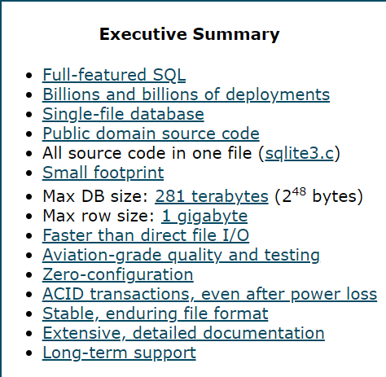

* **Es una librería embebida en aplicaciones de software**
* **SQLite is used to develop embedded software for devices like televisions, cell phones, cameras, etc.**
* **Limited capacity compared with other databases**

