**Signal Modulation and Demodulation**

Maxwell Wisnieski and Librado Anglero (mw9sv@virginia.edu, [lba9wf@virginia.edu](mailto:lba9wf@virginia.edu))

This set of experiments revolved around the use of an AM crystal radio receiver circuit to send or receive signals through the electromagnetic waves in the air. We focused mainly on, initially, getting the circuit to work as intended, and later, the narrowing down the resonance of the circuit and the best frequency for sending signals to the receiver circuit. Both of these proved rather challenging, but led us to a better understanding of the nature of electronic communications through amplitude modulation.

While we take the technology of amplitude modulation for sending signals through space and time for granted these days, from a simple perspective it seems absurd that a collection of wires and electronic components smaller than your finger could be able to send an invisible signal across the air. Even more absurd, perhaps, that we can then receive that signal and transform it back, from currents and waveforms resonating in a small length of wire, into the sound of a human voice repeatedly asking “Testing?”. While today we have even more advanced methods of information technology, such that one can send signals around the world faster than they can blink, the creation and development of radio wave technologies revolutionized the world as it allowed people to communicate in ways that they had never before considered. Our experiments were far more contained than the wide historical impact of the technology of amplitude modulation, but it did allow us to confirm the processes that were involved and reinforce our understanding of electromagnetic processes.

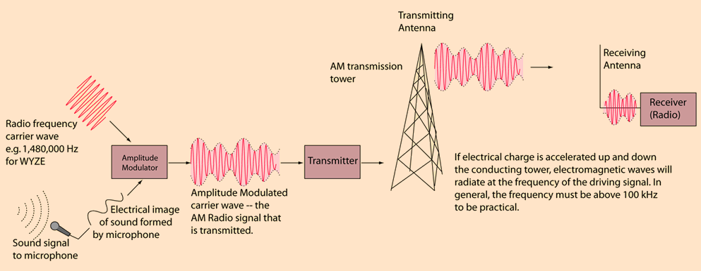 The process of actually receiving or sending signals is one of two processes. First, setting up a useful circuit for the task, and second, using relevant instruments in conjunction with the circuit of be able to filter out noise. To this end, we used a premade circuit format and adjusted it to the best of our ability to get the best signal reception we could. Above, in Image 1[1], the generalized process for transmitting and receiving signals is outlined for amplitude modulation signals, demonstrating the multi-phase process that it requires and the basic components used for the process. The circuit we used was likely not up to a professional standard, but was rather effective when tuned properly.

IMG. 1, An image of the general process of sending signals from a transmitter to a receiver with an antenna.

IMG. 2, An image of general layout of our circuit used for receiving signals. Most components here are far less than ideal, but this abstract diagram is what we ended up building.

In Image 2[2], our circuit is shown with all of the major components that it required to function as a receiver circuit. All of the blue boxes in the image represent pre-built peripheral instruments that we had available, and were assumed to work pretty well. Of note are the four major circuitry components in the diagram, the diode, inductor, capacitor, and variable capacitor. The variable capacitor, together with the inductor and inherent resistances of the circuit served to function as a standard RLC tank circuit, while the diode was used to filter signals. We studied the properties of the available diodes and the resonance of the RCL tank circuit in detail so as to determine the best qualities for each, as well as confirming other properties of the circuit that we found to be advantageous. We did not actually have a regular antenna to use for these experiments, but rather tubes used throughout the entire physics building for the transmission of gas and loops of wire kept very close to one another. The high-pass pre-amp was an instrument used to filter out certain ranges of signals, after which the pre-amp sent an amplified signal with the gain of our choice to the speaker to transmit the sound. In conjunction with the instruments pictured above were digital read-out systems used to record data and store it digitally.

Attaining functionality when attempting to receive latent AM signals that were being broadcast by local radio stations was a rather straightforward process of setting up the circuit as indicated above, with the gas pipes in the building serving as the antenna, and we were eventually able to get an audible signal from the speaker, albeit with a fair amount of background noise making the actual words said slightly indistinct. The only adjustable part of our circuit, aside from various high-pass filters which had to be applied correctly, was the capacitance of the variable capacitor *CA* as shown in Image 2. This particular circuit yielded a very high Q factor, where the capacitance had to be just right, otherwise the radio station would not be audible; millimeter turns on *CA*’s adjustment knob would lead to deafening static. After ascertaining that we could successfully demodulate ambient radio signals, we worked on transmitting the signal from a pre-configured transmitter station to our receiver circuit.

Of more interest was the transmission station, which used a function generator to receive the signal from a small microphone and send the amplified signal from that microphone to a pre-amplifier and then eventually a loop of wire held above our table. That loop of wire was immediately adjacent to another loop which could be connected to our receiver circuit to serve as an antenna. Thus, the signal sent to one loop of wire would induce a magnetic field that would change in strength. The receiver loop was close enough to the sender loop that it was affected by these changes in the magnetic field, inducing a current in the loop that would be sent down to the demodulation circuit and then our speaker. After much testing, we found that the most interesting aspect of the circuit was the carrier frequency granted by the function generator. It gave the best response when set at 800 kHz very sharply; even changes on the scale of 5 kHz would have an audible effect on the strength of the signal being picked up by the receiver circuit. Thus, we concluded that 800 kHz was the ideal carrier frequency for our AM receiver, and tested various noise reduction techniques to little effect.

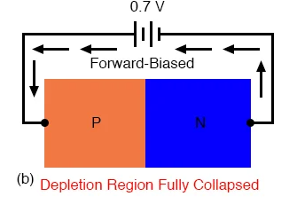Testing the various diodes we had provided to us proved simple, as we set up a circuit that would measure the voltage put into the diode against the voltage out. Since diodes are simple electronic components intended to only permit current in one direction, a voltage range sweep from negative to positive would inform us of their proper functionality. Image 3[3] to the right is a simple schematic of a forward biased diode, one intended to permit positive voltages and block negative voltages. It will incur a small voltage drop across it as a small amount of power is spent, but it should be an exceedingly minimal drop. We first measured a black silicone diode we had and it behaved exactly as expected, which produced the following graph below:

IMG. 3, a diagram of a forward biased diode, containing P-type and N-type regions.

It exhibited all of the properties we expected, appearing as an exponential rise once the voltage was positive, and permitting almost no negative voltage to pass. The voltage drop was actually larger than expected, being about 0.1 volts at low input voltages and growing to 0.2 volts at higher voltages. Errors in these measurements should have been rather minimal, since the circuit was literally only measurement devices and our diode, and the testing frequency was not assumed to be too high for reliable measurements. These result are quite different from a simple resistor, which would permit any polarity of voltage with some voltage drop across it, indicating the necessity of this filtering diode in our circuit.

FIG. 1, a graph of our data collected on the Black diode we had available to us, measuring the input voltage against the output voltage.

Input Voltage (V) vs Output Voltage (V) for the Black diode

The next diode we tested was a small red crystal diode that gave us the following graph:

This diode gave almost identical results to the Black diode, exhibiting an exponential curve that turns positive at a positive input voltage. It permitted only very small amounts of negative input voltage and had a voltage drop that started at 0.1 V and grew to 0.2 V as the input voltage increased. Functionally, this diode behaved almost exactly the same in our circuit as the Black diode, and any errors in these measurements were also assumed to be minimal.

FIG. 2, a graph of our data collected on the Red diode we had available to us, measuring the input voltage against the output voltage.

Input Voltage (V) vs Output Voltage (V) for the Red diode

The final diode we tested was the one actually used in the receiver circuit, which was the white germanium diode. It exhibited much different properties, which are clearly seen in the voltage graph below:

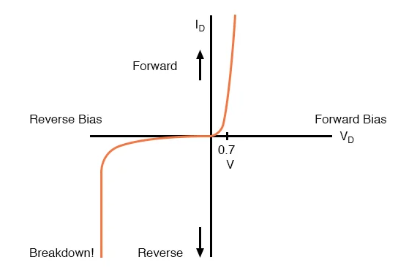This diode permitted any voltage for the range we observed it in and had an abolutely imperceptible voltage drop. The average voltage drop it gave was around ± 0.000184909 V, an incredibly tiny difference that hardly mattered. The key to these measurements is that these occurred at a low signal frequency. The germanium diode is preferred in our demodulation circuit because it almost loss-less at most frequencies, and has a “better high frequency response due to its (usually) lower capacitance”[4]. Thus, it is almost a perfect fit for transmitting the audio data we required it to. At higher frequency signals than the ones we tested here, the diode would begin to exhibit the diode properties we would expect, but with a reverese bias. At breakdown voltages and at high frequencies, the germanium diode would again permit negative current, effectively nullifying any signal with a voltage sitting to near to 0 V. Image 4 gives a visual understanding of this phenomena, as evnetually the negative voltage is simply too large for any insulator, diode or not, and the diode begins to permit negative voltage with a small drop, much as it did for positive votlages. Thus, the diode would serve as an effective noise filter at higher frequencies, since it would barely permit the small voltage fluctuations that are inherent to noise. Even more interesting was the almost identical functioning of our diode when placed forwards or backwards into our democulation circuit. To our ears, there was no real difference to be heard, and when we tested the diode backwards at low frequencies like above, the graph ended up exactly the same.

FIG. 3, a graph of our data collected on the White germanium diode we had available to us, measuring the input voltage against the output voltage.

IMG. 4, a diagram of a diode’s response to both positive and negative voltages.

Input Voltage (V) vs Output Voltage (V) for the White diode

Our final tests were performed on the resonance of the tank circuit before the signal reached the high-pass pre-amplifier, which allowed us to gain a better understanding of how capacitance changed the audibility of the signal we received. The inductance of the inductor could not be changed and the inherent resistances of the circuit were utterly unchangeable outside of simply increasing resistance, so the variable capacitor was naturally the main target of analysis. Image 5[5] shows a simple example of a tank circuit with the inductor and capacitor being given sample values for ease of calculation. We will not be using these values but they do give us a general idea of the form of the circuit that we used. We measured the maximum and minimum capacitance of the capacitor *CA*, which put it in the range of 72.4 pF and 4.1 pF at the two extremes, while the inductor was measured to be about 1.35 mH. Measuring the resistance of the circuit was not quite manageable, so we estimated it using the width of resonance by the relation:

IMG. 5, a diagram of a simple tank circuit with example values for the inductor and capacitor.

(1),

Where is the full-width half-maximum, the frequency where the ratio of output to input voltage is equivalent to , of the given curve, *R* is the resistance of the circuit, and *L* is the inductance of the circuit. To measure the expected resonance frequency, we used the relation:

(2),

Where is the resonance angular frequency, is the resonance frequency, and *C* is the capacitance of the circuit. Combining and allowed us to calculate the Q factor of the circuit by the relation:

(3).

With these equations in mind, we took data on the circuit with the capacitor set to three different settings, maximum capacitance, minimum capacitance, and half-maximum capacitance, values we found easily testable using a handheld multimeter and consistent enough.

First, we took data on the maximum capacitance of *CA*, which produced the following graph:

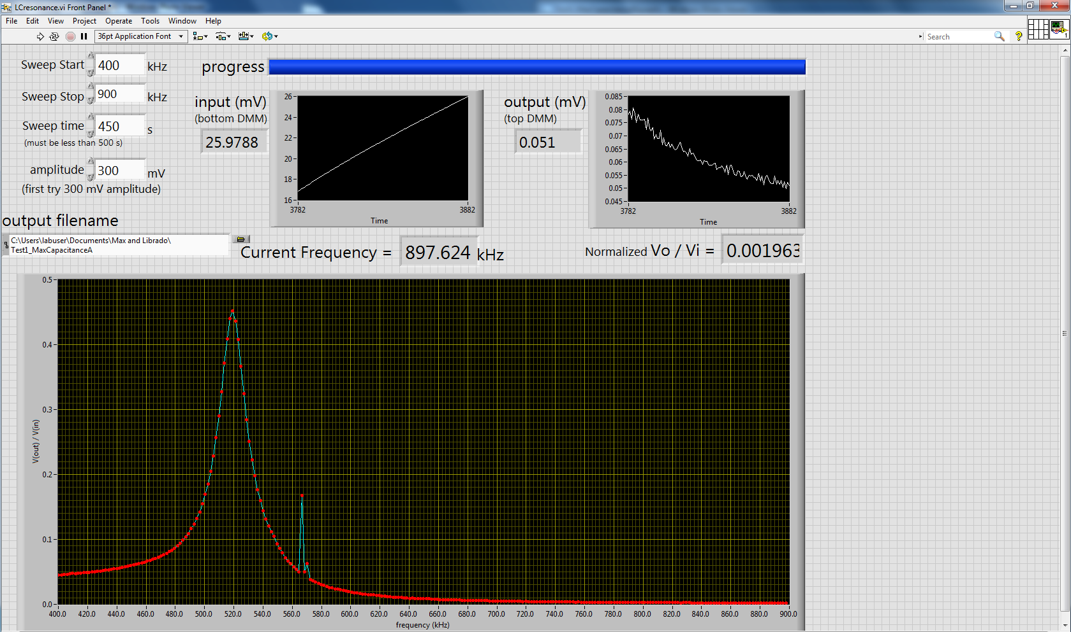Aside from the small jump in the graph, which was due to us accidentally knocking the circuit box over, the data is very consistient with what we expected, with it’s peak landing at 519.33 kHz, which was very close to the expected value of 509.08 kHz. It’s value was about 17 kHz, which gives a resistance of 144.20 Ω. That resistance was relatively near the resistance that we tried to measure across the whole circuit, but ultimately got in consistient results for, which was around 160 Ω. Error in the resonance frequency is likely due to the components not being ideal, since the capacitor was a sereis of metal plates separated by a small distance, it like had some inductance, and the inductor along with other arbitrary parts of the circuit likely also had some capacitance, thus skewing the value to be higher than expected from both effects. This ended up being a consistient skew for the location of the peaks in general, something we observed with the next two peaks at half capacitance.

FIG. 4, a graph of our data collected on the frequency response of the circuit with the maximum possible capacitance.

Frequency (kHz) vs Vout/Vin for maximal capacitance

Below are the graphs for the response at half of the maximum capacitance:

FIG. 6, a graph of our second run of data collected on the frequency response of the circuit with half of the maximum possible capacitance.

Frequency (kHz) vs Vout/Vin for half of maximal capacitance

FIG. 5, a graph of our data collected on the frequency response of the circuit with half of the maximum possible capacitance.

Frequency (kHz) vs Vout/Vin for half of maximal capacitance

While the second graph has some fluctuations on the 670-690 kHz range, this was just due to us bumping the circuit on accident again, just much less dramatic than the first example. We took two samples for this data because we wanted to average the values to make sure we did get near half the maximum of the total capacitance, and to ensure that the runs of data were valid and not hindered by some obscure source of error. They averaged to a value of 718.33 kHz for the peak loaction, which was incredibly close to the predicted 719.94 kHz, being off by just a little over 1 kHz. They both shared a value of about 15.3 kHz, which lead to a resistance of 130 Ω, a value still fairly consistient with the previous resistance. I suspect that the decreased capacitance lead to the capacitor having a lower resistance, and thus bringing the resistance of the system down. Again, the peaks both skewed lower than expected, a phenomenon likely due to incalcuable small capacitances and inductances present in the circuit.

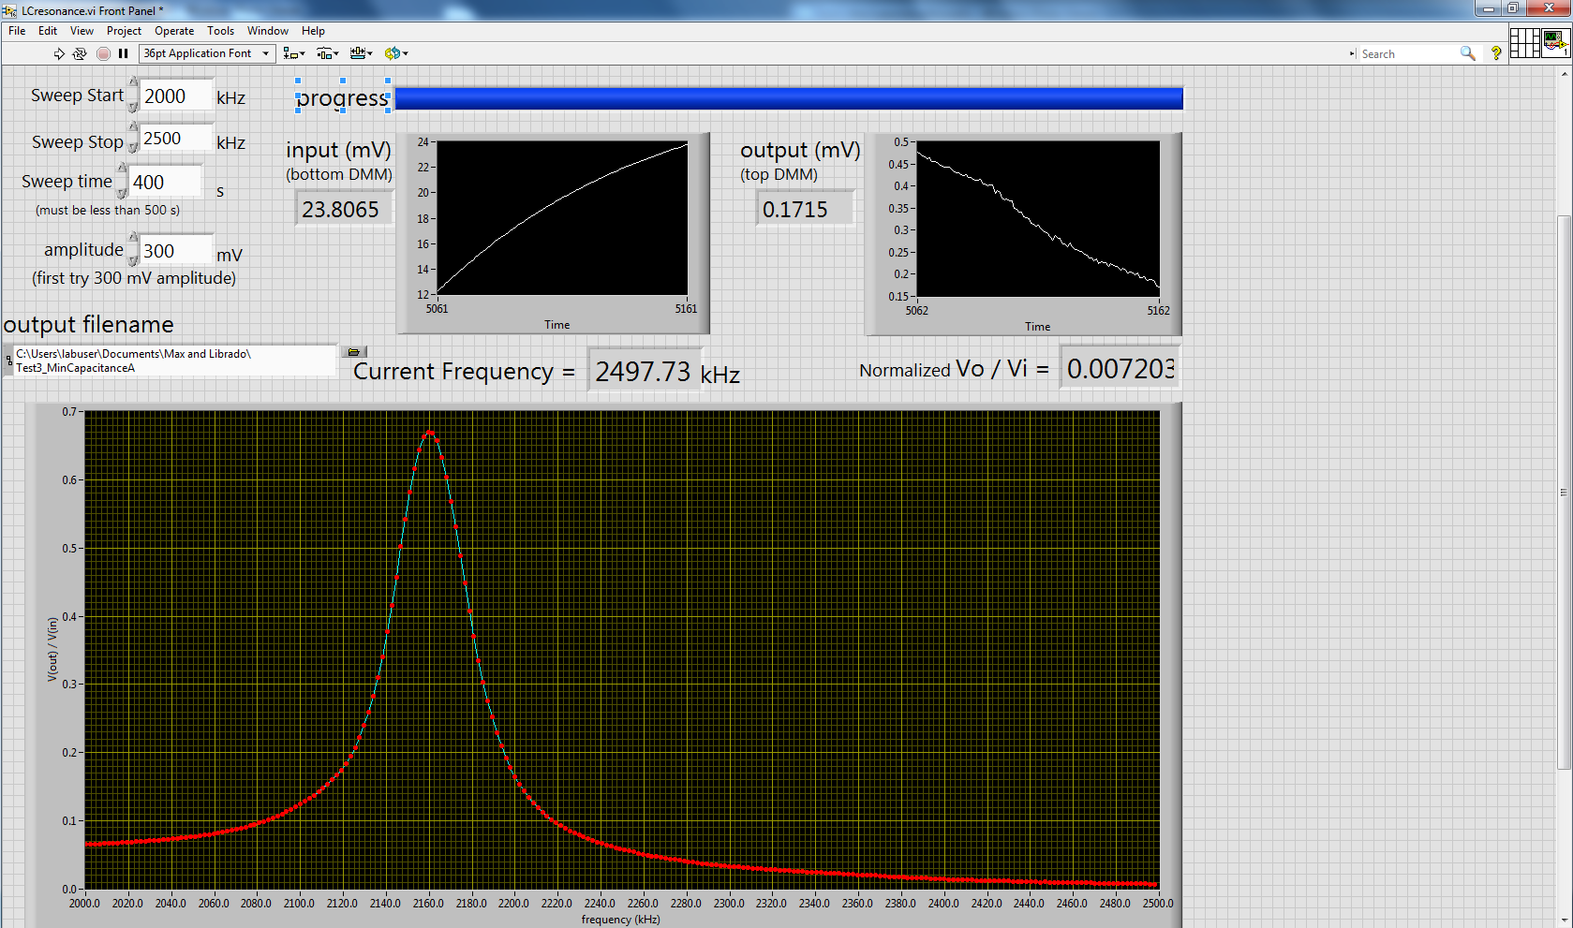 The final resonance measurement we made was on the minimum capacitance of *CA*:

FIG. 7, a graph of our data collected on the frequency response of the circuit with the minimum possible capacitance.

Frequency (kHz) vs Vout/Vin for half of maximal capacitance

This data looked rather smooth and free of bumps, but the peak showed the most skewing of any of the peaks, landing at 2159.52 kHz when the expected frequency for the peak was at 2139.25 kHz, so even more weird was the skewing in the positive direction. While only about 20 kHz off of the expected value, which is about 9% error, the positive skew is rather hard to justify. Even more interesting was the value which landed at about 30 kHz, far larger than any of the previous full-width half-maximums. Thus, the calculated resistance of the circuit was 254.47 Ω, a massvie value that was almost twice the previous resistances. A number of things are possible causes of these results, the first of which we suspect to be the shorting of the capacitor. The multimeter, when shorted or reading empty air, would occasiaonally read values just under 4 pF, while the value it gave us for the minimum capacitance of *CA* was 4.1 pF. Thus, if the capacitor, when turned to the minimum, simply shorts and provides some tiny amount of capacitance in parallel to the short, then it would make sense to produce these bizarre results.

We finally graphed the values for the inverse of the square root of capacitance against the Q factor calculated from Equation (3) to get this graph:

I have graphed all 4 points of data we could produce for this graph, and then the three points of data that might not include the shorted minimum capacitance for additional reference. While the 4 points together make linear realtionship, albeit a rather bad one, I think it is far better to exclude the 4th point and simply use the first 3, whose slope actually returns the resistance of the circuit based on inductance when using Equation 3. Thus, we can establish a linear relationship between the inverse square root of the capacitance and the Q factor of the circuit, as the math behind the circuit indicates.

In summary, we were able to use amplitude modulation and demodulation circuits to collect and hear radio waves in the ambient air, as well as send radio transmissions to ourselves and optimize those signals based on frequency. We were also able to confirm the fucntionality of the different components in the demodulation circuit, justifying the use of the germanium diode over the other diodes and confirming the relationship between resonance and capacitance in a tank circuit. These all gave us a far better understanding of electromagnetic waves, circuitry, and possible errors made when using said circuitry.

**Sources**

[1] Nave, R. “AM Transmission.” *AM Transmission*, <http://hyperphysics.phy-astr.gsu.edu/hbase/Electronic/amtran.html#c3>.

[2] Yoon, J. (2021). *Signal Modulation and Demodulation Experiment*. PHYS 3170. Retrieved November 14, 2021, from https://collab.its.virginia.edu/access/content/group/a124b335-cbe3-45dd-83cd-92a7b97ed76d/Handouts/Exp_4_SignalModulation.pdf.

[3] “Introduction to Diodes and Rectifiers: Diodes and Rectifiers: Electronics Textbook.” *All About Circuits*, https://www.allaboutcircuits.com/textbook/semiconductors/chpt-3/introduction-to-diodes-and-rectifiers/.

[4] Pearson, Brian. “What Are Application of Germanium Diode? - Quora.” *Quora*, 2014, https://www.quora.com/What-are-application-of-germanium-diode.

[5] “Simple Parallel (Tank Circuit) Resonance: Resonance: Electronics Textbook.” *All About Circuits*, https://www.allaboutcircuits.com/textbook/alternating-current/chpt-6/parallel-tank-circuit-resonance/.