Московский авиационный институт

(национальный исследовательский университет)
Факультет информационных технологий и прикладной математики
Кафедра вычислительной математики и программирования
Лабораторная работа по курсу «Базы данных» Тема: Каталог самолетов
Студент: М.А. Бронников
Преподаватель: Е.В. Кузнецова Группа: М8О-307Б Дата:
Оценка: Подпись:
Москва, 2019

База данных в Foxpro
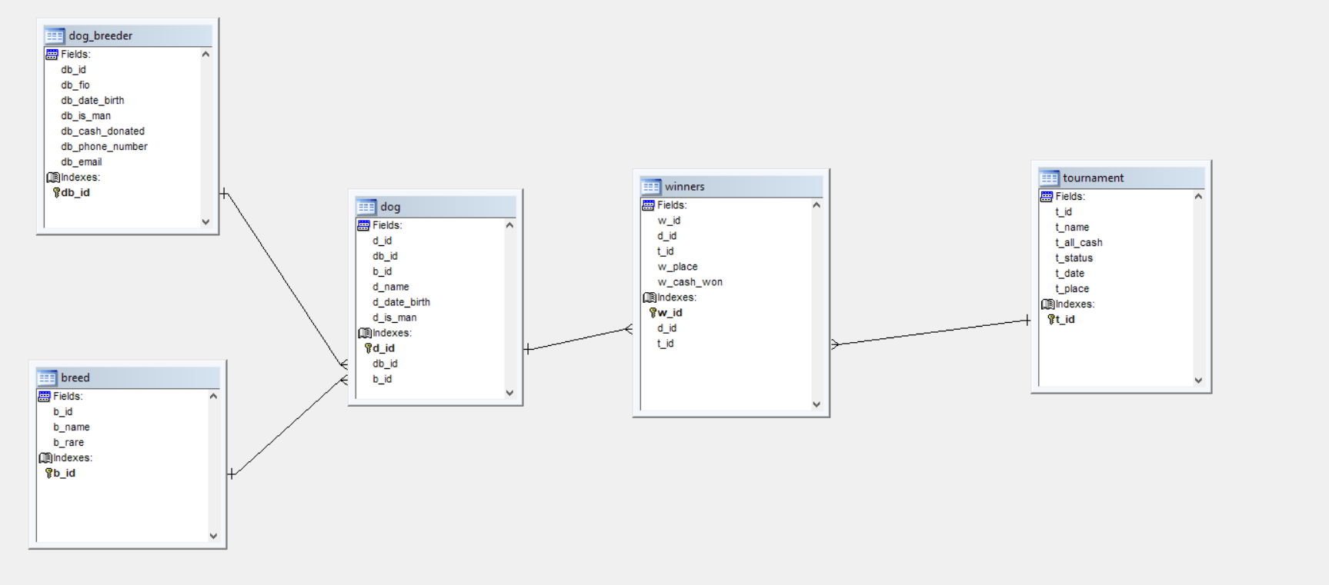
Таблицы:
- Таблица собаководов:
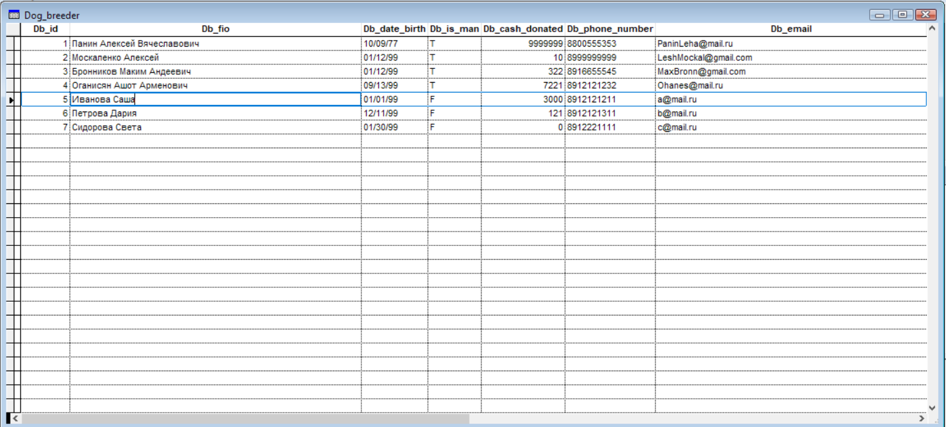
Столбцы:
    - Db_id (int) – Primary key
    - Db_fio (string)
    - Db_date_birth(Date)
    - Db_is_man(Logical)
    - Db_cash_donated(Integer)
    - Db_phone_number(String)
    - Db_email(String)
- Таблица пород собак:
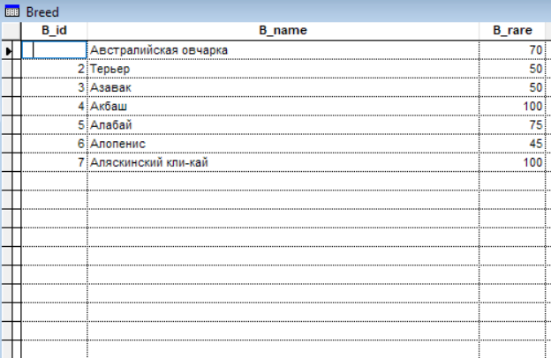
Столбцы:
  - B_id (int) – Prymary key
  - B_name (String)
  - B_rare (int)
- Таблица собак:
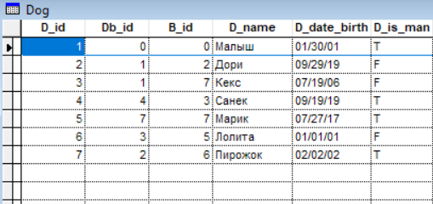
Столбцы:
  - D_id (int) – Primary key
  - Db_id (int) – Regular key
  - B_id (int) – Regular key
  - D_name (string)
  - D _date_birth (date)
  - D_is_man (logical)
- Таблица победителей турнира:
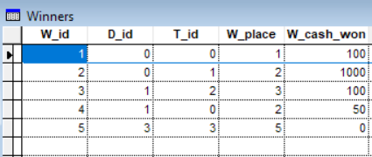
Столбцы:
  - W_id (int) – Primary key
  - D_id (int) – Regular key
  - T_id (int) – Regular key
  - W_place (int)
  - W_cash_won (int)
- Таблица турниров:
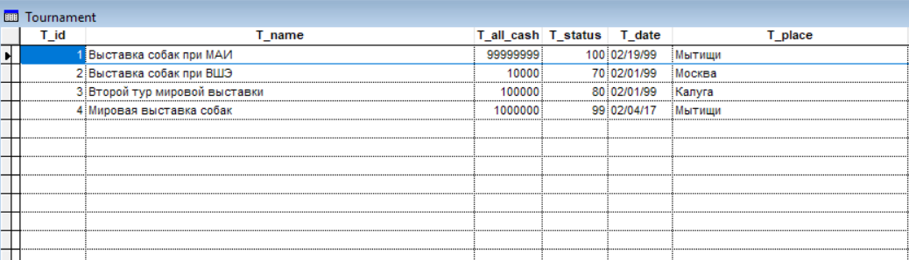
Столбцы:
  - T_id (int) Primary key
  - T_name (string)
  - T_all_cash (int)
  - T_status (int)
  - T_date (date)
  - T_place (string)

Разработка модели в Erwin
- Логическая модель:
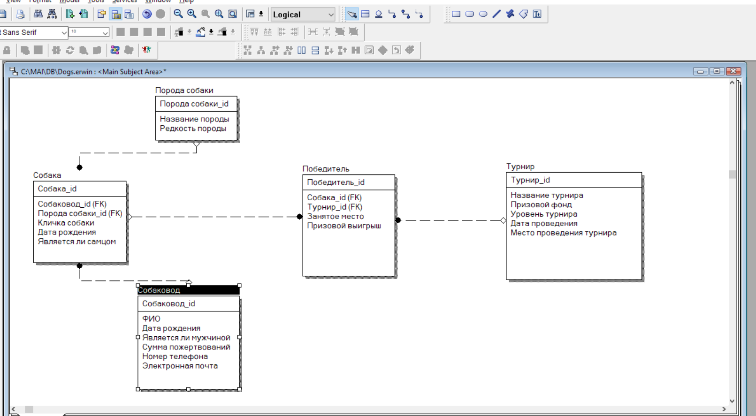
- Физическая модель:
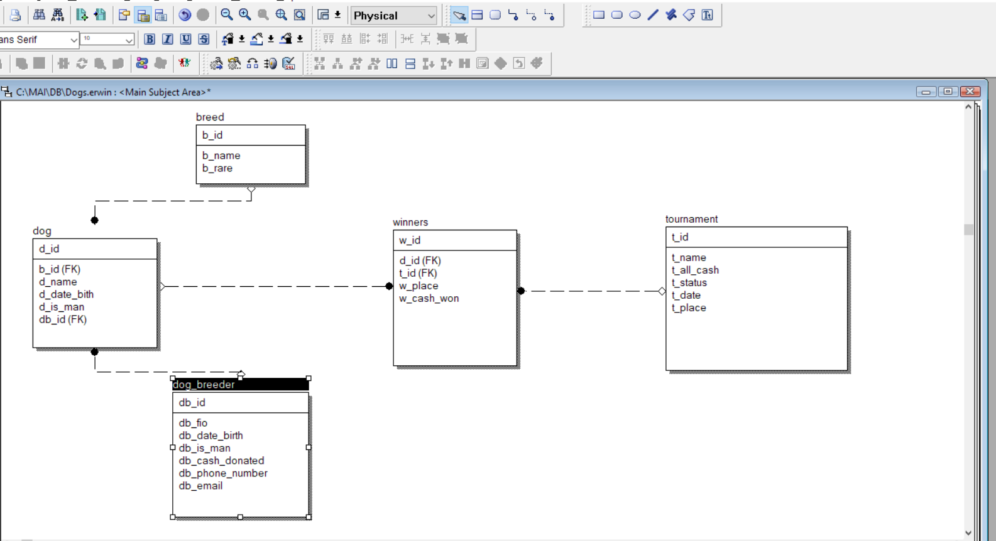
- SQL генерация:
CREATE TABLE Aircraft
(
Aircraft_id Numeric NOT NULL,
Date_of_Production Date NULL,
Price Numeric NULL,
Description Character(20) NULL,
Serial_Number Numeric NULL,
Model_id Numeric NOT NULL, Engine_id Numeric NOT NULL,
Owner_id Numeric NULL,
Location_id Numeric NULL
);
CREATE TABLE Aircraft_Target
(
Target_id Numeric NOT NULL,
Target Character(20) NULL
);
CREATE TABLE Engine
(
Engine_id Numeric NOT NULL,
Name Character(20) NULL,
Power Numeric NULL,
Producer_id Numeric NOT NULL,
Type_id Numeric NOT NULL
);
CREATE TABLE Engine_Type
(
Type_id | Numeric NOT NULL,
Type  ); | Character(20) NULL
CREATE TABLE Location (
Location_id | Numeric NOT NULL,
Country | Character(20) NULL,
Region | Character(20) NULL,
City | Character(20) NULL,
Name | Character(20) NULL,
Street | Character(20) NULL,
Number  );  CREATE TABLE Model  ( | Numeric NULL
Model_id | Numeric NOT NULL,
Creation_Date | Date NULL,
Name | Character(20) NULL,
Target_id | Numeric NOT NULL,
Producer_id  );  CREATE TABLE Person  ( | Numeric NOT NULL
Person_id | Numeric NOT NULL,
First_Name | Character(20) NULL,
Second_Name | Character(20) NULL,
Addres | Character(20) NULL,
Phone_Number | Character(20) NULL,
email | Character(20) NULL,
Date_Of_Birth  ); | Date NULL
CREATE TABLE Producer
(
Producer_id | Numeric NOT NULL,
Name | Character(20) NULL,
Country_Code | Character(20) NULL,
Location_id  ); | Numeric NULL

Составление SQL запросов
- Пары истребителей одного производителя
SELECT t1.name,t2.name ;
FROM aircraft_model t1,aircraft_model t2 ;
WHERE t1.producer_id = t2.producer_id ;
AND t1.id <t2.id ;
AND t1.target_id = 2 ;
AND t2.target_id = 2
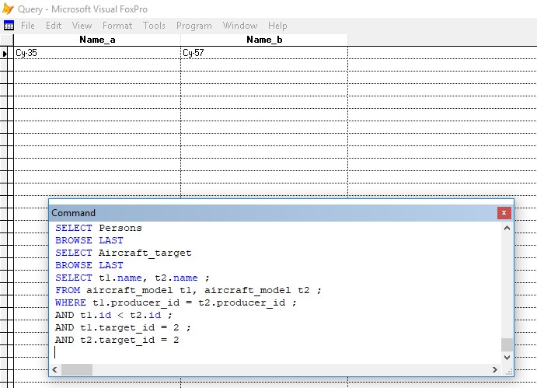
- Какие моторы не используются в бомбардировщиках
SELECT engine.id ,engine.name FROM engine WHERE engine.id ; NOT IN(SELECT engine_id FROM aircraft WHERE ; model_id IN(SELECT id FROM aircraft_model WHERE ; target_id = 1 OR target_id = 8))
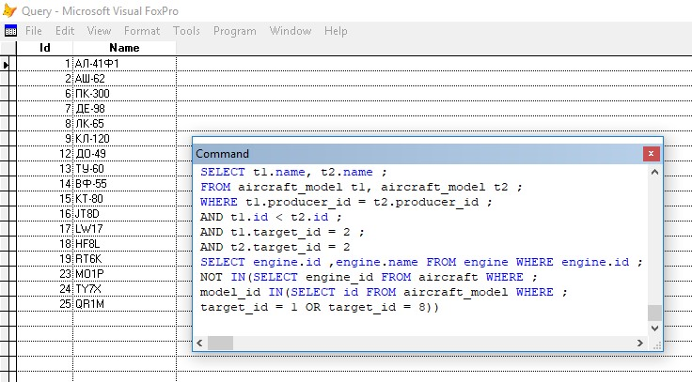
- Владелец с наибольшим разнообразием моделей самолетов
SELECT persons.first_name,persons.second_name,; persons.email,persons.telefone_num ;
FROM (SELECT TOP 1 a.owner_id,COUNT(1) as c FROM ;
(SELECT DISTINCT aircraft.owner_id,aircraft.model_id ;
FROM aircraft) as a GROUP BY a.owner_id ORDER BY c DESC) ; as a JOIN persons ON (persons.id = a.owner_id)
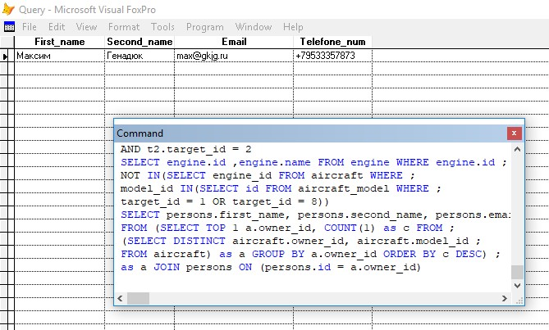
- Какие из типов двигателей используются выше среднего в самолетах гражданской авиации
SELECT engine_type.type FROM engine_type JOIN ;
(SELECT t.type_id FROM (SELECT t1.type_id,COUNT(1) as c FROM (SELECT ; engine.type_id,aircraft.model_id FROM engine ;
JOIN aircraft ON(engine.id = aircraft.engine_id)) as t1 ;
JOIN aircraft_model as t2 ON(t1.model_id = t2.id) ; WHERE t2.target_id = 5 GROUP BY t1.type_id) as t WHERE ;
t.c >(SELECT AVG(t2.c) FROM (SELECT t1.type_id,COUNT(1) as c ;
FROM (SELECT engine.type_id,aircraft.model_id FROM engine ;
JOIN aircraft ON(engine.id = aircraft.engine_id)) as t1 ;
JOIN aircraft_model as t2 ON(t1.model_id = t2.id) ;
WHERE t2.target_id = 5 GROUP BY t1.type_id) as t2)) as t3 ON(engine_type.id = t3.type_id)
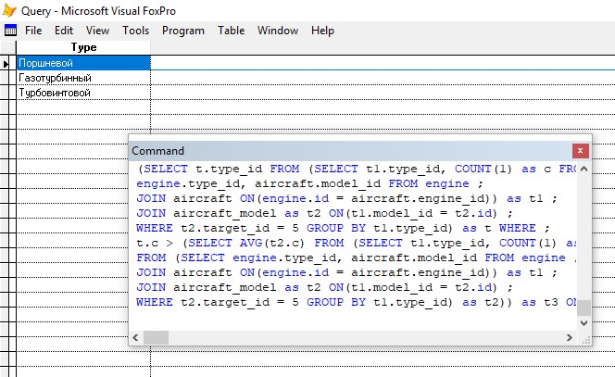
- Определить производителя с наибольшим количеством типов самолетов
SELECT producer.name FROM producer ;
JOIN(SELECT TOP 1 t.producer_id,COUNT(1) as c FROM ; (SELECT DISTINCT aircraft_model.producer_id,; aircraft_model.target_id FROM aircraft_model) as t ;
GROUP BY t.producer_id ORDER BY c DESC) as t2 ON(t2.producer_id = producer.id)
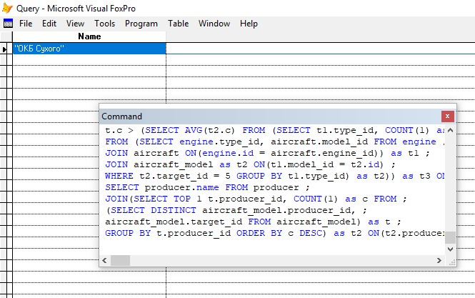
- Определить владельцев ударных БПЛА
SELECT * FROM persons as outert WHERE EXIST ;
(SELECT * FROM aircraft JOIN aircraft_model ;
ON(aircraft.model_id = aircraft_model.id) ;
WHERE aircraft.owner_id = outert.id ;
AND aircraft_model.target_id = 10)
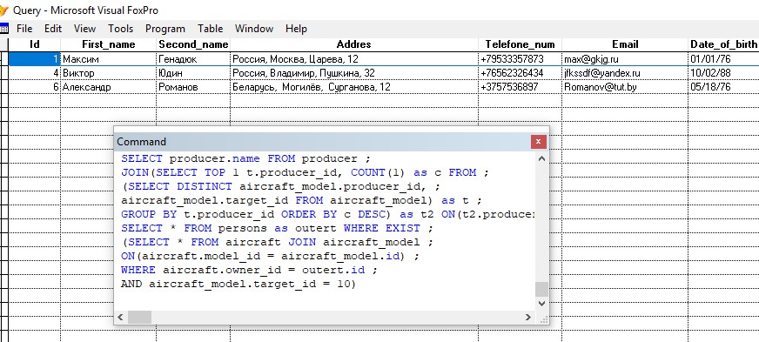
- Кто из владельцев имеет хотя бы один самолет из моделей самолетов, как и у заданного владельца но с меньшей стоимостью
SELECT persons.first_name,persons.second_name FROM persons ;
JOIN (SELECT DISTINCT aircraft.owner_id FROM aircraft ;
JOIN (SELECT owner_id,model_id,MIN(price) as price ;
FROM aircraft WHERE owner_id = 2 GROUP BY owner_id,model_id) as t ;
ON(t.model_id = aircraft.model_id) WHERE aircraft.price <t.price ;
AND aircraft.owner_id <>t.owner_id) as t2 ON (persons.id = t2.owner_id)
