
SVKM's NMIMS
Mukesh Patel School of Technology Management & Engineering
School of Technology Management & Engineering

Year: II | Program: B. Tech (Computer Science) | Semester: IV

Subject: Web Programming

CoreMatrix — Personalized Workout and Nutrition Planner

Team Details

Name | Manas Chauhan | Hardik Goyal | Advait Mhatre
Roll No | N016 | N031 | N061
SAP ID | 70472400113 | 70472400100 | 70472400161

Bachelor of Technology (Computer Science)
Second Year, Semester IV

Faculty: Prof Anuja Naverkar
AY 2025-26

INDEX
Sr. No. | Topic | Page No.
1 | Introduction | 3-4
2 | Requirement Analysis | 5-6
3 | Development Technologies | 7-9
4 | Implementation and Output | 10-18
5 | Observations and Learnings | 19-21
6 | Conclusion | 22

1. Introduction
CoreMatrix is a full-stack web application designed to help users track their fitness journey through workout logging, meal tracking, and progress analytics. The application enables registered users to set personalised fitness goals, log daily workout sessions and meals, and visualise their progress over time through interactive charts and summary metrics.
The project demonstrates the complete web development lifecycle — from requirement gathering and UI/UX design, through client-server architecture and database integration, to a responsive, production-ready application accessible from any browser. CoreMatrix is built using a three-tier architecture: a client-side AngularJS Single Page Application (SPA) for the presentation layer, a Node.js/Express REST API for the logic layer, and a MySQL relational database for persistent data storage.

1.1 Project Background
Physical fitness tracking traditionally requires dedicated mobile applications or expensive wearables. CoreMatrix bridges this gap by offering a lightweight, browser-based alternative that requires no installation. The application is equally accessible on desktop and mobile browsers, making it a practical tool for day-to-day fitness management.

1.2 Project Objectives
- Design and implement a multi-user web application using AngularJS, Node.js, and MySQL.
- Apply core web programming concepts: HTML5, CSS3, JavaScript, REST APIs.
- Implement secure user registration and login with password hashing.
- Enable users to log, edit, and delete workout and meal entries with real-time UI updates.
- Compute and display personalised fitness metrics (BMI, calorie goal, protein goal) automatically.
- Deliver a responsive layout that adapts from mobile (320 px) to desktop (1440 px).

1.3 Scope
CoreMatrix covers six functional modules: user authentication, a personalised dashboard, workout logging (The Forge), meal logging (The Fuel), progress charts, and a full session history. The application is scoped for individual users within a single session — social features, push notifications, and native mobile packaging are identified as future enhancements.

2. Requirement Analysis

2.1 Functional Requirements
- User Registration: The system shall collect name, email, password, training goal, body weight, height, age, and activity level. Upon successful registration, the server shall compute and persist BMI, daily calorie goal, protein goal, and target weight.
- User Login and Session: The system shall validate credentials against hashed passwords. On success, the authenticated user object shall be stored in the browser's localStorage and used to scope all subsequent API calls.
- Workout Logging: Users shall be able to add, edit, and delete workout entries. Each entry shall record exercise name, category, sets, repetitions, weight, intensity level, and date.
- Meal Logging: Users shall be able to add, edit, and delete meal entries. Each entry shall record meal name, type, calories, protein, carbohydrates, fat, and date.
- Dashboard Summary: The home page shall display today's total workout count, total calories consumed, total protein consumed, and calorie surplus or deficit versus the user's goal.
- Progress Visualisation: The progress page shall render a bar chart of daily calorie intake versus goal for the past seven days, and a line chart of weekly workout volume (sets × reps × weight).
- Session History: The logs page shall present a combined, sortable history table of all workout and meal entries, with inline editing and deletion available directly from the table.
- Daily Tip: The application shall surface a contextual nutrition tip on the dashboard, fetched from the /api/tip endpoint.

2.2 Non-Functional Requirements
- Performance: API responses shall return within 500 ms for all standard CRUD operations on the local development setup.
- Responsiveness: The UI shall be fully functional at 320 px, 768 px, and 1440 px viewport widths without horizontal scrolling.
- Security: Passwords shall be hashed using bcryptjs with a minimum of 10 salt rounds. All database queries shall use parameterised statements to prevent SQL injection. Data reads and writes shall be filtered by user_id to prevent cross-user access.
- Maintainability: Client-side logic shall follow the AngularJS MVC pattern with one controller per route and all HTTP calls centralised in DataService.
- Availability: If the backend server is unreachable, the frontend shall fall back to seeded sample data for view rendering, preventing a blank screen.

2.3 Use Case Summary
Actor | Use Case | Outcome
Guest | Register an account | Account created; fitness metrics computed
Registered User | Login | Session established; dashboard loaded
Registered User | Log a workout | Entry saved; history and charts updated
Registered User | Edit a workout inline | Record updated without page navigation
Registered User | Log a meal | Entry saved; macro totals recalculated
Registered User | View progress charts | Bar and line charts rendered from DB data
Registered User | Browse full history | Combined workout and meal log displayed
Registered User | Sign out | Session cleared; redirected to login

3. Development Technologies

3.1 Technology Stack
Layer | Technology | Version | Purpose
Frontend Framework | AngularJS | 1.8.x | SPA routing, two-way data binding, MVC controllers
Markup | HTML5 | — | Semantic structure for all six view templates
Styling | CSS3 | — | Flexbox, Grid, custom properties, media queries
Runtime | Node.js | 18 LTS | Server-side JavaScript execution environment
Web Framework | Express.js | 4.x | HTTP routing, JSON middleware, static file serving
Database | MySQL | 8.0 | Relational data storage with foreign-key integrity
DB Driver | mysql2 | 3.x | Connection pooling and parameterised queries
Security | bcryptjs | 2.x | Password hashing with 10 salted rounds
Session Storage | localStorage | Web API | Client-side persistence of authenticated user
Charts | Chart.js | 4.x | Bar and line chart rendering in the Progress view

3.2 Frontend Architecture — AngularJS SPA
AngularJS was chosen for its complete MVC framework in a single CDN include, requiring no build toolchain. The module is configured in app.js using ngRoute, which maps URL hash fragments to template/controller pairs rendered inside a persistent <ng-view> outlet in index.html.
Route | View Template | Controller | Responsibilities
/auth | auth.html | AuthCtrl | Registration form, login form, validation
/ | home.html | HomeCtrl | Dashboard cards, daily tip banner
/forge | forge.html | WorkoutCtrl | Workout form, inline edit, card list
/fuel | fuel.html | NutritionCtrl | Meal form, macro totals, card list
/progress | progress.html | ProgressCtrl | Chart.js bar and line chart rendering
/logs | logs.html | LogsCtrl | Combined history table, inline edit/delete

3.3 Backend Architecture — Node.js / Express
The Express server (server.js) serves the AngularJS SPA as static files and exposes a REST API under the /api prefix. Route groups are mounted from separate modules: authController.js handles registration and login, while fitnessLogic.js handles all workout and meal CRUD. The database connection pool is initialised once in dbConfig.js, which also runs the schema bootstrap SQL on startup.

3.4 Database Design
The MySQL schema uses three core tables. The users table stores the authenticated user profile along with computed fitness metrics. The workouts table records individual exercise entries linked to a user via a foreign key. The meals table records nutritional intake entries with the same user-scoping pattern. ON DELETE CASCADE on both child tables ensures referential integrity when a user account is removed.
Table | Primary Key | Foreign Key | Key Columns
users | user_id | — | name, email (UNIQUE), password (hash), bmi, calorie_goal, protein_goal, target_weight
workouts | id | user_id → users(user_id) | name, category, sets, reps, weight, intensity, log_date
meals | id | user_id → users(user_id) | name, type, calories, protein, carbs, fat, log_date

3.5 REST API
The API follows RESTful conventions — resource nouns, HTTP verb semantics, and JSON responses with appropriate status codes. Every workout and meal endpoint requires userId in the request to enforce per-user data isolation at the server.
Method | Endpoint | Description
POST | /api/auth/register | Register user; hash password; compute and store fitness metrics
POST | /api/auth/login | Verify credentials; return user profile (no password field)
GET | /api/workouts | Return all workouts for the authenticated user
POST | /api/workouts | Create a new workout entry
PUT | /api/workouts/:id | Update a workout entry by ID (user-scoped)
DELETE | /api/workouts/:id | Delete a workout entry by ID (user-scoped)
GET | /api/meals | Return all meals for the authenticated user
POST | /api/meals | Create a new meal entry
PUT | /api/meals/:id | Update a meal entry by ID (user-scoped)
DELETE | /api/meals/:id | Delete a meal entry by ID (user-scoped)
GET | /api/tip | Return a random daily nutrition tip

3.6 CSS and Responsive Design
style.css defines a dark theme using CSS custom properties (CSS variables) as design tokens, ensuring consistent colours across all views without repetition. The layout system uses CSS Flexbox for one-dimensional arrangements (navigation bar, button rows) and CSS Grid for two-dimensional card layouts (dashboard metric cards). Three responsive breakpoints are defined:
- Desktop (> 768 px): Two-column form layout; four-column metric card grid; full-width navigation.
- Tablet (480 – 768 px): Single-column forms; two-column card grid; navigation wraps.
- Mobile (< 480 px): Full single-column layout; touch targets enlarged; inline edit panels stack vertically.

4. Implementation and Output

4.1 User Registration and Login
When a user completes the registration form in auth.html, the AuthCtrl controller calls DataService.register(), which performs an HTTP POST to /api/auth/register with the form payload. The server validates all required fields, checks email uniqueness, hashes the password using bcryptjs, and computes BMI using the standard formula (weight / (height/100)²), calorie goal using the Mifflin-St Jeor equation multiplied by the activity factor, protein goal at 2 g per kg of body weight, and target weight. All computed values are persisted to the users table and returned to the client. The client stores the user object in localStorage and routes to the dashboard.
Login follows the same flow: HTTP POST to /api/auth/login, bcrypt.compare() on the stored hash, and on success the user profile (without the password field) is returned and cached in localStorage. Sign-out clears the cache and routes back to /auth.
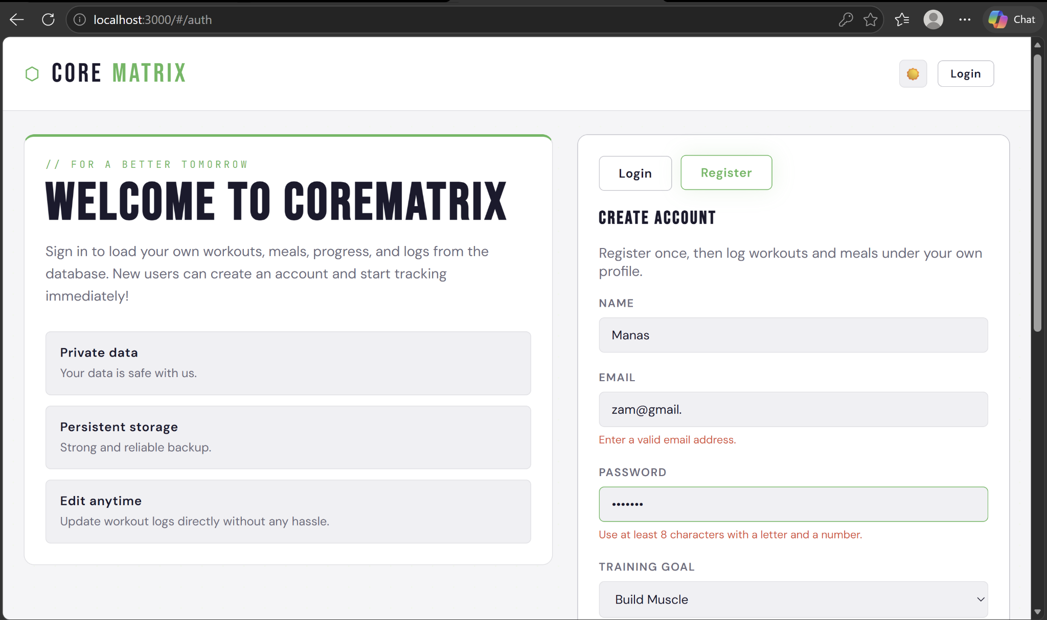
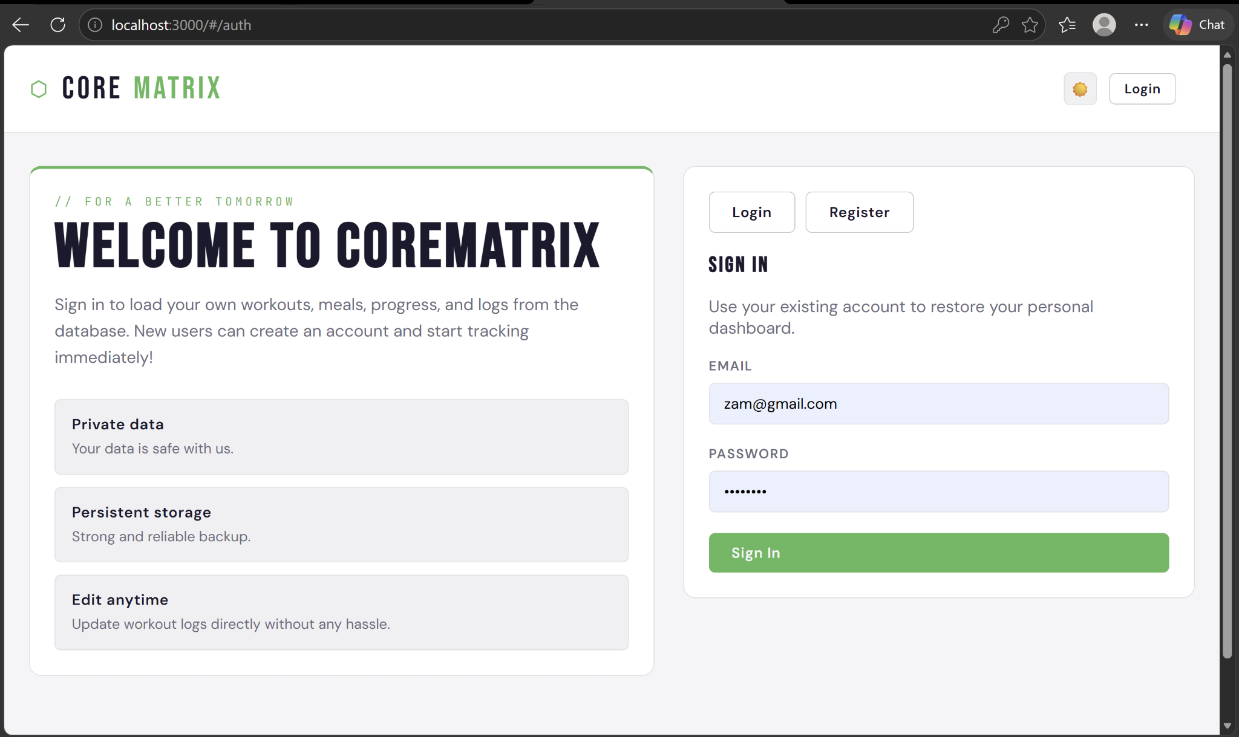
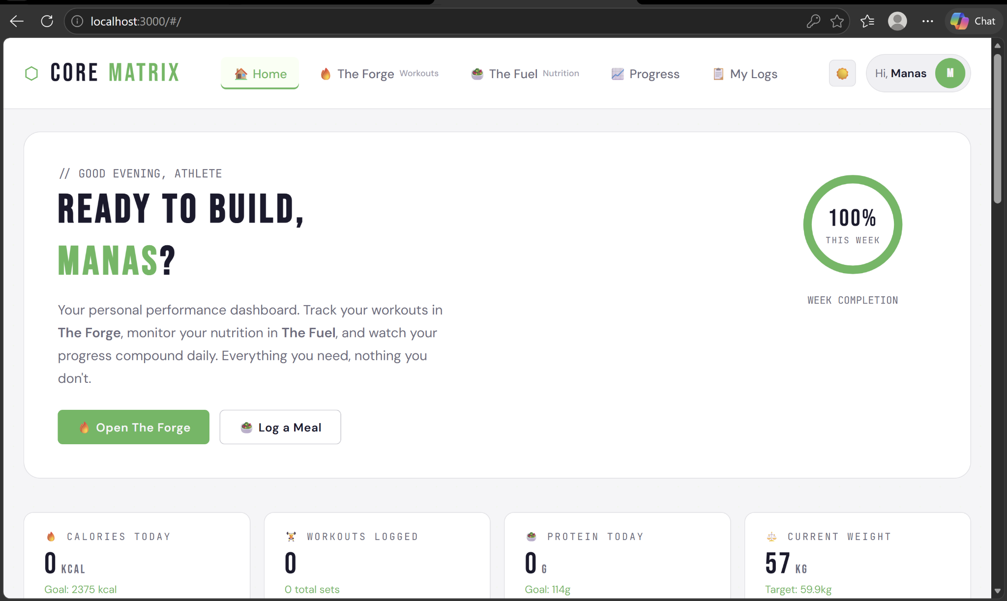

4.2 Workout Logging — The Forge
The Forge view (forge.html, WorkoutCtrl) presents a form with fields for exercise name, category (Strength, Cardio, Flexibility, HIIT, Yoga, Sport), sets, repetitions, weight, and intensity. On submission, the controller calls DataService.addWorkout(), which POSTs to /api/workouts. The response is pushed directly into the controller's local workouts array — because this array is bound to the ng-repeat directive in the view, AngularJS automatically re-renders the card list without a page reload.
Inline editing is implemented using an ng-show toggle on each card. Clicking the Edit button sets a flag on the specific workout object, which reveals an edit form pre-populated with the current values via ng-model binding. Saving calls DataService.updateWorkout(), which sends a PUT request and updates the object in the local array, collapsing the edit panel.
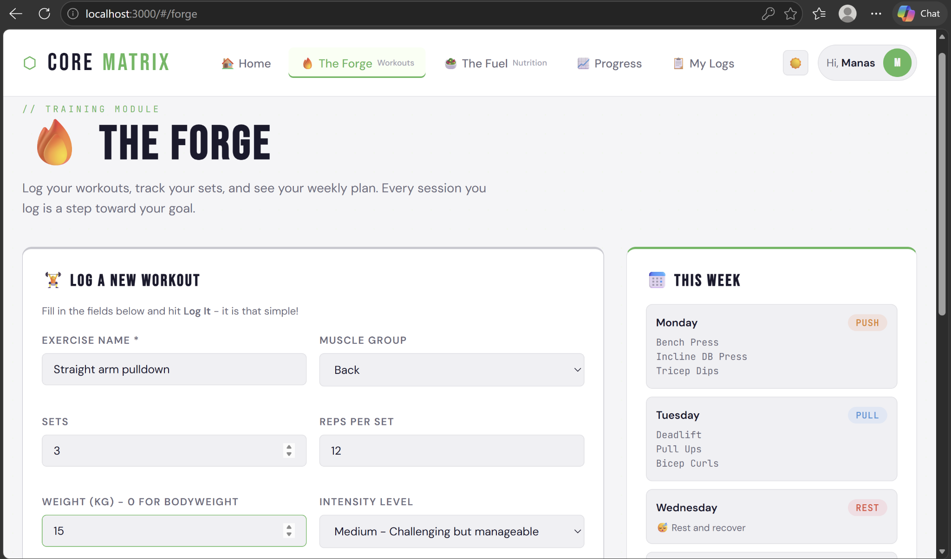
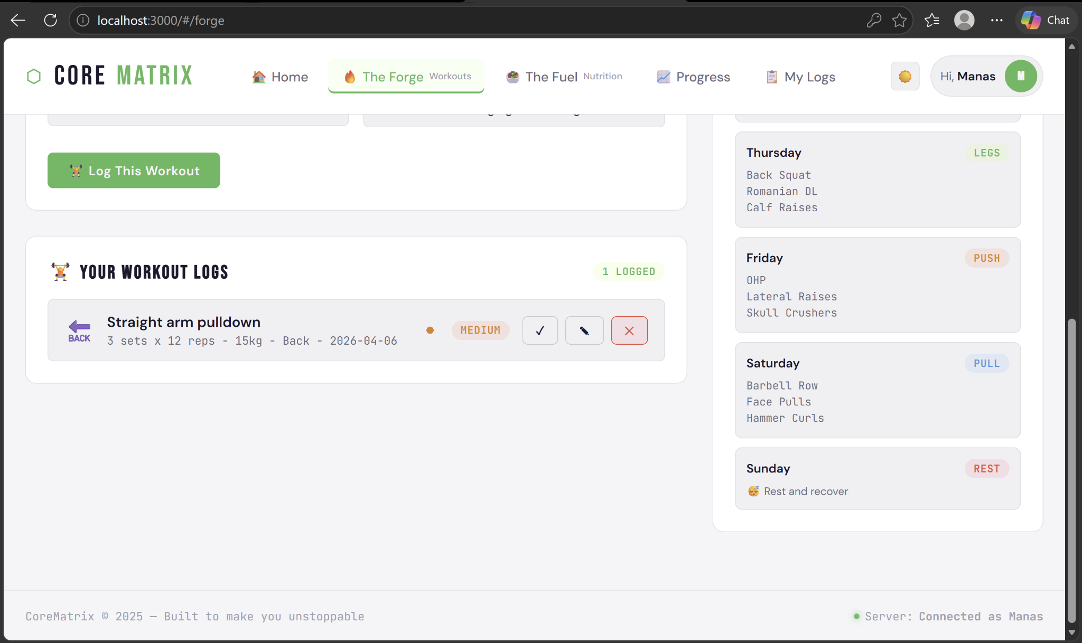

4.3 Meal Logging — The Fuel
The Fuel view mirrors the Forge pattern for nutritional data. The form collects meal name, type (Breakfast, Lunch, Dinner, Snack), calories, protein, carbohydrates, and fat. The controller accumulates daily macro totals by summing the logged entries and displays them in a running summary bar below the form. The comparison against the user's calorie goal (from the cached localStorage profile) is computed client-side in the controller without an additional API call, keeping the UI responsive.
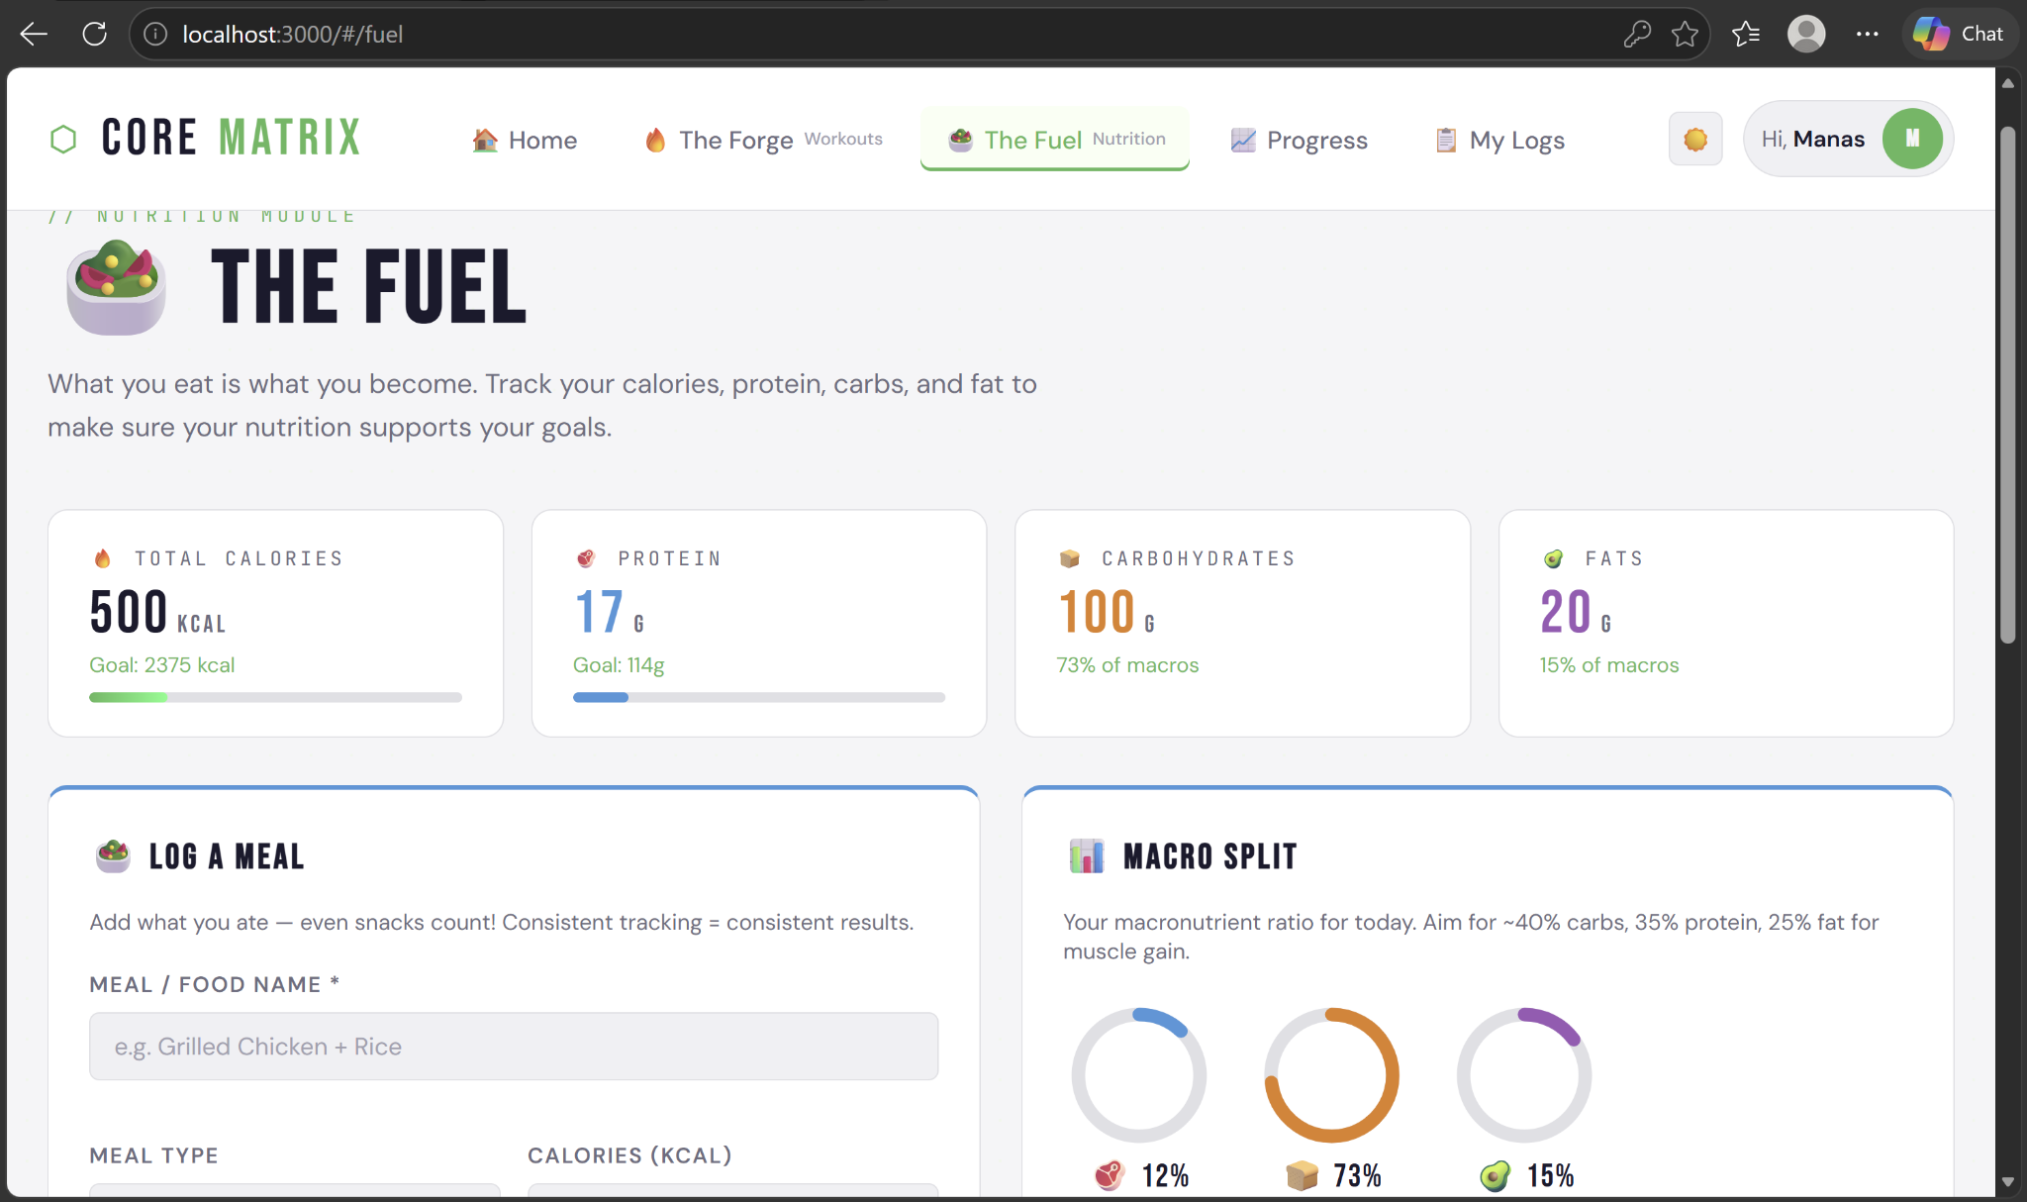
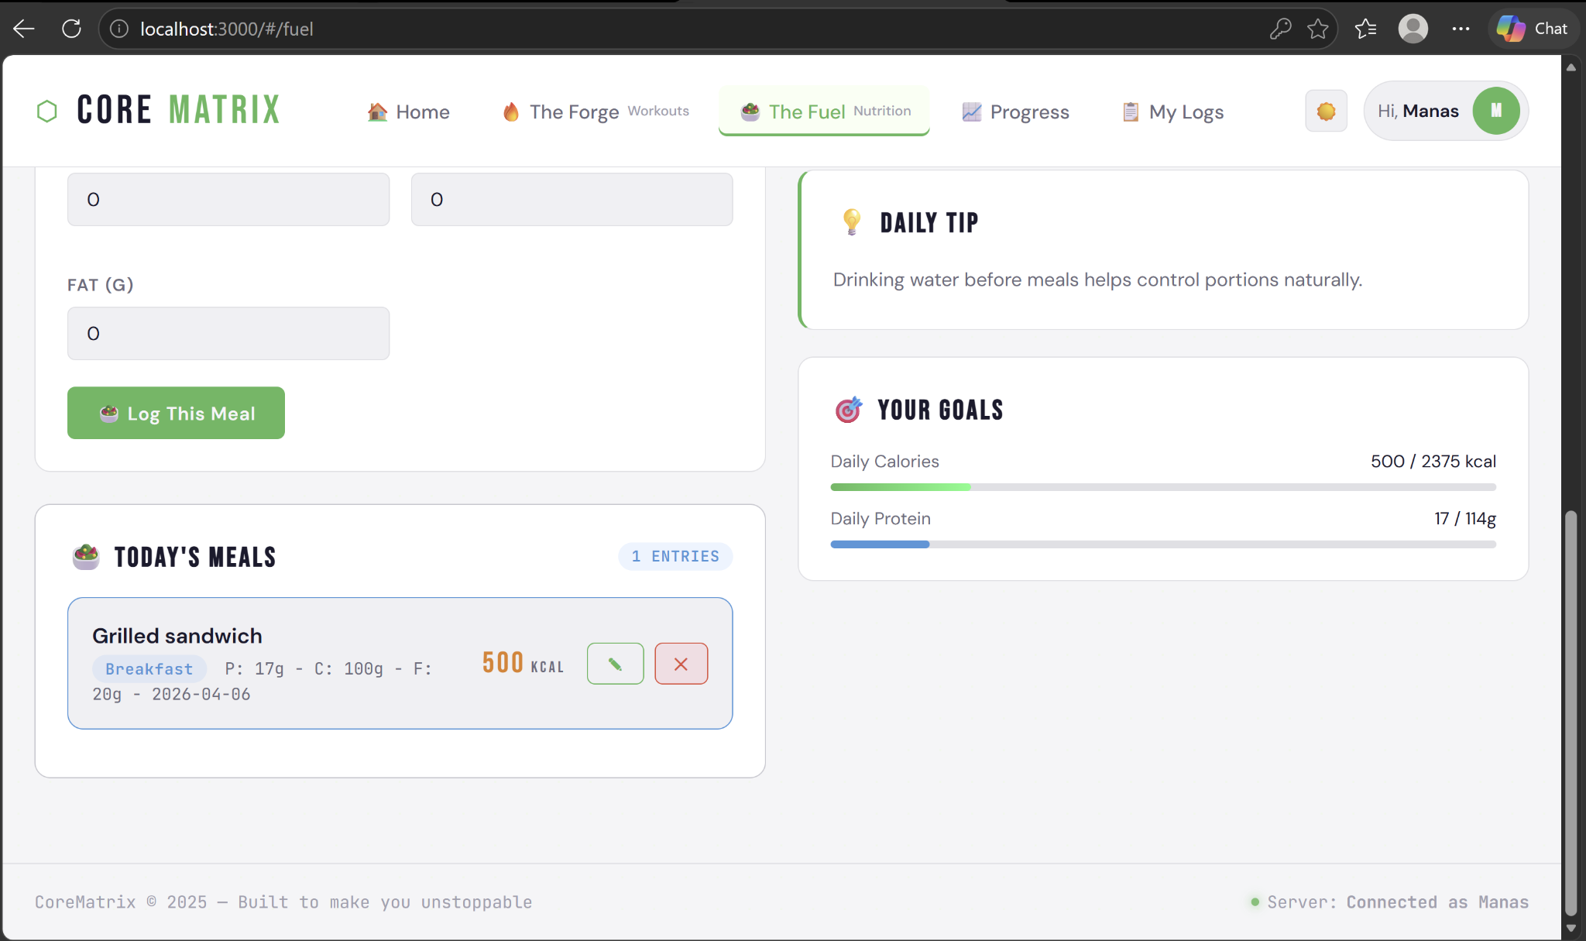

4.4 Progress Visualisation
The Progress view (progress.html, ProgressCtrl) aggregates the loaded meal and workout data in the controller and passes the processed arrays to Chart.js for rendering. Two charts are displayed: a bar chart plotting daily calorie intake versus the calorie goal for the last seven days, and a line chart showing cumulative training volume (sets × reps × weight) per workout session. Both charts are rendered inside HTML5 <canvas> elements and update reactively when new data is added in the same session.
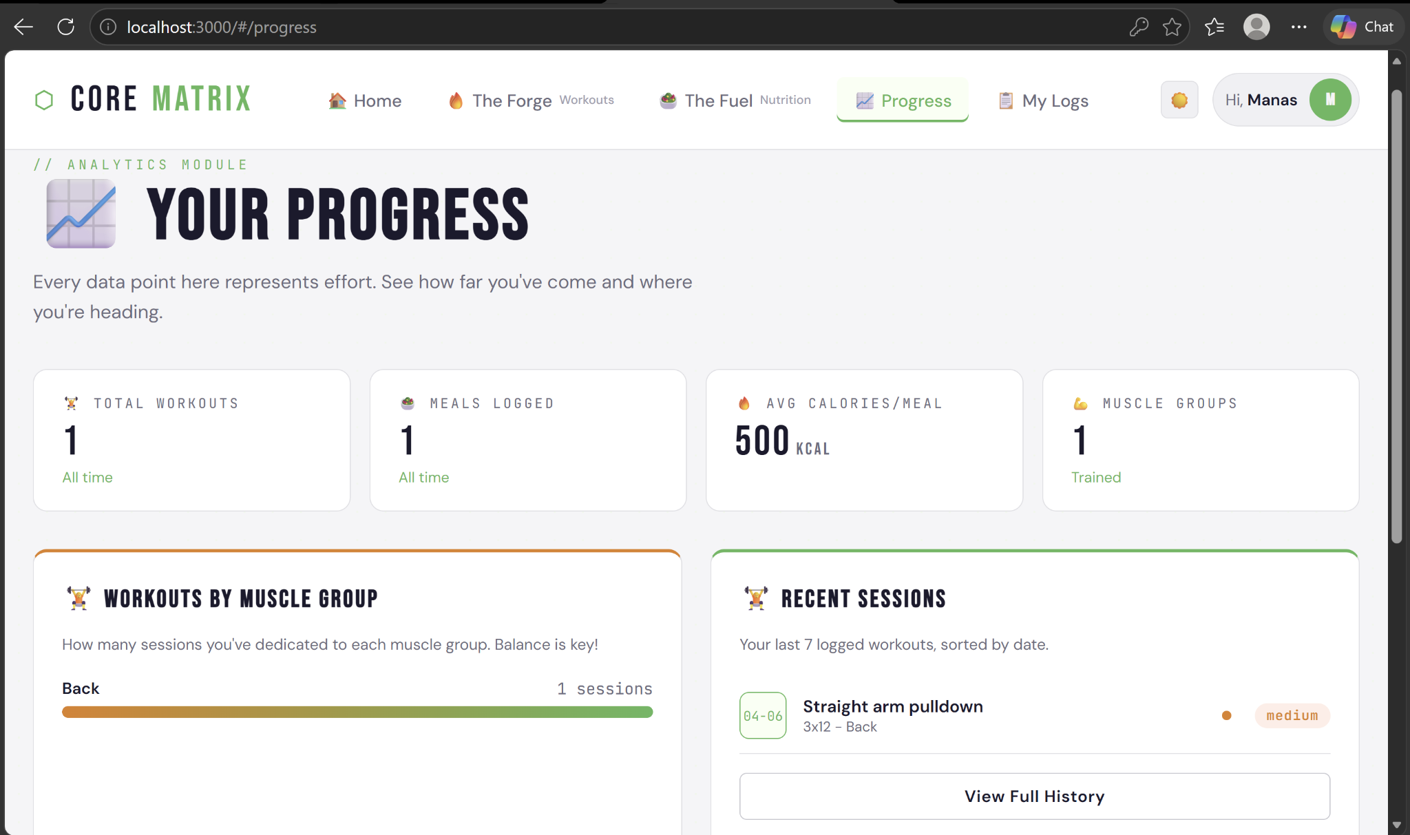

4.5 Session History
The Logs view (logs.html, LogsCtrl) presents a single, combined table of all workout and meal records. Inline edit and delete controls appear on each row, consistent with the Forge and Fuel views. Rows are sorted by date (most recent first) by default. Deletion triggers an HTTP DELETE, removes the entry from the local array, and collapses the row — all without page navigation.
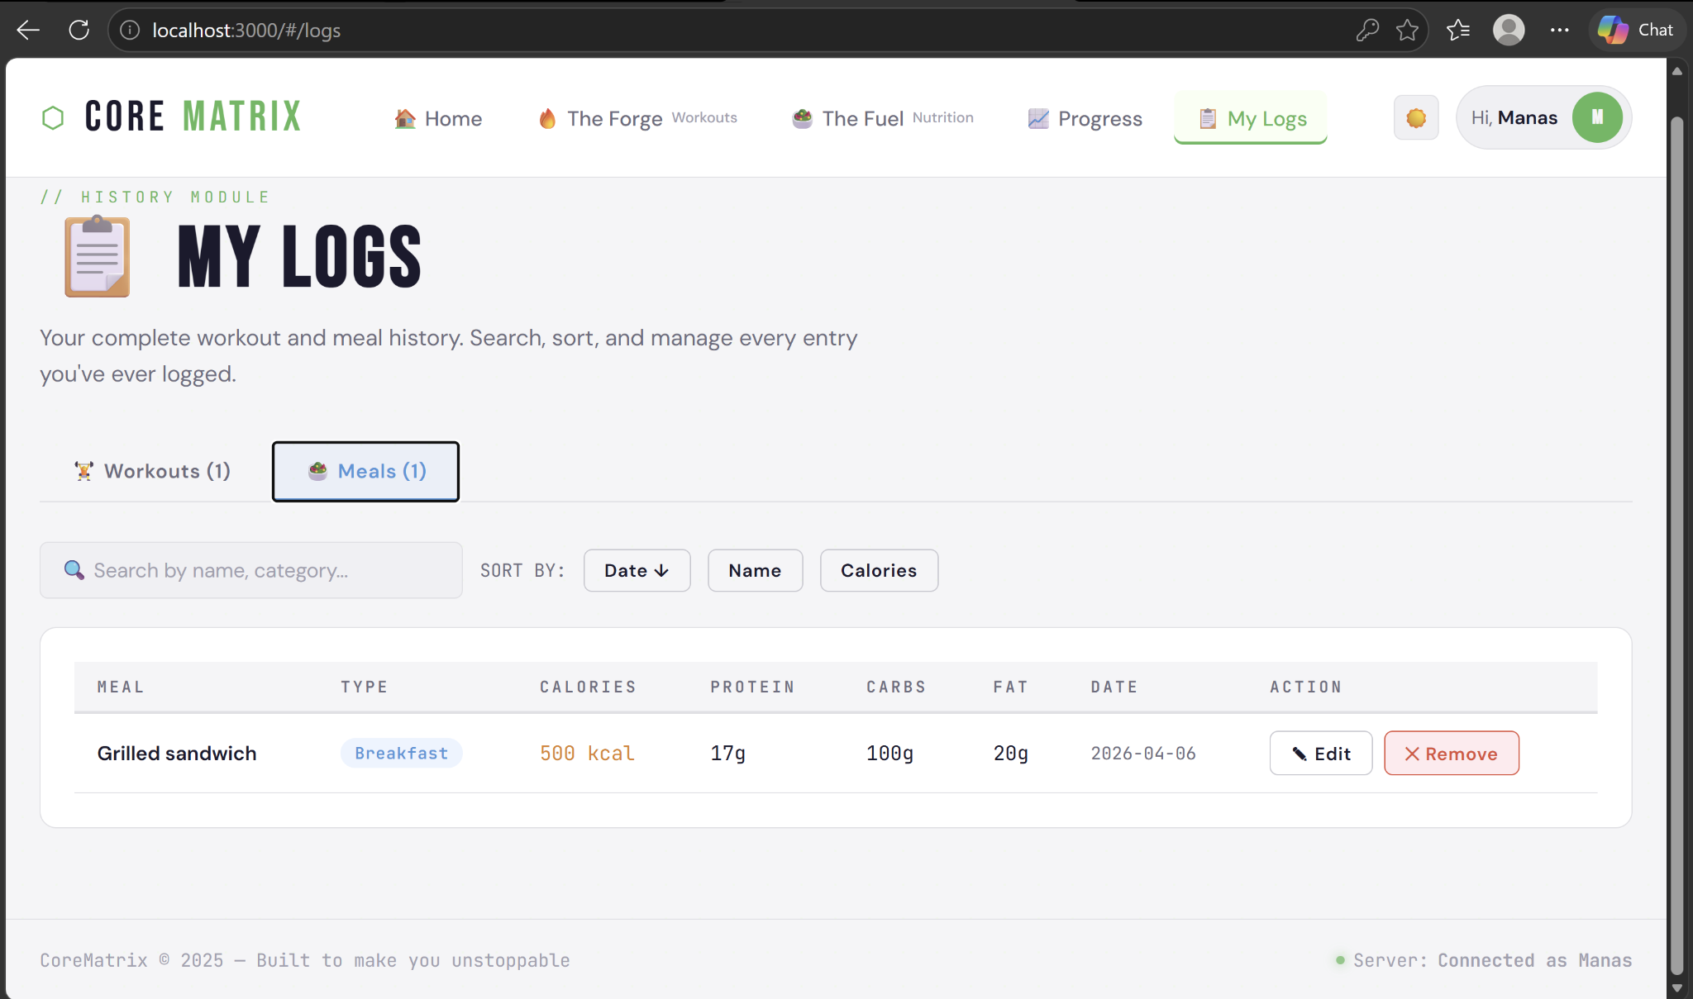

4.6 Setup and Execution
The application runs as a single Node.js process on port 3000. Setup requires Node.js 18 or later, npm, and a running MySQL 8 instance. The schema is auto-created by dbConfig.js on first startup.

# Install dependencies
npm install

# Set environment variables (or defaults apply)
export DB_HOST=localhost DB_USER=root DB_PASSWORD=your_pw DB_NAME=corematrix_db

# Start the server
npm start

# Open in browser
http://localhost:3000
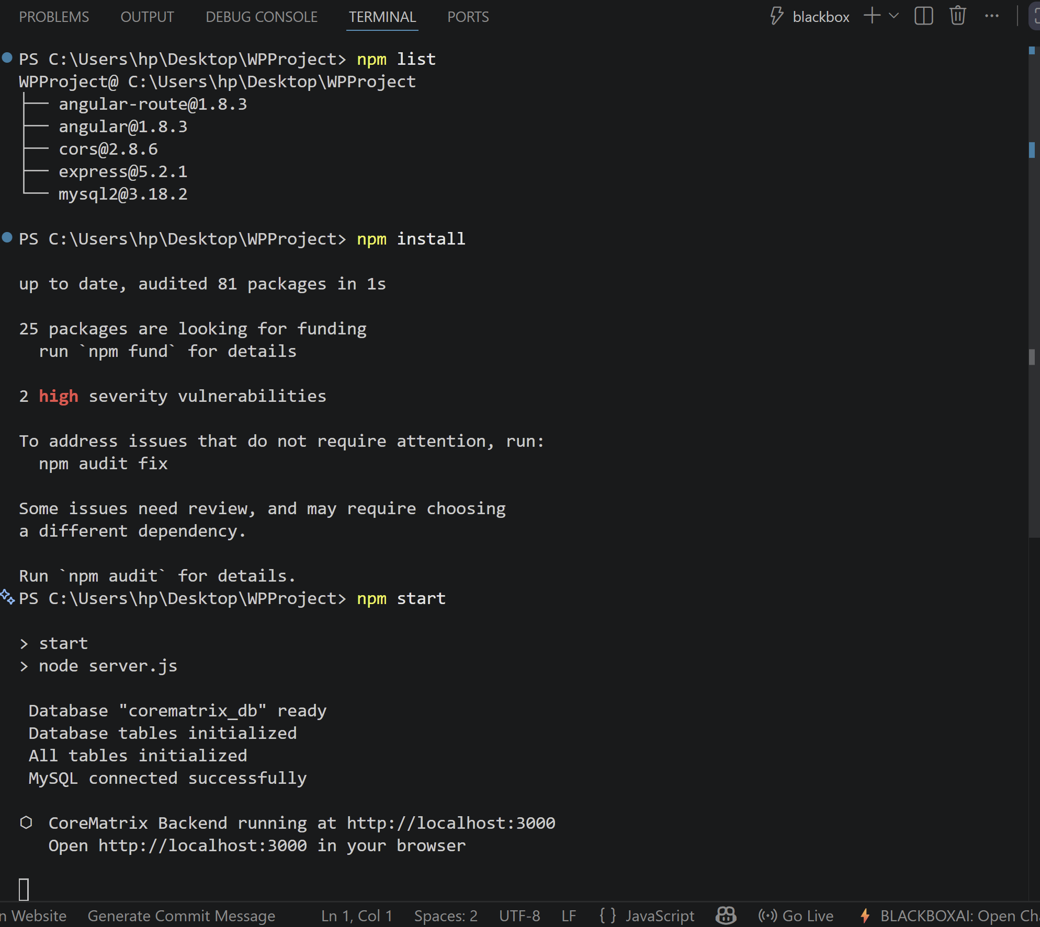

4.7 Key Code Snippets
Registration endpoint — bcrypt hash and metric computation:

// authController.js
const hash = await bcrypt.hash(password, 10);
const bmi = weight_kg / Math.pow(height_cm / 100, 2);
const bmr = 10*weight_kg + 6.25*height_cm - 5*age_years + 5;
const calorie_goal = Math.round(bmr * activityMultiplier);
const protein_goal = Math.round(weight_kg * 2);
const target_weight = Math.round(weight_kg * 0.90);
await pool.query(
'INSERT INTO users (name,email,password,...) VALUES (?,?,?,...)',
[name, email, hash, bmi, calorie_goal, protein_goal, target_weight, ...]
);
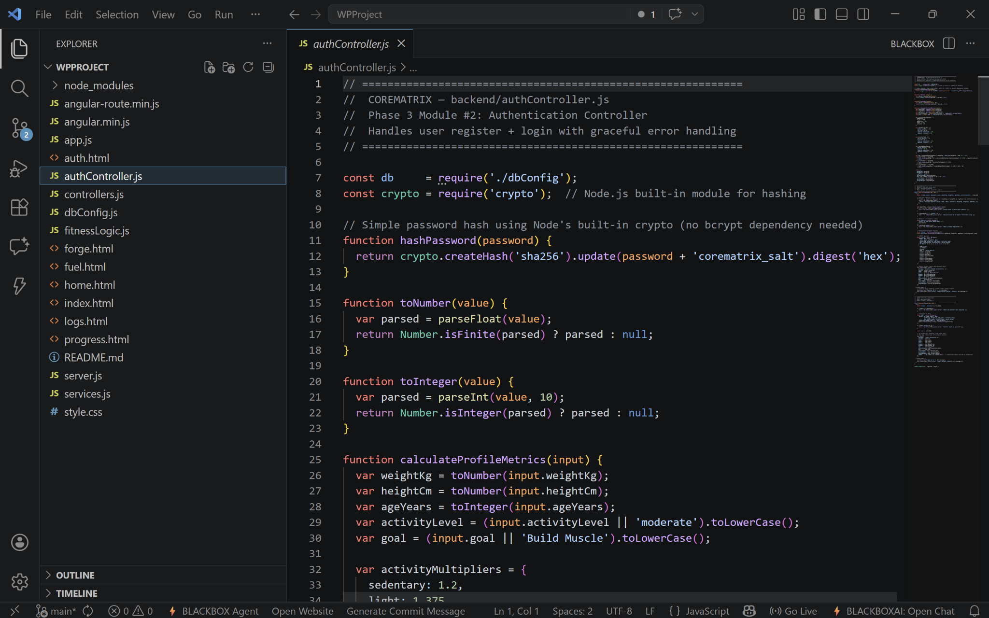
AngularJS DataService — centralised HTTP layer:

// services.js
app.service('DataService', function($http) {
const API = 'http://localhost:3000/api';

this.addWorkout = function(userId, workout) {
return $http.post(API + '/workouts', { userId, ...workout });
};

this.updateWorkout = function(id, userId, data) {
return $http.put(API + '/workouts/' + id, { userId, ...data });
};
});

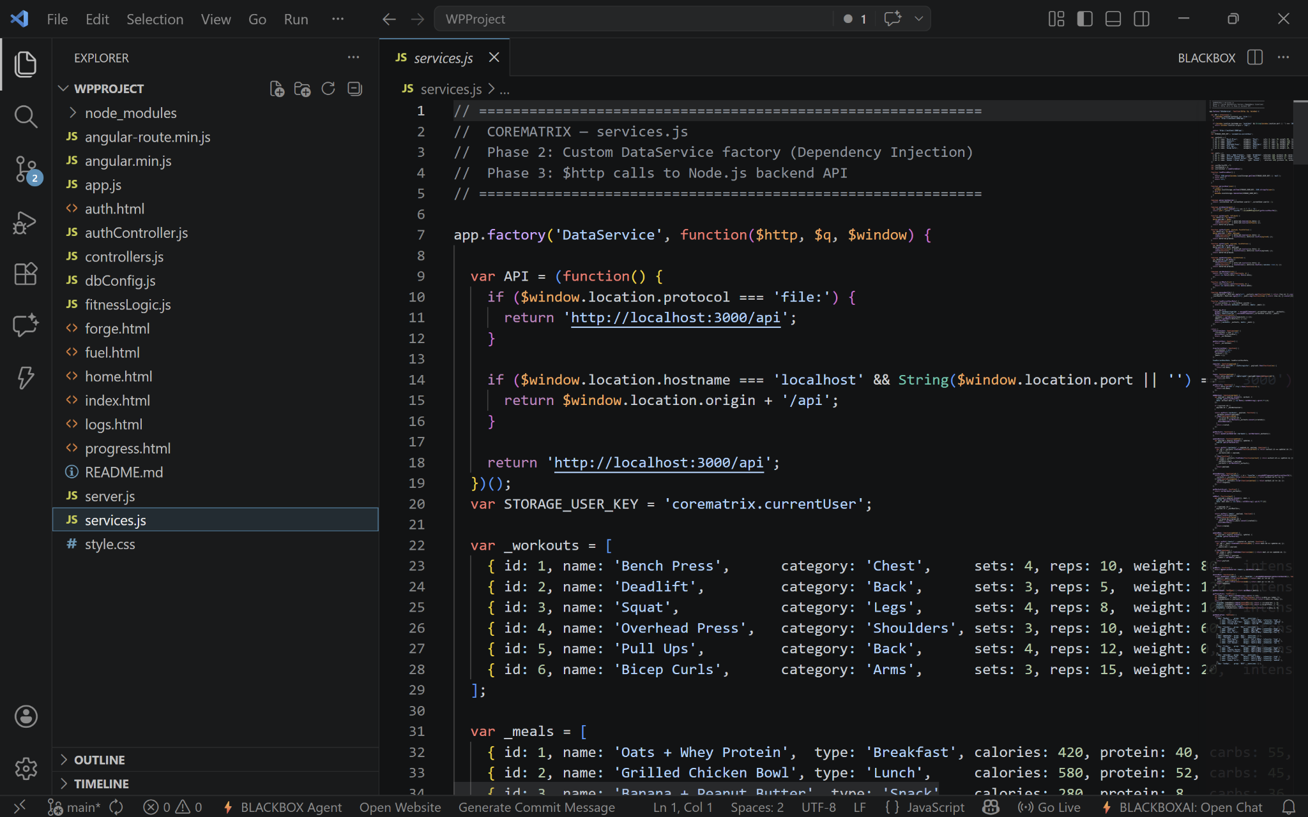

5. Observations and Learnings

5.1 Web Programming Concepts Applied
Concept | Implementation in CoreMatrix
HTML5 Semantic Markup | All six views use <nav>, <main>, <section>, <article>, <form>, <canvas>
CSS3 Custom Properties | Design tokens (--primary, --accent) applied as :root variables across all CSS
CSS Flexbox | Navigation bar, button rows, card grids, and form column layout
CSS Grid | Dashboard metric card auto-fill grid (repeat(auto-fill, minmax(200px, 1fr)))
CSS Media Queries | Responsive breakpoints at 768 px and 480 px; mobile-first approach
JavaScript DOM Binding | AngularJS two-way binding (ng-model) eliminates manual getElementById calls
Client-Side MVC | AngularJS module / controller / service / view pattern across six routes
AJAX / Asynchronous HTTP | $http.post() and $http.get() calls with promise .then() / .catch() handlers
RESTful API Design | 12 endpoints using GET, POST, PUT, DELETE with JSON payloads
Node.js Server-Side JS | Single-language stack — JavaScript on both client and server
Express Middleware | express.json(), express.static(), custom error handlers per route group
MySQL Database Integration | mysql2 connection pool; parameterised queries; ON DELETE CASCADE constraints
Password Security | bcryptjs hash with 10 rounds; plain-text never stored or returned
SPA Navigation | ngRoute hash-based routing; <ng-view> partial template outlet
Chart.js Visualisation | Dynamic bar and line charts driven by aggregated workout and meal data

5.2 Challenges Encountered and Solutions

Challenge 1: Shared State Across Controllers
AngularJS controllers do not share a common scope by default, so the authenticated user object was being lost between route transitions. This was resolved by anchoring the user profile in MainCtrl at the root application scope, which child controllers inherit automatically through AngularJS scope prototypal chaining. DataService also caches the user in localStorage as a fallback for page refreshes.

Challenge 2: Inline Editing Without Page Reload
Standard HTML form submission triggers a full page reload, disrupting the user experience. The solution was to use an ng-show toggle on a hidden edit panel within each card. The panel pre-populates its inputs via ng-model on a copy of the row's data object. On save, a PUT request updates the server and the original array entry is mutated in place, causing AngularJS to re-render only the affected card.

Challenge 3: MySQL Schema Evolution
Adding new profile columns (bmi, calorie_goal, etc.) to the users table during development would fail if the column already existed. The solution was to add ALTER TABLE ... ADD COLUMN IF NOT EXISTS statements in dbConfig.js after the initial CREATE TABLE IF NOT EXISTS, making schema changes idempotent across server restarts without requiring manual migration scripts.

Challenge 4: Responsive Navigation Overflow
The navigation bar's multiple links caused horizontal overflow on small viewports. A media query at 768 px switches the nav container from flex-direction: row to flex-direction: column and applies flex-wrap: wrap to the link group, stacking items vertically on narrow screens while keeping the logo left-aligned.

5.3 Personal Learnings
- Applying the Model-View-Controller pattern on the client side through AngularJS controllers and services enforces a discipline of separating data logic from presentation that carries over into any future framework.
- Designing a REST API before writing any frontend code — defining endpoints, payloads, and status codes first — made integration significantly smoother and reduced debugging time.
- CSS custom properties as design tokens provide a single source of truth for visual values; changing one variable updates the entire application's colour scheme instantly.
- Parameterised SQL queries are both a security and a correctness practice; adopting them from the start prevented an entire class of bugs alongside SQL injection vulnerabilities.
- Working with an asynchronous Node.js event loop reinforced understanding of JavaScript promises, async/await patterns, and the importance of error propagation in callback chains.

6. Conclusion
CoreMatrix successfully demonstrates a complete, end-to-end web application built exclusively with open-standard web technologies — HTML5, CSS3, JavaScript, AngularJS, Node.js, Express, and MySQL. The project covers the full spectrum of the Web Programming curriculum: semantic markup, responsive styling, client-side MVC, asynchronous HTTP communication, RESTful API design, relational database integration, and web security practices.
The three-tier architecture cleanly separates presentation, logic, and data concerns. The AngularJS SPA delivers a fluid, no-reload user experience through hash-based routing and two-way data binding. The Express REST API provides a stateless, scalable backend with consistent JSON responses and per-user data isolation enforced at the query level. The MySQL schema, designed with foreign-key constraints and parameterised queries, ensures data integrity and prevents SQL injection.
From a learning perspective, the project provided hands-on experience with every stage of the web development lifecycle — from requirements analysis and UI/UX design, through implementation and API testing, to responsive layout tuning and security hardening. The challenges encountered in shared state management, inline editing, schema migration, and responsive design produced practical solutions that reflect industry-standard patterns.
Future enhancements identified during development include JWT-based authentication with HTTP-only cookies, a Progressive Web App manifest for offline access and home-screen installation, WebSocket-driven real-time notifications for goal milestones, integration with a food nutrition database API for auto-populated macro data, and a full unit test suite using Mocha/Chai for the API and Karma/Jasmine for the AngularJS controllers.
In summary, CoreMatrix is a functional, well-structured fitness tracking platform that validates the sufficiency of browser-based web technologies for building production-grade applications. It meets all stated functional and non-functional requirements and serves as a strong foundation for continued development.

