**Homework for Chapter7**

**1.** Another placement algorithm for dynamic partitioning is referred to as worst-fit. In this case, the largest free block of memory is used for bringing in a process. Discuss the pros and cons of this method compared to first-, next-, and best-fit. What is the average length of the search for worst-fit?

**2.** A dynamic partitioning scheme is being used, and the following is the memory configuration at a given point in time:

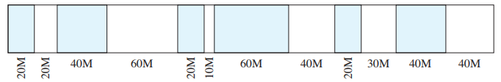

The shaded areas are allocated blocks; the white areas are free blocks. The next three memory requests are for 40M, 20M, and 10M. Indicate the starting address for each of the three blocks using the following placement algorithms:

a. First-fit

b. Best-fit

c. Next-fit. Assume the most recently added block is at the beginning of memory.

d. Worst-fit

**3.** A 1-Mbyte block of memory is allocated using the buddy system.

**a.** Show the results of the following sequence in a figure similar to Figure 7.6: Request 70; Request 35; Request 80; Return A; Request 60; Return B; Return D; Return C.

**b.** Show the binary tree representation following Return B.

**4.** Consider a simple paging system with the following parameters: 232 bytes of physical memory; page size of 210 bytes; 216 pages of logical address space.

**a.** How many bits are in a logical address?

**b.** How many bytes in a frame?

**c.** How many bits in the physical address specify the frame?

**d.** How many entries in the page table?

**e.** How many bits in each page table entry?

**5.** Consider a simple segmentation system that has the following segment table:

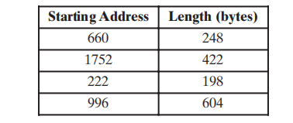

For each of the following logical addresses, determine the physical address or indicate

if a segment fault occurs:

**a.** 0, 198 **b.** 2, 156 **c.** 1, 530 **d.** 3, 444 **e.** 0, 222