**实验二**

**建立数据库**

create database Stu;

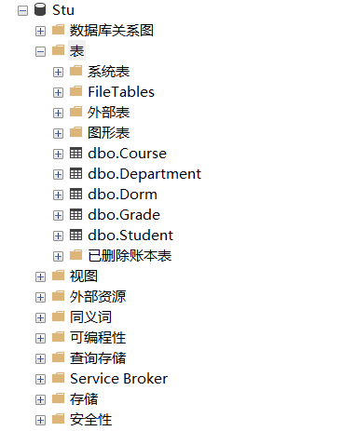

use Stu;

**建立表**

create table Department(

DNO char(4) primary key,

DNAME char(20),

HEAD char(20)

);

create table Dorm(

DORMNO char(5) primary key,

TELE char(7)

);

create table Course(

CNO char(2) primary key,

CNAME char(20),

CPNO char(2),

CREDIT smallint,

TEACHER char(8)

);

create table Student(

SNO char(6) primary key,

SNAME char(8),

SEX char(2),

SAGE smallint,

DNO char(4),

DORMNO char(5),

foreign key(DNO) references Department(DNO),

foreign key(DORMNO) references Dorm(DORMNO)

);

create table Grade(

SNO char(6),

CNO char(2),

SCORE dec(4,1),

primary key(SNO,CNO),

foreign key(SNO) references Student(SNO),

foreign key(CNO) references Course(CNO)

);

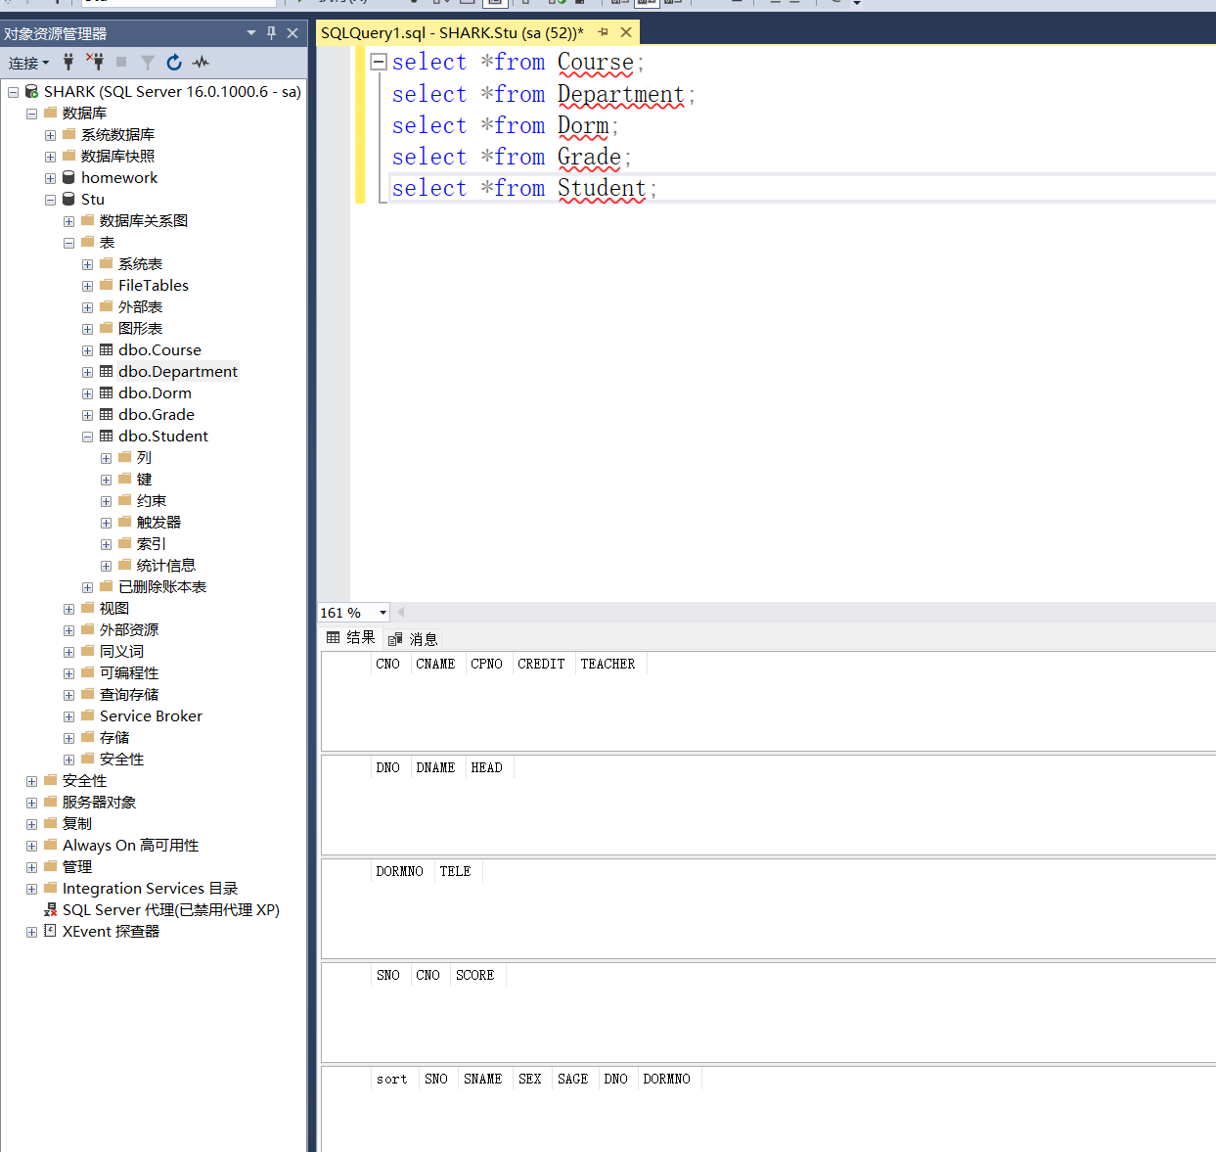

**向表中插入数据**

use Stu;

insert into Department(DNO,DNAME,HEAD)

VALUES

('1','计算机系','王凯峰'),

('2','数学系','李永军'),

('3','物理系','唐键'),

('4','中文系','秦峰');

insert into Dorm(DORMNO,TELE)

VALUES

('2101','8302101'),

('2202','8302202'),

('2303','8302303'),

('2404','8302404'),

('2505','8302505');

insert into Course(CNO,CNAME,CPNO,CREDIT,TEACHER)

VALUES

('01','数据库原理','05',4,'王凯'),

('02','高等数学',Null,6,'张风'),

('03','信息系统','01',2,'李明'),

('04','操作系统','06',4,'许强'),

('05','数据结构','07',4,'路飞'),

('06','算法设计',NULL,2,'黄海'),

('07','C语言','06',3,'高达');

insert into Student(sort,SNO,SNAME,SEX,SAGE,DNO,DORMNO)

VALUES

(1,'990101','原野','男',21,'1','2101'),

(2,'990102','张原','男',21,'1','2101'),

(3,'990103','李军','男',20,'1','2101'),

(4,'990104','汪远','男',20,'1','2101'),

(5,'990105','齐欣','男',20,'1','2101'),

(6,'990201','王大鸣','男',19,'2','2202'),

(7,'990202','徐东','男',19,'2','2202'),

(8,'990301','张扬','女',21,'1','2303'),

(9,'990302','于洋','女',20,'3','2303'),

(10,'990303','姚志旬','男',19,'4','2404'),

(11,'990401','高明镜','男',19,'4','NULL'),

(12,'990402','明天','男',21,'4','2404');

insert into Grade(SNO,CNO,SCORE)

VALUES

('990101','01',85),

('990101','03',65),

('990101','04',83),

('990101','07',72),

('990102','02',80),

('990102','04',81),

('990102','01',NULL),

('990103','07',74),

('990103','06',74),

('990103','01',74),

('990103','02',70),

('990103','04',70),

('990104','01',55),

('990104','02',42),

('990104','03',0),

('990105','03',85),

('990105','06',NULL),

('990301','01',46),

('990301','02',70),

('990302','01',85),

('990401','01',0);

