建库：

CREATE DATABASE homework；

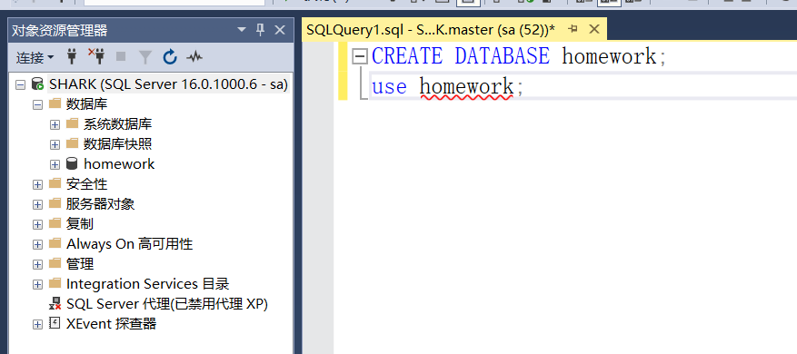

建表：

use homework;

CREATE TABLE S

(

SNO CHAR(2) PRIMARY KEY,

SNAME CHAR(20),

STATUS SMALLINT,

CITY CHAR(20)

);

CREATE TABLE P

(

PNO CHAR(2) PRIMARY KEY,

PNAME CHAR(20),

COLOR CHAR(2),

WEIGHT SMALLINT

);

CREATE TABLE J

(

JNO CHAR(2) PRIMARY KEY,

JNAME CHAR(20),

CITY CHAR(20)

);

CREATE TABLE SPJ

(

SNO CHAR(2),

PNO CHAR(2),

JNO CHAR(2),

QTY SMALLINT,

PRIMARY KEY(SNO,PNO,JNO),

FOREIGN KEY(SNO) REFERENCES S(SNO),

FOREIGN KEY(PNO) REFERENCES P(PNO),

FOREIGN KEY(JNO) REFERENCES J(JNO)

);

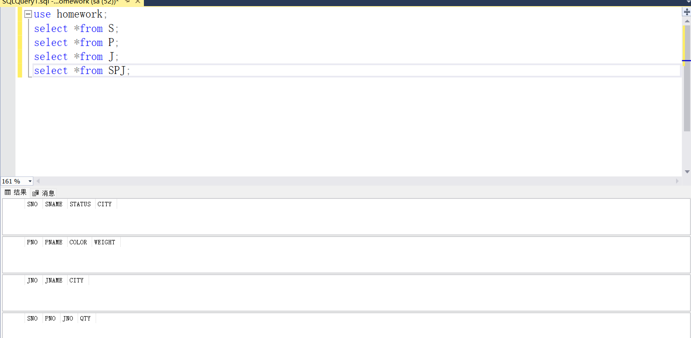

插入数据：

use homework;

INSERT INTO S(Sno,Sname,status,city)

VALUES

('S1','精益',20,'天津'),

('S2','盛锡',10,'北京'),

('S3','东方红',30,'北京'),

('S4','丰泰盛',20,'天津'),

('S5','为民',30,'上海');

INSERT INTO P(Pno,Pname,color,weight)

VALUES

('P1','螺母','红',12),

('P2','螺栓','绿',17),

('P3','螺丝刀','蓝',14),

('P4','螺丝刀','红',14),

('P5','凸轮','蓝',40),

('P6','齿轮','红',30);

INSERT INTO J(Jno,Jname,city)

VALUES

('J1','三建','北京'), ('J2','一汽','长春'),

('J3','弹簧厂','天津'), ('J4','造船厂','天津'),

('J5','机车厂','唐山'),('J6','无线电厂','常州'),

('J7','半导体厂','南京');

INSERT INTO SPJ(Sno,Pno,Jno,qty) VALUES

('S1','P1','J1',200),

('S1','P1','J3',100),

('S1','P1','J4',700),

('S1','P2','J2',100),

('S2','P3','J1',400),

('S2','P3','J2',200),

('S2','P3','J4',500),

('S2','P3','J5',400),

('S2','P5','J1',400),

('S2','P5','J2',100),

('S3','P1','J1',200),

('S3','P3','J1',200),

('S4','P5','J1',100),

('S4','P6','J3',300),

('S4','P6','J4',200),

('S5','P2','J4',100),

('S5','P3','J1',200),

('S5','P6','J2',200),

('S5','P6','J4',500);

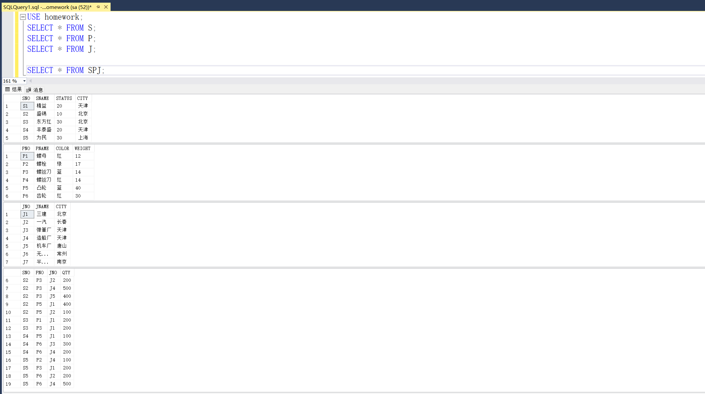

第四题、

1）

select SNO

from SPJ

WHERE JNO='J1';

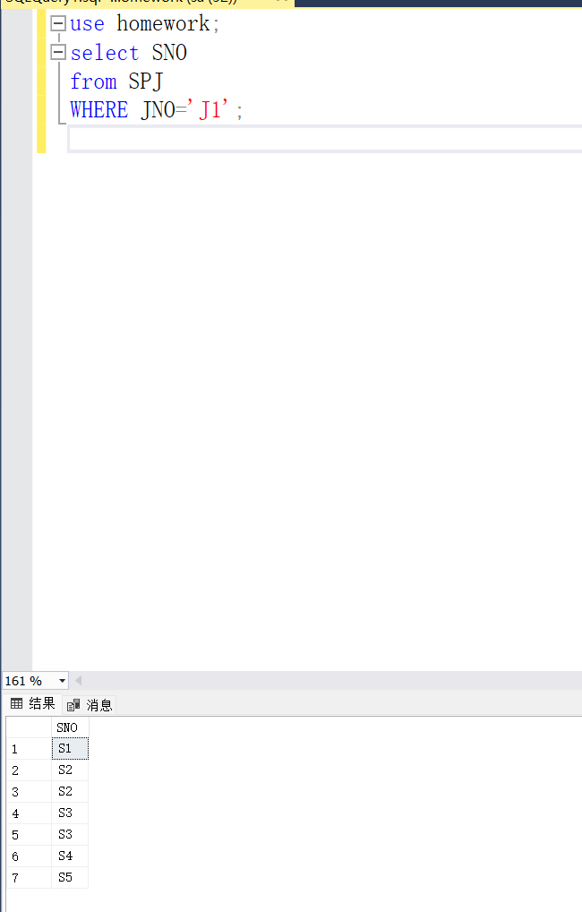

2）

select SNO

from SPJ

WHERE JNO='J1' AND PNO='P1';

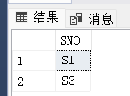

3）

SELECT SNO

FROM SPJ

WHERE JNO='J1' AND PNO IN (SELECT PNO FROM P WHERE COLOR='红');



4）

select JNO

FROM SPJ

WHERE PNO IN (SELECT PNO FROM P WHERE COLOR='红') AND SNO IN(SELECT SNO FROM S WHERE CITY NOT IN('天津'));

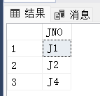

5）

SELECT JNO

FROM SPJ

WHERE PNO IN(SELECT PNO FROM SPJ WHERE SNO ='S1');

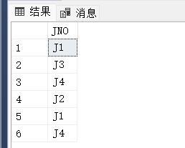

第五题

1）

SELECT SNAME,CITY

FROM S;

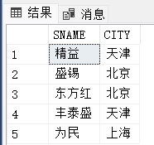

2）

SELECT PNAME,COLOR,WEIGHT

FROM P;

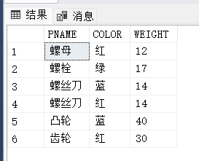

3）

SELECT JNO

FROM SPJ

WHERE PNO IN(SELECT PNO FROM SPJ WHERE SNO ='S1');

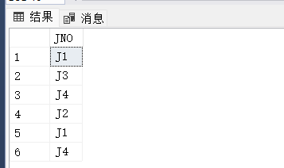

4）

SELECT PNAME,WEIGHT

FROM P

WHERE PNO IN (SELECT PNO FROM SPJ WHERE JNO IN (SELECT JNO FROM J WHERE JNO='J2'));

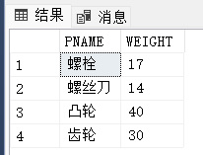

5）

SELECT PNO

FROM P

WHERE PNO IN (SELECT PNO FROM SPJ WHERE SNO IN(SELECT SNO FROM S WHERE CITY = '上海'));

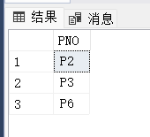

6）

SELECT JNO

FROM J

WHERE JNO IN (SELECT JNO FROM SPJ WHERE PNO IN (SELECT PNO FROM SPJ WHERE SNO IN (SELECT SNO FROM S WHERE CITY = '上海')));

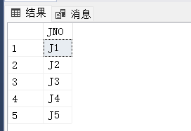

7）

SELECT JNO

FROM J

WHERE JNO NOT IN (SELECT JNO FROM SPJ WHERE PNO IN (SELECT PNO FROM SPJ WHERE SNO IN (SELECT SNO FROM S WHERE CITY ='天津')));

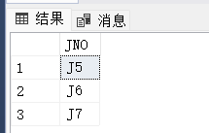

8）

UPDATE P

SET COLOR = '蓝'

WHERE COLOR = '红';

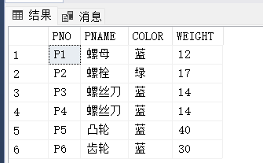

9）

UPDATE SPJ

SET SNO = 'S3'

WHERE JNO='J4'AND PNO = 'P6' AND SNO='S5';

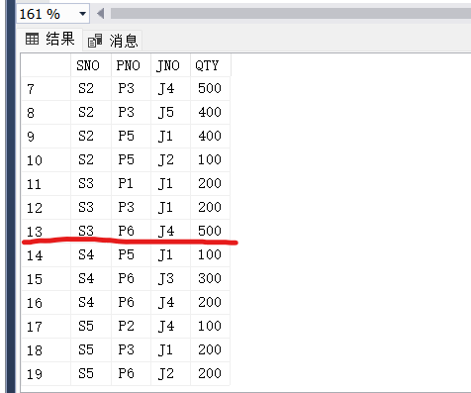

10）

DELETE

FROM S

WHERE SNO='S2';

DELETE

FROM SPJ

WHERE SNO='S2';

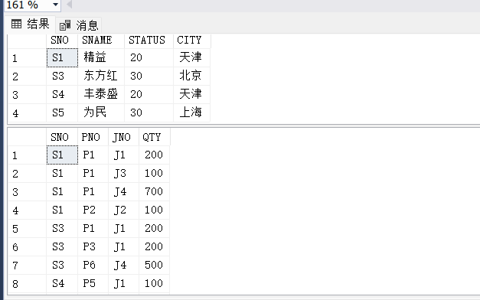

11）

INSERT INTO SPJ(SNO,JNO,PNO,QTY)

VALUES('S2','J6','P4',200);

