**实验三**

**1、查查询‘1’系的全体学生的学号、姓名和宿舍情况，结果按宿舍号升序排**

**列**

select SNO,SNAME,DORMNO

from Student

where DNO = '1'

order by DORMNO;

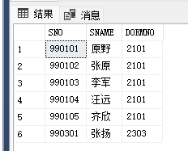

**2、 查询‘1’系的全体学生的详细记录，结果按性别升序、年龄降序排列。**

select *

from Student

where DNO = '1'

order by SEX,SAGE desc;

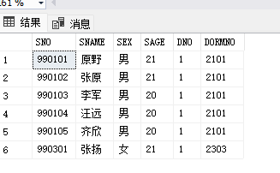

**3、 查询‘2’系的姓名和其出生年月(以 2003 年为标准)，并用“BIRTHDAY” 改变结果标题。**

select SNAME,(SAGE+2003)[BIRTHDAY]

from Student

where DNO = '2';

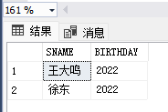

**4、 查询 GRADE 表中所有被学生选修课程号。**

select distinct CNO

from Grade;

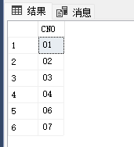

**5、 查询年龄在 21-23 之间（包括 21 和 23）的学生姓名，宿舍号。**

select SNAME,DORMNO

from Student

where SAGE between 21 and 23;

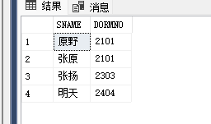

**6、 查询‘2’系、‘3’系和‘4’系的学生姓名。**

select SNAME

from Student

where DNO in ('2','3','4')

order by DNO;

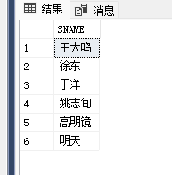

**7、 查询所有姓‘张’的学生情况。**

select *

from Student

where SNAME like '张%';

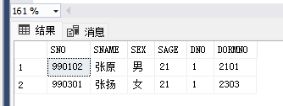

**8、 查询姓名中第二个字为“明”的学生情况**

select *

from Student

where SNAME like '%明%' and SNAME not like '明%';

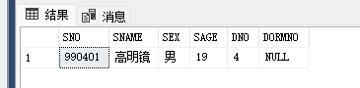

**9、 查询 COURSE 表中没有先修课程的课程名和教师情况**

select CNAME ,TEACHER

from Course

where CNO not in (select CNO from Grade);

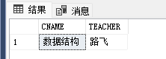

**10、查询‘1’系的所有男学生的信息**

select *

from Student

where SEX ='男' and DNO = '1';

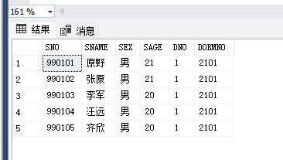

**11、查询所有‘1’系的学生人数。**

select Count(*) as Number_1

from Student

where DNO ='1';

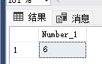

**12、查询‘1’系选修‘01’号课程的最高分、最低分和平均分。**

select max(SCORE)[最高分],min(SCORE)[最低分],round(avg(SCORE),2)[平均分]

from Grade

where SNO in (select SNO from Student where DNO ='1') and CNO = '01';

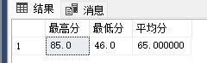

**13、查询选修了 4 门以上课程的学生学号、姓名。**

select SNO,SNAME

from Student

where SNO in

(SELECT SNO from Grade GROUP BY SNO HAVING COUNT(CNO)>=4)

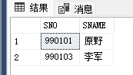

**14、给出所有院系领导检查学生宿舍的所有可能。**

select distinct HEAD,DORMNO

from Department d,Student s

where d.Dno = s.DNO and DORMNO is not null;

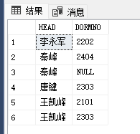

**15、查询所有学生及其宿舍情况。**

select ltrim(s.sname),s.dormno,d.tele

from student s,dorm d

where s.dormno = d.dormno

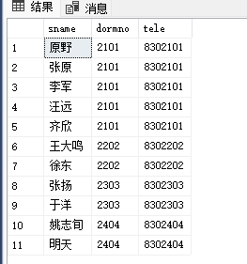

**16、查询所有课程的间接先修课。**

select c1.cname,c2.cname 间接先修

from course c1 left join course c2

on c1.cpno = c2.cno

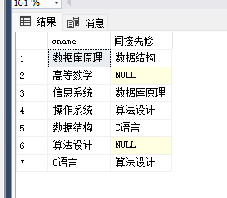

**17、查询所有学生及其选修课程情况。**

select s.sname,g.cno,g.score

from student s right join grade g

on s.sno = g.sno

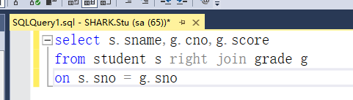

**18、查询所有已选修课程的学生的学号、姓名、选修的课程名和授课教师信息。**

select s.SNO,s.SNAME,c.CNAME,c.TEACHER

from student s right join grade g

on s.sno = g.sno left join course c

on g.cno = c.cno

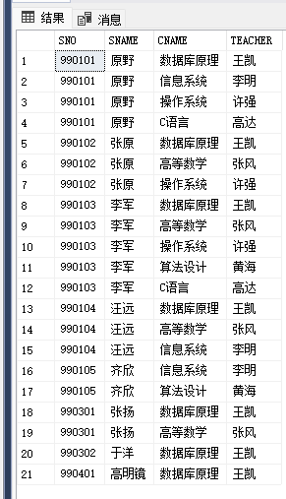

**19、查询是系主任‘秦峰’的学生的姓名和宿舍联系电话。**

select sname,tele

from student s,dorm d, department de

where de.head = '秦峰' and s.dormno = d.dormno

and s.dno = de.dno

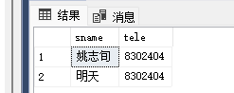

**20、查询其他系比‘计算机系’所有学生年龄大的学生姓名和年龄。**

select s1.sname, s1.sage

from student s1,department d2

where s1.dno = d2.dno

and s1.sage >= (

select max(sage)

from student

where dno = '1'

) and d2.dno not in ('1')

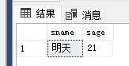

**21、查询选修课程库没有不及格分数的学生。**

select sname

from student s

where s.sno in (

select g.sno

from grade g

group by g.sno having min(score) >= 60)

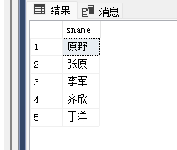

**22、查询至少选修了‘1’号和‘2’号课程的学生号码**

select sno

from Grade

where cno in ('01','02')

group by sno having count(*) =2

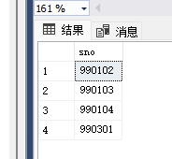

**23、查询至少选修了‘990102’学生的全部课程的学生学号。**

select distinct sno

from grade g1

where not exists(

select *

from grade g2

where g2.sno = '990102'

and not exists(

select *

from grade g3

where g3.cno = g2.cno

and g3.sno = g1.sno)

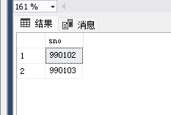

**24、查询‘1’系的学生与年龄大于 20 岁的学生的差集。**

select sname,sno

from student

where dno = '1' and

exists(

select *

where sage <= 20

)

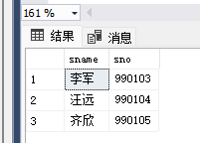

**25、查询选修“数据库原理”的学生与选修“高等数学”的学生的交集。**

select sno

from course c,grade g

where c.cno = g.cno and

c.cname in('数据库原理','高等数学')

group by g.sno

having count(*) = 2

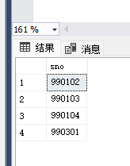

**26、创建“计算机”系的所有男生的视图 VIEW_1（要求反映出学生的出生 年份）。**

create view VIEW_1(sname,sage,sno,dormno,BIRTHDAY)

as

select sname,sage,sno,dormno,2013 - sage

from student s,department d

where s.dno = d.dno and sex = '男' and d.dname = '计算机系'

select *

from VIEW_1

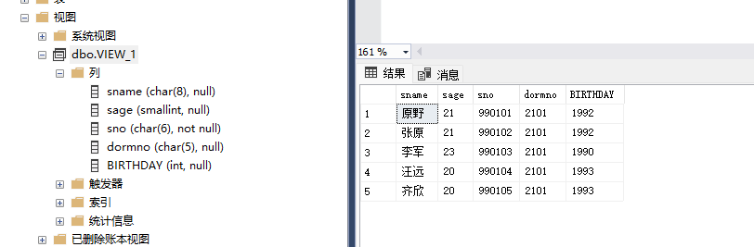

**27、在视图 VIEW_1 中找出名字中有“原”字的学生的学号、姓名、宿舍号。**

select SNO,sname,dormno

from view_1

where sname like '%原%'

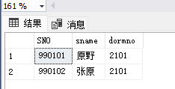

**28、修改视图 VIEW_1 中的学生“李军”的年龄为 23，宿舍号为“2202”**

select *

from view_1

update view_1

set sage =23,dormno = '2202'

where sname ='李军'

select *

from view_1

