1. A straight line 65mm long has one end 15mm in front of VP and 40mm above HP while the other end is 30mm in front of VP and 20mm above HP. Draw the plan and elevation of the line. What is the true inclination of the line with HP? What is the length of the plan?

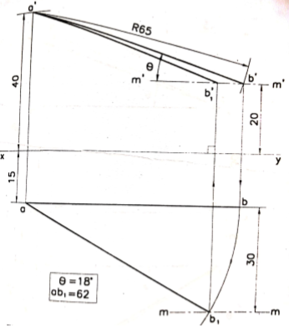

1. A line AB, 65mm long has its end A 20mm above the HP and 25mm in front of VP. The end B is 40mm above the HP and 65mm in front of the VP. Draw the projections of A and B and measure the length of top and front views.

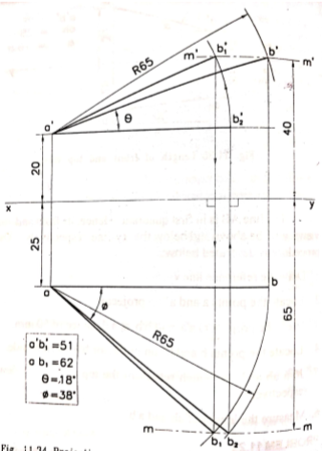

1. Draw the projection of a line AB 100mm ling inclined at 30 o to HP and 45 o to VP. The end A of the line is 50mm below the HP and 25mm behind VP. Mark the angle made by the line with the xy-line.

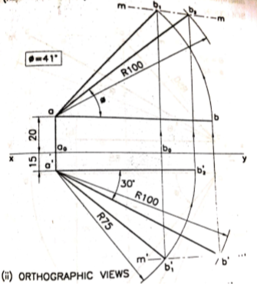

1. A line PQ has its end P 10mm above the HP and 20mm in front of the VP. The end Q is 35mm in front of the VP and the front view of the line measures 75mm. The distance between the end projectors is 50mm. Draw the projections of the line and find its true length and true inclinations with VP and HP.

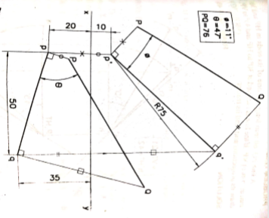

1. A line AB is inclined to both reference planes. Point A is 10mm behind VP and 20mm below HP. Point B is 25mm behind VP and 40mm below HP. The distance between A and B along XY is 50mm. Determine the true length and true inclinations of the line with reference planes.

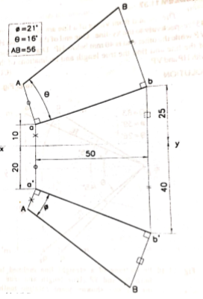

1. A line AB 60mm long is inclined to the HP at 40o. Its plan makes an angle of 30 o with the xy-line. Draw its projections and determine the inclination with VP.

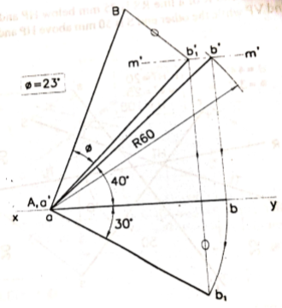

1. A line PQ , 60mm long has one of its ends in HP and 30mm infront of VP. If the line is inclined at 30 o to HP and 30mm in front of VP. If the line is inclined at 30 o to HP and 45 o to VP. Draw the projectioins and find the traces.

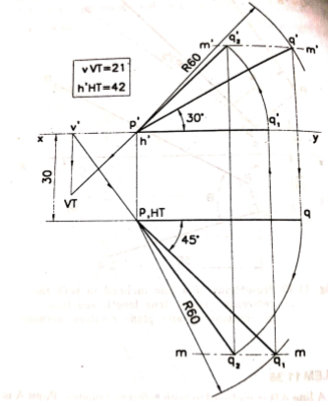

1. The end A of a line AB is in the HP and 25mm behind the VP. The end is in the VP and 50mm above the HP. The distance between the end projections is 75mm. Draw the projections of AB and determine its true length, traces and inclinations with the HP and the VP.

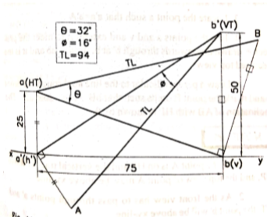

1. The end A of a line AB is in the HP and 25mm in front of VP. The end B is in the VP and 50mm below HP. The distance between the end projectors is 75mm. Draw the projections of AB and determine its true length and inclinations with HP and VP. Also locate its traces.

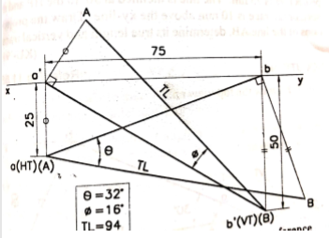

1. The front view of a line AB measures 75mm and makes an angle of 50o with XY. The end A is in the horizontal plane and the vertical trace of the line is 25mm above the horizontal plane. The line is inclined at 35o to the vertical plane. Draw the projections of the line and find its true length and inclination to the horizontal plane.

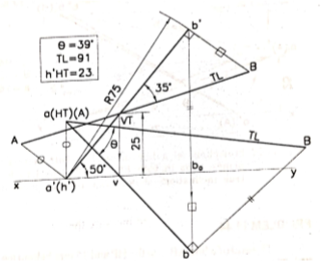

1. The mid point of a line AB is 50mm above HP and 30mm in front of VP. The line measures 80mm and is inclined at 45o to HP and 30o to VP. Draw its projections.

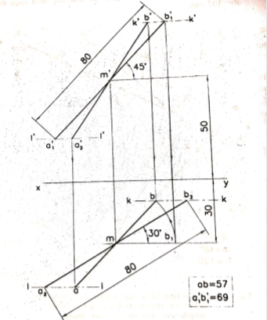

1. Draw the projections of a line AB 90mm long, its midpoint M being 50mm above the HP and 40mm in front of the VP. The end A is 20mm above the HP and 10mm in front of the VP. Show the traces and the inclinations of the line with the HP and VP.

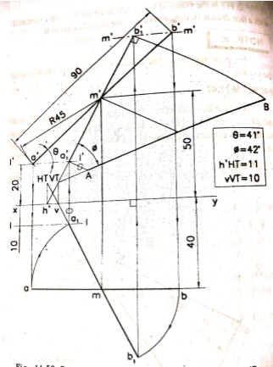

1. A line PQ 120mm long is inclined at 45o to the HP and 30o to the VP. Its end P is in the second quadrant and end Q is in the fourth quadrant. A point R on PQ 50mm froj P, is in both the planes. Draw the projections of PQ. Measure pq and p’q’.

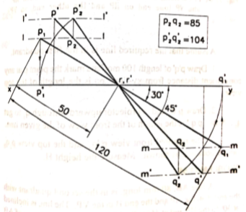

1. One end of a line PQ 100 mm long, is 30mm above HP and 20mm infront of VP. The line is inclined 45 o to HP and 30o to VP. Draw the projections of the line if P lies in the first quadrant and Q lies in the second quadrant. Also indicate the traces of the line. What are the apparent inclinations?

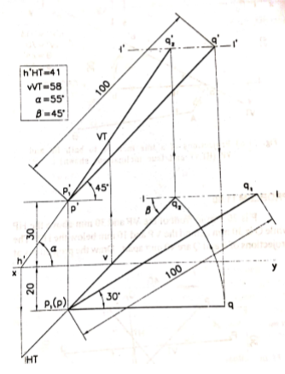

1. A line AB, 75mm has its end A on the ground and 20mm behind the VP. The end B is 30mm above the ground and 65mm behind the VP. The ground plane may be considered as 55mm below the HP. Draw the projections of the line and determine its inclinations with the VP and the ground. Determine traces of the line.

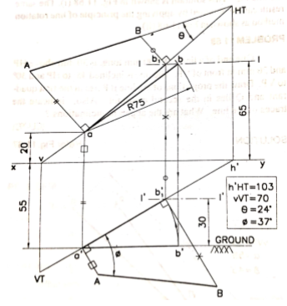

1. The top view of a certain line PQ is 60mm long and is inclined to xy line at 30o. Its front view is inclined at 45 o to xy line. The. end P is 20mm behind the VP and 25mm below the HP. Determine its true length, inclination with the reference planes and traces.

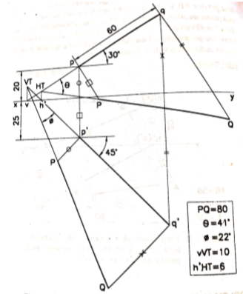

1. The front view of a line BA makes an angle of 30 o with the xy line whose VT is 30mm above HP. The end A is 10mm below HP and end B is 100mm behind VP. Draw the projections of the line if the HT is 40mm above HP. What is the true length and true inclinations?

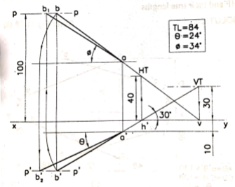

1. The ends of a line AB are 50mm and 20mm above the HP. The length of its front view is 70mm and its VT is 10mm above HP. The line is inclined 40 o  to the VP. Find its true length and true inclination with the HP. Also locate its traces.

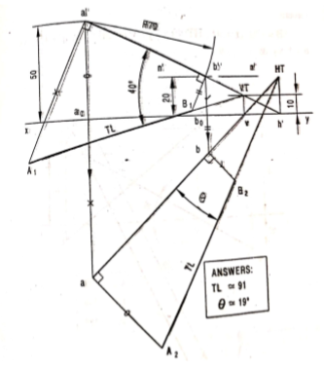

1. The end A of a line AB (True length 100mm) is 10 mm above HP and 20 mm in front of VP. The line AB is inclined at 30 degrees to the HP and 20 degrees to VP. Draw the projections of the line if the end B is in third quadrant and mark its traces.

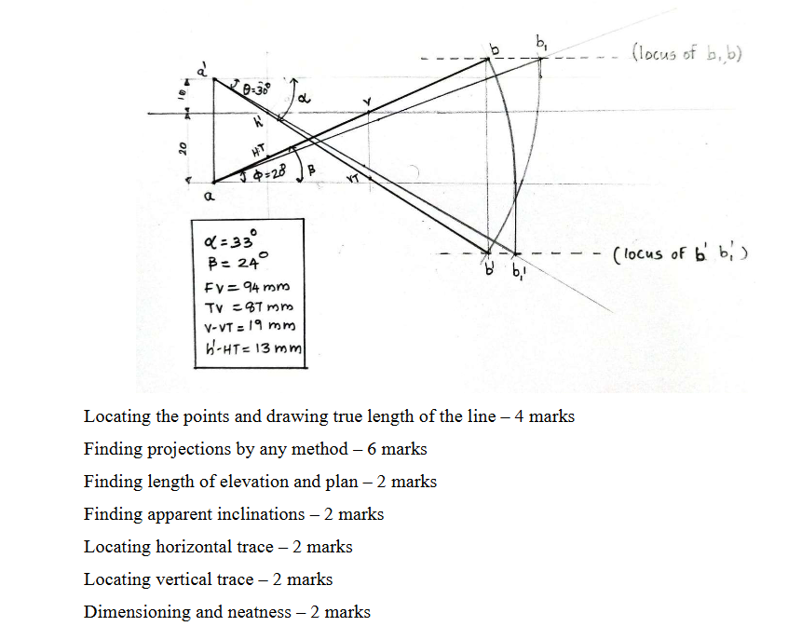

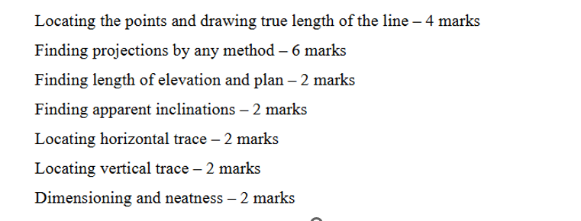

1. One end of line AB is 10 mm above HP and other end is 70 mm in front of VP. It’s FV is 20 degrees inclined to xy while it’s HT & VT are 10 mm and 5 mm below xy respectively. Draw projections and find TL with its inclinations with HP & VP.

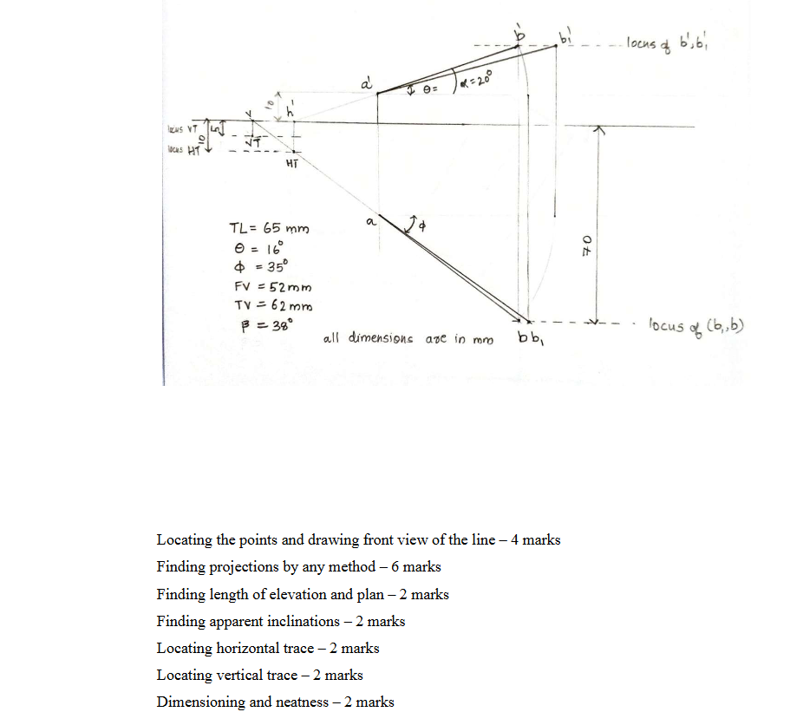



1. One end of a line CD is 15 mm above HP and 20 mm in front of VP. At the same time the other end is 60 mm above HP and 50 mm in front of the VP. The distance between the end projectors is 70 mm. Draw the projections of the line and locate the traces. Determine the true and apparent lengths. Also find the true and apparent inclinations.

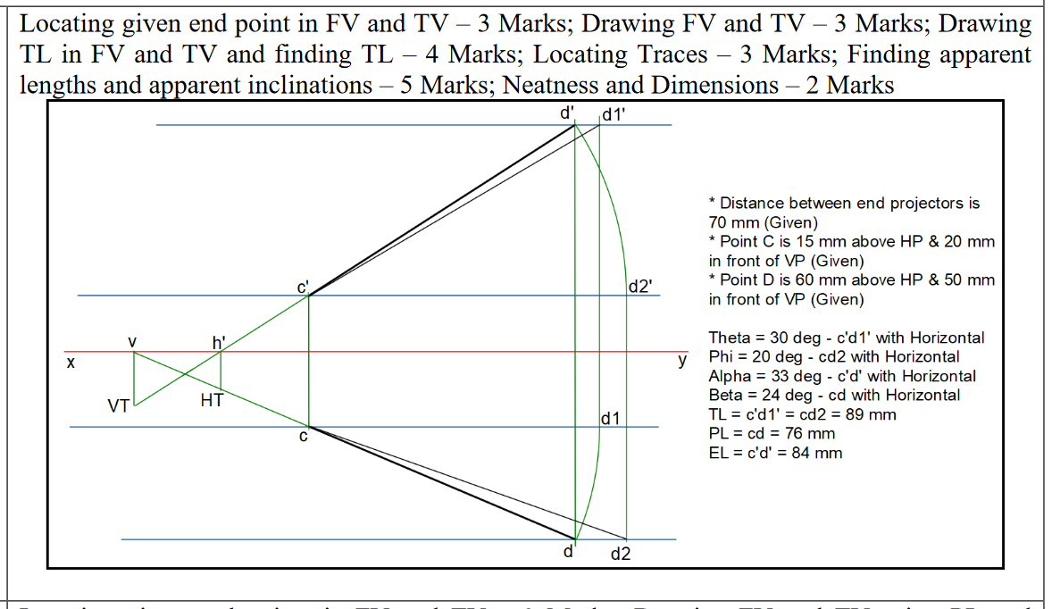

1. The top view of a line AB is 70 mm long and is inclined at 45 degrees to XY line. One end of the line is 22 mm above HP and 12 mm in front of VP. The other end of the line is 60 mm above HP and is in front of VP. Find the true length, elevation length and true inclinations of the line with HP and VP. Show the locations of the traces of the line.

Locating given end points in FV and TV – 2 Marks; Drawing FV and TV using PL and

inclination – 4 Marks; Drawing TL in FV and TV – 4 Marks; Locating Traces – 3 Marks;

Finding TL, EL, and Inclinations – 5 Marks; Neatness and Dimensions – 2 Marks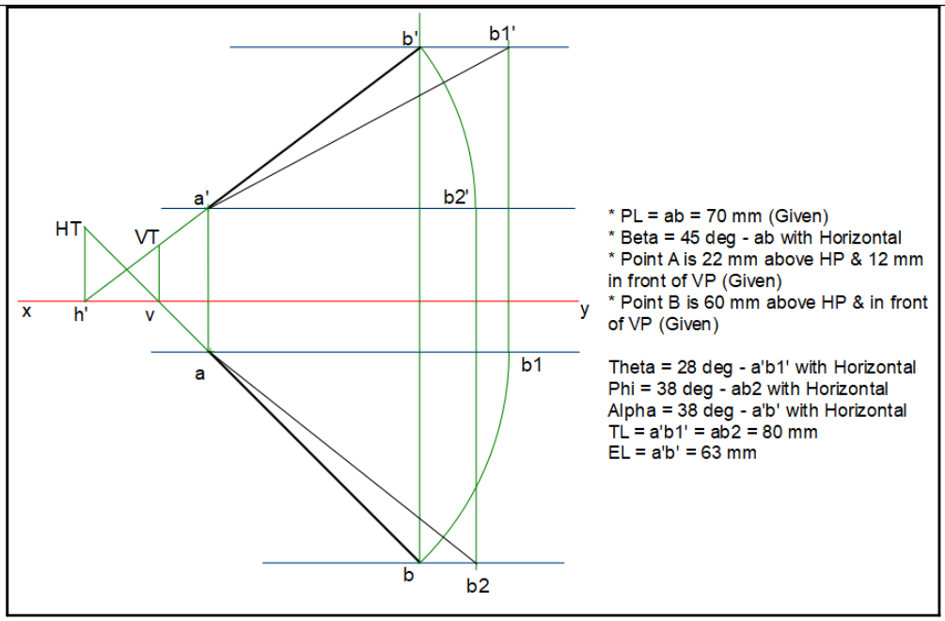

1. The elevation of a straight line CD is 65 mm long. C is 15 mm below HP and is 30 mm in front of VP. D is 55mm below HP and` is in third quadrant. Draw the projections of line CD if the line is inclined 30o to HP. Find out its true length and true inclination with respect to VP.

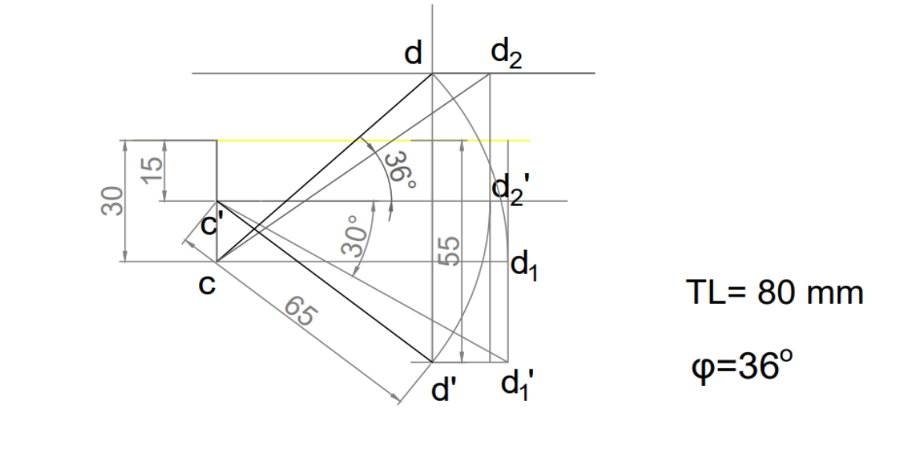

1. The front view of a straight-line MN which is 75 mm long is 70 mm and is inclined 40o to x-y line. The end point M is 20 mm above HP and is 35 mm behind VP. The other end N is 25 mm below HP and is in the third quadrant. Find out the true length and true inclinations of the line with HP and VP.

