AES Cryptographic Algorithm
1/ AES Algorithm
This prompts the user to enter a sentence which he want to encrypt, and the entered text is stored in the originalText variable.
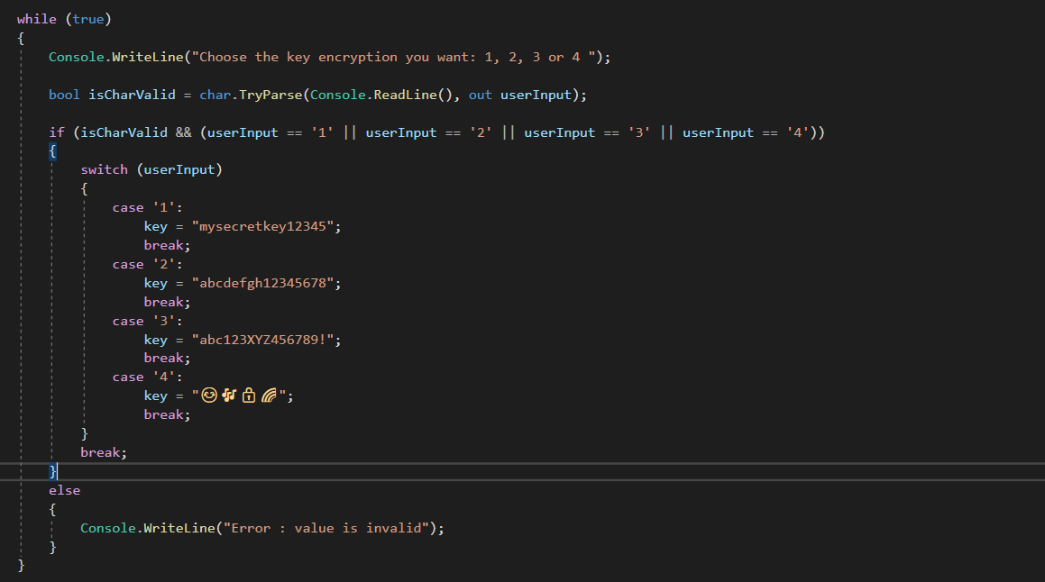
This code snippet establishes an indefinite loop that continuously prompts the user to select a key for encryption. The user is prompted to input a digit (1, 2, 3, or 4). The code validates the input, ensuring it is a valid character and within the specified range. If the input is valid, a switch statement assigns a predefined key to the variable 'key' based on the user's choice. Subsequently, the loop is terminated using the 'break' statement. In the event of invalid input, an error message is displayed, and the loop persists until the user provides a valid key. The selected key is then stored in the 'key' variable for use in subsequent encryption processes.
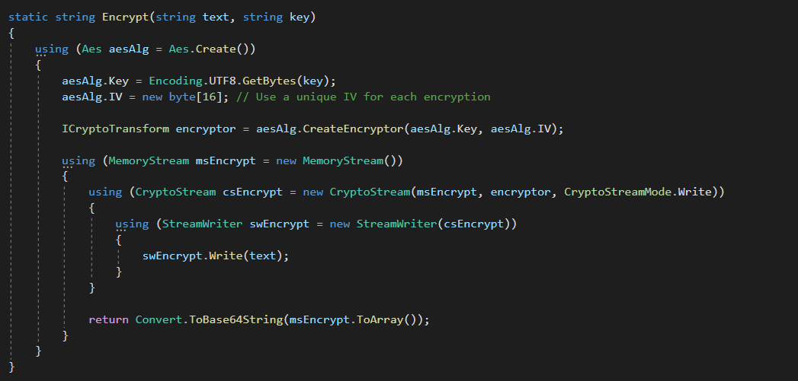

This code snippet implements the Encrypt function, utilizing the Advanced Encryption Standard (AES) algorithm for symmetric encryption. Firstly, it creates an instance of the Aes class, representing the AES algorithm. The encryption key is set by converting the input key (a string) into a byte array using UTF-8 encoding, and a zero-filled Initialization Vector (IV) of 16 bytes is established. The next step involves creating an ICryptoTransform object through the CreateEncryptor method of the Aes instance, which is responsible for executing the encryption process.
The actual encryption is performed by writing the input text to a CryptoStream, linked to a MemoryStream. This combination facilitates the storage of the encrypted data in the memory stream. The encrypted data is then converted to a Base64 string using Convert.ToBase64String. This encoding is employed to represent binary data as a text string, particularly useful when dealing with data containing non-printable characters. The resulting output of this function is the encrypted text, represented as a Base64-encoded string. It's important to note that this code solely addresses the encryption aspect, and a corresponding Decrypt function would be necessary to retrieve the original text. Additionally, the security of the encryption hinges on factors such as the strength of the key, proper handling of the initialization vector, and the overall implementation of the cryptographic algorithm.

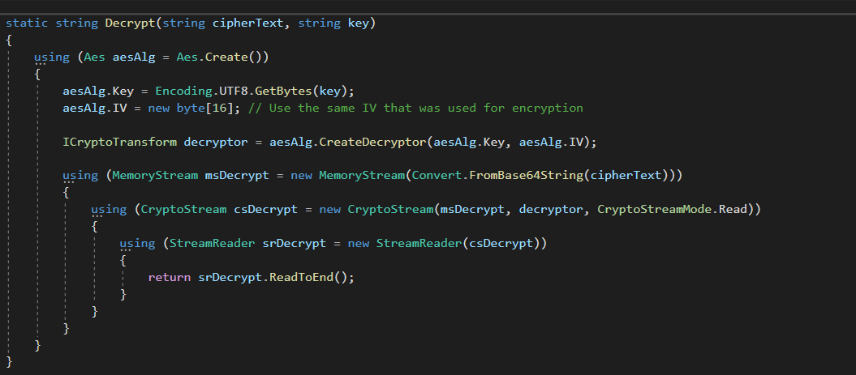

This code snippet defines a Decrypt function, responsible for decrypting a given ciphertext using the Advanced Encryption Standard (AES) algorithm with a specified key. The function begins by creating an instance of the Aes class to represent the AES algorithm. It then sets the encryption key by converting the input key (a string) into a byte array using UTF-8 encoding. Additionally, it initializes the Initialization Vector (IV) to a zero-filled array of 16 bytes. Notably, it's crucial to use the same IV during decryption as was used during encryption.
The next step involves creating an ICryptoTransform object by calling the CreateDecryptor method of the Aes instance. This object is responsible for the actual decryption process. Subsequently, the decryption process begins with the creation of a MemoryStream initialized with the Base64-decoded ciphertext. A CryptoStream is then established, linked to the memory stream, and configured for reading. Finally, a StreamReader is utilized to read the decrypted data from the crypto stream, and the decrypted text is returned.

2/ Console App Results
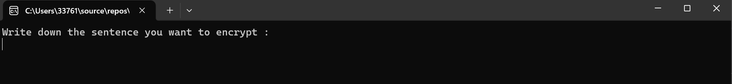
The first step when running the program is to write the sentence or words you want to encrypted.
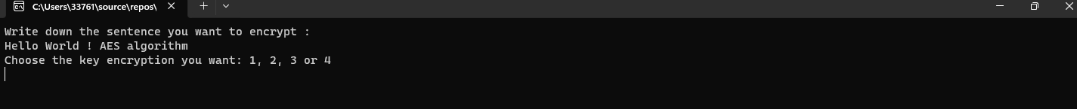
Then, you have the choice between 4 different encryption key which are : “mysecretkey12345”, “abcdefgh12345678”, “abc123XYZ456789!” and “😊🎶🔒🌈”. Each one of these are 136 bits key. The user choose one of them.
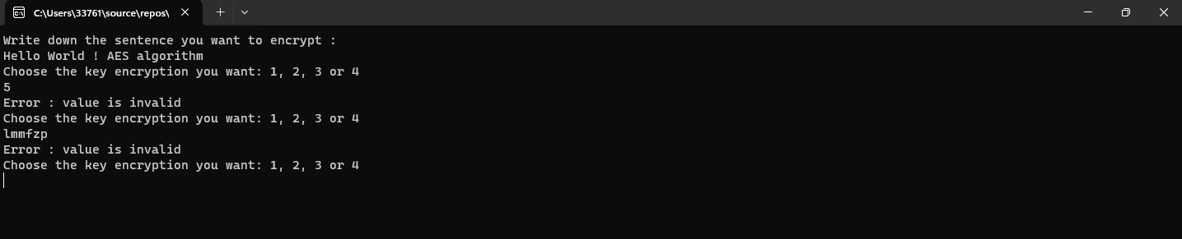
If the user enters a wrong value (something else than 1, 2, 3 or 4) a message will appear and ask the user to input another value until it is a correct one.

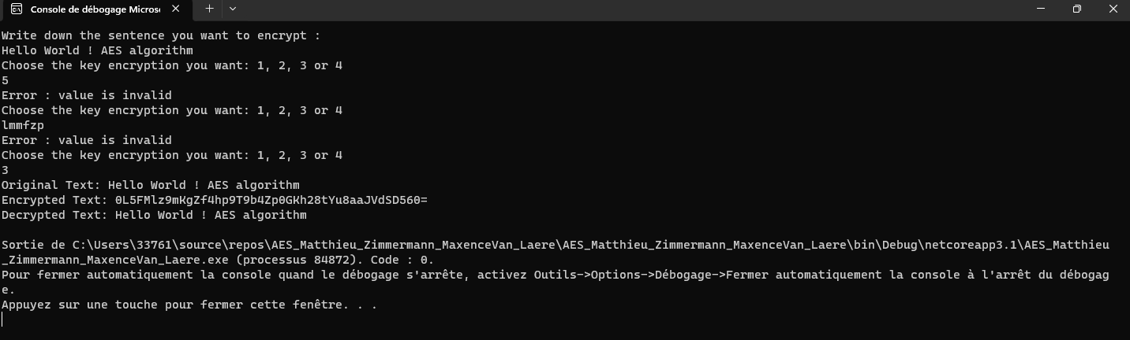
As soon as a valid value is entered, the sentence will be encrypted. The encrypted sentence is displayed, then the encrypted message will be decrypted and the result of this process will also be displayed to be sure that the original sentence is matching with the new one.

To close the Console App and stop debugging, simply press any key on the keyboard.

