x@gb-linux:~$ ll

x@gb-linux:~$ cd Test

x@gb-linux:~/Test$ ll

x@gb-linux:~/Test$ cat > Pets.txt

Dog Didi

Cat Lusy

Hamster Toby

x@gb-linux:~/Test$ cat Pets.txt

Dog Didi

Cat Lusy

Hamster Toby

@gb-linux:~/Test$ cat > Pack_animals.txt

Horse Star

Camel Sandy

Donkey Sam

x@gb-linux:~/Test$ ll

total 20

drwxrwxr-x 2 x x 4096 фев 14 10:42 ./

drwxr-x--- 17 x x 4096 фев 14 10:25 ../

-rw-r--r-- 1 root root 216 янв 16 14:42 docker-compose.yml

-rw-rw-r-- 1 x x 34 фев 14 10:44 Pack_animals.txt

-rw-rw-r-- 1 x x 31 фев 14 10:38 Pets.txt

x@gb-linux:~/Test$ cat Pack_animals.txt

Horse Star

Camel Sandy

Donkey Sam

x@gb-linux:~/Test$ cat Pets.txt Pack_animals.txt > Human_Friends.txt

x@gb-linux:~/Test$ ll

total 24

drwxrwxr-x 2 x x 4096 фев 14 10:46 ./

drwxr-x--- 17 x x 4096 фев 14 10:25 ../

-rw-r--r-- 1 root root 216 янв 16 14:42 docker-compose.yml

-rw-rw-r-- 1 x x 65 фев 14 10:46 Human_Friends.txt

-rw-rw-r-- 1 x x 34 фев 14 10:44 Pack_animals.txt

-rw-rw-r-- 1 x x 31 фев 14 10:38 Pets.txt

x@gb-linux:~/Test$ cat Human_Friends.txt

Dog Didi

Cat Lusy

Hamster Toby

Horse Star

Camel Sandy

Donkey Sam

x@gb-linux:~/Test$ cd ..

x@gb-linux:~$ mkdir Animals

x@gb-linux:~$ ls

Animals Desktop Documents Downloads Music Pictures Public shared snap Templates Test Videos

x@gb-linux:~$ cd Test

x@gb-linux:~/Test$ pwd

/home/x/Test

x@gb-linux:~/Test$ mv Human_Friends.txt /home/x/Animals/

x@gb-linux:~/Test$ ll

total 20

drwxrwxr-x 2 x x 4096 фев 14 11:03 ./

drwxr-x--- 18 x x 4096 фев 14 10:47 ../

-rw-r--r-- 1 root root 216 янв 16 14:42 docker-compose.yml

-rw-rw-r-- 1 x x 34 фев 14 10:44 Pack_animals.txt

-rw-rw-r-- 1 x x 31 фев 14 10:38 Pets.txt

x@gb-linux:~/Test$ cd ..

x@gb-linux:~$ cd Animals

x@gb-linux:~/Animals$ ll

total 12

drwxrwxr-x 2 x x 4096 фев 14 11:03 ./

drwxr-x--- 18 x x 4096 фев 14 10:47 ../

-rw-rw-r-- 1 x x 65 фев 14 10:46 Human_Friends.txt

x@gb-linux:~/Animals$ cd ..

x@gb-linux:~$ sudo apt update

x@gb-linux:~$ sudo apt install mysql-server -y

x@gb-linux:~$ sudo systemctl start mysql

x@gb-linux:~$ sudo systemctl status mysql

● mysql.service - MySQL Community Server

Loaded: loaded (/lib/systemd/system/mysql.service; enabled; vendor preset: enabled)

Active: active (running) since Wed 2024-02-14 11:17:58 MSK; 11min ago

Process: 6939 ExecStartPre=/usr/share/mysql/mysql-systemd-start pre (code=exited, status=0/SUCCESS)

Main PID: 6956 (mysqld)

Status: "Server is operational"

Tasks: 37 (limit: 2260)

Memory: 355.5M

CPU: 5.834s

CGroup: /system.slice/mysql.service

└─6956 /usr/sbin/mysqld

фев 14 11:17:58 gb-linux systemd[1]: Starting MySQL Community Server...

фев 14 11:17:58 gb-linux systemd[1]: Started MySQL Community Server.

x@gb-linux:~$ cd Downloads

x@gb-linux:~/Downloads$ ll

total 103944

drwxr-xr-x 2 x x 4096 фев 14 11:53 ./

drwxr-x--- 18 x x 4096 фев 14 11:43 ../

-rw-rw-r-- 1 x x 106428268 фев 14 11:53 google-chrome-stable_current_amd64.deb

x@gb-linux:~/Downloads$ sudo dpkg --install google-chrome-stable_current_amd64.deb

x@gb-linux:~/Downloads$ cd ..

x@gb-linux:~$ pwd

/home/x

x@gb-linux:~$ sudo dpkg --remove google-chrome-stable

x@gb-linux:~$ sudo mysql -u root -p

Enter password:

Welcome to the MySQL monitor. Commands end with ; or \g.

Your MySQL connection id is 10

Server version: 8.0.36-0ubuntu0.22.04.1 (Ubuntu)

Copyright (c) 2000, 2024, Oracle and/or its affiliates.

Oracle is a registered trademark of Oracle Corporation and/or its affiliates. Other names may be trademarks of their respective owners.

Type 'help;' or '\h' for help. Type '\c' to clear the current input statement.

mysql> SHOW DATABASES;

+--------------------+

| Database |

+--------------------+

| information_schema |

| mysql |

| performance_schema |

| sys |

+--------------------+

4 rows in set (0,06 sec)

mysql> CREATE DATABASE Human_Friends;

Query OK, 1 row affected (0,02 sec)

mysql> SHOW DATABASES;

+--------------------+

| Database |

+--------------------+

| Human_Friends |

| information_schema |

| mysql |

| performance_schema |

| sys |

+--------------------+

mysql> CREATE TABLE cats ( id INT PRIMARY KEY AUTO_INCREMENT, name VARCHAR(45) NOT NULL, birthday DATE NOT NULL, commands VARCHAR(255) NOT NULL );

Query OK, 0 rows affected (0,06 sec)

mysql> CREATE TABLE dogs ( id INT PRIMARY KEY AUTO_INCREMENT, name VARCHAR(45) NOT NULL, birthday DATE NOT NULL, commands VARCHAR(255) NOT NULL );

Query OK, 0 rows affected (0,03 sec)

mysql> CREATE TABLE hamsters ( id INT PRIMARY KEY AUTO_INCREMENT, name VARCHAR(45) NOT NULL, birthday DATE NOT NULL, commands VARCHAR(255) NOT NULL );

Query OK, 0 rows affected (0,04 sec)

mysql> show tables;

+-------------------------+

| Tables_in_Human_Friends |

+-------------------------+

| cats |

| dogs |

| hamsters |

+-------------------------+

3 rows in set (0,00 sec)

mysql> CREATE TABLE horses ( id INT PRIMARY KEY AUTO_INCREMENT, name VARCHAR(45) NOT NULL, birthday DATE NOT NULL, commands VARCHAR(255) NOT NULL );

Query OK, 0 rows affected (0,02 sec)

mysql> CREATE TABLE camels ( id INT PRIMARY KEY AUTO_INCREMENT, name VARCHAR(45) NOT NULL, birthday DATE NOT NULL, commands VARCHAR(255) NOT NULL );

Query OK, 0 rows affected (0,03 sec)

mysql> CREATE TABLE donkeys ( id INT PRIMARY KEY AUTO_INCREMENT, name VARCHAR(45) NOT NULL, birthday DATE NOT NULL, commands VARCHAR(255) NOT NULL );

Query OK, 0 rows affected (0,02 sec)

mysql> show tables;

+-------------------------+

| Tables_in_Human_Friends |

+-------------------------+

| camels |

| cats |

| dogs |

| donkeys |

| hamsters |

| horses |

+-------------------------+

6 rows in set (0,00 sec)

mysql> CREATE TABLE Pets ( id INT PRIMARY KEY AUTO_INCREMENT, type VARCHAR(45) NOT NULL );

Query OK, 0 rows affected (0,04 sec)

mysql> CREATE TABLE Pack_animals ( id INT PRIMARY KEY AUTO_INCREMENT, type VARCHAR(45) NOT NULL );

Query OK, 0 rows affected (0,04 sec)

mysql> show tables;

+-------------------------+

| Tables_in_Human_Friends |

+-------------------------+

| Pack_animals |

| Pets |

| camels |

| cats |

| dogs |

| donkeys |

| hamsters |

| horses |

+-------------------------+

8 rows in set (0,00 sec)

mysql> ALTER TABLE cats ADD type VARCHAR(45) NOT NULL ;

Query OK, 0 rows affected (0,01 sec)

Records: 0 Duplicates: 0 Warnings: 0

mysql> ALTER TABLE dogs ADD type VARCHAR(45) NOT NULL ;

Query OK, 0 rows affected (0,01 sec)

Records: 0 Duplicates: 0 Warnings: 0

mysql> ALTER TABLE hamsters ADD type VARCHAR(45) NOT NULL ;

Query OK, 0 rows affected (0,03 sec)

Records: 0 Duplicates: 0 Warnings: 0

mysql> ALTER TABLE horses ADD type VARCHAR(45) NOT NULL ;

Query OK, 0 rows affected (0,03 sec)

Records: 0 Duplicates: 0 Warnings: 0

mysql> ALTER TABLE camels ADD type VARCHAR(45) NOT NULL ;

Query OK, 0 rows affected (0,02 sec)

Records: 0 Duplicates: 0 Warnings: 0

mysql> ALTER TABLE donkeys ADD type VARCHAR(45) NOT NULL ;

Query OK, 0 rows affected (0,02 sec)

Records: 0 Duplicates: 0 Warnings: 0

mysql> SHOW COLUMNS FROM cats;

+----------+--------------+------+-----+---------+----------------+

| Field | Type | Null | Key | Default | Extra |

+----------+--------------+------+-----+---------+----------------+

| id | int | NO | PRI | NULL | auto_increment |

| name | varchar(45) | NO | | NULL | |

| birthday | date | NO | | NULL | |

| commands | varchar(255) | NO | | NULL | |

| type | varchar(45) | NO | | NULL | |

+----------+--------------+------+-----+---------+----------------+

5 rows in set (0,02 sec)

mysql> ALTER TABLE cats MODIFY type VARCHAR(45) NOT NULL AFTER id ;

Query OK, 0 rows affected (0,04 sec)

Records: 0 Duplicates: 0 Warnings: 0

mysql> SHOW COLUMNS FROM cats;

+----------+--------------+------+-----+---------+----------------+

| Field | Type | Null | Key | Default | Extra |

+----------+--------------+------+-----+---------+----------------+

| id | int | NO | PRI | NULL | auto_increment |

| type | varchar(45) | NO | | NULL | |

| name | varchar(45) | NO | | NULL | |

| birthday | date | NO | | NULL | |

| commands | varchar(255) | NO | | NULL | |

+----------+--------------+------+-----+---------+----------------+

5 rows in set (0,00 sec)

mysql> ALTER TABLE dogs MODIFY type VARCHAR(45) NOT NULL AFTER id ;

Query OK, 0 rows affected (0,06 sec)

Records: 0 Duplicates: 0 Warnings: 0

mysql> ALTER TABLE hamsters MODIFY type VARCHAR(45) NOT NULL AFTER id ;

Query OK, 0 rows affected (0,04 sec)

Records: 0 Duplicates: 0 Warnings: 0

mysql> ALTER TABLE camels MODIFY type VARCHAR(45) NOT NULL AFTER id ;

Query OK, 0 rows affected (0,06 sec)

Records: 0 Duplicates: 0 Warnings: 0

mysql> ALTER TABLE horses MODIFY type VARCHAR(45) NOT NULL AFTER id ;

Query OK, 0 rows affected (0,05 sec)

Records: 0 Duplicates: 0 Warnings: 0

mysql> ALTER TABLE donkeys MODIFY type VARCHAR(45) NOT NULL AFTER id ;

Query OK, 0 rows affected (0,04 sec)

Records: 0 Duplicates: 0 Warnings: 0

mysql> INSERT INTO cats (type, name, birthday, commands) VALUES('cat', 'Sonia', '2001-01-01', 'мяукать, играть');

Query OK, 1 row affected (0,01 sec)

mysql> INSERT INTO cats (type, name, birthday, commands) VALUES('cat', 'Kitty', '2001-02-02', 'мяукать, ласкаться');

Query OK, 1 row affected (0,00 sec)

mysql> INSERT INTO cats (type, name, birthday, commands) VALUES('cat', 'Tom', '2001-03-03', 'мяукать, играть, ласкаться');

Query OK, 1 row affected (0,01 sec)

mysql> INSERT INTO dogs (type, name, birthday, commands) VALUES('dog', 'Tom', '2002-01-01', 'сидеть, лаять, гулять');

Query OK, 1 row affected (0,01 sec)

mysql> INSERT INTO dogs (type, name, birthday, commands) VALUES('dog', 'Bobby', '2002-02-02', 'сидеть, лаять, гулять');

Query OK, 1 row affected (0,01 sec)

mysql> INSERT INTO dogs (type, name, birthday, commands) VALUES('dog', 'Rex', '2002-03-03', 'сидеть, гулять');

Query OK, 1 row affected (0,01 sec)

mysql> INSERT INTO hamsters (type, name, birthday, commands) VALUES('hamster', 'Bob', '2003-01-01', '- бегать по кругусидеть, лаять, гулять');

Query OK, 1 row affected (0,01 sec)

mysql> UPDATE hamsters SET commands = 'бегать по кругу, лежать, спать';

Query OK, 1 row affected (0,01 sec)

Rows matched: 1 Changed: 1 Warnings: 0

mysql> INSERT INTO hamsters (type, name, birthday, commands) VALUES('hamster', 'Sam', '2003-02-02', 'бегать по кругу, лежать, спать');

Query OK, 1 row affected (0,01 sec)

mysql> INSERT INTO hamsters (type, name, birthday, commands) VALUES('hamster', 'Lory', '2003-03-03', 'лежать, спать');

Query OK, 1 row affected (0,01 sec)

mysql> INSERT INTO horses (type, name, birthday, commands) VALUES('horse', 'Star', '2004-01-01', 'скакать галопом, идти, стоять');

Query OK, 1 row affected (0,02 sec)

mysql> INSERT INTO horses (type, name, birthday, commands) VALUES('horse', 'Black', '2004-02-02', 'идти, стоять');

Query OK, 1 row affected (0,01 sec)

mysql> INSERT INTO horses (type, name, birthday, commands) VALUES('horse', 'Candy', '2004-03-03', 'скакать галопом, идти, стоять');

Query OK, 1 row affected (0,00 sec)

mysql> INSERT INTO camels (type, name, birthday, commands) VALUES('camel', 'Sandy', '2005-01-01', 'бежать, стоять, идти');

Query OK, 1 row affected (0,01 sec)

mysql> INSERT INTO camels (type, name, birthday, commands) VALUES('camel', 'Sunny', '2005-02-02', 'бежать, стоять, идти');

Query OK, 1 row affected (0,02 sec)

mysql> INSERT INTO camels (type, name, birthday, commands) VALUES('camel', 'Suzy', '2005-03-03', 'бежать, стоять, идти');

Query OK, 1 row affected (0,01 sec)

mysql> INSERT INTO donkeys (type, name, birthday, commands) VALUES('donkey', 'Gary', '2006-01-01', 'скакать, говорить, идти');

Query OK, 1 row affected (0,01 sec)

mysql> INSERT INTO donkeys (type, name, birthday, commands) VALUES('donkey', 'Rob', '2006-02-02', 'скакать, говорить, идти');

Query OK, 1 row affected (0,01 sec)

mysql> INSERT INTO donkeys (type, name, birthday, commands) VALUES('donkey', 'Ron', '2006-02-02', 'скакать, говорить, идти');

Query OK, 1 row affected (0,02 sec)

mysql> SELECT * FROM cats;

+----+------+-------+------------+--------------------------------------------------+

| id | type | name | birthday | commands |

+----+------+-------+------------+--------------------------------------------------+

| 1 | cat | Sonia | 2001-01-01 | мяукать, играть |

| 2 | cat | Kitty | 2001-02-02 | мяукать, ласкаться |

| 3 | cat | Tom | 2001-03-03 | мяукать, играть, ласкаться |

+----+------+-------+------------+--------------------------------------------------+

3 rows in set (0,00 sec)

mysql> SELECT * FROM dogs;

+----+------+-------+------------+----------------------------------------+

| id | type | name | birthday | commands |

+----+------+-------+------------+----------------------------------------+

| 1 | dog | Tom | 2002-01-01 | сидеть, лаять, гулять |

| 2 | dog | Bobby | 2002-02-02 | сидеть, лаять, гулять |

| 3 | dog | Rex | 2002-03-03 | сидеть, гулять |

+----+------+-------+------------+----------------------------------------+

3 rows in set (0,00 sec)

mysql> SELECT * FROM hamsters;

+----+---------+------+------------+--------------------------------------------------------+

| id | type | name | birthday | commands |

+----+---------+------+------------+--------------------------------------------------------+

| 1 | hamster | Bob | 2003-01-01 | бегать по кругу, лежать, спать |

| 2 | hamster | Sam | 2003-02-02 | бегать по кругу, лежать, спать |

| 3 | hamster | Lory | 2003-03-03 | лежать, спать |

+----+---------+------+------------+--------------------------------------------------------+

3 rows in set (0,00 sec)

mysql> SELECT * FROM camels;

+----+-------+-------+------------+--------------------------------------+

| id | type | name | birthday | commands |

+----+-------+-------+------------+--------------------------------------+

| 1 | camel | Sandy | 2005-01-01 | бежать, стоять, идти |

| 2 | camel | Sunny | 2005-02-02 | бежать, стоять, идти |

| 3 | camel | Suzy | 2005-03-03 |'бежать, стоять, идти |

+----+-------+-------+------------+--------------------------------------+

3 rows in set (0,01 sec)

mysql> SELECT * FROM horses;

+----+-------+-------+------------+-------------------------------------------------------+

| id | type | name | birthday | commands |

+----+-------+-------+------------+-------------------------------------------------------+

| 1 | horse | Star | 2004-01-01 | скакать галопом, идти, стоять |

| 2 | horse | Black | 2004-02-02 | идти, стоять |

| 3 | horse | Candy | 2004-03-03 | скакать галопом, идти, стоять |

+----+-------+-------+------------+-------------------------------------------------------+

3 rows in set (0,00 sec)

mysql> SELECT * FROM donkeys;

+----+--------+------+------------+--------------------------------------------+

| id | type | name | birthday | commands |

+----+--------+------+------------+--------------------------------------------+

| 1 | donkey | Gary | 2006-01-01 | скакать, говорить, идти |

| 2 | donkey | Rob | 2006-02-02 | скакать, говорить, идти |

| 3 | donkey | Ron | 2006-02-02 | скакать, говорить, идти |

+----+--------+------+------------+--------------------------------------------+

3 rows in set (0,00 sec)

mysql> INSERT INTO Pets (type) VALUES('cats');

Query OK, 1 row affected (0,01 sec)

mysql> INSERT INTO Pets (type) VALUES('dogs');

Query OK, 1 row affected (0,00 sec)

mysql> INSERT INTO Pets (type) VALUES('hamsters');

Query OK, 1 row affected (0,01 sec)

mysql> SELECT * FROM Pets;

+----+----------+

| id | type |

+----+----------+

| 1 | cats |

| 2 | dogs |

| 3 | hamsters |

+----+----------+

3 rows in set (0,00 sec)

mysql> INSERT INTO Pack_animals (type) VALUES('horses');

Query OK, 1 row affected (0,02 sec)

mysql> INSERT INTO Pack_animals (type) VALUES('camels');

Query OK, 1 row affected (0,01 sec)

mysql> INSERT INTO Pack_animals (type) VALUES('donkeys');

Query OK, 1 row affected (0,01 sec)

mysql> SELECT * FROM Pack_animals;

+----+---------+

| id | type |

+----+---------+

| 1 | horses |

| 2 | camels |

| 3 | donkeys |

+----+---------+

3 rows in set (0,00 sec)

mysql> ALTER TABLE Pets

-> ADD COLUMN pet_type_id INT;

Query OK, 0 rows affected (0,03 sec)

Records: 0 Duplicates: 0 Warnings: 0

mysql> UPDATE Pets p

-> JOIN cats c ON p.type = c.type

-> SET p.pet_type_id = c.id;

Query OK, 0 rows affected (0,00 sec)

Rows matched: 0 Changed: 0 Warnings: 0

mysql> ALTER TABLE Pets

-> ADD CONSTRAINT fk_cats_pet_type

-> FOREIGN KEY (pet_type_id)

-> REFERENCES cats(id);

Query OK, 3 rows affected (0,05 sec)

Records: 3 Duplicates: 0 Warnings: 0

mysql> UPDATE Pets p

-> JOIN dogs d ON p.type = d.type

-> SET p.pet_type_id = d.id;

Query OK, 0 rows affected (0,00 sec)

Rows matched: 0 Changed: 0 Warnings: 0

mysql> ALTER TABLE Pets

-> ADD CONSTRAINT fk_dogs_pet_type

-> FOREIGN KEY (pet_type_id)

-> REFERENCES dogs (id);

Query OK, 3 rows affected (0,05 sec)

Records: 3 Duplicates: 0 Warnings: 0

mysql> UPDATE Pets p

-> JOIN hamsters h ON p.type = h.type

-> SET p.pet_type_id = h.id;

Query OK, 0 rows affected (0,00 sec)

Rows matched: 0 Changed: 0 Warnings: 0

mysql> ALTER TABLE Pets

-> ADD CONSTRAINT fk_hamsters_pet_type

-> FOREIGN KEY (pet_type_id)

-> REFERENCES hamsters (id);

Query OK, 3 rows affected (0,07 sec)

Records: 3 Duplicates: 0 Warnings: 0

mysql> ALTER TABLE Pack_animals

-> ADD COLUMN pet_type_id INT;

Query OK, 0 rows affected (0,02 sec)

Records: 0 Duplicates: 0 Warnings: 0

mysql> UPDATE Pack_animals p

-> JOIN horses h ON p.type = h.type

-> SET p.pet_type_id = h.id;

Query OK, 0 rows affected (0,00 sec)

Rows matched: 0 Changed: 0 Warnings: 0

mysql> ALTER TABLE Pack_animals

-> ADD CONSTRAINT fk_horses_pet_type

-> FOREIGN KEY (pet_type_id)

-> REFERENCES horses (id);

Query OK, 3 rows affected (0,06 sec)

Records: 3 Duplicates: 0 Warnings: 0

mysql> UPDATE Pack_animals p

-> JOIN camels c ON p.type = c.type

-> SET p.pet_type_id = c.id;

Query OK, 0 rows affected (0,00 sec)

Rows matched: 0 Changed: 0 Warnings: 0

mysql> ALTER TABLE Pack_animals

-> ADD CONSTRAINT fk_camels_pet_type

-> FOREIGN KEY (pet_type_id)

-> REFERENCES camels (id);

Query OK, 3 rows affected (0,06 sec)

Records: 3 Duplicates: 0 Warnings: 0

mysql> UPDATE Pack_animals p

-> JOIN donkeys d ON p.type = d.type

-> SET p.pet_type_id = d.id;

Query OK, 0 rows affected (0,00 sec)

Rows matched: 0 Changed: 0 Warnings: 0

mysql> ALTER TABLE Pack_animals

-> ADD CONSTRAINT fk_donkeys_pet_type

-> FOREIGN KEY (pet_type_id)

-> REFERENCES donkeys (id);

Query OK, 3 rows affected (0,08 sec)

Records: 3 Duplicates: 0 Warnings: 0

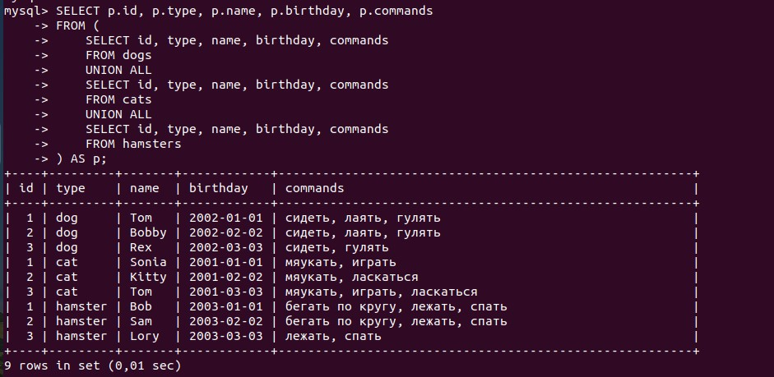

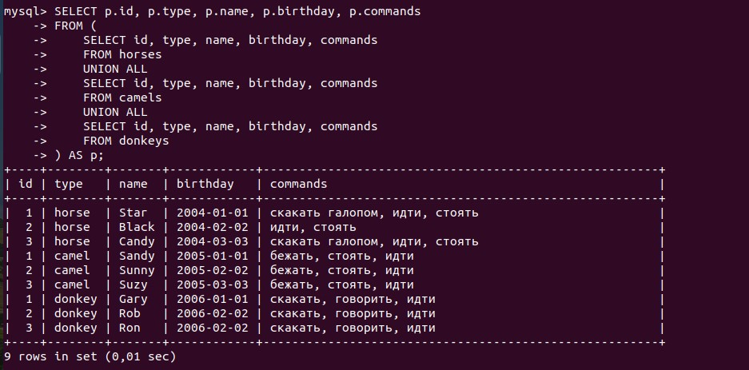

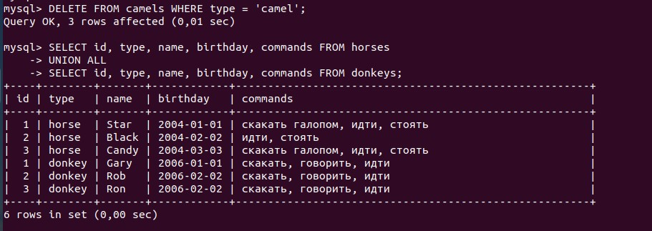

mysql> CREATE TABLE animals_age

-> SELECT id, type, name, birthday, commands,

-> TIMESTAMPDIFF( YEAR, birthday, now() ) as year,

-> TIMESTAMPDIFF( MONTH, birthday, now() ) % 12 as month

-> FROM (

-> SELECT id, 'dog' AS type, name, birthday, commands

-> FROM dogs

-> UNION ALL

-> SELECT id, 'cat' AS type, name, birthday, commands

-> FROM cats

-> UNION ALL

-> SELECT id, 'hamster' AS type, name, birthday, commands

-> FROM hamsters

-> UNION ALL

-> SELECT id, 'horse' AS type, name, birthday, commands

-> FROM horses

-> UNION ALL

-> SELECT id, 'camel' AS type, name, birthday, commands

-> FROM camels

-> UNION ALL

-> SELECT id, 'donkey' AS type, name, birthday, commands

-> FROM donkeys

-> ) AS p;

Query OK, 15 rows affected (0,04 sec)

Records: 15 Duplicates: 0 Warnings: 0

