**maximiliano_bianchi_teladoc_challenge**

**BDD automation framework:** Selenium IDE

**Browser:** Chrome webdriver

**Url tested:** <http://www.way2automation.com/angularjs-protractor/webtables/>

**Steps to follow:** First of all I open Selenium IDE to créate the Project for the test scenarios.

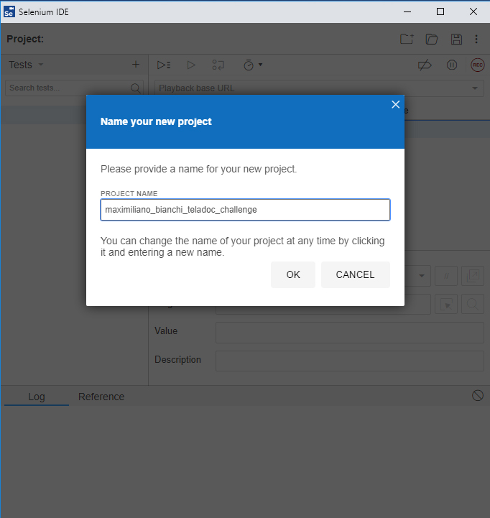

Test Scenario 1:

STEP 1 – Create the test scenario named “User Created”.

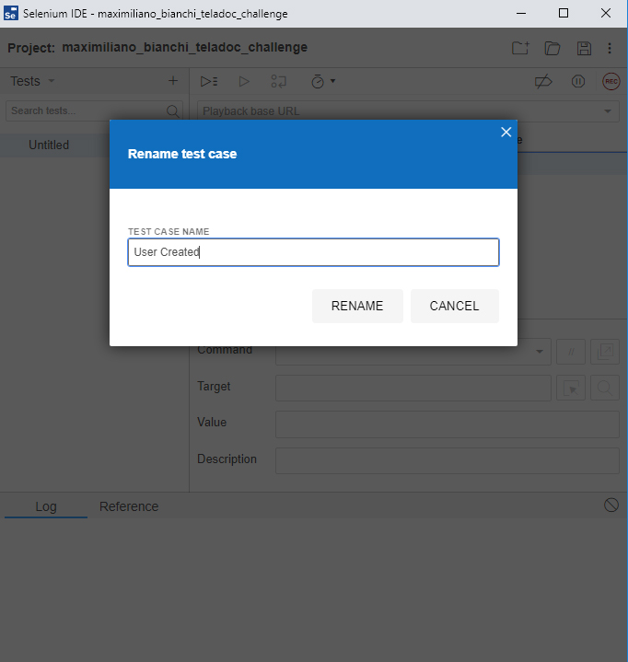

STEP 2 – Click on record in Selenium IDE and specified the url to record the test scenario.

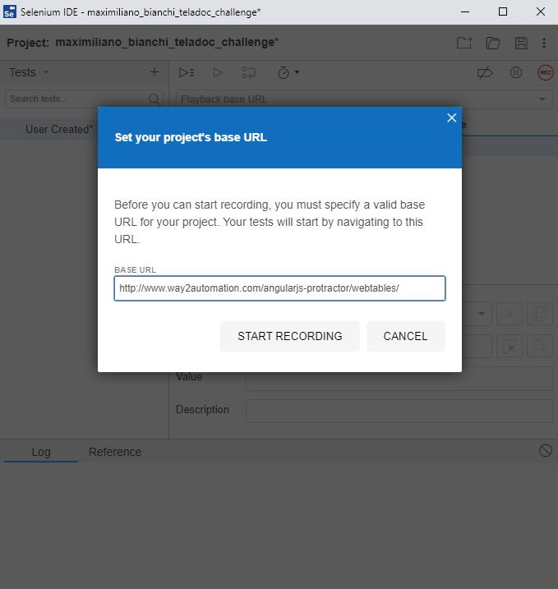

STEP 3 – While Selenium IDE is already recording run the test scenario.

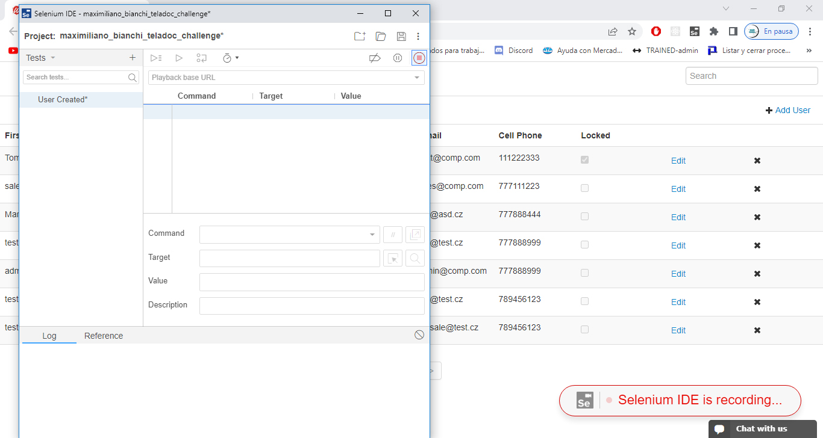

Selenium will now automatically complete the steps of the test scenario.

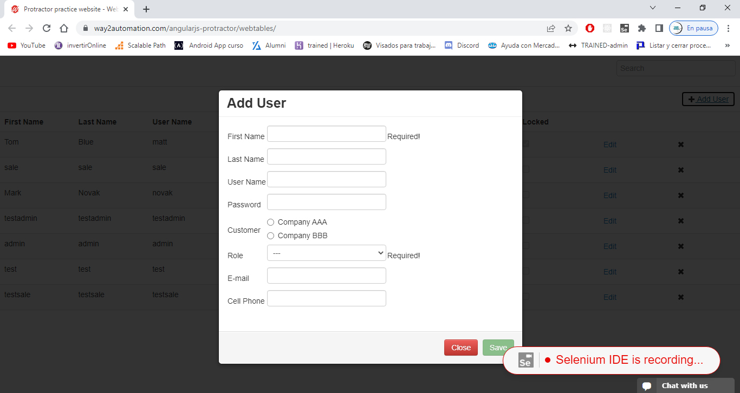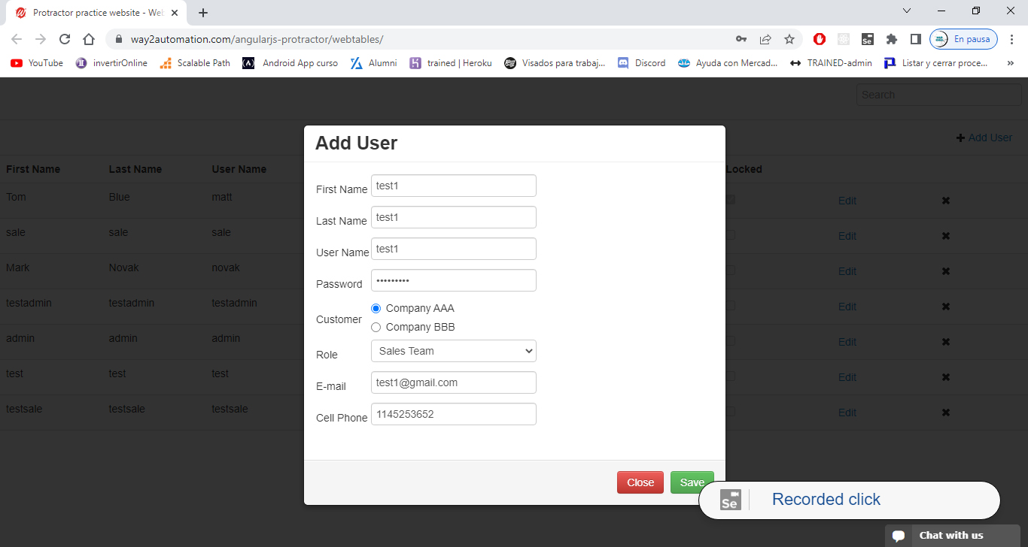

STEP 4 - After that, we check the user is created visualizing the data is entered on the table.

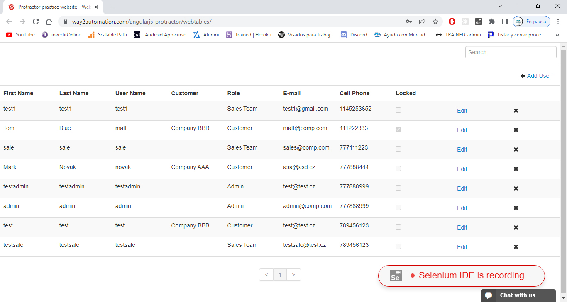

STEP 5 – Last but not least we run the test scenario in Selenium so we can validate the user is already created successfully.

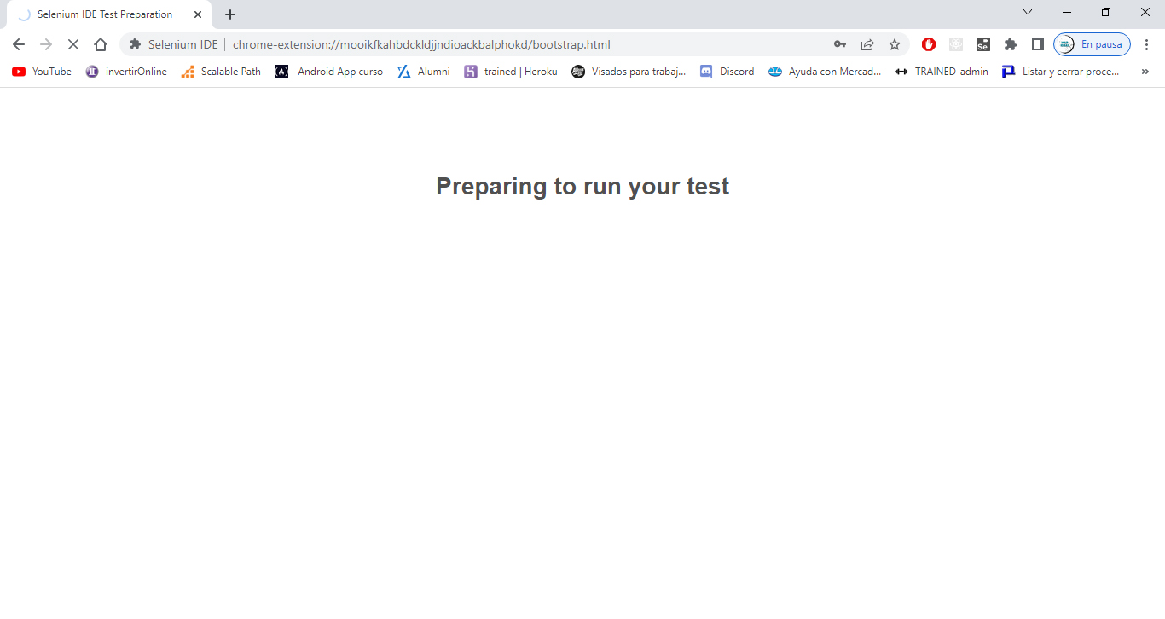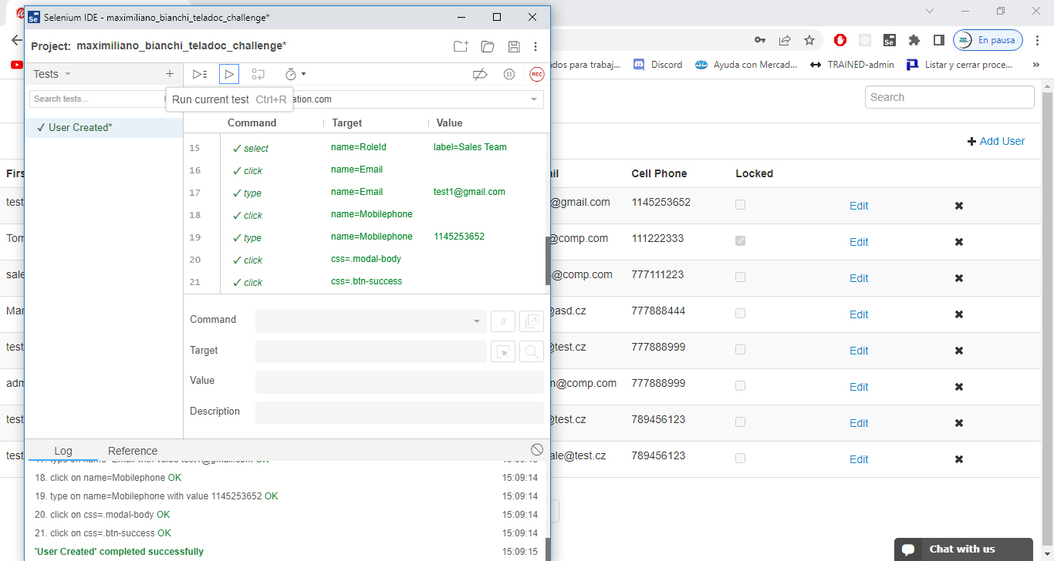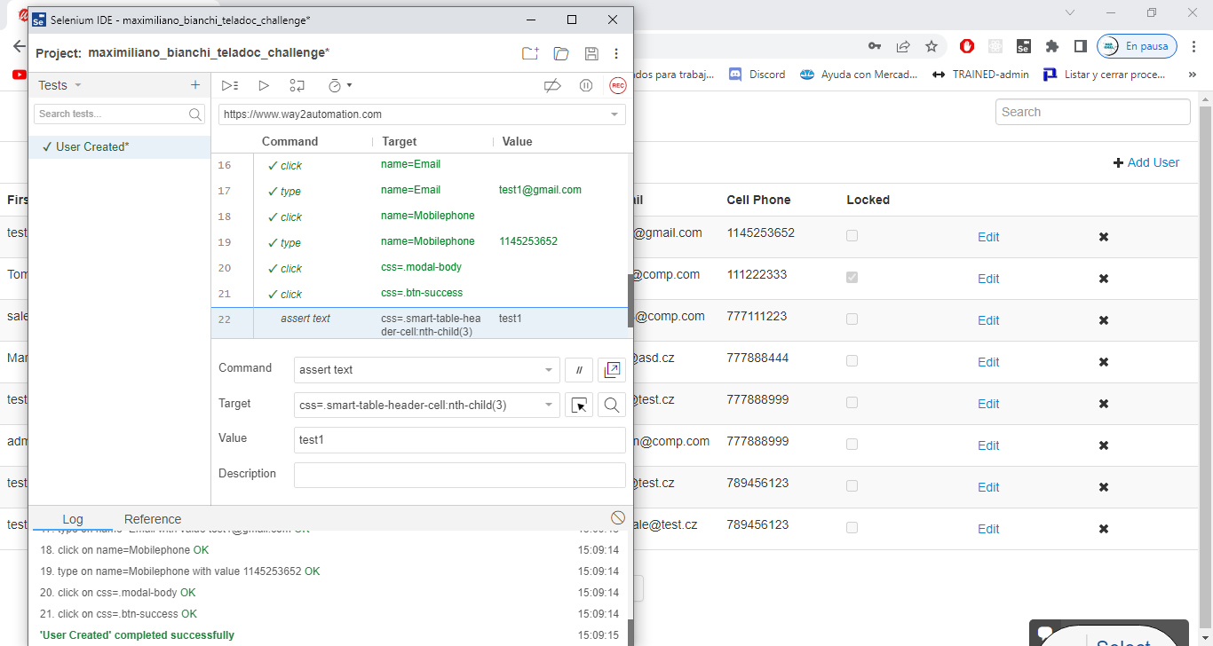

Test Scenario 2:

STEP 1 – Create the test scenario named “User Deleted” and also start recording in the specified url.

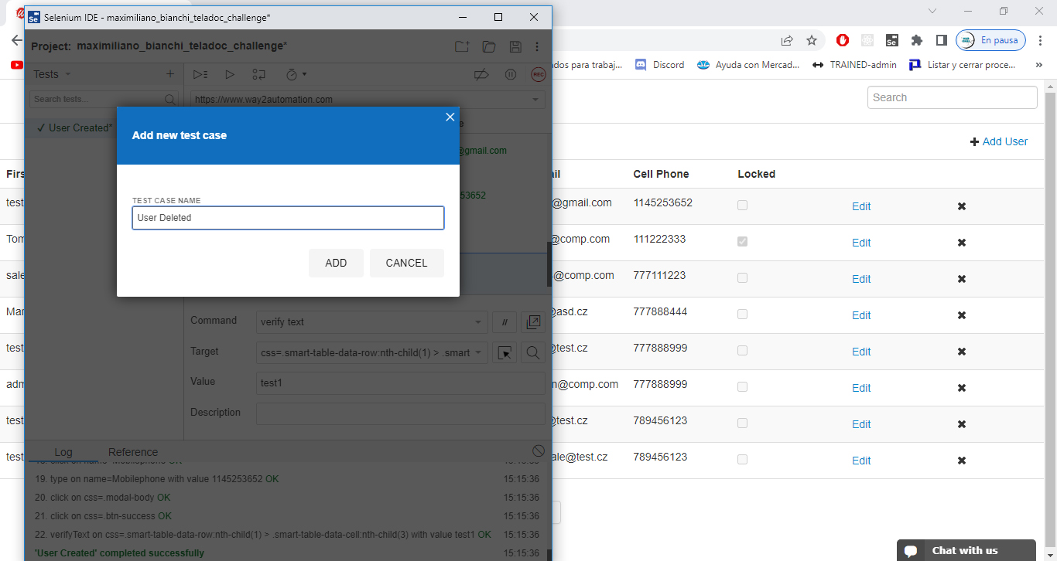

STEP 2 – We proceed to delete the user and check that is already not visualizing on the table.

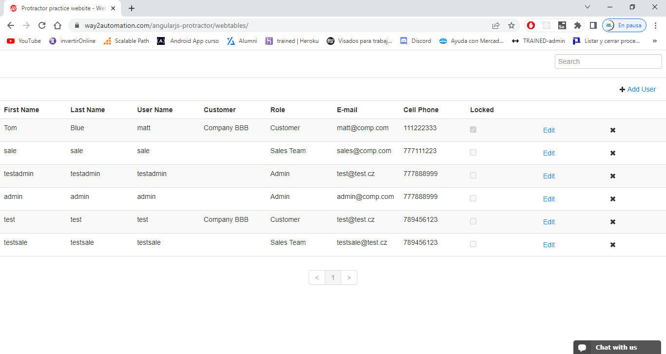

STEP 3 – Finally we run the test scenario and Selenium automatically complete the process and also we validate that the user is already deleted.

