KEMET TECHNOLOGIES
Website Copywriting — Full Content Guide
Pages: Home | About | Services | Portfolio | Contact | Blog
Prepared for Kemet Technologies | March 2026

HOME PAGE
Website Section: Home

HERO SECTION

Headline
Building Digital Solutions That Drive Real Business Growth

Subheadline
From startups finding their footing to enterprises scaling at speed, Kemet Technologies designs and engineers the websites, mobile apps, and intelligent software systems that move your business forward.

Primary CTA
Start Your Project

Secondary CTA
View Our Work
[Design note: Hero — bold split layout, deep navy background (#1A3C6E), gold accent line, device mockup or animation on the right side.]

TRUST INDICATORS BAR
5+ Years of Industry Experience | 120+ Projects Delivered | 100+ Satisfied Clients | Nationwide Remote Service

INTRODUCTION / VALUE PROPOSITION

Headline
Your Technology Partner - Built for Results
At Kemet Technologies, we don't just build digital products, we architect strategic solutions. Based in the Fresno/Clovis area and serving clients nationwide, we bring enterprise-grade thinking to businesses of every size.
Whether you need a high-converting website, a custom mobile app, a powerful CRM, or AI capabilities embedded into your existing workflows, our team has the depth and discipline to deliver it right.

SERVICES OVERVIEW SECTION

Section Heading
What We Do Best

Section Subheading
Comprehensive digital services, from strategy to deployment.

01. Web Design & Development
Visually compelling, performance-optimized websites that represent your brand and convert your visitors into clients.

02. Mobile App Development
Native and cross-platform mobile applications built for iOS and Android, designed for seamless user experiences and built to scale.

03. SEO, GEO & AEO
Be found everywhere your clients are searching, on search engines, AI-powered assistants, and voice platforms, through our integrated search optimization strategies.

04. Custom Software Development
Bespoke CRM systems, ERP platforms, analytics dashboards, and business automation tools tailored precisely to how your organization operates.

05. AI Integrations
Embed intelligent automation, AI-driven workflows, and smart decision-making tools directly into your business operations.
[Design note: Display services as icon cards in a 3-column grid. Each card links to its dedicated Services subpage.]

WHY CHOOSE US SECTION

Headline
A Partnership Built on Accountability, Expertise & Execution
We understand that choosing a technology partner is a significant decision. Our clients from emerging startups to established enterprises, trust Kemet Technologies because we earn that trust on every project.

Experienced, Cross-Functional Team
Our team spans UI/UX design, full-stack development, mobile engineering, and AI implementation, all under one roof.

Transparent Communication
You'll always know where your project stands. We believe clear communication is as important as clean code. Assigned project manager to handle all your project spects through every stage of the project timeline.

Scalable, Future-Ready Solutions
We build with growth in mind. Every solution is architected to evolve alongside your business.

Nationwide Reach, Personalized Attention
Remote-first and coast-to-coast capable, while never losing the personal, responsive service of a dedicated local firm.

FEATURED WORK SECTION

Headline
Selected Projects
A snapshot of the digital experiences we've built for our clients. (I’ll provide Max with the featured 3 projects to be displayed on the home page)

Featured Project 1: https://gksus.com/
Featured Project 2: https://gnmusa.com/
Featured Project 3: https://urbandesignengineering.com/
[Design note: 3 featured portfolio cards with project name, category tag, thumbnail. CTA: 'View All Projects']

CLIENT TESTIMONIALS SECTION

Headline
What Our Clients Say (We can pull out some of the best project reviews from our google business).
https://share.google/pL389GkAjXdudDJxN
[Design note: Rotating testimonial slider, 2-3 quotes with client name, company, optional photo/logo. Placeholder — to be populated with real client testimonials.]

BOTTOM CTA SECTION

Headline
Ready to Build Something Exceptional?
Let's talk about your project. Schedule a free discovery call with our team and get a clear roadmap for your next digital initiative.

CTA Button
Book a Free Consultation

ABOUT PAGE
Website Section: About Us

PAGE HERO

Headline
More Than a Tech Firm. We are a Strategic Growth Partner

Subheadline
We combine technical depth with business intelligence to help organizations build, launch, and scale their digital products with confidence.

OUR STORY

Who We Are
Kemet Technologies was founded with a clear purpose: to fill a critical gap in the market for a technology partner that is both genuinely capable and genuinely accountable.
Headquartered in Clovis, California, and serving clients across the United States, we have spent more than seven years designing, engineering, and delivering digital solutions for businesses across diverse industries, from e-commerce and logistics to healthcare, real estate, and professional services.
Our name draws inspiration from Kemet, the ancient Egyptian word for the fertile, life-giving land. It reflects our commitment to helping businesses grow and thrive through the power of thoughtful technology.
Today, our team of designers, developers, and strategists operates as a fully remote-capable firm, giving our clients direct access to senior talent without geographic limitations.

MISSION & VISION

Our Mission
To empower businesses of all sizes with innovative, reliable, and results-driven digital solutions, delivered with integrity, precision, and a deep commitment to client success.

Our Vision
To be the most trusted technology partner for growth-focused businesses nationwide, recognized not just for the quality of what we build, but for the outcomes we help our clients achieve.

CORE VALUES

The Principles We Work By

Integrity First
We are transparent about what is possible, honest about timelines, and accountable for our results. Always.

Client-Centered Execution
Every decision we make, from architecture to design; is guided by a single question: does this serve our client's business goals?

Technical Excellence
We hold ourselves to high standards in every line of code, every design system, and every system we architect.

Continuous Innovation
The technology landscape evolves rapidly. We invest continuously in staying ahead, so our clients don't have to.

Long-Term Partnerships
We measure success not by project completion, but by the sustained growth of the businesses we serve.

TEAM SECTION

The People Behind the Work
A cross-functional team of professionals united by a shared commitment to craft and client success.
[Design note: 3-column grid of team cards. Team: George Wahba (Founder & CEO), Antonios Milad (Software Development Manager & Technical Team Leader), Abanoub Mounir (UI/UX Designer), Bishoy Sabri (Data Architect Engineer), Kristen Samir (Full Stack Developer), Mary Mikhail (Frontend & Cross-Platform Developer), Andrew Amir (Software Engineer), Maximous Atef (Web & Mobile app. Developer]

BY THE NUMBERS

Our Track Record Speaks for Itself
5+ Years in Business | 120+ Projects Delivered | 90+ Happy Clients | 5 Core Service Lines | Serving Clients Nationwide & Internationally.

BOTTOM CTA

Let's Build Something Together
We're selective about the projects we take on because we commit fully to every client we work with. If you're ready to partner with a team that treats your business like their own, we'd love to hear from you.

CTA Button
Get in Touch

SERVICES PAGE
Website Section: Our Services

PAGE HEADER

Headline
Full-Spectrum Digital Services for Modern Businesses

Subheadline
Whether you're launching a new venture or scaling an established enterprise, Kemet Technologies delivers the technical expertise and strategic thinking your digital presence demands.

SERVICE 1: WEB DESIGN & DEVELOPMENT

Web Design & Development

Tagline
Websites That Work - Beautifully and Strategically
Your website is often the first interaction a potential client has with your brand. We design and develop websites that make that first impression count, combining strategic UX thinking with polished visual design and robust engineering.
From marketing websites and landing pages to full-scale e-commerce platforms and content management systems, we deliver web experiences that are fast, accessible, and built to convert.

What's Included
- Custom UI/UX design and wireframing
- Responsive, mobile-first development
- CMS integration (WordPress, Webflow, headless CMS)
- E-commerce development (Shopify, WooCommerce, custom)
- Performance optimization and Core Web Vitals compliance
- Ongoing maintenance and support

CTA
Request a Web Design Quote

SERVICE 2: MOBILE APP DEVELOPMENT

Mobile App Development

Tagline
Apps That Users Love. Platforms That Businesses Trust.
Mobile is no longer optional, it is essential. Our mobile development team builds intuitive, high-performance applications for iOS and Android that reflect your brand, serve your users, and support your operational goals.
We develop native and cross-platform apps using the latest technologies, ensuring your product is built for today's standards and tomorrow's growth.

What's Included
- iOS and Android native development
- Cross-platform development (React Native, Flutter)
- UI/UX design for mobile interfaces
- API integration and backend connectivity
- App Store and Google Play submission support
- Post-launch updates and performance monitoring

CTA
Start Your App Project

SERVICE 3: SEO, GEO & AEO

SEO, GEO & AEO

Tagline
Be Found — On Search Engines, AI Platforms, and Everywhere Else That Matters
The way people discover businesses is changing fast. Traditional search engine optimization is no longer enough. Kemet Technologies offers an integrated visibility strategy that covers all three dimensions of modern search:

Search Engine Optimization (SEO)
Technical, on-page, and off-page optimization that strengthens your organic rankings across Google, Bing, and beyond.

Generative Engine Optimization (GEO)
Positioning your brand to appear prominently in AI-generated search responses — including Google's AI Overviews, Perplexity, and other large language model-powered platforms.

Answer Engine Optimization (AEO)
Structuring your content so it is surfaced as authoritative answers by voice assistants, featured snippets, and AI-powered knowledge panels.

What's Included
- Technical SEO audit and remediation
- Keyword strategy and content planning
- On-page optimization and schema markup
- Local SEO and Google Business Profile management
- GEO content structuring for AI visibility
- Monthly reporting and performance analysis

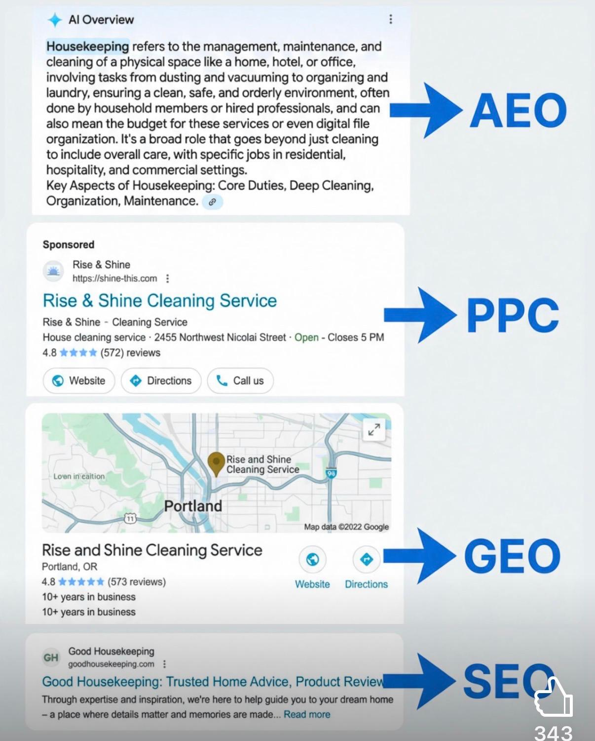

CTA
Get a Free SEO Audit

SERVICE 4: CUSTOM SOFTWARE DEVELOPMENT

Custom Software Development

Tagline
Software Built Around Your Business — Not the Other Way Around
Off-the-shelf software rarely fits the way your business actually works. Our custom software development practice designs, builds, and deploys purpose-built solutions — from CRM and ERP systems to analytics dashboards and internal business tools — that align precisely with your processes and objectives.
We work closely with stakeholders at every stage: discovery, architecture, development, testing, and deployment — ensuring the final product delivers measurable value from day one.

What We Build
- Customer Relationship Management (CRM) systems
- Enterprise Resource Planning (ERP) platforms
- Analytics and business intelligence dashboards
- Workflow automation and process management tools
- Client portals and internal operations platforms
- SaaS product development

CTA
Discuss Your Custom Software Needs

SERVICE 5: AI INTEGRATIONS

AI Integrations

Tagline
Harness the Power of Artificial Intelligence — Without the Complexity
Artificial intelligence is no longer a competitive advantage reserved for large enterprises. Kemet Technologies makes intelligent automation and AI-powered capabilities accessible to businesses of all sizes — integrating them directly into your existing systems, websites, and workflows.
We identify where AI creates the most meaningful impact for your specific business, then implement and integrate the right tools — reducing manual effort, enhancing decision-making, and creating new value for your customers.

Our AI Integration Services Include
- AI chatbots and intelligent virtual assistants
- AI-powered content generation and personalization engines
- Predictive analytics and automated reporting
- Large Language Model (LLM) integration via API (OpenAI, Anthropic, Gemini)
- Automated document processing and data extraction
- AI-enhanced CRM and customer intelligence features

CTA
Explore AI Solutions for Your Business

SERVICES PAGE BOTTOM CTA

Not Sure Where to Start?
Schedule a free discovery session with our team. We'll assess your current digital infrastructure, understand your business goals, and recommend the right combination of services to get you where you want to go.

CTA Button
Book a Free Consultation

PORTFOLIO PAGE
Website Section: Our Work

PAGE HEADER

Headline
Work We're Proud to Stand Behind

Subheadline
Explore a selection of projects we've delivered for clients across industries — from e-commerce and professional services to logistics, hospitality, and beyond.
[Design note: Filter bar at top — All | Web Design | Mobile App | Custom Software | E-Commerce | Marketing Sites]

PORTFOLIO INTRO
Every project in our portfolio represents a real business challenge — and a solution built with intention. We partner closely with each client to understand not just what they want built, but why it matters to their business.
Below is a curated selection of our completed work. For a full list of projects or case studies specific to your industry, contact us directly.

CATEGORY: E-COMMERCE & ONLINE STORES

E-Commerce & Online Stores
[Each project card: Project Name, Location, 1-2 sentence description, Category Tag, 'View Project' CTA]

Queen Mini Market
Category: E-Commerce | Location: Belleville, NJ
A fully functional online grocery and deli store for a neighborhood market in New Jersey — built for ease of browsing, seamless ordering, and local delivery management.

SF-Shoply
Category: E-Commerce | Location: National
An e-commerce platform for the delivery and shipment of specialty halal food products, featuring a comprehensive product catalog, shipping integrations, and a streamlined checkout experience.

Brothers Dream Distro Inc.
Category: E-Commerce | Location: United States
A digital storefront for a family-owned distribution business, featuring product management, wholesale ordering flows, and brand-aligned design.

Golden Eagle Jewelry Tools
Category: E-Commerce | Industry: Specialty Retail
An e-commerce site for an exclusive distributor of professional jewelry-making alloys and plating solutions — designed for both retail and trade buyers.

CATEGORY: MARKETING WEBSITES & CORPORATE PLATFORMS

Marketing Websites & Corporate Platforms

Hero Expressway Inc.
Category: Marketing Website | Industry: Logistics & Trucking | Location: Wilmington, CA
A professional marketing website for a drayage trucking company — conveying operational capability, service coverage, and credibility to freight and port clients.

St. George Private Security
Category: Marketing Website | Industry: Security Services
A corporate website for a private security firm, designed to communicate professionalism, trust, and service range to commercial and residential clients.

Matteo Landscaping & Construction
Category: Marketing Website | Industry: Construction & Landscaping
A visual, project-focused website for a landscaping and construction company — showcasing completed work and driving local service inquiries.

Elegant Transportation Group
Category: Marketing Website | Industry: Medical Transportation
A clean, accessible website for a non-emergency medical transportation company, highlighting service reliability and booking processes for patients and care coordinators.

Urban Design Engineering
Category: Corporate Website | Industry: Architecture & Engineering
A professional digital presence for an architectural and engineering firm, designed to reflect technical precision and attract project clients.

Pacific Dental Clinic Fresno
https://pacificdentalclinics.com/

C4 Fresno
https://www.c4fresno.org/

True Care Clinic Florida
https://truecareclinic.net/
Crystal Housekeeping
https://www.crystalhousekeeping.net/
Stavros Catering
https://stavroscatering.com/
Luxury Limo OC
https://www.luxurylimooc.com/
Zuni’s Plumbing Lamoore
https://www.zunisplumbing.com/
I.E. Finish Carpentry
https://www.zunisplumbing.com/
Archangel Michael & Gabriel Coptic Orthodox Church Fresno
https://www.aamgcoc.org/
PORTFOLIO BOTTOM CTA

Have a Project in Mind?
Our portfolio is a starting point — but our best work is always the next project we take on. Let's discuss what we can build for you.

CTA Button
Start a Conversation

CONTACT PAGE
Website Section: Contact Us

PAGE HEADER

Headline
Let's Start with a Conversation

Subheadline
Whether you have a fully scoped project or just an idea you're exploring — we're here to help you think it through. Reach out and a member of our team will be in touch within one business day.

CONTACT FORM

Form Heading
Send Us a Message

Form Fields
- Full Name (required)
- Company Name (optional)
- Email Address (required)
- Phone Number (optional)
- Service of Interest (dropdown: Web Design & Development / Mobile App Development / SEO, GEO & AEO / Custom Software Development / AI Integrations / Not Sure — Let's Talk)
- Project Budget Range (dropdown: Under $5,000 / $5,000-$15,000 / $15,000-$50,000 / $50,000+ / Prefer to Discuss)
- Tell Us About Your Project (text area required)
- How Did You Hear About Us? (optional dropdown)

Submit Button
Send My Message
[Post-submission message: 'Thank you for reaching out. A member of our team will contact you within one business day.']

DIRECT CONTACT INFORMATION

Prefer to Reach Us Directly?

Phone
+1 (559) 712-8024

Email
editors@kemetmediagroup.com

Address
777 Minnewawa Ave, Clovis, CA 93612, USA

Business Hours
Monday - Friday: 9:00 AM - 6:00 PM (Pacific Time)
We respond to all inquiries within one business day.

SCHEDULING CTA

Prefer to Schedule a Call?
Use the link below to book a free 30-minute discovery call directly on our calendar. No pressure — just a conversation about where you want to take your business.

CTA Button
Book a Discovery Call
[Integrate Calendly or similar scheduling tool here]

MAP SECTION
[Embed Google Map centered on 777 Minnewawa Ave, Clovis, CA 93612. Include note: We serve clients nationwide remotely.]

BLOG PAGE
Website Section: Blog & Insights

PAGE HEADER

Headline
Insights, Perspectives & Industry Intelligence

Subheadline
Practical thinking on web development, mobile technology, AI, SEO, and the digital strategies shaping how modern businesses grow.

BLOG INTRODUCTION
The Kemet Technologies blog is where our team shares what we're seeing in the field — emerging technology trends, strategic frameworks, and actionable guidance for business owners and digital leaders navigating a rapidly evolving landscape.
We write for decision-makers, not just developers. If you're trying to understand your options, evaluate a technology investment, or stay ahead of digital trends without getting lost in technical jargon — you're in the right place.

RECOMMENDED BLOG TOPICS (CONTENT STARTER CALENDAR)
[These are recommended initial blog posts to establish topical authority and drive organic search traffic across all five service lines.]

Web Design & Development
- Why Your Business Website Is Losing You Clients (And How to Fix It)
- 5 Website Performance Metrics Every Business Owner Should Track
- Custom Website vs. Template: Which Is Right for Your Business?
- What Are Core Web Vitals and Why Do They Affect Your Revenue?

Mobile App Development
- Native vs. Cross-Platform Mobile Apps: A Decision Guide for Non-Technical Founders
- How to Validate Your Mobile App Idea Before You Spend a Dollar on Development
- 5 Signs Your Business Is Ready for a Mobile App
- What Does It Actually Cost to Build a Mobile App?

SEO, GEO & AEO
- Beyond Google: Why AI Visibility Is the New SEO Frontier
- What Is Generative Engine Optimization (GEO) — and Why Your Business Can't Afford to Ignore It
- How Voice Search and AI Assistants Are Changing the Way Customers Find Businesses
- The Complete Guide to Local SEO for Small and Mid-Sized Businesses

Custom Software Development
- When Off-the-Shelf Software Stops Working: Signs You Need a Custom Solution
- CRM vs. Off-the-Shelf Tools: What Growing Businesses Need to Know
- How a Custom Analytics Dashboard Can Transform Business Decision-Making
- What to Expect From a Custom Software Project — From Discovery to Launch

AI Integrations
- 5 Ways Small Businesses Can Use AI Without Hiring a Data Scientist
- How AI Chatbots Are Transforming Customer Service for SMBs
- The Non-Technical Business Owner's Guide to AI Integration
- Automating Business Workflows with AI: Where to Start and What to Avoid

BLOG LISTING PAGE DESIGN NOTES
[Each blog post card: Featured Image, Category Tag, Post Title, 1-2 sentence excerpt, Author name, Date Published, 'Read More' CTA]
[Sidebar: Category Filter, Search Bar, Recent Posts, Newsletter Signup CTA]

NEWSLETTER SIGNUP CTA

Stay Ahead of the Curve
Subscribe to the Kemet Technologies newsletter for monthly insights on digital strategy, technology trends, and practical advice to help your business grow.

Form Fields
- First Name
- Email Address
- Subscribe Button: 'Get Monthly Insights'
[Privacy note: 'We respect your privacy. No spam, ever. Unsubscribe at any time.']

