### Website Interaction

Go to the Florida Cyber Hub proving grounds and complete the challenge "**PHP Server**" found under the "**Hard Challenges**" [500]

**flag{you_should_have_solved_this_in_ruby}**

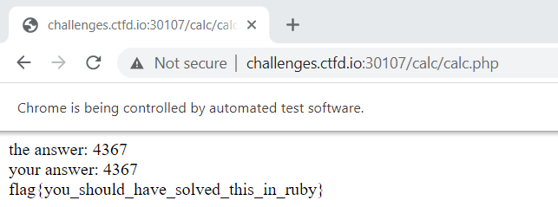

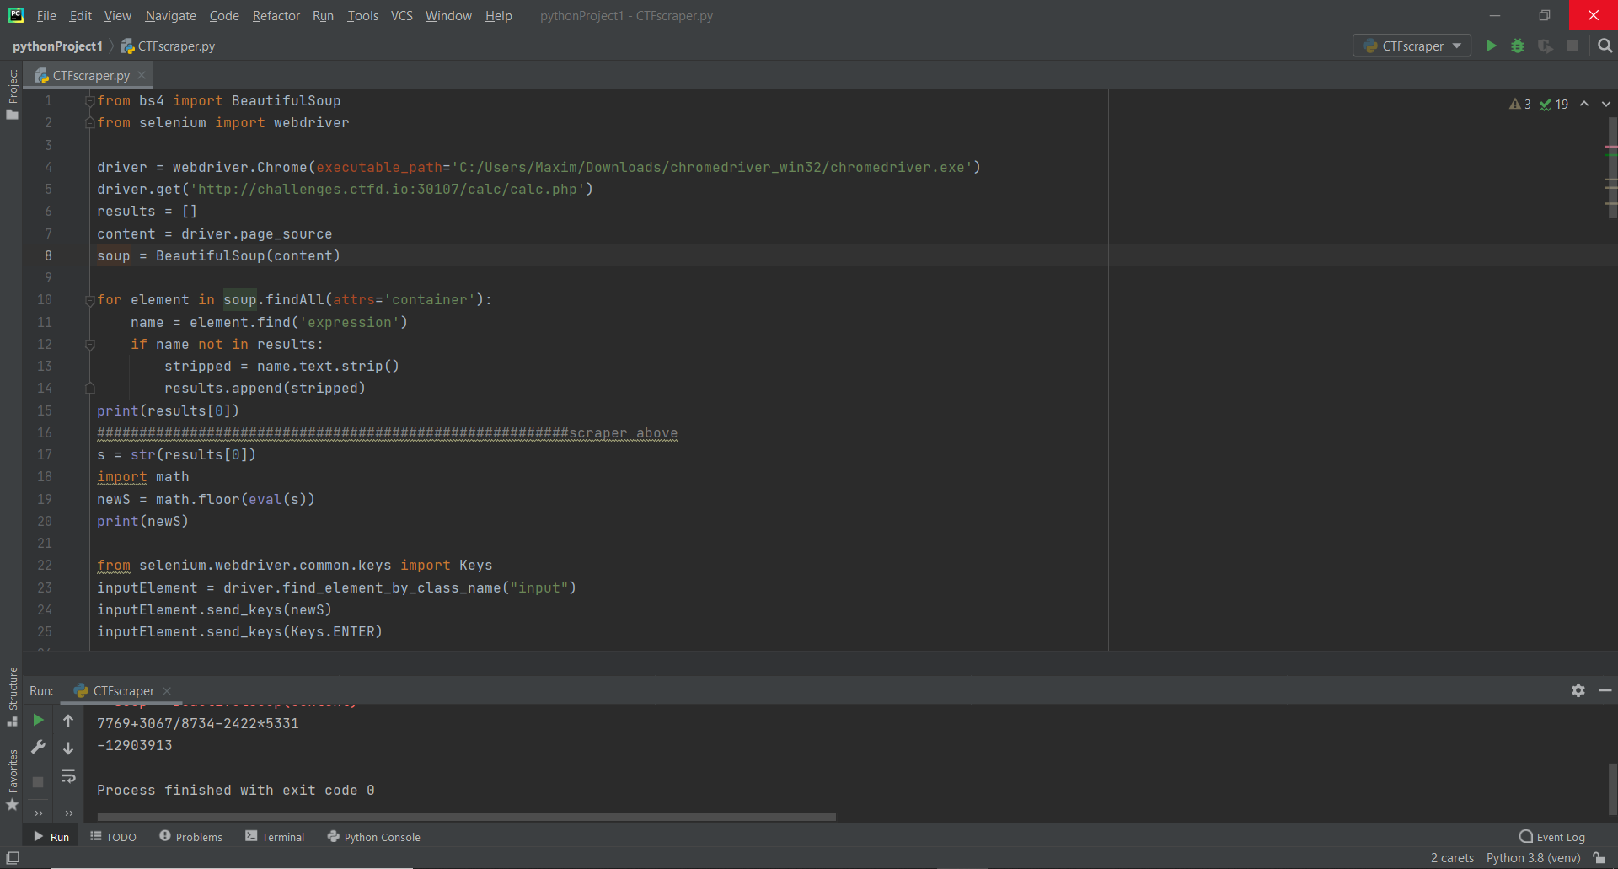

Explanation of code:

Through the use of modules BeautifulSoup, selenium, and math we were able to create a concise piece of code to obtain this flag. We first set up a chrome web driver and used it along with BeautifulSoup to parse the webpage for the necessary numbers and operators. We then parsed these values into a list by selecting the appropriate html attribute and element, and then casted the result into a string. Using the math module, we used eval(string) to parse the string for the equation and solve it. This answer was then rounded down using the math.floor() function. Finally, we had the script enter and submit the value using selenium web driver common keys to input the value then simulate hitting the enter key.