RTM View Shell
B-02 | Dashboard Management
User Guide
Field | Value | Notes
Document ID | B-02 | Dashboard Management User Guide
Version | 1.3 | Added Widget Configuration Reference
Date | 2026-05-29
Prepared by | RTM View Shell
Audience | All users | Editors, Administrators, Viewers
Language | English

1. Revision History
Ver. | Date | Author | Change
1.0 | 2026-05-28 | Documentation team | Initial release
1.1 | 2026-05-29 | Documentation team | Added Section 9: Widget Configuration Reference (all tabs, all parameters for all 6 widgets)
1.3 | 2026-05-30 | Documentation team | Added screenshots for all sections and widget configuration tabs

2. Contents

3. Introduction
This guide explains how to use the RTM View Shell dashboard (screen) management system. Screens are real-time monitoring dashboards that display live contact centre data through configurable widgets. This document covers creating, editing, and managing screens as well as configuring each available widget type.

3.1 Who This Guide Is For
Role | Access Level | Capabilities
Viewer | Read-only | View permitted screens and their live data
Editor | Create / Edit | Create and configure screens within their Permission Group
Administrator | Full tenant | All Editor capabilities plus user and group management
Superadmin | All tenants | Full system access across all tenants

4. Accessing Screens
The main Screens page is accessible from the sidebar navigation. Click Screens in the Content section. The system displays only screens your Permission Group is allowed to view, plus any screen marked as Public.
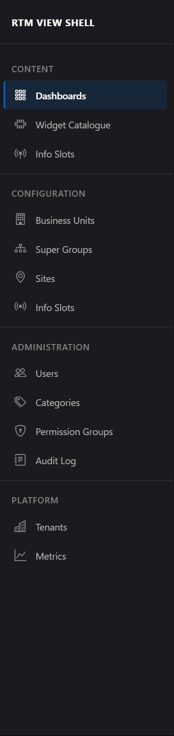

5. Screen List
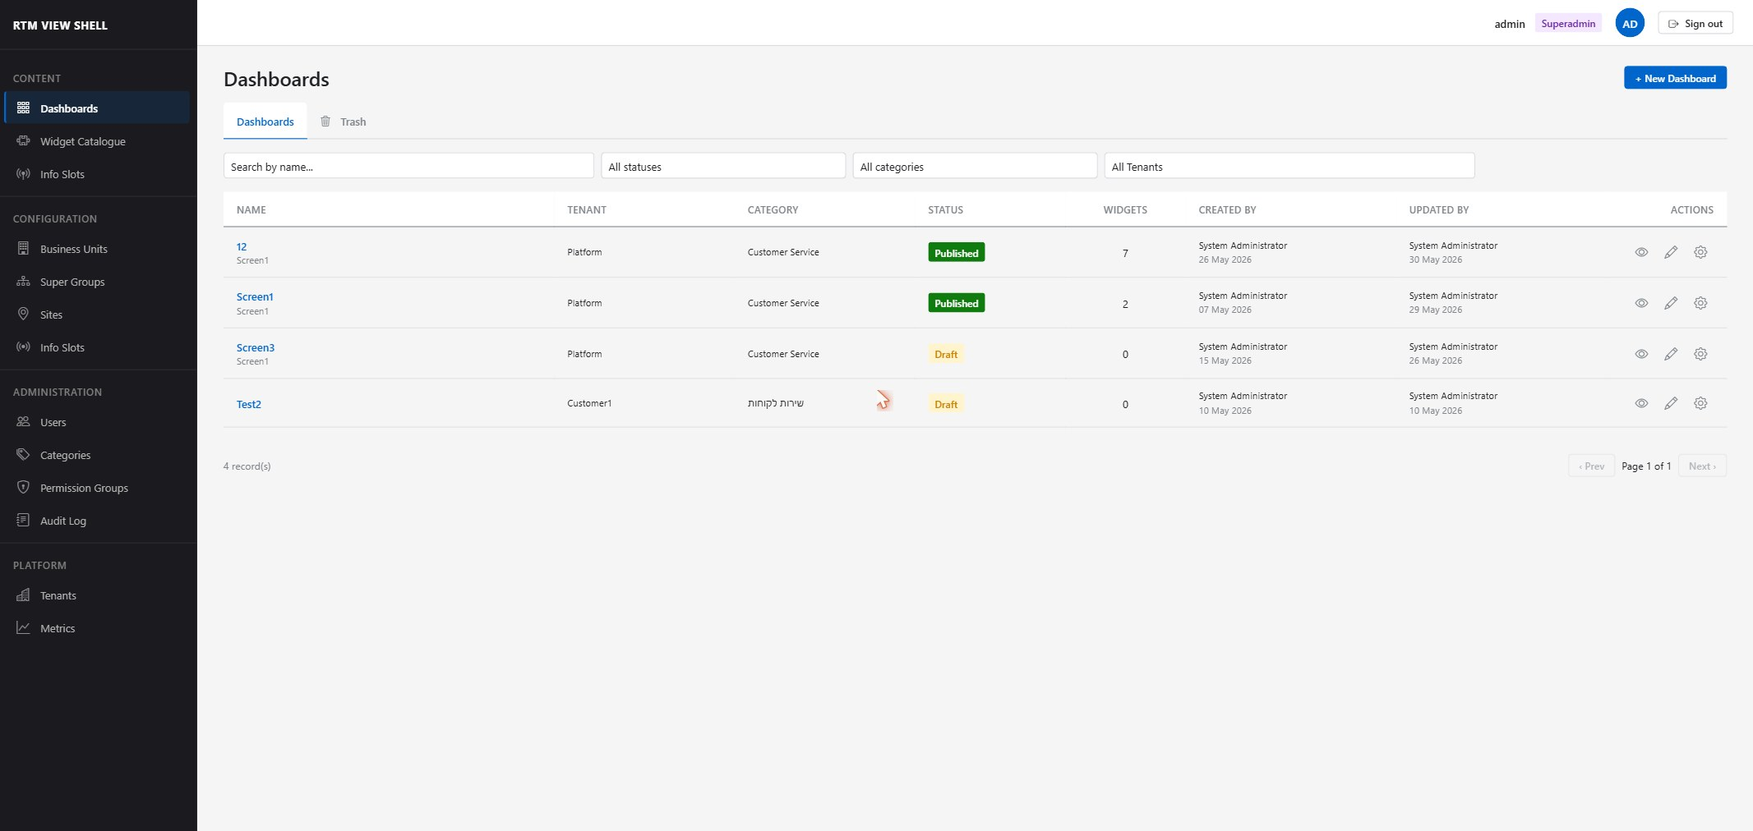

5.1 List Columns
Column | Description
Name / Description | The screen name (bold) and optional description below it
Tenant | The tenant that owns this screen (Superadmin view only)
Category | Organisational category assigned at creation
Status | Draft (orange) or Published (green) badge
Widgets | Number of widgets placed on the screen
Created | Creator name and creation date
Updated | Last-modified-by name and date
Actions | Edit settings (✎ pencil) and Delete (🗑 trash) buttons

5.2 Search and Filters
Control | Behaviour
Search box | Full-text search on Name; press Enter to apply
Status dropdown | Filter to Draft, Published, or All statuses
Category dropdown | Filter by screen category
Tenant dropdown | Superadmin only: filter by tenant
ℹ Pagination is set to 25 rows per page. Use the page controls at the bottom to navigate.

5.3 Trash Tab
When soft-delete is enabled (configured by Administrator), deleted screens appear in the Trash tab instead of being permanently removed. Each entry shows a days-remaining badge (red when ≤ 7 days). Use the ↩ Restore button to undelete a screen.
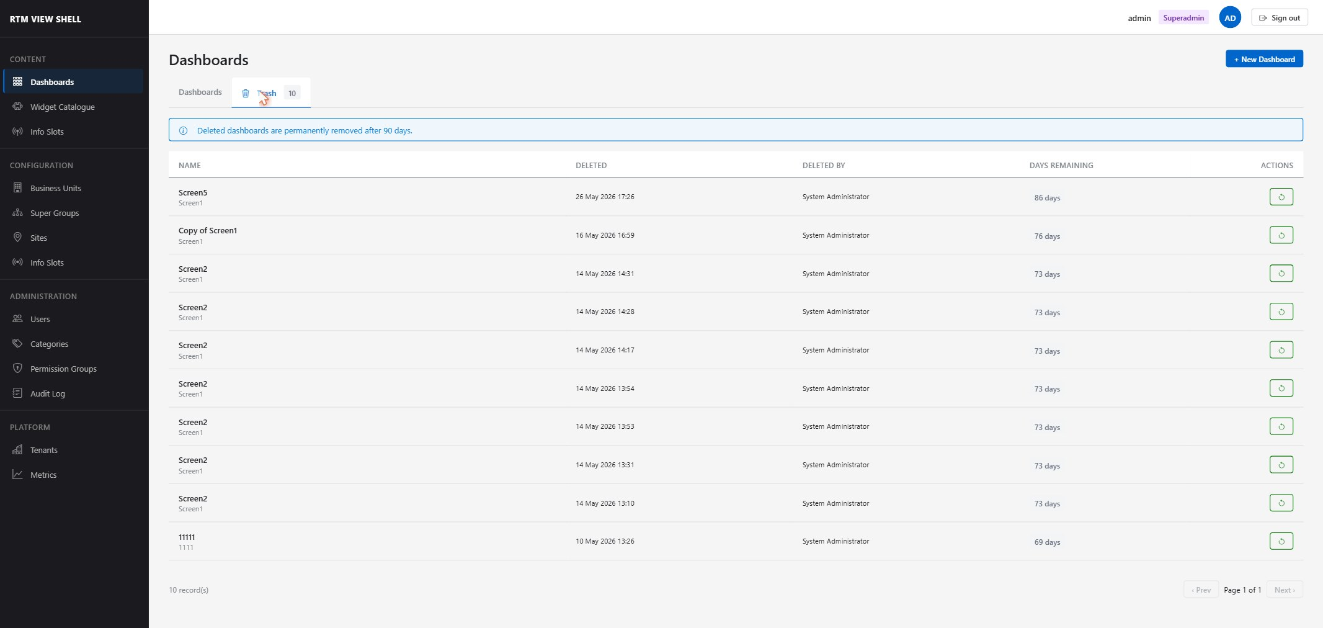

6. Creating a Screen
- Click + New Screen in the top-right corner of the Screen List.
- Complete the New Screen form:

Field | Details
Name | Required. Unique within the tenant. Maximum 200 characters.
Description | Optional. Displayed below the name in the list.
Category | Select a category to organise screens (e.g. Inbound, Outbound, Quality).
Is Public | If enabled, all authenticated tenant users can view this screen regardless of Permission Group. Editors and higher can toggle this.
Tenant | Superadmin only: choose which tenant to create the screen in.
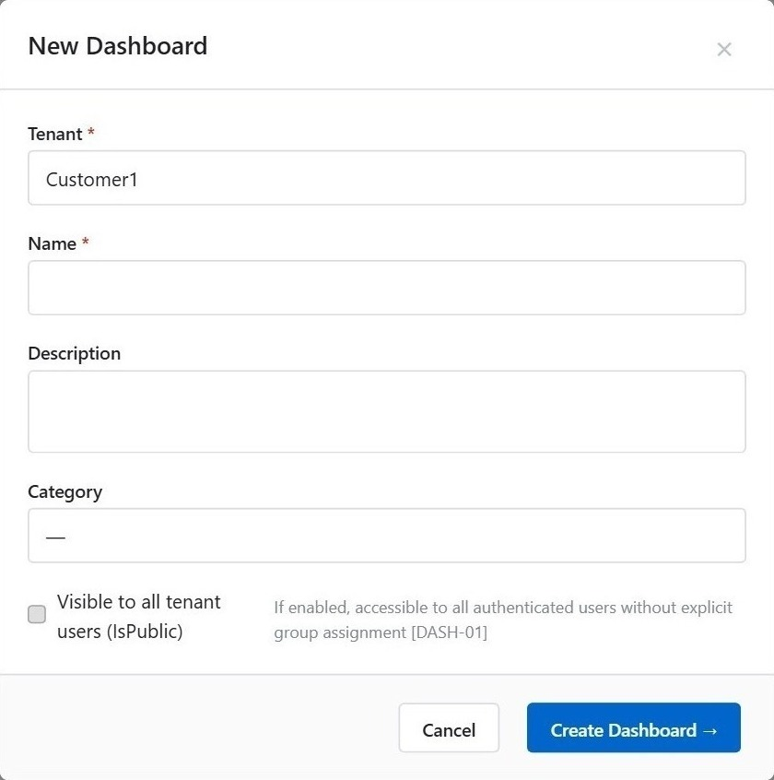
- Click Create Screen. The editor opens immediately.
ℹ After creation, your Permission Group automatically receives Full access (View + Edit + Delete) to the new screen.

7. Screen Settings
Open Screen Settings by clicking the pencil icon on any screen card in the list.
Field | Details
Name | Editable. Renaming takes effect immediately after Save.
Description | Editable.
Category | Editable.
Status | Draft ↔ Published. Draft screens are hidden from Viewers.
Is Public | Toggle to share the screen with all tenant users without explicit group assignment.
Danger Zone | Delete screen — requires inline confirmation. If soft-delete is enabled, the screen moves to Trash; otherwise it is permanently removed.
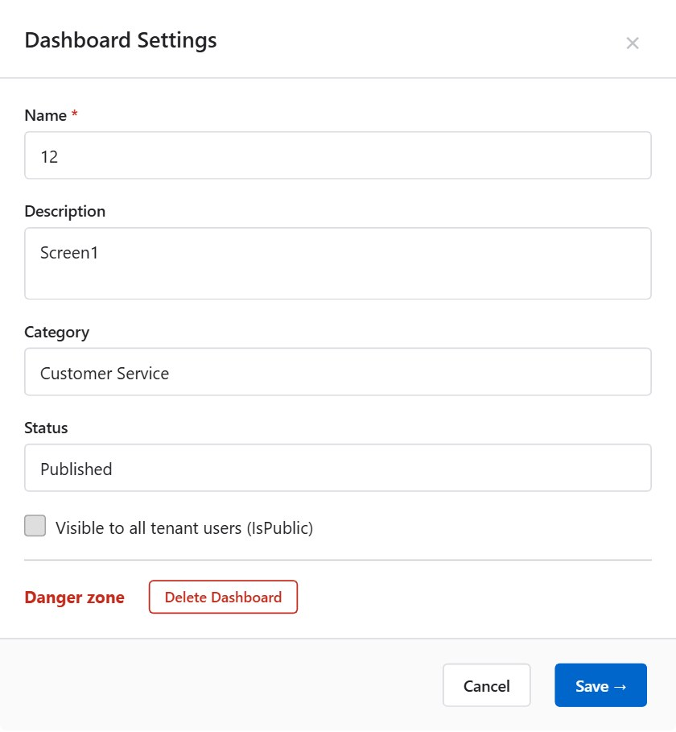

8. Screen Editor
The Screen Editor opens when you click a screen card or immediately after creating a new screen.
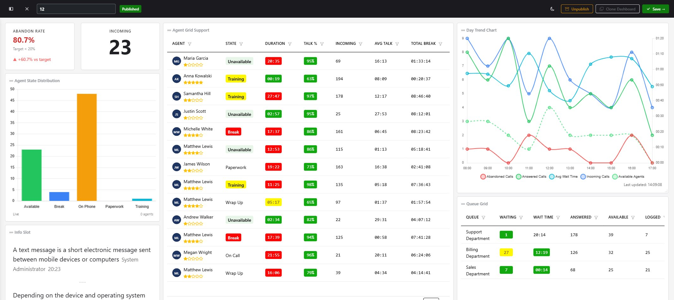

8.1 Header Bar
Element | Description
Screen name | Displayed at top-left; click Edit Settings to rename
Dark mode toggle | Switches the editor canvas between light and dark colour themes
Add Widget button | Opens the widget palette panel on the left
Templates button | Opens the template library to save or load pre-configured widget sets
Save button | Saves all layout and configuration changes. Changes are NOT auto-saved.
Back to list | Returns to the Screen List. Unsaved changes are lost.

8.2 Widget Palette
The palette panel slides in from the left when you click Add Widget. Widgets are grouped by type. Click any widget to add it to the canvas.
Widget | Category
Agent Grid | Agent monitoring — tabular agent status
Queue Grid | Queue monitoring — tabular queue metrics
Data Slot | Single-metric KPI card
Day Trend | Intraday trend chart
Agent State Distribution | Agent state breakdown chart
Info Slot | Scrolling text / ticker panel
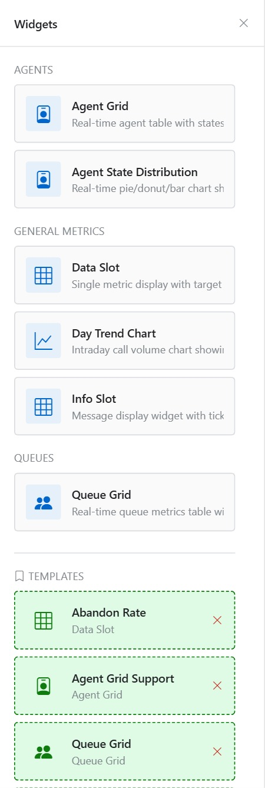

8.3 Canvas
Widgets on the canvas can be moved, resized, and configured:
- Move — drag the widget header to reposition
- Resize — drag the bottom-right corner handle
- Configure — click the ⚙ gear icon on the widget header to open the configuration modal
- Delete — click the ✕ close button on the widget header; confirm in the dialog
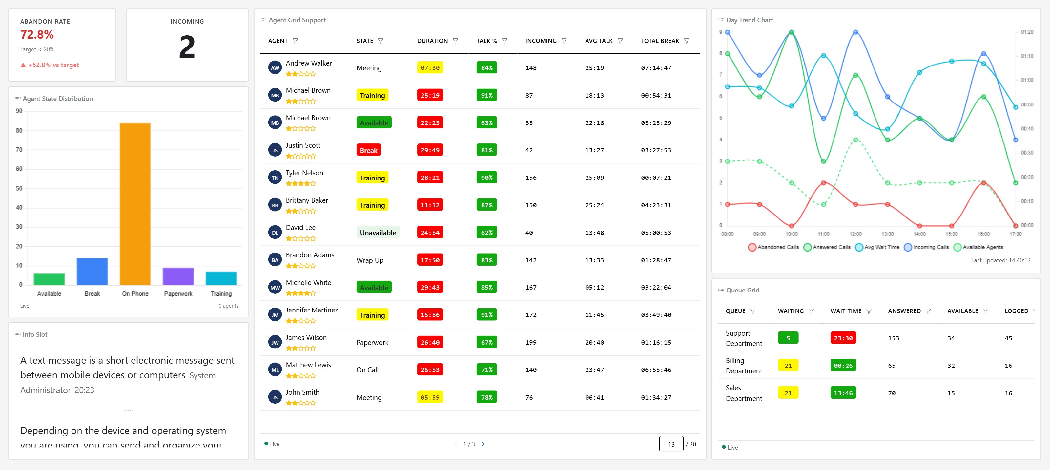

9. Widget Configuration Reference
Every widget has a configuration modal with multiple tabs. Open it by clicking the gear icon (⚙) on the widget. Click Save to apply changes; Cancel to discard. The tabs available depend on the widget type, as summarised below.

Widget | Available Tabs
Agent Grid | General, Appearance, Thresholds, Filters, Columns, Score
Queue Grid | General, Appearance, Thresholds, Rows, Queue Columns
Data Slot | General, Appearance, Thresholds
Day Trend | General, Appearance, Call Metrics, Agent Metrics
Agent State Distribution | General, Appearance
Info Slot | General, Appearance

ℹ All widgets share the same General and Appearance tabs, though some parameters within those tabs are widget-specific. The sections below document each widget's complete configuration.

9.1 Agent Grid
Displays a live table of agents with customisable columns, colour thresholds, row filters, and a performance score indicator. Suitable for supervisor wallboards and quality-monitoring screens.
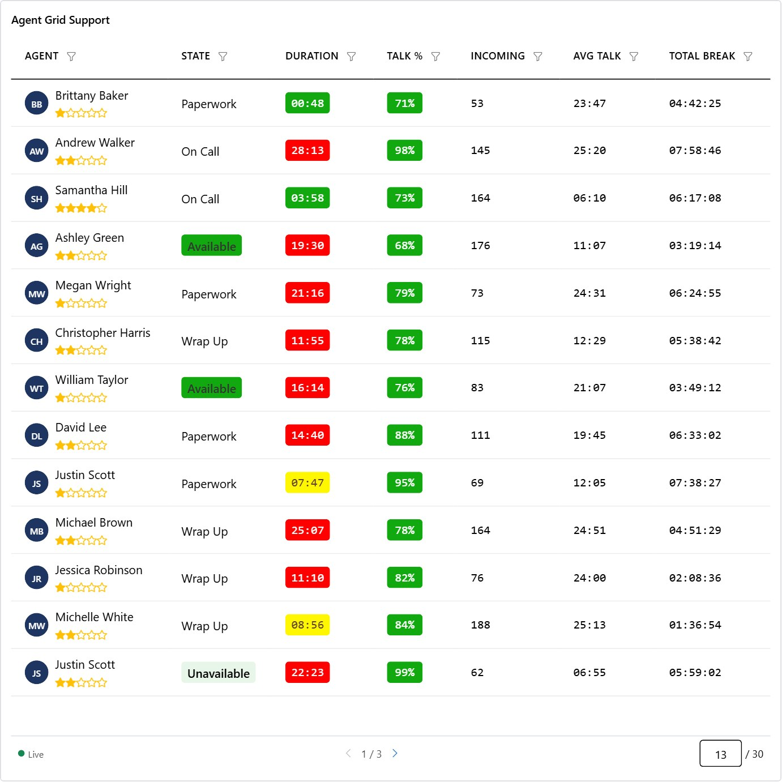

General Tab
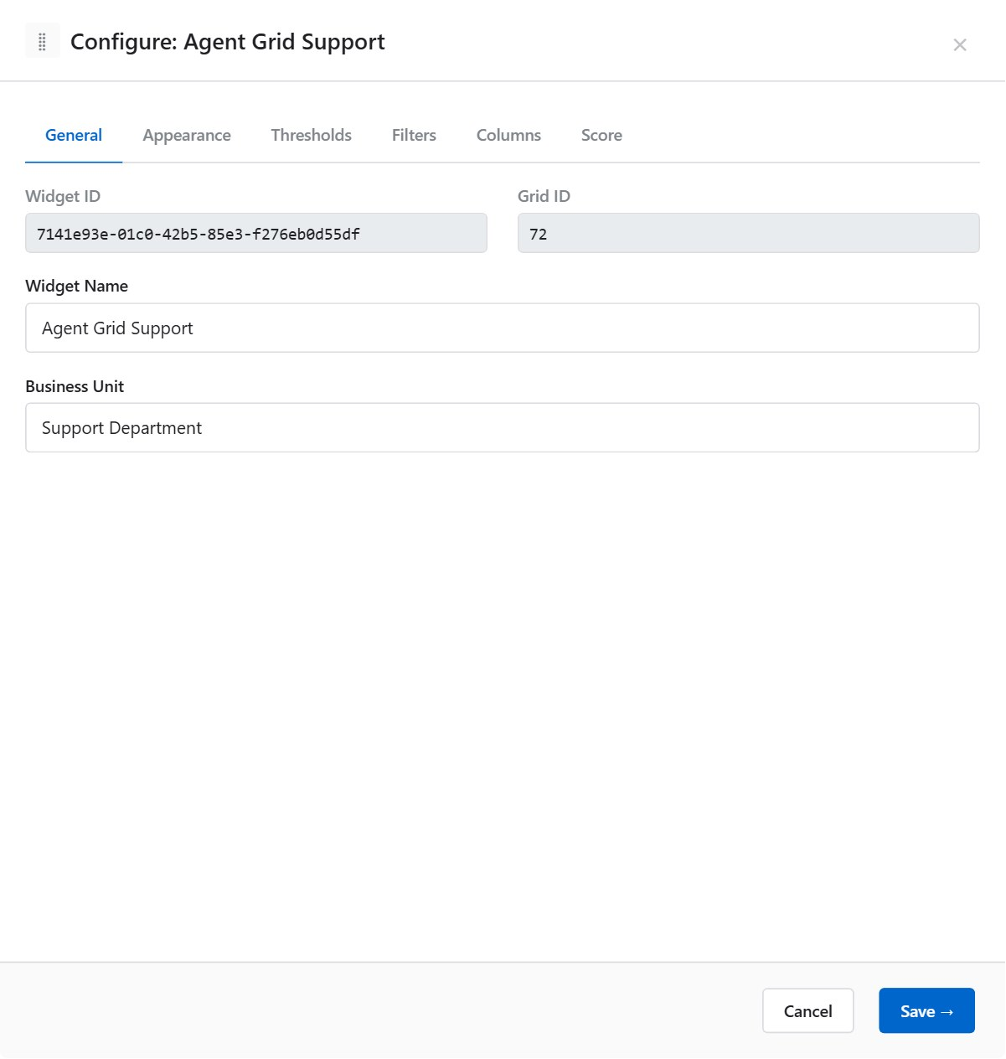
Parameter | Description | Options / Example
Widget ID | Read-only system identifier for this widget instance. | e.g. 42 (assigned automatically)
Grid ID | Read-only identifier of the underlying real-time data grid. | e.g. 7 (from RTSGrid)
Display Name | Label shown in the widget header bar. Edit to override the default name. | e.g. "Sales Team Agents"
Business Unit | Filters data to agents belonging to the selected Business Unit only. | Select from list; leave blank for all BUs

Appearance Tab
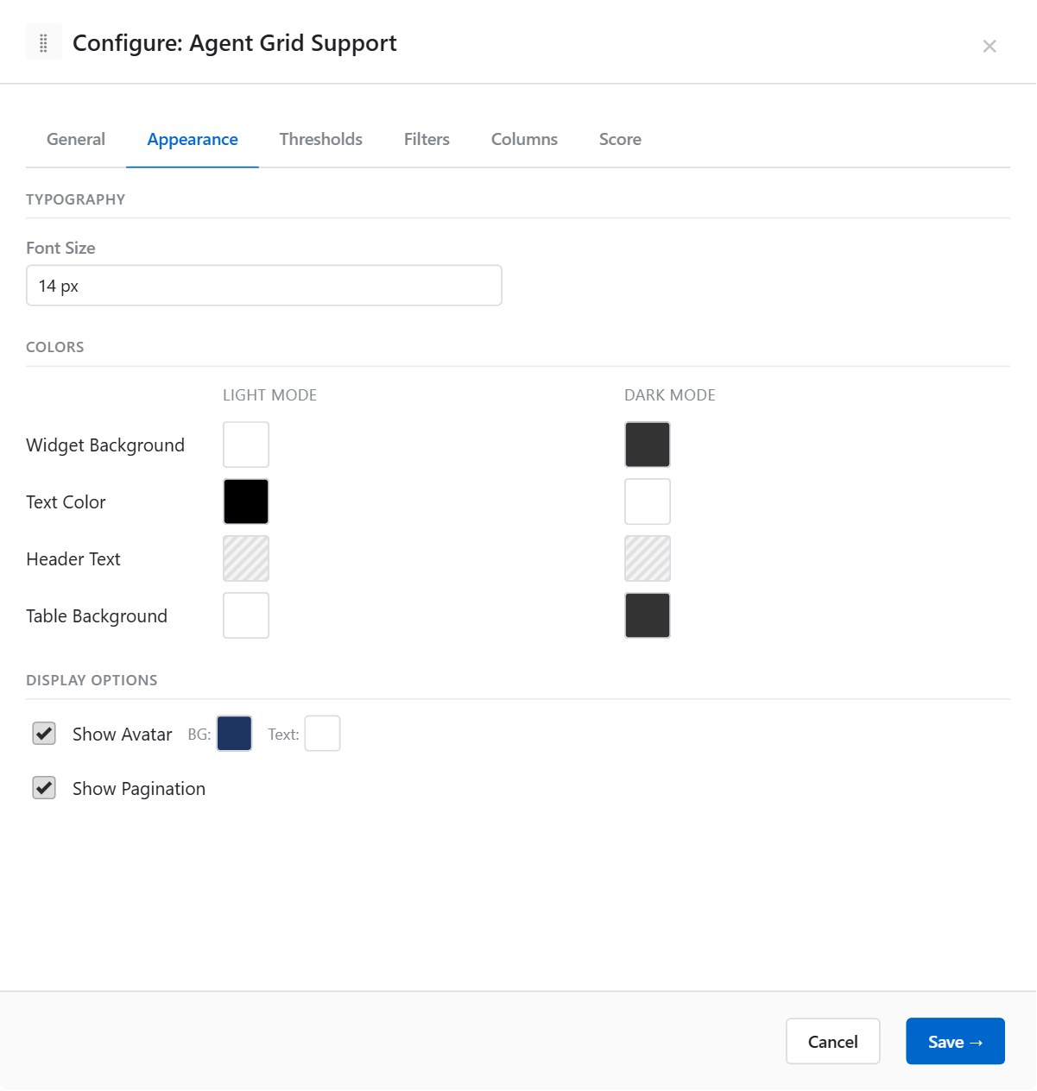

Typography
Parameter | Description | Options / Example
Font Size | Text size for cell content. Values come from the tenant's configured font-size list. | e.g. 12, 14, 16 (px)

Display Options
Parameter | Description | Options / Example
Show Avatar | Displays a circular avatar with the agent's initials in the first column. | On / Off (default: On)
Avatar BG Colour | Background colour of the avatar circle. Visible only when Show Avatar is On. | Colour swatch palette
Avatar Text Colour | Initials text colour inside the avatar circle. | Colour swatch palette
Show Pagination | Adds a pagination bar when the agent list exceeds the widget height. | On / Off (default: Off)

Colours — Light Mode and Dark Mode
Each colour has a Light Mode and a Dark Mode variant. Dark mode colours apply when the screen editor's dark mode toggle is active.
Parameter | Description | Options / Example
Widget Background | Canvas background of the entire widget. | Light: White / Dark: Dark navy
Text Colour | Default cell text colour. | Light: Dark grey / Dark: White
Header Background | Background of the column header row. | Light: Steel blue / Dark: Dark blue
Header Text Colour | Text colour of the column header row. | Light: White / Dark: White
Table Background | Alternating row background (even rows). | Light: Light grey / Dark: Charcoal

Thresholds Tab
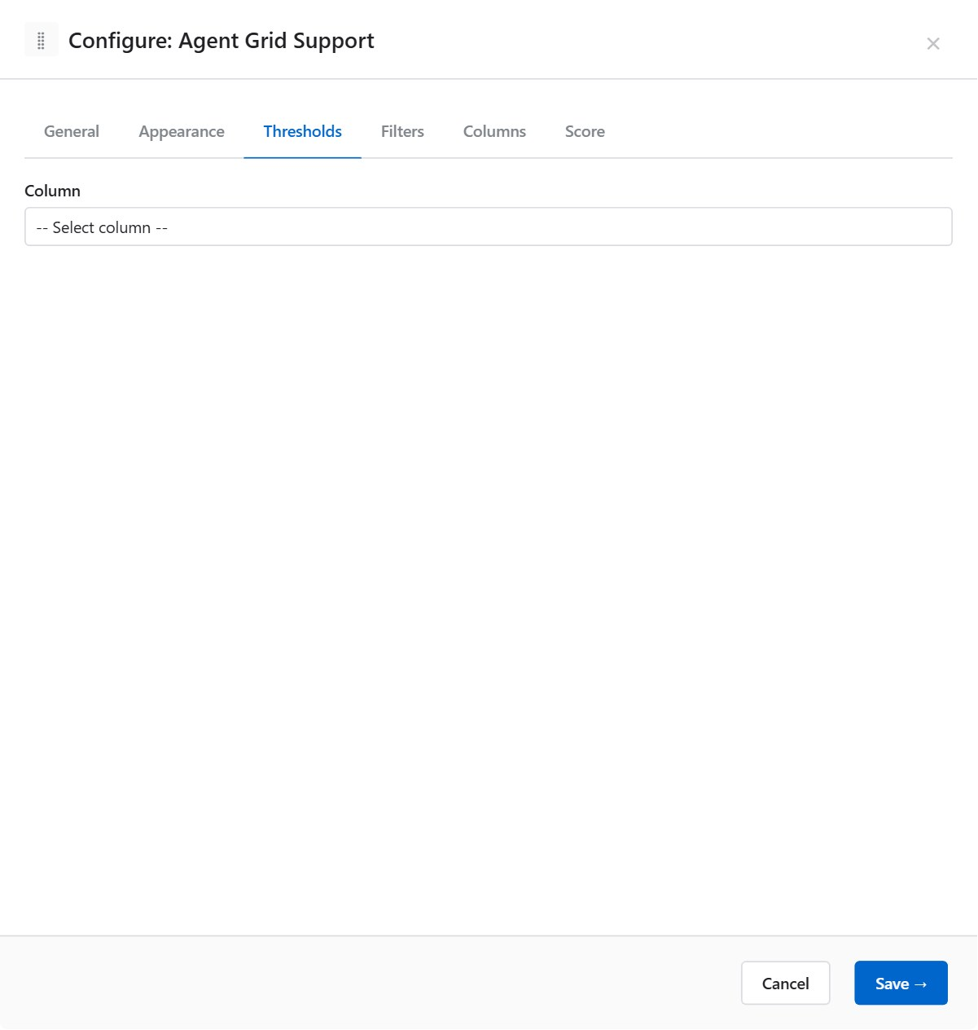
Thresholds apply conditional colour formatting to cells based on metric values. Rules are evaluated per column and per cell.
- Select a column from the column selector on the left.
- Click + Add Rule.
- Set the condition and badge colours.

Numeric column threshold rule parameters:
Parameter | Description | Options / Example
From | Lower bound of the range (inclusive). Leave blank for no lower bound. | e.g. 0
To | Upper bound of the range (inclusive). Leave blank for no upper bound. | e.g. 300
Badge Background | Cell background colour when the rule matches. | Colour swatch palette
Badge Font Colour | Cell text colour when the rule matches. | Colour swatch palette

Text column threshold rule parameters:
Parameter | Description | Options / Example
Match Type | How the cell value is compared to the match value. | Equal / Not equal / Contains / Starts with / Ends with / Is empty / Is not empty
Match Value | The string to compare against. Not shown for Is empty / Is not empty. | e.g. "AVAILABLE"
Badge Background | Cell background colour when the rule matches. | Colour swatch palette
Badge Font Colour | Cell text colour when the rule matches. | Colour swatch palette
ℹ Multiple rules can be defined per column. Rules are evaluated top-to-bottom; the first matching rule wins.

Example — highlight agents on a call in red:
Setting | Value
Column | Status
Match Type | Equal
Match Value | ONPHONE
Badge Background | #D32F2F (red)
Badge Font | #FFFFFF (white)

Filters Tab
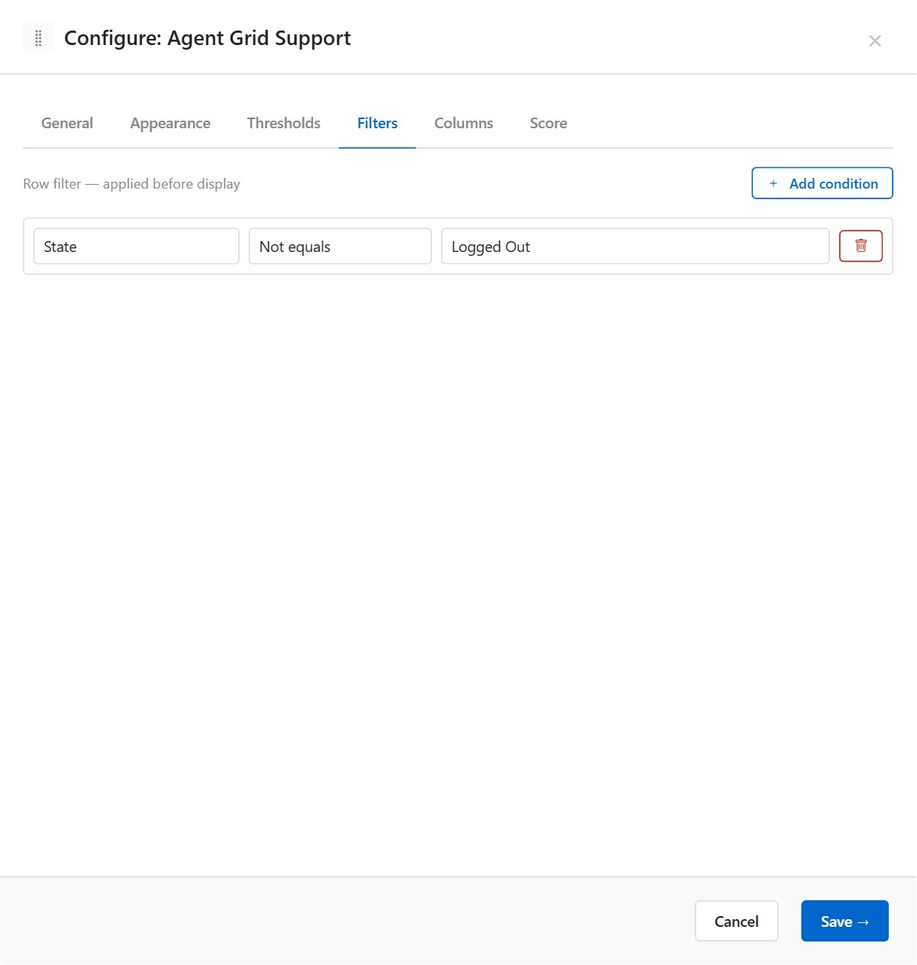
Row filters hide agents from the widget display before data is rendered. Filters are evaluated after data arrives from the real-time feed.
- Click + Add condition.
- Select a Column, an Operator, and enter a Value.
- If adding multiple conditions, choose AND (all must match) or OR (any must match) between them.

Parameter | Description | Options / Example
Column | The column to filter on. Populated from the Columns tab. | Select from defined columns
Operator | Comparison operator for the filter condition. | Equals / Not equals / Contains / Starts with / Ends with / Is empty / Is not empty
Value | The value to match against. Hidden when Operator is Is empty or Is not empty. | e.g. "AVAILABLE"
Connector | Logical connector between consecutive conditions. | AND / OR
ℹ Filters hide rows from the widget only — they do not affect the underlying data or other widgets. An agent filtered out of one widget will still appear in others.

Example — show only Available agents:
Setting | Value
Column | Status
Operator | Equals
Value | AVAILABLE

Columns Tab
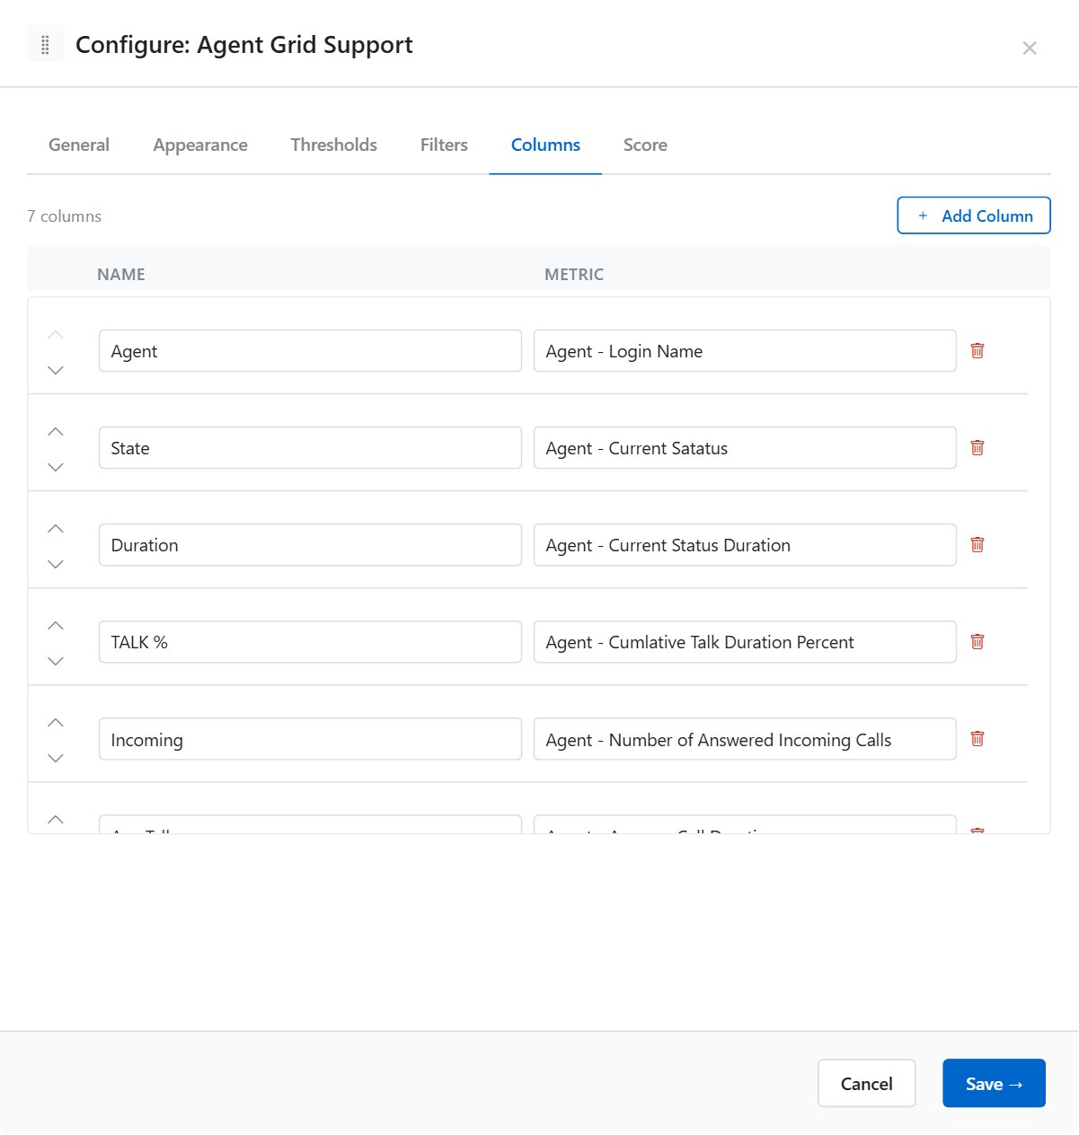
Defines which data columns are displayed in the Agent Grid and in which order. The Columns tab also provides the list used by the Filters and Score tabs.
- Click + Add Column to create a new column.
- Enter a display Name for the column header.
- Click the Metric field and search for the metric to bind to this column.
- Use the ▲ / ▼ arrow buttons to reorder columns.
- Click the trash icon to remove a column.

Parameter | Description | Options / Example
Name | Column header text shown to users. | e.g. "Status", "AHT", "Calls Handled"
Metric | The RTSGrid metric ID that provides live data for this column. Searchable dropdown. | e.g. AgentStateName, CallsHandled, AHT
ℹ The column list here is shared with the Filters and Score tabs. Columns must be defined before filter conditions or score rules can reference them.

Score Tab
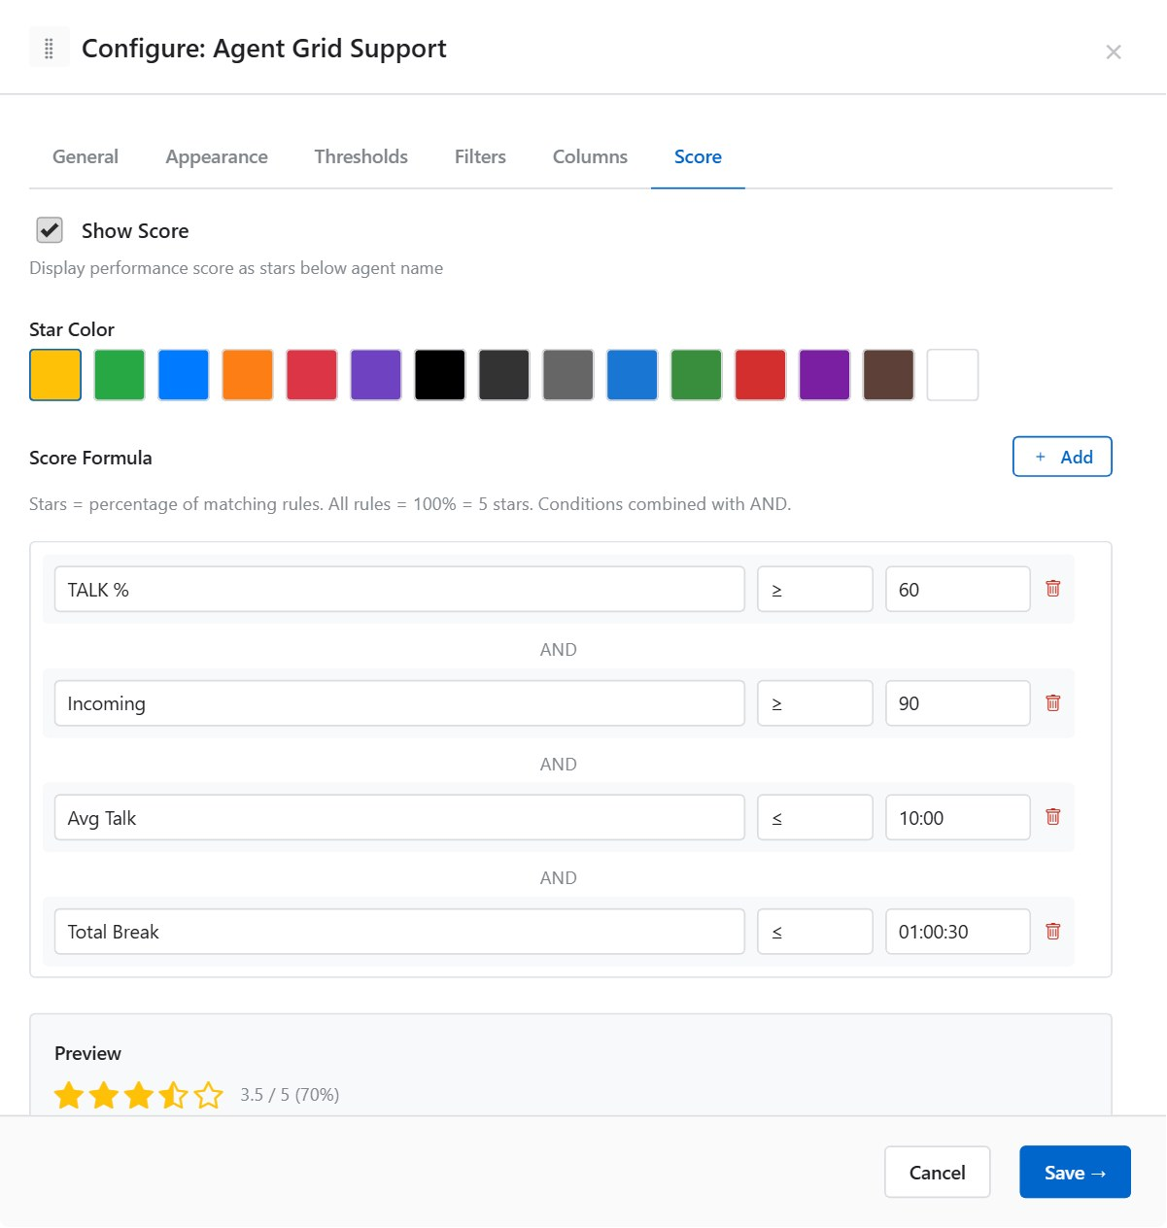
Adds a 1–5 star performance score column to the Agent Grid. The score is calculated at the end of each data refresh cycle based on user-defined formula rules.

Enable / Disable
Parameter | Description | Options / Example
Show Score | Master switch. When off, the score column is hidden and no calculation is performed. | On / Off (default: Off)

Star Colour
Choose the colour of the star icons from a palette of preset colours. The colour applies to all filled stars.

Score Formula
The score formula consists of one or more rules. Each rule specifies a condition; the score equals (number of rules passed / total rules) × 5, rounded to one decimal place.
- Click + Add to add a rule.
- Select a Column (from the Columns tab).
- Select an Operator.
- Enter a Value.
- Multiple rules are AND-joined.

Parameter | Description | Options / Example
Column | The metric column to evaluate. | Select from defined columns
Operator | Comparison operator. | ≥ (>=), ≤ (<=), > (>), < (<), == (equal), ≠ (not equal)
Value | Numeric or text value to compare against. | e.g. 90 (for AHT < 90s)

Example — score agents on three criteria:
Rule | Condition | Meaning
Rule 1 | AHT ≤ 180 | Average Handle Time within 3 minutes
Rule 2 | CallsHandled ≥ 20 | At least 20 calls handled
Rule 3 | Occupancy ≥ 85 | Occupancy rate at least 85%
An agent who passes all three rules scores 5.0 ★. An agent who passes two out of three scores 3.3 ★.

9.2 Queue Grid
Displays a tabular view of queue metrics, with rows representing Business Units or named queues and columns showing real-time metrics such as calls in queue, SLA percentage, and abandonment rate.
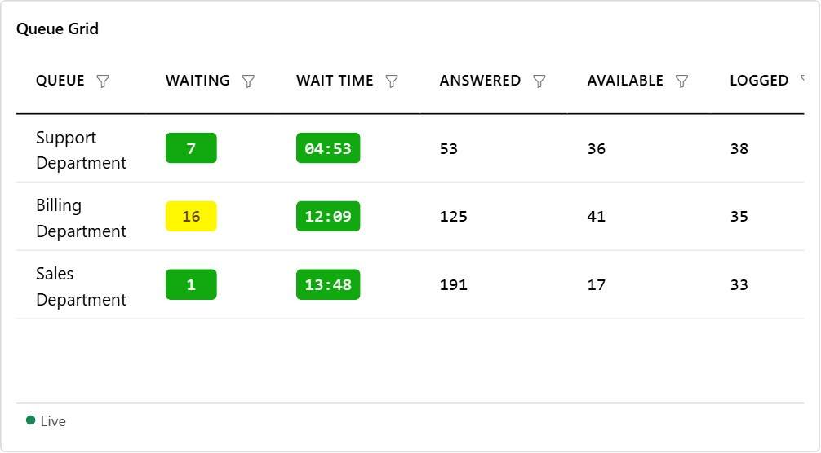

General Tab
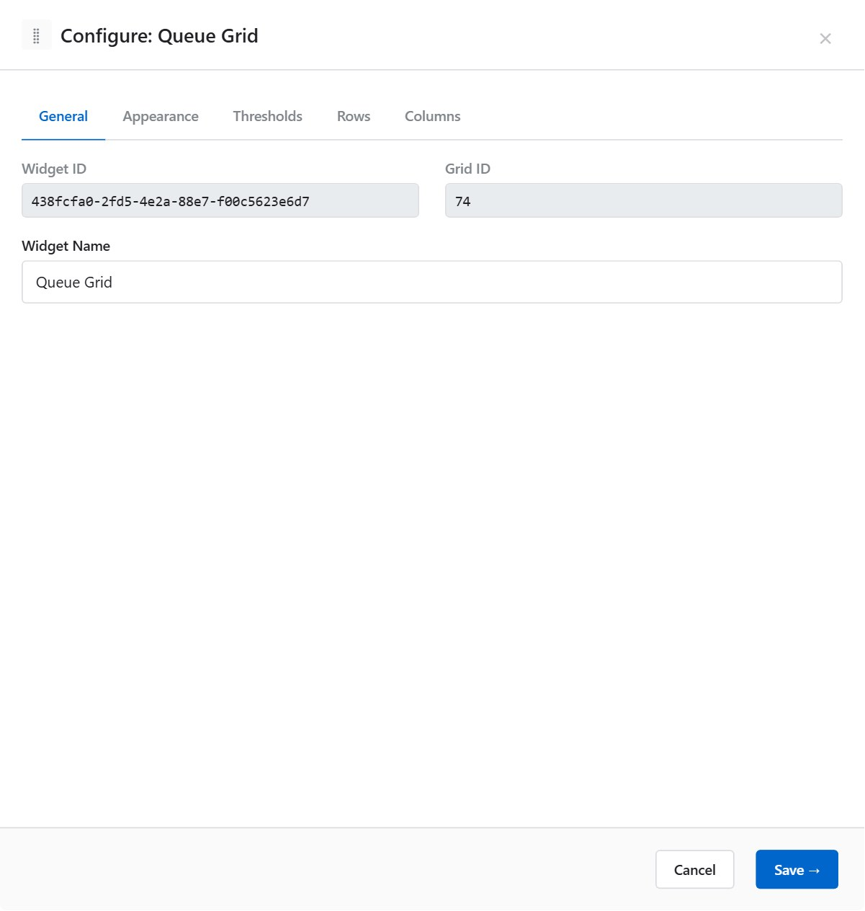
Parameter | Description | Options / Example
Widget ID | Read-only system identifier for this widget instance. | e.g. 15
Grid ID | Read-only identifier of the underlying real-time data grid. | e.g. 3
Display Name | Widget header label. | e.g. "Inbound Queues"
ℹ Queue Grid does not have a Business Unit selector in the General tab — queues are defined per-row in the Rows tab.

Appearance Tab
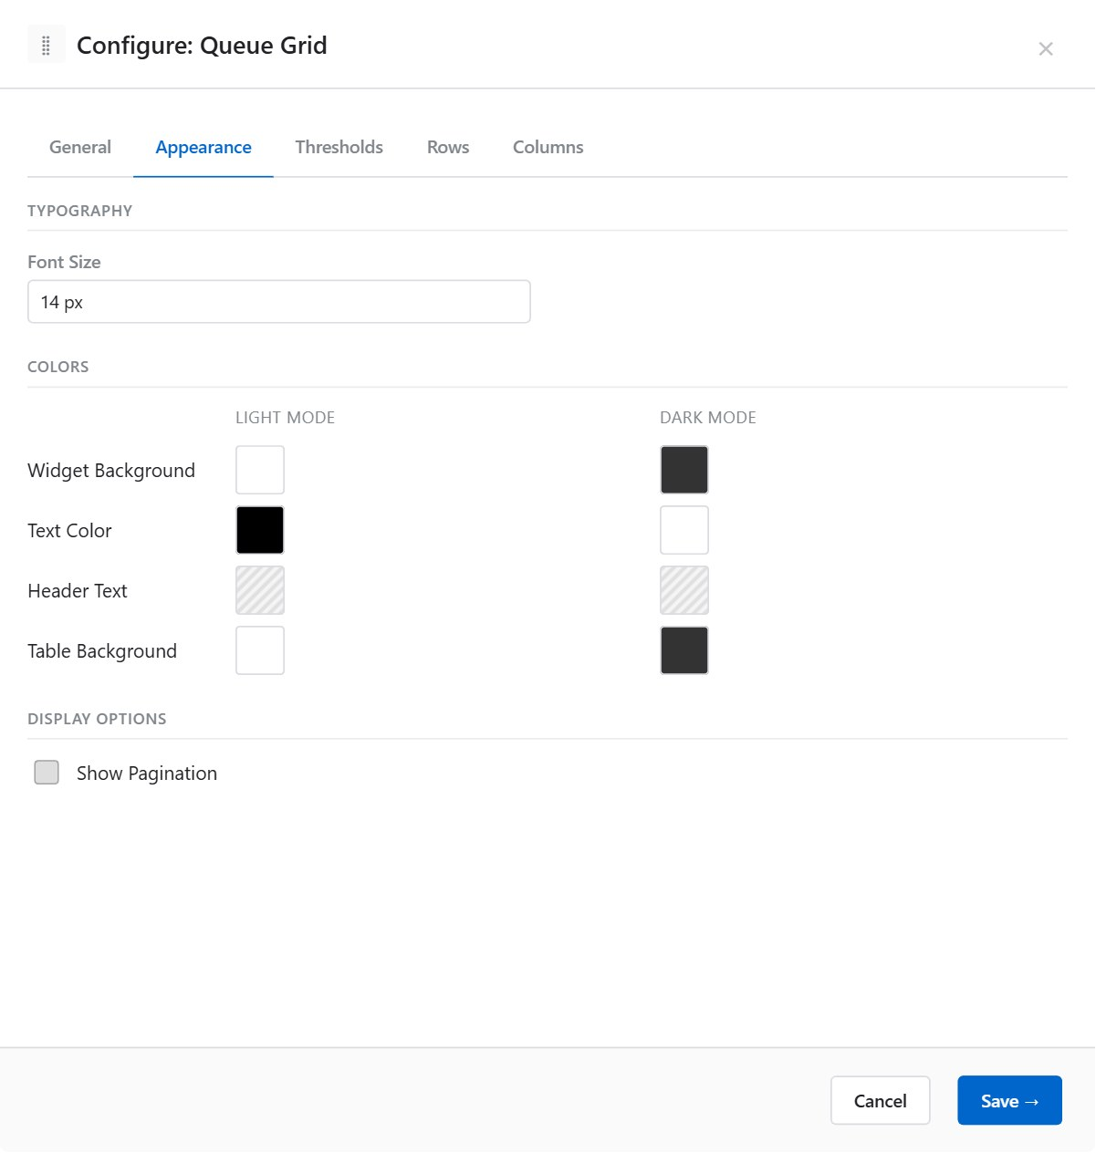

Typography
Parameter | Description | Options / Example
Font Size | Cell text size. Values from the tenant font-size list. | e.g. 12, 14, 16 (px)

Display Options
Parameter | Description | Options / Example
Show Pagination | Adds a pagination bar when the row count exceeds the widget height. | On / Off

Colours — Light Mode and Dark Mode
Parameter | Description | Options / Example
Widget Background | Canvas background of the entire widget. | Colour swatch
Text Colour | Default cell text colour. | Colour swatch
Header Background | Background of the column header row. | Colour swatch
Header Text Colour | Text colour of the column header row. | Colour swatch
Table Background | Alternating row background (even rows). | Colour swatch

Thresholds Tab
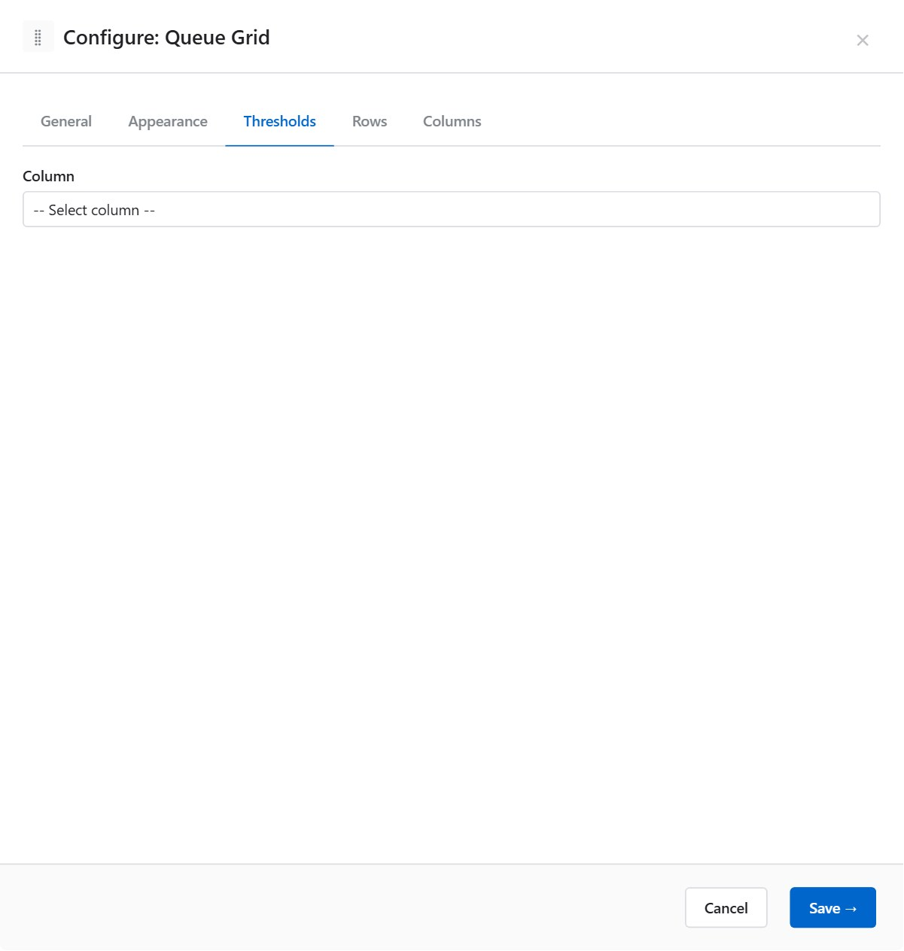
Same per-column threshold mechanism as Agent Grid (see Section 9.1, Thresholds Tab). Select a Queue Column, add rules with numeric From/To or text match conditions, and assign badge background and font colours.

Rows Tab
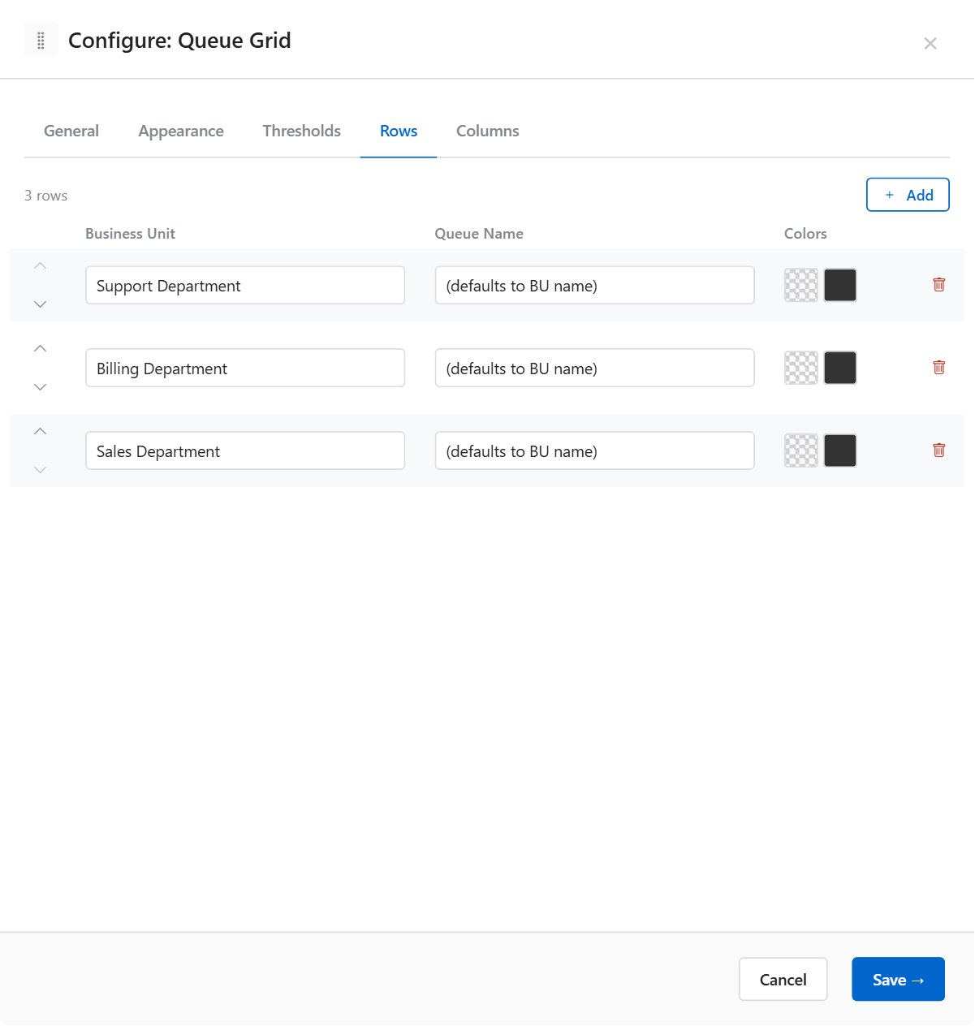
Each row in the Queue Grid represents one queue or Business Unit. Rows appear in the display in the order defined here.
- Click + Add to create a new row.
- Select a Business Unit from the searchable dropdown.
- Optionally enter a Queue Name override.
- Optionally set row-level Background and Font colours.
- Use ▲ / ▼ to reorder rows.

Parameter | Description | Options / Example
Business Unit | The Business Unit to display data for. Required. | Searchable dropdown — select from available BUs
Queue Name | Display name for this row. Defaults to the Business Unit name. | e.g. "Sales" (leave blank to use BU name)
Background | Optional row background colour override. | Colour swatch; leave blank for default
Font Colour | Optional row text colour override. | Colour swatch; leave blank for default
ℹ Row colours are applied at the row level and override the table alternating row colour for that specific row.

Example — two rows with custom colours:
Queue Name | Business Unit | Background | Font
Sales | Sales BU | #E8F5E9 (light green) | Default
Support | Support BU | #FFF3E0 (light amber) | Default

Queue Columns Tab

Defines which metrics appear as columns in the Queue Grid. These are QM (Queue Manager) or Agent Group metrics from the RTSGrid system.
- Click + Add to create a new column.
- Enter a display Name.
- Search and select a Metric from the dropdown.
- Use ▲ / ▼ to reorder.

Parameter | Description | Options / Example
Name | Column header text. | e.g. "In Queue", "SLA %", "Abandoned"
Metric | The QM/Agent Group metric ID. Searchable dropdown. | e.g. CallsWaiting, ServiceLevel, AbandonRate

9.3 Data Slot
A compact KPI card that displays a single real-time metric value with an optional target indicator and delta arrow. Ideal for prominent headline numbers on executive dashboards.
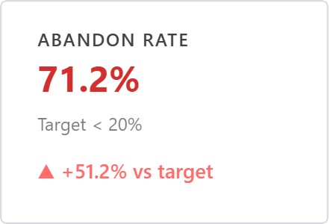

General Tab

Parameter | Description | Options / Example
Widget ID | Read-only system identifier. | e.g. 8
Grid ID | Read-only underlying grid identifier. | e.g. 2
Display Name | Widget header label. | e.g. "Service Level"
Business Unit | Filters the metric to the selected BU. | Select from list; blank = all
Title | Large title text displayed above the metric value. | e.g. "Today's SLA"
Metric | The real-time metric to display. Full-text searchable dropdown. | e.g. ServiceLevel, CallsHandled, AHT
Target Value | A numeric target for the metric. Enables the target indicator. | e.g. 80 (for 80% SLA target)
Target Mode | How the current value is evaluated against the target. | Less than: good when value < target  Greater than: good when value > target
Target Label | Text label shown next to the target value. | e.g. "Target: 80%"
ℹ Leave Target Value blank to disable the target indicator entirely.

Example — SLA target widget:
Setting | Value
Title | Today’s Service Level
Metric | ServiceLevel
Target Value | 80
Target Mode | Greater than (good when SLA ≥ 80%)
Target Label | Target: 80%

Appearance Tab


Typography
Parameter | Description | Options / Example
Font Size | Text size for the metric value. Values from tenant font-size list. | e.g. 32, 48 (px)
Bold | Renders the metric value in bold. | On / Off (default: Off)

Display Options
Parameter | Description | Options / Example
Alignment | Horizontal alignment of the metric value and title. | Left / Centre / Right (default: Centre)
Show Target Label | Toggles the target label text below the value. | On / Off
Show Delta Arrow | Displays an up/down arrow indicating whether the value improved since last update. | On / Off
Hide Header | Hides the widget header bar (Display Name is not shown). Useful for large-value tiles. | On / Off

Colours — Light Mode and Dark Mode
Parameter | Description | Options / Example
Widget Background | Canvas background. | Colour swatch
Text Colour | Metric value and title colour. | Colour swatch
Header Background | Header bar background. | Colour swatch
Header Text Colour | Header bar text colour. | Colour swatch

Thresholds Tab

Global thresholds applied to the metric value. Unlike Agent Grid and Queue Grid, Data Slot thresholds colour the entire widget background rather than a table cell.
- Click + Add Rule.
- Set From and To numeric bounds.
- Set badge background and font colours.

Parameter | Description | Options / Example
From | Lower bound (inclusive). Leave blank for no lower bound. | e.g. 0
To | Upper bound (inclusive). Leave blank for no upper bound. | e.g. 79
Badge Background | Widget background colour when the rule matches. | e.g. #D32F2F (red — SLA < 80%)
Badge Font Colour | Text colour when the rule matches. | e.g. #FFFFFF (white)

9.4 Day Trend
An intraday trend chart that plots call and agent metrics across time intervals throughout the day. Supports multiple series displayed simultaneously with configurable chart types.
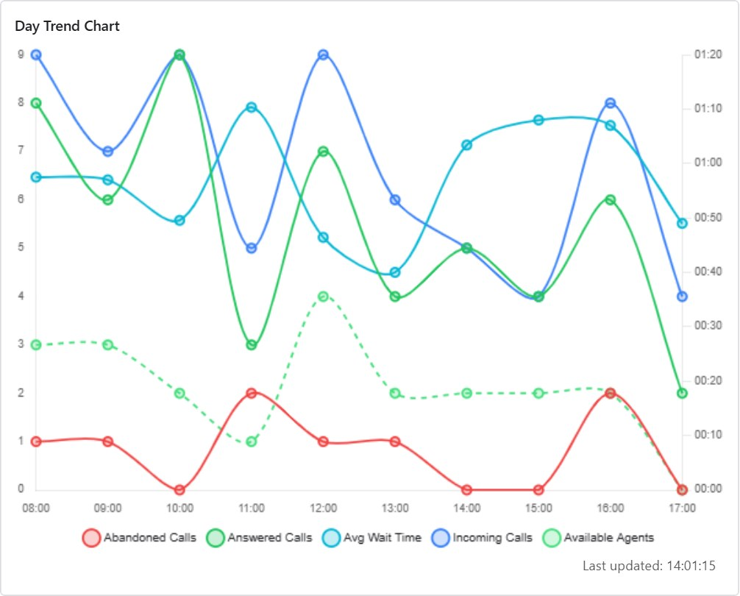

General Tab
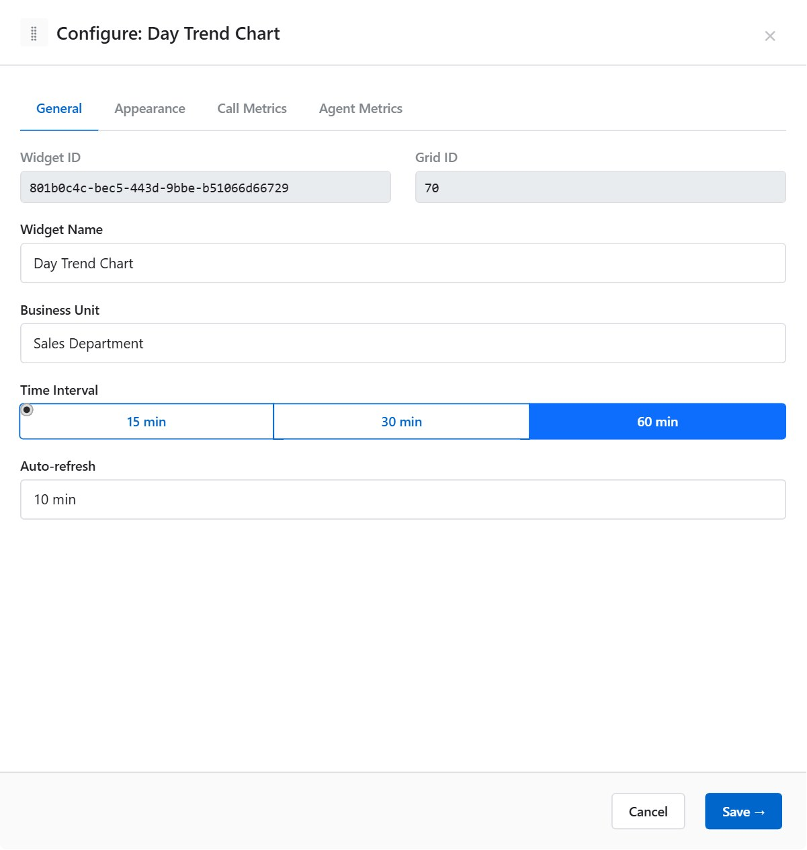
Parameter | Description | Options / Example
Widget ID | Read-only system identifier. | e.g. 3
Grid ID | Read-only underlying grid identifier. | e.g. 1
Display Name | Widget header label. | e.g. "Calls Today"
Business Unit | Restricts data to the selected BU. | Select from list; blank = all
Interval | The time bucket size for each data point along the horizontal axis. | 15 min / 30 min / 60 min
Auto-refresh | How often the chart data is refreshed. | 1 min / 5 min / 10 min / Manual
ℹ A shorter interval gives more granular data points but may result in a more volatile chart. The default interval is 30 minutes.

Example: for a high-traffic contact centre, use 15-minute intervals with 5-minute auto-refresh to track intraday patterns in near-real time.

Appearance Tab
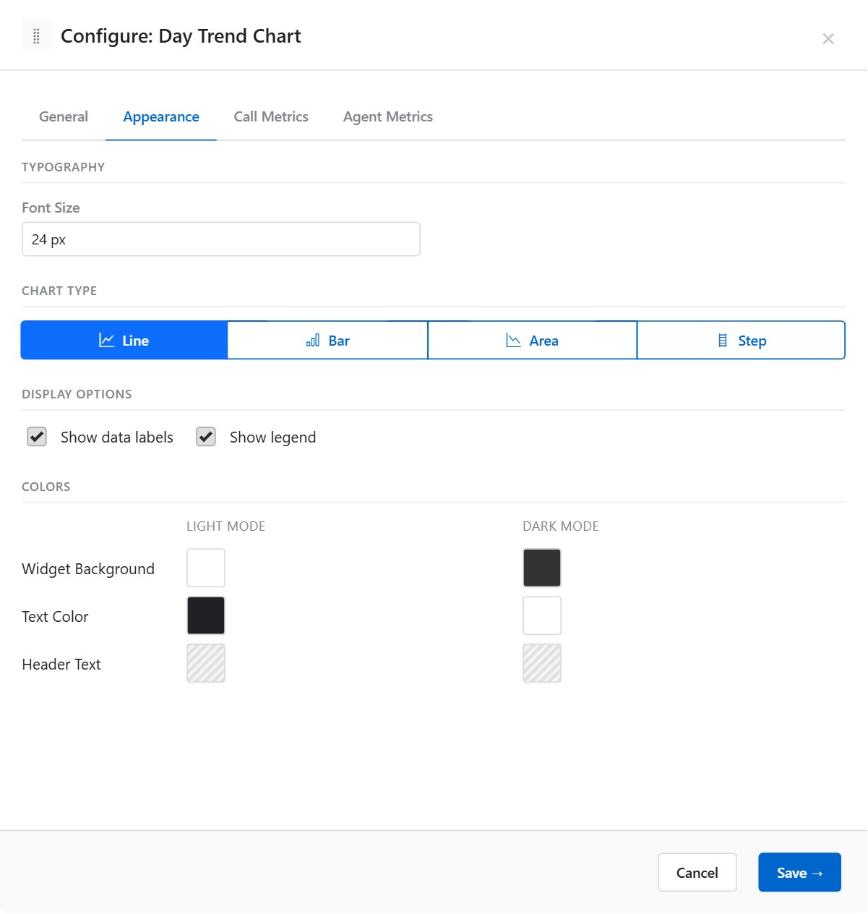

Chart Options
Parameter | Description | Options / Example
Chart Type | Visual style of the chart. | Line / Bar / Area / Step (default: Line)
Show Data Labels | Displays numeric values above each data point. | On / Off (default: Off)
Show Legend | Displays the metric legend below the chart. | On / Off (default: On)

Colours — Light Mode and Dark Mode
Parameter | Description | Options / Example
Widget Background | Canvas background. | Colour swatch
Text Colour | Axis labels and legend text. | Colour swatch
Header Background | Header bar background. | Colour swatch
Header Text Colour | Header bar text. | Colour swatch

Call Metrics Tab
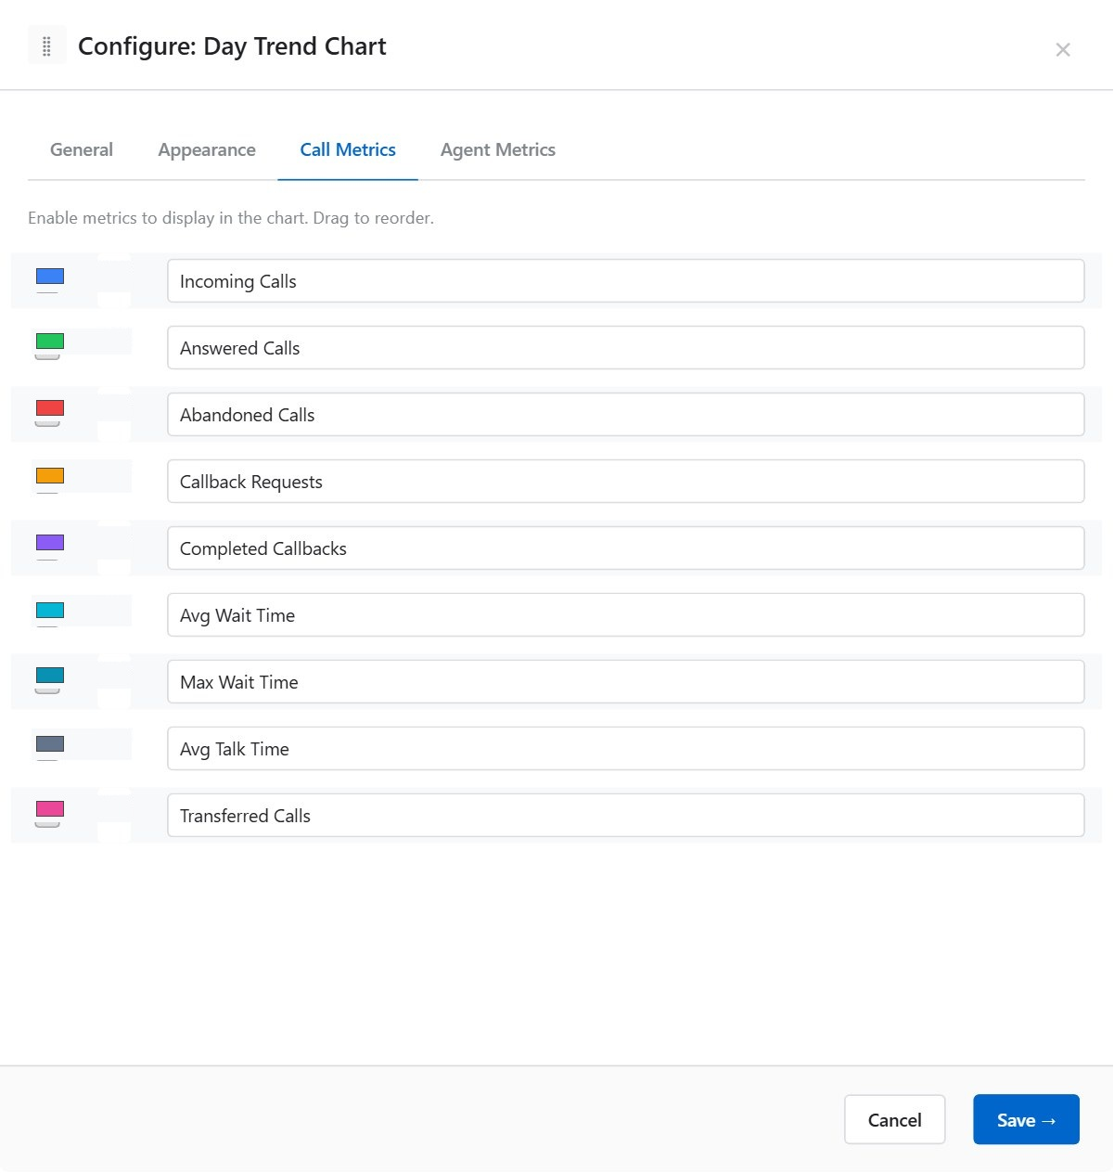
Select which call-based metrics are plotted as series on the Day Trend chart. Each metric can be enabled/disabled, assigned a unique colour, and given a custom label.


Parameter | Description | Options / Example
Enable toggle | Shows or hides this metric series on the chart. | On / Off
Colour | Line/bar colour for this series. Uses a native colour picker. | Any hex colour, e.g. #2980B9
Label | Custom display name for this series in the legend. Leave blank to use the default metric name. | e.g. "Calls Offered" instead of "TotalCallsOffered"
ℹ At least one metric must be enabled for the chart to display data.

Agent Metrics Tab
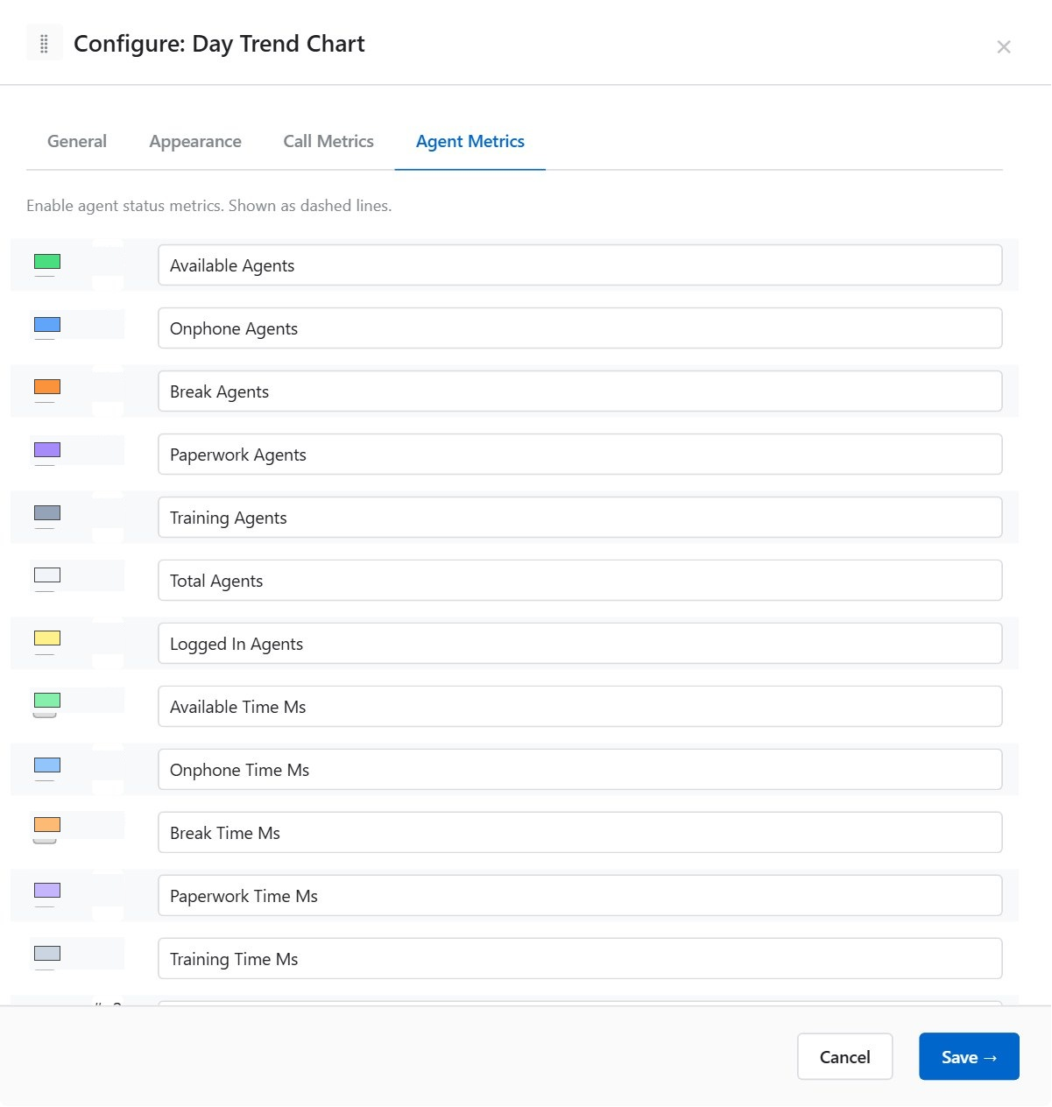
Select which agent-based metrics are overlaid on the Day Trend chart as secondary series. Configuration is identical to the Call Metrics tab.
Parameter | Description | Options / Example
Enable toggle | Shows or hides this agent metric series. | On / Off
Colour | Series colour. | Any hex colour
Label | Custom series label for the legend. | e.g. "Available Agents"
ℹ Agent Metrics are plotted on the same chart as Call Metrics. Use contrasting colours to distinguish call-count series from agent-count series.

Recommended colour scheme example:
Metric | Colour | Rationale
Calls Offered | #2980B9 (blue) | Primary call volume — prominent colour
Calls Handled | #27AE60 (green) | Positive outcome — green
Calls Abandoned | #E74C3C (red) | Alert metric — red
Available Agents | #F39C12 (amber) | Secondary metric — warm contrast

9.5 Agent State Distribution
A pie, doughnut, or bar chart showing the breakdown of agents by their current state or state group. Useful for at-a-glance visibility of team availability.
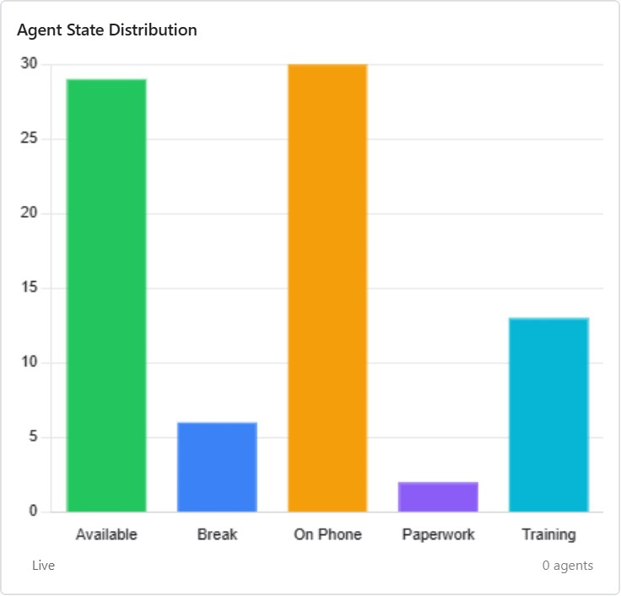

General Tab
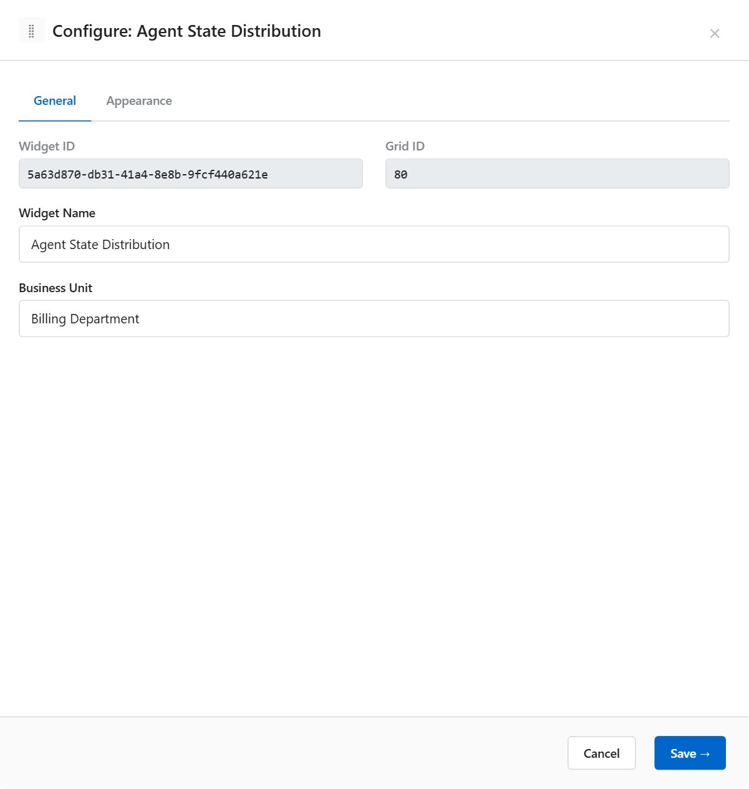
Parameter | Description | Options / Example
Widget ID | Read-only system identifier. | e.g. 9
Grid ID | Read-only underlying grid ID. | e.g. 5
Display Name | Widget header label. | e.g. "Team Availability"
Business Unit | Filters to agents in the selected BU. | Select from list; blank = all

Appearance Tab
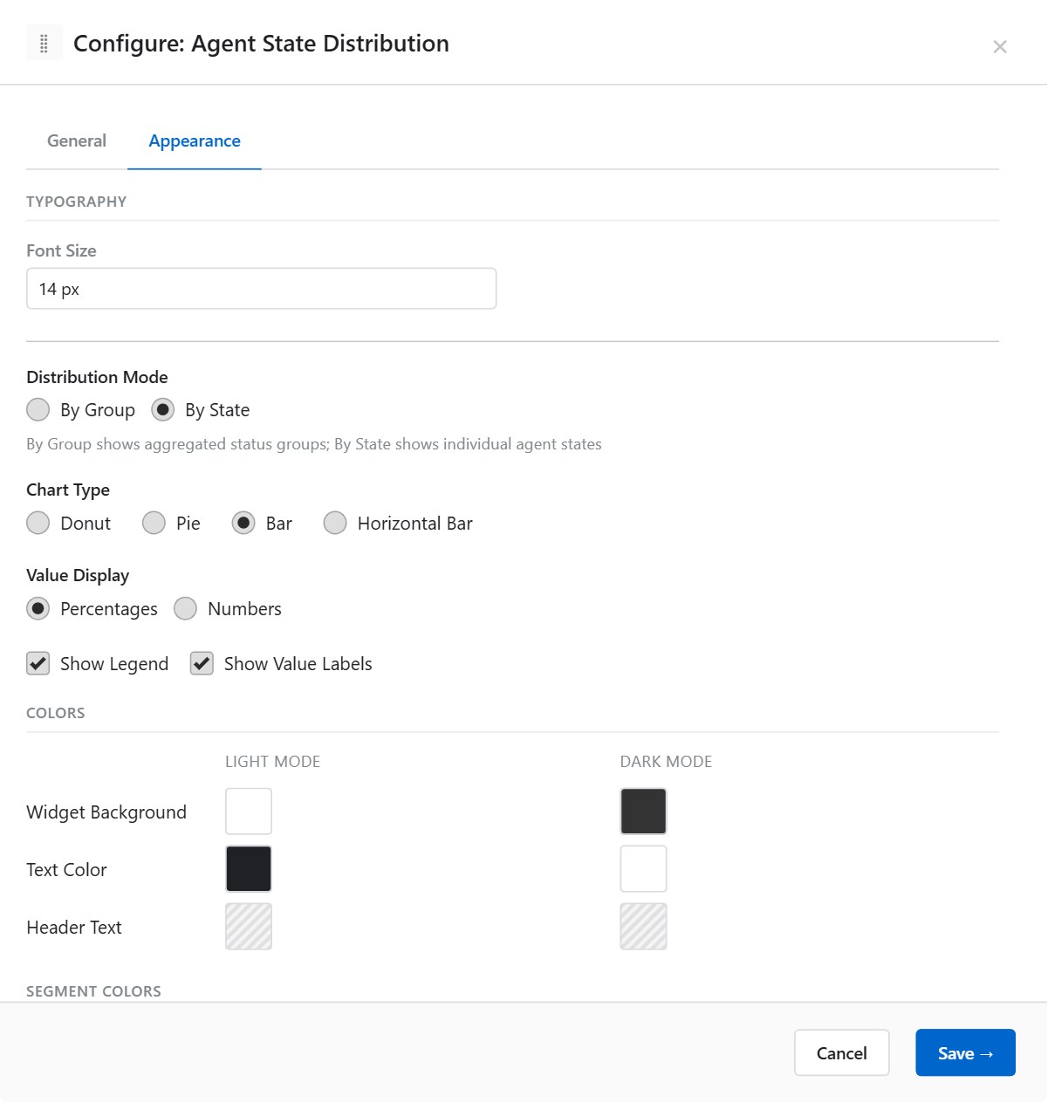

Chart Configuration
Parameter | Description | Options / Example
Distribution Mode | Controls the granularity of state grouping. | Group: aggregate states into state groups (e.g. Available, Break)  State: show individual raw states (e.g. AVAILABLE, LUNCH, TRAINING)
Chart Type | Visual style of the chart. | Doughnut / Pie / Bar (vertical) / Horizontal Bar
Value Display | What values are shown in the chart segments and tooltip. | Percentages (e.g. 45%) / Numbers (e.g. 12 agents)
Show Legend | Displays the state/group name legend. | On / Off (default: On)
Show Value Labels | Renders the value directly on the chart segment. | On / Off (default: On)

Colours — Light Mode and Dark Mode
Parameter | Description | Options / Example
Widget Background | Canvas background. | Colour swatch
Text Colour | Legend and label text. | Colour swatch
Header Background | Header bar background. | Colour swatch
Header Text Colour | Header bar text. | Colour swatch
ℹ Segment colours for each state/group are configured in the Tenant Settings > Agent States section by the Superadmin. These colours cannot be overridden per widget.

Chart type selection guide:
Chart Type | Best Used For
Doughnut | Primary overview chart; space in the centre can show a headline number
Pie | Compact proportion view without a centre gap
Bar (vertical) | Comparing absolute agent counts across states, especially when many states exist
Horizontal Bar | Same as Bar but works better in narrow widget widths

9.6 Info Slot
A scrolling text / ticker panel that displays configurable text content with priority-based colour highlighting. Used for announcements, alerts, and team notices on wallboards.
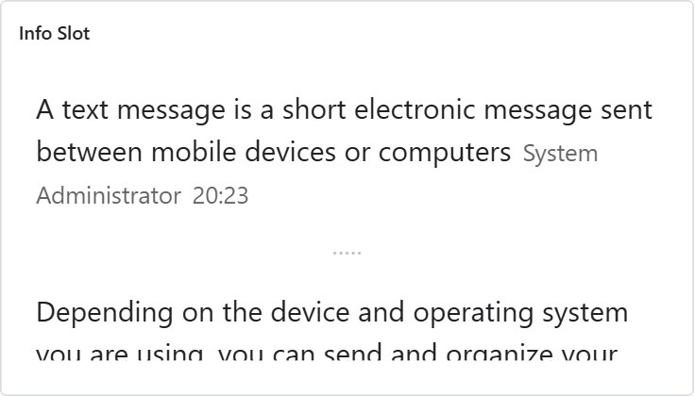

General Tab
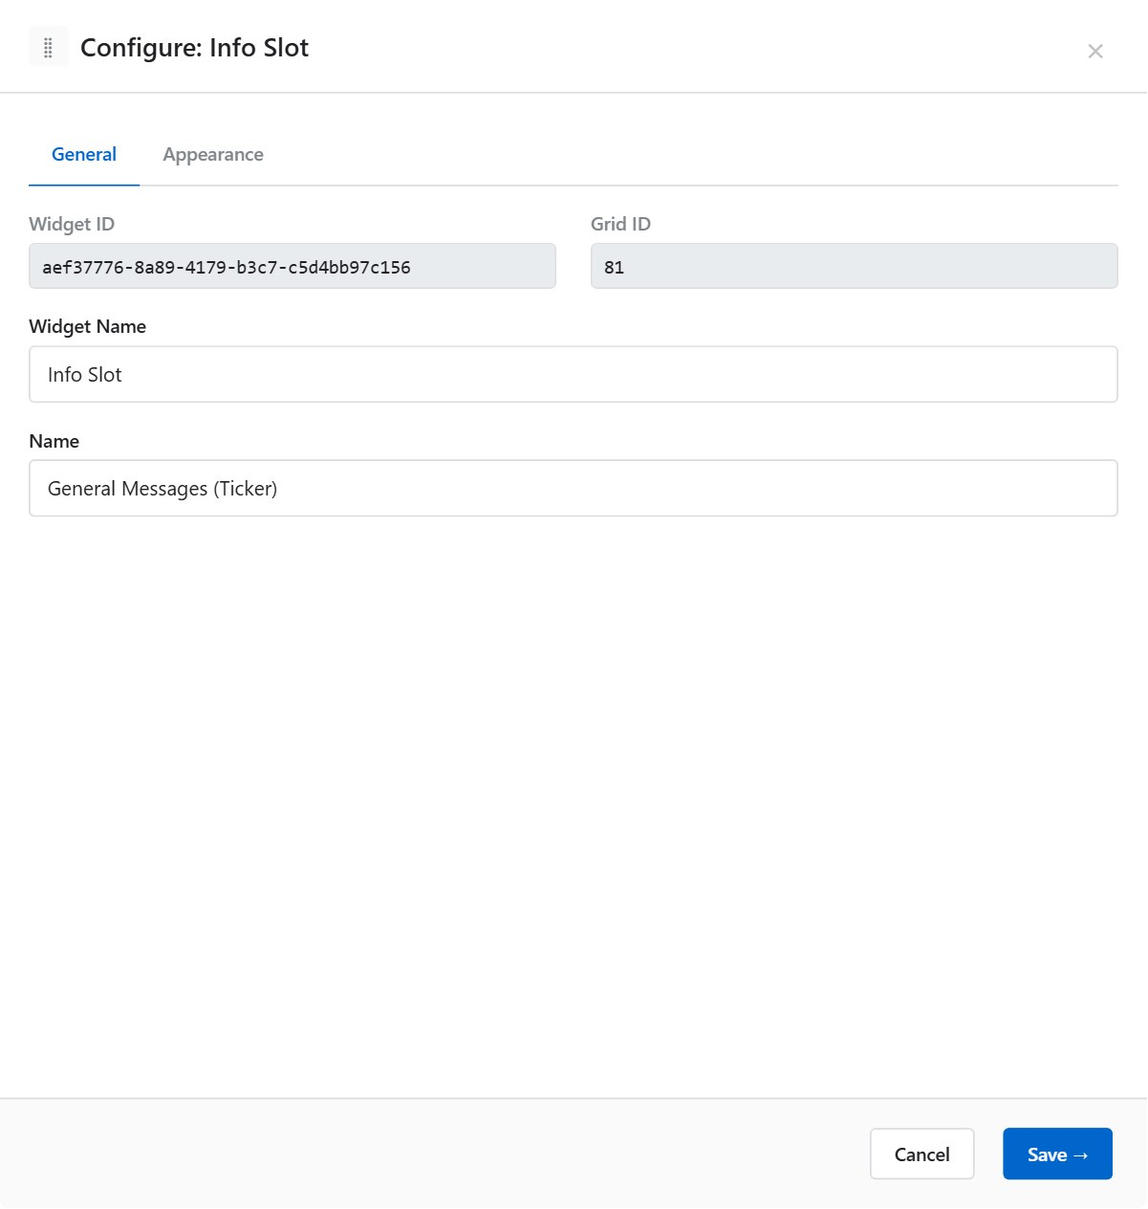
Parameter | Description | Options / Example
Widget ID | Read-only system identifier. | e.g. 11
Grid ID | Read-only underlying grid ID. | e.g. 4
Display Name | Widget header label. | e.g. "Team Notices"
Slot | The configured Info Slot data source to display. Defined in Admin > Info Slots. | Select from available slots
ℹ Info Slot does not have a Business Unit selector — content is managed at the slot level by Administrators.

Appearance Tab
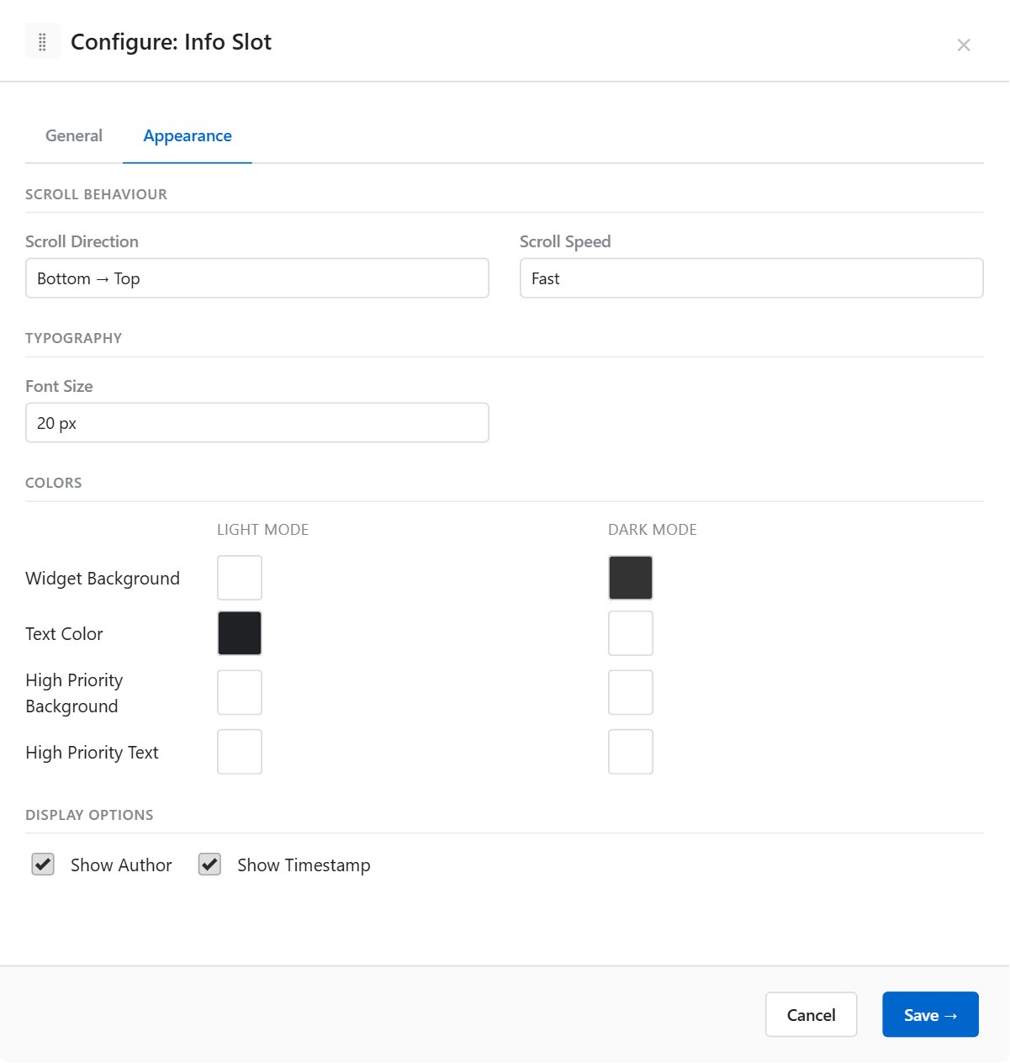

Typography
Parameter | Description | Options / Example
Font Size | Text size for the scrolling content. | e.g. 14, 18, 24 (px)

Scroll Behaviour
Parameter | Description | Options / Example
Scroll Direction | Direction the text moves across or up/down the widget area. | Left to Right / Right to Left / Top to Bottom / Bottom to Top
Scroll Speed | Speed of the scroll animation. Only applies when a scrolling direction is selected (Ticker mode). | Slow / Medium / Fast
ℹ Right to Left is the appropriate scroll direction for RTL languages (Arabic, Hebrew). Set the direction to match the screen’s language.

Colours — Light Mode and Dark Mode
Parameter | Description | Options / Example
Widget Background | Default canvas background. | Colour swatch
Text Colour | Default scrolling text colour. | Colour swatch
Header Background | Header bar background. | Colour swatch
Header Text Colour | Header bar text. | Colour swatch

Priority High Colours
Messages marked as Priority High in the slot data source are displayed with distinct colours to attract attention.
Parameter | Description | Options / Example
Priority High Background (Light) | Background for priority messages in light mode. | e.g. #FFEB3B (yellow)
Priority High Text (Light) | Text colour for priority messages in light mode. | e.g. #212121 (dark)
Priority High Background (Dark) | Background for priority messages in dark mode. | e.g. #F57F17 (amber)
Priority High Text (Dark) | Text colour for priority messages in dark mode. | e.g. #FFFFFF (white)

10. Publishing Management
Screens have two statuses: Draft and Published. The status is set in Screen Settings.
Status | Behaviour
Draft | Visible only to Editors and Administrators. Hidden from Viewers. Use Draft for screens under construction or requiring review.
Published | Visible to all users with view permission (or all users if IsPublic is set). Suitable for live wallboards and shared screens.
ℹ Changing a screen from Published to Draft immediately hides it from Viewers. Viewers currently viewing the screen will see it disappear on their next page load.

11. Trash (Soft Delete)

When the Administrator has enabled Soft Delete in Tenant Settings, deleted screens are moved to the Trash tab on the Screen List page rather than being permanently removed.

11.1 Trash Tab Columns
Column | Description
Name | Screen name
Deleted by | User who deleted the screen
Deleted at | Deletion timestamp
Days remaining | Days until permanent deletion. Shown as a red badge when ≤ 7 days

11.2 Restoring a Screen
- Click the Trash tab.
- Find the screen to restore.
- Click the ↩ Restore button.
- The screen reappears in the main Screen List in its original status.
ℹ The retention period before permanent deletion is configured by your Administrator (default: 90 days).

12. Tips and Best Practices
- Always click Save in the editor header before closing the browser tab. Changes are not auto-saved.
- Use Categories to organise screens by team or function (e.g. Inbound, Outbound, Quality).
- Use Templates to share pre-configured widget layouts across multiple screens.
- Set dark mode colours in widget Appearance if screens will be displayed on wall monitors in low-light areas.
- Use IsPublic for shared overview screens that all staff should see, avoiding repeated Permission Group assignments.
- On Agent Grid, define Score rules to give supervisors an instant performance snapshot without reading individual metrics.
- On Data Slot, enable Show Delta Arrow to show whether the metric is trending up or down since the last refresh.
- On Day Trend, use contrasting colours for call metrics vs. agent metrics to keep dual-axis data readable.
- On Info Slot, test Priority High colours against your actual screen background — they should be clearly distinct from standard messages.
- On Queue Grid, assign custom row background colours to differentiate queues at a glance (e.g. green for met SLA, amber for at-risk).

13. Glossary
Term | Definition
Agent Grid | Widget displaying a live table of agents with configurable columns, thresholds, filters, and score.
Agent State Distribution | Widget showing agent state/group breakdown as a pie, doughnut, or bar chart.
Business Unit (BU) | A data segmentation level used to filter widget data to a specific organisational unit.
Canvas | The editing area in the Screen Editor where widgets are placed and arranged.
Category | An organisational label assigned to a screen (e.g. Inbound, Quality).
Data Slot | Widget displaying a single real-time KPI metric with optional target and delta.
Day Trend | Widget plotting intraday call and agent metrics on a time-series chart.
Draft | Screen status — visible only to Editors and Administrators.
Info Slot | Widget displaying a scrolling text/ticker feed with priority colour coding.
IsPublic | A screen flag that makes it visible to all authenticated tenant users without explicit group assignment.
Metric | A specific real-time data value (e.g. ServiceLevel, AHT, CallsWaiting) sourced from RTSGrid.
Palette | The slide-out panel in the Screen Editor listing available widget types and templates.
Permission Group | A set of permissions controlling which screens, queues, and features a user can access.
Published | Screen status — visible to all users with view permission.
Queue Grid | Widget displaying a live table of queue metrics with configurable rows and columns.
RTSGrid | The underlying real-time data grid system that supplies live metrics to all widgets.
Screen | A named dashboard containing one or more widgets. Also referred to as a Dashboard.
Score | An optional 1–5 star indicator on Agent Grid calculated from user-defined formula rules.
SignalR | The real-time communication technology used to stream live data to widgets.
Soft Delete | Deletion mode where screens move to Trash with a retention period before permanent removal.
Template | A saved widget configuration reusable across screens.
Threshold | A colour rule applied to a metric value when it crosses a defined boundary.
Widget | A real-time data display component placed on a screen.

