
RTM View Shell
Data Reference: RTSData interaction / agent-status tables
RTSData_Interaction · RTSData_UserStatus · RTSData_UserStatusLog
Data reference — for BI / data-warehouse and integration teams
Edition EN · 2026-07-22 · RTM View Shell

Document revision history
This table lists the revision history of this document.
Version | Date | Summary of changes | Product release ID | Shipped-with (commit/barrier)
1.0 | 2026-07-22 | Initial | RTM-REL-2026.07 (proposed) | (pending push)

Contents

Source of truth: db/schema.sql (DDL) + db/functions/02_rtsdata_functions.sql (write/read routines) + RTM engine value literals. Tables: RTSData_Interaction, RTSData_UserStatus, RTSData_UserStatusLog. (“User” = agent throughout.)

1. Entity-relationship diagram
Relationships are logical — these real-time tables are denormalized and joined by string keys, with no enforced foreign keys (RTM writes fast; keys are external CC ids).
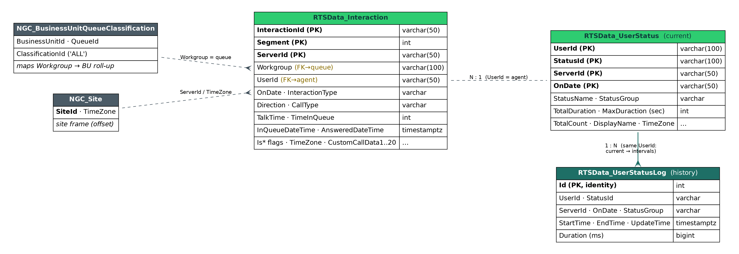
Composite natural keys (upsert targets):
- RTSData_Interaction → (InteractionId, Segment, ServerId) — unique index IX_RTSData_Interaction_UpsertKey.
- RTSData_UserStatus → (UserId, StatusId, ServerId, OnDate).
- RTSData_UserStatusLog → surrogate Id (append-only; no natural upsert).

2. Write / lifecycle semantics
Table | Written by | Mode | Lifecycle
RTSData_Interaction | RTSData_SetInteraction | UPSERT on (InteractionId, Segment, ServerId) | Live + today’s rows; wiped daily by the midnight-clear routine
RTSData_UserStatus | RTSData_SetUserStatus (snapshot part) | UPSERT on (UserId, StatusId, ServerId, OnDate) | Current state only; wiped daily by the midnight-clear routine
RTSData_UserStatusLog | RTSData_SetUserStatus (interval part) | APPEND-ONLY; a row is inserted only when StartTime+EndTime present and EndTime > StartTime | Durable history; NOT cleared at midnight
RTSData_UserStatus = “where each agent is right now” (one row, overwritten). RTSData_UserStatusLog = “how long each agent spent in each status” (one row per completed interval, kept) — the durable source for historical staffing.

3. RTSData_Interaction — one row per interaction segment
Column | Type | Key | Meaning
InteractionId | varchar(50) NN | External CC-platform interaction/call id (opaque string). PK part.
Segment | int NN | Segment index within the interaction: 0 = original leg; 1, 2, … added by each transfer / conference leg. PK part.
OnDate | varchar(50) NN | Server-local business-day string (e.g. 2026-07-22). Scope key — NOT a timestamp; never time-filter on it. PK part.
ServerId | varchar(50) NN | RTM/CC server-node / site code (e.g. IL). PK part.
Workgroup | varchar(100) NN | Queue name (== QueueId in the model). Examples: DE - Support, US - Onboarding, Callbacks, Everyone.
UserId | varchar(50) NN dflt '' | Agent login/id handling the segment; '' (empty) while unassigned / still in queue.
ClassificationCode | text | Classification / disposition code (adapter-defined; nullable).
InteractionType | varchar(50) | Call · Callback · Chat · Email. (Chat/Email also flagged by IsMessaging=true.)
CallType | varchar(50) | External · Internal.
Direction | varchar(50) | Incoming · Outgoing. (Realized callbacks are Outgoing.)
CustomCallData | text | Primary attached-data slot (adapter/customer payload; nullable).
IsTransferred | bool | true if this segment was transferred; else false/null.
IsAnswered | bool | true once answered by an agent.
IsInQueue | bool | true while waiting in queue (not yet answered).
IsTalk | bool | true while in active talk.
IsAbandoned | bool | true if the caller hung up before answer.
TimeInQueue | int | Seconds spent waiting in queue (>= 0).
TalkTime | int | Talk duration, seconds (>= 0). WFM AHT source — talk only, no separate hold/wrap column -> AHT is wrapIncluded=false.
InQueueDateTime | timestamptz | When it entered the queue. WARN: stamped as UtcNow + site-offset, stored SpecifyKind(Utc) (local wall-time labelled UTC — see section 6).
AnsweredDateTime | timestamptz | When answered (same stamping convention); null if never answered.
UpdateTime | timestamptz | Last write time for the row.
LastUserId | varchar(50) | Previous agent (after a transfer); nullable.
LastWorkgroup | varchar(100) | Previous queue (after a transfer); nullable.
IsMessaging | bool | true for chat/email channels (vs voice).
RemoteAddress | varchar(50) | ANI / remote-party address (e.g. phone number); nullable.
IsCallbackRequest | bool | true on the original inbound Call when it is deflected to a callback (the realized callback is a separate Outgoing row). Lambda dedup marker: 1 arrival, not 2.
TimeZone | varchar(10) | Per-row site TZ offset used to stamp the datetimes. Examples: +02:00, -04:00, +00:00, +12:00; occasionally an IANA name; can be misconfigured (e.g. DE -01:00) but stays self-consistent with the stamp.
CustomCallData1 … CustomCallData20 | text x 20 | 20 additional attached-data slots (customCallData1..20 from the adapter); each nullable.

4. RTSData_UserStatus — CURRENT agent-status snapshot
Column | Type | Key | Meaning
UserId | varchar(100) NN | Agent login/id. PK part.
StatusId | varchar(100) NN | Raw status code from the CC platform. PK part.
ServerId | varchar(50) NN | RTM/CC server-node / site code. PK part.
OnDate | varchar(50) NN | Server-local business-day string. PK part.
StatusName | varchar(100) | Granular per-state name. Examples seen live: Available, Incoming Ext Call, Ringing, Back Office, Meeting, Callback Outgoing, Callback Incoming, Special Projects, Unavailable, Lunch, Training.
StatusGroup | varchar(100) | Canonical status group the state rolls up to — the WFM 'serving-groups' (N) source. Canonical groups: AVAILABLE · ONPHONE · PAPERWORK · BREAK · TRAINING · UNAVAILABLE. (May also appear title-cased: Available, On Phone, Paperwork, Break, Training, Unavailable.)
TotalDuration | int | Cumulative seconds in this status today (>= 0).
MaxDuraction | int | Max single-occurrence duration, seconds. WARN: column name is misspelled MaxDuraction in the schema — keep as-is.
TotalCount | int | Number of times the agent entered this status today (>= 0).
UpdateTime | timestamptz | Last update.
DisplayName | varchar(100) | Agent display name (e.g. Mirna Barakat).
TimeZone | varchar(10) | Per-row site TZ offset (as in section 3).

5. RTSData_UserStatusLog — agent-status INTERVAL history (append-only)
One row per completed status interval. NOT cleared at midnight -> durable source for historical staffing (e.g. the planned WFM graph).
Column | Type | Key | Meaning
Id | int IDENTITY, PK | Surrogate auto-increment key (1, 2, …).
UserId | varchar(100) | Agent login/id.
StatusId | varchar(100) | Raw status code for the interval.
ServerId | varchar(50) | RTM/CC server-node / site code.
OnDate | varchar(50) | Server-local business-day string.
StartTime | timestamptz | Interval start.
EndTime | timestamptz | Interval end (> StartTime; a row is only written once the interval is closed).
Duration | bigint | Interval length in milliseconds = (EndTime − StartTime) × 1000. WARN: milliseconds here vs seconds in RTSData_UserStatus.TotalDuration.
UpdateTime | timestamptz | Write time.
TimeZone | varchar(10) | Per-row site TZ offset.
StatusGroup | varchar(50) | Canonical group of the interval (AVAILABLE/ONPHONE/PAPERWORK/BREAK/TRAINING/UNAVAILABLE). Note: varchar(50) here vs varchar(100) on UserStatus.StatusGroup.

6. Notes & gotchas
- OnDate is varchar, not a date — a business-day scope key. Never filter time ranges on it; use the timestamptz columns (InQueueDateTime / AnsweredDateTime / UpdateTime / StartTime / EndTime).
- Timezone stamping — InQueueDateTime / AnsweredDateTime hold site-local wall time labelled as UTC (UtcNow + TimeZone-offset, SpecifyKind(Utc)). Any windowing must frame with the row’s own TimeZone to stay self-consistent. A wrong site offset (e.g. DE -01:00) is self-consistent for windowing but skews cross-TZ display.
- Current vs history — RTSData_UserStatus cannot answer “how many agents were serving at time T” (current only). Use RTSData_UserStatusLog interval overlap. This is the key dependency for historical staffing views.
- Duration units differ — RTSData_UserStatusLog.Duration = ms; RTSData_UserStatus.TotalDuration / MaxDuraction = seconds.
- Midnight clear wipes RTSData_Interaction + RTSData_UserStatus daily; the Log survives. Live views reset at the business-day boundary; interval history persists.
- Callback dedup — a deflected call keeps ONE Incoming row with IsCallbackRequest=true; the executed callback is a separate Outgoing row -> arrivals (lambda) filter Direction='Incoming' to avoid double-counting.
- Serving-group ↔ state mapping — StatusName (granular, e.g. Incoming Ext Call, Back Office) rolls up to StatusGroup (canonical, e.g. ONPHONE, PAPERWORK). Which StatusGroups count as “serving” is per-deployment WFM config.
Schema quirks to preserve (real, not typos to fix)
MaxDuraction — the column name is misspelled in the actual DDL. Keep it exactly.
StatusGroup width mismatch — varchar(50) on RTSData_UserStatusLog vs varchar(100) on RTSData_UserStatus.
Duration units — milliseconds in RTSData_UserStatusLog.Duration vs seconds in RTSData_UserStatus.TotalDuration / MaxDuraction.

