MAX78000 Secure Bootloader

In-Application Programming

with Python® User Guide

UGxxxx, Rev 4.2; 12/24

Abstract

This user guide details how to update the end-user software application in the MAX78000 through the in-application programming, plus how to program the host code into the MAX32630FTHR board. Details on the MAX78000 secure bootloader can be found in the [MAX78000 Secure Bootloader User Guide](https://www.maximintegrated.com/en/design/technical-documents/userguides-and-manuals/6/6471.html).

Python is a registered trademark of the Python Software Foundation.

Table of Contents

Introduction 4

System Requirements 5

Maxim Toolchain Installation 5

Environment Setup 6

Programming the MAX32630FTHR 6

Hardware Setup 8

In-Application Programming 9

Installing Microsoft Visual C++ Runtime 9

Installing OpenSSL Library 10

Compiling the Hello World Example in the Release Package with the Make Command 14

Generating AES Keys 14

Generating Bootloader Compatible Binary Using Maxim SDK Project 15

Converting the .bin File to the .msbl File Format 15

Programming Keys to the Bootloader 15

MSBL File Programming 16

Locking the SWD Interface 18

Unlocking the SWD Interface 18

Revision History 19

List of Figures

Figure 1. The MAX32630FTHR and MAX32625PICO board connection. 6

Figure 2. Serial port list. 6

Figure 3. CDC device driver warning. 6

Figure 4. MAX32630FTHR host reset button. 7

Figure 5. MAX32630FTHR host blinking LED. 7

Figure 6. Pin Connection between the MAX32630FTHR and MAX78000FTHR 8

Figure 7. Downloading firmware with the download_fw_over_host.exe 17

Figure 8. Bootloader Configuration File. 18

List of Tables

Table 1. Pin Connection between the MAX32630FTHR and MAX78000FTHR 8

Introduction

This application note provides the instructions to program example host code into the MAX32630FTHR development platform.

The document also gives details related to hardware setup and application programming by using the MAX78000 bootloader and example host code.

Note that the screenshots may differ according to the software versions, but the steps will be the same.

System Requirements

To program the MAX78000 bootloader code into the MAX78000FTHR, the minimum requirements are as follows:

* Windows® PC
* Windows 10, Windows 7
* OpenSSL
* Maxim Toolchain Software (more information, including download and installation instructions, is in this document)
* MAX78000FTHR and micro-USB cable
* MAX32630FTHR and micro-USB cable
* MAX32625PICO evaluation kit (EV kit) and micro-USB cable
* Test wires to connect the MAX78000FTHR and MAX32630FTHR

Maxim Toolchain Installation

To install the Maxim Toolchain to your PC, use the following steps:

1. Download the Maxim SDK [here](https://www.maximintegrated.com/en/design/software-description.html/swpart=SFW0010820A).
2. After downloading is complete, double-click  **MaximMicrosSDK.exe** and use the default settings and select **Next** until finished.

Environment Setup

Copy the release package content to your PC under the *C:\ MAX78000_MSBL* folder.

Programming the MAX32630FTHR

To program example host code into the MAX32630FTHR, use the following steps:

1. Connect the grey 10-pin connector to the MAX32630FTHR and the MAX32625PICO board.
2. Connect the micro-USB cable to the MAX32625PICO and the PC.
3. Connect the micro-USB cable to the MAX32630FTHR and the PC.

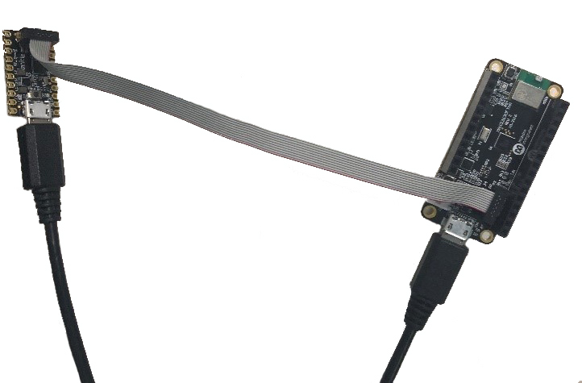

Figure 1. The MAX32630FTHR and MAX32625PICO board connection.

1. Wait a few minutes for the Windows driver to install, then verify that it is installed correctly.
2. In the Windows 10 search box, type **Control Panel** (or for Windows 7, click **Control Panel** on the right side of the **Start Menu**). Either click **Hardware and Sound**, then **Device Manager**, or type **Device Manager** in the search box in the upper right.
3. If the drivers have correctly installed, you should see one port listed as **mbed Serial Port** for the MAX32625PICO. Note the COM port number for the USB serial device.

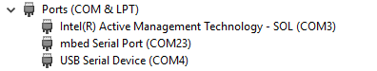

Figure 2. Serial port list.

1. If you see the following, then you will need to install the correct Windows driver:

https://confluence.maxim-ic.com/download/attachments/100767430/cdc.JPG?version=1&modificationDate=1520035665595&api=v2

Figure 3. CDC device driver warning.

1. Download the [Arm Mbed® Windows serial port driver](http://os.mbed.com/media/downloads/drivers/mbedWinSerial_16466.exe) [here](https://www.mbed.com/en/).
2. For Windows 10, run *mbedWinSerial_16466.exe* by double-clicking it.
3. Drag and drop *max32630fthr-host-vx.x.x.bin* into the correct DAPLINK drive. This binary file resides in the MAX78000_MSBL directory.
4. Press the reset button on the MAX32630FTHR, as shown in **Figure 4**.

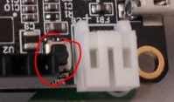

Figure 4. MAX32630FTHR host reset button.

1. Verify that the LED on the MAX32630FTHR is blinking, as shown in **Figure 5**.

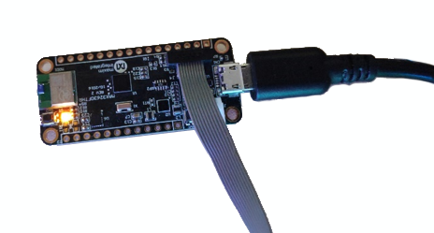

Figure 5. MAX32630FTHR host blinking LED.

Hardware Setup

Connect the MAX32630FTHR and MAX78000 with test wires according to **Table 1.** Pin connection between MAX32630FTHR and MAX78000FTHR is given in **Figure 6**.

Table 1. Pin Connection between the MAX32630FTHR and MAX78000FTHR

|  |  |  |
| --- | --- | --- |
| Pin Function | MAX78000FTHR | MAX32630FTHR |
| **EBL GPIO** | P0.5 | P5.4 |
| **I2C1_SCL** | P0.16 | P3.5 + 4.7K pullup |
| **I2C1_SDA** | P0.17 | P3.4 + 4.7K pullup |
| **RST** | RSTN | P5.6 |
| **GND** | GND | GND |

Note that R6 and R11 slots can be used for pull-up resistors which are not placed on default for the MAX32630FTHR board.

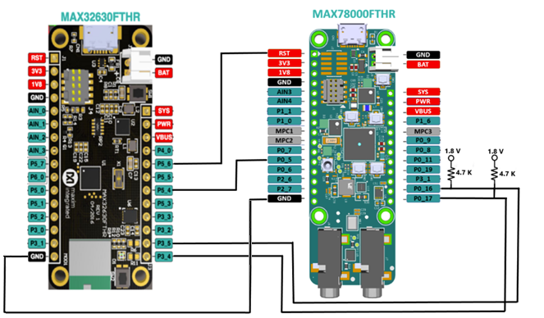

Figure 6. Pin Connection between the MAX32630FTHR and MAX78000FTHR

On the other hand, see the document “Maxim_Bootloader_Tools_UG .pdf” to use MAX32625PICO2 or a custom board such as MAX32665 EvKit as host device instead of MAX32630FTHR board.

In-Application Programming

Installing Microsoft Visual C++ Runtime

To download and install Microsoft Visual C++ Runtime, use the following steps:

1. Visit the download link [here](https://www.microsoft.com/en-us/download/details.aspx?id=40784) and click Download button.

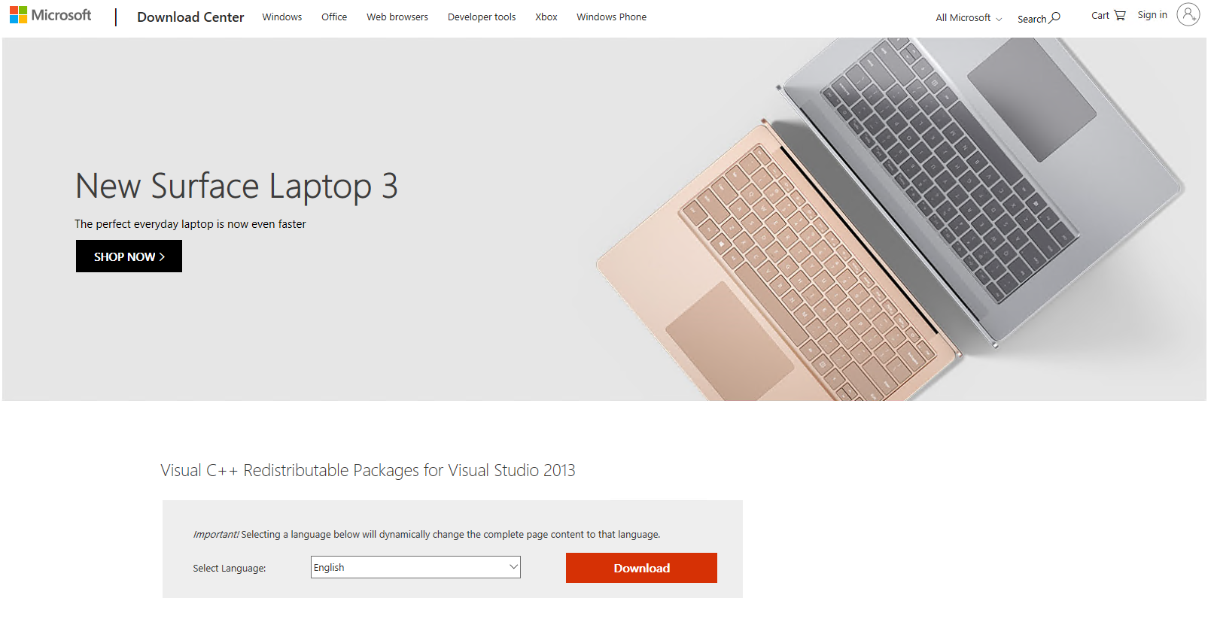

1. Select vcredist_x86.exe and continue by selecting Next.

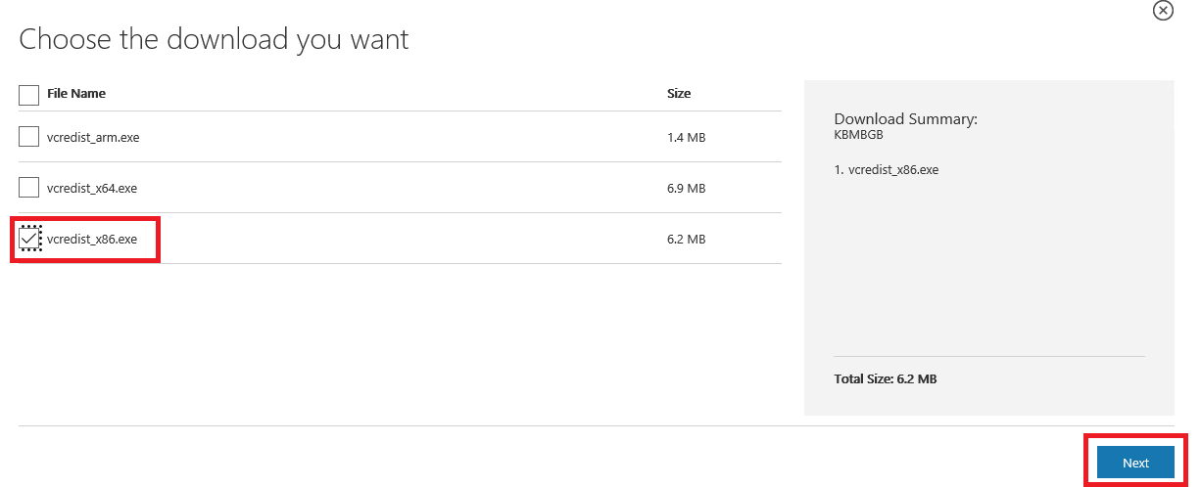

1. Download and run the setup file.
2. Read and click if you agree with the terms. Then select Install.

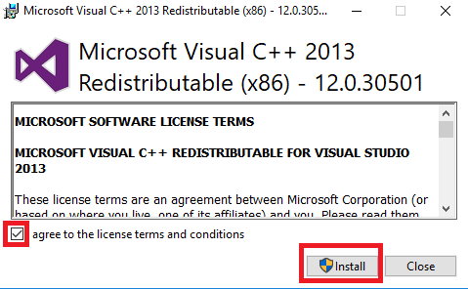

1. Close the installation application.

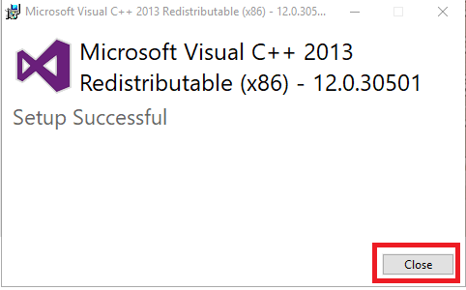

Installing OpenSSL Library

To download and install OpenSSL Library, use the following steps:

1. Visit OpenSSL downloads page [here](https://slproweb.com/products/Win32OpenSSL.html).
2. Select **Win32 OpenSSL v1.1.10L Light** package.

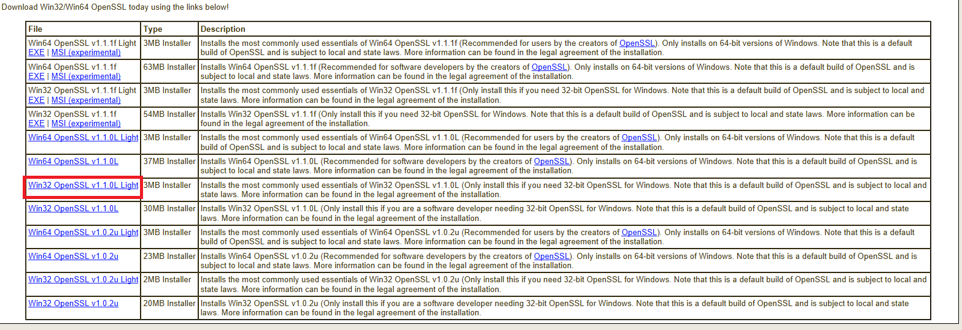

1. Download and run the installer.
2. Read and click if you agree with the terms. Then select Next.

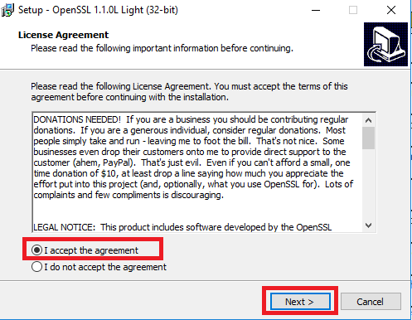

1. Leave the destination location default and click Next.

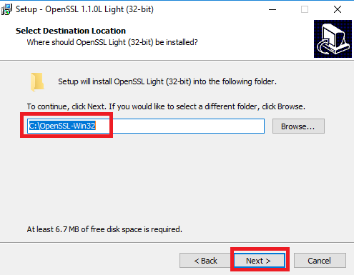

1. Leave “**The Windows system directory**” selected and click Next.

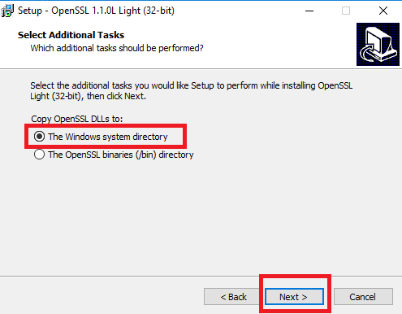

1. Click install.

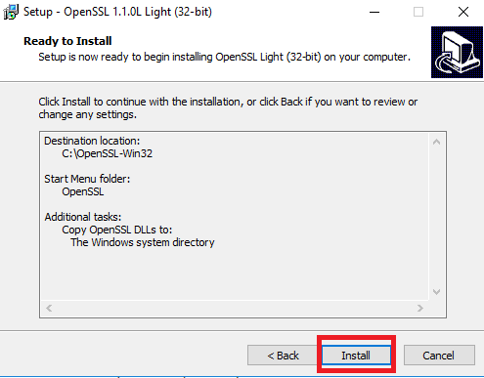

1. When the installation is completed, click finish.

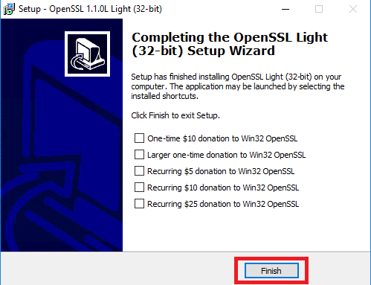

Compiling the Hello World Example in the Release Package with the Make Command

To compile the Hello World with the make command, use the following steps:

1. Navigate to the correct directory consisting of the “Hello World” Example in the **MinGW** window with the following command:

*cd " C:\MAX78000_MSBL \MAX78000_Hello_World”*

2. Enter the following command in the **MinGW** window and wait several minutes for the command to complete:

*make*

3. After successful compiling, the Hello world binary image *max78000.bin* will be in the *“C:\MAX78000_MSBL \MAX78000_Hello_World\build”* directory.

Be sure that the correct linker file is used for generating the .bin file. A sample linker file, max78000_with_bl.ld, can be found under the Hello_World example folder.

4. If you want to rebuild, then enter these commands respectively:

*make clean*

*make*

Generating AES Keys

Generated AES keys can be used for encrypting bin files during msbl file generation and loading to the bootloader. Customer can use their own method for generating keys, but the file format should be similar to the sample max78000_sample_key.txt file.

1. Navigate to the correct directory consisting of the key generation script in the **MinGW** window with the following command:

*cd "C:\MAX78000_MSBL”*

2. Enter the following command in the **MinGW** window to generate a key:

*./generate_key_vX.sh*

*Where “X” corresponds to the version the file.*

3. Rename generated key.txt as *max78000_key.txt* file for using msbl file generation or bootloader key programming.

Generating Bootloader Compatible Binary Using Maxim SDK Project

Following steps should be applied for generating bootloader compatible binary using the Maxim SDK project:

1. Update your linker file:
   1. Copy max78000_with_bl.ld file which is located under *MAX78000_MSBL \MAX78000_Hello_World* to your Maxim SDK project.
2. Update the makefile
   1. Set the linker file variable (LINKERFILE) in makefile as below:

Add following lines to project.mk:

# Point this variable to a linker file to override the default file

**LINKERFILE**=$(TARGET_LC)_with_bl.ld

* 1. Add following lines to makefile under all targets for generating the necessary bin file:

all:

arm-none-eabi-objcopy $(BUILD_DIR)/$(PROJECT).elf -O binary $(BUILD_DIR)/$(PROJECT).bin

Another way (using Eclipse), generating bin files:

* + 1. Go to the project explorer, right click and select “Properties”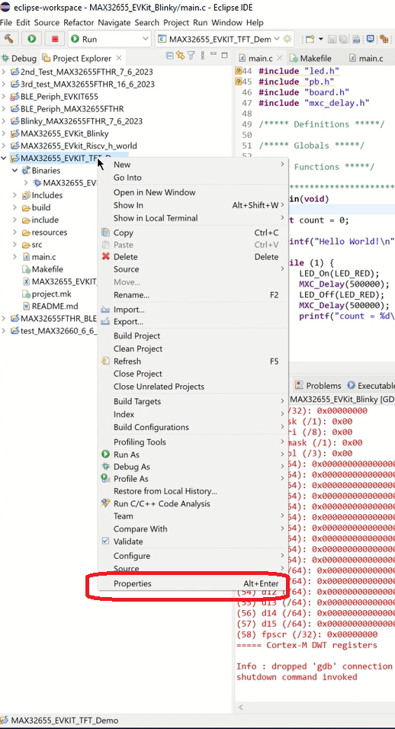
    2. From the left pane, choose the “C/C++ Build”, select “Behavior”

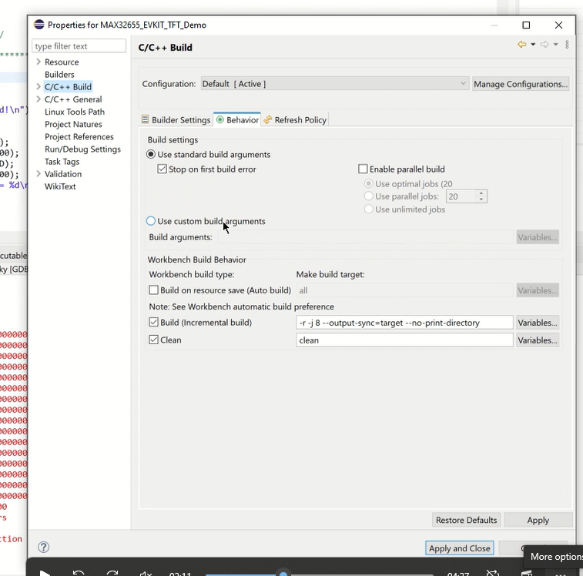

* + 1. Choose the “Use Custom Build Arguments” and type “release” (without the quotes). Click “Apply” then “Apply and Close”.

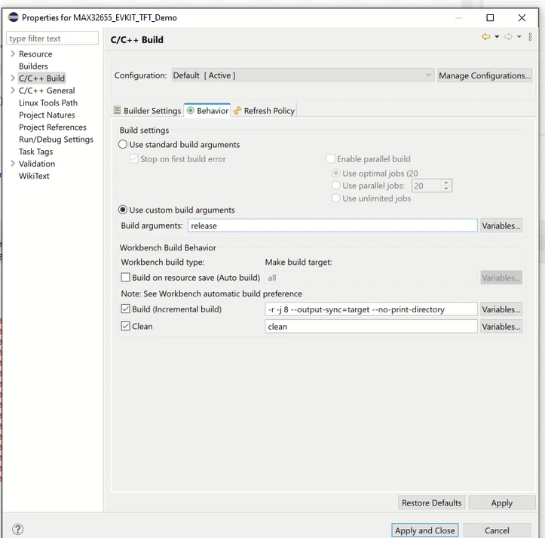

1. Build the project.
2. .bin file is generated under build folder.

Converting the .bin File to the .msbl File Format

The .msbl file is generated automatically by using a .msbl generator.

1. Navigate to the directory consisting of msbl generator and the .bin file to be converted in the **MinGW** window.

2. Enter the following command in the **MinGW** window to convert the .bin (max78000.bin as an example) application to a .msbl file:

*./msblGenWin32.exe max78000.bin MAX78000 8192 max78000_key.txt*

3. “*max78000.msbl” file will be generated*

Note that the msblGenWin32.exe, the binary file and the key text file might be in different directories. Therefore, don’t forget to give the path of them individually using the command in step 2.

Programming Keys to the Bootloader

To program the keys to the MAX78000 by using the MAX78000 bootloader, use the following steps:

At the command prompt or in the PowerShell window, enter the following commands, replacing COMxx with the correct USB serial device COM port found in section Programming the MAX32630FTHR at step 4.b. The “download_fw_over_host.exe” executable file resides in the MAX78000_MSBL directory.

*./download_fw_over_host.exe -k max78000_key.txt -p COMXX*

Note that the shared keys are sample one and they should be updated accordingly before programming keys. Moreover, key cannot be updated unless SWD lock/unlock procedure and this procedure can be processed up to 4 times.

MSBL File Programming

To flash the application to the MAX78000 by using the MAX78000 bootloader, use the following steps:

At the command prompt or in the PowerShell window, enter the following commands, replacing COMxx with the correct USB serial device COM port found in section Programming the MAX32630FTHR at step 4.b.

*./download_fw_over_host.exe -f MAX78000_Hello_World.msbl -p COMXX*

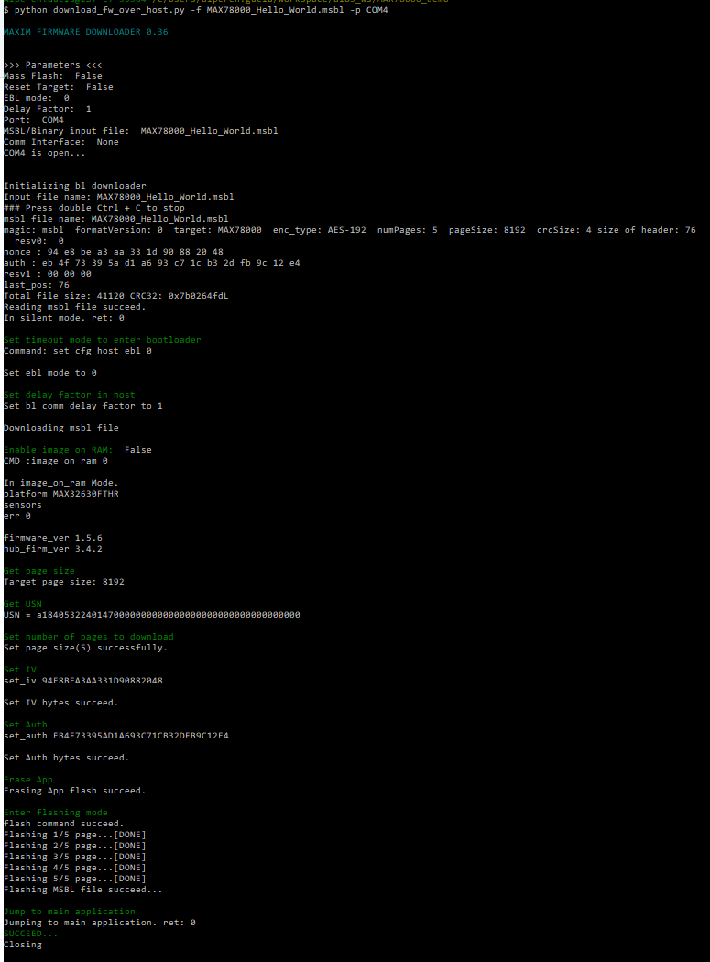

Figure 7. Downloading firmware with the download_fw_over_host.exe

1. The application has now been flashed to the chip. For advanced usage of flasher script, refer to the *Firmware_downloader_usage.txt* file.

Locking the SWD Interface

To lock the SWD Interface, use the following steps:

1. At file max78000_bl_config.cfg: Change the swd_lock value to 1 and save the file.

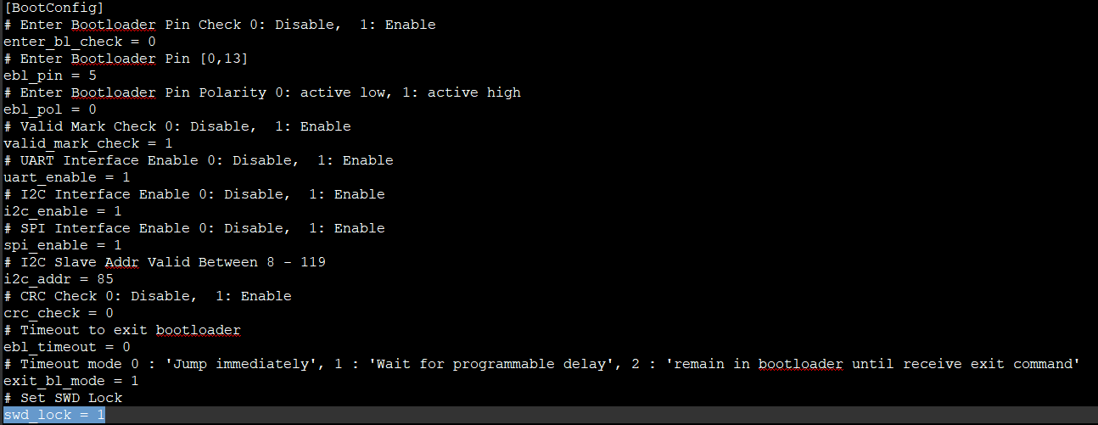

Figure 8. Bootloader Configuration File.

1. Run the following command:

*configure_bootloader.exe -f max78000_bl_config.cfg -p COMXX*

1. Disconnect the micro-USB cable.
2. Reconnect the micro-USB cable. SWD is locked now.

Unlocking the SWD Interface

To unlock the SWD Interface, use the following steps:

* 1. At file max78000_bl_config.cfg: Change the swd_lock value to 0 and save the file.
  2. Run the following command:

*./configure_bootloader.exe -f max78000_bl_config.cfg -p COMXX*

* 1. Disconnect the micro-USB cable.
  2. Reconnect the micro-USB cable Now key and application are erased, SWD is unlocked, so a new key can be loaded.

Note that SWD can only be locked and unlocked up to 4 times.

Revision History

|  |  |  |  |
| --- | --- | --- | --- |
| REVISION NUMBER | REVISION DATE | DESCRIPTION | PAGES CHANGED |
| 0 | 3/21 | Initial release | — |
| 1 | 3/21 | * Programming the MAX78000 with the Bootloader Firmware section added * Pin Connection between the MAX32630FTHR and * MAX78000FTHR Figure added * Programming Keys to the Bootloader Section added | 5, 8, 16 |
| 2 | 5/21 | * SWD Lock and Unlock Sections are Added | 16,17 |
| 3 | 8/21 | * Generating Bootloader Compatible Binary Using Maxim SDK Project Section added | 15 |
| 4 | 10/21 | * Improve readability | — |
| 4.1 | 11/21 | * General Improvements * Update logo |  |
| 4.2 | 12/24 | * General Improvements * Generating Bootloader Compatible Binary Using Maxim SDK Project Section updated | 8, 14, 15 |

©2021 by Maxim Integrated Products, Inc. All rights reserved. Information in this publication concerning the devices, applications, or technology described is intended to suggest possible uses and may be superseded. MAXIM INTEGRATED PRODUCTS, INC. DOES NOT ASSUME LIABILITY FOR OR PROVIDE A REPRESENTATION OF ACCURACY OF THE INFORMATION, DEVICES, OR TECHNOLOGY DESCRIBED IN THIS DOCUMENT. MAXIM ALSO DOES NOT ASSUME LIABILITY FOR INTELLECTUAL PROPERTY INFRINGEMENT RELATED IN ANY MANNER TO USE OF INFORMATION, DEVICES, OR TECHNOLOGY DESCRIBED HEREIN OR OTHERWISE. The information contained within this document has been verified according to the general principles of electrical and mechanical engineering or registered trademarks of Maxim Integrated Products, Inc. All other product or service names are the property of their respective owners.