# Introduction

This document is the proposed software specifications for a graphical user interface (GUI) software to run under Windows 10 x64, specifically to read and write the DS2413 1-Wire Dual-Channel Addressable Switch devices. There are no .NET examples currently for these chips available for customers.

# Description

The software shall consist of a Microsoft GUI written in C# that allows for exercising both GPIO channels and reading both latch states and pin states.

# Hardware Setup and Test Fixture Requirements

* 2 DS2413 devices in TSOC packages (DS2413P+).
* DS9120P+ 1-Wire socket board (comes with RJ12 male/male cable). It can hold 2 DS2413 devices.
* DS9490R and/or DS9481-3C7 1-Wire adapter.
* Test circuit materials. This shall include a breadboard, a minimum of 1 LED, two 1KOhm resistors, 6 Dupont wires (4 female-male, and 2 male-male).
* Connect 1-Wire adapter of choice to the PC on a spare USB port. Plug in RJ12 cable to adapter with the other end plugged into DS9120P+. Insert 2 DS2413 devices into clamshell socket. Use the test circuit materials to create the circuit in Figure 1 below.

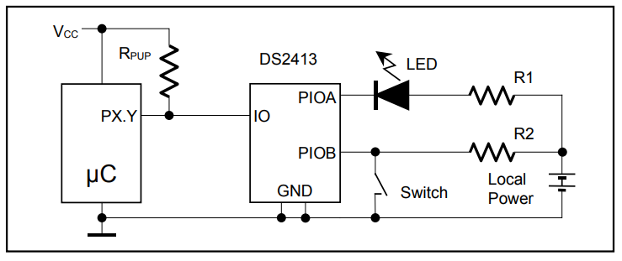

Figure 1. DS2413 Test Circuit Taken from Data Sheet

# Software Development Tools Requirements

* Visual Studio 2017 capable of writing/compiling C# programs.
* Microsoft SignTool.exe. This is used to digitally sign files. This comes as part of Visual Studio (use Visual Studio’s command-line to access it).
* Maxim’s Authenticode code-signing certificate. It is located here: <https://confluence.maxim-ic.com/display/SET/Digital+Signing+Instructions>.

# Software Library Dependencies

* .NET version 4.8 developer pack runtime installed from here: <https://dotnet.microsoft.com/en-us/download/dotnet-framework/net48>.
* Analog Device’s LookAndFeel.dll for ADI-approved GUI components such as a splash screen, icon, buttons, etc. This is available in the following Subversion repository: <https://svn.maxim-ic.com/svn/tts/ADI_TTSGenericGUITemplate/trunk/ADI_TTS_Template/packages/LookAndFeel.1.1.0/lib/net48>.
* It assumes that the 1-Wire Drivers have been installed for USB DS9490R adapter support but should work stand-alone without 1-Wire Drivers for the DS9481R-3C7 PC adapter. Download the 1-Wire Drivers here: <https://www.maximintegrated.com/en/products/ibutton-one-wire/one-wire/software-tools/drivers.html>.
* The 1-Wire .NET library, OneWireLinkLayer.dll, which is taken from the 1-Wire SDK for Windows located here: <https://www.maximintegrated.com/en/design/design-tools/applications-software/product-software/ibutton/software/1wire/software-tools/sdk-windows.html>.

# Operation or Software Flow

When run, the GUI software will do the following before the main Window appears:

1. Automatically discover the first 1-Wire adapter it can. It does this by first looking to see if a DS9490R 1-Wire USB adapter exists on “USB1”. USB1 is mapped as a copy of the first Windows “handle” to the hardware device that was most recently plugged in. If it doesn’t find one there, it will attempt to find a DS9481R-3C7 serial port 1-Wire adapter on COM1 through COM64. If no adapters are found, the GUI will generate a “MessageBox” error message before the main Window appears and before the Splash Screen is visible (see step 2). Figure 1 shows the error message.

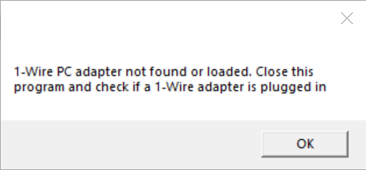

Figure 2. No Adapter Found Error.

1. The GUI will display a splash screen before the main window appears (using the LookAndFeel.dll). It will appear for 3 seconds and give the name of the software, along with copyright information, version information, and how to contact Analog Devices. It also has a checkbox that a user can check to disable the splash screen as needed. Figure 2 shows the splash screen. To re-enable the splash screen, the user can click the “About” menu item from the main menu of the main GUI window as shown in Figure 3 below. This is the same splash screen but dismisses with a click of the “OK” button.

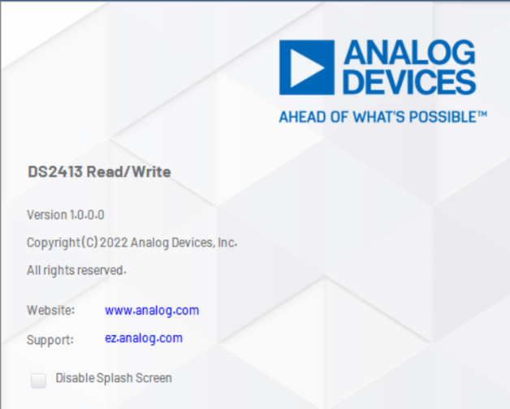 

Figure 3. Splash Screen on Startup Figure 4. About Screen with OK Button

When the main Window appears, it will contain a Search button that searches for 1-Wire switches when clicked, a ListView to display the serial numbers of the DS2413 devices found from a search, and an area to exercise the DS2413 selected from the ListView (a.k.a., the “Device List”). This area has 2 GUI toggle switches allowing the user to toggle the latch states of PIOA and PIOB, along with a read-only area to display the pin states with radio boxes. It will contain a GUI label that displays the selected DS2413’s serial number, along with a PIO Read button that reads the status of both latches when clicked. See Figure 5 below for a screenshot.

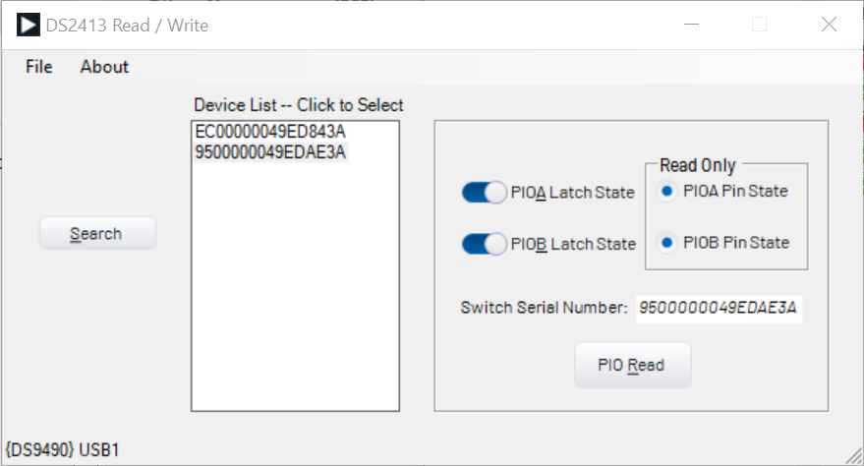

Figure 5. GUI Main Window

## PIOA and B Latch State Toggle Switches

When the PIOA or PIOB Latch State GUI Toggle switch is clicked, the program shall perform a PIO Access Write command setting the hardware’s specific latch states to the value indicated by the GUI. For immediate effect, this shall be followed by a PIO Access Read command sequence to display the results of both PIO pin states (and latch states).

## Reading

The button labeled “PIO Read” on the GUI (see Figure 5) simply performs a PIO Access Read command sequence and reads the states of both switches, including latch states and pin states, and updates the GUI to show what these are (i.e., the GUI toggle switches, and the GUI radio boxes).

## Other GUI Functions

1. The Status Bar. This is at the very bottom of the main Window and shall either display “No Adapter Found” or the adapter and port, such as “{DS9490} USB1” connected as shown in Figure 4.
2. Main Menu. See Figure 4. This is located at the top of the main window and consists of “File” and “About” menu items. When clicking File, it will present a sub menu item called “Exit”. This shall cause the program to exit. Clicking About will cause the “About Screen” to appear as shown in Figure 3.

# Limitations

* Testing will only be done on Windows 10 x64.
* Only DS2413 devices will be tested.