# Introduction

This document gives a detailed description of the test plan results performed on the DS2413 Read/Write Example. This is a GUI software example intended to run on Windows 10 x64 and enables an end customer to read and write the PIOA and PIOB latch states and read the PIOA and PIOB pin states.

# Test Equipment Used

The following is the test equipment used:

* Two DS2413 devices in TSOC packages (DS2413P+).
* DS9120P+ 1-Wire socket board (comes with RJ12 male/male cable). It can hold two DS2413P+ devices.
* DS9490R and/or DS9481-3C7 1-Wire adapter.
* Test circuit materials. This shall include a breadboard, a minimum of 1 LED, two 1KOhm resistors, 6 Dupont wires (4 female-male, and 2 male-male).
* Connect 1-Wire adapter of choice to the PC on a spare USB port. Plug in RJ12 cable to adapter with the other end plugged into DS9120P+. Insert 2 DS2413 devices into clamshell socket. Use the test circuit materials to create the circuit in Figure 1 below. See Figure 2 below for an image of an actual test setup.

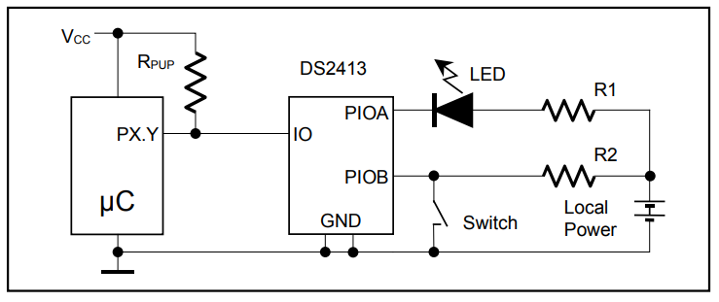

*Figure 1. DS2413 Test Circuit (from Data Sheet)*

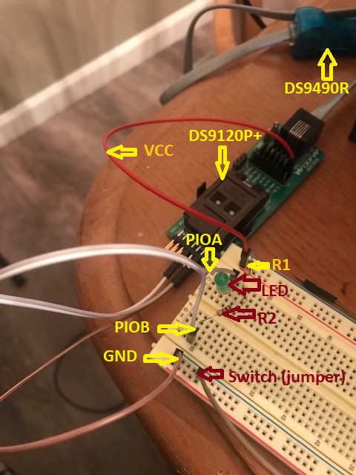

*Figure 2. Test Setup*

Tests Conducted

|  |  |  |  |
| --- | --- | --- | --- |
| Case | Description | Test Procedure | Result |
| Splash Screen Disable | The splash screen can be disabled by checking a box on the splash screen. | Upon startup, the splash screen will appear for 3 seconds. On the splash screen is a checkbox labeled “Disable Splash Screen”. Click it to put a check in the checkbox. Exit the program and run it again. The splash screen should not display. | Pass |
| Splash Screen Enable | The splash screen, when disabled, can be re-enabled. | With splash screen disabled, run the program. From the main window, click “About” from the main menu. It will have a check in the check box labeled “Disable Splash Screen”. Click the checkbox to remove the check. Click OK and then exit the program. The splash screen should appear upon the next startup of the program. | Pass |
| No Adapters Found | When program is launched, it automatically detects the first 1-Wire adapter. It should handle the error of no adapters found. | With no adapter plugged in, start the program. It should eventually give an error and show the string “No Adapter” in the main window’s status bar. | Pass |
| File Exit | Clicking File->Exit should close the program. | From the main menu on the main window, click on the “File” menu item, followed by clicking on the Exit sub-menu item. The program should close. | Pass |
| Latch Inputs:  AN, BN, SN | Latch Inputs:  PIOA Not Conducting  PIOB Not Conducting  Switch Not Conducting | Setup latch states with the GUI toggle switches. Remove grounding jumper wire from PIOB on test circuit. Click PIO Read button. GUI output should be: | PASS |
| Latch Inputs:  AN, BN, SC | Latch Inputs:  PIOA Not Conducting  PIOB Not Conducting  Switch Conducting | Setup latch states with the GUI toggle switches. Ground PIOB with Dupont jumper wire. Click PIO Read button. GUI output should be: | PASS |
| Latch Inputs:  AN, BC, SN | Latch Inputs:  PIOA Not Conducting  PIOB Conducting  Switch Not Conducting |  | PASS |
| Latch Inputs:  AN, BC, SC | Latch Inputs:  PIOA Not Conducting  PIOB Conducting  Switch Conducting |  | PASS |
| Latch Inputs:  AC, BN, SN | Latch Inputs:  PIOA Conducting  PIOB Not Conducting  Switch Not Conducting |  | PASS |
| Latch Inputs:  AC, BN, SC | Latch Inputs:  PIOA Conducting  PIOB Not Conducting  Switch Conducting |  | PASS |
| Latch Inputs:  AC, BC, SN | Latch Inputs:  PIOA Conducting  PIOB Conducting  Switch Not Conducting |  | PASS |
| Latch Inputs:  AC, BC, SC | Latch Inputs:  PIOA Conducting  PIOB Conducting  Switch Conducting |  | PASS |

# Conclusion

The ds2413_read_write.exe GUI works as specified.