Team: Crawling in My Skin

**1.**

1.

1. A.

| (1,2,3,4,5) | | (1,6,7) | = | (1) | = 1

| (1,2,3,4,5) | | (1,6,7) | = | (1,2,3,4,5,6,7) | = 7

$$⇒JC=\frac{1}{7}$$

B.

| (1,2,3,4,5) | | (2,4,6,8) | = | (2,4) | = 2

| (1,2,3,4,5) | | (2,4,6,8) | = | (1,2,3,4,5,6,8) | = 7

$$⇒JC=\frac{2}{7}$$

C.

| (1,6,7) | | (2,4,6,8) | = | (6) | = 1

| (1,6,7) | | (2,4,6,8) | = | (1,2,4,6,7,8) | = 6

1. | (Greek Alphabet) | | (Latin Alphabet) | = | (A, B, E, Z, H, I, K, M, N, O, P, T, Y, X) | = 14

| (Greek Alphabet) | | (Latin Alphabet) | =

| (Greek Alphabet) | + | (Latin Alphabet) | - | (A, B, E, Z, H, I, K, M, N, O, P, T, Y, X) | =

24 + 26 – 14 = 36

$$⇒JC=\frac{14}{36}=7/18$$

Jaccard coefficient is a metric to compare the similarity between two sets.

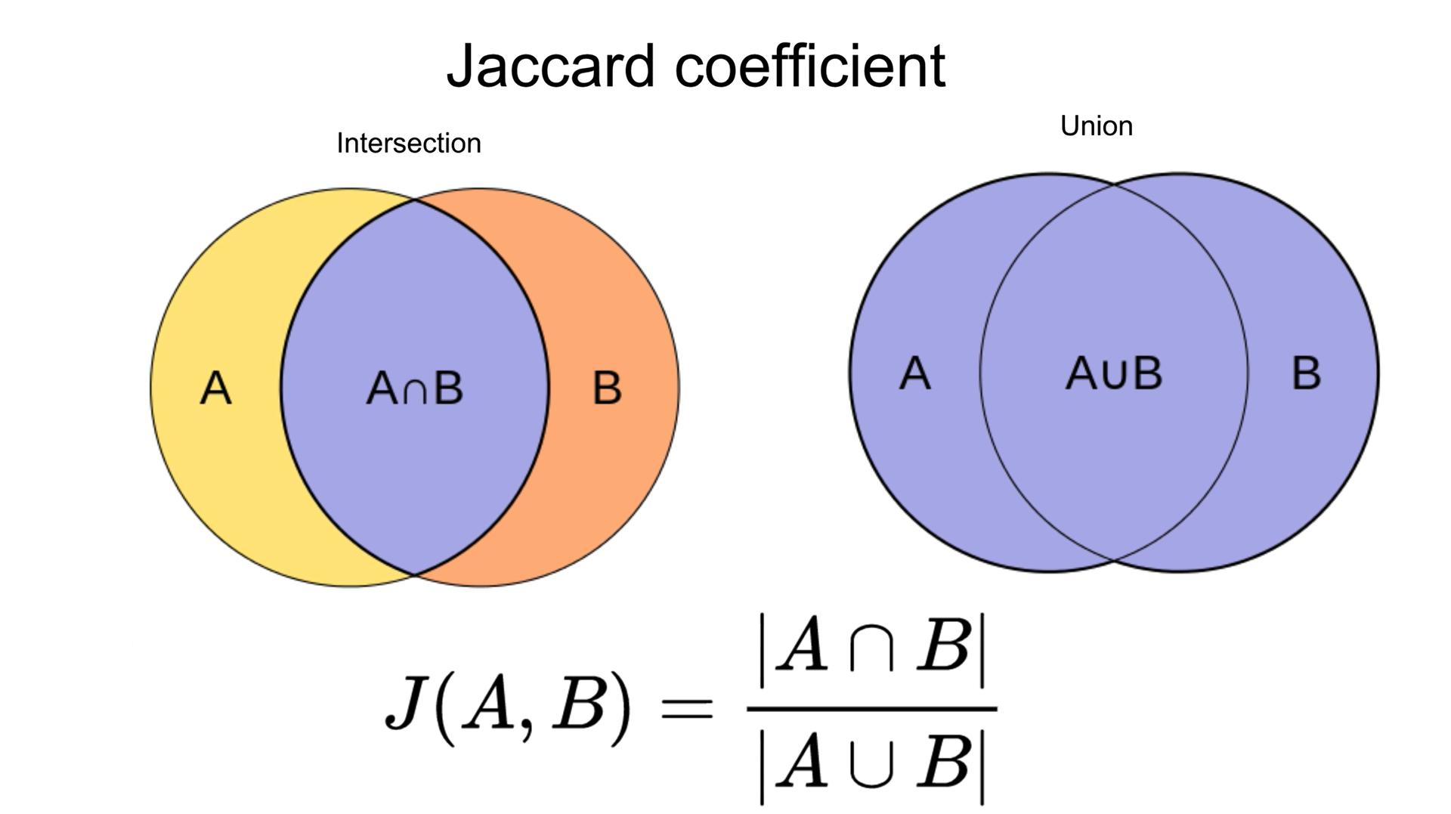

Figure 1 Jaccard coefficient.

2.

Figure 2 Code output.

The code itself located at the HW1 folder in our GitHub repository.

**3.**

1. [MyProtein](https://www.myprotein.com/) is a company website that sells sports nutrition and equipment, a variety of protein powders, workout supplements, athletic equipment and more. The users can use the website to get access to different types of supplements, their description, suggestion for usage and more relative data. Their catalogue also includes gym equipment, clothes, and foods. For each item they can see the price, other users review about the product and suggestions on relative products.
2. 1. “sucralose”, we would like to find specific ingredients contained in a product description. Each item has a description, each food item has an ingredient list. From which we will pull the data.

2. “Gym equipment”, users need to search “Gym” and by looking through different related and unrelated items, to find what they are looking for. Each item has item details, for example gym equipment labelled as “Hard accessory”, with that we will know to access the right products.

3. “<product> price: 40 - 70”, there is a specific price range on the website, which we would like to make more flexible. Give the user the option to set the range. Each item has a price, when the user specifies price or price range, sort all the items in that price range and display them to the user.