**STEPITAcademyMoldova**

**Specialitatea: Elaborare software**

*Susținerea a avut loc: _______________ (data)*

*cu calificativul __________________*

*Manager procesului de studii: ____________________ (semnătura)*

**PROIECT DE DIPLOMĂ**

Tema:

„Elaborarea aplicației web bibliotecă de carți audio ( MyAudioLib )”

The theme:

„ Development of the web application library of audio books ( MyAudioLib )”

Тема:

” Разработка веб-приложения библиотеки аудиокниг ( MyAudioLib )”

Executor, studentul: Roman Maxim

**Grupa**: LPD2021ro

**Conducător:** _________________ (semnătura)

_____Panco Tristan_______

(Nume, Prenumele)

___________________________ (calificativul recomandat)

**Comisia de examinare pentru susținerea proiectelor de diploma:**

_____________________ (semnătura)

___________________________ (semnătura)

___________________________ (semnătura)

________________________________________ (Nume, Prenume)

________________________________________ (Nume, Prenume)

________________________________________ (Nume, Prenume)

**Chișinău 2022**

CUPRINS

INTRODUCERE 2

CAPITOLUL 1 3

1.1 3

CAPITOLUL 2 4

CAPITOLUL 3 5

BIBLIOGRAFIA 6

# INTRODUCERE

Scopul proiectului **MyAudioLib** este de a crea o aplicație web care va oferi utilizatorilor acces la o colecție de cărți audio unde ei vor avea posibilitatea de a asculta aceste cărți cu ajutorul player-ului audio de pe pagina cărții selectate. Pe lîngă aceasta ei vor avea posibilitatea de a î-și exprima părerea fața de oricare din aceste cărți prin adaugarea comentariilor sau sistemul de like/dislike iar cărțile care le vor fi mai aproape sufletului ei le pot adăuga in lista de cărți favorite pentru acces mai rapid la acestea .

Cărtile în colecție vor fi adaugate, modificate sau eliminate de catre utilizatorii cu drept de **admin** cu ajutorul funcționalului oferit în aplicație.

# CAPITOLUL 1

## 1.1

# CAPITOLUL 2

## 2.1 Etapele de realizare:

### 2.1.1 – Proiectarea schematica a tabelelor și legaturilor intre tabelele bazei de date:

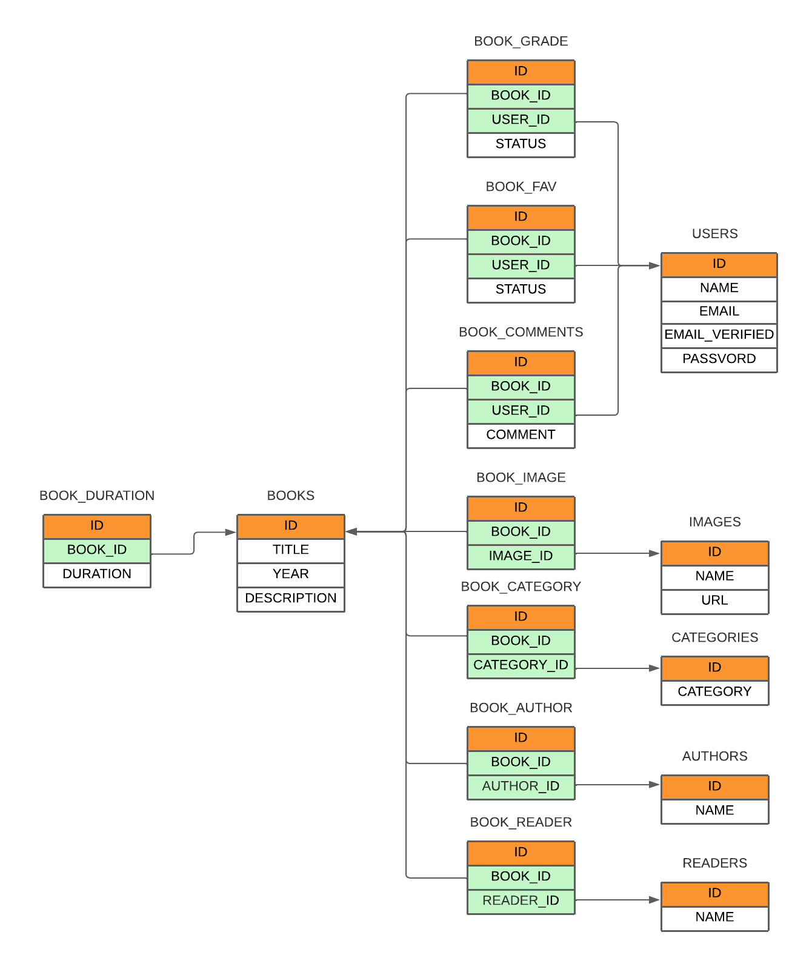

### 2.1.2 - Proiectarea schematica a aspectului site-ului pe diferite dispozitive:

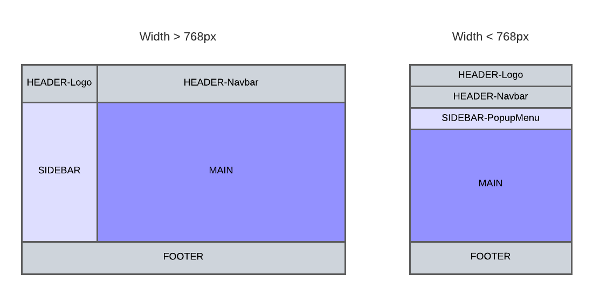

# CAPITOLUL 3

# BIBLIOGRAFIA

Webografia

1. <https://spring.io/guides>

2. <https://spring.io/projects/spring-restdocs>

3. https://docs.spring.io/spring-restdocs/docs/2.0.5.RELEASE/reference/html5/ 4. <https://angular.io/>

Resurse Aditionale:

1. <https://spring.io/guides/tutorials/spring-security-and-angular-js/> 2. <https://www.javatpoint.com/angular-spring-crud-example>

3. <https://www.split.io/blog/crud-app-spring-boot-angular/>

[4. https://www.javaguides.net/2021/01/angular-spring-boot-rest-api-example.html](https://www.javaguides.net/2021/01/angular-spring-boot-rest-api-example.html)

5. <https://ng-bootstrap.github.io/#/home>

6. <https://www.youtube.com/watch?v=Gx4iBLKLVHk> 7. <https://www.youtube.com/watch?v=DKlTBBuc32c> 8. <https://www.flaticon.com/>

9. <https://getbootstrap.com/> 10[.https://codepen.io/mandy13511/pen/zYORLrJ](https://codepen.io/mandy13511/pen/zYORLrJ) [11.https://www.javaguides.net/2020/06/pagination-and-sorting-with-spring-](https://www.javaguides.net/2020/06/pagination-and-sorting-with-spring-boot-thymeleaf-spring-data-jpa-hibernate-mysql.html)

[boot-thymeleaf-spring-data-jpa-hibernate-mysql.html](https://www.javaguides.net/2020/06/pagination-and-sorting-with-spring-boot-thymeleaf-spring-data-jpa-hibernate-mysql.html) 12[.https://www.javatpoint.com/angular-spring-search-field-example](https://www.javatpoint.com/angular-spring-search-field-example) 13[.https://www.bezkoder.com/angular-11-spring-boot-crud/](https://www.bezkoder.com/angular-11-spring-boot-crud/) 14[.https://www.bezkoder.com/spring-boot-pagination-filter-jpa-pageable/](https://www.bezkoder.com/spring-boot-pagination-filter-jpa-pageable/) 15[.https://www.bezkoder.com/angular-11-jwt-auth/](https://www.bezkoder.com/angular-11-jwt-auth/) [16.https://www.bezkoder.com/spring-boot-security-postgresql-jwt-](https://www.bezkoder.com/spring-boot-security-postgresql-jwt-authentication/)

[authentication/](https://www.bezkoder.com/spring-boot-security-postgresql-jwt-authentication/)

17[.https://www.bezkoder.com/spring-boot-refresh-token-jwt/](https://www.bezkoder.com/spring-boot-refresh-token-jwt/) 18[.https://www.npmjs.com/](https://www.npmjs.com/)

19[.https://ng-select.github.io/ng-select#/data-sources](https://ng-select.github.io/ng-select#/data-sources) 20[.https://freshdesignweb.com/css-registration-form-templates/](https://freshdesignweb.com/css-registration-form-templates/) 21[.https://www.bezkoder.com/spring-boot-upload-file-database/](https://www.bezkoder.com/spring-boot-upload-file-database/) 22[.https://www.bezkoder.com/angular-11-spring-boot-file-upload/](https://www.bezkoder.com/angular-11-spring-boot-file-upload/) 23.Mail server <https://www.baeldung.com/spring-email>

[24.https://github.com/eligrey/FileSaver.js/wiki/Saving-a-remote-file#using-http-header](https://github.com/eligrey/FileSaver.js/wiki/Saving-a-remote-file#using-http-header)

[25.https://www.codejava.net/frameworks/spring-boot/spring-security-forgot-password-tutorial](https://www.codejava.net/frameworks/spring-boot/spring-security-forgot-password-tutorial)