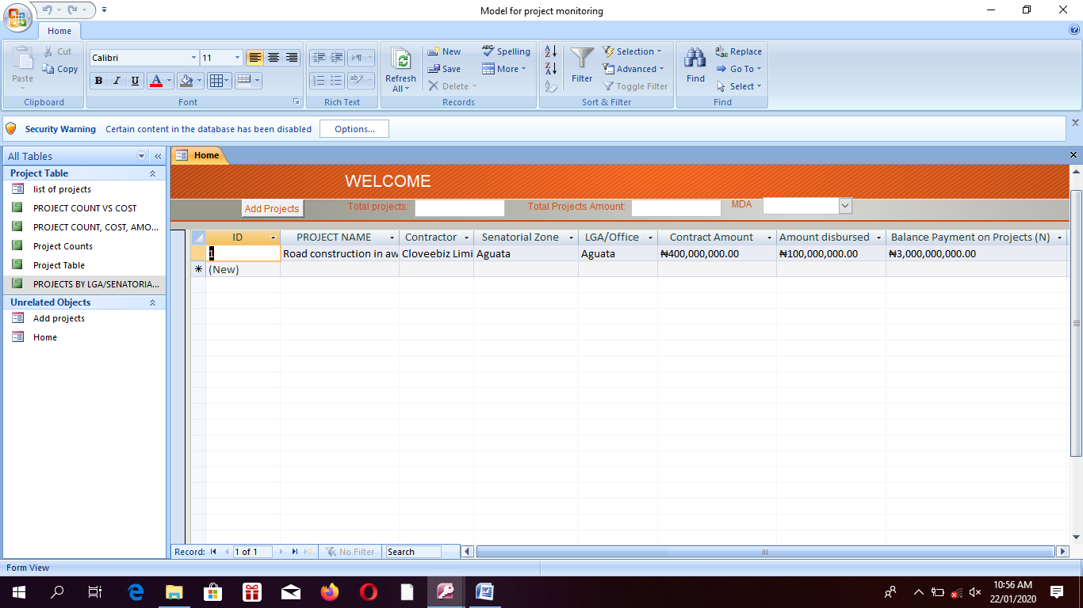

These will be all the fields to add new Projects. After filling them you save and the record will appear on the list of projects in the dashboard

Here will show total number of projects added in the application

You click Here to add New projects

Here will be list of all the projects added

Here will be search. You can search the record with any of the field e.g project name , LGA/office, MDA etc.

Here will show list of the MDA. So any of the MDA you select will bring out only projects linked to that MDA

The total sum of the project amount

The picture up is all about the dashboard

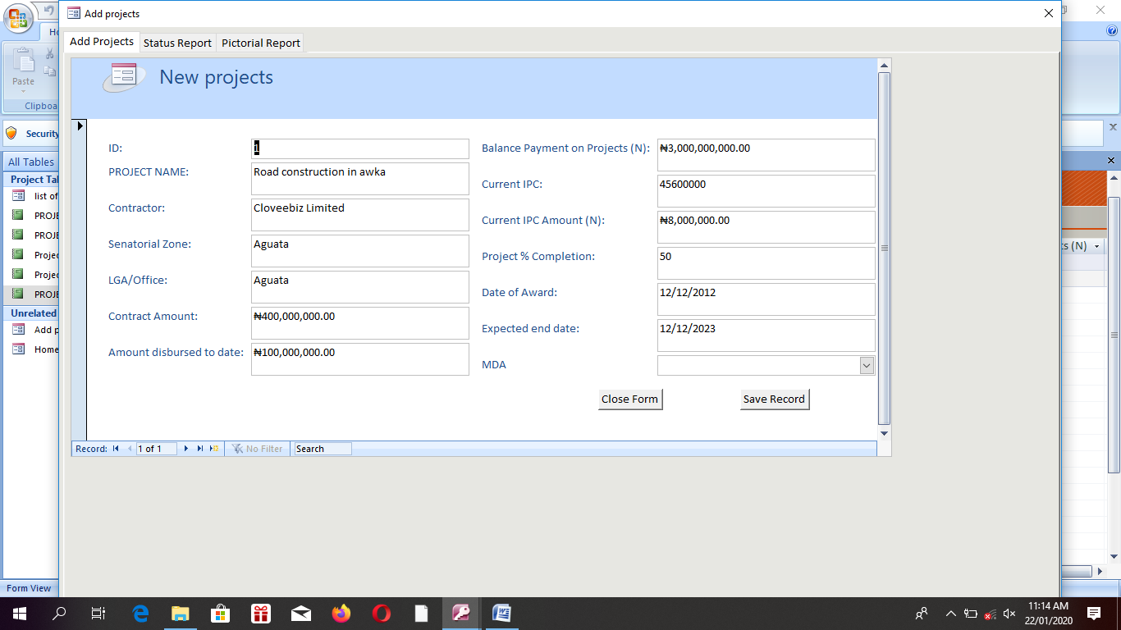

These all about adding a new project

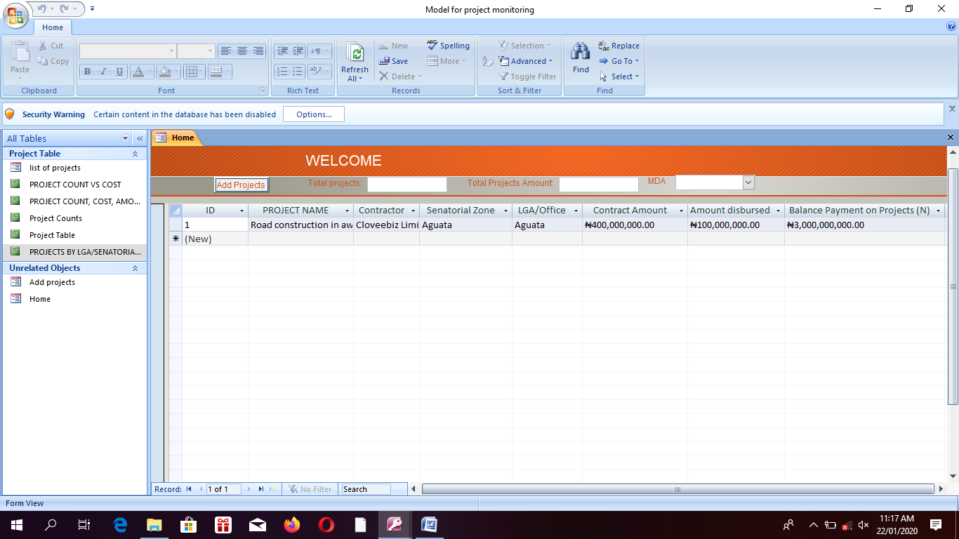

Here will show information about the project you click on

Any project you add should be clickable. For example, I have added a project called road consruction, if I click on it , it should open up like the picture in fig 2.0, 2.1 and 2.2

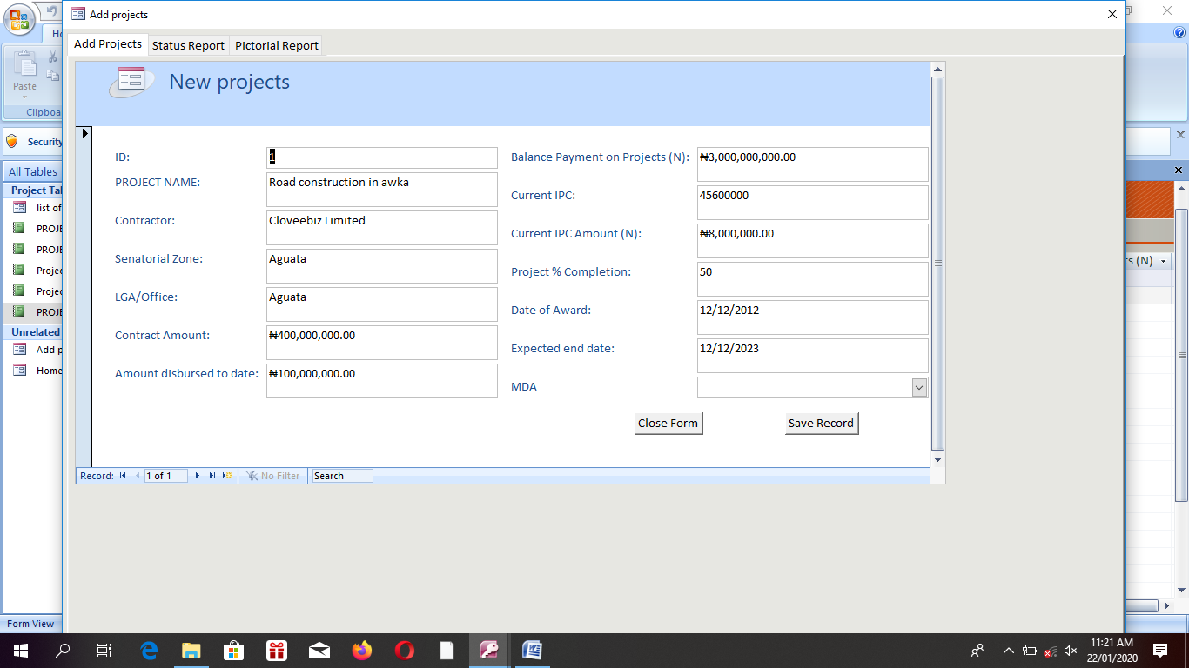

Fig 2.0

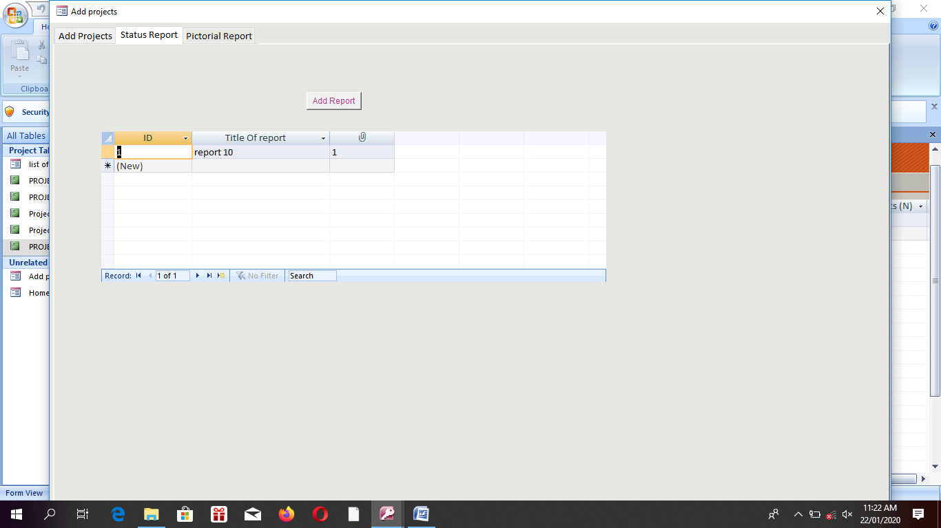

Here will be list of all the file uploaded with title and dates so that someone In charge of viewing reports can download then later and read

From this button your upload report in pdf or Microsoft word

Fig. 2.1

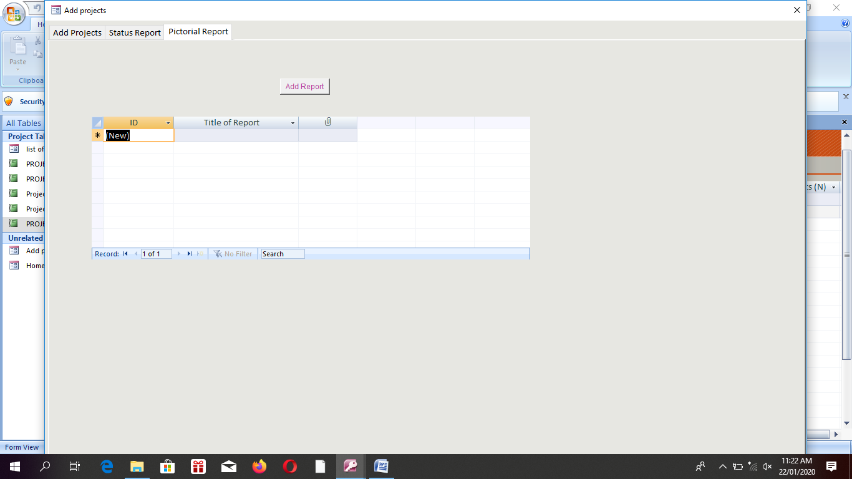

Fig 2.1 and 2.2 work the same way

Fig 2.2

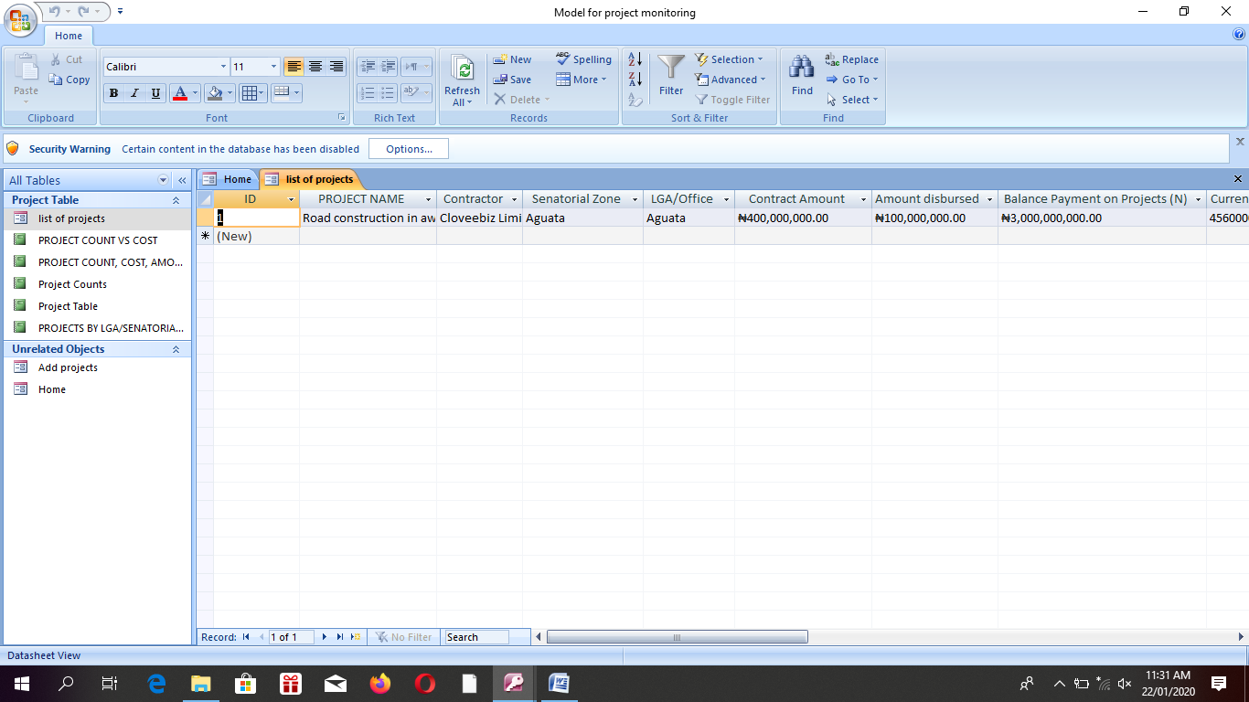

At end should sum total of all the amount of all this field showing on the dashboard

Here will show list of all the projects added just the was as the dash board

THE REPORTS;

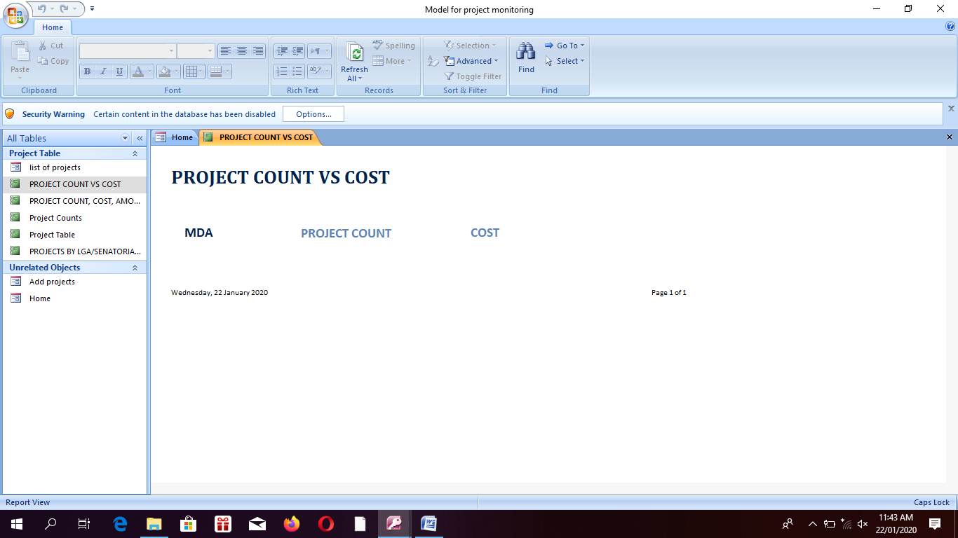

Under MDA should output all the list of the MDA, under PROJECT COUNT, should output number of projects linked to each of the MDA, and COST will output total cost of projects linked to them. For example: 1. MDA: Ministry of works, PROJECT COUNT: 4, TOTAL COST: 2,000,0000, 2. MDA: Ministry of agric, PROJECT COUNT: 3, TOTAL COST: 1,000,0000,

Follow the same process for all the other four report, you can also add graphs.

Don’t forget the application will have login details and admin can create other users with privileges.