IT 2110 – Android Mobile App Development   
**Lab 7 – Layouts (15 Points)**

**Description:**Exploring basic layout configurations

**Instructions:** for each screenshot below, use the requirements and create a layout. Paste a screenshot of the layout in a running AVD and the XML code (paste the full XML code as opposed to a screenshot) below. [5 points per problem]

**Deliverables:**Please submit screenshots and XML code for your layouts in this document after each question.

**Layout 1:**

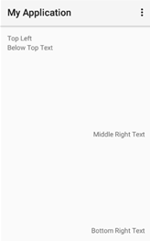

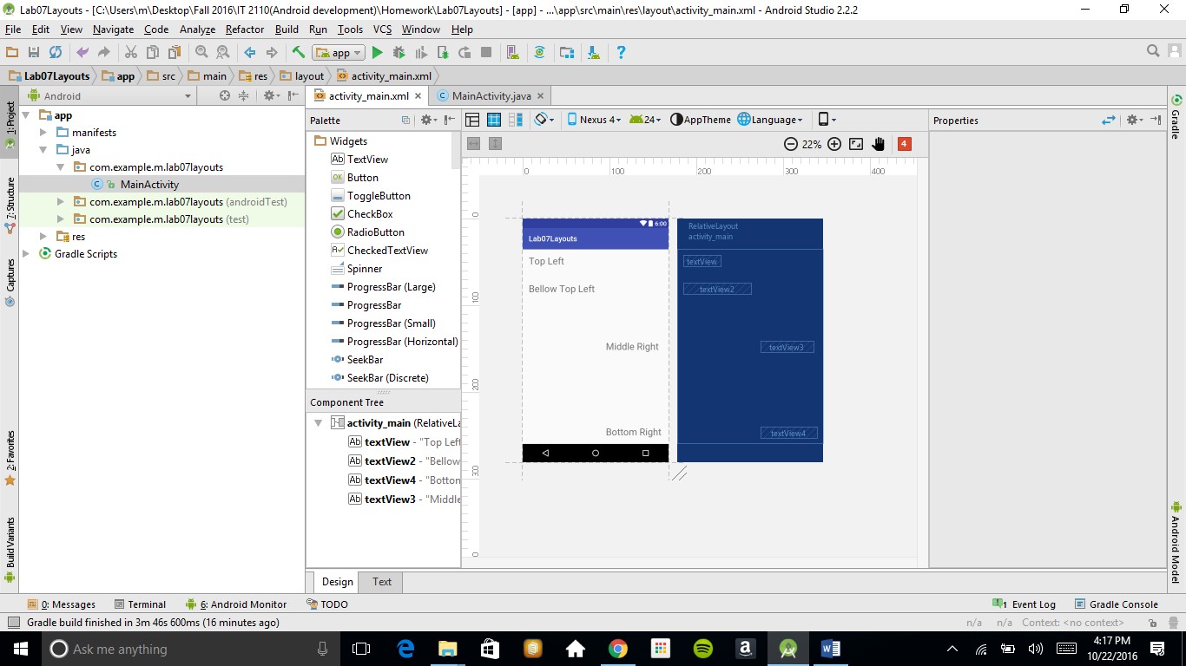

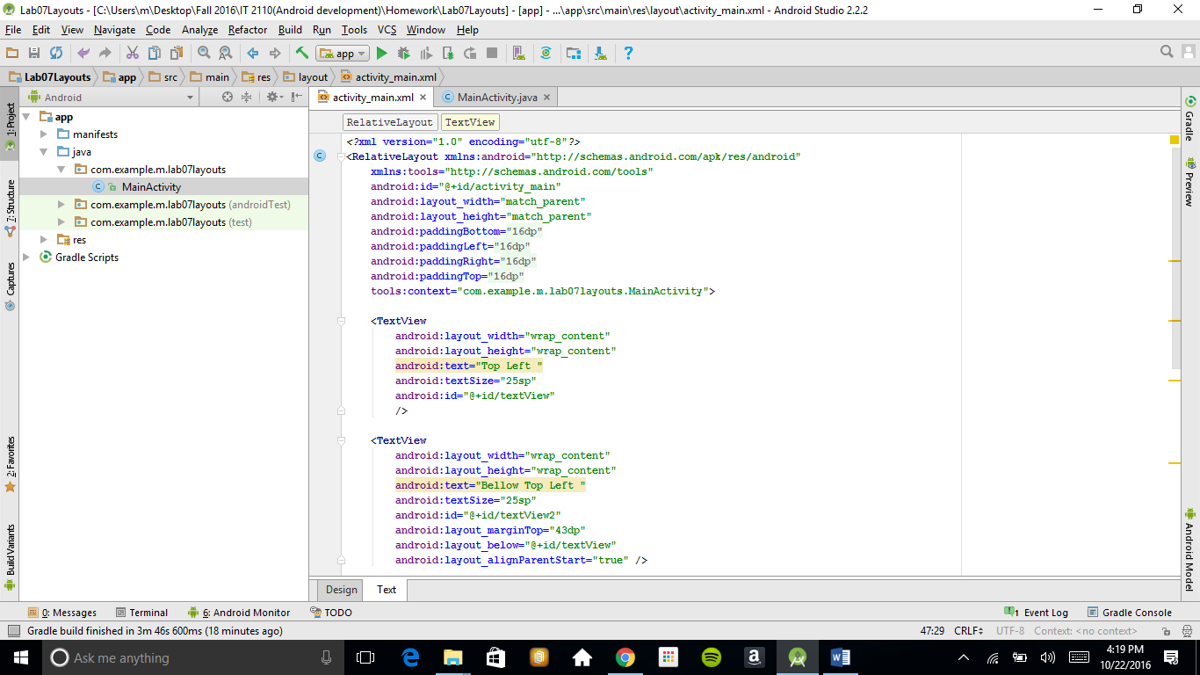

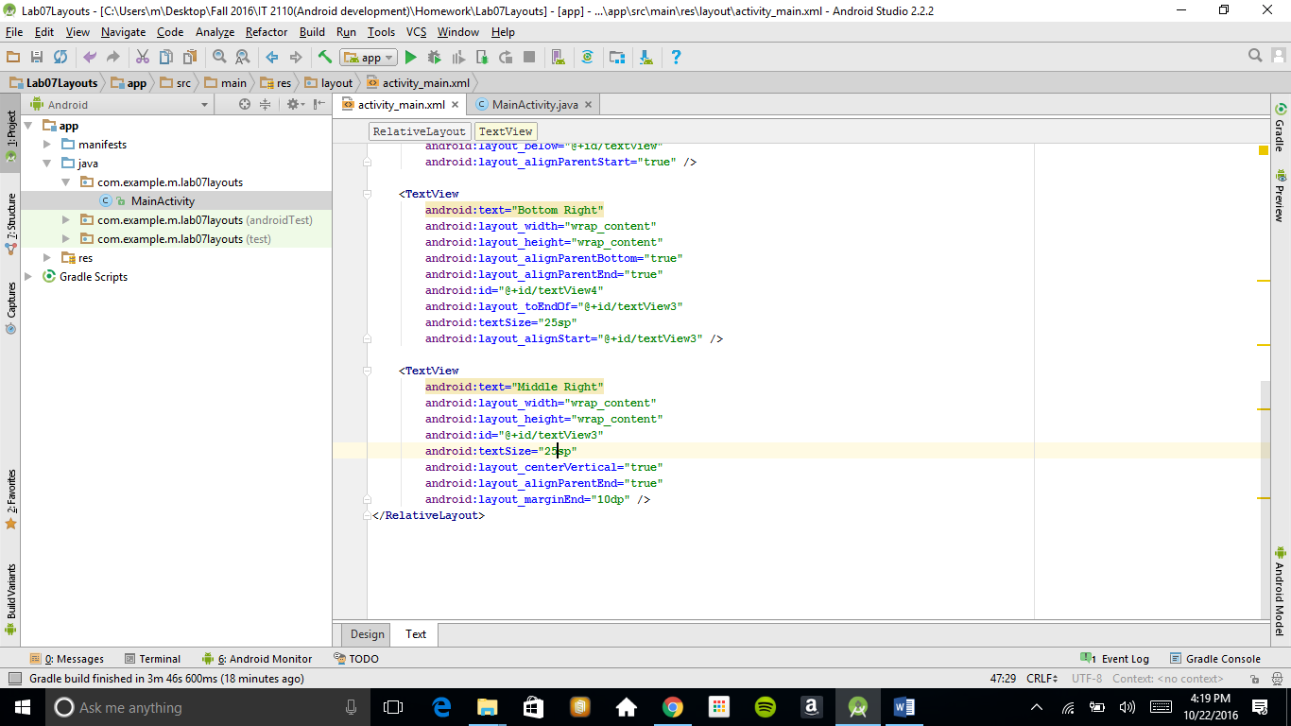

**Requirements:**

* RelativeLayout
* 4 TextView widgets with width and height set to wrap_content
* Your layout should look the same as the image above

**Layout 2:**

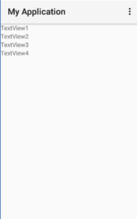

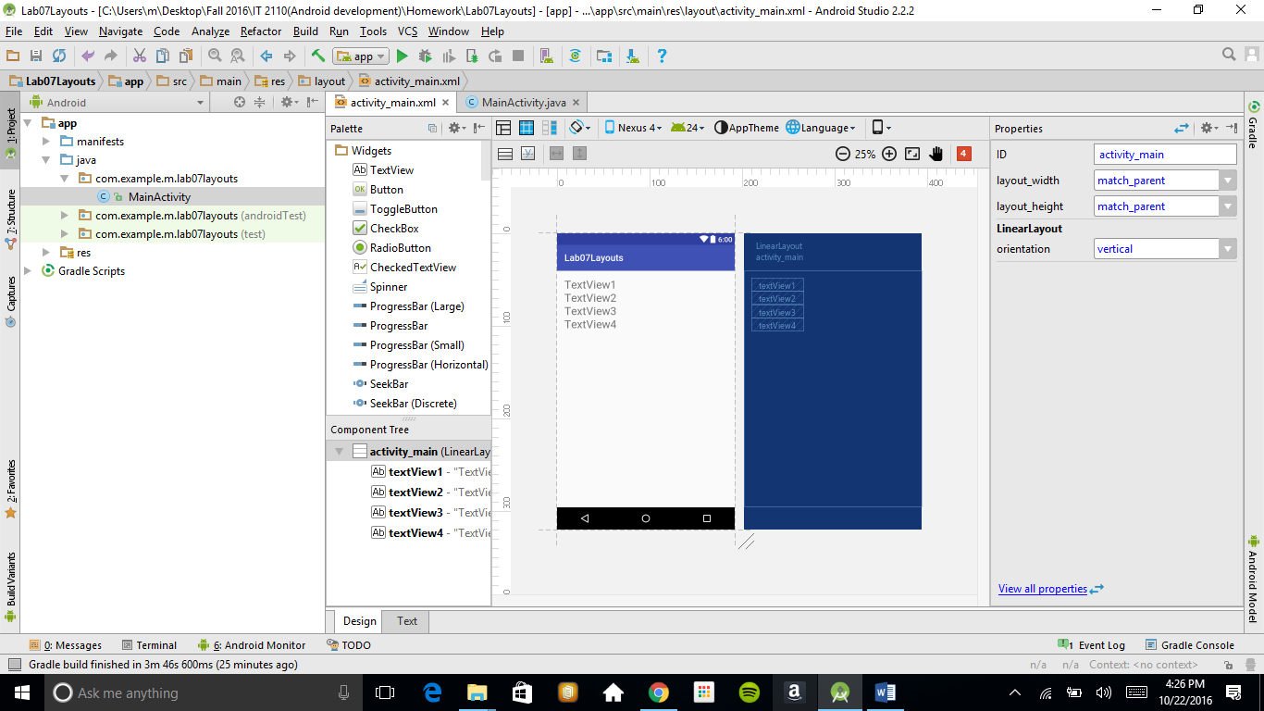

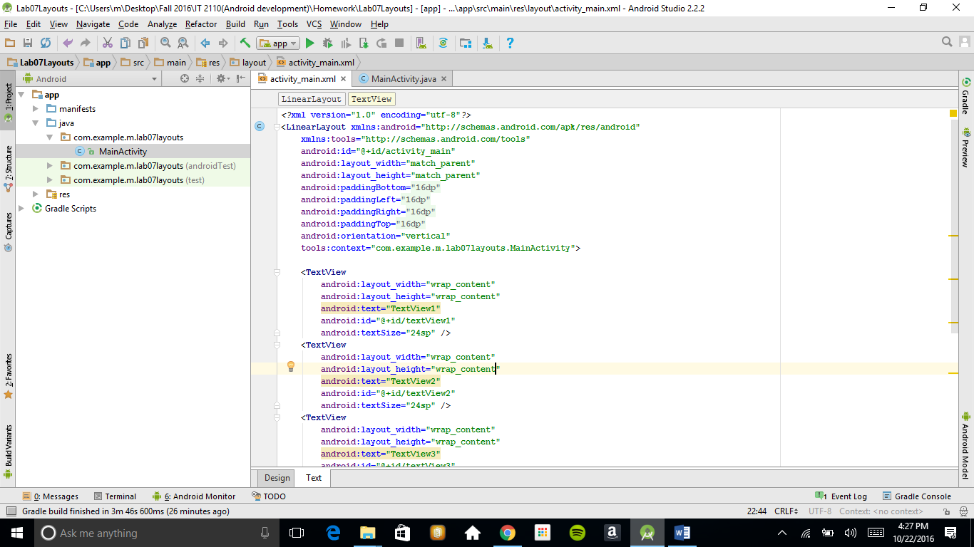

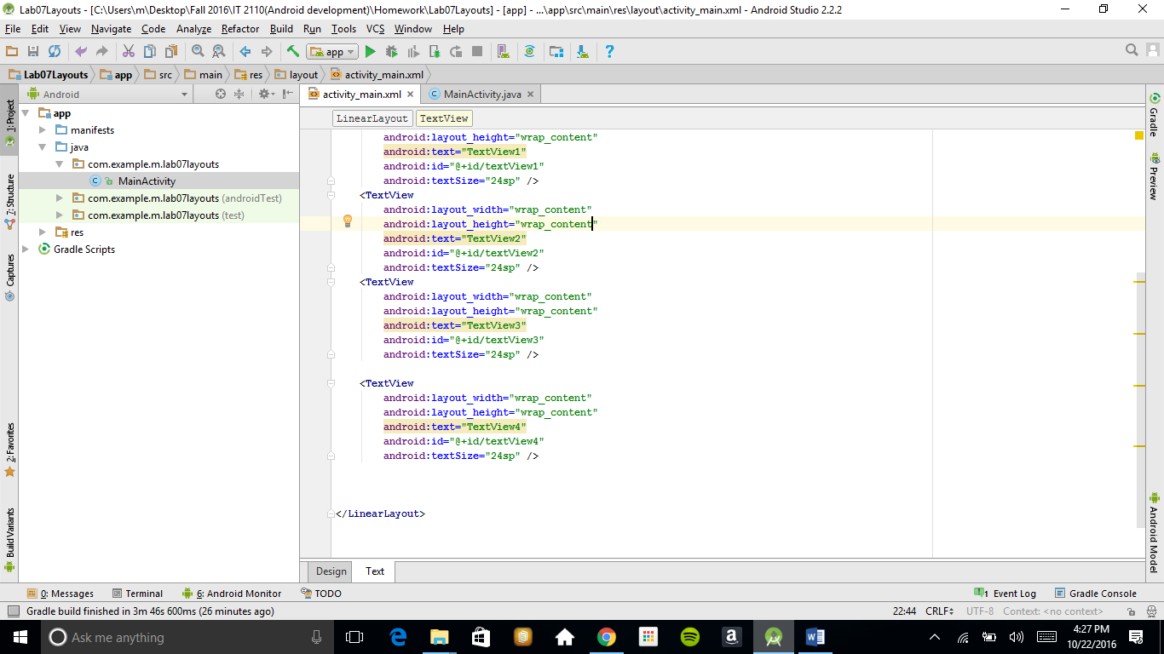

**Requirements:**

* Use a LinearLayout
* Include the following content in your layout

<TextView  
 android:layout_width="wrap_content"  
 android:layout_height="wrap_content"  
 android:text="TextView1"  
 android:id="@+id/textView1" />  
  
<TextView  
 android:layout_width="wrap_content"  
 android:layout_height="wrap_content"  
 android:text="TextView2"  
 android:id="@+id/textView2" />  
  
<TextView  
 android:layout_width="wrap_content"  
 android:layout_height="wrap_content"  
 android:text="TextView3"  
 android:id="@+id/textView3" />  
  
<TextView  
 android:layout_width="wrap_content"  
 android:layout_height="wrap_content"  
 android:text="TextView4"  
 android:id="@+id/textView4" />

* Your layout should look the same as the image above

**Layout 3:**

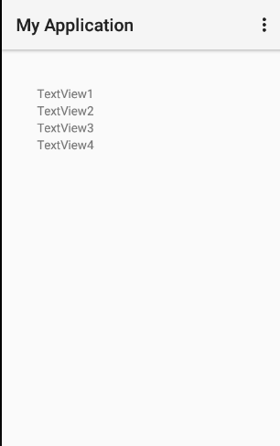

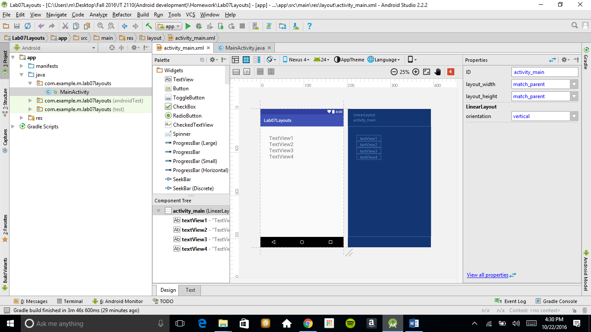

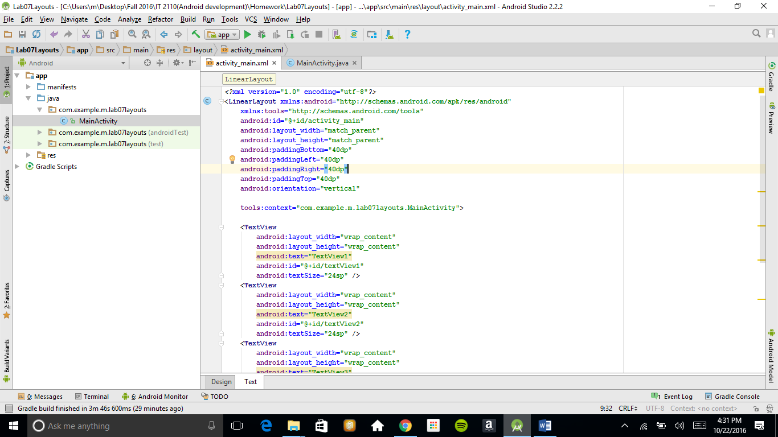

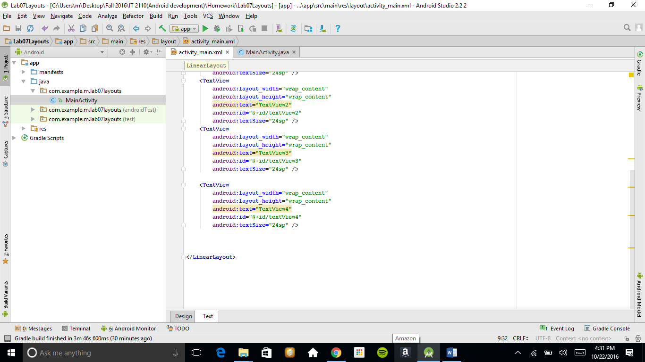

**Requirements:**

* Modify your layout from problem 3, so there is 40dp of padding around the contents of the layout
* Your layout should look the same as the image above