5 Point Each / 10 Points Total :

Create an app that displays the tutorial found in the following. Note that the app content does not need to match what is found in the tutorial.You only need to demonstrate use of the concept that is covered.

1 - Using the Material Theme

https://developer.android.com/training/material/theme.html

- Display your app in using both the Dark material theme and Light material theme

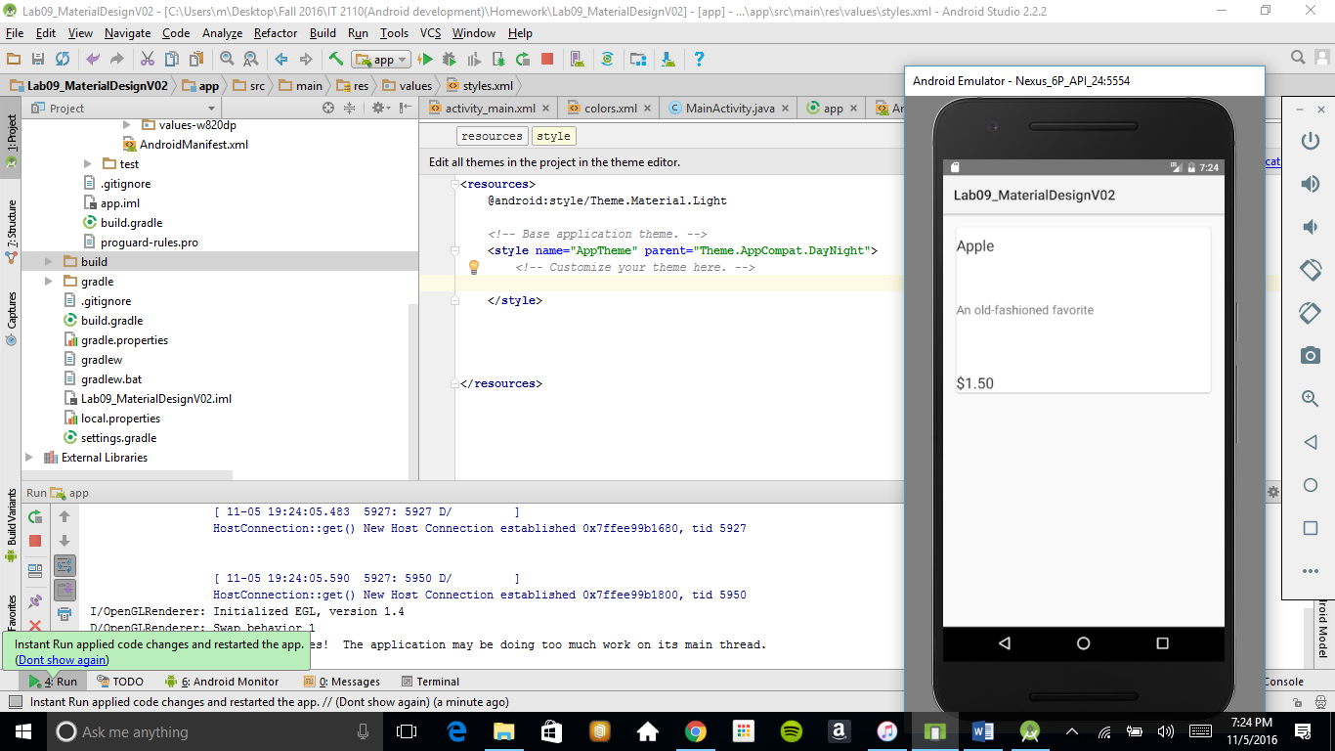

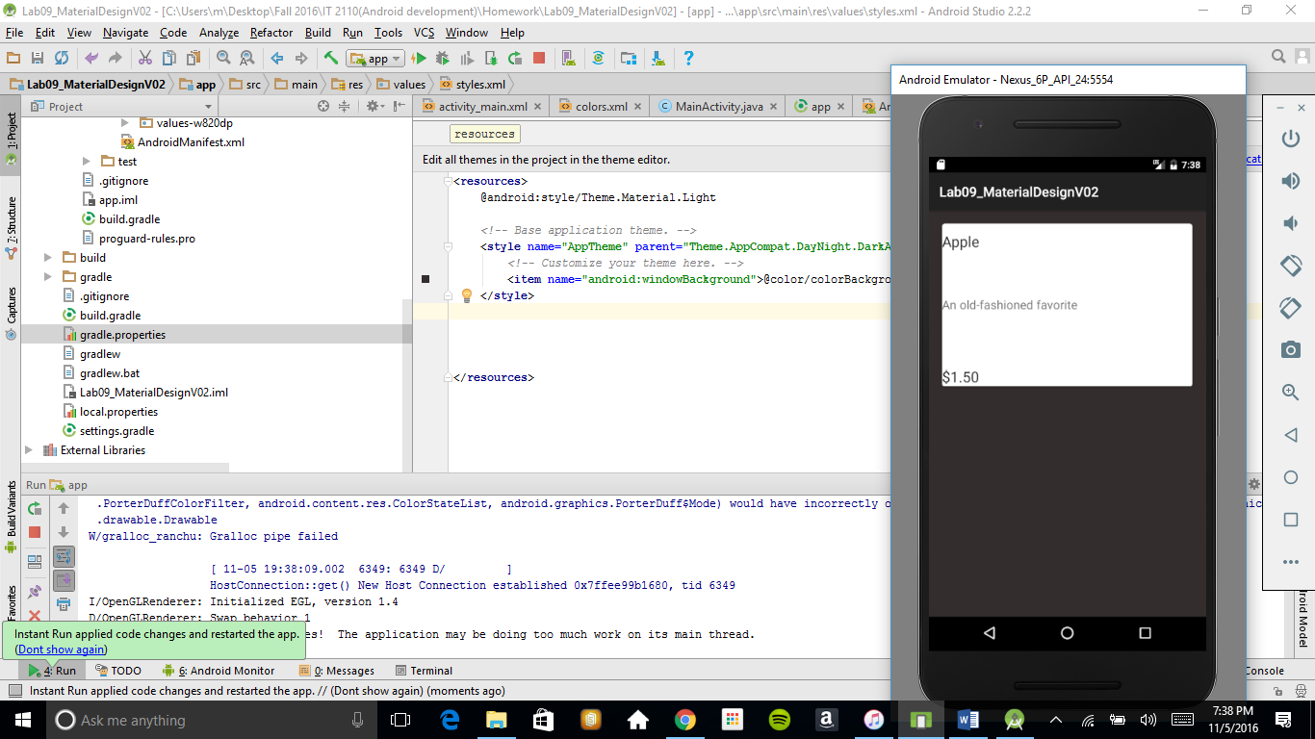

- Describe how you accomplished this

For light theme I used presseted theme DayNight

For dark I used DayNight.Darkbar plus I added windowBackground color of dark-grey

2 - Creating Lists and Cards

https://developer.android.com/training/material/lists-cards.html

- display at least 1 card

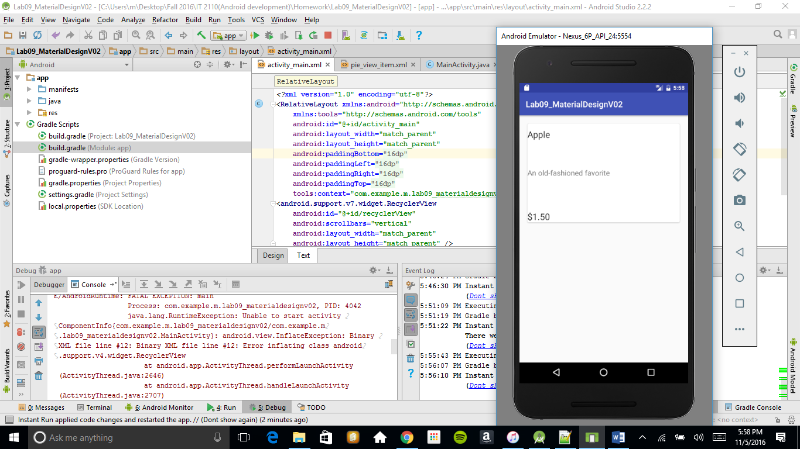

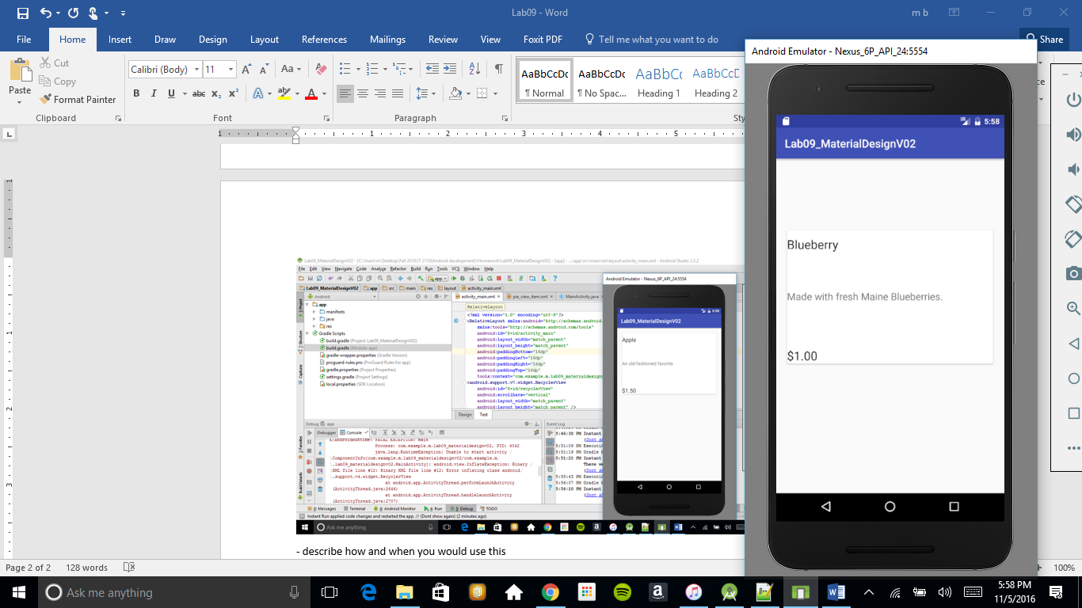

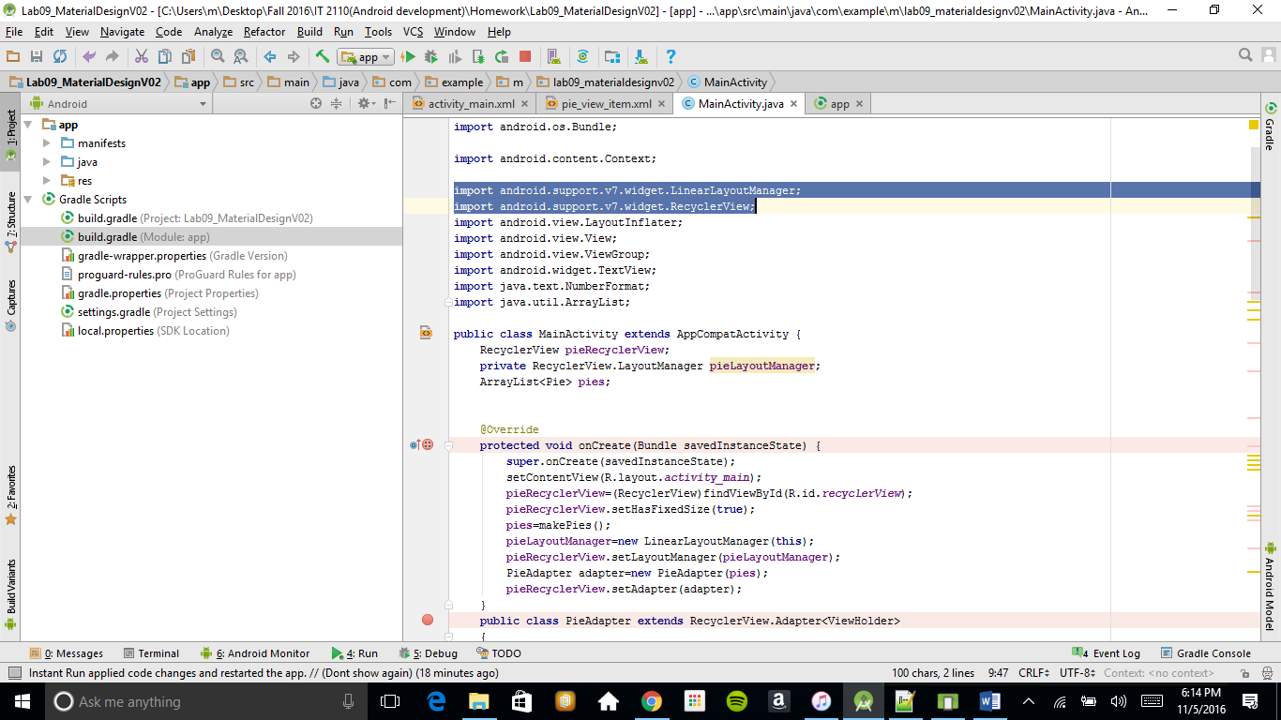

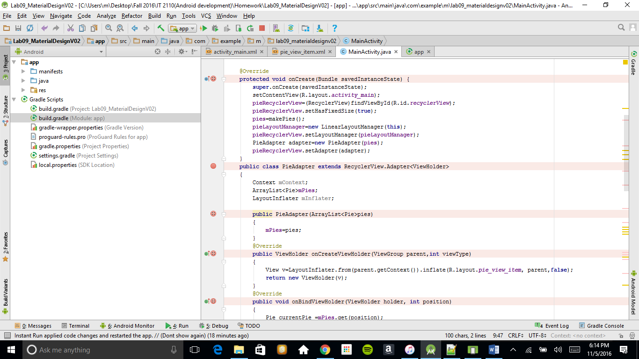

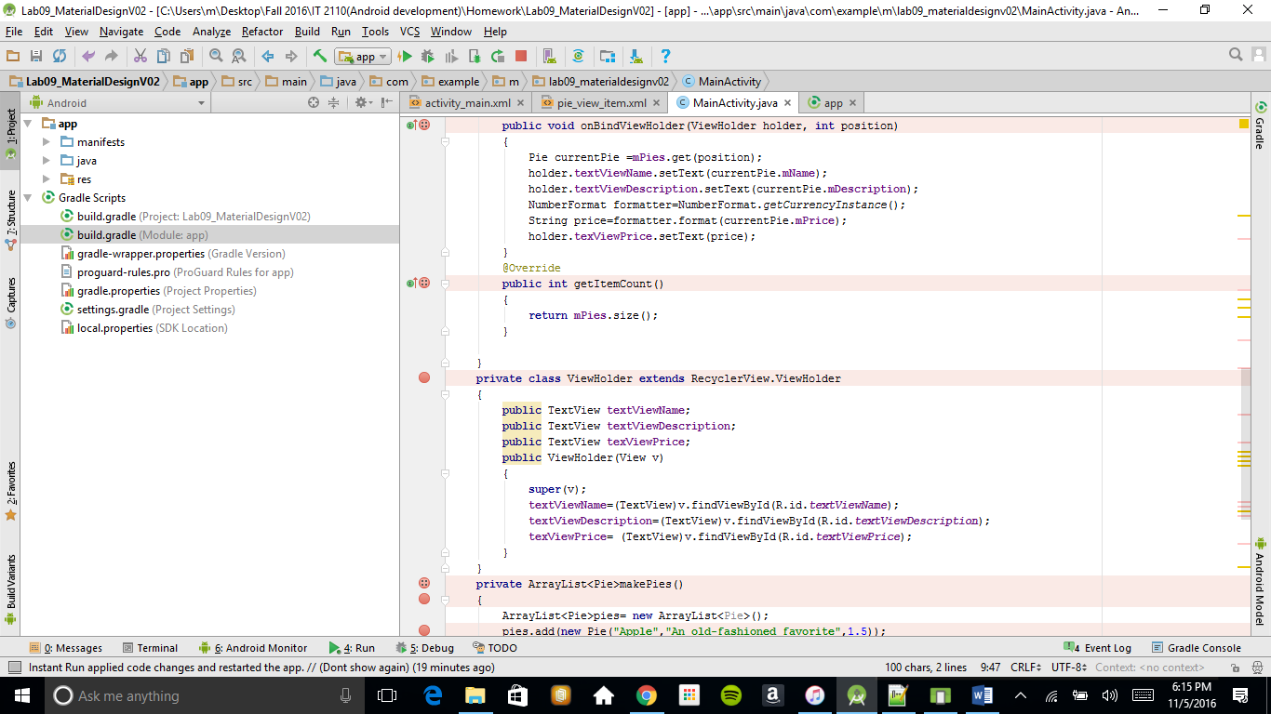

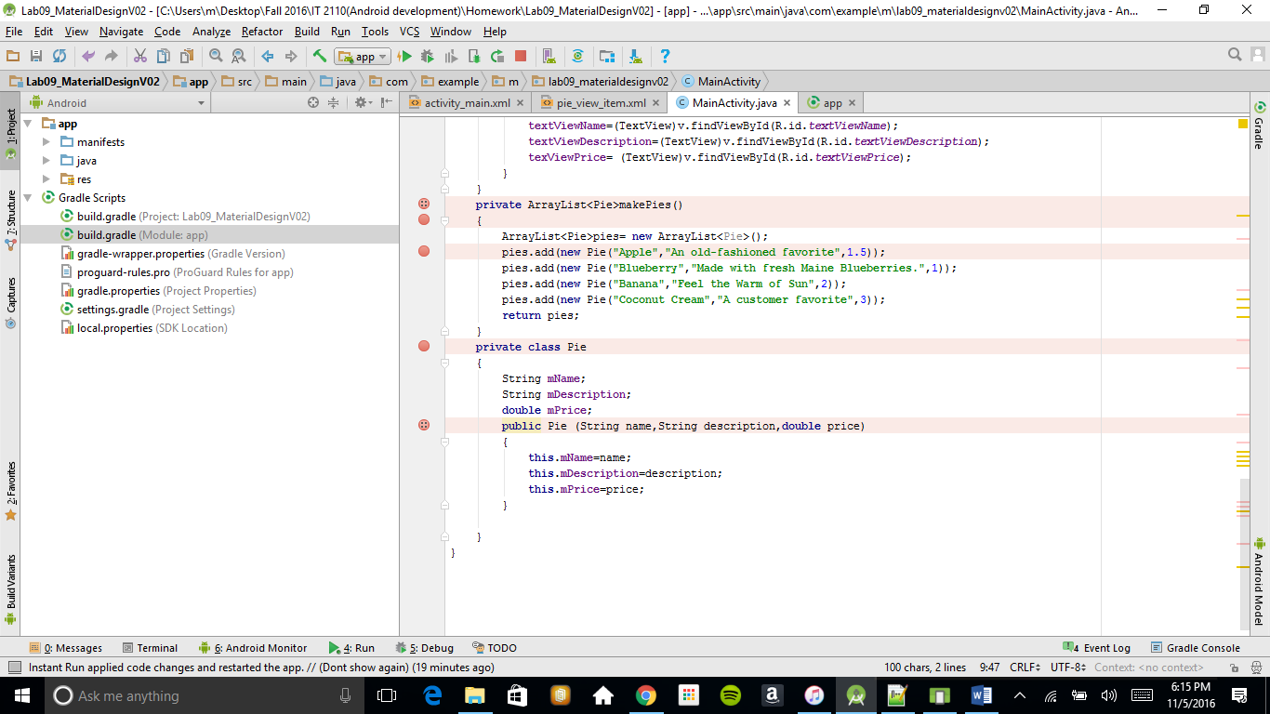

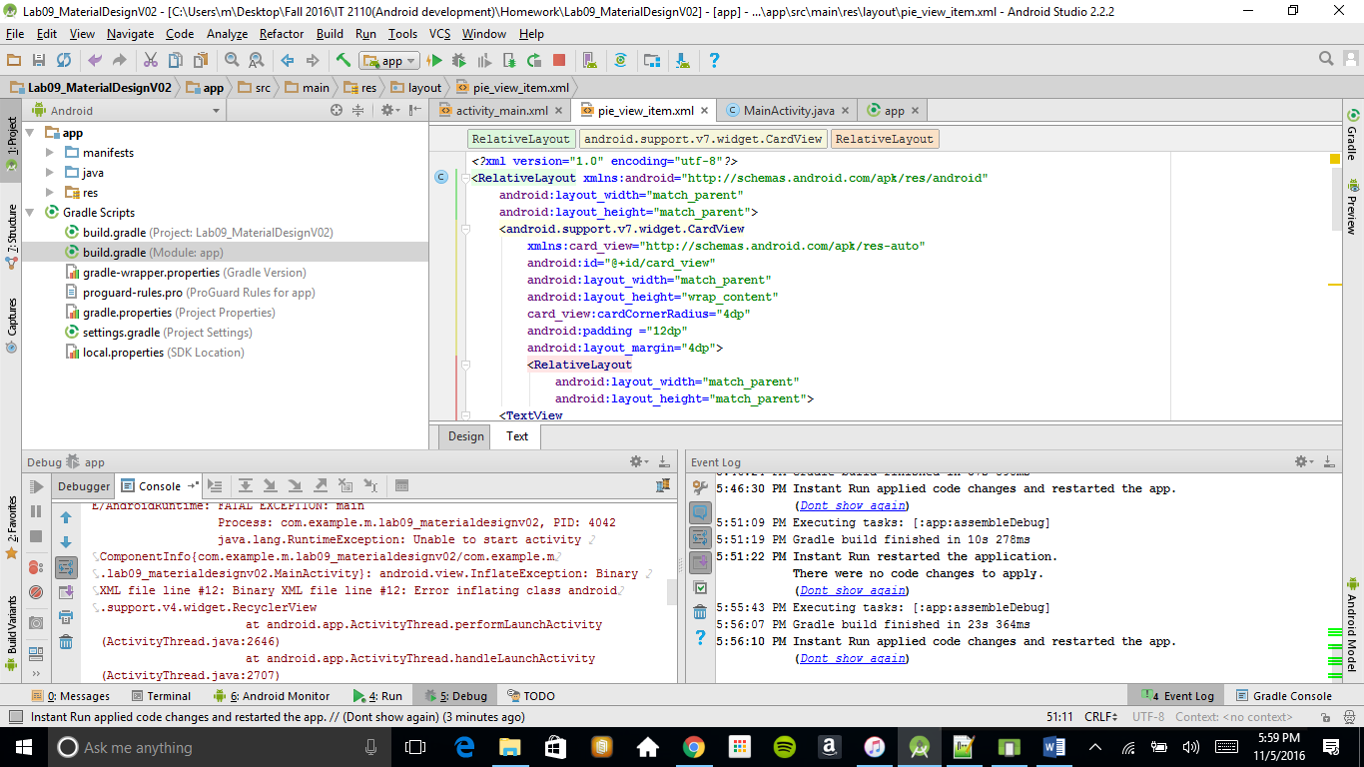

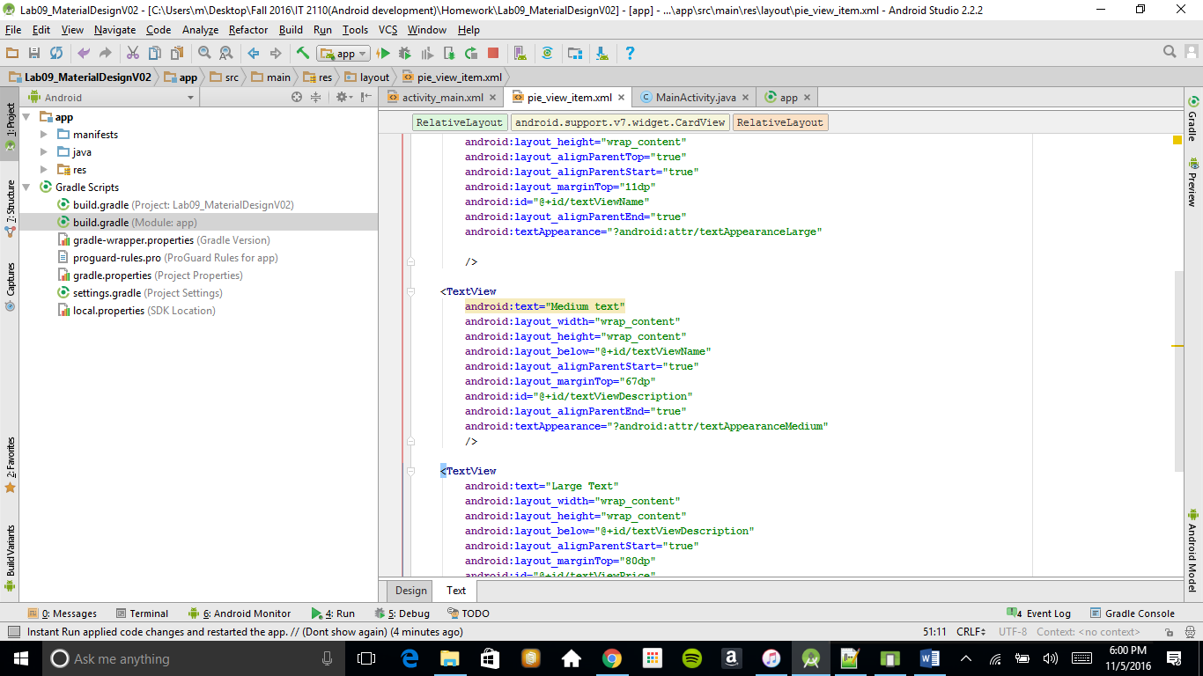

- describe how and when you would use this

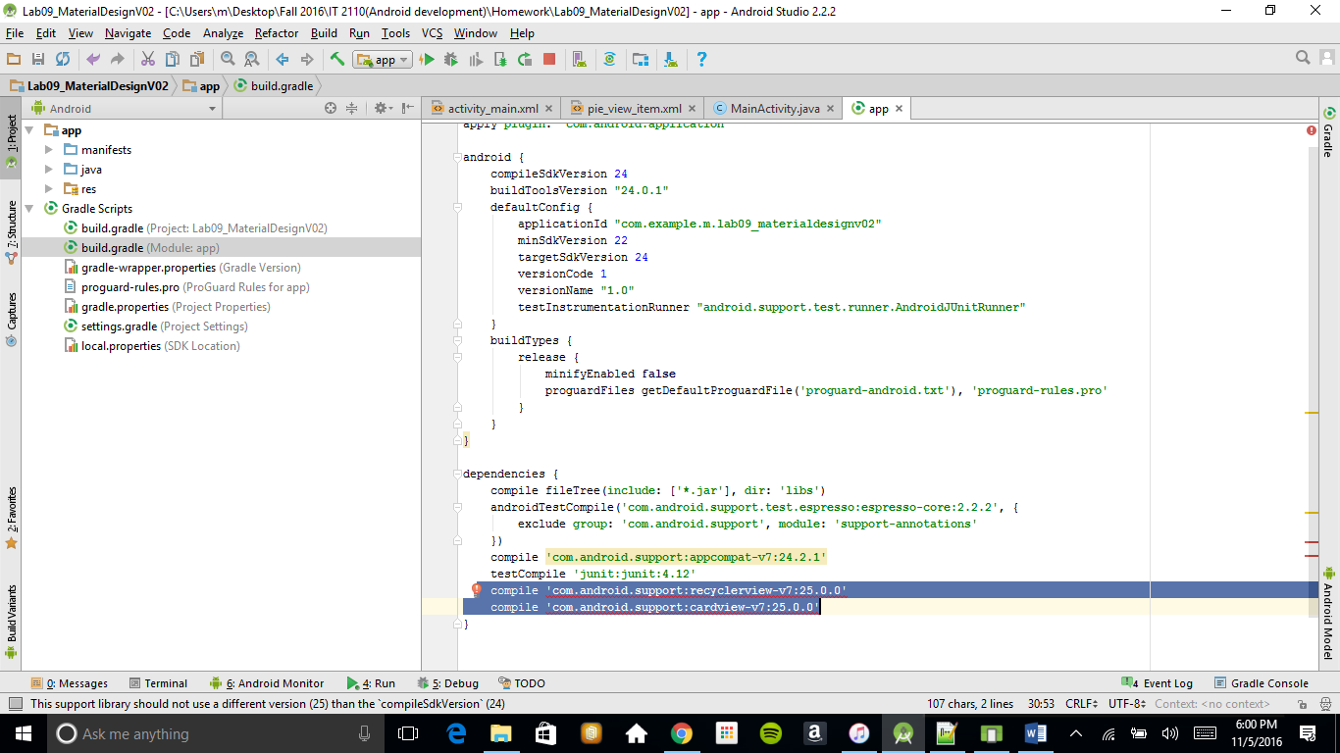

1First I added this part of code to the build.grade it can be done mannualy or File/project structure/dependencies and add the library

2 I imported this 2 libaries

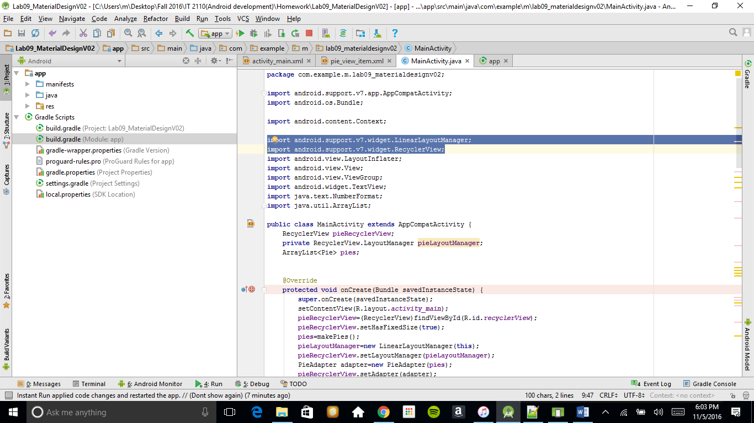



3 replace ListView with RecycleView

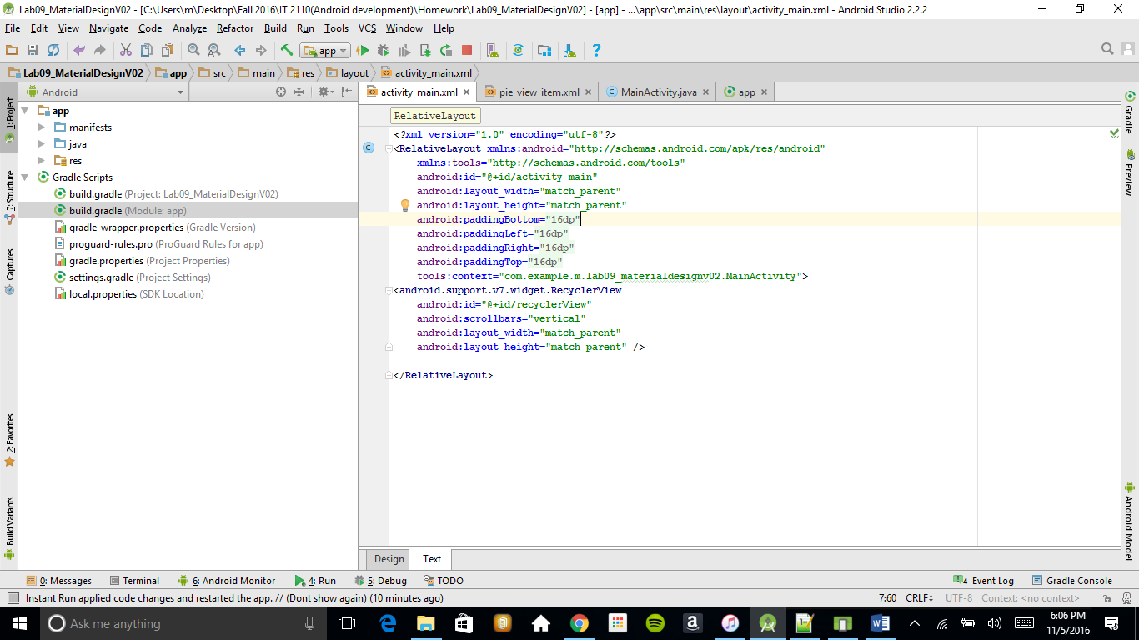



4 I added a card view to the pie_view_item.xml file making CardView a main view while the TextView a inserted inside

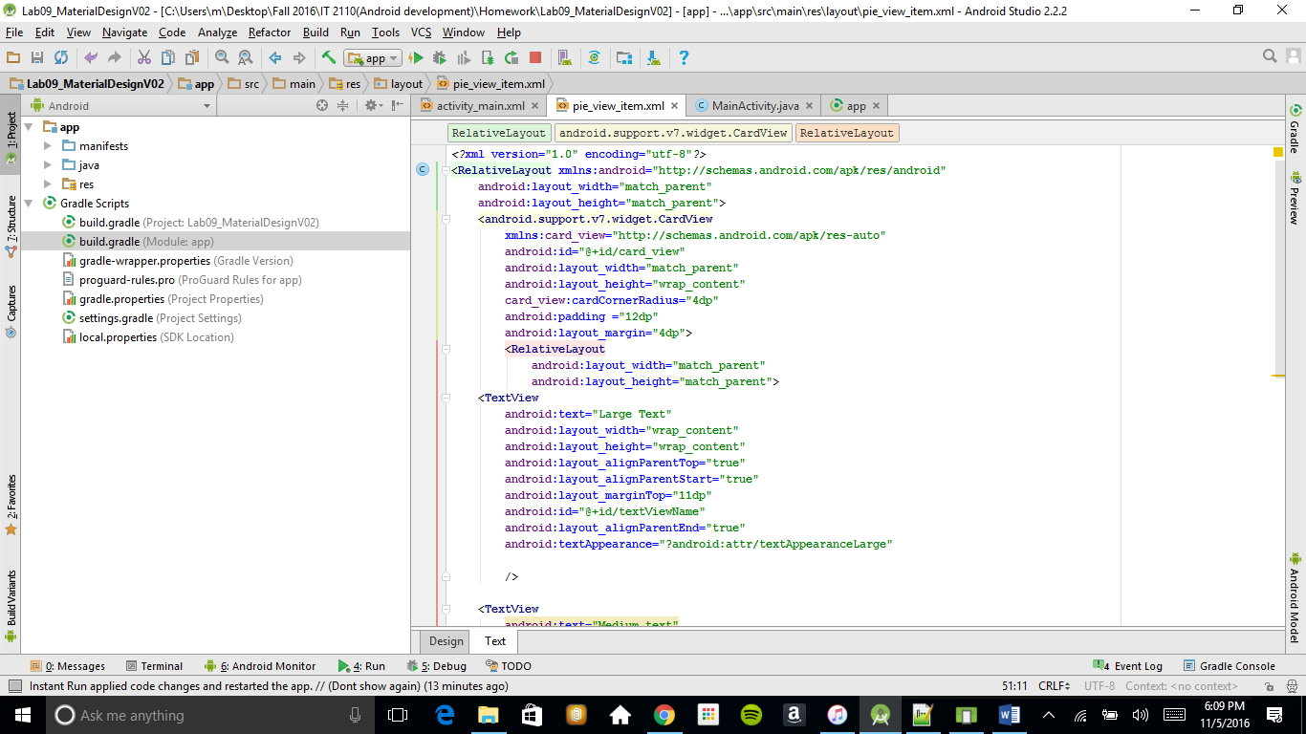



All this is done for esthetical reasons and for an easy navigation

Deliverables:

Upload screenshots of your code and the apps running. Please include your responses to the questions alongside the screenshots.

If you follow the tutorial online, you shouldn't have too much guesswork.