In this lab, we'll try out a few of the controls described in the chapter.  Note that each of the following problems can be completed separately from one another (separate Activities or apps - your choice).   **Due 11/12/2006 11:59 pm**

1. Following the tutorial (http://developer.android.com/guide/topics/ui/controls/spinner.html), allow end-users to select from a list and display the results in a TextViewcontrol. [5 points]

2. Following the example (http://developer.android.com/guide/topics/ui/layout/gridview.html#example), create the GridView as seen in the example.  Note that step two provides you with the images for download. [5 points]

3. Following the tutorial (<http://developer.android.com/guide/webapps/webview.html>

), add a WebView control to an app that displays Tri-C's homepage.[5 points]

Please upload a Word document with screenshots of your code and a demonstration of the apps running.

1--------------------------------------------------------------------------------------------------------------------------------------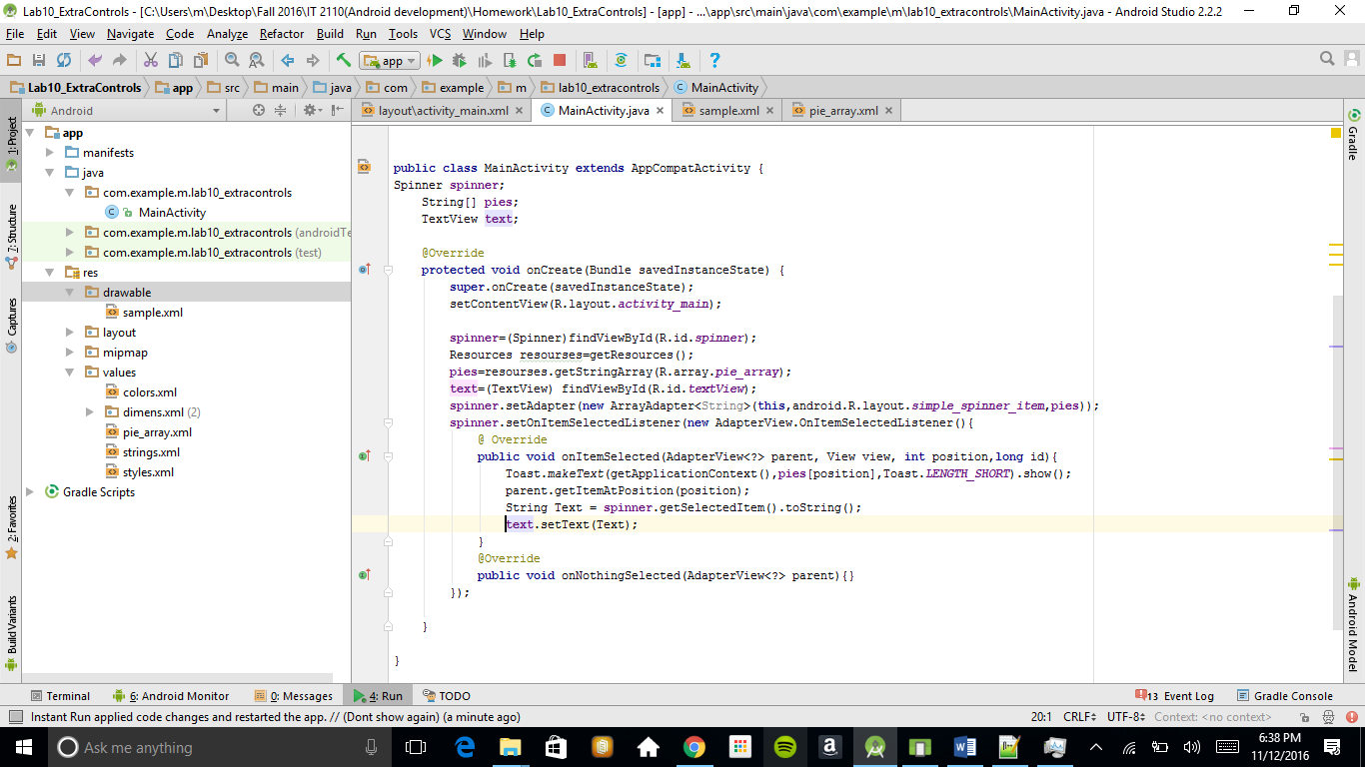

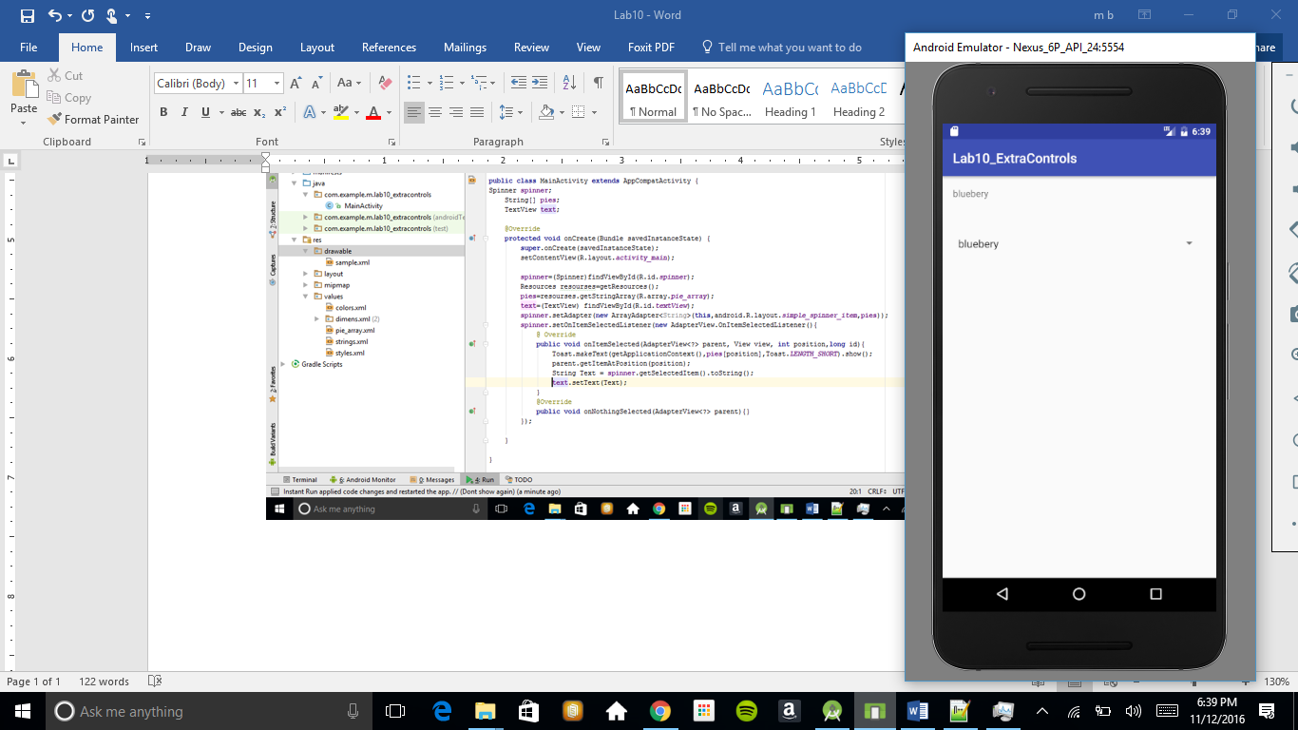

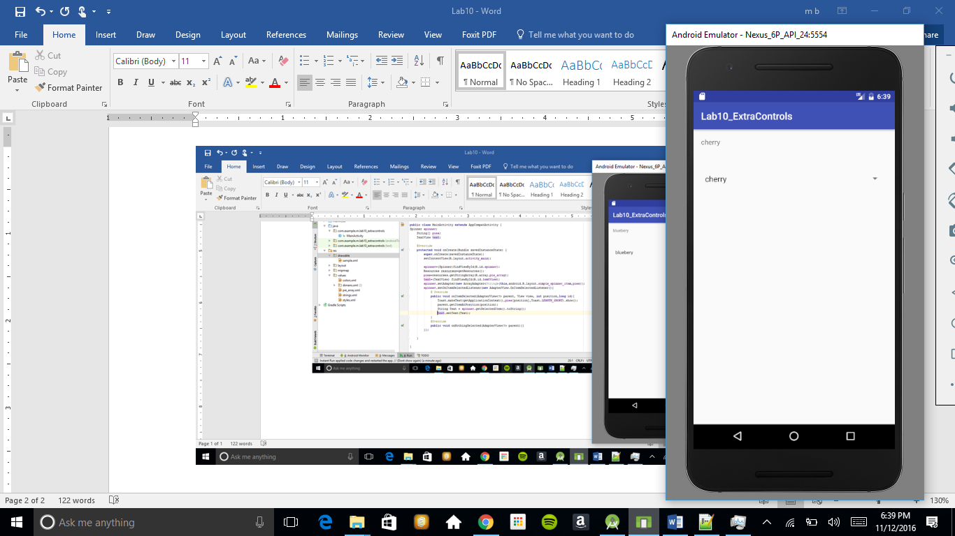

2------------------------------------------------------------------------------------------------------------

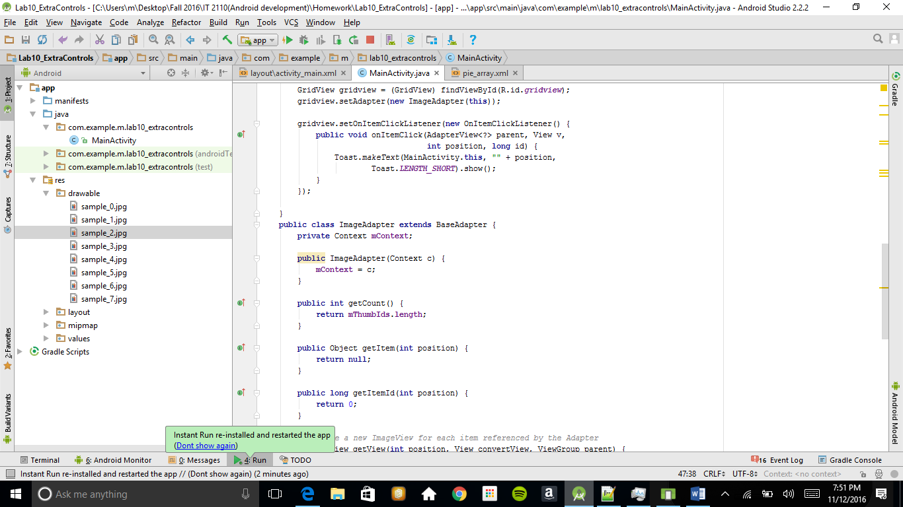

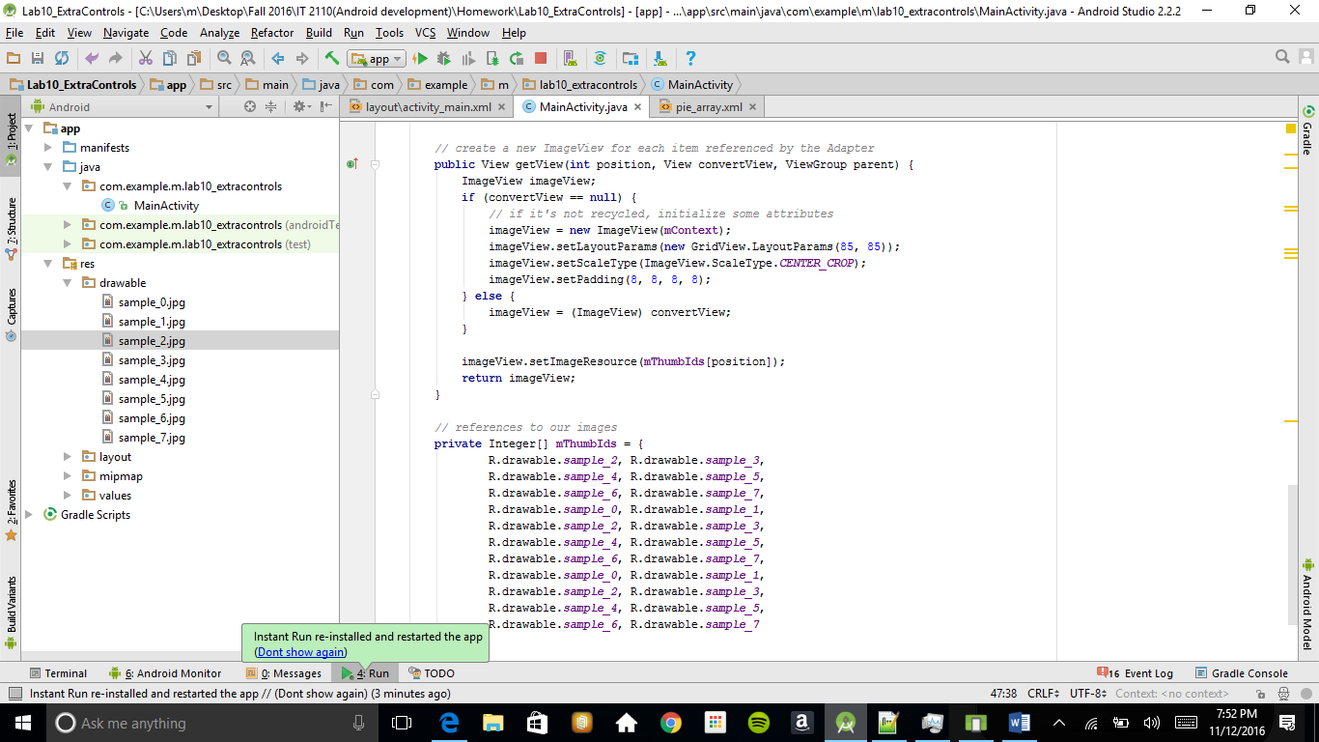

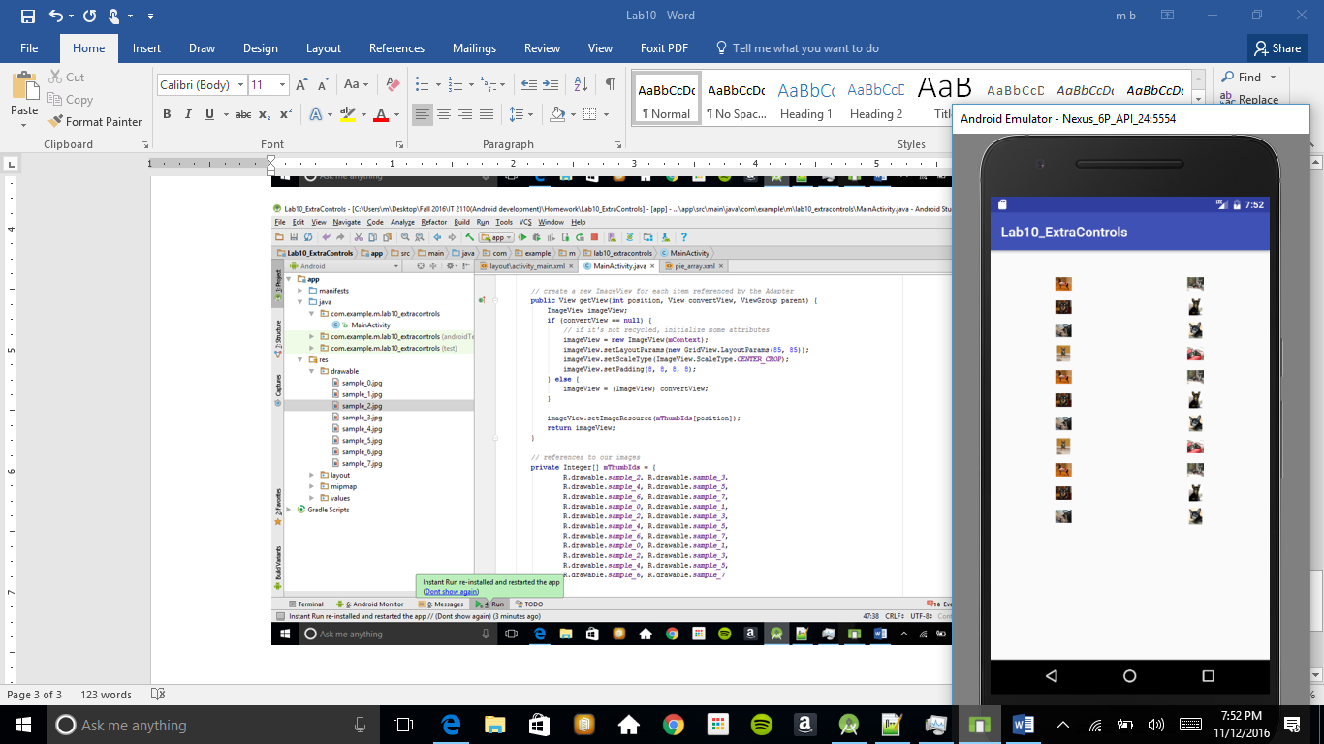

3-------------------------------------------

