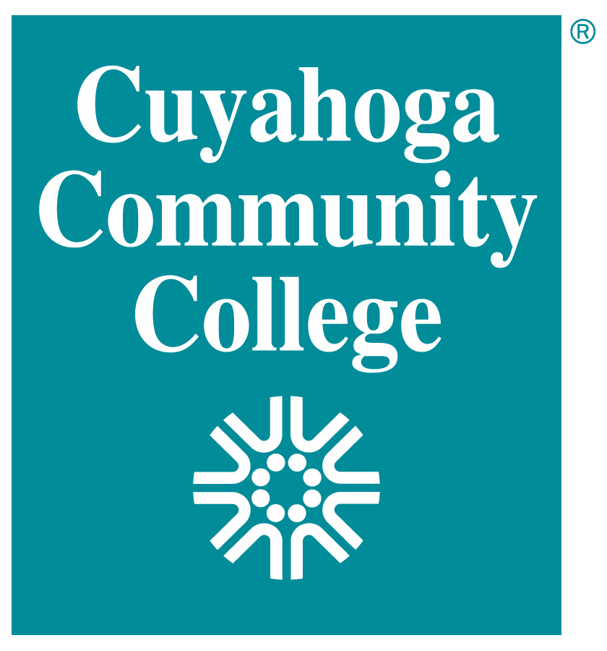
Cuyahoga Community College
West Campus
Information Technology
IT 2110 Android Mobile App Development (84015)
Fall 2016, 16 week online

Faculty Information
Faculty | Padman Krishnan
Office | WBT C245
Phone | Use email address below for all communications.
Email or Course Correspondence | Padmanabhan.krishnan@tri-c.edu  I will primarily be using tri-c email for communications, apart from Blackboard discussion boards.
Office Hours | 8:00 pm – 10:00 pm Monday and Thursday  virtual office hours via Blackboard Monday and Thursday evenings 8 pm – 10 pm –incl. email.

Course Information
Course Title | IT 2110 Android Mobile App Development (84015)
Class time | On-line
Classroom | WBT, C245
Prerequisites | - IT 2650 Java Programming
Drop Date | On or before 11/20/2016 for a “W” grade. 9/12/2016 with no record.
Credit Hours | 3
Lecture Hours | 2
Lab Hours | 2
Academic Calendar | http://www.tri-c.edu/acadcalendar

Course Catalog Description

Introduction to mobile development using the Android Software Development Kit (SDK).
Focuses on the skills required to design, develop and publish applications for the Android platform. Covers the fundamentals of Android application development including designing an application, implementing specific framework components such as a splash screen and main menu, how to handle user interaction and make an application available in the Android market.

Course Outcomes & Objectives

Upon satisfactory completion of this course, the student should be able to perform the following outcomes and objectives:

Outcomes:

A. Design, develop and create an Android application using the Android Software Development Kit (SDK).
B. Test and prepare a Android Mobile app for publishing
Objectives:

A. Discuss the use of Eclipse with the Android SDK.
B. Demonstrate how to run and debug applications using the DDMS.
C. Configure and manage an application’s settings.
D. Discuss techniques for managing permissions.
E. Design a user-friendly splash screen for an application.
F. Design a user-friendly Main Menu.
G. Discuss the need to design for accessibility for all users.
H. Develop a help screen for an application.
I. Demonstrate an understanding of advanced mobile platform features.
J. Prepare and test a release candidate build.
K. Test a signed application.
L. Discuss methods for selling on the android market.
M. Discuss methods for publishing android applications.

Required Text and Supplies

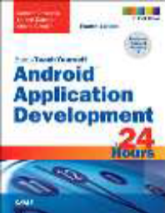 Android Application Development in 24 Hours, Sams Teach Yourself
4th Edition
by Carmen Delessio, Lauren Darcey, Shane Conder
Publisher: Sams Publishing; 4 edition
ISBN-10: 0-13-421172-5
ISBN-13: 978-0-13-421172-5



Academic Credit
According to the Ohio Board of Regents Operating Manual, one (1) semester hour of college credit will be awarded for each lecture hour. Students will be expected to work at out-of-class assignments on a regular basis which, over the length of the course, would normally average two hours of out-of-class study for each hour of formal class activity. For laboratory hours, one (1) credit shall be awarded for a minimum of three laboratory hours in a standard week for which little or no out-of-class study is required since three hours will be in the lab (i.e. Laboratory 03 hours). Whereas, one (1) credit shall be awarded for a minimum of two laboratory hours in a standard week, if supplemented by out-of-class assignments which would normally average one hour of out-of class study preparing for or following up the laboratory experience (i.e. Laboratory 02 hours). Credit is also awarded for other hours such as directed practice, practicum, cooperative work experience, and field experience. The number of hours required to receive credit is listed under Other Hours on the syllabus. The number of credit hours for lecture, lab and other hours are listed at the beginning of the syllabus. Make sure you can prioritize your time accordingly. Proper planning, prioritization and dedication will enhance your success in this course.

The standard expectation for an online course is that you will spend atleast 3 hours per week for each credit hour.

Accessibility Statement

If you need any special course adaptations or accommodations because of a documented disability, or issues of accessibility to online, hybrid, or web-enhanced classes, please contact the ACCESS office at one of the campuses listed below as soon as possible. Visit on the web at http://www.tri-c.edu/apply/specialinterest/disabilities

If you have emergency medical information to share, or if you will need assistance in the event of an
evacuation, please discuss this with me in private of contact the Access Office.
Eastern | (216) 987-2052 | TDD (216) 987-2230*
Metropolitan | (216) 987-4344 | TDD (216) 987-4048*
Western | (216) 987-5079 | TDD (216) 987-5117*

This is a structured online course which means that you can determine your own work pace within the confines of the timelines established in the course schedule. There are not specific times you have to be in a classroom, but there are participation expectations. Students are expected to access the course regularly.

Methods of Evaluation/Grading Policy
All grades fall into a single category in Blackboard called “Assignments”. Your grade will be calculated by
taking the number of points you have received and dividing by the total possible number of points.

EVALUATION METHOD | Number | Points for each | Total Points | Approximate Percent of Grade
Lab Assignments | 15 | 20 | 300 | 50 %
Weekly Quizzes | 15 | 15 | 225 | 37.5 %
In Class Discussions | 15 | 5 | 75 | 12.5 %
Total |  |  | 600 | 100 %
The points for each weekly evaluation are subject to change. The overall point values and
approximate percentages may change. You can always take the total amount of points that you have
earned and divide by the total number of points possible to determine where you stand.

GRADING | SCALE
A | 90 -100%
B | 80 - 89%
C | 70 -79%
D | 60 - 69%
F | Under 60%

Course Schedule

Week | Date | Chapter – Subject – Topic | Assignments
1 | 8/29 – 9/5 | Introduction to Android. Development environment setup. | Lab 1, Quiz 1, Discussion 1
2 | 9/5 – 9/12 | Intents | Lab 2, Quiz 2, Discussion 2
3 | 9/12 – 9/19 | Android Project Resources | Lab 3, Quiz 3, Discussion 3
4 | 9/19 – 9/26 | Activities and Fragments | Lab 4, Quiz 4, Discussion 4
5 | 9/26 – 10/3 | Responsive Apps : Background processing | Lab 5, Quiz 5, Discussion 5
6 | 10/3 - 10/10 | Basic UI Controls | Lab 6, Quiz 6, Discussion 6
7 | 10/10 – 10/17 | Layouts | Lab 7, Quiz 7, Discussion 7
8 | 10/17 – 10/24 | ListViews and Adapters | Lab 8, Quiz 8, Discussion 8
9 | 10/24 – 10/31 | App Design | Lab 9, Quiz 9, Discussion 9
10 | 10/31 – 11/7 | Additional Views and Controls | Lab 10, Quiz 10, Discussion 10
11 | 11/7 – 11/14 | ImageViews and Bitmaps | Lab 11, Quiz 11, Discussion 11
12 | 11/14 – 11/21 | Navigation with the ActionBar and ToolBar | Lab 12, Quiz 12, Discussion 12
13 | 11/21 – 11/28 | Using the FileSystem | Lab 13, Quiz 13, Discussion 13
14 | 11/28 – 12/05 | Using SharePreferences | Lab 14, Quiz 14, Discussion 14
15 | 12/05 – 12/12 | Introducing Content Providers and Notification | Quiz 15, Discussion 15
16 | 12/12 – 12/15 | Finals Week, Class Wrap-up | Final Exam

**This schedule is tentative and subject to change at the discretion of the faculty member. All changes will be announced.

Late Work & Assignments
Assignments and other graded projects are your responsibility. Please consult the Assignments Due Day List for due dates and % of your grade.

Any work that is due for a grade is expected to reach me on or before the due date.
- Any work received after each due date will receive 3 % less for each day it is late by. After 10 days, do not send that assignment as it will not get any credit. Exceptions to this rule are handled on a case-by-case basis. All judgments are final.
- No work will be accepted after the last day of the fall semester.
- Generally, tests cannot be made up if you happen to miss them.

If you are unable to complete assignments or exams due to illness or other serious issues, please come to me before the due date and I will work to assist you.

Expectations

• You will complete the homework assignments on-time and to the best of your ability
• You participate in-class and/or during weekly discussions in a timely and professional manner
• Whenever possible, you will work together in small study groups
• You will post on-topic threads to any discussion forums, using proper netiquette
• You will contact me as quickly as possible if you have questions or concerns about the class – let me know right away if there’s anything that I can help with!
• You will not cheat. If you do so, academic policy guidelines will be followed
• You will work with other students to learn the material and ensure that your classmates learn as well

Technology & Technology Skill Requirements
You will need basic computer skills and should be comfortable using a word processing program, browsing for files, copying and pasting between programs.
You will need a computer that connects to the Internet. Your student ID number and password are required for access. If you do not own a computer OR if your computer malfunctions during the semester, you will be expected to identify a computer to use. Computers are available at the Public Library and in the Tri-C Technology Learning Centers (TLC) on each campus. Technology problems are not an excuse for missed or late work.

The Office of eLearning and Innovation offers Blackboard Orientation at https://portal2.tri-c.edu/OnlineOrientation/Home/LoginEliO. Visit Tri-C Online Learning at http://www.tri-c.edu/onlinelearning/Pages/default.aspx for more information.

Technical Help
If you experience a technical problem, you should call the 24/7 Customer Care Technical Support at
216-987-HELP to receive technical phone support in the following areas:
- Blackboard
- Internet Explorer
- Login issues (password resets) for My Tri-C Space
- Microsoft Office (Word, Excel, PowerPoint)
- Navigation of My Tri-C Space
- Tri-C email

Some technical support issues may not be able to be resolved over the phone. While the Customer Care Technical Support team will work diligently to assist students, it is possible that personal computer problems may require the student to contact outside technical support for assistance.

There are computers available for student use at each Campus Technology Learning Center (TLC) and your local public library. These resources should be used to keep up with your coursework while you work to resolve a computer problem.

Incompletes/Grading System

Instructors determine grades, subject to the College’s policies and procedures. A notation of “I” indicates that a student has not completed all course requirements as a result of circumstances judged by the instructor to be beyond the student’s control. Failure to complete such requirements no later than the end of the fifth full week of the next semester will result in an “F” (Failing) grade.
Pass/No Pass Statement
(From the College Catalog found on My Tri-C Space > My Info tab > under Registration Information)

An alternative to a letter grade called Pass/No Pass grade options allows students who want to explore a discipline and/or course to register without the penalty of a grade impacting their grade point average.

A student can elect up to 12 credits taken Pass/No Pass to fulfill degree requirements at Cuyahoga Community College. Whereas, audited courses do not count, students may select up to 12 credits of Pass/No Pass that may transfer to another college or university as electives.

Some restricted/selective admission program courses require traditional letter grades for their core requirements. Students are responsible for consulting with their program manager or counselor to determine Pass/No Pass grading options. Once you have registered for a course and select the Pass/No Pass grade options you cannot convert back to a traditional grade option nor can you change a traditional letter grade to a P/NP option for a particular course after the 100% refund period.

International students and Post-Secondary Enrollment Options program students are not eligible to utilize the Pass/No Pass option. Courses taken Pass/No Pass count toward financial aid enrollment requirements.
Withdrawal Statement
(From the College Catalog found on My Tri-C Space > My Info tab > under Registration Information)

Regular class attendance is expected. Tri-C is required by law to verify the enrollment of students who participate in Federal Title IV student aid programs and/or who receive educational benefits through other funding sources. Tri-C is responsible for identifying students who have not attended or logged into a class for which they are registered. At the conclusion of the first two weeks of a semester, instructors may report any registered students who have "Never Attended" a class so that those reported students will be administratively withdrawn from that class. However, it is the student's responsibility to withdraw, using the appropriate Tri-C form, from any class which she/he is no longer attending or risk receiving a failing grade in that class. Student's wishing to withdraw must complete and submit the appropriate Tri-C form by the established withdrawal deadline.

Student Conduct and Academic Honor Code
Any student found to have committed or to have attempted to commit any act of dishonesty, including cheating, plagiarism, or other forms of academic dishonesty, is subject to the disciplinary sanctions outlined in the Student Judicial System.

Refer to the Student Conduct Code 3354:1-30-03.5 and Student Judicial System 3354:1-30-03.6 for more information about violations and College disciplinary procedures. The Student Conduct and Academic Honor code can be accessed via My Tri-C Space on the Student Services tab. The policies are located in the College Guidelines channel located near the bottom of the page.

- Penalties for Academic Dishonesty are defined in the Student Judicial System 3354:1-30-03.6 - (D) Sanctions.

- Plagiarism as Academic Dishonesty is defined in Tri-C Student Handbook via My Tri-C Space on the Student Services tab under College Guidelines.

Check to See How Close You Are to Graduation Using DARS or MAP

Program Completion Audit Systems at Tri-C: Degree Audit Reporting System (DARS) and My Academic Plan (MAP)

DARS & MAP both compare academic program requirements against a student’s academic history. The resulting report lists courses taken that apply toward graduation, courses yet to be taken, and courses that do not apply to the program major. The ability of both students and staff to obtain this information is part of an effective academic advising program. DARS is for all students enrolled prior to Fall 2014. MAP is the tool for students new to the College Fall 2014.

Netiquette – Policy on Online Communications

Etiquette n. forms of proper or polite behavior in society; good manners
net n. an abbreviation for internet
Netiquette n. proper or polite behavior on the internet
Communication is very important a course. To maintain a positive online environment, each of us is expected to follow these netiquette guidelines. Be advised that rules for student conduct apply in the online environment. Any use of electronic communication on Tri-C’s network, which includes Blackboard, Tri-C email, etc. for flaming or other kinds of harassment may be treated as a student conduct violation in the Student Handbook (accessible via My Tri-C Space on the Student Services tab).
- Show respect for the instructor, other students, and for the privacy of those in the online environment. Nothing threatening is ever appropriate.
- Express differences of opinion in a polite and rational way, maintaining a supportive academic environment.
- Stay focused by avoiding irrelevant topics in discussion or collaborative activities
- Use proper capitalization and punctuation rules. Use of all uppercase in a message is the equivalent of shouting and is considered offensive.
(Adapted from Barrington 220 Community Unit School Netiquette Policy)
Project Go!

Project Go! is the Tri-C program for the Benefits Access for College Completion (BACC) initiative,
seeking to improve community college completion rates by helping students gain access to public
benefits in order to close the gap in unmet financial need beyond financial aid. These benefits include
Food Stamps, Medicaid, and temporary assistance for needy families, child care subsidies, transportation
subsidies, refundable tax credits, and others. We have partnered with the Cleveland Food Bank and
Ohio Job and Family Services (ODJFS), to become an Ohio Benefit Bank (OBB) Community Student
Site. The program will provide information, screening and application assistance to students.

