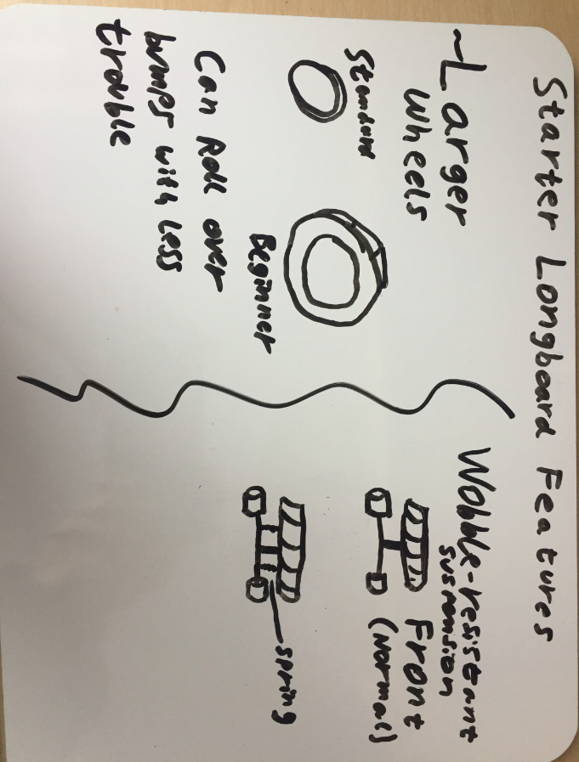
Maximilien McDermott
ETECH 100 Design Project
Professor Xu

The Starter Longboard boasts two features that offer advantages to beginning users, great for introducing new people into the wonderful world of Longboarding!
1) Central to new users worries is the jarring experience of your first sudden stop as a result of rocks/cracks in the sidewalk. To make this experience less deterring, this board features much larger wheels, which, couples with the spring suspension, should allow a little wiggle room to turn a sudden jam into a painless learning experience.

2) For those still finding their legs, the suspension on the Starter Longboard offers a great way to get accustomed to the new mode of transport – a set of ‘training wheels’ almost to prevent over-correction and leaning.

