OBAFEMI AWOLOWO UNIVERSITY, ILE-IFE
FACULTY OF TECHNOLOGY
DEPARTMENT OF COMPUTER SCIENCE AND ENGINEERING
OAU LOGO
(replace this box with the crest)

DEVELOPMENT OF AN INTELLIGENT MULTI-AGENT CAMPUS SECURITY SURVEILLANCE SYSTEM
Distributed Sensor Agents with a Centralised Alerting and Audit Hub
A Project Report Submitted in Partial Fulfilment of the
Requirements for
CPE 310 — AGENT-BASED SYSTEMS
GROUP 12
COURSE COORDINATOR
DR. T. F. SHOLANKE
Academic Session: [ACADEMIC SESSION]
AUGUST, 2026

GROUP MEMBERS

S/N | NAME | MATRICULATION NUMBER
1 | Olatunde Ibrahim Akinade | CSC/2022/177
2 | Ologunebi Tobiloba Ifeoluwa | CSC/2022/180
3 | Popoola Faith | CSC/2022/212
4 | Akinwamide Williams | CSC/2022/055
5 | Kasali Kamil Ademola | CSC/2022/348
6 | Majekodunmi Oyindamola | CSC/2022/295
7 | Omidiora Ojuolape | CSC/2022/303
8 | Olatunji Goodness | CSC/2022/178
9 | Aderibigbe Emmanuel Semilore | CSC/2022/029
10 | Adejumo Adeyinka Mosope | CSC/2022/019
11 | Adeleke Semiloore Mueez | CSC/2022/021
12 | Akinbode David Oluwagbemiga | CSC/2022/053
13 | [NAME MISSING] | CSC/2023/200
14 | Orisasona Ayoola Williams | CSC/2022/330
15 | Payne Simeon Oyelekan | CSC/2022/357
16 | Odejide Oluwatunmise Benjamin | CSC/2022/383
17 | Aregbesola Temiloluwa Mary | CSC/2023/246
18 | Ibrahim Ramlah Adenike | CHE/2022/017

Project repository: a pnpm monorepo containing the hub, the operator dashboard, the Python collector agents and the ESP32 firmware.

1. INTRODUCTION
This report describes the design, implementation and testing of an intelligent multi-agent campus security surveillance system. The system watches a campus building through a set of independent sensor agents — motion detectors, door contacts and cameras — which report to a central hub. The hub decides what each observation means, raises alerts when it matters, keeps a record of who did what, and presents everything to an operator through a web dashboard.
The central idea is a separation between OBSERVATION and JUDGEMENT. An agent reports only facts: a pin went high, a door opened, a camera saw movement of a given size. It never decides whether that is an intrusion. That decision belongs to the hub, which alone knows whether the building is armed, what has already been reported, and whether a human has acknowledged it. This division is what allows a sensor to be cheap, replaceable and mildly untrusted while the system as a whole remains coherent.
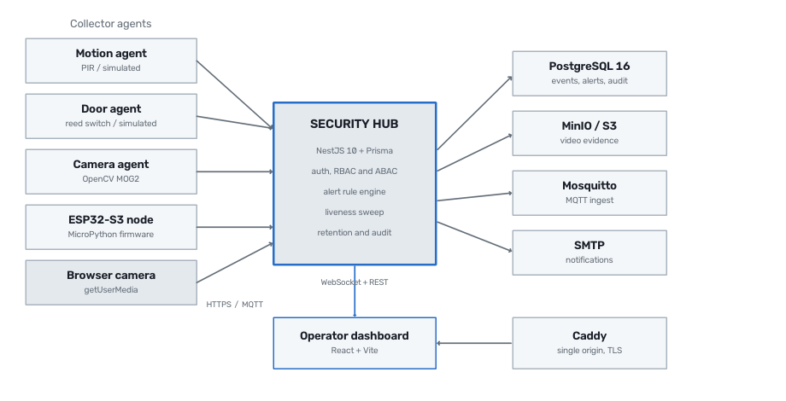
Figure 1: System architecture. Collector agents report to a central hub over HTTP or MQTT; the hub owns all judgement, persistence and access control.

1.1 Aim and Objectives
The aim of the project was to build a working security monitoring system rather than a simulation of one. The objectives were:
- To design a distributed architecture in which sensor agents and the central hub can fail independently without loss of recorded history.
- To implement role-based and attribute-based access control so that the system refuses dangerous actions rather than merely discouraging them.
- To detect not only sensor activity but sensor SILENCE, since a disabled sensor is the failure a security system most needs to notice.
- To provide an operator interface that makes the state of the building readable at a glance and explains every refusal in words a human can act on.
- To verify the system against a real database and a real browser, not only against mocks.

1.2 Scope
The system covers sensing, ingestion, alerting, notification, live video, scheduling, auditing and data retention. It does not attempt access control of physical doors, face recognition, or offsite monitoring. Where a capability is partially implemented — notably the GPIO readers for physical PIR and reed sensors on a Raspberry Pi — this is stated plainly in Section 8 rather than presented as complete.

2. LITERATURE AND DESIGN CONTEXT
Conventional intruder alarm systems use a wired panel with dedicated zones. They are reliable but closed: adding a sensor type means new hardware, and the panel keeps little history beyond a short event log. Commercial IP camera systems solve the video problem but treat sensors as an afterthought, and typically send footage to a vendor cloud.
The design adopted here follows the multi-agent pattern, in which several autonomous processes each handle one concern and communicate through a well-defined contract. This is the same reasoning behind microservice architectures, but applied at the sensing edge: each agent runs its own detection loop, holds its own credential, and can be restarted, replaced or moved without the hub being reconfigured.
The contract between agent and hub is deliberately small — three HTTP requests — which is what allows the same protocol to be spoken by a Python process on a laptop, a Raspberry Pi, an ESP32 microcontroller running MicroPython, or a web browser publishing its own camera.
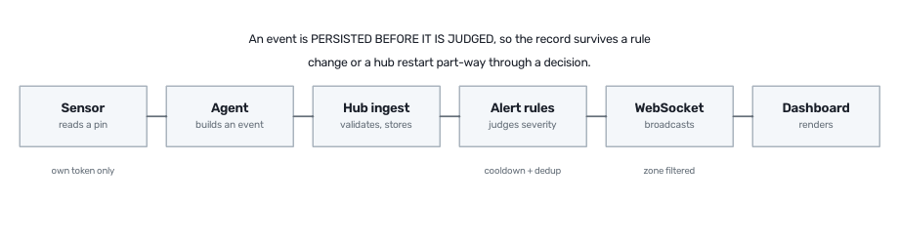
Figure 2: The path of a single observation, from sensor pin to operator display.

3. SYSTEM DESIGN

3.1 Components
The project is organised as a monorepo with four workspaces so that the wire contract is shared rather than duplicated. A renamed field becomes a compile error instead of a silently dead panel.
- The HUB (10,556 lines of TypeScript) is a NestJS application backed by PostgreSQL through the Prisma ORM. It owns authentication, the alert rules, liveness detection, retention, auditing and the WebSocket broadcast.
- The DASHBOARD (7,165 lines) is a React single-page application. Server state is held in TanStack Query and client state in Zustand, so there is exactly one copy of every entity.
- The AGENTS (4,603 lines of Python) implement motion, door and camera collectors, each able to run in simulation or against real hardware.
- The CONTRACTS package (940 lines) holds the shared wire types and is the single source of truth for every string that crosses the network.
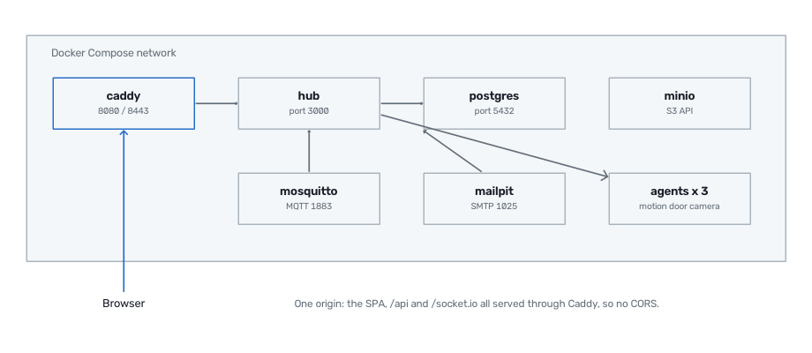
Figure 3: Deployment topology under Docker Compose. Caddy serves the dashboard and proxies the API and WebSocket, so the whole system presents a single origin.

3.2 Data Model
The database contains 8 models and 12 enumerated types, evolved through 6 migrations. Two decisions are worth drawing out. First, an Event records the hub's own arrival time separately from the agent's reported time, so ordering survives a sensor with a wrong clock. Second, an Alert keeps its own message and severity rather than depending on the event that caused it, which is why deleting old events cannot destroy the record of a judgement.
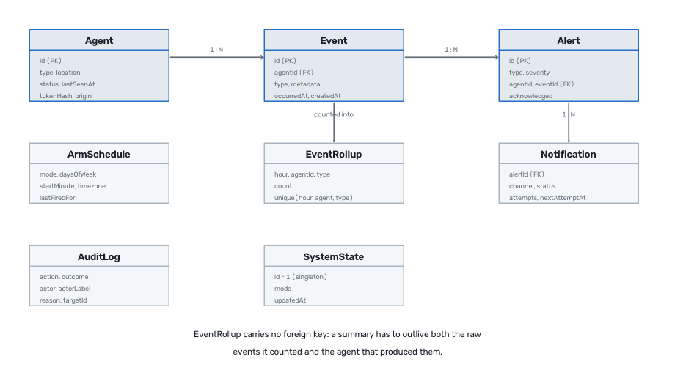
Figure 4: Entity relationships. Alerts survive the deletion of the events that produced them, and rollups survive both.

4. SECURITY MODEL
Security was treated as a design constraint rather than a feature. The system began with a single shared key, under which any holder could forge an event as any sensor, disarm the building and clear the resulting alerts. That was replaced with per-role credentials and per-agent tokens.

4.1 Roles and Permissions
Routes are guarded on PERMISSIONS rather than on roles, so changing what a role may do never means editing a controller. A route that declares no permission is denied to everyone, meaning a forgotten decorator fails closed rather than open. There are 17 permissions across five roles.
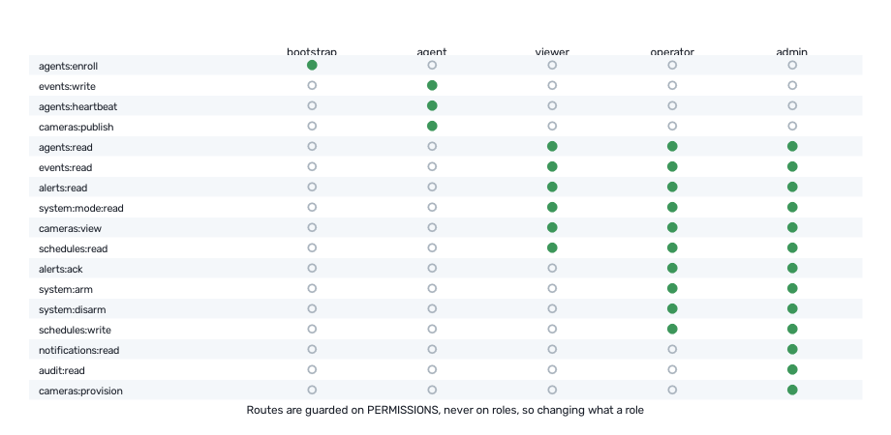
Figure 5: The role to permission mapping. A sensor token holds only what a sensor needs, and never the ability to acknowledge the alert its own tampering raised.
Each agent receives its own bearer token at enrolment. Only a SHA-256 hash of that token is stored, so a database dump yields no working credentials, and a lost token can be rotated but never recovered. The guard additionally enforces that an agent token may act only as its own agent, which prevents a single compromised sensor from injecting a door-closed event to mask an intrusion elsewhere.

4.2 Attribute-Based Rules
Roles answer what a kind of user may do; policies answer whether they may do it right now, to this thing. The headline rule is that DISARMING WHILE A CRITICAL ALERT IS UNACKNOWLEDGED REQUIRES AN ADMINISTRATOR. The failure this prevents is entirely realistic: an alarm is sounding and the fastest way to stop it is to disarm rather than investigate, which is exactly what an intruder who reached the panel would do. Acknowledging first is the intended path, and it unlocks disarming.
Figure 6: The arm control refusing a disarm, and explaining why in words the operator can act on rather than returning a bare error.

5. IMPLEMENTATION

5.1 The Operator Dashboard
The dashboard is the system's only human interface. It renders entirely from the permissions the hub reports, so a policy change on the server takes effect in the browser without a redeployment and a stale client cannot grant itself anything.
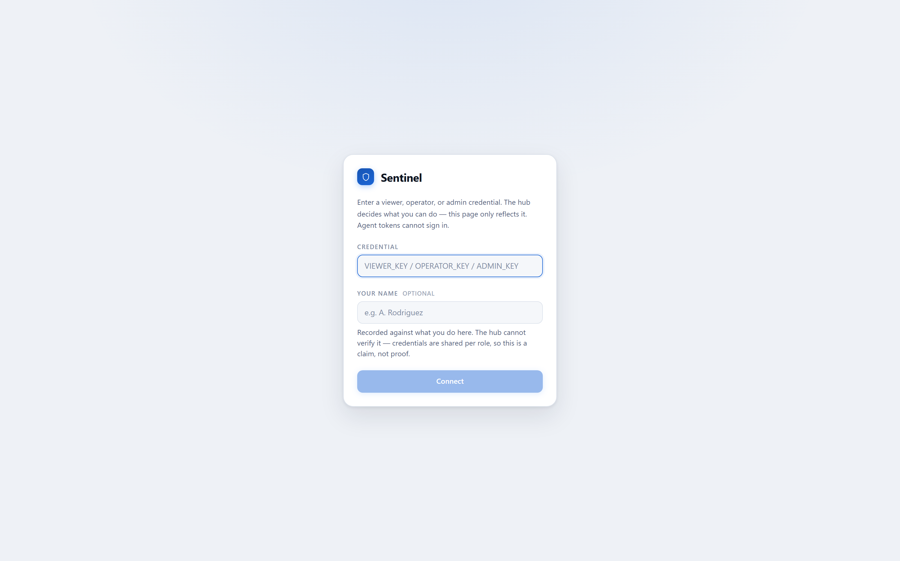
Figure 7: Sign-in. The credential determines the role; the optional name is recorded as an unverified claim, and the form says so.
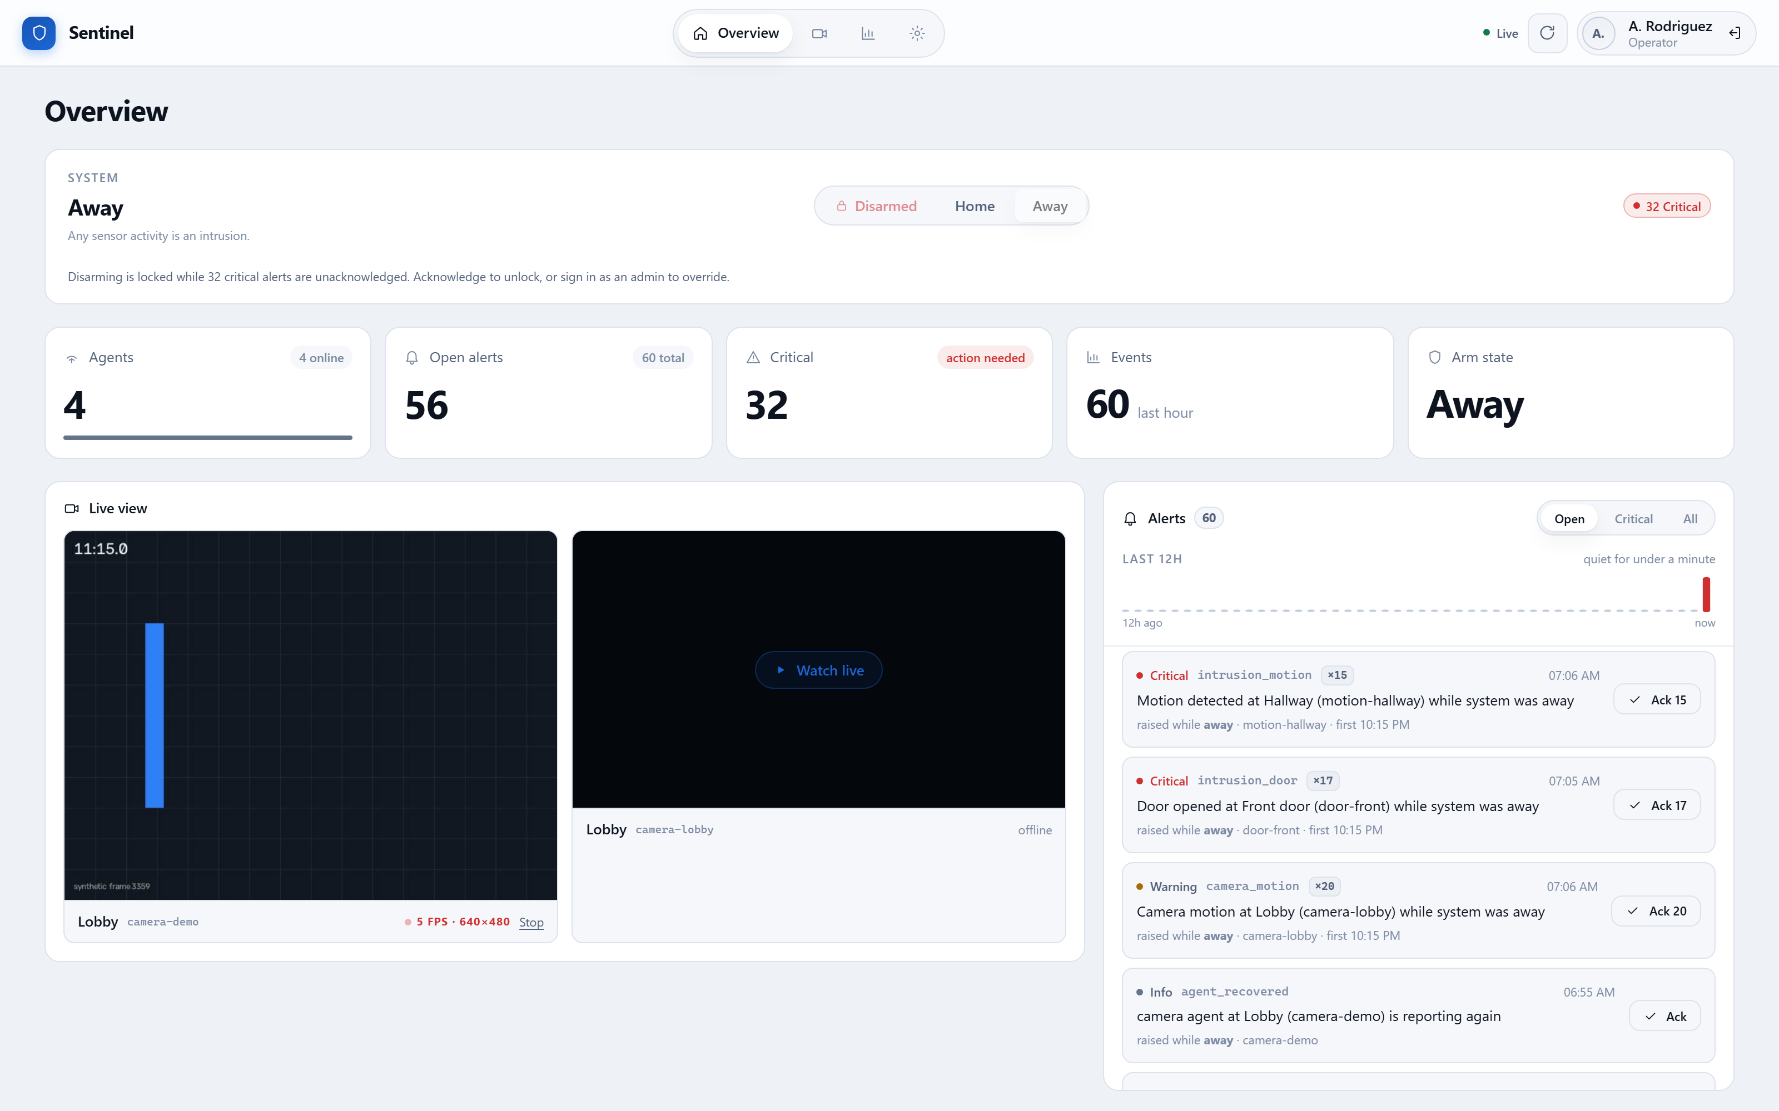
Figure 8: The operator overview: arm state, counters, live camera view and the alert queue on one screen.
Figure 9: At-a-glance counters. Colour marks exceptions only, so a nominal system is visually quiet.

5.2 Alert Rules and Clustering
Whether an event becomes an alert depends on the arm mode. In DISARMED nothing is raised; in HOME only perimeter sensors are armed; in AWAY every sensor is. A duplicate of the same type from the same agent is suppressed while an earlier matching alert is still unacknowledged.
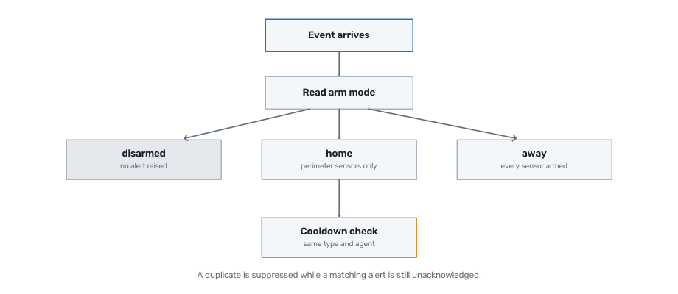
Figure 10: Alert rule evaluation. The arm mode at the moment of the event is recorded on the alert, so the reason it exists is never lost.
A motion sensor tripping repeatedly produces many near-identical alerts. Listed individually they bury everything else, so the dashboard groups them by type and agent, showing a count and allowing one acknowledgement to clear the whole cluster. Twenty repeats of one problem are one decision for the operator.
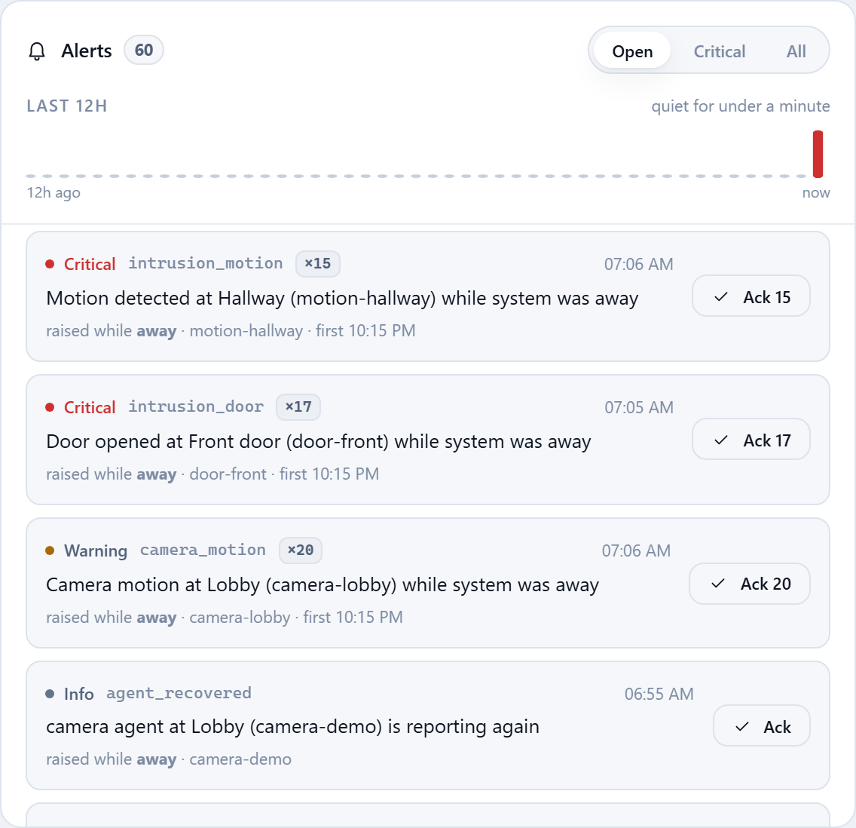
Figure 11: The alert panel. Repeats are collapsed into counted clusters that can be acknowledged together.

5.3 Liveness and Tamper Detection
An agent cannot report its own failure: a sensor that has been unplugged or disabled does not get to send a going-offline message. The hub therefore decides liveness itself, sweeping for agents that have stopped sending heartbeats and raising an alert on their behalf. A startup grace period prevents a hub restart from declaring the entire healthy fleet tampered with.
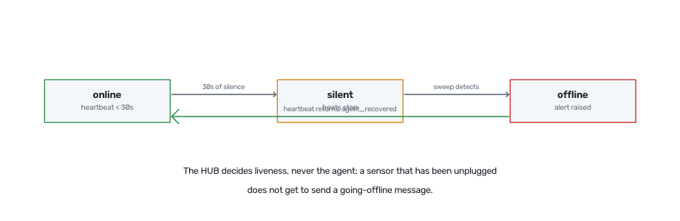
Figure 12: Liveness state transitions. Silence is treated as evidence, because it is the only signal a disabled sensor can produce.
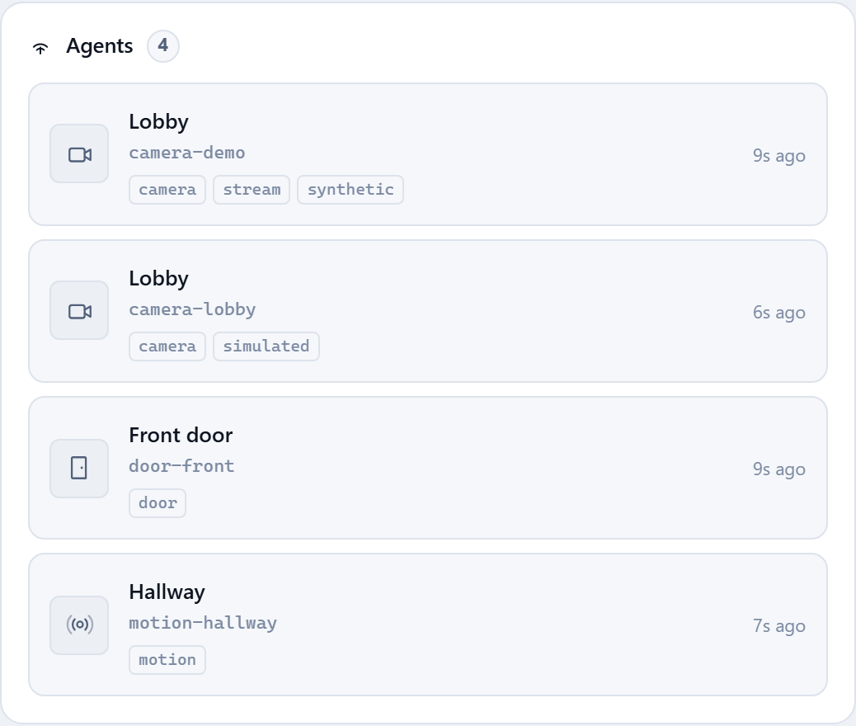
Figure 13: The agent fleet, showing type, location, status and time since last contact.

5.4 Live Camera View
Cameras publish JPEG frames to the hub, which holds only the newest frame per camera in memory and re-serves them as an MJPEG stream. Frames are never written to the database: they are worthless a second later, and a database is the wrong place for them. Because an image tag cannot send an authorisation header, the dashboard exchanges its credential for a single-use ticket that expires in seconds and grants exactly one thing — watching one camera.
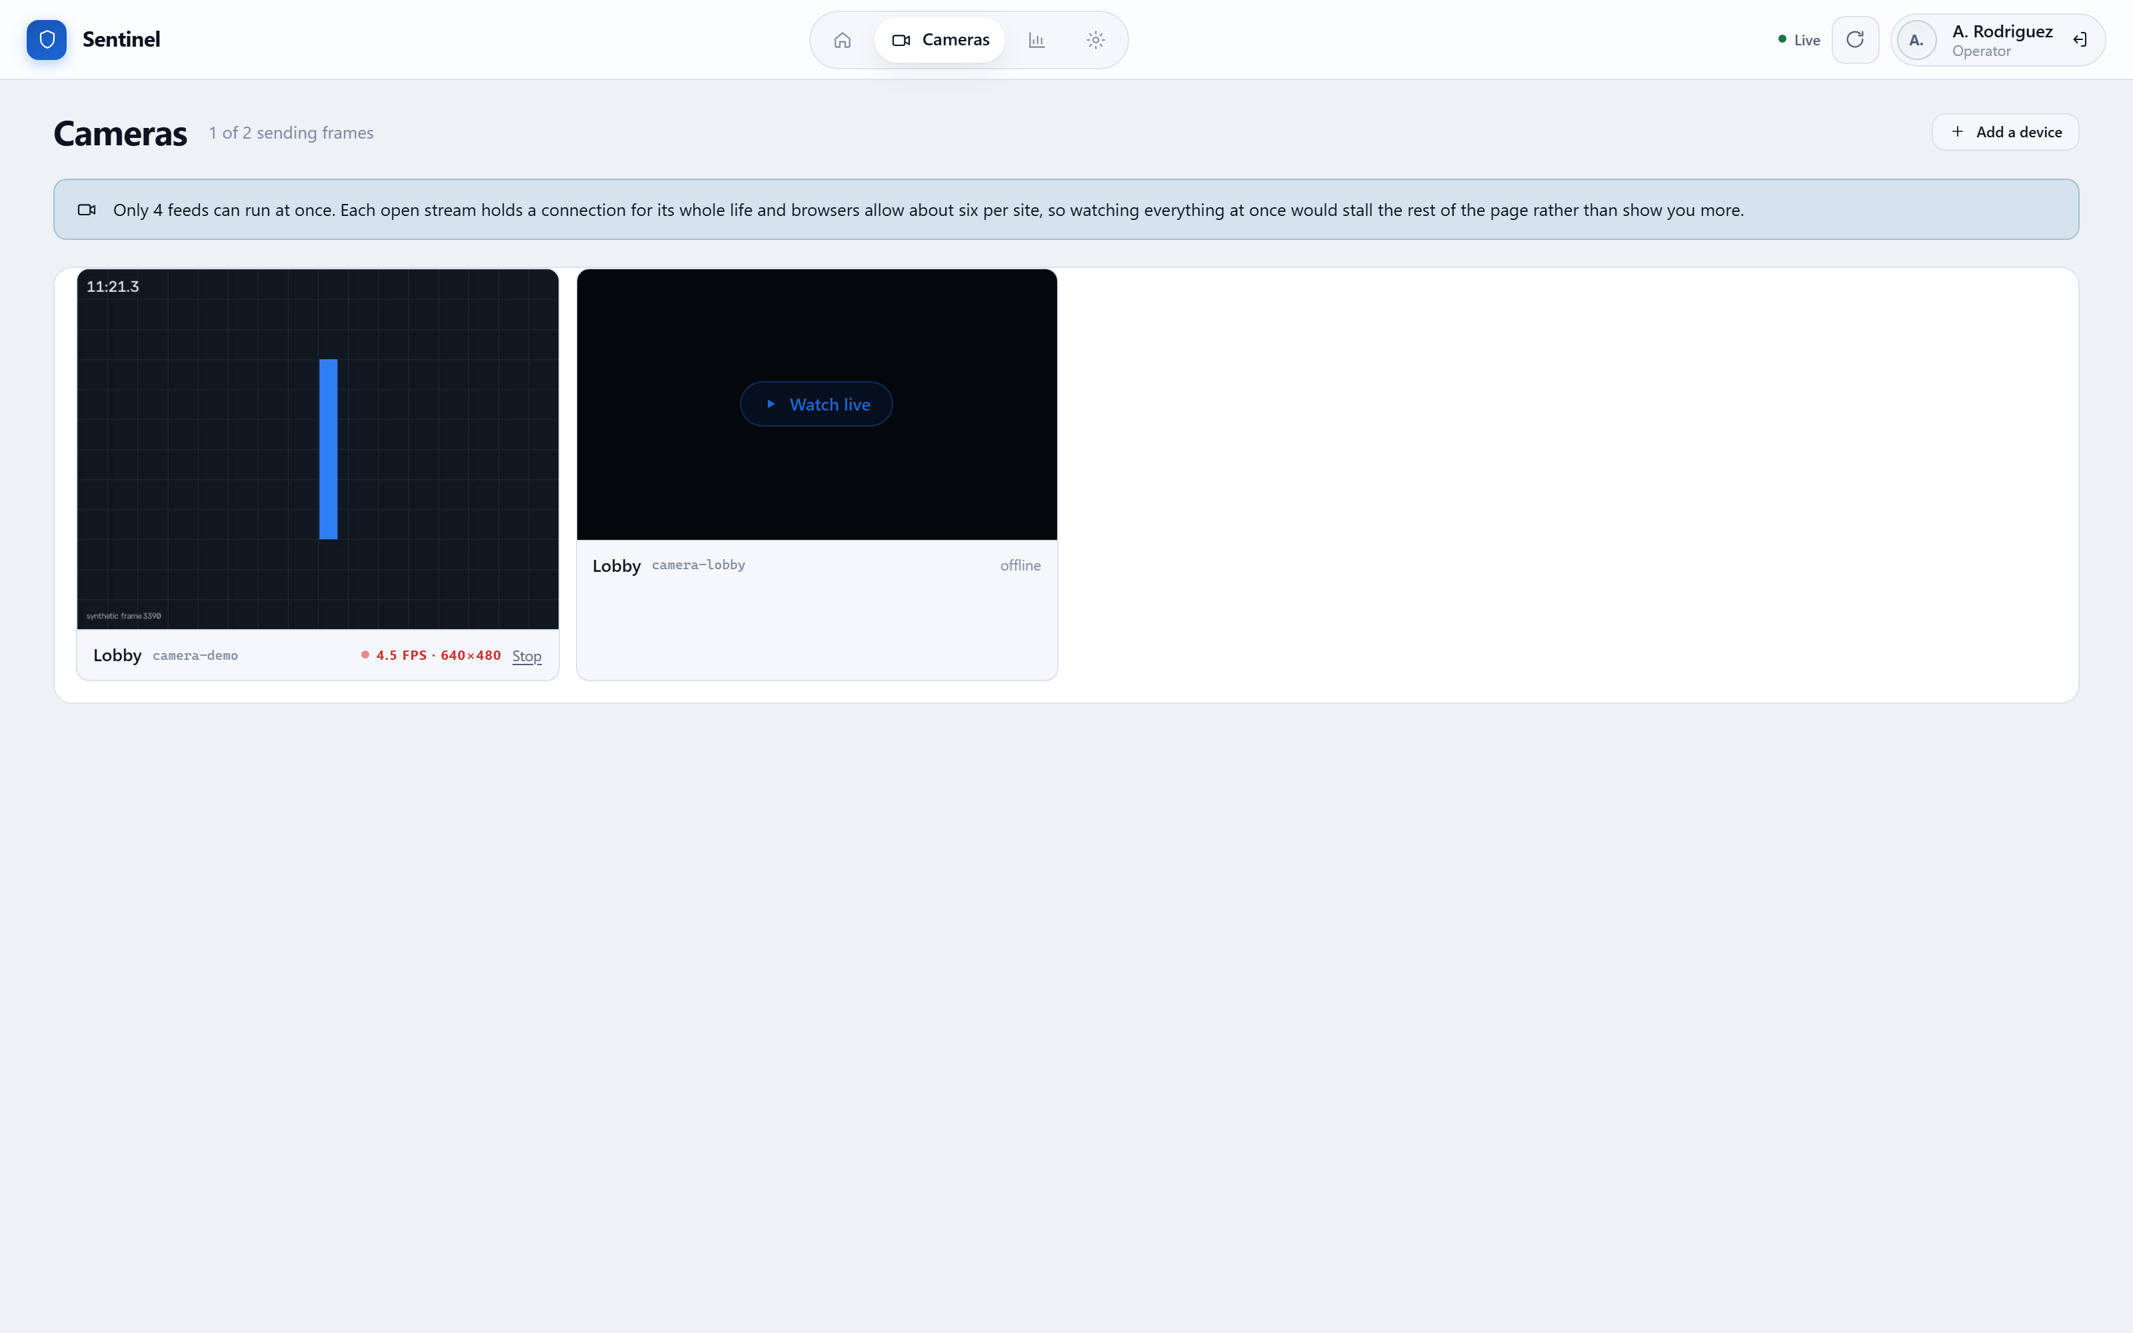
Figure 14: The camera wall. Feeds start automatically and are capped, because each open stream holds a connection for its whole life.
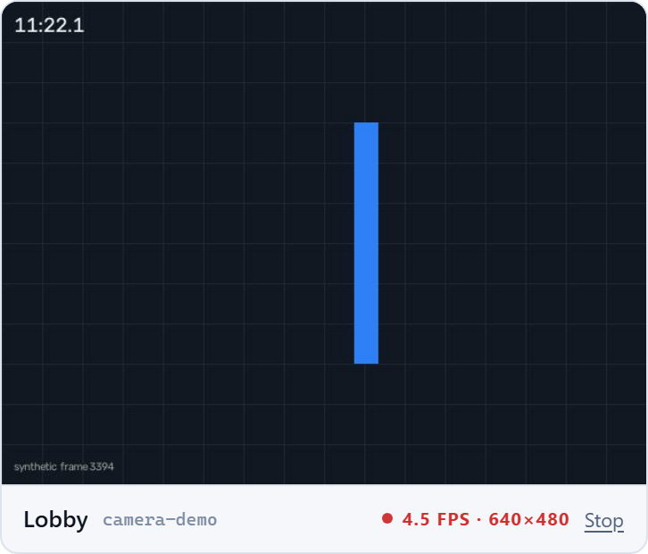
Figure 15: A single tile showing the MEASURED frame rate and resolution, which is what makes a slow feed diagnosable rather than a matter of impression.

5.5 Event Stream and Reporting
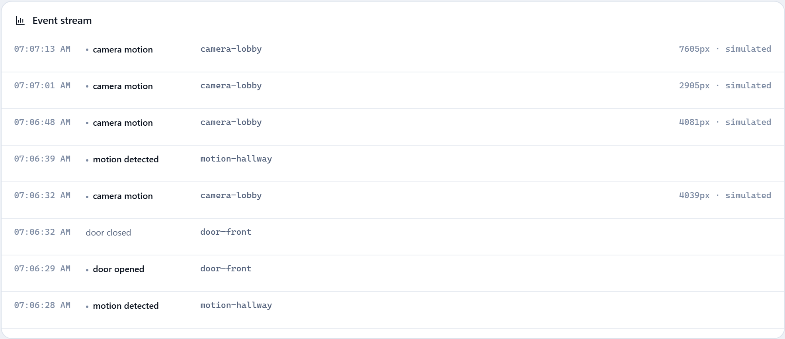
Figure 16: The raw event stream, filterable to a single agent.
Historical reporting reads from hourly rollups where they exist and from raw rows for the most recent hours, so the page continues to work on periods whose individual events have long been deleted.
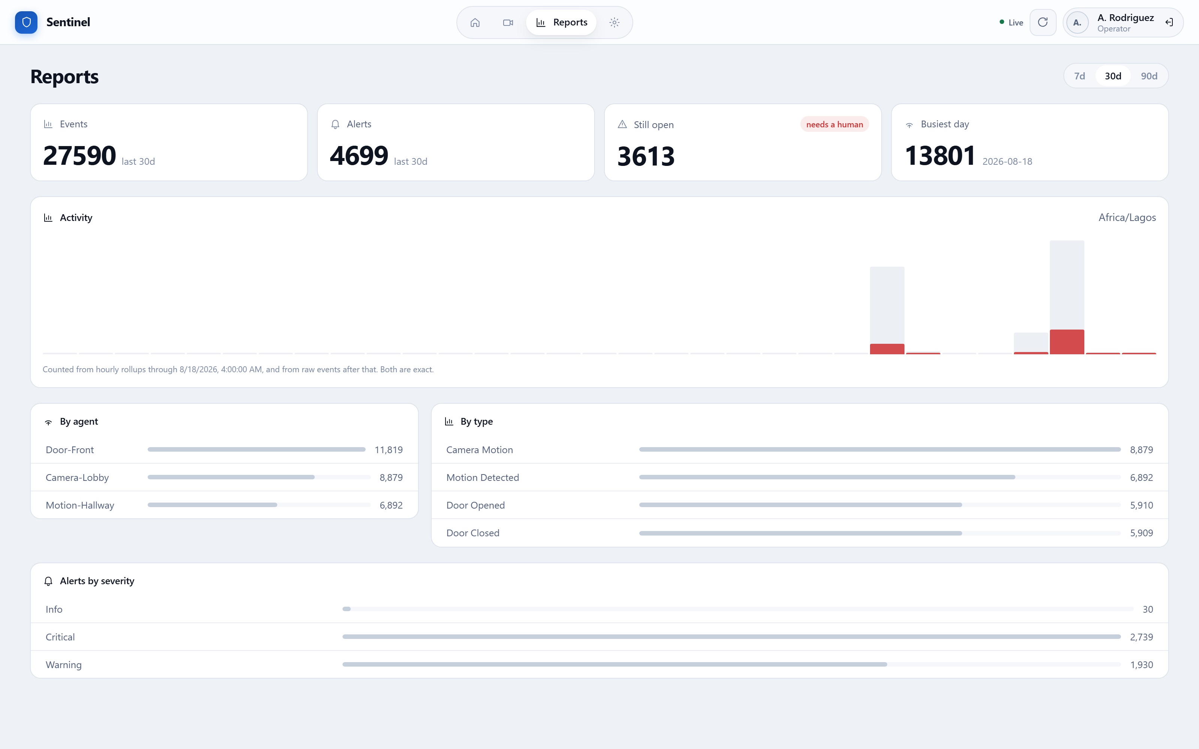
Figure 17: Aggregated history over a thirty-day window, broken down by agent, by event type and by alert severity.
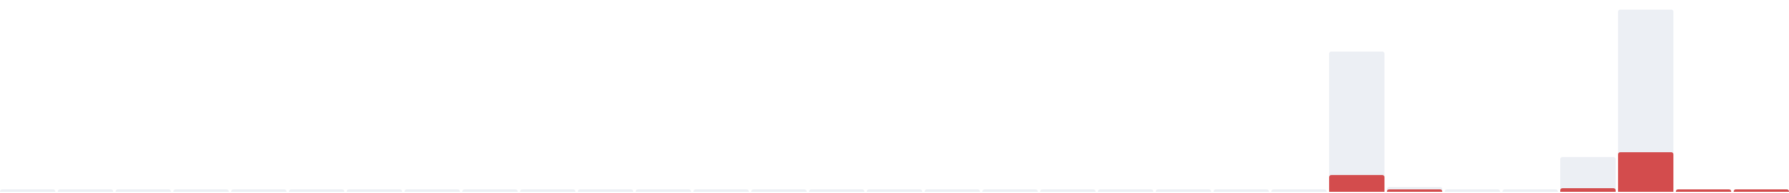
Figure 18: Daily activity. Alerts are overlaid on events rather than charted separately, because the question is always whether activity became alarm.

6. DATA RETENTION, AUDIT AND SCHEDULING

6.1 Retention and Rollups
Nothing in the system deleted a row until retention was added, so the event table grew without bound. Rather than simply deleting history, each hour of events is first summarised into a count per agent and per event type. On measured data this achieved a 137:1 reduction — 9,727 events became 71 rows — while remaining exact for the question historical views actually ask.
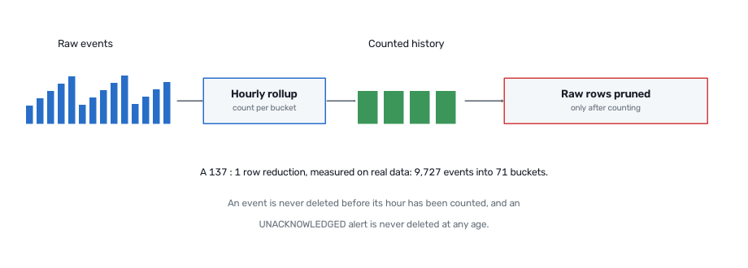
Figure 19: Retention with rollups. An event is never deleted before its hour has been counted, and an unacknowledged alert is never deleted at any age.
Every retention window ships disabled, meaning keep forever. Deleting evidence is something an operator opts into deliberately; an upgrade must never begin destroying records on its own.

6.2 The Audit Trail
The system records who changed the arm mode, who acknowledged an alert, who enrolled an agent and who was REFUSED. Denials are recorded as well as successes, because a refused disarm during an active incident is the most interesting line the trail will ever hold.
The trail is honest about what it can prove. Because credentials are shared per role, the hub knows the ROLE that acted but not the PERSON. An optional name typed at sign-in is stored and displayed as a CLAIM, visually separated from the verified role, and the interface says plainly that it is not checked. The table deliberately holds no credential material, not even a hash.
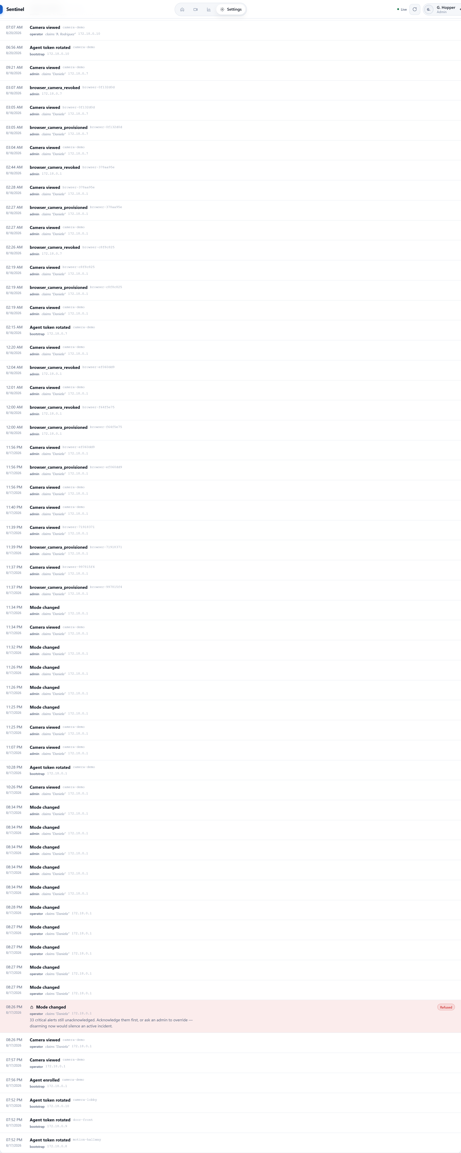
Figure 20: The audit trail. The verified role and the self-asserted name are presented differently, because they are different kinds of fact.

6.3 Scheduled Arming
A schedule is a TRANSITION, not a continuously enforced state: it fires once when its boundary passes and then leaves the system alone. Re-asserting the mode every minute would fight an operator who deliberately disarmed. A manual change is therefore respected until the next boundary, and that boundary still fires — because the usual reason a building is left unarmed is that somebody forgot.
A scheduled disarm obeys the same critical-alert rule a human does, with no administrator override. That override exists so that a named person can take responsibility for silencing an active incident, and a timer cannot take responsibility for anything.
Figure 21: Schedule management. Each schedule stores its own time zone, so it stays correct across daylight-saving changes.

7. ACCESS CONTROL IN PRACTICE
The clearest demonstration of the security model is to view the same system through different credentials. The interface is not merely hiding buttons: every rule shown here is independently enforced by the hub, and calling the API directly produces the same refusal.
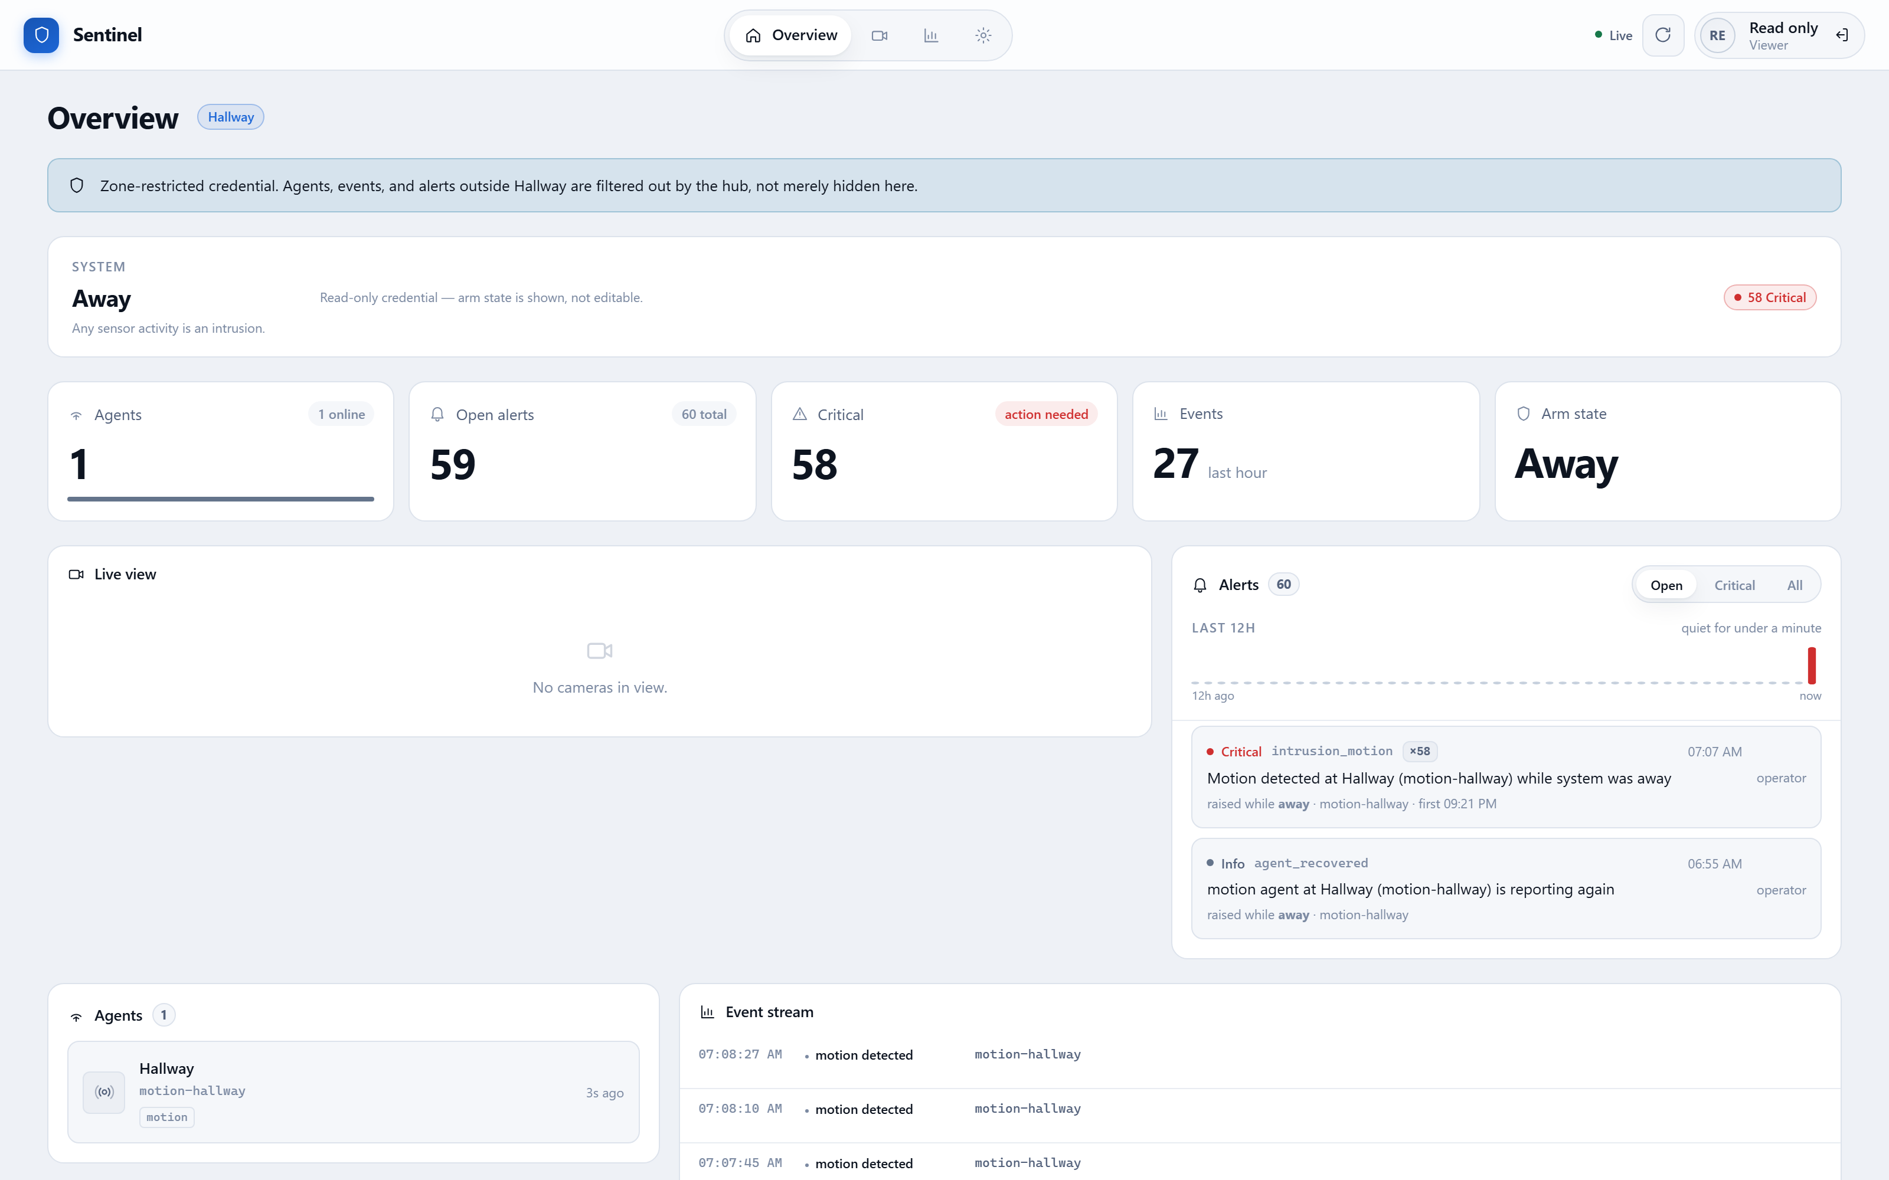
Figure 22: The same overview seen by a read-only viewer. The arm controls and acknowledgement actions are absent.
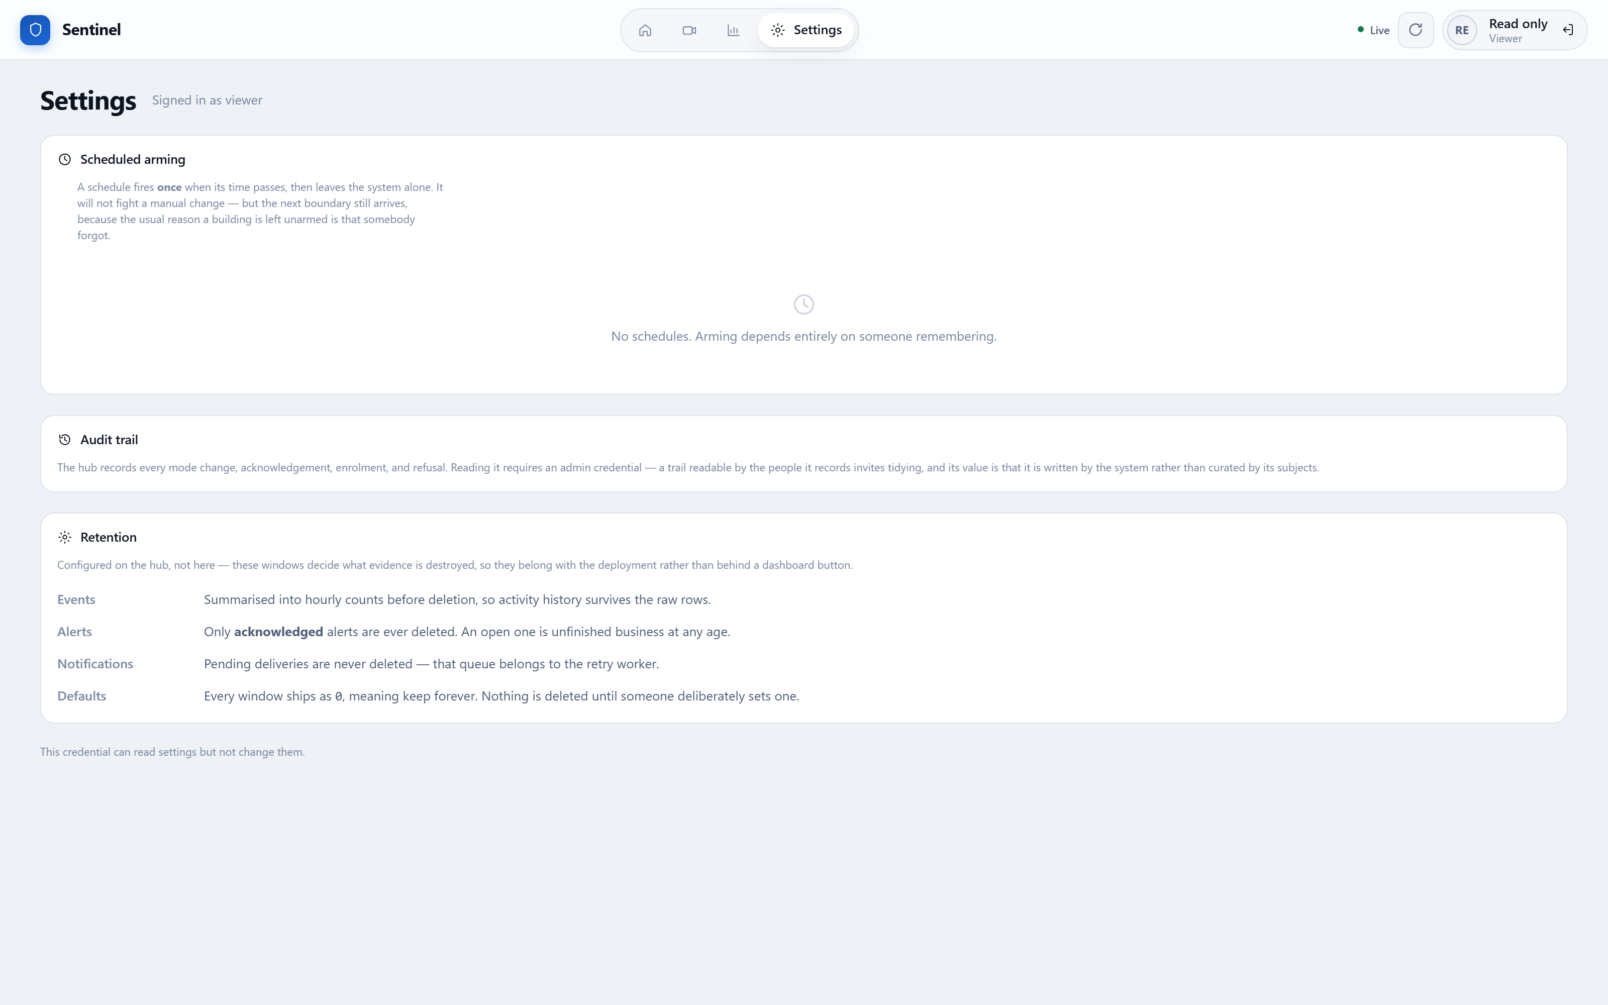
Figure 23: Settings as a viewer. The audit trail is described but withheld, rather than hidden entirely — an operator who cannot find it should not conclude the system has none.
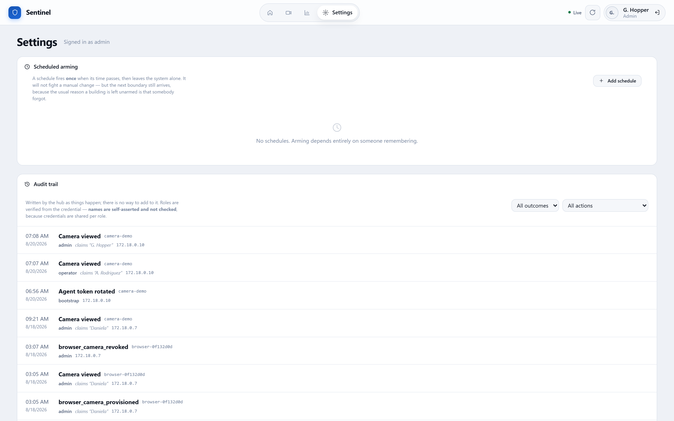
Figure 24: Settings as an administrator, with the audit trail available.
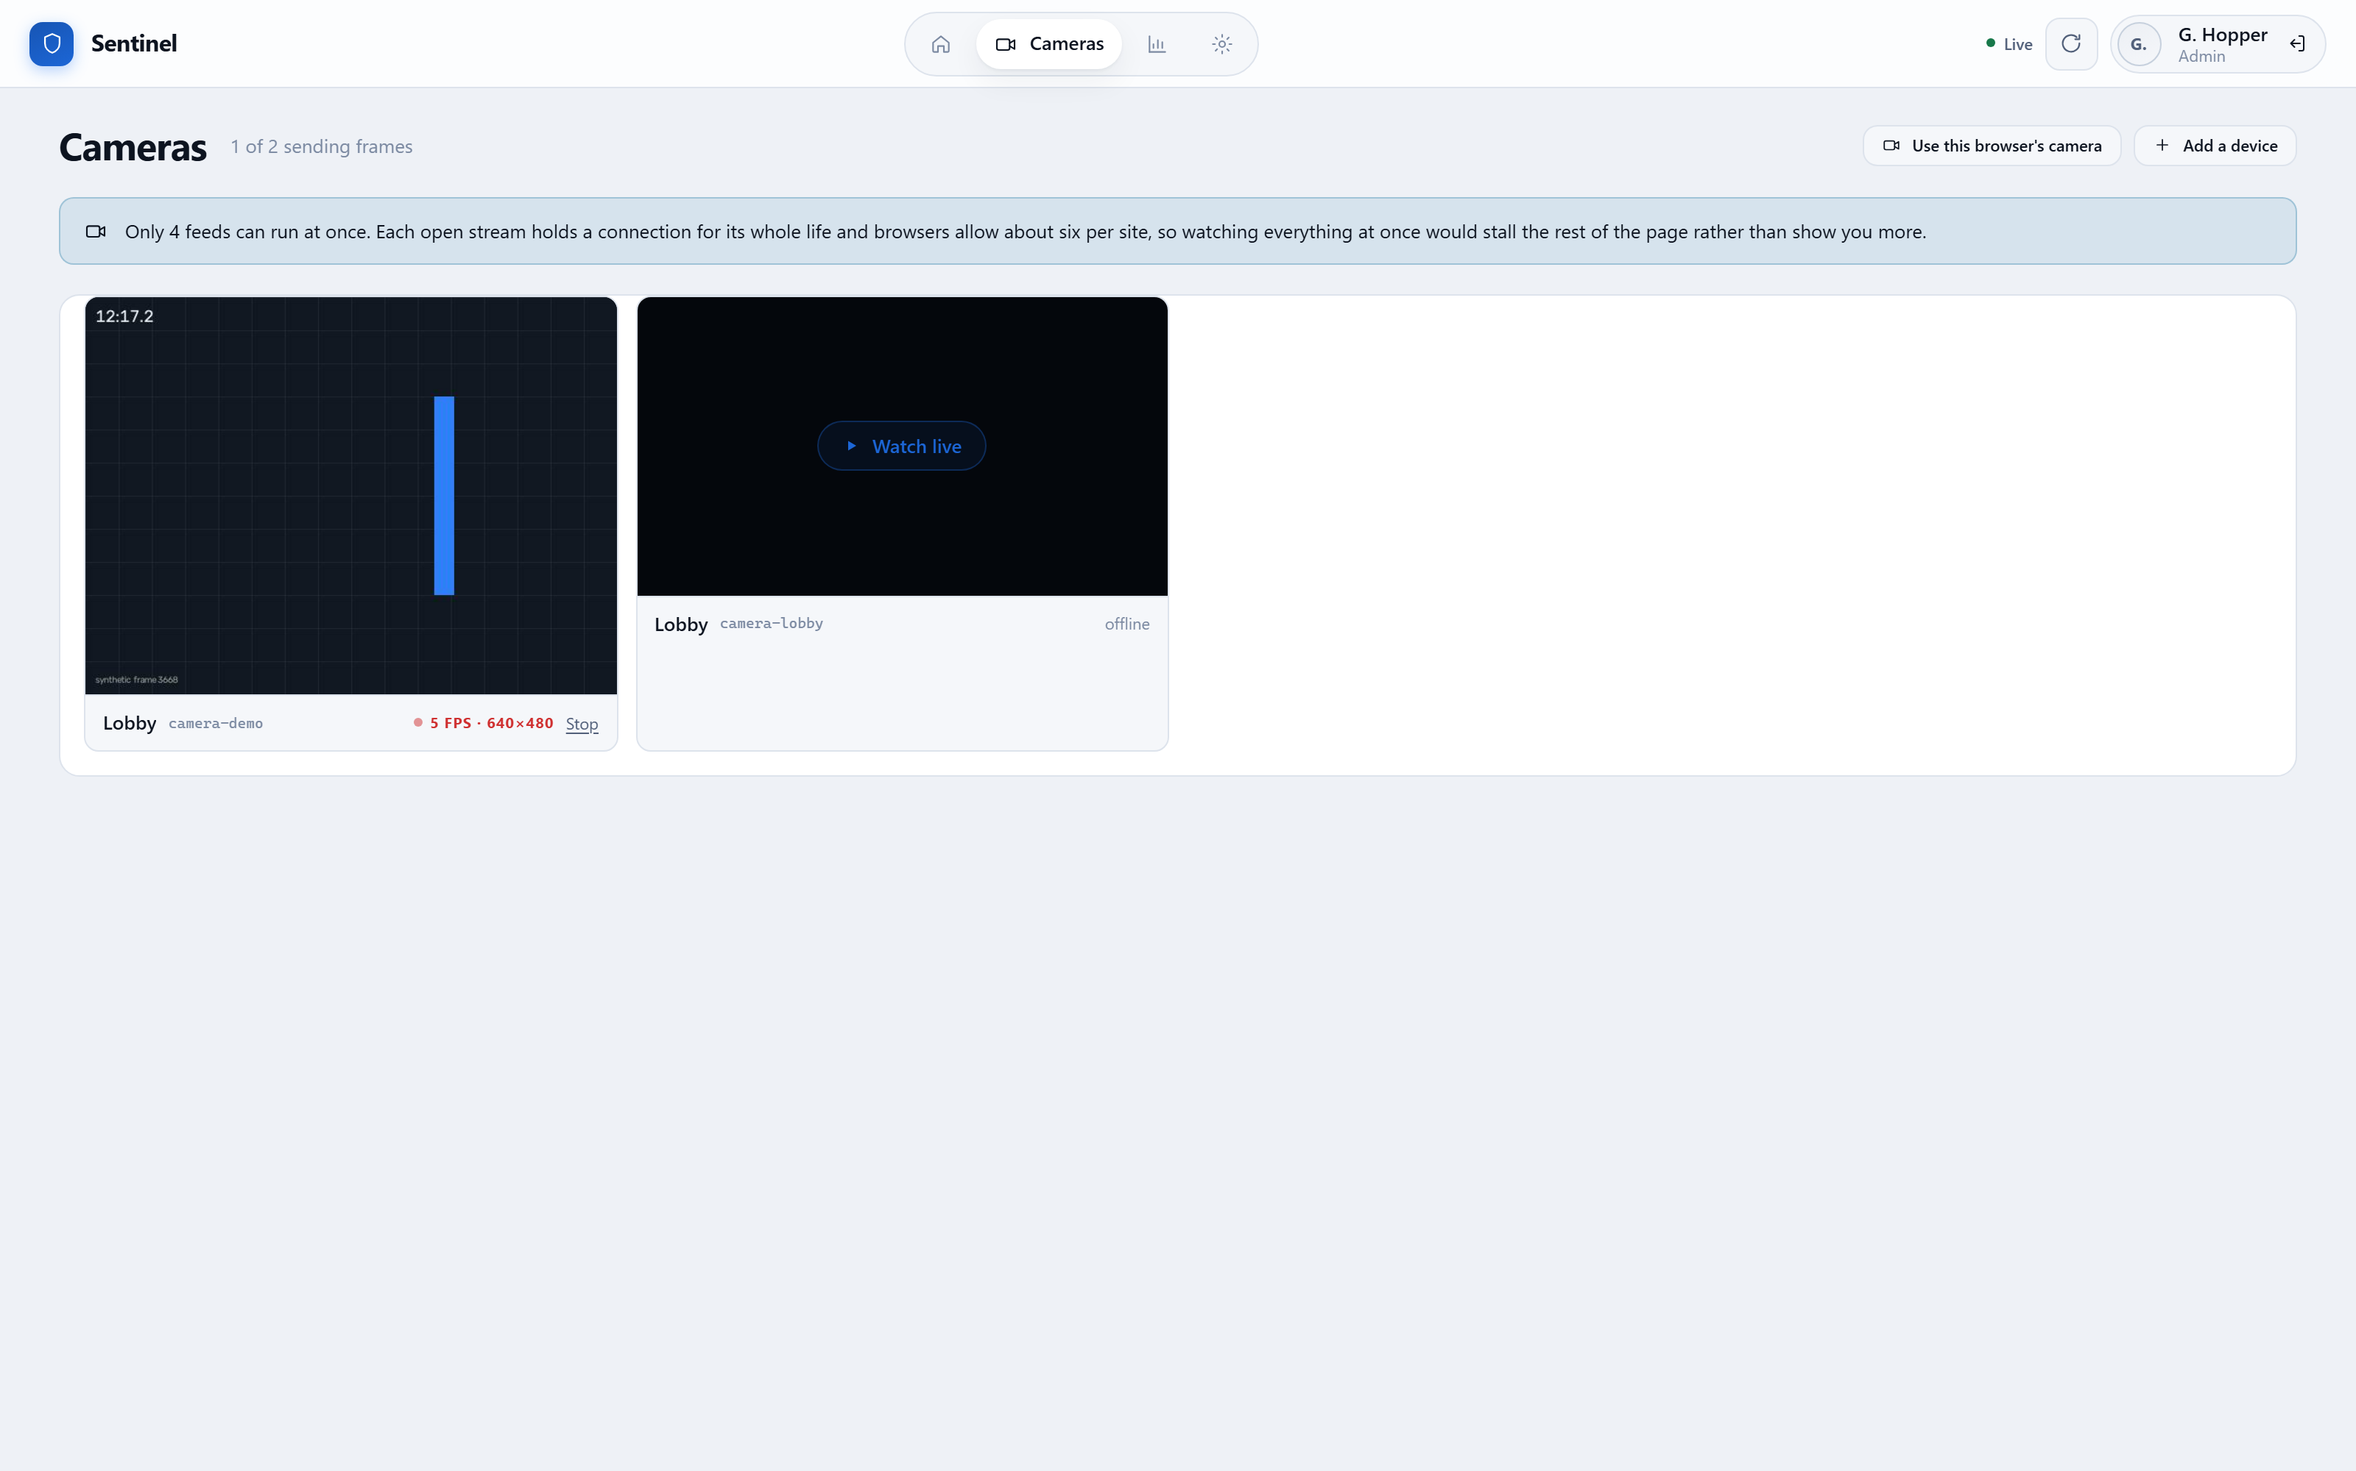
Figure 25: Camera management. Provisioning a browser camera is an administrator action, because it mints a credential capable of publishing video.

8. TESTING AND VERIFICATION
The system carries 355 hub tests, 136 dashboard tests and 90 agent tests, all passing. Unit tests alone were not treated as sufficient: they mock the database, so they prove that the code issues the right instructions but not that PostgreSQL accepts them.
Four verification scripts therefore exercise the real service against the real database and the real HTTP surface. They confirm, among other things, that an unacknowledged alert survives retention at any age; that a refused disarm is recorded with its reason; that a schedule fires exactly once and is held during an open incident; and that a browser-published camera cannot be named to impersonate hardware.
This approach found defects that unit tests could not. One example: the scheduled arming feature passed all of its unit tests while being completely inert, because the database query used to claim a schedule excluded rows whose value was null — which is every schedule that has never fired. In SQL, a comparison against null is not true, and a mocked database cannot reproduce that. Only running it against PostgreSQL revealed that no schedule would ever have fired.

8.1 Known Limitations
Stated plainly, because a report that omits them is less useful:
- The GPIO readers for physical PIR and reed sensors on a Raspberry Pi are documented stubs. The camera hardware path is complete and tested; the two sensor hardware paths raise an explicit not-implemented error and require the commented driver calls to be enabled.
- Credentials are shared per role rather than per person, so the audit trail can attribute an action to a role but not to an individual. A users table is the documented next step.
- The ESP32 firmware has been written and its logic unit-tested in CPython, but the on-device paths remain unverified pending hardware.

9. CONCLUSION
The project delivers a working multi-agent security system rather than a prototype of one. Sensor agents report facts; the hub judges them against the current arm state, raises and de-duplicates alerts, notices sensors that have gone silent, records who did what, and presents all of it through an interface that explains its refusals.
The most valuable lessons were not about any single technology. They were that a system should refuse dangerous actions rather than merely discourage them; that silence from a sensor is itself information; that a record is only worth keeping if it is honest about what it can and cannot prove; and that software which passes its tests can still be entirely inert, which is why verification against real infrastructure earned its place.
Future work follows directly from the limitations in Section 8.1: completing the GPIO sensor drivers, introducing per-user credentials so the audit trail can name individuals, and flashing the ESP32 firmware onto hardware so that a complete sensor node costs a few dollars rather than the price of a single-board computer.

