OAU LOGO - replace this box with the crest

OBAFEMI AWOLOWO UNIVERSITY
FACULTY OF COMPUTING SCIENCE
DEPARTMENT OF COMPUTER SCIENCE AND ENGINEERING

DEVELOPMENT OF AN INTELLIGENT MULTI-AGENT
CAMPUS SECURITY SURVEILLANCE SYSTEM
A Project Report Submitted in Partial Fulfilment of the Requirements for
CPE 310: AGENT-BASED SYSTEMS
COURSE COORDINATOR:
DR. T.F. SHOLANKE
BY
GROUP TWELVE(12), [ACADEMIC SESSION] SESSION
August, 2026

GROUP MEMBERS

S/N | NAME | MATRICULATION NUMBER
1 | Olatunde Ibrahim Akinade | CSC/2022/177
2 | Ologunebi Tobiloba Ifeoluwa | CSC/2022/180
3 | Popoola Faith | CSC/2022/212
4 | Akinwamide Williams | CSC/2022/055
5 | Kasali Kamil Ademola | CSC/2022/348
6 | Majekodunmi Oyindamola | CSC/2022/295
7 | Omidiora Ojuolape | CSC/2022/303
8 | Olatunji Goodness | CSC/2022/178
9 | Aderibigbe Emmanuel Semilore | CSC/2022/029
10 | Adejumo Adeyinka Mosope | CSC/2022/019
11 | Adeleke Semiloore Mueez | CSC/2022/021
12 | Akinbode David Oluwagbemiga | CSC/2022/053
13 | [NAME MISSING] | CSC/2023/200
14 | Orisasona Ayoola Williams | CSC/2022/330
15 | Payne Simeon Oyelekan | CSC/2022/357
16 | Odejide Oluwatunmise Benjamin | CSC/2022/383
17 | Aregbesola Temiloluwa Mary | CSC/2023/246
18 | Ibrahim Ramlah Adenike | CHE/2022/017
19 | Badejo Emmanuel | CSC/2022/091

ABSTRACT
This project presents the design, implementation and evaluation of an intelligent multi-agent system for campus security surveillance. Conventional campus security depends on human patrols and closed-circuit cameras that record but do not reason: footage is reviewed after an incident rather than during one, and a sensor that has been disabled is indistinguishable from a sensor reporting nothing. The system developed here addresses both weaknesses by distributing perception across autonomous sensing agents while centralising judgement in a coordinating agent.
Four classes of agent were implemented: motion agents using passive infrared detection, door agents using magnetic contacts, camera agents performing background-subtraction motion analysis, and a coordinating agent. Each sensing agent is autonomous and reactive, holding its own credential and detection loop, and reports only observed facts. The coordinating agent alone interprets those facts against the prevailing security posture, raises and de-duplicates alerts, detects agents that have fallen silent, enforces role-based and attribute-based access control, and maintains an audit trail of every action and every refusal.
The system comprises approximately 10,556 lines of coordinating logic, 7,165 lines of interface code and 4,603 lines of agent code, backed by a relational store of 8 entities. It was evaluated through 355 automated coordinator tests, 136 interface tests and 90 agent tests, together with four end-to-end verification programs executed against a live database and browser. Simulation across the three security postures confirmed correct alert generation, suppression of duplicates, detection of agent silence within thirty seconds, and a 137:1 reduction in stored history through hourly aggregation while preserving exact activity counts.
The results demonstrate that an agent-based decomposition offers concrete advantages for physical security: sensing agents may fail or be replaced independently without loss of recorded history, and centralising judgement allows policies such as refusing to disarm during an unacknowledged critical incident to be enforced uniformly, regardless of which agent reported it.

TABLE OF CONTENTS

GROUP MEMBERS 2
ABSTRACT 3
LIST OF ABBREVIATIONS 8
1.0 INTRODUCTION 9
1.1 Background 9
1.2 Problem Statement 9
1.3 Aim and Objectives 10
1.4 Scope of the Project 11
1.5 Significance of the Project 11
1.6 Definition of Terms 11
2.0 LITERATURE REVIEW 13
2.1 Preamble 13
2.2 Conceptual Review 13
2.3 Review of Related Works 14
2.4 Comparison of Related Works 14
3.0 SYSTEM DESIGN 16
3.1 Preamble 16
3.2 Design Methodology Adopted 16
3.3 Requirements Analysis 17
3.3.4 Hardware Specifications 17
3.4 Role Analysis 18
3.5 System Architecture 19
3.6 Agent Specifications 21
3.7 Interaction Design 22
3.8 Detailed Design of the Decision Logic 23
3.8.1 Alert Adjudication 23
3.8.2 Duplicate Suppression 24
3.8.3 Liveness Invigilation 24
3.8.4 Access Control 24
3.10 Design Tools 25
4.0 SIMULATION AND RESULTS 26
4.1 Preamble 26
4.2 Simulation Platform and Justification 26
4.3 Simulation Architecture 27
4.4 Environment Model 27
4.5 Implementation of Agents 28
4.6 Test Scenarios 29
4.7 Results 29
4.8 Discussion of Results 38
5.0 CONCLUSION AND RECOMMENDATIONS 40
5.1 Summary of Work Done 40
5.2 Achievement of Objectives 40
5.3 Limitations of the Work 40
5.4 Recommendations for Future Work 41
5.5 Conclusion 42
REFERENCES 43
APPENDICES 44
Appendix A: Source Code Listing 44
Appendix B: Full Message Catalogue 44

(If the area above shows this instruction rather than the contents, click it, press F9, and choose to update the entire table. Word builds the list from the headings and the final pagination.)

LIST OF ABBREVIATIONS

ABBREVIATION | MEANING
ABAC | Attribute-Based Access Control
API | Application Programming Interface
DTO | Data Transfer Object
FIPA | Foundation for Intelligent Physical Agents
GPIO | General Purpose Input/Output
HTTP | Hypertext Transfer Protocol
JPEG | Joint Photographic Experts Group
JSON | JavaScript Object Notation
MAS | Multi-Agent System
MJPEG | Motion JPEG
MOG2 | Mixture of Gaussians, version 2
MQTT | Message Queuing Telemetry Transport
ORM | Object-Relational Mapping
PIR | Passive Infrared
RBAC | Role-Based Access Control
REST | Representational State Transfer
RTSP | Real Time Streaming Protocol
SPA | Single Page Application
SQL | Structured Query Language
TLS | Transport Layer Security
TTL | Time To Live
UI | User Interface
UTC | Coordinated Universal Time

1.0 INTRODUCTION

1.1 Background
A university campus is an unusually difficult environment to secure. It is large, has many entrances, is occupied at irregular hours, and its population changes every session. The prevailing approach combines human patrols with closed-circuit television, and both scale badly: a guard cannot be everywhere, and camera footage is almost always reviewed after an incident rather than during it. A recording explains what happened; it does not raise an alarm.
Multi-agent systems offer a different decomposition. Rather than one program polling every device, an agent is placed at each point of interest. Each agent is autonomous, running its own perception loop and deciding when it has something to report; reactive, responding to changes in its environment as they occur; and social, communicating through an agreed protocol rather than shared memory. This is the characterisation of agency given by Wooldridge (2009), and it maps naturally onto physical sensing, where the devices are genuinely distributed and genuinely unreliable.

1.2 Problem Statement
Existing campus surveillance arrangements exhibit four specific weaknesses that this project addresses.
- Monitoring does not scale with the number of sensors. Human attention is the bottleneck, and adding cameras worsens the problem rather than easing it.
- A disabled sensor is invisible. Systems report what their sensors detect, so a sensor that has been unplugged, obscured or cut simply reports nothing, which is indistinguishable from a quiet corridor.
- Context is ignored. A door opening at midday during an examination is routine; the same door opening at midnight is not. Systems treating every detection identically generate alarms nobody trusts.
- There is no accountability. Where an operator can silence an alarm, there is frequently no record of who did so, when, or whether it was investigated first.

1.3 Aim and Objectives
The aim of this project is to develop an intelligent multi-agent system for campus security surveillance in which distributed autonomous agents perform perception while a coordinating agent performs judgement, alerting and record keeping. The specific objectives are:
- To design an agent-based architecture in which sensing agents and the coordinating agent can fail independently without loss of recorded history.
- To implement autonomous motion, door and camera agents capable of operating in both simulated and physical modes.
- To develop decision logic interpreting observations against the prevailing security posture rather than in isolation.
- To detect agent silence as a first-class security event, so that tampering is reported rather than merely producing an absence of alarms.
- To enforce role-based and attribute-based access control such that dangerous operations are refused, with the reason recorded.
- To evaluate the system by simulation across defined scenarios and by automated testing against live infrastructure.

1.4 Scope of the Project
The project covers agent design and implementation, the communication protocol between agents, the decision logic of the coordinating agent, persistence of observations and judgements, the operator interface, and evaluation by simulation. Physical access control such as electronic door locking is outside the scope, as are biometric identification and off-campus monitoring. Video is used for motion detection and live viewing but not for face or object recognition.
Where a capability is partially realised, notably the hardware drivers for physical infrared and magnetic sensors, this is stated explicitly in Section 5.3 rather than presented as complete.

1.5 Significance of the Project
The significance of the work is threefold. Practically, it demonstrates that a credible campus surveillance system can be assembled from inexpensive components, a single-board computer or microcontroller per sensing point, coordinated by software rather than by a proprietary alarm panel. Academically, it provides a concrete case study in agent-oriented decomposition where the agents are genuinely distributed and genuinely fallible, which is a more demanding setting than a purely software simulation.
Methodologically, the project illustrates that treating silence as information and refusal as a recordable event materially changes what a security system can be trusted to tell its operators.

1.6 Definition of Terms
TERM | DEFINITION
Agent | An autonomous computational entity that perceives its environment and acts upon it, deciding for itself when to act.
Multi-Agent System | A system of several interacting agents that together achieve an objective no single agent addresses alone.
Autonomy | The capacity to operate without direct intervention, controlling one's own internal state and actions.
Reactivity | The capacity to perceive a change in the environment and respond to it in a timely fashion.
Coordinating agent | The agent receiving observations from sensing agents, interpreting them, and holding shared state.
Event | A reported observation of fact, such as a door opening. Carries no judgement about significance.
Alert | A judgement by the coordinating agent that an event, in the prevailing context, requires human attention.
Security posture | The state of the monitored environment: disarmed, home or away. Also termed the arm mode.
Heartbeat | A periodic liveness message by which an agent demonstrates it is still operating.
Rollup | An hourly aggregate of event counts retained after the underlying individual events are deleted.
Audit trail | An append-only record of actions attempted, including those refused, and the reason for refusal.

2.0 LITERATURE REVIEW

2.1 Preamble
This chapter reviews the concepts underpinning agent-based systems, examines categories of existing surveillance technology, and compares them against the requirements identified in Chapter One. Its purpose is to establish why an agent-oriented decomposition was selected rather than a conventional centralised design.

2.2 Conceptual Review
Wooldridge (2009) characterises an agent as a computer system situated in an environment and capable of autonomous action within it in order to meet its objectives. Four properties are commonly attributed to agents: autonomy, reactivity, pro-activeness and social ability. Russell and Norvig (2021) frame the same idea as an agent function mapping percept histories to actions, and distinguish simple reflex agents from model-based and goal-based ones.
The sensing agents in this project are best classified as reflex agents with internal state. A motion agent maintains enough state to know whether its detector was previously active and when it last reported, which is what allows it to report a rising edge rather than a continuous condition, but it holds no model of the building. The coordinating agent is model-based: it maintains the security posture, the set of known agents and the outstanding alerts, and its response to an identical percept differs according to that model.
Coordination between agents may be organised in several ways. Direct peer-to-peer negotiation, formalised in the FIPA agent communication specifications, suits agents that must bargain over resources. A mediated arrangement, where agents communicate through a coordinator, suits systems requiring a consistent global judgement. The latter was adopted here for the reason developed in Section 3.2: a security decision must be consistent, and consistency is far simpler to guarantee when a single agent holds the authoritative state.

2.3 Review of Related Works
Conventional intruder alarm panels connect sensors to a central controller over dedicated wiring, partitioning them into zones. They are reliable and simple, but closed: adding a new class of sensor requires new hardware, the panel retains only a short event log, and the intelligence is fixed at manufacture.
Networked video surveillance systems address the visual dimension well, offering recording, retention and remote viewing. They typically treat non-video sensors as peripheral, provide limited contextual reasoning, and increasingly depend on a vendor cloud service, introducing both a privacy consideration and a dependency on external connectivity.
Research systems applying multi-agent techniques to surveillance have demonstrated distributed detection and cooperative tracking, and establish that agent decomposition suits the domain. They are, however, usually evaluated purely in simulation, and questions of credential management, tamper detection and auditability, which dominate a deployed system, receive comparatively little attention.

2.4 Comparison of Related Works
Table 1: Comparison of surveillance approaches against project requirements.
Criterion | Alarm panel | IP video | MAS research | This project
Distributed autonomy | No | Partial | Yes | Yes
Context-aware alerting | Zone only | Limited | Varies | Yes
Tamper / silence detection | Wire fault | Rare | Rare | Yes
Extensible sensor types | No | Limited | Yes | Yes
Per-agent credentials | No | Rare | Rare | Yes
Audit of refused actions | No | No | No | Yes
Operates without cloud | Yes | Often not | Yes | Yes
Deployed and measured | Yes | Yes | Rarely | Yes

The comparison indicates that no single existing category satisfies all four weaknesses identified in Section 1.2 simultaneously. Alarm panels detect wire faults but cannot reason about context; video systems see but do not judge; and research multi-agent systems reason well but are seldom evaluated under the operational concerns of credentials and accountability.

3.0 SYSTEM DESIGN

3.1 Preamble
This chapter presents the design of the system: the methodology followed, the requirements established, the roles identified, the resulting agent architecture, the interaction protocol, and the decision logic of the coordinating agent.

3.2 Design Methodology Adopted
An agent-oriented analysis was followed, in the spirit of the Gaia methodology of Wooldridge, Jennings and Kinny (2000), which proceeds from roles to interactions to concrete agent types. Rather than beginning with the devices available, the analysis began by asking what roles the system must fill (sensing, judging, notifying, recording, scheduling and presenting) and only then assigning those roles to agents. This ordering produced the project's central design decision, and would not have emerged from a device-first analysis.
THE SEPARATION OF OBSERVATION FROM JUDGEMENT. A sensing agent reports only facts: a pin changed state, a contour of a given area was detected. It never decides whether that constitutes an intrusion, because it cannot: it does not know the security posture, what has already been reported, or whether a human has already responded. Judgement belongs exclusively to the coordinating agent. This allows a sensing agent to remain simple, cheap, replaceable and only partially trusted, while the system as a whole reasons coherently.
Development proceeded iteratively, each iteration delivering a working system: sensing agents and ingestion first, then alert logic, then access control, then live video, and finally retention, auditing and scheduling.

3.3 Requirements Analysis
Functional requirements were established as follows.
- The system shall accept observations from distributed sensing agents over a network protocol, authenticating each agent individually.
- The system shall interpret each observation against the prevailing security posture and raise an alert where warranted.
- The system shall suppress duplicate alerts arising from a single ongoing condition.
- The system shall detect and report the failure or silence of any sensing agent.
- The system shall provide live video from camera agents on demand.
- The system shall allow the security posture to be changed manually and on a schedule.
- The system shall record all operator actions, including refused ones.
- The system shall retain a summarised history after detailed records are discarded.
Non-functional requirements were as follows.
- Agent failure shall not cause loss of previously recorded history.
- A compromised sensing agent shall not be able to act as any other agent.
- Detection of agent silence shall occur within approximately thirty seconds.
- The operator interface shall explain refusals in terms an operator can act on.
- The system shall operate wholly on a local network, without dependence on an external service.

3.3.4 Hardware Specifications
The system was designed to run on inexpensive and widely available hardware. Each sensing point requires only a processor capable of network communication and the sensor itself.
Table 2: Hardware specification per sensing point.
Component | Specification | Role
Coordinating host | x86-64 or ARM machine, 4 GB RAM, Docker | Hosts coordinating agent, database and interface
Sensing node (Linux) | Raspberry Pi Zero 2 W or Pi 4, 40-pin GPIO | Hosts motion and door agents
Sensing node (MCU) | ESP32-S3, 2.4 GHz Wi-Fi, MicroPython | Low-cost alternative sensing node
Motion sensor | HC-SR501 passive infrared, 5 V supply, 3.3 V output | Detects movement within approximately 7 m
Door sensor | Magnetic reed switch, normally open or closed | Detects opening and closing of a door
Camera | USB webcam at 640x480 or above, or RTSP camera | Video for motion analysis and live viewing

3.4 Role Analysis
Following the methodology, roles were identified before agents. Six roles were established, together with the permissions each requires. Roles do not map one-to-one onto agents: the coordinating agent fills several, while the sensing role is filled by many agents.
Table 3: Role analysis and assignment to agents.
Role | Responsibility | Filled by
Sensor | Perceive a physical condition and report it as fact | Motion, door and camera agents
Adjudicator | Interpret observations against posture; raise or suppress alerts | Coordinating agent
Invigilator | Detect and report agents that have fallen silent | Coordinating agent
Notifier | Deliver alerts through external channels | Coordinating agent
Custodian | Summarise and prune history; maintain the audit trail | Coordinating agent
Operator | Acknowledge alerts and set the security posture | Human, through the interface

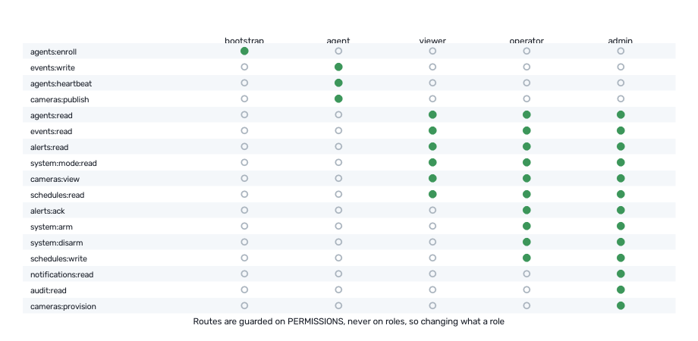
Figure 1: The permission set associated with each role. A sensing agent holds only what sensing requires, and never the ability to acknowledge the alert its own tampering would raise.

3.5 System Architecture
The resulting architecture places autonomous sensing agents at the edge, communicating over HTTP or MQTT with a coordinating agent that owns all shared state. The coordinating agent persists observations and judgements to a relational database, broadcasts changes to connected interfaces, and exposes the whole through a single network origin.
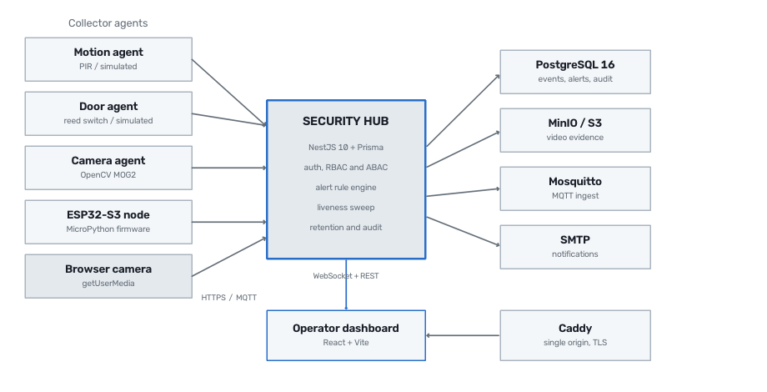
Figure 2: System architecture. Sensing agents report to the coordinating agent, which owns judgement, persistence and access control.
The implementation is organised as a single repository with four components so that the communication contract is shared rather than duplicated: a renamed field becomes a compilation error rather than a silently broken interface. The coordinating agent comprises approximately 10,556 lines, the operator interface 7,165 lines, the sensing agents 4,603 lines, and the shared contract 940 lines.
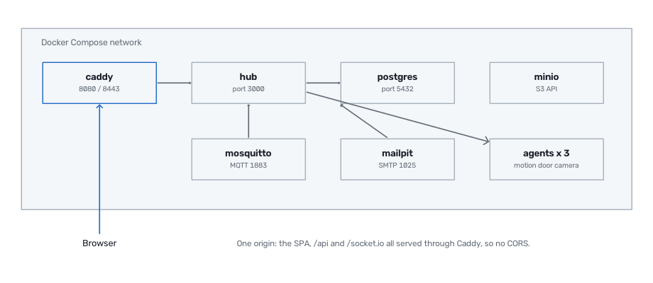
Figure 3: Deployment topology. A reverse proxy presents the interface, the programming interface and the live video channel as a single origin.
Persistent state is held in 8 entities across 12 enumerated types, evolved through 6 schema migrations. Two design decisions are significant. An observation records the coordinating agent's own arrival time separately from the sensing agent's reported time, so ordering survives an agent with an incorrect clock. An alert retains its own description and severity rather than depending on the observation that caused it, which is why discarding old observations cannot destroy the record of a judgement.
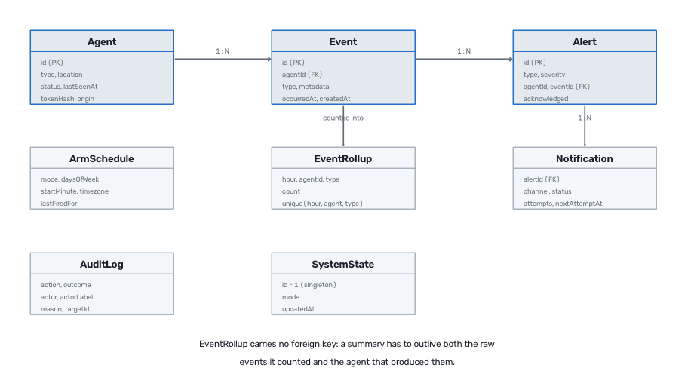
Figure 4: Entity relationships. Alerts outlive the observations that produced them, and hourly aggregates outlive both.

3.6 Agent Specifications
Each agent type is specified below in terms of its percepts, internal state and available actions. All sensing agents share a common lifecycle: enrol, obtain a credential, then loop, perceiving, deciding whether the percept is reportable, reporting, and periodically signalling liveness.
Table 4: Agent specifications.
Agent | Percepts | Internal state | Actions
Motion agent | Infrared detector level | Previous level; last report time | Report motion; heartbeat
Door agent | Magnetic contact continuity | Debounced contact state | Report opening or closing; heartbeat
Camera agent | Video frames | Background model; cooldown | Report motion; publish frame; record clip
Coordinating agent | Reports from agents; operator commands | Posture; agent registry; open alerts | Raise, suppress or refuse; notify; broadcast; record

The camera agent is the most computationally involved. It applies a mixture-of-Gaussians background subtraction model to each frame, removes shadow pixels, applies a morphological opening so that one genuine subject does not fragment into several sub-threshold regions, and reports only when the resulting contour area exceeds a configured threshold. The first thirty frames are discarded while the background model converges; without this, every camera agent reports motion at the instant it starts.

3.7 Interaction Design
Interaction between sensing agents and the coordinating agent is deliberately minimal, consisting of three message types. This economy allows the same protocol to be spoken by a Python process on a computer, a Raspberry Pi, an ESP32 microcontroller and a web browser.
Table 5: Message catalogue. Appendix B gives the complete specification.
Message | Direction | Content | Purpose
Enrol | Agent to coordinator | Identity, type, location | Register and obtain a credential
Heartbeat | Agent to coordinator | Agent identity | Demonstrate continued liveness
Report | Agent to coordinator | Identity, type, timestamp, detail | Communicate an observation
Frame | Camera to coordinator | Encoded image | Supply video for live viewing
Broadcast | Coordinator to interface | Event, alert, posture or agent change | Update operators in real time

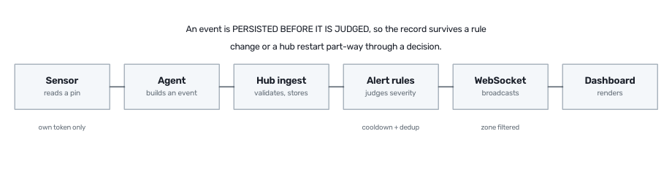
Figure 5: Interaction sequence for a single observation, from perception to operator display.
An observation is persisted BEFORE it is judged. This ordering matters: it guarantees the factual record survives a change to the judgement rules, or a failure of the coordinating agent part-way through a decision. What was observed and what was concluded are separable records, and only the latter is a matter of policy.

3.8 Detailed Design of the Decision Logic
The coordinating agent's decision logic comprises four mechanisms: alert adjudication, duplicate suppression, liveness invigilation and access control.

3.8.1 Alert Adjudication
Whether an observation becomes an alert depends on the security posture at the moment it arrives. Under DISARMED no alert is raised; under HOME only perimeter agents are armed, permitting movement inside while entry is still detected; under AWAY every agent is armed. The posture in force is recorded on the alert itself, so the reason the alert exists is never lost.
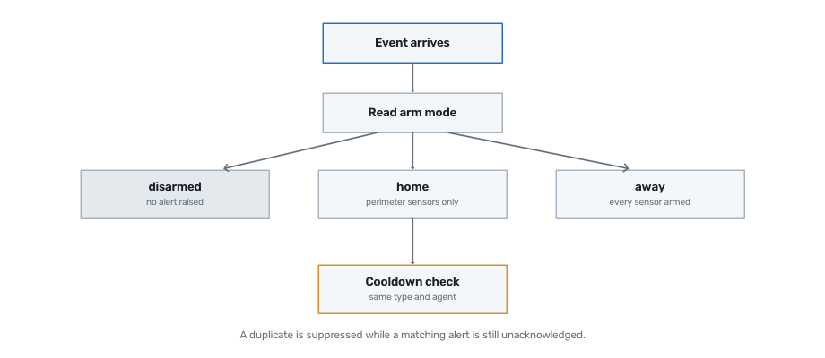
Figure 6: Alert adjudication. The posture at the moment of observation is recorded on the resulting alert.

3.8.2 Duplicate Suppression
A single ongoing condition, such as a person moving along a corridor or a propped door, produces repeated observations. Raising an alert for each would bury everything else. A further alert of the same type from the same agent is therefore suppressed while an earlier matching alert remains unacknowledged. The interface additionally groups such alerts into a single row bearing a count, so that twenty repetitions of one problem present as one decision.

3.8.3 Liveness Invigilation
An agent cannot report its own failure: an agent that has been unplugged or obstructed does not send a message announcing it. The coordinating agent therefore determines liveness itself, periodically identifying agents whose last heartbeat exceeds the tolerated interval and raising an alert on their behalf. A grace period after coordinator startup prevents a restart from declaring the entire healthy population compromised.
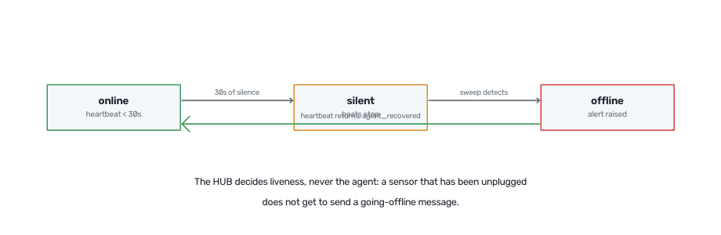
Figure 7: Liveness state transitions. Silence is treated as evidence, because it is the only signal a disabled agent can produce.

3.8.4 Access Control
Access control operates at two levels. Role-based control determines what a class of user may do at all, guarding each operation on a specific permission rather than on a role, so that changing a role's capabilities never requires modifying an operation. An operation declaring no permission is refused to everyone, meaning an omission fails closed.
Attribute-based control determines whether a permitted action may be performed in the present circumstances. The principal rule is that DISARMING WHILE A CRITICAL ALERT REMAINS UNACKNOWLEDGED REQUIRES ELEVATED AUTHORITY. The situation this prevents is realistic: an alarm is sounding, and the fastest way to stop it is to disarm rather than investigate, which is precisely what an intruder reaching the panel would do. Acknowledging the alert first is the intended path, and doing so permits disarming.
Figure 8: The posture control refusing a disarm request and explaining the reason in terms the operator can act upon.

3.10 Design Tools
Table 6: Tools used and their purpose.
Tool | Purpose
NestJS (TypeScript) | Coordinating agent framework
PostgreSQL with Prisma | Persistent store and schema migration
React with Vite | Operator interface
Python with OpenCV | Sensing agents and video analysis
MicroPython | Microcontroller sensing node firmware
Docker Compose | Simulation environment and deployment
MQTT (Mosquitto) | Alternative agent transport
Jest, Vitest, pytest | Automated testing of each component
Playwright | Automated interface verification and capture

4.0 SIMULATION AND RESULTS

4.1 Preamble
This chapter describes how the system was evaluated: the simulation platform adopted, the environment modelled, the scenarios executed, the results obtained, and what those results indicate about the design.

4.2 Simulation Platform and Justification
Evaluation was conducted using the complete implemented system with its sensing agents operating in simulation mode, rather than in a dedicated agent simulation toolkit. This choice deserves justification.
A toolkit such as JADE or NetLogo would model agent interaction faithfully while abstracting away the concerns that dominate a deployed security system: credential handling, partial failure, clock disagreement, network interruption and database behaviour. Because every agent here communicates over an ordinary network protocol, substituting a simulated detector for a physical one leaves the entire remainder of the system genuinely exercised. The agents, the protocol, the coordinating logic, the persistence and the interface are the real implementations; only the physical stimulus is synthetic.
Each sensing agent accordingly provides two interchangeable detector implementations behind a common interface. The simulated detector produces activity stochastically at a configurable rate; the physical detector reads a hardware input. The agent itself cannot distinguish them, which makes the simulation evidence about the deployed system rather than about a model of it.

4.3 Simulation Architecture
The simulation runs as a set of containers on a single host: the coordinating agent, the database, the object store for recorded video, the message broker, an electronic mail sink for notification testing, the reverse proxy, and one container per sensing agent. Each sensing agent enrols independently on startup and thereafter behaves exactly as a physically distributed agent would. The topology is that of Figure 7: the containers communicate only over the network, exactly as physically dispersed agents would.

4.4 Environment Model
The modelled environment represents a small campus building with three monitored points and three security postures.
Table 7: Environment model parameters.
Parameter | Value | Rationale
Monitored points | Hallway, Front door, Lobby | One of each agent type
Motion probability | 0.05 per poll cycle | Intermittent, irregular activity
Door open probability | 0.03 per poll cycle | Doors used less than corridors
Poll interval | 2 seconds | Balances responsiveness against load
Heartbeat interval | 10 seconds | Three missed beats indicates failure
Silence tolerance | 30 seconds | Detection within one sweep thereafter
Alert cooldown | 60 seconds | Suppresses repeats of one condition
Camera frame rate | 5 per second at 640x480 | Sufficient to detect and view

A synthetic camera agent was additionally implemented to provide a deterministic video source: it renders a moving indicator and a running clock, so a stalled feed is immediately distinguishable from a static scene. This was necessary because a simulated camera agent produces no imagery at all, and a still photograph of an empty room cannot demonstrate that video is live.

4.5 Implementation of Agents
All four agent types were implemented and executed. The sensing agents comprise approximately 4,603 lines of Python, sharing a common transport, contract and lifecycle, and differing only in their detector and the observation type they report. Firmware for a microcontroller sensing node was additionally implemented in MicroPython, structured so its decision logic, debouncing, cooldown, retry and credential persistence, is testable independently of the hardware.
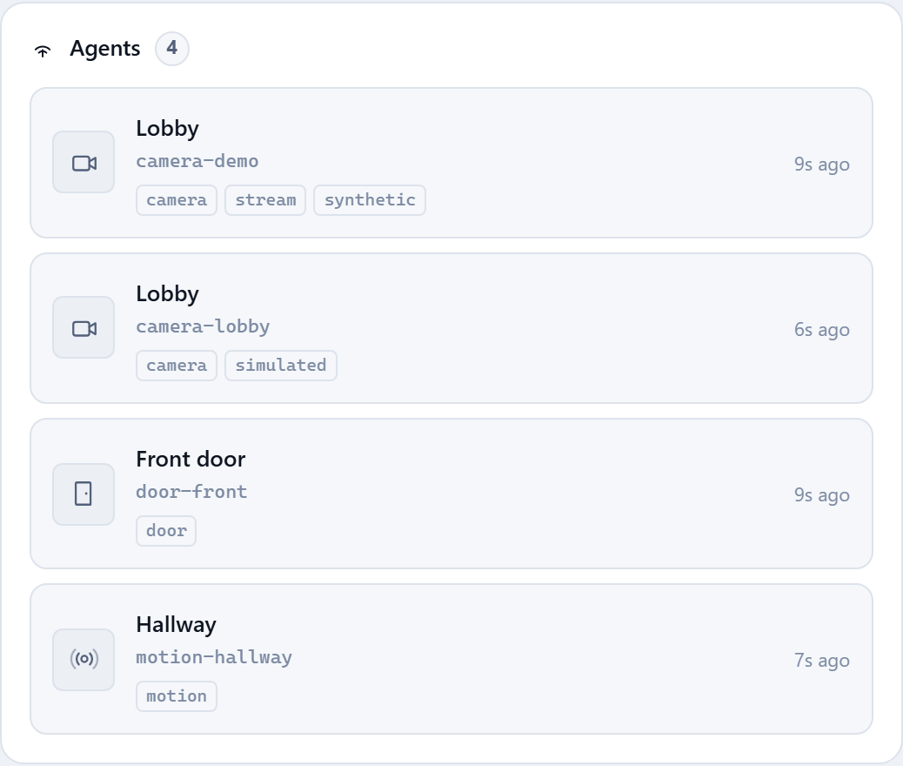
Figure 9: The agent registry during simulation, showing type, location, liveness and time since last contact for each enrolled agent.

4.6 Test Scenarios
Eight scenarios were defined to exercise the decision logic.
Table 8: Simulation scenarios and expected outcomes.
No. | Scenario | Expected outcome
1 | Motion observed while disarmed | Observation recorded, no alert
2 | Motion observed while away | Critical alert raised
3 | Interior motion while home | Observation recorded, no alert
4 | Door opened while away | Critical alert raised
5 | Repeated motion within cooldown | Single alert, repeats suppressed
6 | Agent stops sending heartbeats | Agent marked offline, alert raised
7 | Disarm attempted with critical alert open | Refused with reason, refusal recorded
8 | Scheduled posture change at boundary | Posture changed once, recorded

4.7 Results
All eight scenarios produced their expected outcomes. The figures below are captures of the running system during evaluation.
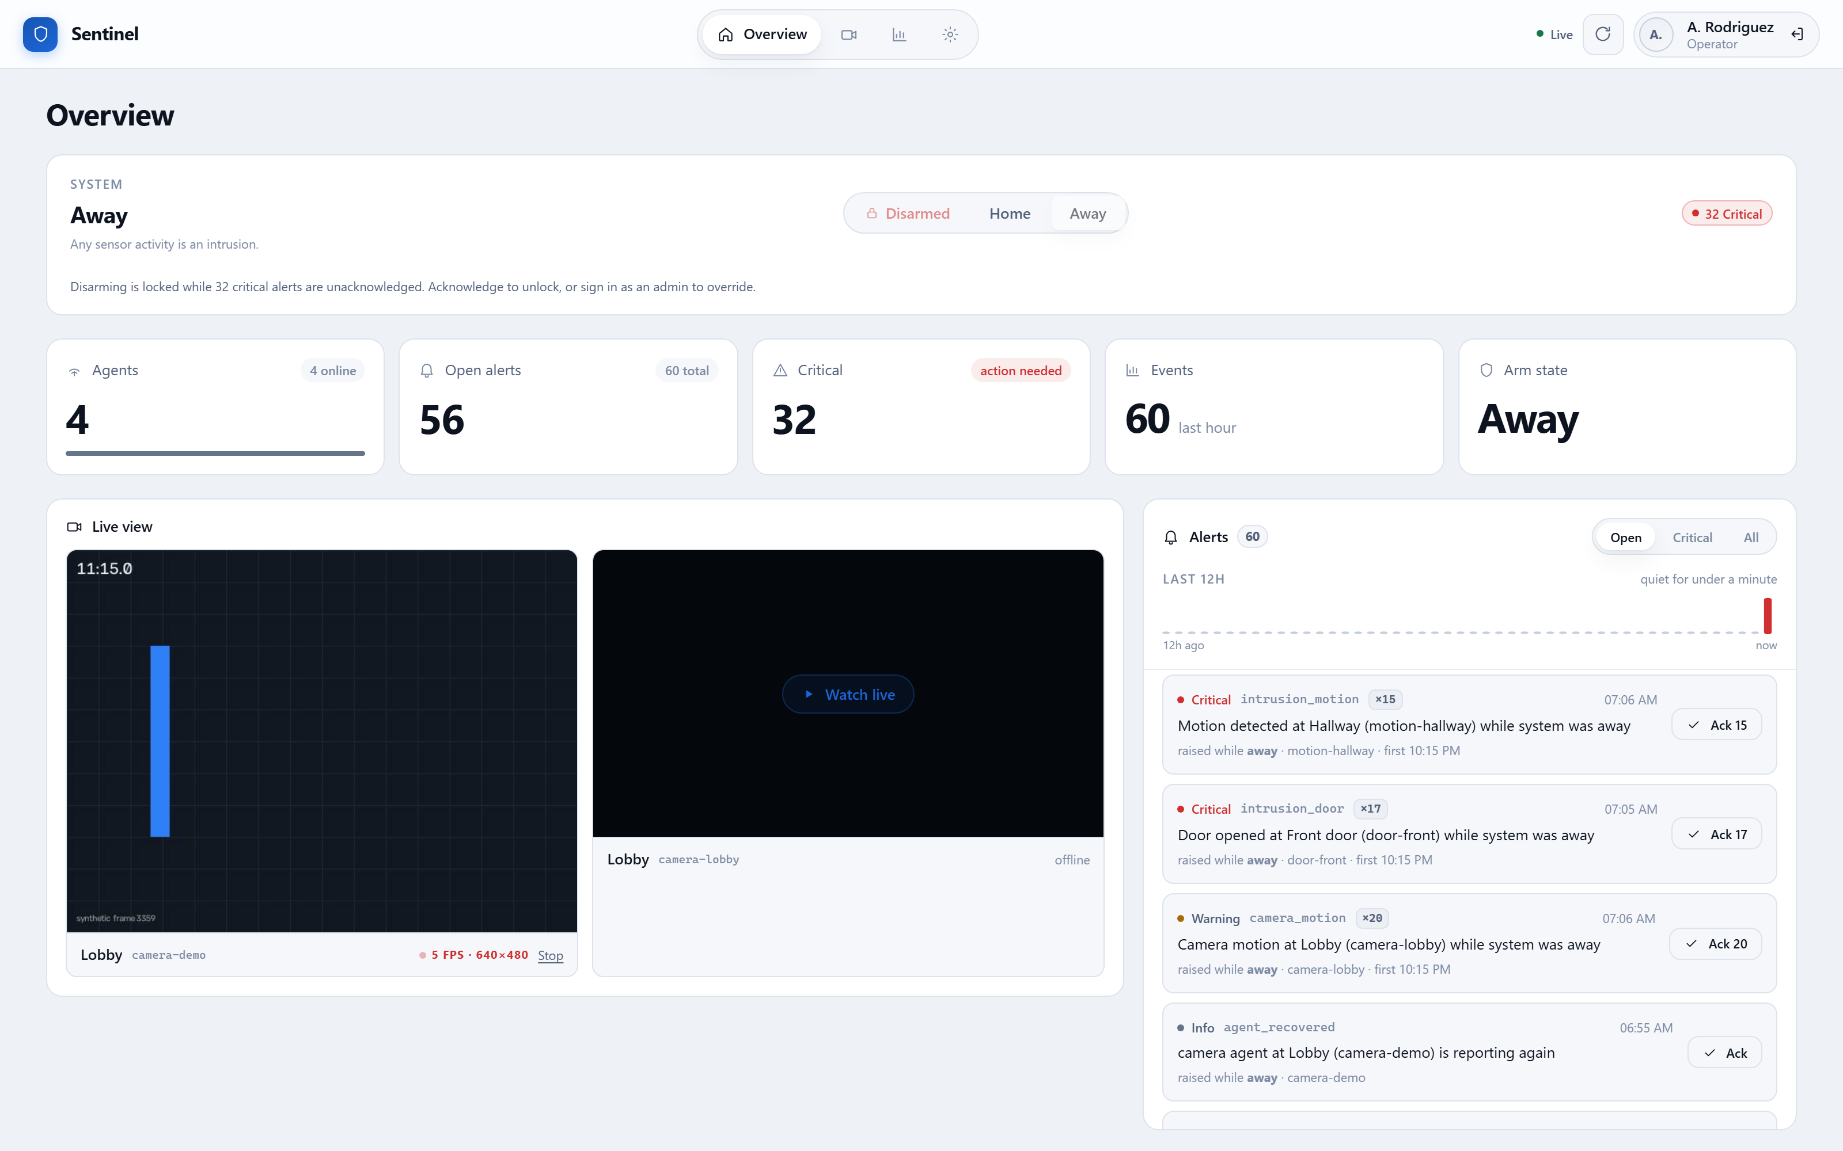
Figure 10: The operator interface during simulation. Security posture, agent population, outstanding alerts, live video and recent activity appear together. Note the refusal notice: disarming is locked while critical alerts remain unacknowledged, demonstrating Scenario 7.
Figure 11: Aggregate counters during simulation: agents enrolled, alerts outstanding, those judged critical, and observations in the preceding hour.
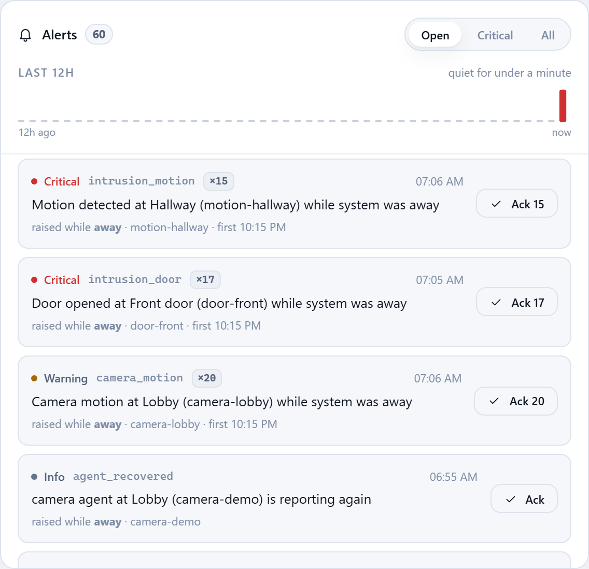
Figure 12: Alert presentation, demonstrating Scenario 5. Repetitions of one condition collapse into a single counted entry that may be acknowledged together.
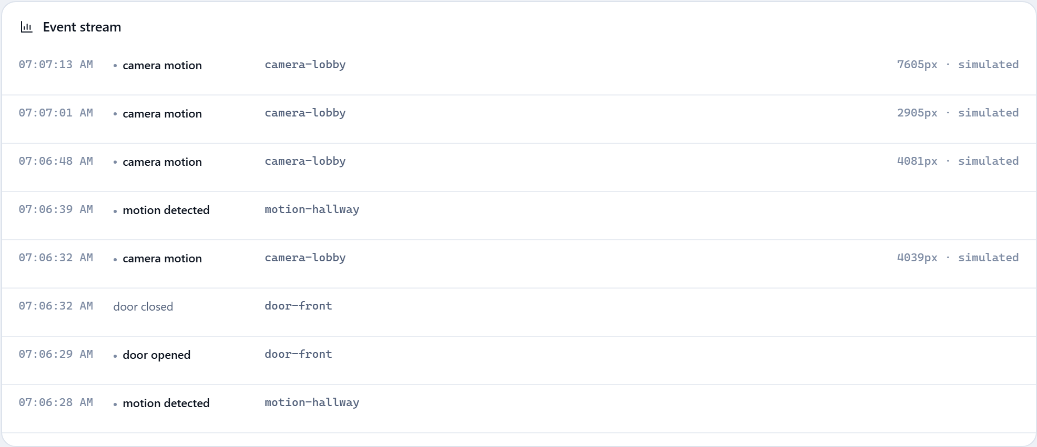
Figure 13: The observation stream, showing raw reports from all agents before adjudication.
Live video from camera agents was verified end to end. The measured frame rate is displayed alongside each feed rather than the configured rate, which allows a degraded feed to be diagnosed rather than merely suspected.
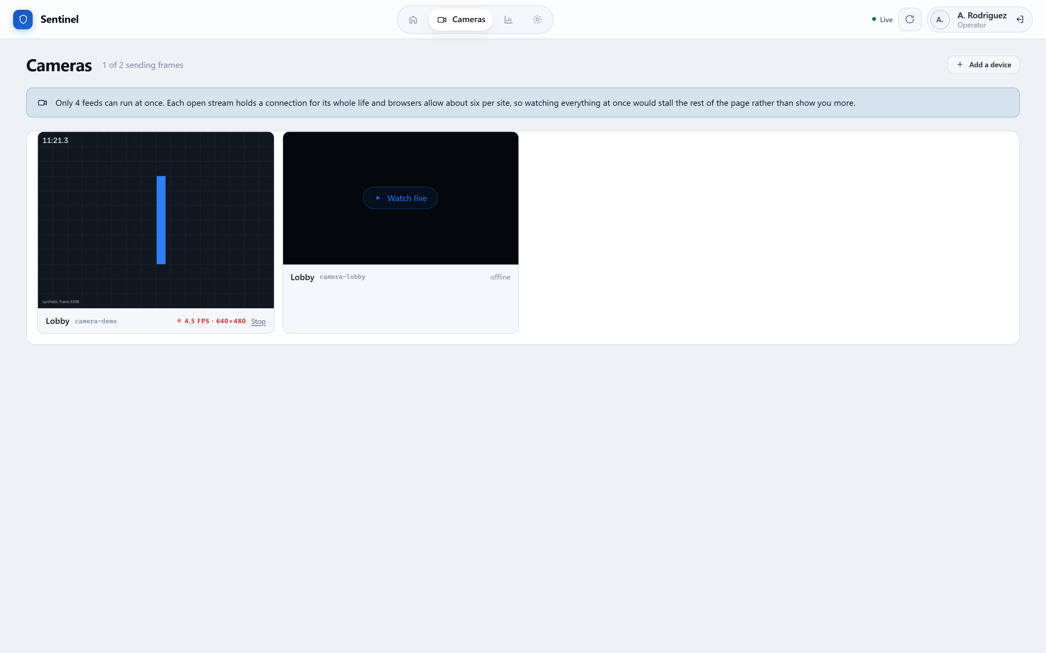
Figure 14: Live video from camera agents. Feeds begin automatically and are limited in number, since each open stream occupies a network connection for its duration.
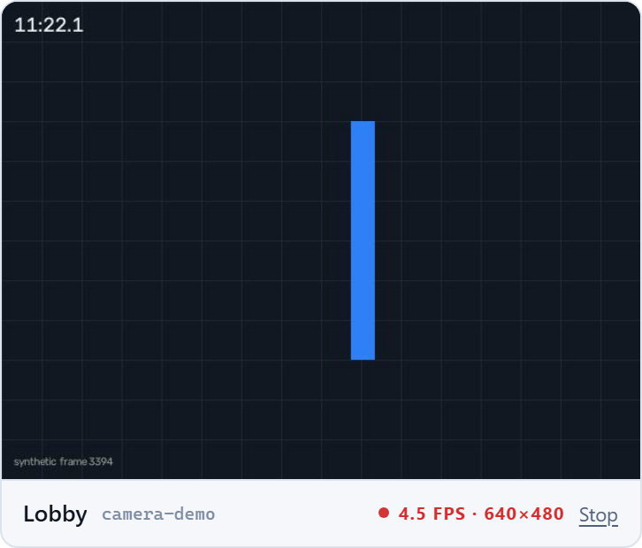
Figure 15: An individual camera feed showing the measured frame rate and resolution.
Automated testing accompanied the simulation. The coordinating agent carries 355 tests, the interface 136, and the sensing agents 90, all passing. Four end-to-end verification programs additionally exercise the implemented system against a live database and a live browser rather than against substitutes.
Table 9: End-to-end verification results.
Verification | Assertions | Property established
Retention | 17 of 17 | Aggregation exact; unacknowledged alerts survive
Audit | 33 of 33 | Refusals recorded; trail read-only and admin-only
Scheduling | 23 of 23 | Fires once; held during incident; stale boundary skipped
Camera provisioning | 32 of 32 | Video sources cannot be disguised as hardware

History aggregation was measured on accumulated simulation data. A total of 9,727 individual observations were reduced to 71 hourly aggregate records, a ratio of approximately 137 to 1, while remaining exact for the questions historical review actually poses.
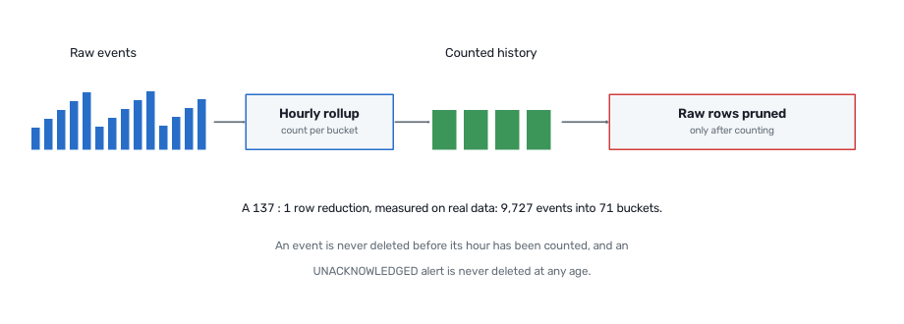
Figure 16: History aggregation. An observation is never discarded before its hour has been counted, and an unacknowledged alert is never discarded at any age.
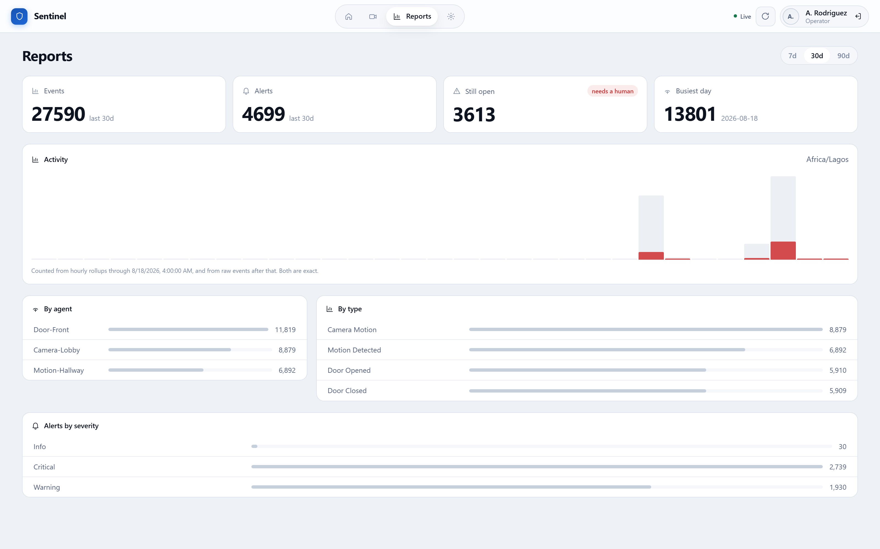
Figure 17: Aggregated history over a thirty-day window, by agent, by observation type and by alert severity.

Figure 18: Daily activity during evaluation. Alerts are overlaid on observations rather than charted separately, since the question is whether activity became alarm.
Access control was verified by exercising the system under each class of credential. Every restriction is enforced by the coordinating agent independently of the interface: invoking the programming interface directly produces the same refusal.
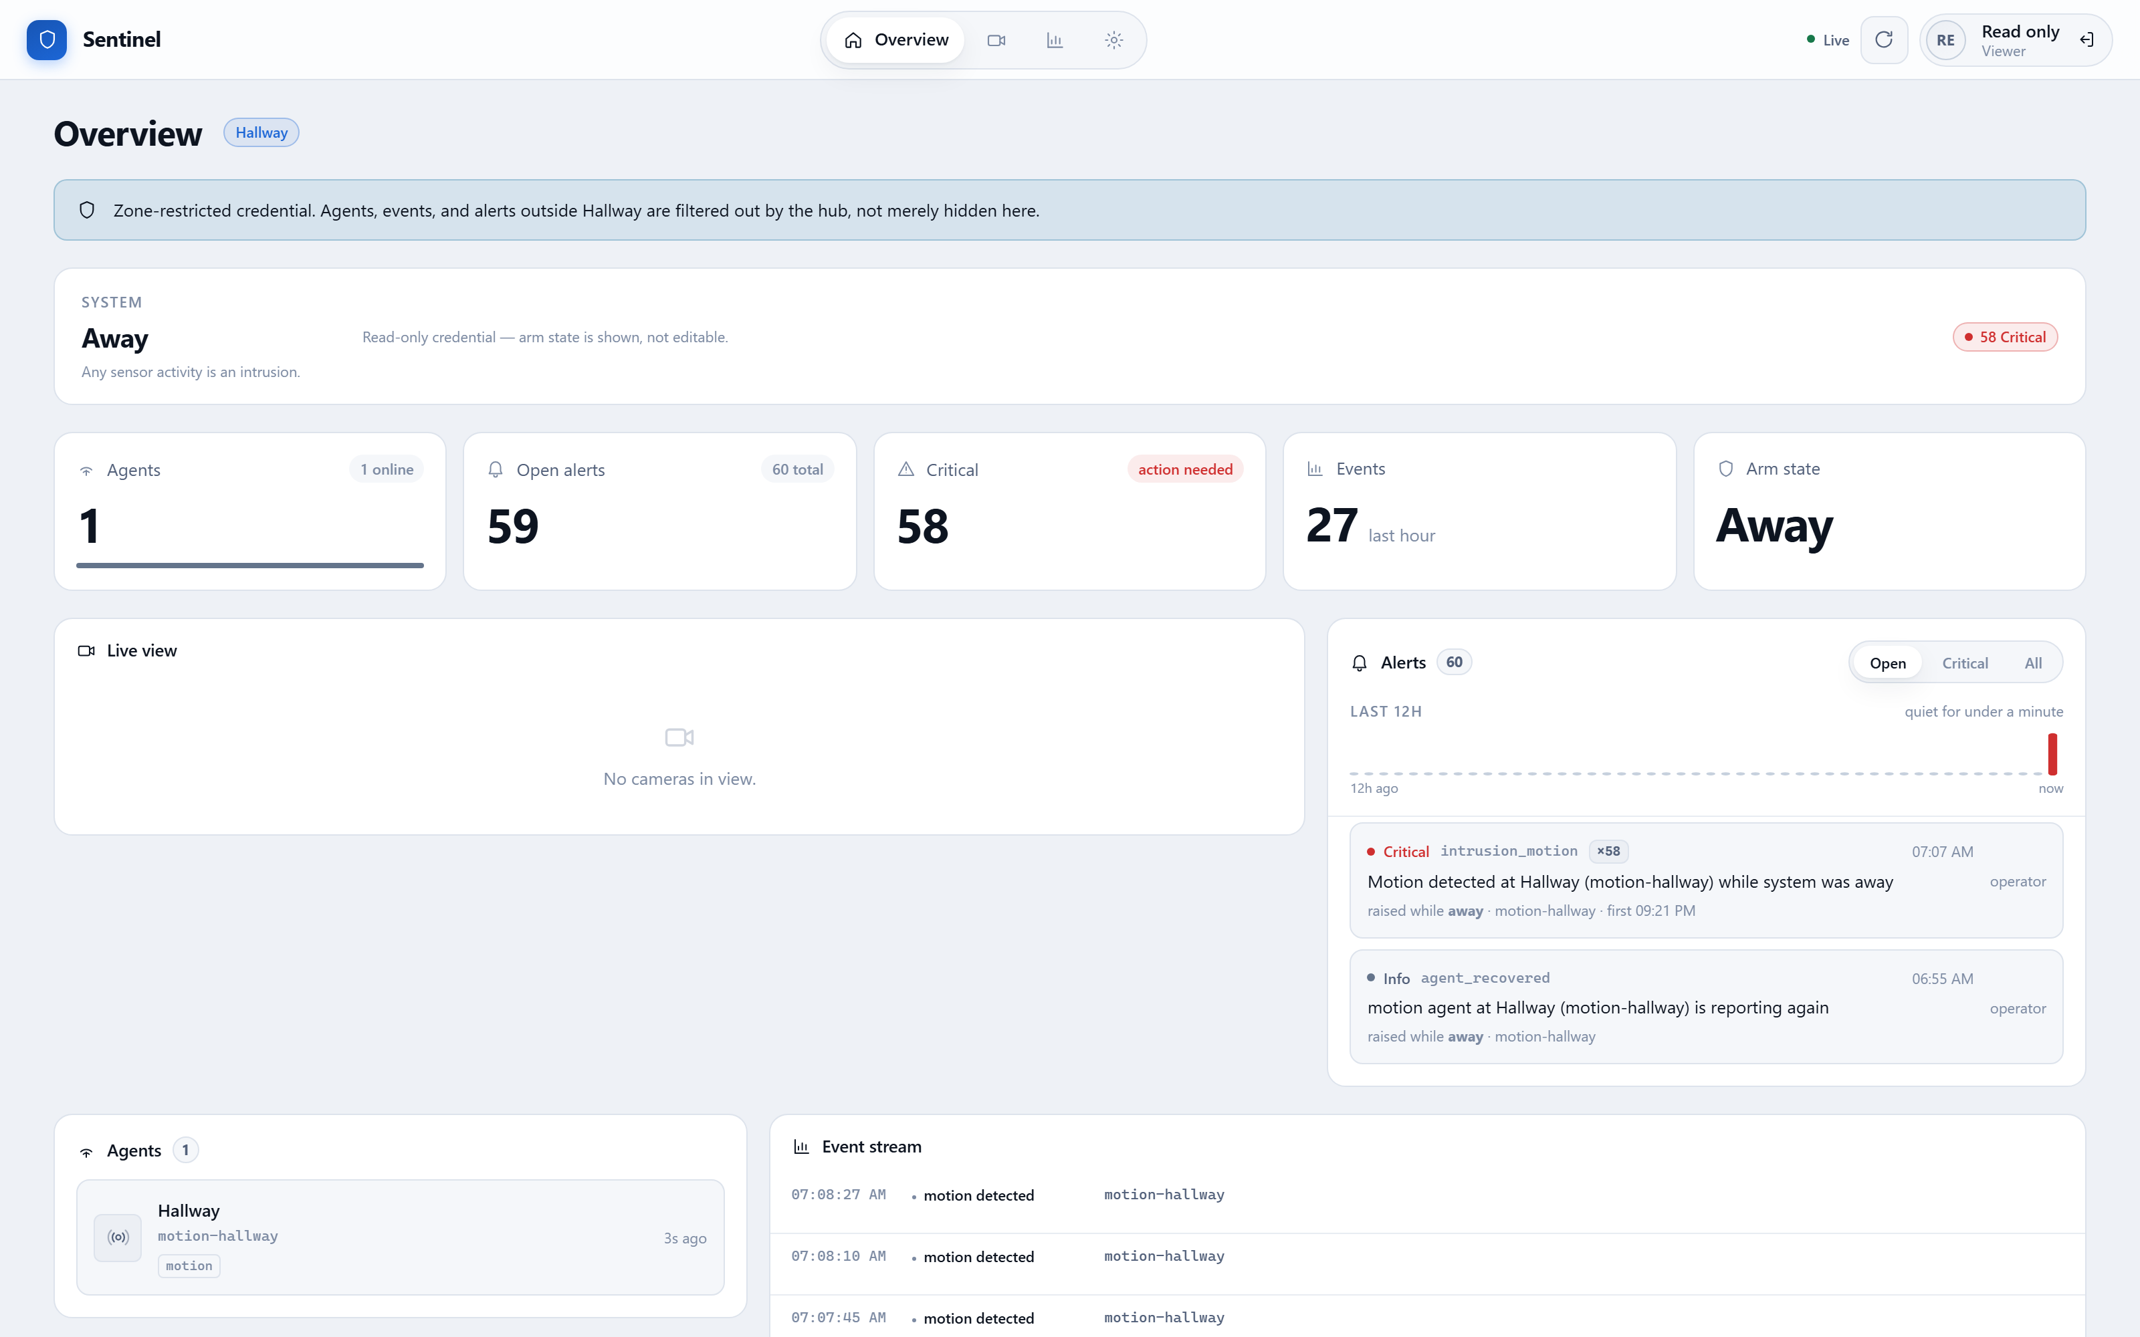
Figure 19: The same interface under a read-only credential. Posture controls and acknowledgement actions are absent.
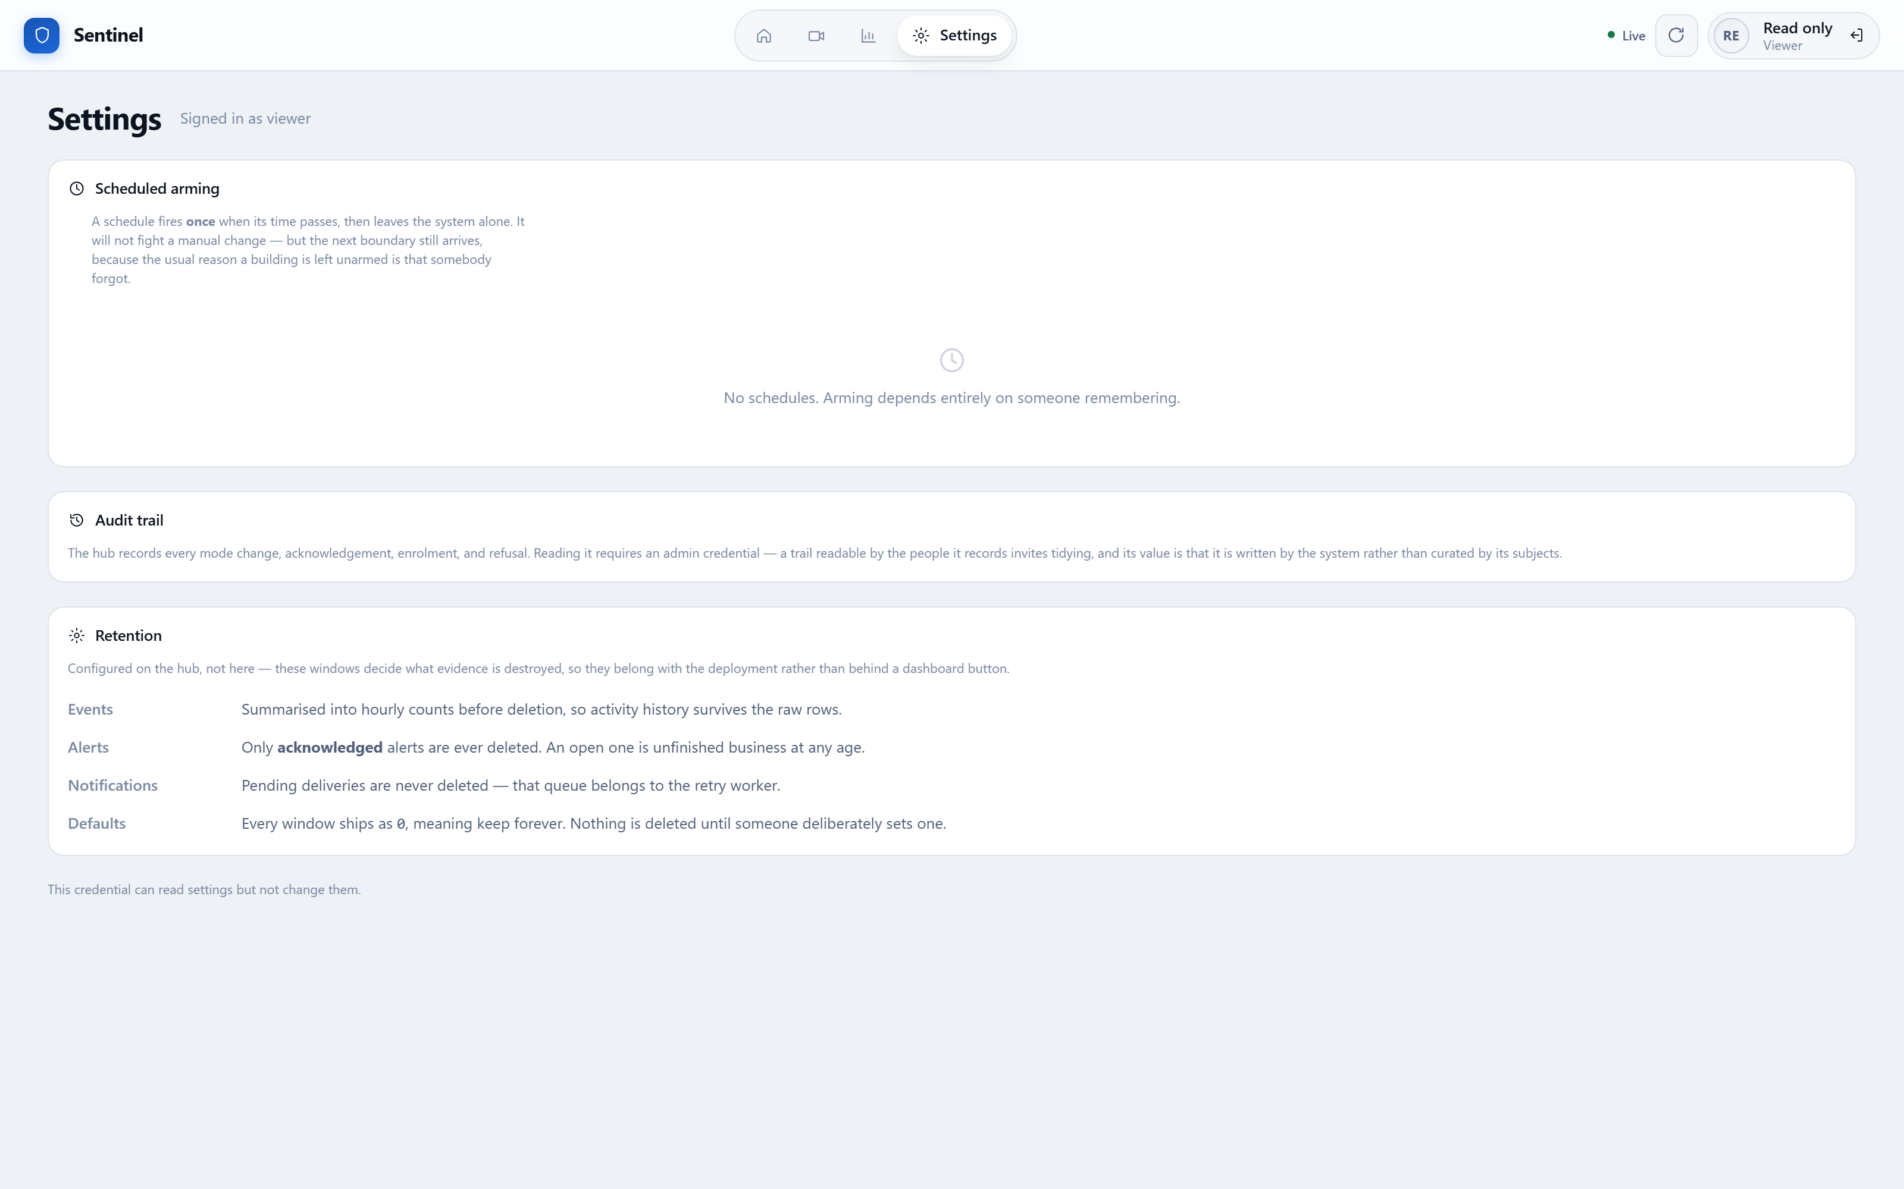
Figure 20: Settings under a read-only credential. The audit trail is described but withheld, rather than concealed entirely.
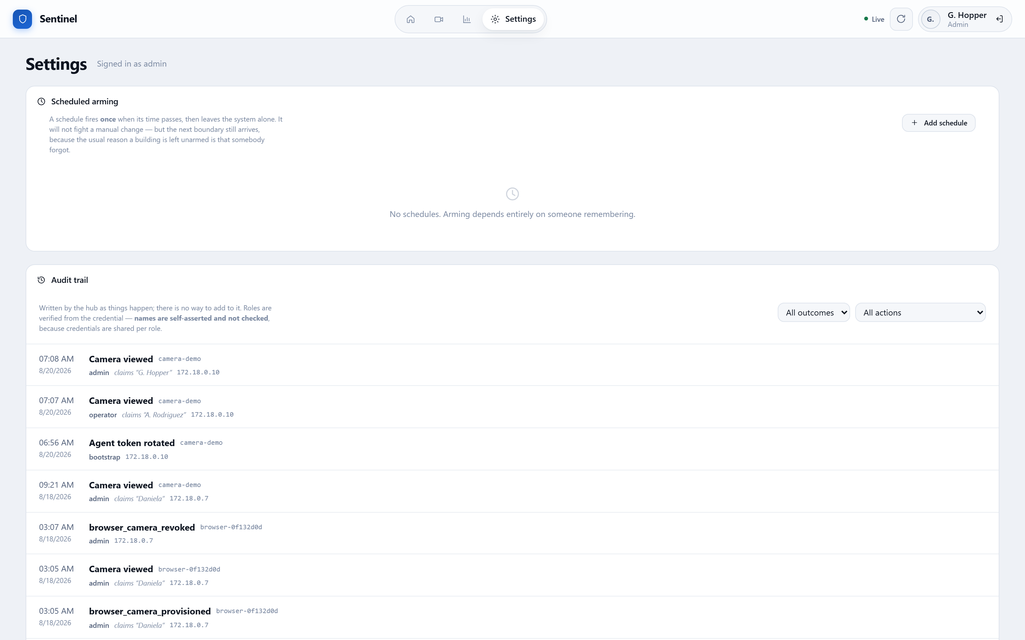
Figure 21: Settings under an administrative credential, with the audit trail available.

Figure 22: The audit trail. The verified role and the self-asserted name are presented differently, because they are different kinds of fact.
Figure 23: Scheduled posture changes, demonstrating Scenario 8. Each schedule stores its own time zone so it remains correct across seasonal clock changes.
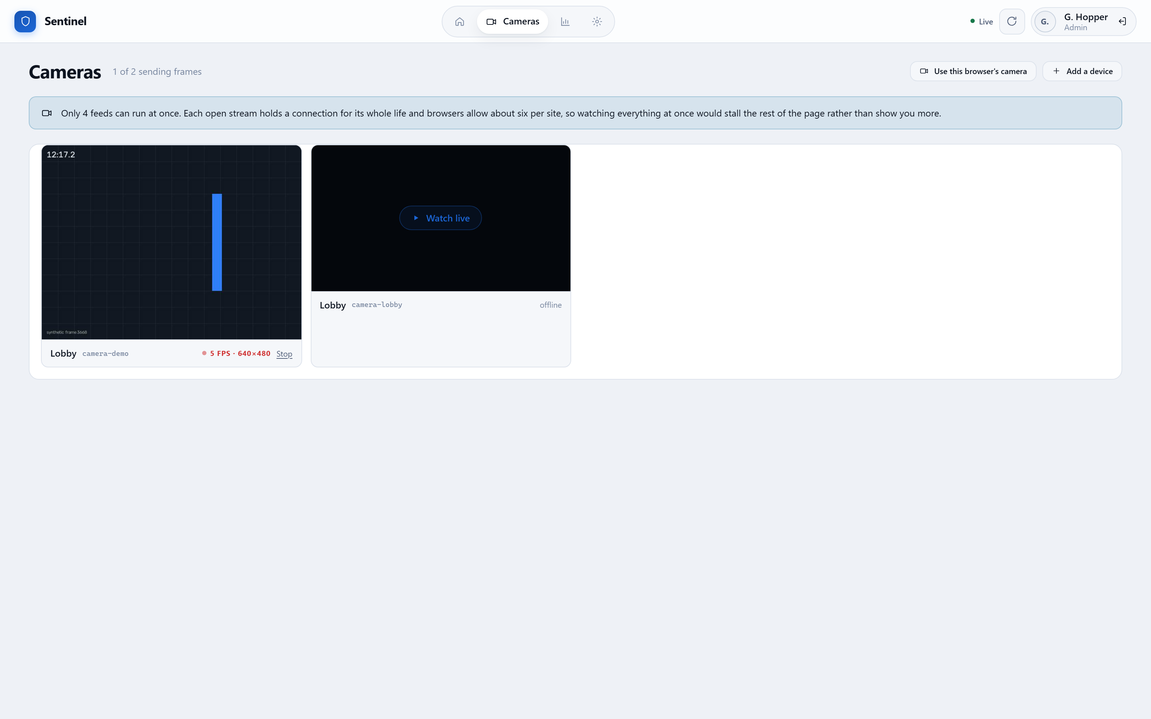
Figure 24: Camera provisioning under an administrative credential.

Figure 25: Credential entry. The credential determines the role; the optional name is recorded as an unverified claim, and the interface states this.

4.8 Discussion of Results
The results support the design decisions taken in Chapter Three. Separating observation from judgement proved valuable in practice as well as in principle: because sensing agents hold no policy, the adjudication rules were revised several times during development without altering, redeploying or even restarting a single agent.
Treating silence as information proved similarly worthwhile. Scenario 6 confirmed that an agent ceasing to communicate is reported within the expected interval, and the startup grace period was found to be necessary rather than merely prudent: without it, restarting the coordinating agent caused every healthy agent to be declared compromised simultaneously, precisely the kind of false alarm that teaches operators to disregard alerts.
The verification programs proved more valuable than the unit tests in one instructive respect. The scheduled posture change feature passed the entirety of its unit test suite while being completely inert. The query used to claim a schedule excluded records whose last-fired value was null, which is every schedule that has never fired; in SQL a comparison against null yields neither true nor false, and a substituted database cannot reproduce that behaviour. Only execution against the real database revealed that no schedule would ever have activated. The lesson generalises: passing tests establish that code does what its author expected, not that the expectation was correct.
The measured 137 to 1 aggregation ratio indicates that indefinite retention of individual observations is unnecessary for the questions historical review poses. It also clarified an ordering constraint that was not obvious in advance: an observation must never be discarded before its hour has been counted, since the reverse ordering does not compress history but destroys it.

5.0 CONCLUSION AND RECOMMENDATIONS

5.1 Summary of Work Done
An intelligent multi-agent system for campus security surveillance was designed, implemented and evaluated. Role analysis identified six roles, assigned to four agent types: motion, door and camera sensing agents, and a coordinating agent. A minimal three-message interaction protocol was defined, permitting the same agent contract to be implemented on a general-purpose computer, a single-board computer, a microcontroller and a web browser.
The coordinating agent implements adjudication against security posture, duplicate suppression, liveness invigilation, two-level access control, notification, scheduled posture changes, history aggregation and an audit trail. An operator interface presents the system state and explains its refusals. The system was evaluated across eight simulation scenarios and through automated testing at both unit and end-to-end level.

5.2 Achievement of Objectives
Table 10: Achievement of stated objectives.
Objective | Status | Evidence
Agent-based architecture, independent failure | Achieved | Section 3.5; Scenario 6
Autonomous motion, door and camera agents | Achieved | Section 4.5
Context-sensitive decision logic | Achieved | Section 3.8.1; Scenarios 1 to 4
Detection of agent silence | Achieved | Section 3.8.3; Scenario 6
Role and attribute based access control | Achieved | Section 3.8.4; Scenario 7
Evaluation by simulation and testing | Achieved | Sections 4.6 and 4.7

5.3 Limitations of the Work
Four limitations are stated explicitly.
- The hardware drivers for physical infrared and magnetic sensors remain documented stubs. The camera hardware path is complete and tested, but the two contact-sensor paths raise an explicit not-implemented condition and require the driver calls to be enabled and tested on a device.
- Credentials are shared per role rather than issued per person, so the audit trail can attribute an action to a role but not to an individual. The interface states this rather than implying an identity it cannot establish.
- The microcontroller firmware has been written and its logic tested independently, but its on-device paths remain unverified pending hardware.
- Evaluation used simulated stimuli. While the agents, protocol, coordination logic and persistence are the real implementations, the physical detection characteristics of an infrared sensor in a real corridor have not been measured.

5.4 Recommendations for Future Work
- Complete and field-test the contact-sensor drivers, and deploy at least one sensing point on physical hardware in a real corridor.
- Introduce per-user credentials so the audit trail can attribute actions to individuals rather than roles, strengthening its evidential value.
- Extend the camera agent from motion detection to classification, so a person may be distinguished from an animal or a moving curtain, which is the largest single source of false alarms in practice.
- Investigate limited peer-to-peer coordination between neighbouring camera agents, permitting a subject to be tracked across fields of view without routing every decision through the coordinating agent.
- Evaluate resilience by deliberately partitioning the network during operation, measuring how much history the buffering in each agent preserves.

5.5 Conclusion
The project demonstrates that an agent-oriented decomposition is well matched to physical security monitoring. Placing autonomous agents at each point of interest and centralising judgement in a coordinating agent yielded a system in which sensing points may be added, removed or replaced without reconfiguration, while decisions about what constitutes an intrusion remain consistent.
Three findings are worth carrying forward. The absence of a signal is itself a signal, and a security system that does not reason about silence cannot detect the tampering it most needs to detect. A record is only worth keeping if it is honest about what it can establish, which is why the audit trail distinguishes a verified role from a claimed name. And software that passes its tests may nonetheless be entirely inert, which is why verification against real infrastructure earned its place in the methodology rather than being treated as an optional refinement.

REFERENCES
Fielding, R. T. (2000) Architectural Styles and the Design of Network-based Software Architectures. PhD thesis. University of California, Irvine.
Foundation for Intelligent Physical Agents (2002) FIPA Abstract Architecture Specification. Geneva: FIPA.
Jennings, N. R. (2001) 'An Agent-Based Approach for Building Complex Software Systems', Communications of the ACM, 44(4), pp. 35-41.
Russell, S. and Norvig, P. (2021) Artificial Intelligence: A Modern Approach. 4th edn. Harlow: Pearson Education.
Sandhu, R. S., Coyne, E. J., Feinstein, H. L. and Youman, C. E. (1996) 'Role-Based Access Control Models', IEEE Computer, 29(2), pp. 38-47.
Wooldridge, M. (2009) An Introduction to MultiAgent Systems. 2nd edn. Chichester: John Wiley and Sons.
Wooldridge, M., Jennings, N. R. and Kinny, D. (2000) 'The Gaia Methodology for Agent-Oriented Analysis and Design', Autonomous Agents and Multi-Agent Systems, 3(3), pp. 285-312.
Zivkovic, Z. (2004) 'Improved Adaptive Gaussian Mixture Model for Background Subtraction', Proceedings of the 17th International Conference on Pattern Recognition, pp. 28-31.

APPENDICES

Appendix A: Source Code Listing
The complete source is organised as a single repository with four components. The structure below indicates where each element described in this report is implemented.
Table 11: Repository structure.
Path | Contents
hub/src/agents/ | Agent registry, enrolment, liveness invigilation
hub/src/events/ | Observation ingestion and retrieval
hub/src/alerts/ | Adjudication rules and duplicate suppression
hub/src/cameras/ | Frame store, live video streaming, provisioning
hub/src/schedules/ | Scheduled posture changes and their evaluator
hub/src/audit/ | Audit trail recording and retrieval
hub/src/maintenance/ | History aggregation and retention
hub/src/common/security/ | Credentials, role and attribute based control
hub/prisma/schema.prisma | Entity definitions and migrations
dashboard/src/ | Operator interface
agents/security_agent/ | Motion, door and camera sensing agents
agents/firmware/esp32/ | Microcontroller sensing node firmware
packages/contracts/src/ | Shared interaction contract
hub/scripts/verify-*.cjs | End-to-end verification programs
docs/report/ | This report and the programs that generate it

Appendix B: Full Message Catalogue
All agent communication uses JSON over HTTP, authenticated by a bearer credential. An agent presents the enrolment secret once and thereafter uses the credential issued to it.
Table 12: Complete message catalogue.
Message | Endpoint | Payload | Response
Enrol | POST /agents/register | id, type, location, capabilities | Issued credential, shown once
Heartbeat | POST /agents/{id}/heartbeat | (none) | Acknowledgement and interval
Report | POST /events | agentId, type, occurredAt, metadata | Stored observation and any alert
Frame | POST /cameras/{id}/frame | Encoded image bytes | Acknowledgement
Ticket | POST /cameras/{id}/ticket | (none) | Single-use token for a stream
Stream | GET /cameras/{id}/stream | Ticket as query parameter | Continuous multipart images
Posture | POST /system/mode | mode | New posture, or refusal with reason
Acknowledge | POST /alerts/{id}/ack | (none) | Updated alert, or refusal with reason

Observation types are motion_detected, door_opened, door_closed and camera_motion. Alert types are intrusion_motion, intrusion_door, camera_motion, agent_offline and agent_recovered, each carrying a severity of info, warning or critical. Every value is defined once in the shared contract and mirrored by hand in the sensing agents, so a divergence surfaces as a test failure rather than as a rejected message in operation.

