2024-02
MSDP SOFTWARE GUIDE

Some data processing methods

Pierre Mein

Many processing methods were used until 2023 to process data from MSDP imaging spectrometers in Meudon Solar Tower, Pic du Midi Turret Dome, Wroclaw Coronagraph, Tenerife VTT and THEMIS. Except for Wroclaw observations, processed with IDL software (P. Rudawy, JOSO 1995), all other data were processed with a Fortran code using the computation methods detailed in this document. We think that most of them can be used again in modern softwares for new instruments. We note also that, to increase the accuracy, the methods include some corrections of slight distorsions due to the double pass optics.

Each file from a given sequence corresponds to simultaneous 3D data (X,Y, Lambda).
Filenames include :
sequence number
date,
time,
and one of the letters x dark current sequences
y flat field, and possibly field-stop geometry if the spectral line is not too dark and allows to detect edges of channels
z field-stop geometry (if not obtained with y)
b target observations for scientific analysis
(example in Fig. 1).
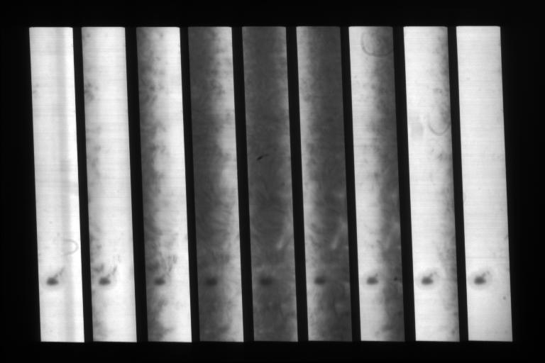

Figure 1. Nine channels of a Meudon MSDP spectro-image in the H_{α} line.

As an example, we shall list now computations of successive steps in the data processing of a N=9 channels MSDP from Meudon Solar Tower.
For each computation, some parameters from the Fortran codes used in this example are shown in italics (explanations in the file msdp.par attached after the present document).

Next figures show results obtained for the ground-space paper :
Bidirectional Reconnection Outflows in an Active Region
Ruan,G.; Schmieder,B.; Masson,S.; Mein,P.; Mein,N.; Aulanier,G.; Chen,Y.
The Astrophysical Journal, Volume 883, Issue 1, article id. 52, 17 pp. (2019)

Step 1) Averages of sequences for dark current (x), flat field (y) and field stop (z)
To get a good accuracy with calibrations, sequences x,y,z must include many files across quiet regions of the Sun. They must be averaged.
Averages of dark currents are subtracted from averages of flat field and field-stop, and are used later for all individual files of target sequences (b).

Step 2) Channel geometry
It must be noted that coordinates i,j of next figures correspond to pixels j,i of the detector (to keep the i coordinate for the long edge of field-stop). They will be converted by step 2 into final solar coordinates (X,Y) in each channel, with X also in the long edge of field of view.
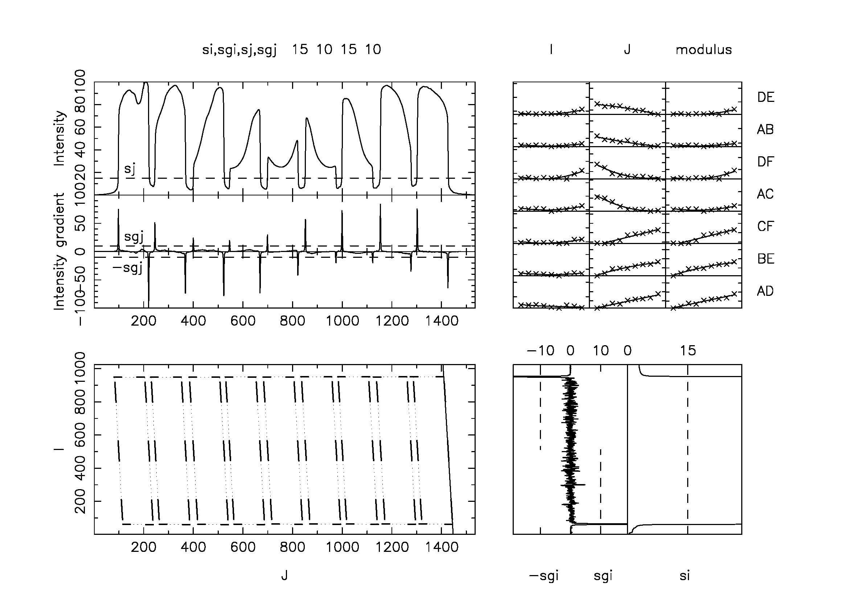

Figure 2 – Geometry of channels (plot geo.ps) :
Bottom left : edges of channels , j = close to spectrograph dispersion
Top left : Typical intensities (sj) and intensity gradients (sgj) along j for detection of channel edges
Bottom right : intensities (si) and gradients (sgi) along i
Top right : Fluctuations of dimensions obtained for segments DE,AB,DF,… (see Fig. 3) in
the 9 channels (pixel units)

Figure 2 (top left and bottom right) shows sections of the averaged flat field file and intensity gradients along i and j , leading to the choice of parameters si,sj,sgi,sgj in order to determine the accurate location of channel edges. The corresponding geo.ps is plotted immediately if igeops=1.
Variations between successive channel sizes (top right) due to the spectrograph optics are always less than 1 pixel. They show the good accuracy of the results expected from the following detection (Fig. 3).

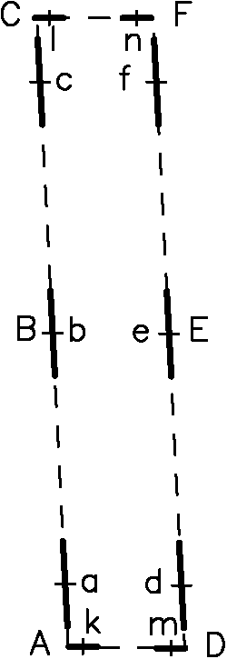

X

Y

Figure 3. Determination of the XY field-stop solar geometry inside each channel.
The pixel size, determined by input parameters, is here 0.5x0.5 arcsec.

The accurate location of channel edges is obtained (with smoothing shown by full lines) through highest intensity gradients around points a,b,c,d,e,f (versus j) and k,l,m,n (versus i).
Points ABCDEF (Fig. 3) are extrapolated from a,b,c,d,e,f and k,l,m,n. ABC and DEF can be parabolic curves because of distorsion (if parameter distor=1).
A short iteration is used for the angle of ac and df versus i (parameter milangi).
Inside each channel, intensities are linearly interpolated between left and right channel edges.
The numbers of pixels along AC and AD (and DF and CF) depend on length and width of the field-stop, expressed in arcsec and divided by the proposed pixel size milsec/1000. They define X and Y coordinates of the solar target.

Step 3) Wavelength and intensity calibration

a) Wavelength translation in successive channels
Several methods can be used to specify the translation between points of the same wavelength in successive channels (see Fig. 4 A). We shall name it Ts for spectrum translation expressed in Y pixels.

- 1) if values of translations between beams of successive channels going into the slicer (t1) and going out of the slicer (t2) are available (here 2.5 and 9 mm), we can use the following relationship to deduce Ts from the the geometrical translation (Tg) of channels n and n+1
Ts / Tg = t1 / t2
where Tg is the distance in the output focus between successive channels. But Tg must be also expressed in Y pixels, different from CCD ones. Let us name Tg,ij this distance expressed in the CCD coordinates of step (2).
If W is the width of the field-stop expressed in Y pixels (W= ymax-1 if ymax is the Y dimension proposed by parameter lj) and Wij the same width computed in step (2) with CCD pixels, the ratio W/Wij can also define the local distorsion, so that
Tg = Tg,ij * (W/Wij)
on the condition that Tg,ij and Wij are determined around the same channels. This can be done for example by computing Wij in the channel 5 (averages between segments AD, CF) and Tg,ij between channels 4 and 6 (averages of distances between A,C,D,F in both channels).

- 2) a generally less accurate method can use locations of line centers (smallest intensities obtained by least squares approximation) in successive channels (see Fig. 4 A).
- 3) if the first method is not available, departures between intensities for several Ts values can be compared so that intensity departures between successive channels at the same wavelengths can be reduced to the smallest possible level (see intensity calibration and Fig. 4B).

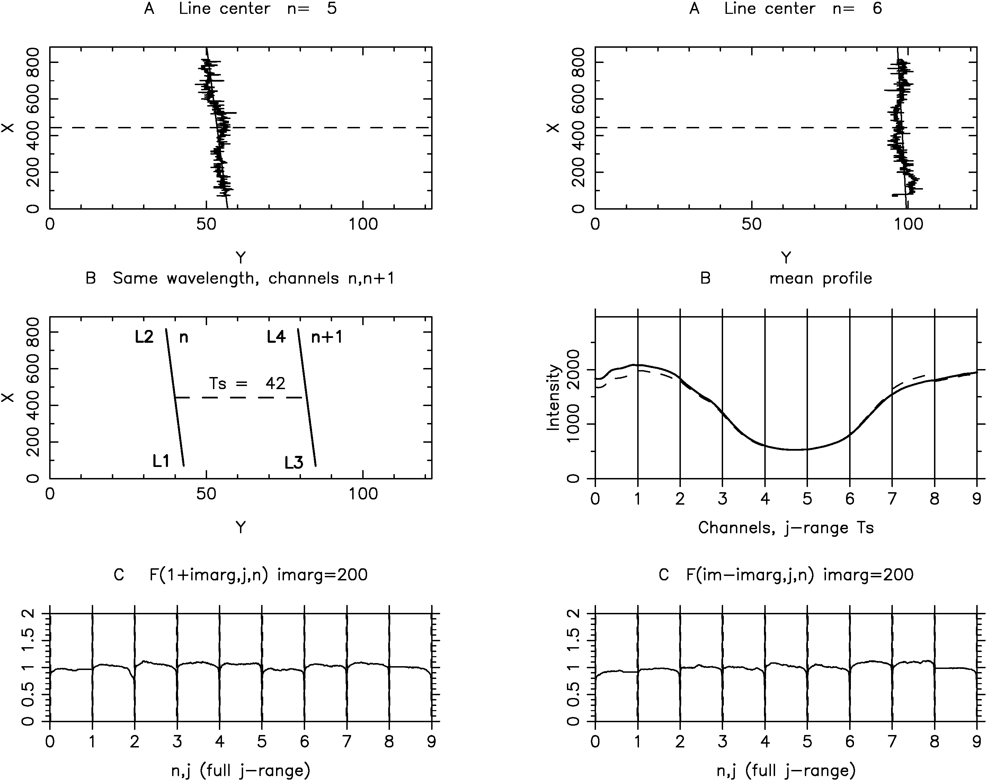
Fig. 4. Calibrations (plot cal.ps) :
A) Line center in channnels 5,6 with respect to coordinates X,Y (pixels 0.5 arcsec)
B) Determination of mean line profile (dashed lines before corrections)
C) Calibration function versus j for two i-values (imarg given in parameters)

The Fig. 4(A) shows line centers obtained in successive channels ncurv1,ncurv2 (minimum values of parabolic approximation along Y). In this example, for channel 6, the line center is probably a little too close to the edge to give a very high accuracy. The angle (versus X) is deduced from channel 5. The distances between line centers in successive channels are deduced from the formula Ts / Tg = t1 / t2.
b) Intensity calibration
Constant wavelength versus X can be found in each channel along line L1 L2 for channel n and L3 L4 for channel n+1 (first plot B of Fig. 4), if the distance is Ts between both lines.
A full mean profile of the flat field spectral line (second plot B of Fig. 4) can be obtained by comparing parts of the profile deduced successively from all channels between both lines L1 L2 and L3 L4 (with the middle point between both lines located in the center of field-stop), and averaged along a central part of the X field of view.
We introduce also correcting intensity factors in successive channels by adjusting successively averaged intensities of the same wavelengths defined by lines L1 L2 and L3 L4 in all couples of channels n and n+1. Little departures can be seen between mean profile curves printed before correction (dash lines) and after correction (full line).

c) Calibration function

A calibration function fl(X,Y,n) is defined as the flat field intensity divided by the mean profile intensity in the same wavelength (taking into account the wavelength function along the X-coordinate).
In the following steps, calibrated intensities wil be obtained by dividing the observed intensities by the calibration function in each point X,Y,n.

Step 4) Computation of c-files → calibrated channels
By subtracting averages of dark currents and by using the geometry and the calibration function derived from flat fields, we can now, for any file of a time-sequence, compute a c-file giving an intensity map of the N observed channels (Fig. 5).
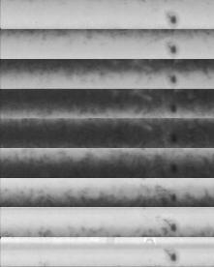

Y

X

Fig. 5 Calibrated intensity map of the N channels (c-file).
Step 5) Computation of d-files → line profiles, filtergrams and Intensity/Velocity maps (bisector method)
In each solar point, the line profile of N=9 points can be interpolated at first into 4xN-3=33 wavelength points, by third degree interpolation (profiles in cmd files). Each small interval is then interpolated linearly. To get intensity map at a given wavelength similar to a filtergram, a new local interpolation can be used. To compute intensity and velocity corresponding to a given distance between two points of equal intensity (bisector method), a linear interpolation is used again in the profile of 4xN-3 points. It can be noted that dopplershifts are generally determined in parts of profiles near inflexion points, reducing interpolation errors.
The previous polynomial interpolation may introduce errors in intensity and velocity maps. Because dopplershits are small as compared to wavelength distance between channels, errors are similar along large X distances for a given Y value. For solar disk observations with full solar fields of view, it is possible to reduce such departures (parameter cordisk=1). For each Y value, a parabolic approximation is computed along X. Errors are roughly periodic due to successive useful channels along Y. Then for each (X,Y) value, intensities and velocities can be corrected by subtraction of the difference between approximated X-parabolas and averaged values over Y to reduce possible errors. Residual mean zero velocity, due partially to the non-integral number of Y periods in the field of view, can be corrected by the mcorrec parameter (see step 7). For prominences, the field of view is not full enough of solar structures for that. But It can be noted that, for prominences, velocities are generally larger, and a lower accuracy is more acceptable.
Step 6) Severald-files → Scans of full targets → q-files
When scans are used to observe wide targets, several parameters define the files to be used simultaneously to compute XY maps (nob1, nob2, ntmax, priscan). 2D correlations between common fields of successive images are used to associate successive d-files (parameter lcorrel chooses generally line center maps). Correlations values are listed in scan.lis.
Resulting filtergrams and intensity/velocity maps are recorded in q-files.
Step 7) Plots of q-files maps
The code uses the standard subroutine PGGRAY to plot quickly maps for each intensity or velocity map. Parameters blackq and whiteq control the plots of q* maps. They define levels corresponding to black and white colors. The scan.lis file gives the averaged velocity corresponding to the map of the first Velocity map. This averaged velocity refers to the channel ncurv1. A parameter (mcorrec) is available to modify the zero value in velocity maps.

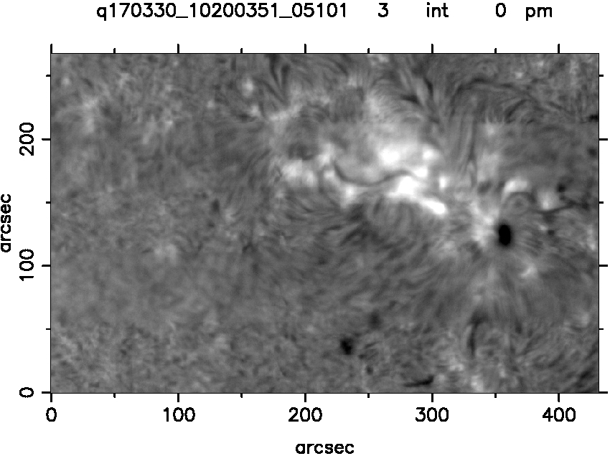

Fig. 6 Filtergram at line center.

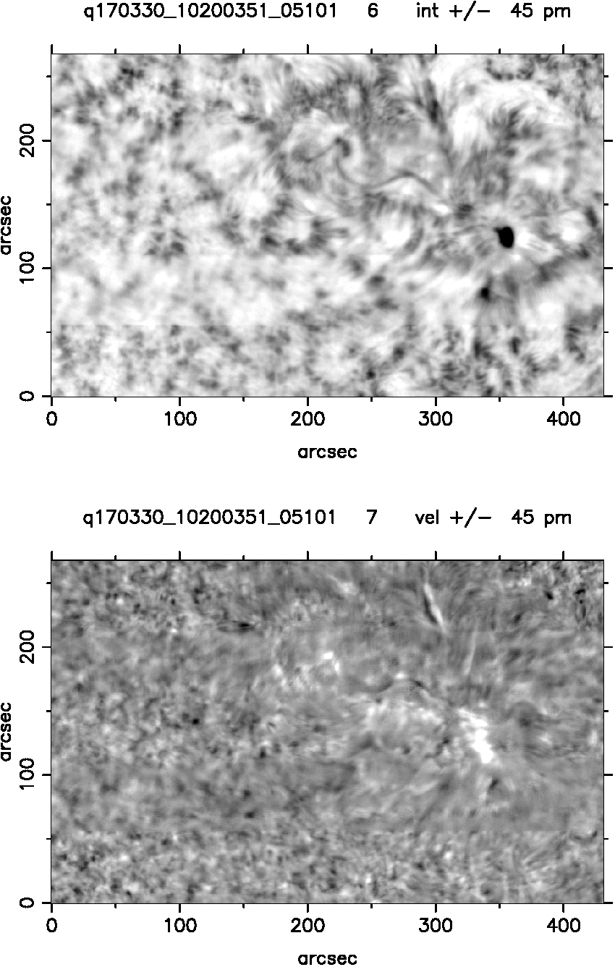

Fig. 7. Maps for intensity (top),and velocities (bottom) from bisector method at ± 45 pm.

Figures 6 and 7 show the line center intensity and the couple Intensity/Velocity with bisector method at ± 45 pm, with the option of improved interpolation (cordisk=1). For velocities, black and white correspond to -3 and +3 km/s in this example.

Note : New Spectro-imaging Polarimetric observations with MSDP

New polarimetric observations have been tested with the Meudon S4I prototype. They ave been details in the papers
Four decades of advances from MSDP to S4I and SLED imaging spectrometers
Mein P., Malherbe J-M., Sayède F., Rudawy P., Kenneth P., Keenan F.,
2021, Solar Physics, Volume 296, Issue 2, article id.30,
arxiv:2101.03918
Optical capabilities of the Multichannel Subtractive Double Pass (MSDP) for imaging spectroscopy and polarimetry at the Meudon Solar Tower
Malherbe,J-M., Mein, P., Sayède,F.,
2023arXiv231202555M

The width of the field-stop is divided by 2. A simple birefringent plate creates 2 parallel beams with 2 linear orthogonal polarizations I+S, I-S. As a result, twice as many channels (18→36 with S4I) are obtained simultaneously with both polarizations. Such methods could be used with new MSDP spectrographs, and with processing steps similar to the steps listed in this report.

file msdp.par
========

Parameters for MSDP observations
(format a8,i8)
name, value
(several lines if dimension>1)
* parameters often modified

Meudon Solar Tower 2017-03-30 10:20:03 (solar disk)

SUCCESSIVE STEPS
================
ixy 1 * computation of average files dark, flat, field-stop
igeo 1 * geometry
iflat 1 * calibration
ibmc 1 elementary calibrated c-files (1 file per time)
icmd 1 d-files (spectroheliograms and I/V maps)
iquick 1 q-filesfor full scanned targets
igrayq 1 plots of q-files
idem
--------
igeops 1 automatic plot of geo.ps
icalps 1 automatic plot of cal.ps
ndprofps 3 number of d-file for automatic plot of profiles 3
see Plots of Line Profiles for parameters
igrayqps 1 automatic plot of sq....ps

SELECTED OBSERVATIONS
=====================
nob1 1 first image to be processed 1
nob2 5 last image to be processed 300
ntmax 5 number of images per scan
priscan 4 = 4 for Meudon (5 images), scanning by prisms (2,3,1,5,4))
nobstep 5 step between first images of two scans

dob20170330 date of observation (optional)
tob110200300 * first time for observations to be processed
tob224000000 last time
tdc1 0 09564585 same for dark current
tdc224000000 09564585
tfs109593900 09571701 same for field stop
tfs224000000 09572084 09571701
calfs -1 0
-1 if flat field Y replaces field stop Z
tff109593900 09571701 same for flat field
tff224000000 09572084 09571701
nff 1 number of flat fields
------
GEOMETRY
========
li 442000 field stop length (arcsec/1000)
lj 61000 field stop width
jypas 45000 < translation between images (for correlations)
nline 1 spectral line index
ncam1 1 detector index
nm 9 number of channels
lbda 6563 line wavelength (Angst)
dlbd 300 wavelength distance between channels (mA)
mupris 9000 translation between output channels (microns)
mustep 2500 distance betwwen successive slits (microns)

nwinp 1 number of simultaneous detectors
interc 15 approximate distance between right edge of a channel
and left edge of the next one (unit = CCD pixel)
nbcln 1024 number of X-CCD pixels
nblgn 1536 number of Y-CCD pixels
invern 0 0 j-value of pixels of same wavelength
decreases with channels
1 j-value of pixels of same wavelength
increases with channels
idc 1 generally 1
0 = dark current not subtracted
-1 = dark current not abvailable
si 15 intensity threshold for channel edges detection versus X
0 = automatic detection for si,sgi,sj,sgj
sgi 10 intensity threshold for intensity gradients versus X
sj 15 the same for intensity versus Y
sgj 10 the same for gradients versus Y
milangi -40 approximated angle between longer edge of channels
and CCD (radian/1000)
milgeo 2000 threshohld for geometry accuracy:,maximum departure between
values and regression lines (plot geo.ps, unit pixel/1000)
nleft 0 interpolated approximations for bad channels (left)
nright 0 the same (right)
i1 1 first useful pixel in the i-direction
i2m 0 the last useful pixel in the i-direction is
i2=im-i2m (im = total number of pixels)
j1 1 same definitions for j
j2m 0 .....
lip 40 the curvature of channels is determined by
3 intervals around 3 points of the longer edge.
If L is the length of this edge, the points
are located at
L*(o.5-lip/100)
L*(o.5+lip/100)
jeps 20 The accurate determination of the longest edges
is searched around
approximate values +/- jeps pixels
intvi 60 The edges parallel to i are determined by cuts
along j, averaged over the interval
+/- intvi around the 3 points metioned above
(see lip)
intvj 30 Similar definition for short edges parallel to j,
but with the intervals
left end - left end +intvj
right end - right end - intvj
leps 50 The detection of points with maximum gradient
is made in 2 steps:
- approximate values corresponding to
signal = intensity threshold
- search of maximum gradient in intervals
+/- leps around these values
n1 1 The useful channels are numbers n so that
n1.le.n.le.(nm-n1+1)
where nm is the total number of observed channels
distor 1 1 = curvature of channels taken into account
for detection (check not included in calculation)
0 = curvature not taken into account

calfs -1 -1 = field stop is replaced by flat field
for geometry
-----
iswap 1 1 for LINUX
ipermu 1 permutation of CCD X and Y coordinates
milsec 500 output pixel (unit arcsec/1000)

CALIBRATION
===========
(msdp2.f: cmf1.f -> cal.ps, bmc1.f -> fichiers c*)
icalct 0 0 = calibration by flat field
1 = calibration by field stop (continuum)
inclin 1 0 = line profiles determined by previous calculations
(-> jt1000,ja1000,jb1000)
1 = determination of mean curve of absorption line

ncurv1 5 first channel plotted for line profile determination (4)
ncurv2 6 last channel ..... (6)
il1p 1 beginning of computation interval of meanline profile (%)
il2p 99 end .....
curv 0 1 = line curvature taken into account
0 = inclination of line only taken into account
iliss 60 smoothing over 2*iliss+1 i-points before detection of
line center
jparli 5 parabolic smoothing over 2*jparli+1 j-points for
line center
lispro 5 parabolic smoothing over 2*lispro points of
mean line profile (-> fl profile)
imarg 200 margin for small and large X (i0=1+imarg, i0=im-imarg)
for fig. C in cal.ps

FILTERGRAMS + MAPS INTENSITY/VELOCITY
=====================================
(msdp3.f: cmd1.f -> files d*)
SUPPRESSION of a few arcsec near EDGES
NEW RESTRICTED FIELDS
(msdp3.f: cmd1.f -> d* files)
ix1 1000 if ix1>0 and/or ix2<li, the length of the field of view
is restricted to ix1<-->ix2 (unit arcsec/1000)
This allows to eliminate bad points at the edges of the
field-of-view (1000 = 2 arcsec suppressed)
No suppression means ix1=0, ix2=li, jy1=0, hy2=lj
ix2 441000
jy1 1000 similarly, new limits of the width of field-of-view
(jy1>0 and jy2<lj).
The difference jy2-jy1 must be larger than the step "jypas"
to save some overlap between successive images of each scan
jy2 60000
jyq1 2000 similarly, limits of the field-of-view for "d" and "q"
files (jyq1>jy1 and jyq2<jy2), in the same coordinates as
for jy1 and jy2
(if inverj=1, the code converts automatically
jyq1 into jy2-jyq2
jyq2 into jy2-jyq1)
If zero, automatically put to jy1 and jy2.
jyq2 59000
cented 1 1 = line center map

=== number of filtergrams/sums and diff/IV couples ===|
lmpd 2 filtergrams for lmpd lambdas
0 the same for sums and differences of filtergrams (not used)
1 * number of couples Int/Velocity with bissector
ex.: cented+2*lmpd = 1+2*8=17 points in the profile
(1 = 2 maps, 2 = 4 maps, ...)

=== First dlambda for filtergrams and I/V couples ===
(unit dlbd/1000 :
for Meudon 1000 means 300 mA = wavelength between channels)
lbd1d 1000 first dlambda for filtergrams (unit dlbd/1000)
0 first dlambda for sums and differences (not used)
1500 * first dlambda for couples I/V 1500
(3 lines)

=== dlambda steps ===
lbpasd 1000 step for dlambdas of filtergrams (unit: dlbd/1000)
0 step for sums and differences (not used)
0 step for bissector I/V maps
(3 lines)

ispline3 1 1 = profile interpolation degree 3
0 = profile interpolation degree 4

inveri 1 1 to invertX-values in the d maps (0 = no inversion)
inverj 0 the same for Y-values
inverl 1 1 to invert the wavelength orientation in the spectrum
mps 1 velocity unit = mps m/s
norma 0 Normalization for thin clouds correction. No effect if = 0.
norma = 'abcd' with a,b,c,d integers of one figure:
let us call L the total length of the field.
Normalizarion is calculated over 2 intervals
ab -> from 0.1*L*a to 0.1*L*b
cd -> c d
Both intervals should avoid active regions
If d=0, d is replaced by 10
example: 0059: one interval 0.5L to L

PLOTS OF LINE PROFILES
======================
icplot 440 center point for plots (index c-files: pixels)
jcplot 60 " " "
icstep 220 i-step
jcstep 30 j-step
njm 3 number of lines and columns

POSSIBLE LINE PROFILE INTERPOLATION CORRECTIONS FOR DISK
cordisk 1 correction of disk line profile interpolations,
by equalization of mean values along X.

FOR PROMINENCES (iminpro.ne.0)
===============
iminpro 0 minimum intensity for prominences (bissector)
nodisbis 0 1 = no plot disk(absorpt.line) for bissector map (1442msdp3
FOR SCATTERED LIGHT IN PROMINENCES
==================================
ilin1 0 X-value (arcsec) pour j=1 (0= no scattered lght correction)
0
0
0
0
ilinm 0 X-value for j=jm
0
0
0
0
linvisu 0 intensity to visualize vectors of scattering
intadd 0 additional intensity for plot of weak prominences
maxwing 0 no linscat correction for wing intensity > maxwing (disk)

FULL TARGETS
==============
(dme1.f -> fichiers q*)
invi 0 1 to invert X in the output maps of q-files
invj 0 1 to invert Y in the output maps of q-files

CORRELATIONS BETWEEN SUCCESSIVE IMAGES
lcorrel 0 filtergram number in d-file (generally line center)
used to correlate successive parts of scan.
Note that in d-file the filtergrams are in order
left wing / center / right wing
if = 0: autonatically lcorrel = map intensity line center
copasq 4000 step for correlations unit arcsec/1000
(< structures: mottles..)
milcoq 100 correlations accepted if corm > milcoq/1000 (see scan.lis) ?

POSSIBLE CORRECTION OF ZERO DOPPLER VELOCITY
vrejec 10000 rejected velocities for mean velocities (m/s)
mcorrec 119 * correction of reference velocities (m/s)
(mcornew red in previous scan.lis)
for prominence velocities and mcorrec calculation:
minint 0 min I for mean velocities (no effect if 0)
maxint 10000 max I ................... (no effect if 10000)
minmax 0 minmax=1 -> V=0 for I<minint or I>maxint

PLOTS OF Q FILES
================
(grayq msdp4.f gray1 subgray)
vps 1 1 = vps
igrq 1 nombre de plots disposes horizontal.t dans la page sq...ps
jgrq 3 ........................ verticalement .................
slw 2 line width
milsch 1500 character size *1000
smallq 0 if =1 takes into account iqa,iqb,jqa,jqb for small plot
iqa 0 starting point X (arcsec) in field of q-file plot
iqb 0 end point X
jqa 0 starting point Y
jqb 0 end poiny Y
blackq 0 minimum values
0
350
0
0 5
600
-3000
0
0
0 10
0
0
0
0
0 15
0
0
0
0
0 20
whiteq 0 maximum values 1 100
0
600
0
0 5
1000
3000
0
0
0 10 line center
0
0
0
0
0 15
0
0
0
0
0 20
end

