2024-12

MSDP SOFTWARE GUIDE

Some remarks about geometry of MSDP channels

Pierre Mein

We present some additional remarks to « processing methods » of MSDP data (2024-02).
They correpond to last versions of Fortran codes, in the step of « Channel geometry ».

1) The upper part of Figure 1 (file geo1.ps) shows the cross-sections of intensity and intensity gradient along the central part of field of view plotted in the lower part (section y=500). Maximum values are adjusted to 100 in both cases.
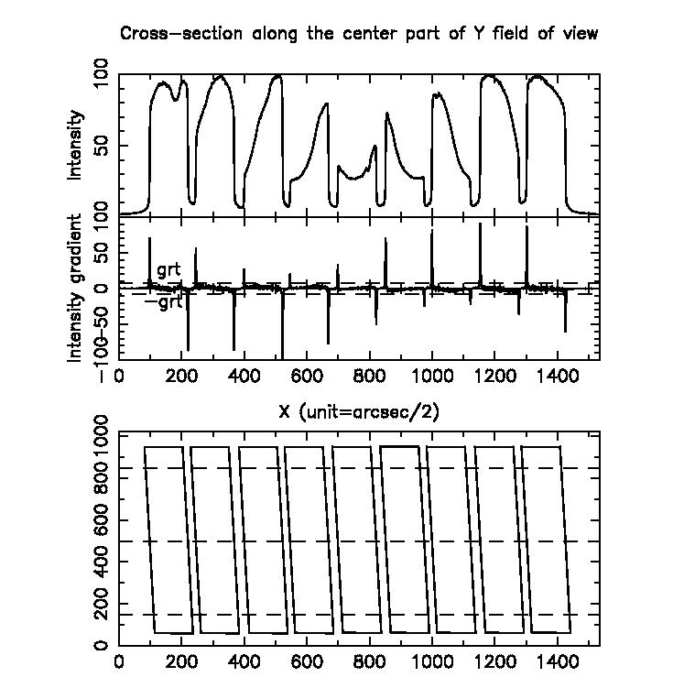
The lower part is the full field of view with 3 sections at Y-values 150, 500, 850, used to determine the left and right edges of all channels, as seen in Figure 3.
The full drawing of channel edges is shown also, according to all determinations using cross-sections X and Y described in Figure 3 .

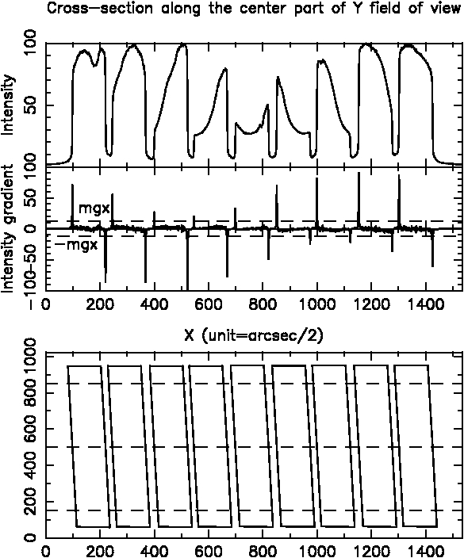

Figure 1

The intensity gradients, shown in Figure 1, show that, in spite of low intensity of the spectral line, gradients can be used to determine channel edges, on the condition that their absolute value exceeds some thresholds. Quantities mgx (minimum gradient for left side of channels) and -mgx (right side) are selected through Figure 1.
We can note that, to increase signal-to-noise ratios, because of the very small angle between sides of channels and Y axis (around 0.04 rad), the detection of edges can be done also with average intensity gradients of some horizontal sections, around each of the 3 above mentionned.. The parameter laddx (additional lines X, up and down) leads to average gradients between Y-laddx and Y+laddx.
In the example of our MSDP observation, 25 flat-field data are averaged. The used laddx is 0. In the case of observations with far fewer data, laddx could be accepeted easily up to 5 (shifts ± 0.2 pixel in extreme sections).

2) Figure (2) is an enlargement of the upper part of Figure 1. The cross-sections of intensity and intensity gradient are plotted again along the central part of field of view (Y=500), but only 120 pixels around the left edge of first channel.
The maximum gradient (greater than mgx) is plotted between intensities X=97 and X=98 (upper part of the figure), and in intensity gradient X=97.5 (lower part) .The parabolic interpolation of intensity gradients is used with the 3 gradients in X= 96.5, X=97.5 and X=98.5 (lower part). The parabola is printed with a thick line.
Gradients X=97.5 and X=98.5 are in this example almost equal. So the maximum of interpolated parabola, defining the first left channel edge, is close to the middle abscissa X=98. In Figure 3, this will define the point b, which becomes B in final drawing of channels.

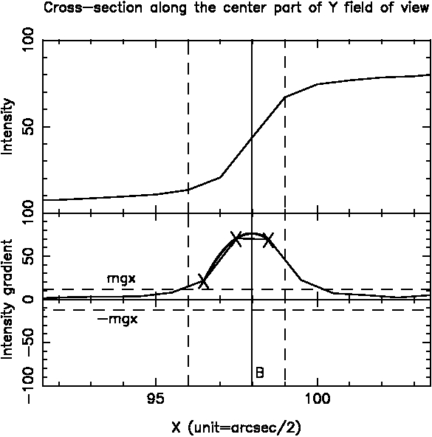
Figure 2

3) Figure 3 (geo3.ps) shows the first channel geometry :
- points a,b,c,d,e,f determined by using the 3 cross-sections of Figure 1 with the same method as seen in Figure 2
- points k,m,l,n by using Y cross-sections, starting from Y values of ad and cf, and X-values shifted by 25 pixels towards channel inside. Unlike X cross-sections used with a,b,c,d,e,f, each Y cross-section looks here for only one point. A new gradient threshold mgy is available (here the same as mgx).

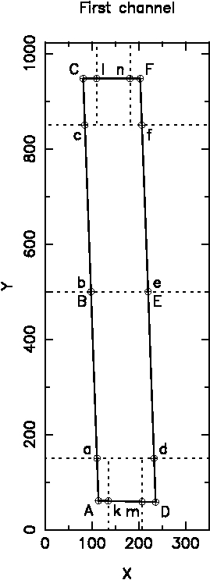

Fiure 3

It can be noted that the coordinates of points a,b,c and d,e,f of Figure 3 can be used to estimate the distortion due to spectrograph. In this example, the quantities for all channels
X(b)-(X(a)+X(c))/2 (left side) and X(e)-(X(d)+X(f))/2 (right side)
have respective averages - 0.08 and + 0.19 (with the pixel unit close to 0.5 arcsec), with departures less than ± 0.2.
This is very small and suggests to discuss again in this case the option of parabolas, adjusted to channel sides abc and def.

4) Figure 4 (geo4.ps) gives the lengths in X and Y of the sides of 9 channels, AC, DF, AD and CF. The very small departures between successive channels show the good accuracy of the parabolic interpolation.

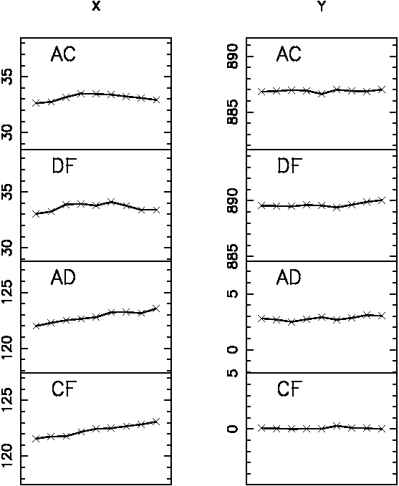

Figure 4

