Building a Weather Station Track Temp

What You’ll Need:

- Raspberry Pi 4 (minimum 2GB RAM)
- Micro SD card (minimum 16GB)
- ADC converter shield (103030279 | Seeed Studio 4 Channel 16-bit ADC Interface Add on Board for Raspberry Pi | RS (rs-online.com))
- Temperature Sensor (SEN0256)

Hardware Setup:

- Mount the ADC shield onto the Raspberry Pi.
- Disconnect both connectors from the temperature sensor.
- Reattach the black pin to the red wire only.
- Remove the black wire used for shielding and strip the remaining wire slightly to allow connection on the ADC shield.

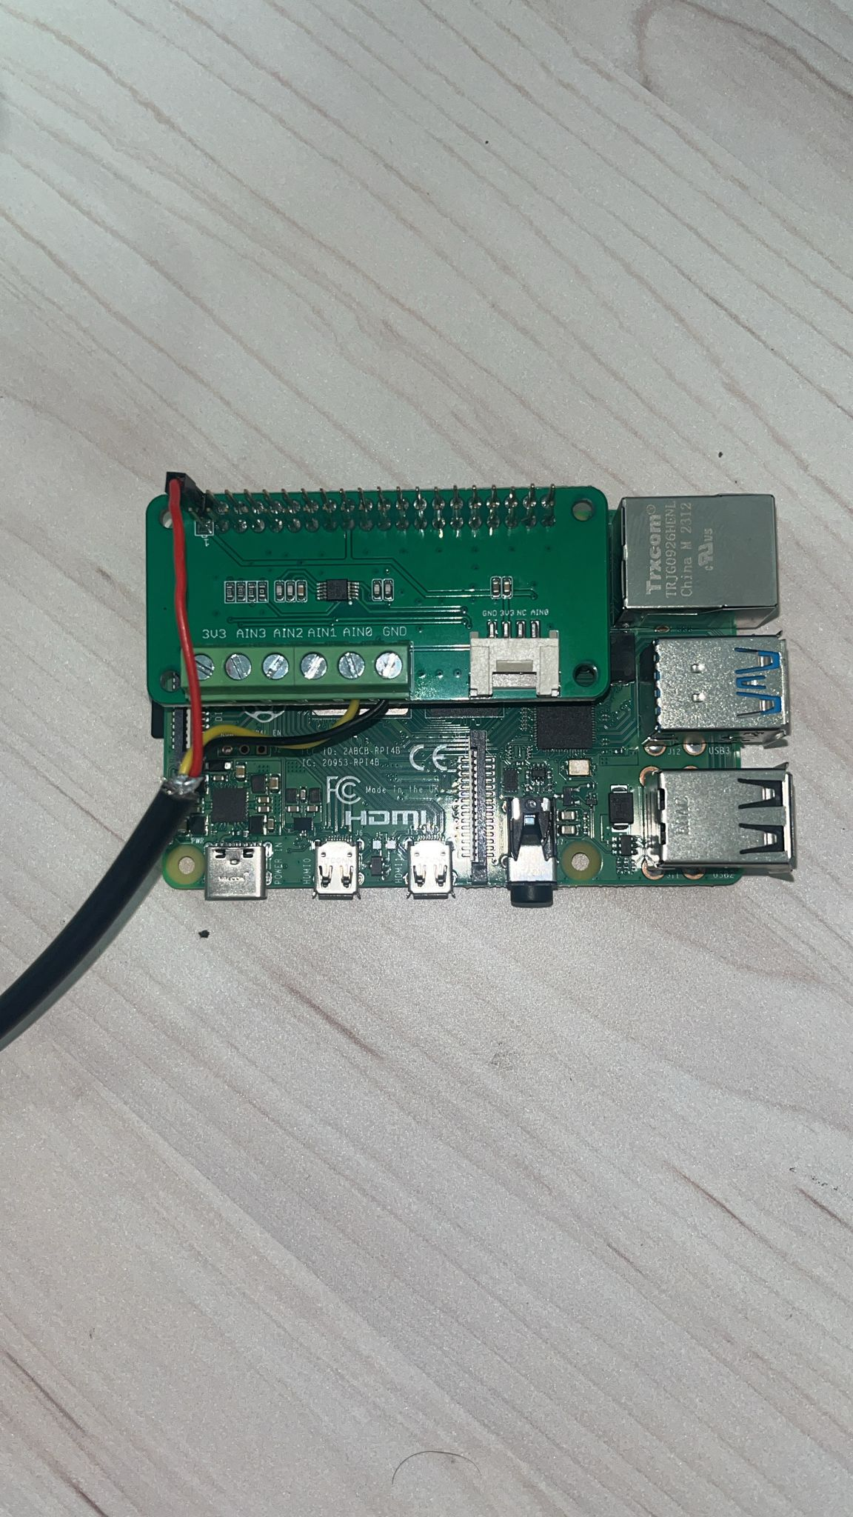

3D print the pieces and fucking mount it (rédige mon reuf)

Software SetUp :

Install OS

Insert the SD card into your computer. Install/Launch Raspberry PI manager on your computer.

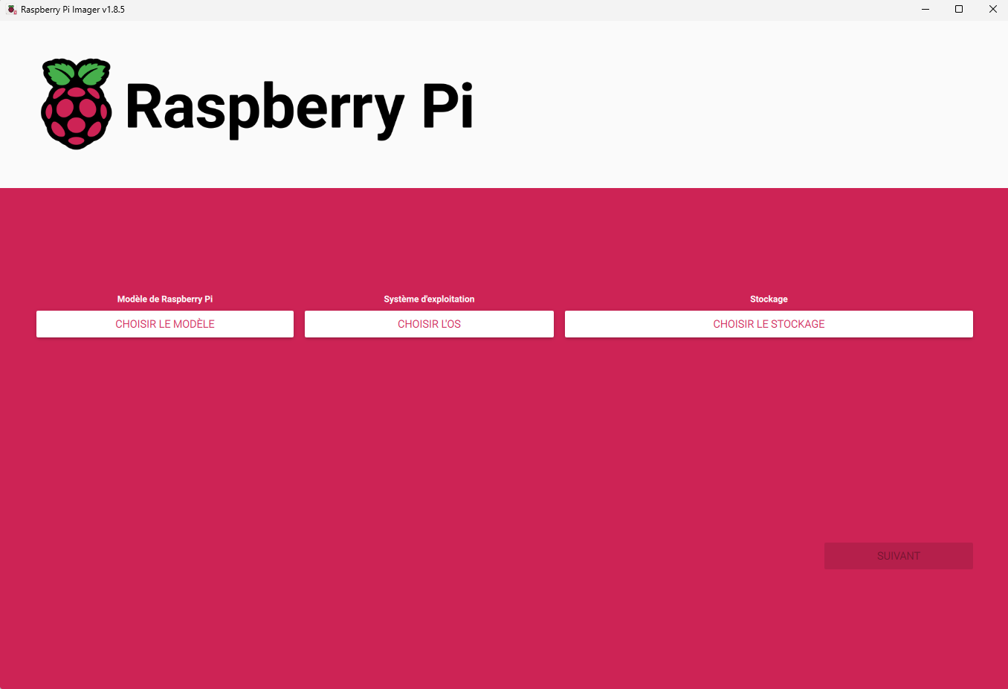

- Select the Raspberry Pi 4 model (obviously).
- Choose the recommended operating system: "Raspberry Pi OS 64-bit".
- Select the storage device where your SD card is located.
- Select "Next" and you will see the following window
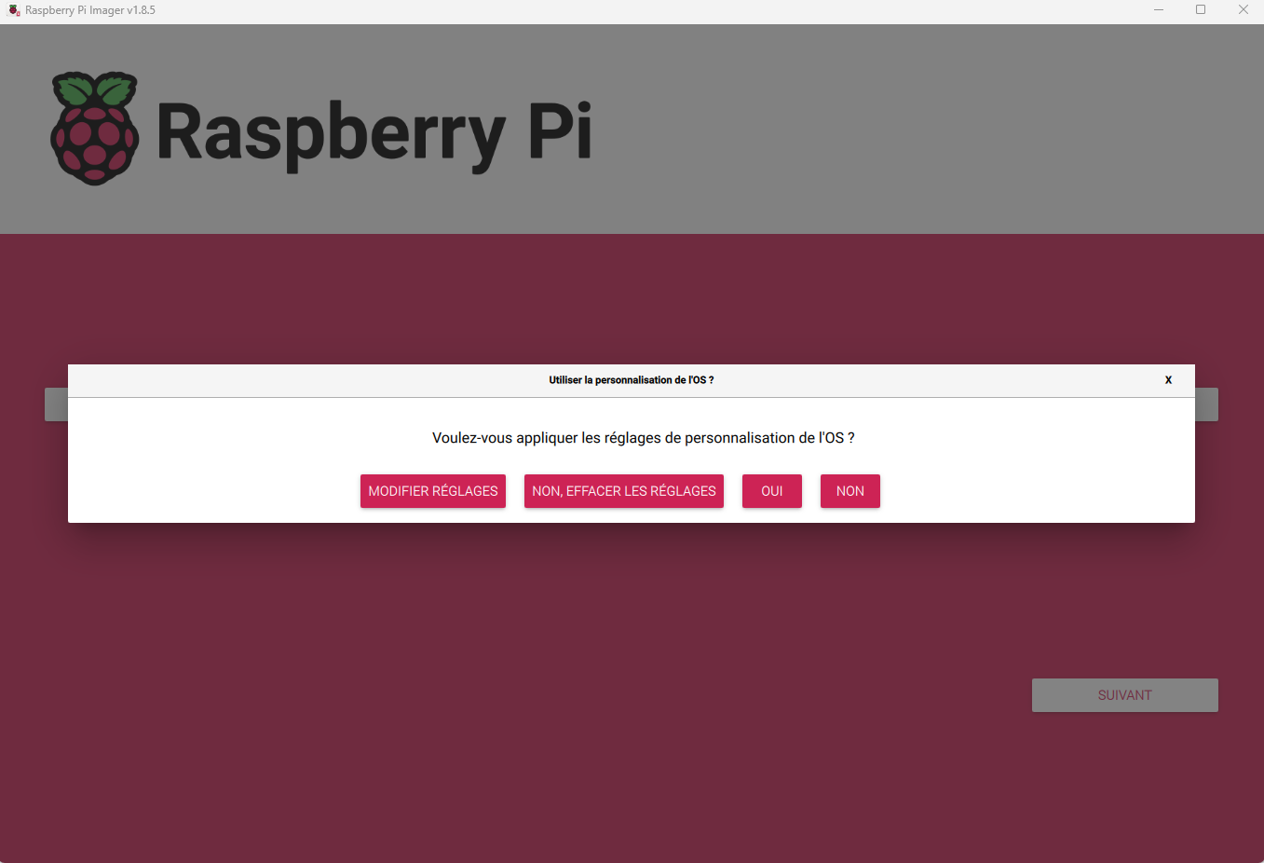

Select "Modify Settings" and apply the following options:

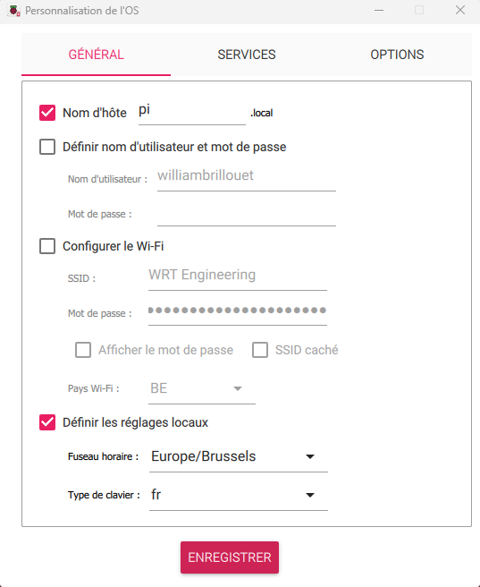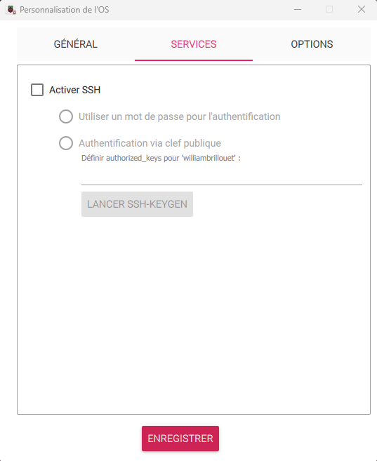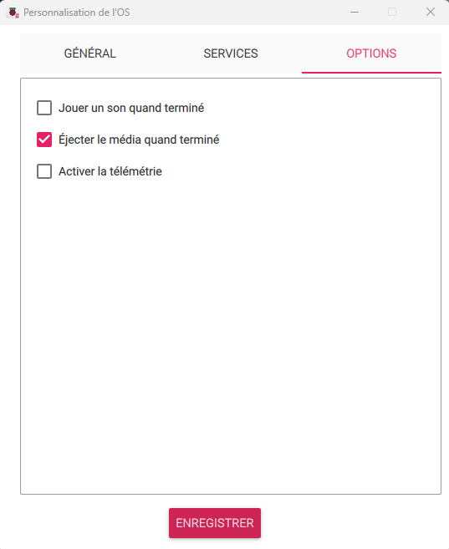

Then click "Save" and confirm by selecting "Yes"

Put the SD card in the Raspberry, then start it. Follow the installation procedure until you reach the desktop (peut être on peut dev ici ?? mais flemme donc démerde toi mon reuf)

Launch a console. Type the command “sudo raspi-config” then type enter. Follow this :
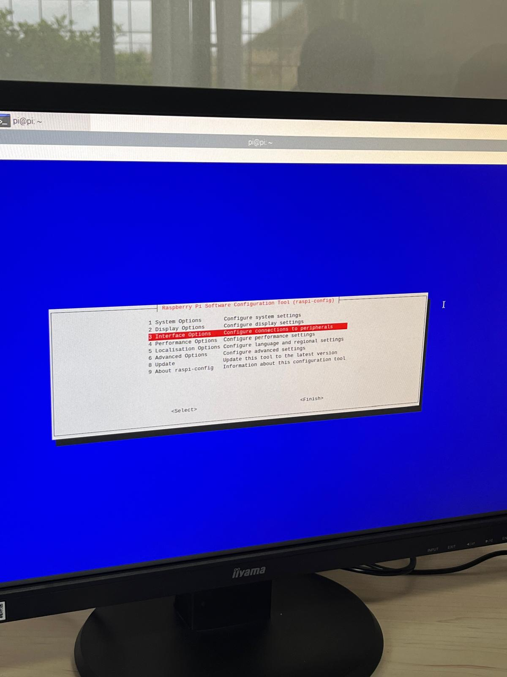
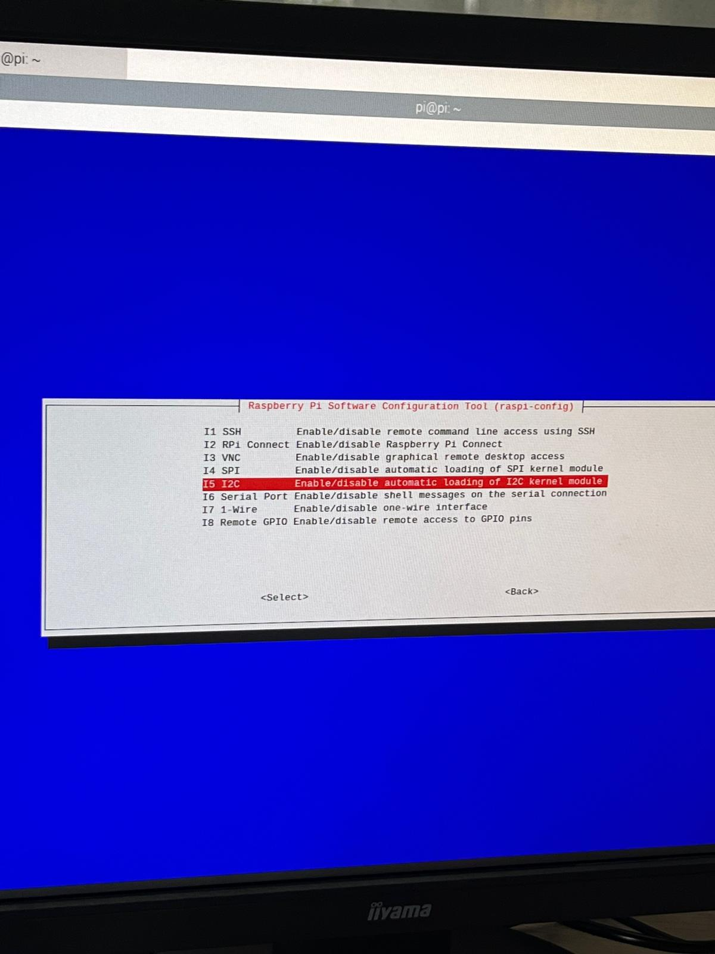
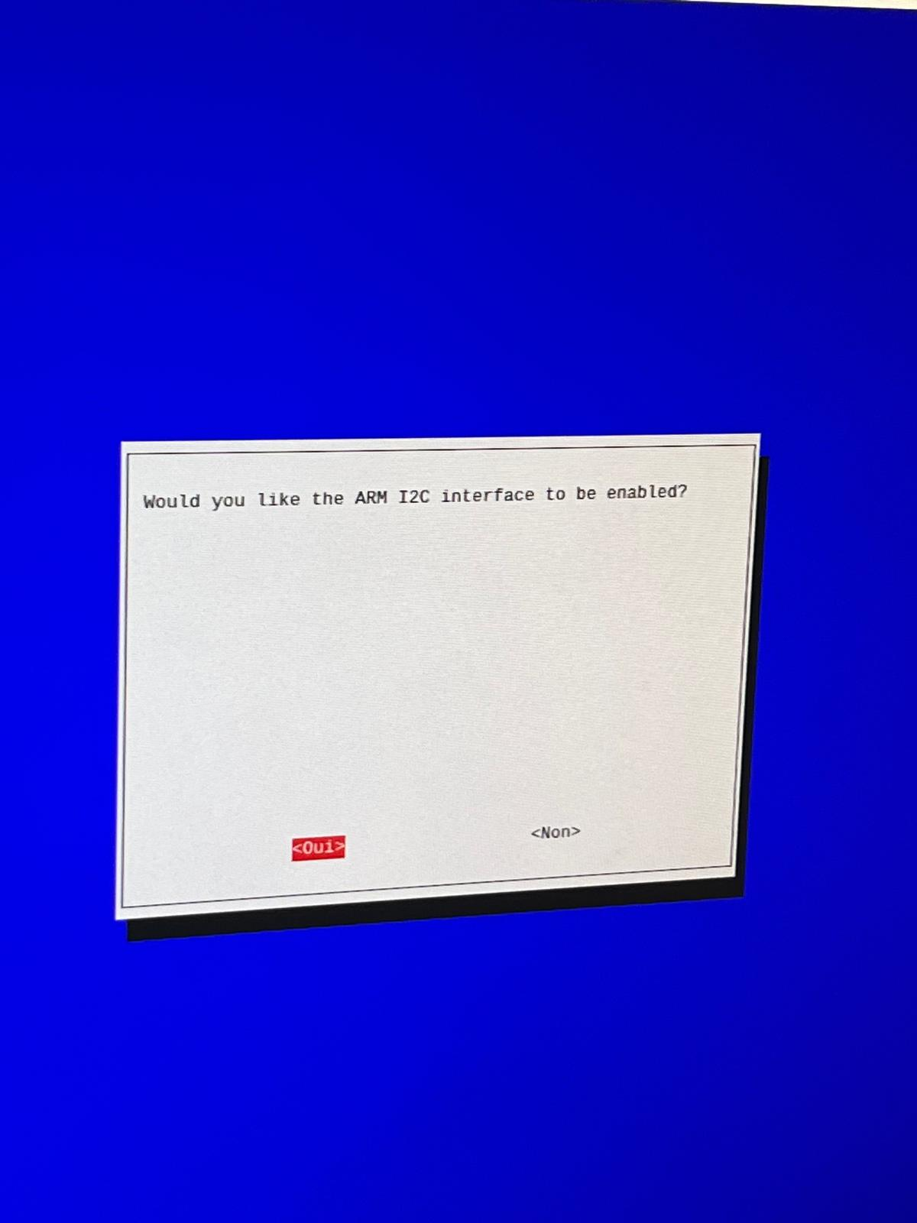
Reboot the raspberry.

Move the folder Station_meteo into the directory /home/pi.

Open the terminal and type the following command:
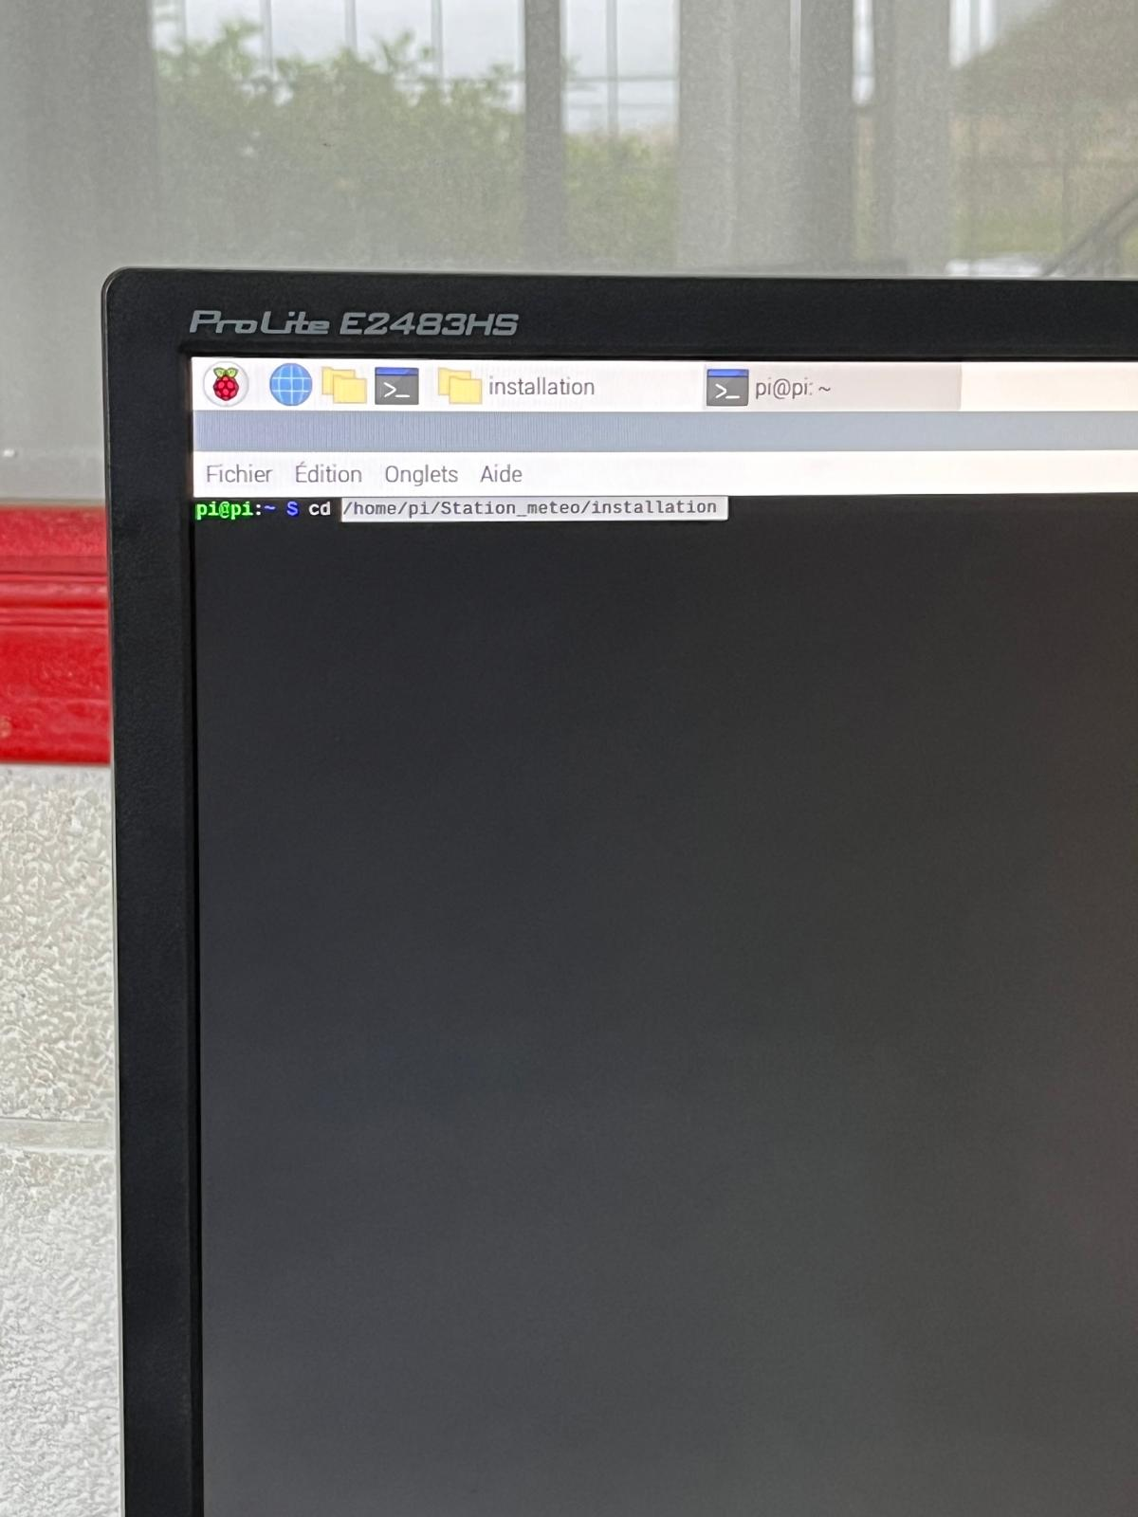
Wait for the installation of all necessary modules to complete.

Next, run the command crontab -e, then press Enter twice.

At the end of the file (after where the text is in blue), paste the contents of the “crontab” file located in the “installation” folder. Then CTRL+X. Then O. Then Enter.

Redo this operation with the command sudo crontab -e

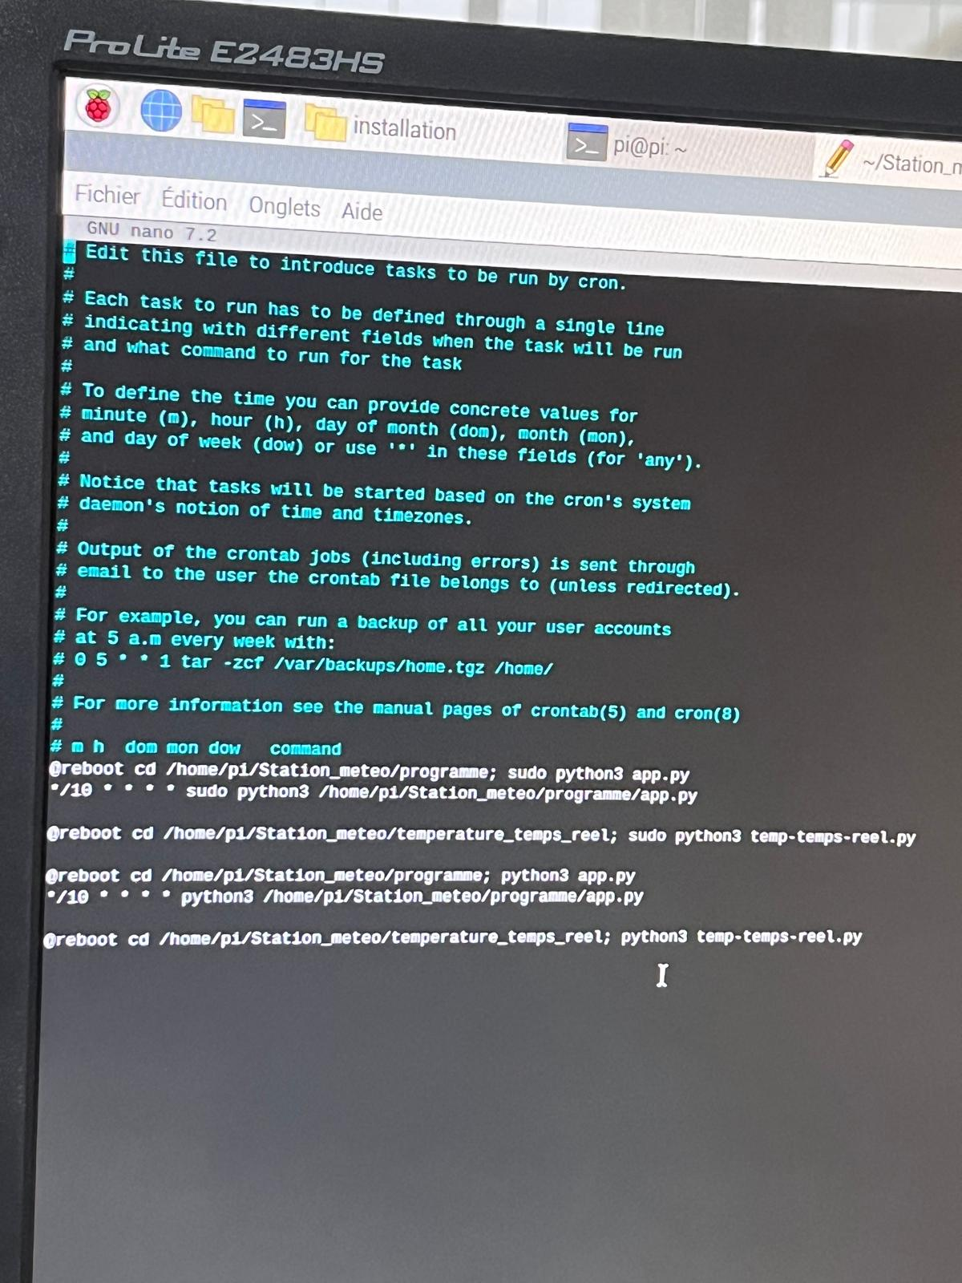
Reboot the raspberry again.

The Weather station should be working.

You have to connect it to the WiFi of the actual network used on track and fix the IP.

Then, if you are connected on the same network, you can launch :

“ip”:9000 : to see the current value of the track temp
“ip”:9001 : to see the log file used in HH

Enjoy

