

**OPENING PRAYER**

***All stand****: The Director leads with the Sign of the Cross.*

***Director***: Come, Holy Spirit…

***All***: …Fill the hearts of your faithful, and kindle in them the fire of your love.

***Director***: Send forth your Spirit and they shall be created.

***All***: And you will renew the face of the earth.

***Director***: Let us pray.

*After a brief pause for silent prayer, the Director continues*:

***Director***: Lord…

***All***: …By the light of the Holy Spirit, you have taught the hearts of your faithful. * In the same Spirit, help us to relish what is right and always rejoice in your consolation. * We ask this through Christ our Lord. Amen.



"I Am Filled With Zeal,

For God,

The King Of All Hosts"

1 Kings 19:14

**Lay Carmelite Vocation Prayer**

Our Lady of Mount Carmel,

we ask you to bring us all

your loved ones who yearn

for a closer union with God.

Help our Order to grow by

inspiring us to pray and reach

out to others, that we together

may work for God’s Glory.

**Hail Mary** – 3 times

Before you begin…

* Confirm pages
* Assign sides
* Assign roles
* Announce Hymn
* Tell which verses

**Prayer before the Office (Optional)**

Lord, open my lips to praise your holy name. Cleanse my heart of any worthless, evil or distracting thoughts. Give me the wisdom and love necessary to pray this Liturgy of the Hours with attention, reverence and devotion. Father, let my prayer be heard in your presence, for it is offered through Christ our Lord. Amen.

*Carmel’s Call page 297*

|  |  |
| --- | --- |
| *Stand* **Presider** | God come to my assistance. |
| **All** | Lord, make haste to help me. |
| **All** | Glory to the Father and to the Son and to the Holy Spirit. As it was in the beginning is now and will be forever. Amen. |
| **Cantor 1** begins**, All** join | Hymn |
| **Cantor 1** prays word or phrase, pauses  **All** join to complete | Antiphon 1 |
| **Cantor 1** starts 1st line  *Sit* **Side 1** joins in  **Side 2** & **Side 1** alternate strophes | Psalm  Glory to…  As it was… |
| **Presider** | Psalm Prayer, if applicable |
| **Cantor 1** prays word or phrase, pauses  **All** join to complete | Antiphon 1 |
| **Cantor 2** prays word or phrase, pauses  **All** join to complete | Antiphon 2 |
| **Cantor 2** prays first line  **Side 2** joins in  **Side 2** & **Side 1** alternate strophes | Canticle  Glory to…  As it was… |
| **Presider** | Psalm Prayer, if applicable |
| **Cantor 2** prays word or phrase, pauses  **All** join to complete | Antiphon 2 |

|  |  |
| --- | --- |
| **Cantor 1** prays word or phrase, pauses  **All** join to complete | Antiphon 3 |
| **Cantor 1** prays first line  **Side 1** joins in  **Side 1** & **Side 2** alternate strophes | Second Psalm  Glory to…  As it was… |
| **Presider** | Psalm Prayer, if applicable |
| **Cantor 1** prays word or phrase, pauses  **All** join to complete | Antiphon 3 |
| **Reader** | Reading |
|  | *Pause for one minute of silent reflection* |
| **Reader** | Responsory 1 |
| **All** | Responsory 1 |
| **Reader** | Responsory 2 (first half) |
| **All** | Responsory 2 (second half) |
| **Reader** | Glory to the Father, and to the Son, and to the Holy Spirit. |
| **All** | Responsory 1 |
| *Stand* **Presider** prays word or phrase, pauses  **All** join to complete | Antiphon for Canticle of Zechariah |

|  |  |
| --- | --- |
| **Cantor 1** prays first line  **Side 1** Joins in | Blessed be the Lord, the God of Israel; He has come to his people and set them free. |
| **Side 2** | He has raised up for us a mighty savior, Born of the house of his servant David. |
| **Side 1** | Through his holy prophets he promised of old that he would save us from our enemies, from the hands of all who hate us. |
| **Side 2** | He promised to show mercy to our fathers And to remember his holy covenant. |
| **Side 1** | This was the oath he swore to our father Abraham: To set us free from the hands of our enemies, Free to worship him without fear, Holy and righteous in his sight All the days of our life. |
| **Side 2** | You, my child shall be called the prophet of the Most High; For you will go before the Lord to prepare his way, To give his people knowledge of salvation By the forgiveness of their sins. |
| **Side 1** | In the tender compassion of our God The dawn from on high shall break up on us, To shine on those who dwell in darkness and the shadow of death, And to guide our feet into the way of peace. |
| **Side 2** | Glory to the Father, and to the Son, and to the Holy Spirit. |
| **Side 1** | As it was in the beginning is now and will be forever. Amen |

|  |  |
| --- | --- |
| **Presider** prays word or phrase, pauses  **All** join to complete | Antiphon for Canticle of Zechariah |
| **Presider** | Opening prayer for intercessions |
| **All** | Prayer in italics |
| **Reader** | Each petition – first half |
| **All** | Each petition – second half |
|  | (other **general** intercessions may be added) |
| **All** | Repeat prayer in italics |
| **Presider** starts  **All** join | Our Father… |
| **Presider** | Closing Prayer |
| **All** | Amen |
| **Presider**  *(if no ordained present)* | May the Lord bless us, protect us from all evil and bring us to everlasting life. |
| **All** | Amen |

**The Four Phases of Lectio Divina**

**Lectio** - Reading

“…we read the Word of God, slowly and reflectively so that it sinks into us.”

**Meditatio** - Reflection

“…we think about the text we have chosen and ruminate upon it so that we take from it what God wants to give us.”

**Oratio** - Prayer Response

“…we leave our thinking aside and simply let our hearts speak to God. This response is inspired by our reflection on the Word of God”

**Contemplatio** - Contemplation

“…we let go not only of our own ideas, plans and meditations but also of our holy words and thoughts. We simply rest in the Word of God. We listen at the deepest level of our being to God who speaks within us with a still small voice. As we listen, we are gradually transformed from within.”

*Quotes from* [*http://ocarm.org/en/content/lectio/what-lectio-divina*](http://ocarm.org/en/content/lectio/what-lectio-divina)

**Lectio Divina in Community**

1. Word/phrase
2. Gospel meaning
3. Personal meaning
4. Silence

**Act of Consecration to Our Lady of Mount Carmel**

O Mary, Queen and Mother of Carmel, I come today to consecrate myself entirely to you. To you as the Mother of Grace, I owe all that I have, and my whole life is but a very small return for the many graces and blessings that have come from God to me through your hands. Since you regard with an eye of special kindness those who wear your Scapular, I implore you to strengthen my weakness with your power, to enlighten the darkness of my mind with your wisdom, to increase in me faith, hope and charity, that I may render, day by day, my debt of humble homage to you.

May your Scapular keep your eyes of mercy turned toward me always, and bring me your special protection in the daily struggle to be faithful to your Divine Son and to you. May it separate me from all that is sinful in life and remind me constantly of my duty to behold you and clothe myself with your virtues. From henceforth I shall strive to live in the sweet companionship of your spirit, to offer all to Jesus through you and to make my life the mirror of your humility, charity, patience, meekness and prayerfulness.

O dearest Mother, support me by your never-failing love so that I, an unworthy sinner, may come one day to exchange your Scapular for the wedding garment of heaven and dwell with you and the saints of Carmel in the kingdom of your Son. Amen.

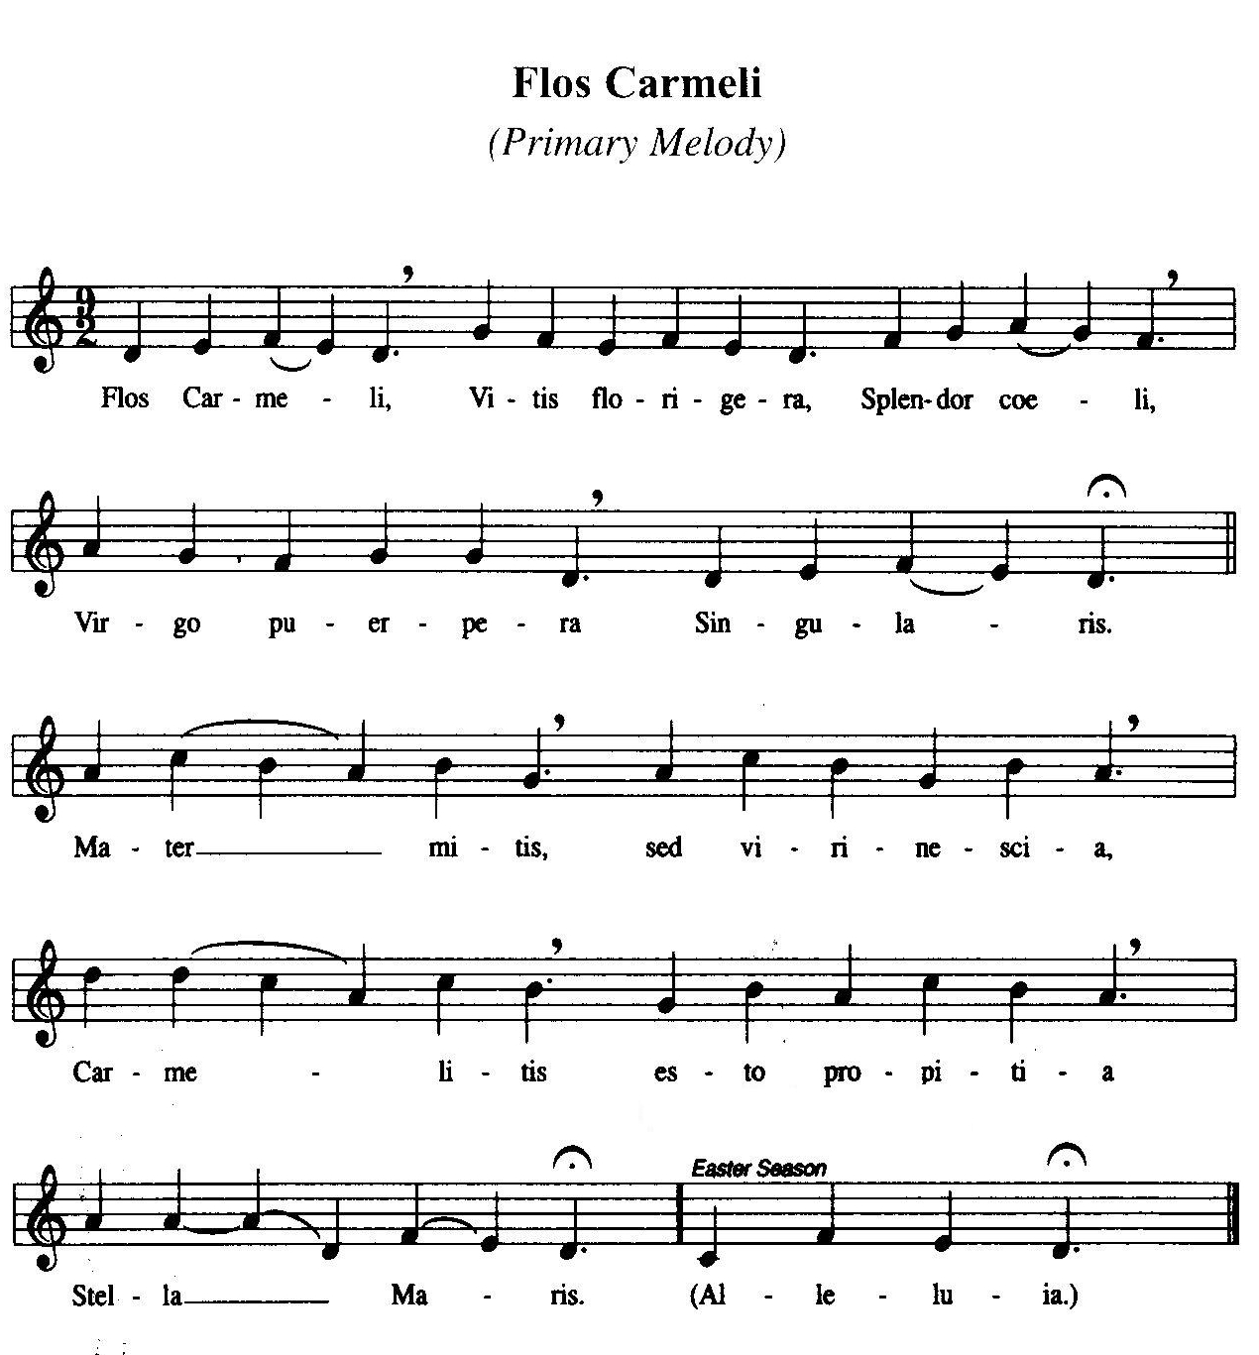

**CLOSING PRAYER**

***All stand****: The Director leads with the Sign of the Cross.*

***Director***: Praised be Jesus Christ!

***All***: Now and forever. Amen.

*Then follows the “Flos Carmeli”*

***Director***: O beautiful Flower of Carmel…

***All***: …Most fruitful vine, * Splendor of heaven, * Holy and Singular, * Who brought forth the Son of God * Still ever remaining a pure Virgin, * Assist us in our necessities. * O Star of the Sea, Help and protect us. * Show us that you are our Mother.

***Director***: Hope of all Carmelites.

***All***: Pray for Us.