**Library Functionality**

Student: Maximilian Mihoc

Student number: C12728559

Library functionality

***Login***– The user must identify themselves to the system in order to use the system. If they have not previously used the system, they must register their details.

My *login.php* file looks like this:

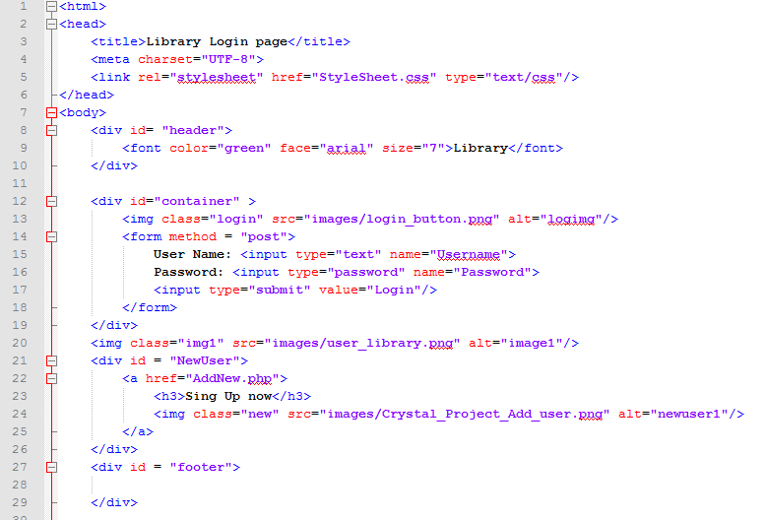

If a user want to use the Library he must be a member or else he must be registered.

Explanation of the code: When a username and a password is write in the specific section, it is checked if they exist in the database and in case they exist, the home page will appear and they can manage their account from there. If they are not in the database, they have to register.

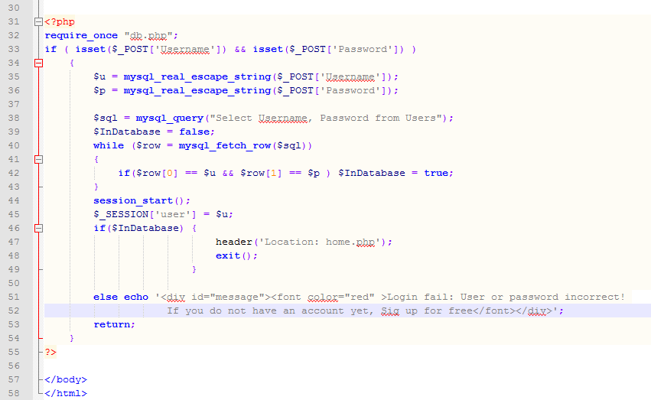

***Registration*** *-* This allows a user to enter their details on the system. The registration process should validate that all details are entered. Mobile phone numbers should be numeric and 10 characters in length. Password should be at least six characters and have a password confirmation function. The system should ensure that each user can be identified using a unique username.

All fields have to be completed but telephone number is not mandatory. I give my project to some people to check it and many of them told me that I have to change the Sing up section in my web page so that the telephone number do not have to be mandatory, it is enough a mobile number.

My *AddNew.php* page, used for Registration is:

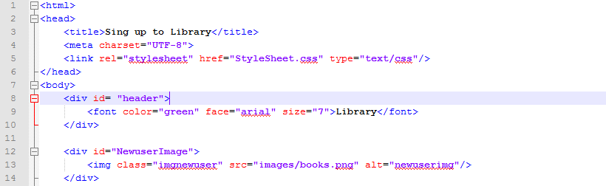

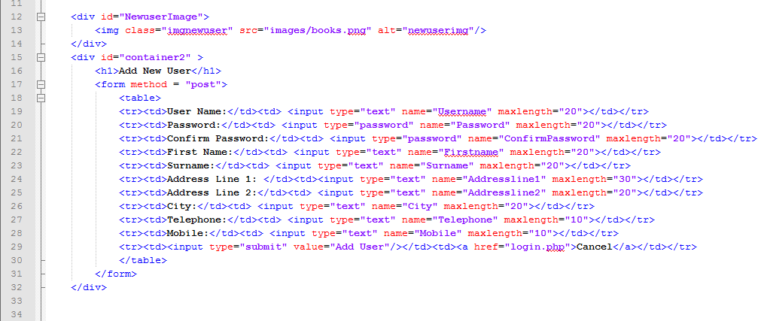

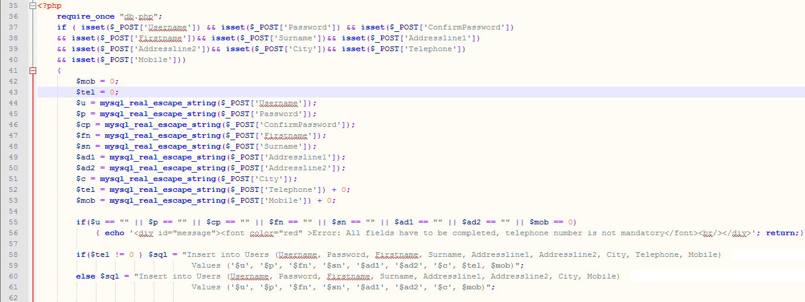

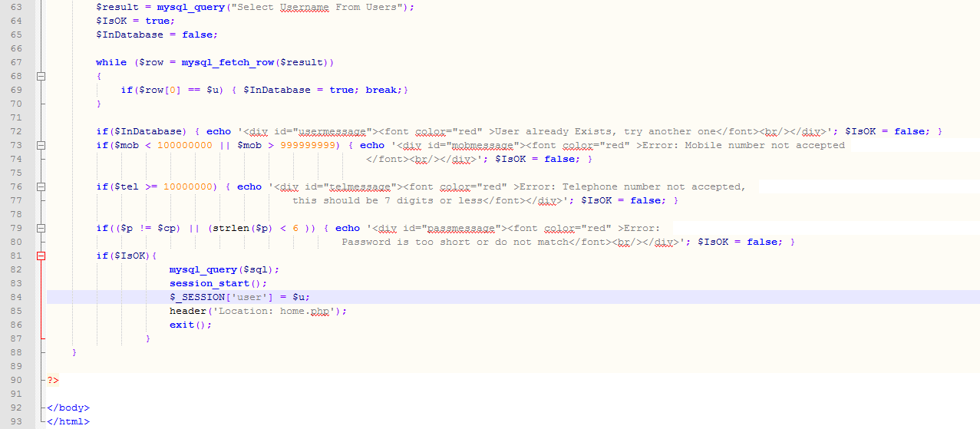

The next page, is the user home page that allow to a user to choose what he want to do in his library account. In home page he has many options: Search and reserve book, view books reserved and log out. This is my *home.php* page:

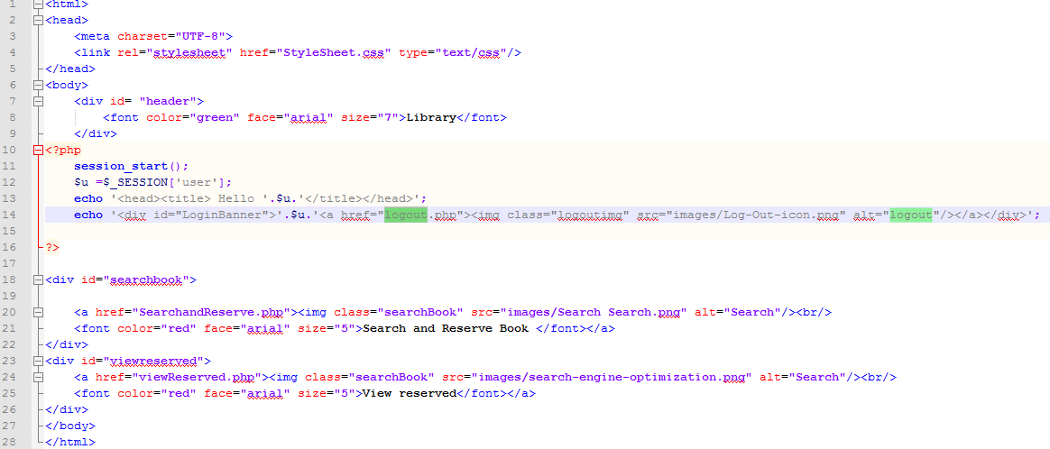

***Search for a book***: The system should allow the user to search in a number of ways:

* + by book title and/or author (including partial search on both)
  + by book category description (book category should retrieved from database)

In my website, the user can search a book by book title, by author name or by category.

The *SearchandReserve.php* page look like this:

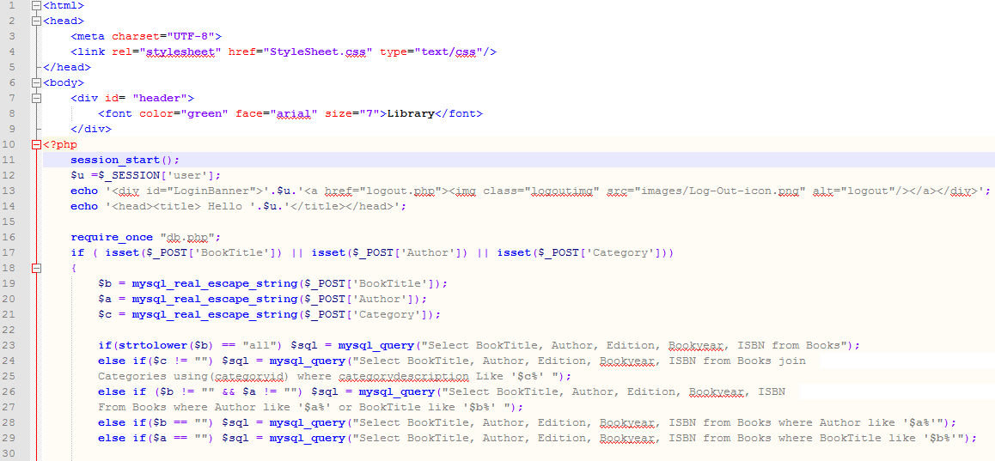

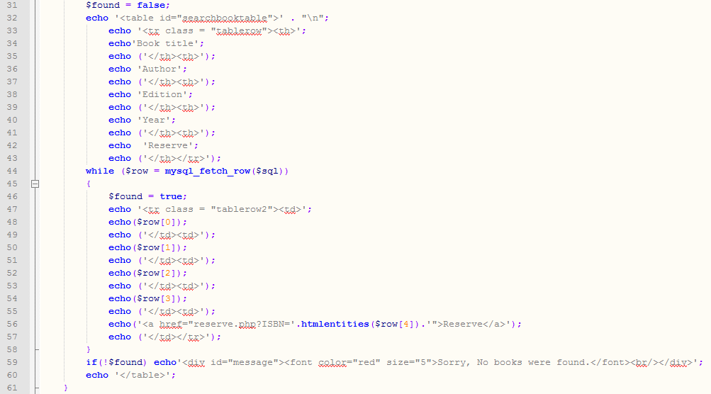

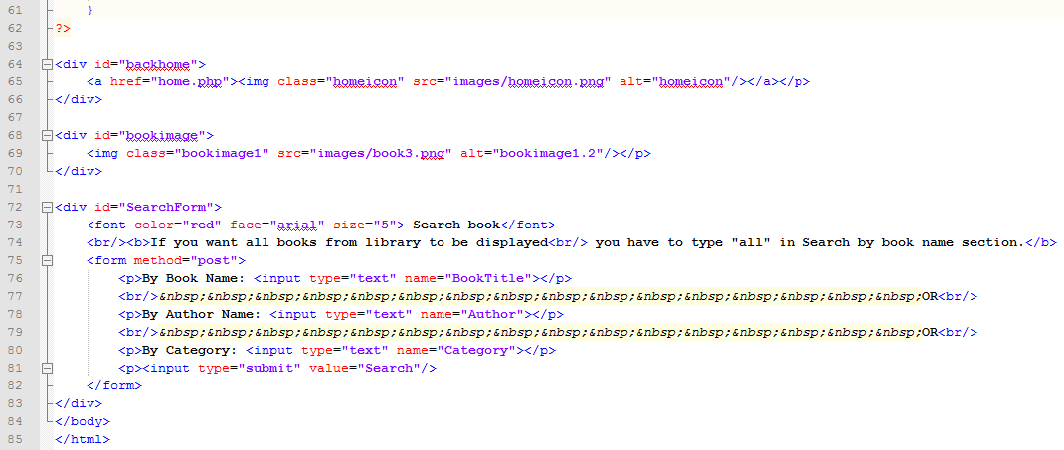

***Reserve a book***– The system should allow a user to reserve a book provided that no-one else has reserved the book yet. The reservation functionality should capture the date on which the reservation was made.

In order to do that, I create a php file called reserve.php. This is my *reserve.php* file:

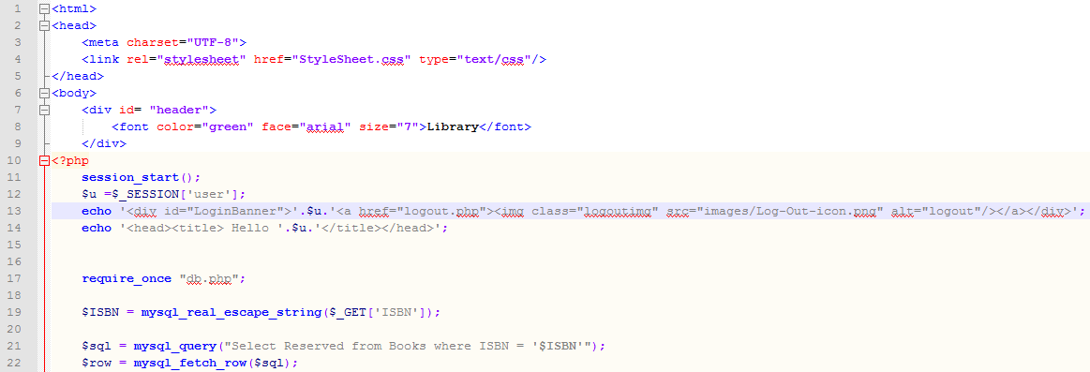

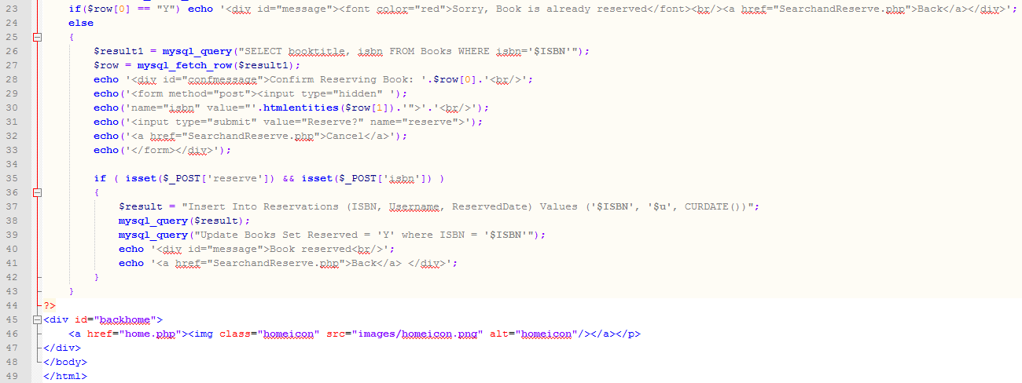

***View reserved books*** - the system should allow the user to see a list of the book(s) currently reserved by that user. User should be able to remove the reservation as well.

The next page is *Viewreserved.php* page where the user can see a table of books that he reserved.

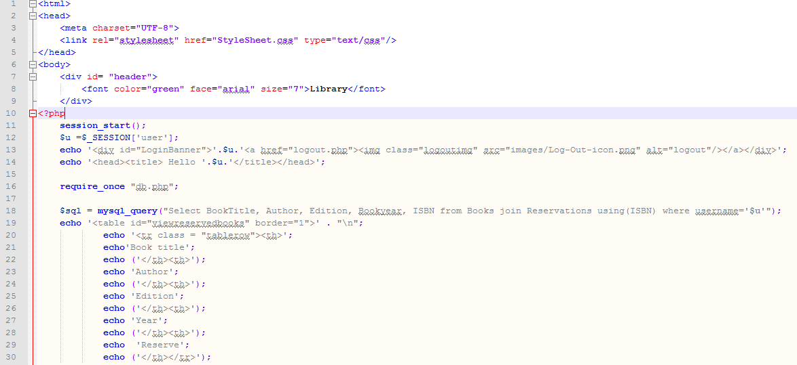

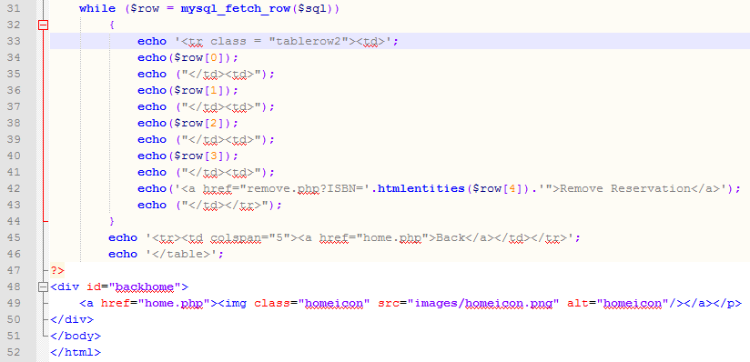

The next page is made to allow to a user to remove a book that he reserved. The next page is called *remove.php.*

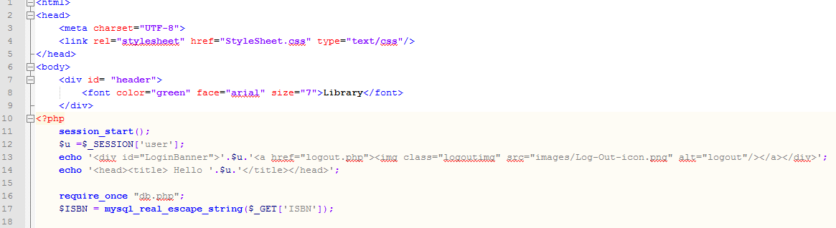

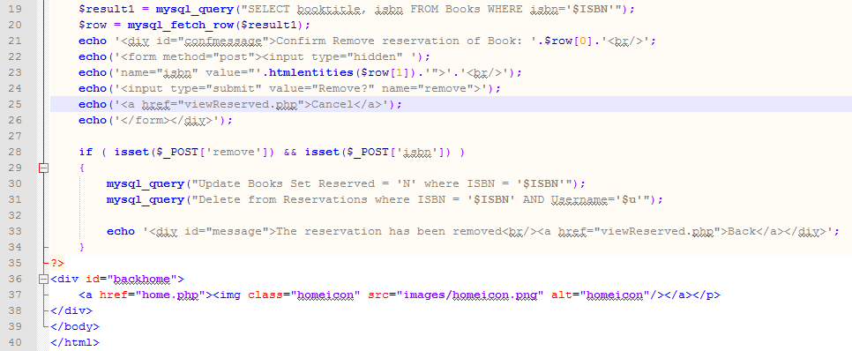

For all this files, we need 2 more files, one file called *db.php* used to make a connection with the database and a CSS file used for the database design.

*db.php* file:

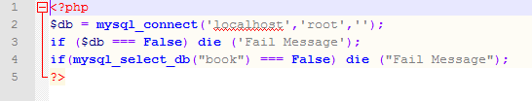

I also have a *logout.php* page:

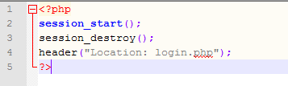

The next file is the CSS file.

*StyleSheet.css*

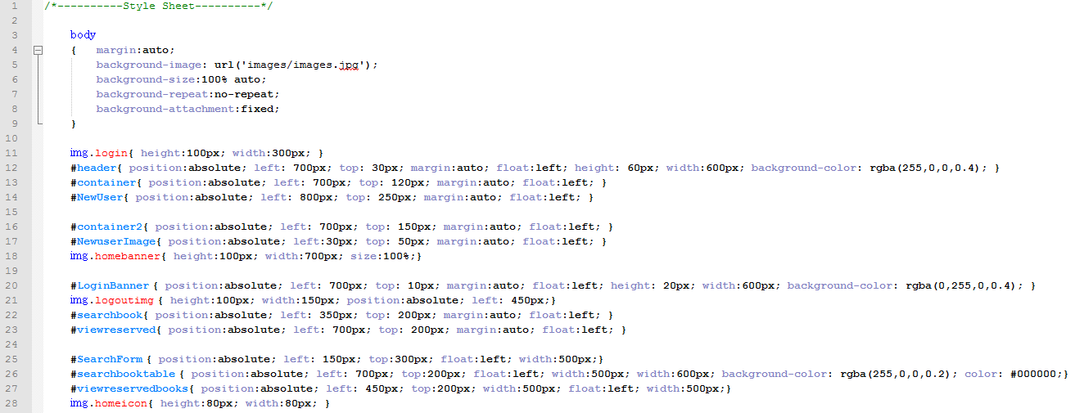

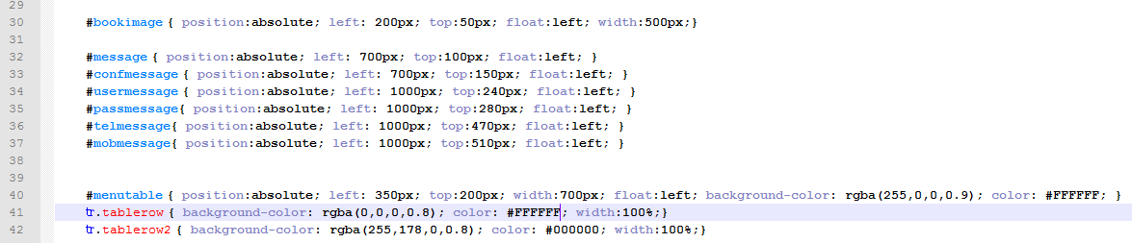

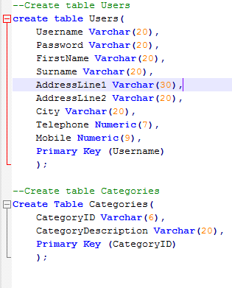For all this things to be possible, we need to create the database before executing any of the above files. To create a database called book we use this comment: **create database book**;

After I create the database, I used the following MySQL commands to create and populate the tables.

