Supporting information Appendix for Pichler & Hartig – Can machine learning be used for causal inference?

Table of contents

**Summary:** This document provides supporting information on Pichler & Hartig – Can machine learning be used for causal inference.

## 1 Proof of concept

### 1.1 Variance

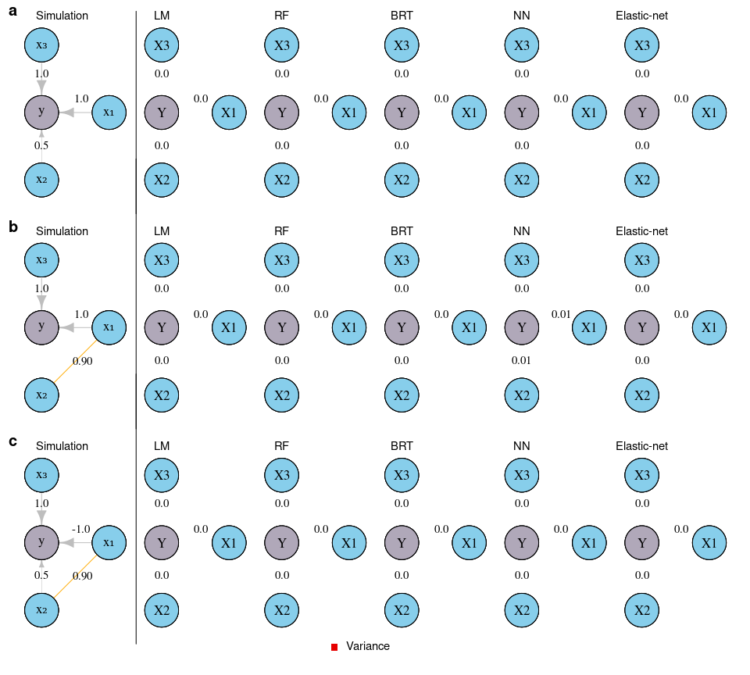

#### 1.1.1 RMSE on holdout

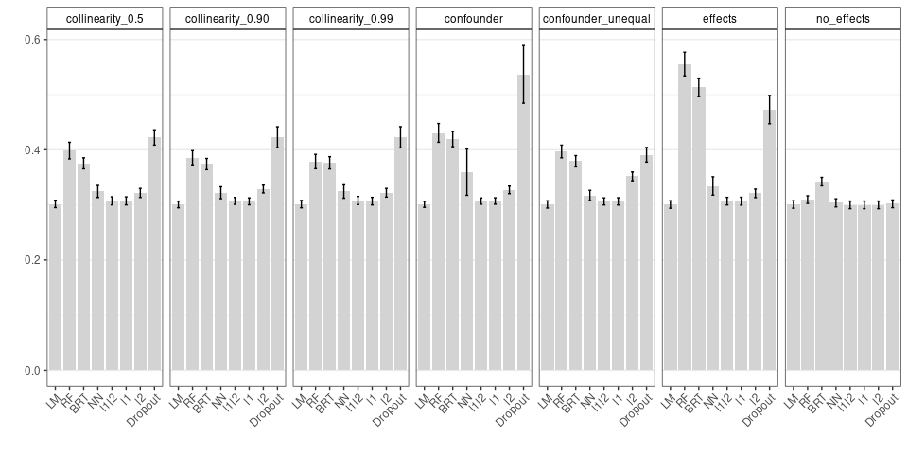

### 1.2 NN with Dropout, LASSO, and Ridge

#### 1.2.1 Bias

Dropout, l1 and l2 bias

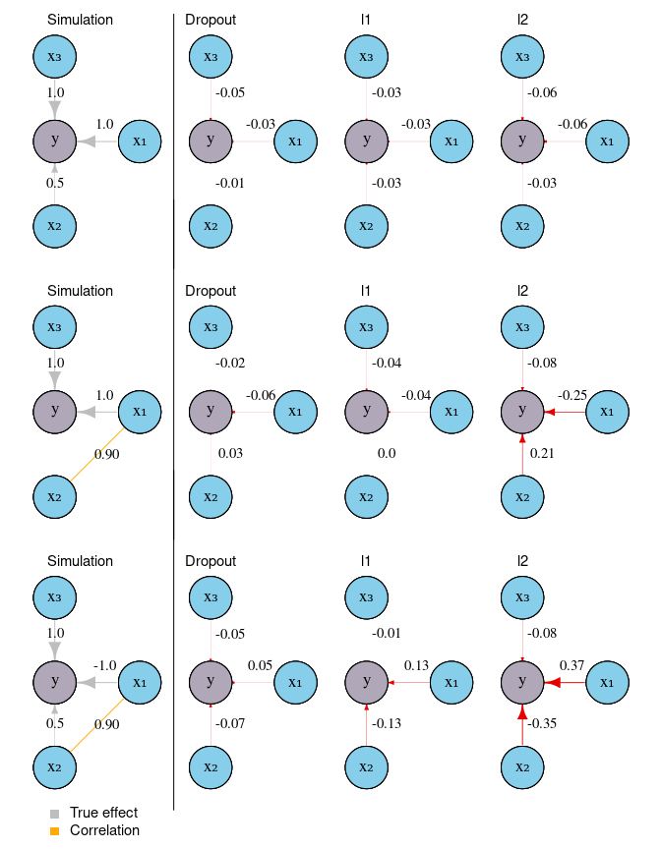

#### 1.2.2 Variance

Dropout, l1 and l2 variance

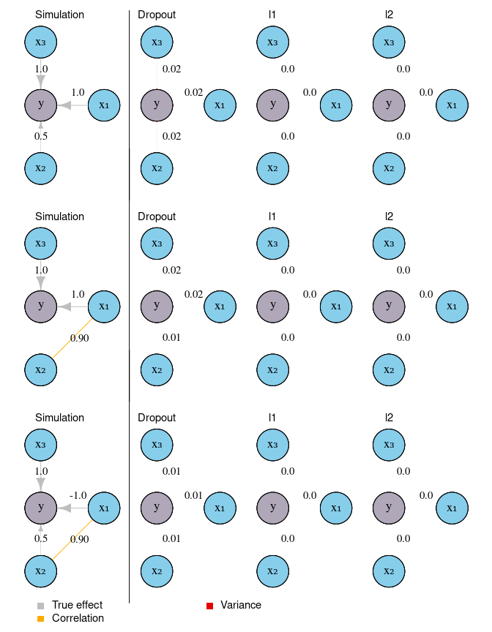

## 2 Sensitivity analysis

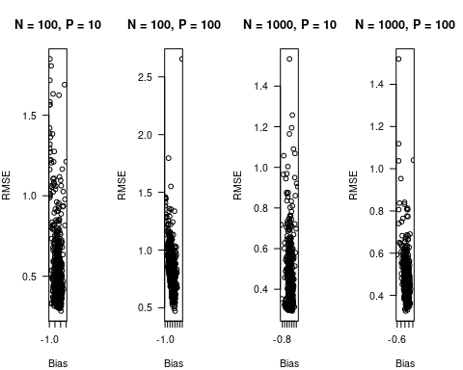

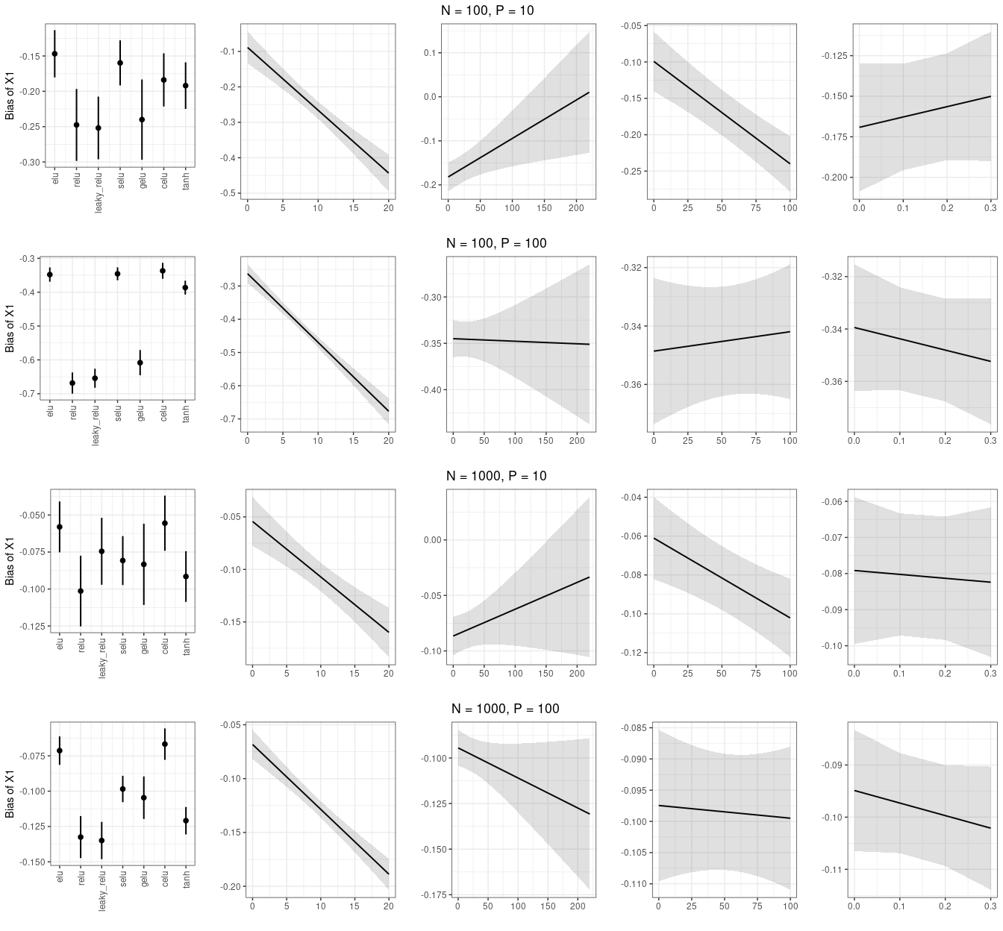

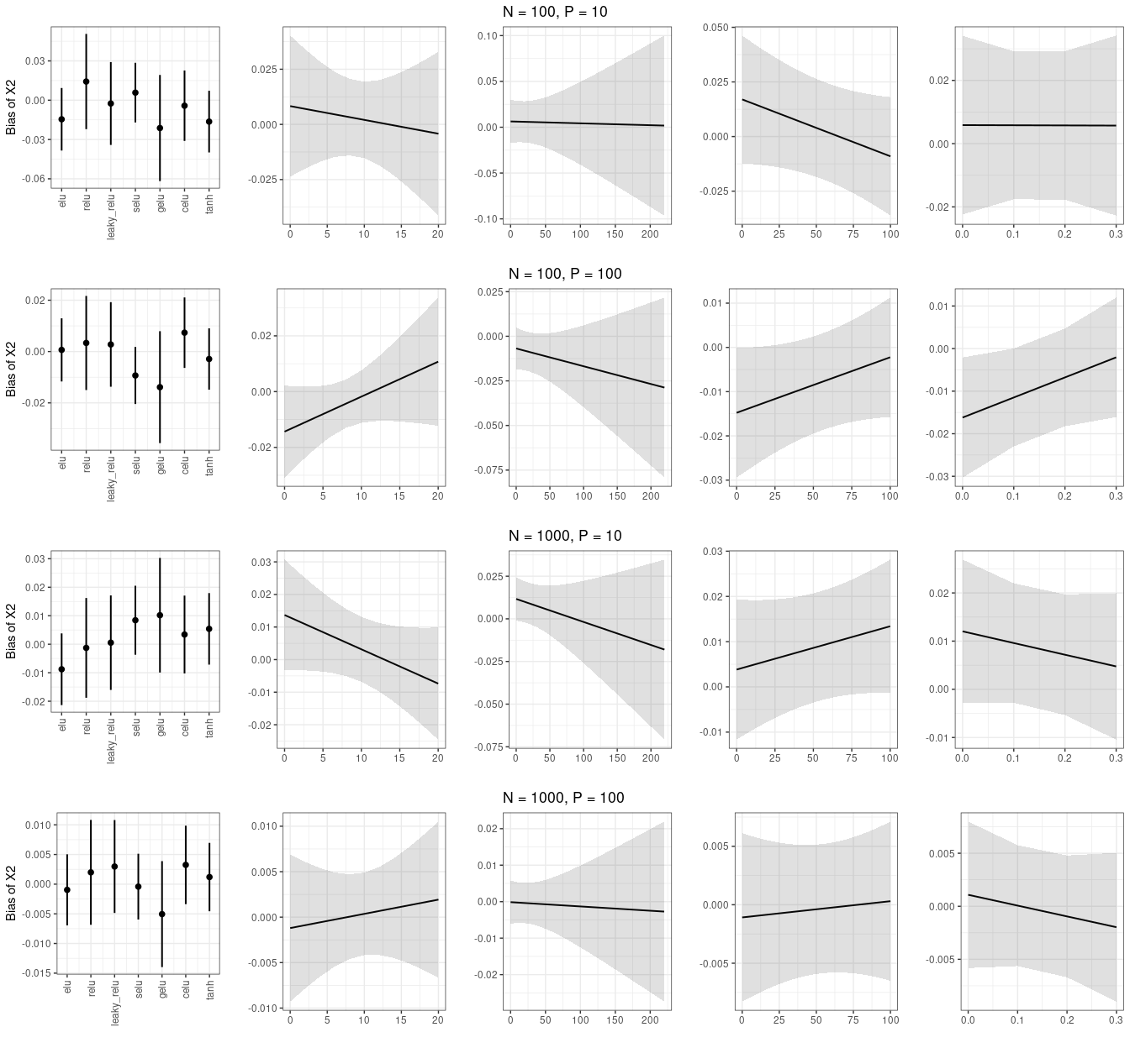

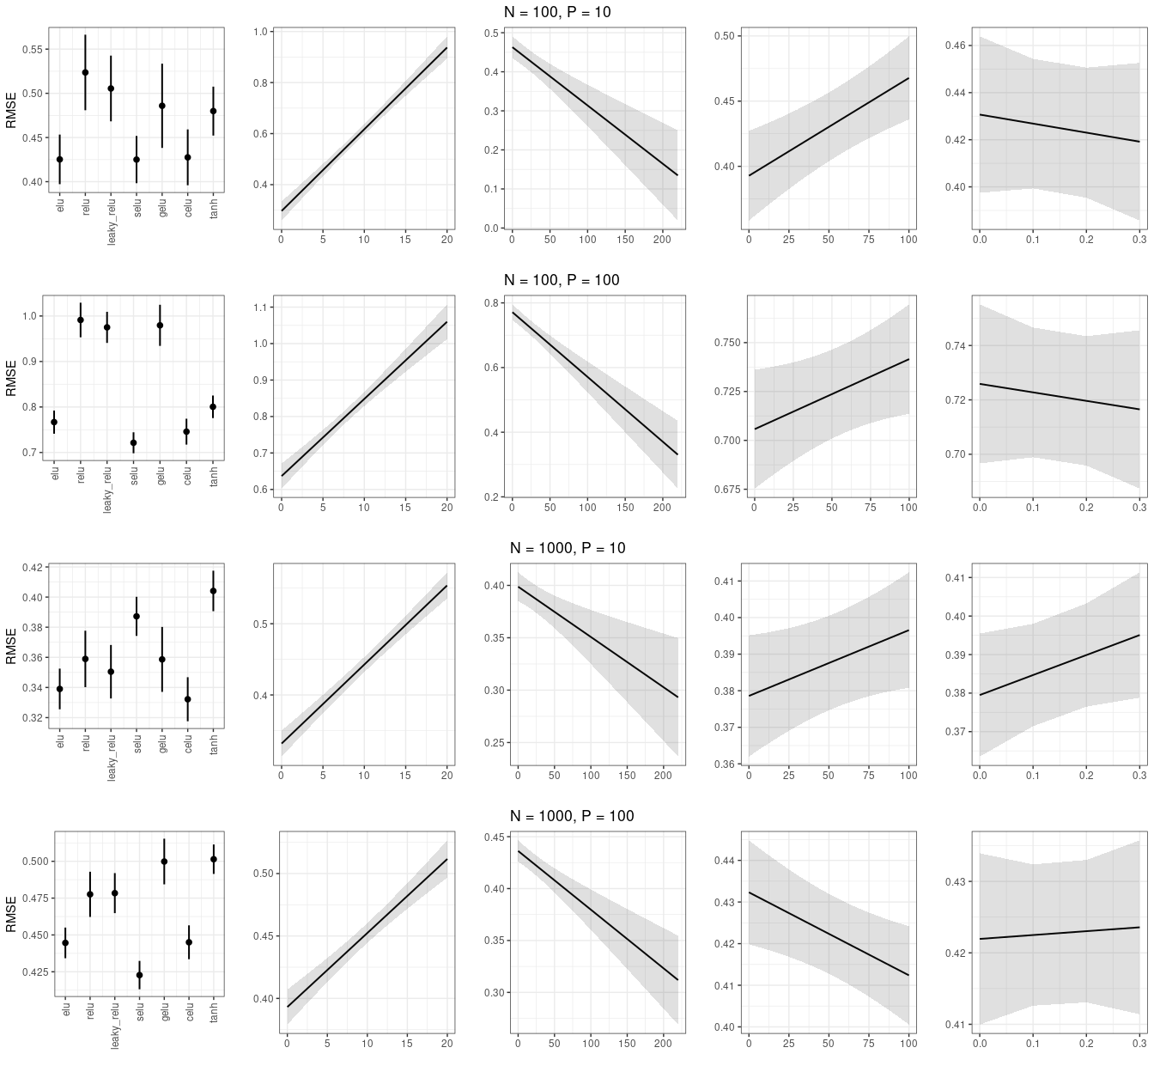

## 3 Data-poor simulation

### 3.1 RMSE data-poor without interactions

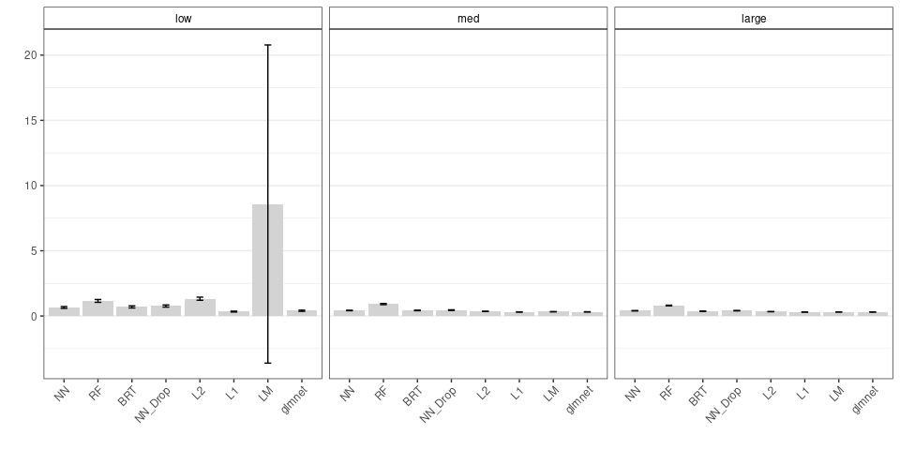

### 3.2 With interactions and Collinearity

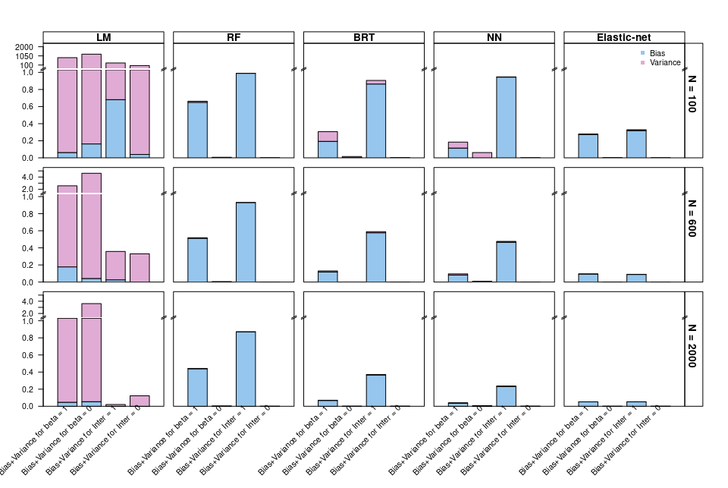

#### 3.2.1 RMSE

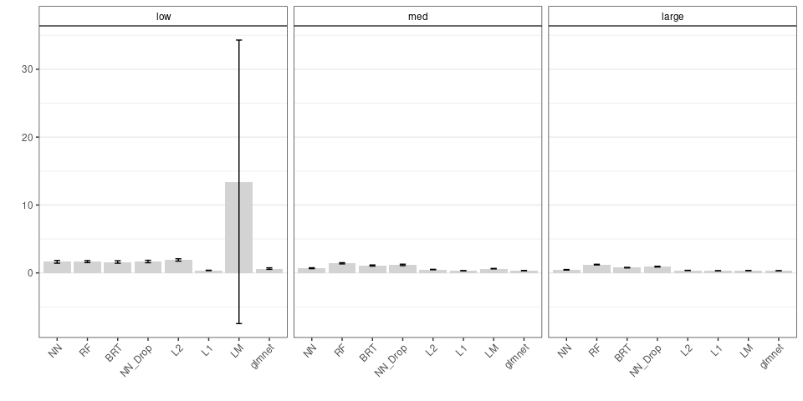

### 3.3 With interactions without collinearity

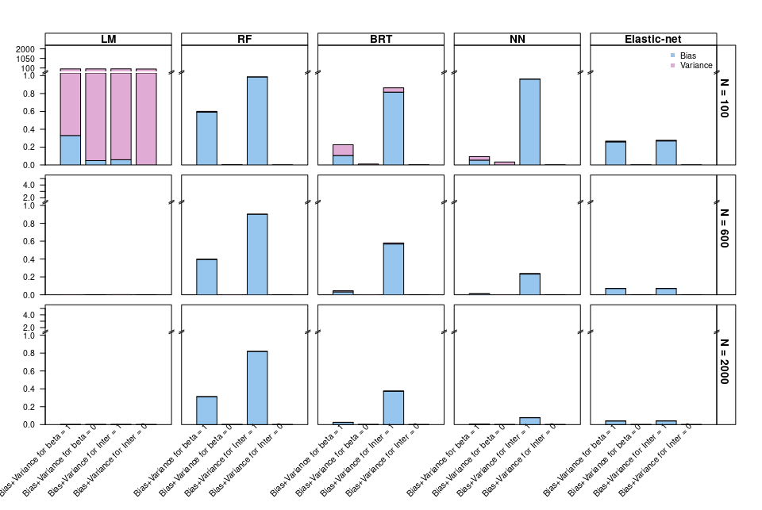

## 4 Weighted MCE

