DynNestSapl_metsim
It reads automatically EMCCD and CAMO all .pickle data that finds and combine EMCCD luminosity and CAMO deceleration if present for the one that share the same time (creates an folders and file called _combined), they are all going to be save in a separate folder for the given event if an output folder is provided, if the output folder is not provided the run will be saved where the pickle files where found. The code will continue for all the solutions if one run does not work it will save the error message in the log_ file and continue to the next. The motto is “RUN IT AND FORGET ABOUT IT" because it is going to take a while to get any results (1 to 2 days with 96 cores and in rare occasion 6 days, either a bright fireball or bad data). It is better to run it on a Linux machine, on Windows it can get stuck. If for some reason the simulations was interrupted the code will continue on with the same .dynesty file without overwriting, you can do that by simply running again the same command make sure to keep the .dynesty in the output folder).
python "WMPG-repoMAX\Code\DynNestSampl\DynNestSapl_metsim.py" "C:\Users\maxiv\Documents\INPUT-FOLDER" --output_dir "C:\Users\maxiv\Desktop\OUTPUT-FOLDER" --prior "C:\Users\maxiv\WMPG-repoMAX\Code\DynNestSampl\stony_meteoroid.prior"
When run you will see a bunch of number going by that sows you the state of the run:
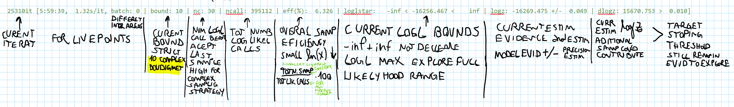
If you want to check at which stage is your result you can generate a plot with what is present in the .dynesty file thus far (doing so it will not overrite or change any of the file in the input folder, except for the log_ file, it will just generate all the images) :
python "WMPG-repoMAX\Code\DynNestSampl\DynNestSapl_metsim.py" "C:\Users\maxiv\Documents\INPUT-FOLDER" -plot
It can also work with MetSim json data if path and file name are in the input directory, it will introduced a set noise as given in the prior file (you can generate a new distribution of noise by running it again). If it has already been introduced before it will generate the same name json file and add _with_noise and you can load that from now on so it will keep the same datapoints.
python "WMPG-repoMAX\Code\DynNestSampl\DynNestSapl_metsim.py" "C:\Users\maxiv\Documents\INPUT-FOLDER\meteor_metsim.json" --output_dir "C:\Users\maxiv\Desktop\OUTPUT-FOLDER" --prior "C:\Users\maxiv\WMPG-repoMAX\Code\DynNestSampl\stony_meteoroid.prior"
You can process specific files or folders by separating them via a ',' comma.
python "WMPG-repoMAX\Code\DynNestSampl\DynNestSapl_metsim.py" "C:\Users\maxiv\Documents\INPUT-FOLDER, C:\Users\maxiv\Documents\INPUT-FOLDER_2" --output_dir "C:\Users\maxiv\Desktop\OUTPUT-FOLDER" --prior "C:\Users\maxiv\WMPG-repoMAX\Code\DynNestSampl\stony_meteoroid.prior"
If you do not specify the ouput folder it will use the folder where it found the pickle file, and if you do not specify the priors it will look for it in the folder where it found the pickle file if it does not find it will use the default value with a single fragmentation
python "WMPG-repoMAX\Code\DynNestSampl\DynNestSapl_metsim.py" "C:\Users\maxiv\Documents\INPUT-FOLDER"
if you want to change the prior you can do so by editing the .prior file, anything after a # is not going to be read by the code:
# Each line represents a (min, max) tuple
# you can input expression and numpy functions (e.g. np.pi)
# without options it consider by default a uniform distribution with min and max value
# options:
# - nan : set it to default values or estimate the most likely for v_init,zenith_angle,m_init,erosion_height_start (default norm sigma only for v_init 500 and zenith_angle 0.01)
# - norm : considers instead of uniform distribution a normal distribution and substitutes min and max with mean and sigma, good for velocity or zenith angle
# - invgamma: considers instead of uniform distribution a inverse gamma distribution that peak around the mode and have a long trail so it substitutes min and max with alpha and mode, good for noise uncertanty
# - log : cosider the log10 of the range given consider it for priors that extend for multiple order of magnitude (if 0.0 is set to 1e-12)
# - fix : fix the value to the first value given so it is not estimated by dynesty, the assumend noise in lag (noise_lag) for EMCCD is 40 m and CAMO is 5 m while for both in luminosity (noise_lum) is 2.5 J/s
# what is writen after '#' is ignored
# name var, min/sigma/alpha, max/mean/mode, options

v_init,500,nan,norm # v_init [m/s] (gausian distribution)
zenith_angle,nan,fix # zenith_angle [rad] (fix by default)
m_init,nan,nan # m_init [kg]
rho,10,4000,log # rho [kg/m^3] (np.log10 applied)
sigma,0.001/1e6,0.05/1e6 # sigma [kg/J]
erosion_height_start,nan,nan # erosion_height_start [m]
erosion_coeff,0.0,1e-6,log # erosion_coeff [kg/J] (np.log10 applied)
erosion_mass_index,1,3 # erosion_mass_index [-]
erosion_mass_min,5e-12,1e-9,log # erosion_mass_min [kg] (np.log10 applied)
erosion_mass_max,1e-10,1e-7,log # erosion_mass_max [kg] (np.log10 applied)
erosion_height_change,nan,nan # erosion_height_change [m]
erosion_rho_change,10,4000,log # erosion_rho_change [kg/m^3] (np.log10 applied)
erosion_sigma_change,0.001/1e6,0.05/1e6 # erosion_sigma_change [kg/J]
erosion_coeff_change,0.0,1e-6,log # erosion_coeff_change [kg/J] (np.log10 applied)
noise_lag,10,nan,invgamma # noise_lag [m] (inverse gamma distribution)
noise_lum,5,nan,invgamma # noise_lum [J/s] (inverse gamma distribution)

If you do not want a double fragmentation you can simply delete that from the prior file and add the second fragmentation altitude in the code will be put at 1 km (i.e. inactive)
If you want to fix the noise delete the noise from the list and it will be considered fix (better not though)
If your camera in the pickle file is not an EMCCD or a CAMO widefield or narrow field, you can specify the zero magnitude power (P_0m) an the fps of it by fixing it in the prior file.
P_0m,840,fix
fps,20,fix
At the beginning it will create an output folder where it will copy the input pickle file, the prior file and the .txt report form the trajectory solution used to defined the specific meteor shower. Right after it will generate a log_ file will be generated with the range of priors that the code will work with (i.e. log_20191023_084916_combined.txt) and will generate an initial image to show how the data look like. This will be later populated again with the rest of the results or in case it crashed it will write the error message without breaking the code.

Advance
If you more flexibility to your simulations you can add more variables to tune with the .extraprior file, they contain dust release, more erosion heights and specific change on the main fragment characteristics. These parameters are especially important for fireballs. Consider that above 30 variables to tune dynesty will have an hard time finding a good solution so do not put to many in!
python "WMPG-repoMAX\Code\DynNestSampl\DynNestSapl_metsim.py" "C:\Users\maxiv\Documents\INPUT-FOLDER,WMPG-repoMAX\Code\DynNestSampl\DynNestSapl_metsim.py" "C:\Users\maxiv\Documents\INPUT-FOLDER" --output_dir "C:\Users\maxiv\Desktop\OUTPUT-FOLDER" --prior "C:\Users\maxiv\WMPG-repoMAX\Code\DynNestSampl\ stony_meteoroid_2frag.prior" --extraprior "C:\Users\maxiv\WMPG-repoMAX\Code\DynNestSampl\ metsim_fragmentation.extraprior"
If need be you can run a new simulations in the same output folder by mentioning -new so it will not mix things up if you have two dynasty file in the same folder but if there are two dynasty file and you want to continue a simulation it will pick the first one (strongly recommend to use two separate folder for each)
python "WMPG-repoMAX\Code\DynNestSampl\DynNestSapl_metsim.py" "C:\Users\maxiv\Documents\INPUT-FOLDER,WMPG-repoMAX\Code\DynNestSampl\DynNestSapl_metsim.py" "C:\Users\maxiv\Documents\INPUT-FOLDER" --output_dir "C:\Users\maxiv\Desktop\OUTPUT-FOLDER" --prior "C:\Users\maxiv\WMPG-repoMAX\Code\DynNestSampl\ stony_meteoroid_2frag.prior" -new
If you want to use all the data available you can do so by adding -all but make sure the magnitude are overlapping and the declaration are all computed from the same pickle file or different reference lag will be on top of each other (i.e. run wmpl.Formats.ECSV.py with all the .ecsv files so that you have a .pickle file with the solution with all the camera data combined correctly).
python "WMPG-repoMAX\Code\DynNestSampl\DynNestSapl_metsim.py" "C:\Users\maxiv\Documents\INPUT-FOLDER,WMPG-repoMAX\Code\DynNestSampl\DynNestSapl_metsim.py" "C:\Users\maxiv\Documents\INPUT-FOLDER" --output_dir "C:\Users\maxiv\Desktop\OUTPUT-FOLDER" --prior "C:\Users\maxiv\WMPG-repoMAX\Code\DynNestSampl\ stony_meteoroid_2frag.prior" -all
If you did not pick the leading edge you can correct that by defining were you pick. For pick position in the meteor frame ranging from 0 to 1, for leading edge picks is 0 for the centroid on the entire meteor is 0.5 (centroid picks are mainly valid for fireball data) :
python "WMPG-repoMAX\Code\DynNestSampl\DynNestSapl_metsim.py" "C:\Users\maxiv\Documents\INPUT-FOLDER,WMPG-repoMAX\Code\DynNestSampl\DynNestSapl_metsim.py" "C:\Users\maxiv\Documents\INPUT-FOLDER" --output_dir "C:\Users\maxiv\Desktop\OUTPUT-FOLDER" --prior "C:\Users\maxiv\WMPG-repoMAX\Code\DynNestSampl\ stony_meteoroid_2frag.prior" --pick_pos 0.5
You can specify the number of cores that the code will use by mentioning the precise number if not specify it is going to use all of them (maybe useful if you still wanna open 200 tabs on your browser while waiting for the run to finish):
python "WMPG-repoMAX\Code\DynNestSampl\DynNestSapl_metsim.py" "C:\Users\maxiv\Documents\INPUT-FOLDER,WMPG-repoMAX\Code\DynNestSampl\DynNestSapl_metsim.py" "C:\Users\maxiv\Documents\INPUT-FOLDER" --output_dir "C:\Users\maxiv\Desktop\OUTPUT-FOLDER" --prior "C:\Users\maxiv\WMPG-repoMAX\Code\DynNestSampl\ stony_meteoroid_2frag.prior" –-cores 7
You can specify not to create the backup file, the backup file contains more information specific to the simulations like the mass ls at the second fragmentiont event the meadian rh if you use a erosion change other than the samples and weights. The Backup takes a bit to run so it you avoid running it will save you 10-20 min or so, useful if you wants to replot something :
python "WMPG-repoMAX\Code\DynNestSampl\DynNestSapl_metsim.py" "C:\Users\maxiv\Documents\INPUT-FOLDER,WMPG-repoMAX\Code\DynNestSampl\DynNestSapl_metsim.py" "C:\Users\maxiv\Documents\INPUT-FOLDER" --output_dir "C:\Users\maxiv\Desktop\OUTPUT-FOLDER" --prior "C:\Users\maxiv\WMPG-repoMAX\Code\DynNestSampl\ stony_meteoroid_2frag.prior" -NoBackup

Run your first DynNestSapl_metsim
To test if the code works check you can try with this test folder:
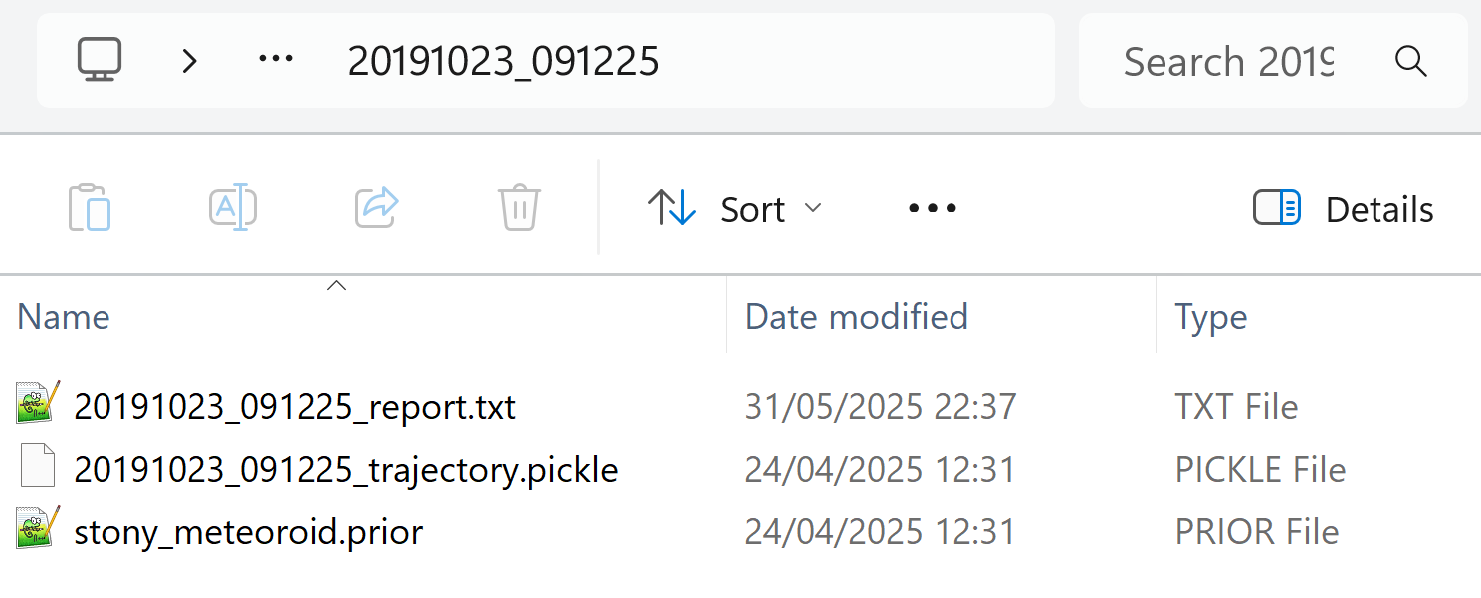
If you want to test if the code loads it correctly try running -plot, it will show you what data is loaded. The image LumLag_pot will show what is the image loaded, the log file for now will have all the file loaded and the prior range with their values, the obs_data is a file that shows the input file generated (only used to check the data is correctly loaded). If you run it in the _results folder (where there is a .dynesty file) it will generate more results. If you put in the same directory .json file from the .GUI, it will generate the plots considering the luminosity integration and the initial velocity as for the lag (what used in the code).
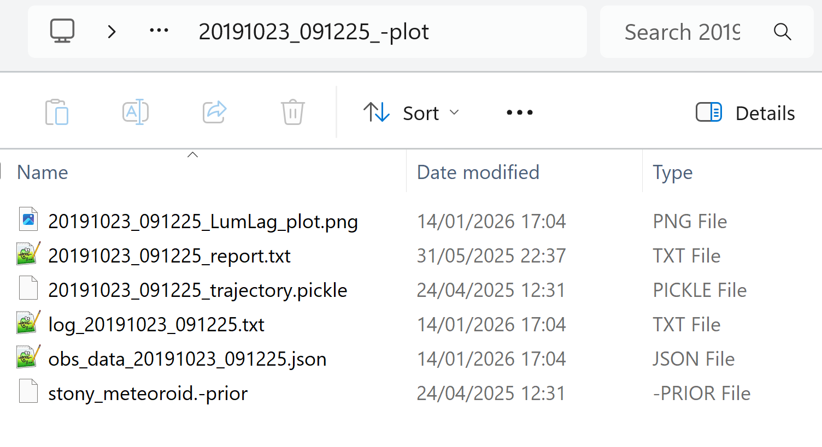
If you run now the normal command in the folder 20191023_091225, i.e. python "WMPG-repoMAX\Code\DynNestSampl\DynNestSapl_metsim.py" "your_path/20191023_091225” (please do it on a Linux machine, it can get stuck on Windows), the results will take quite some time but they should look like something like what is shown in 20191023_091225_results.
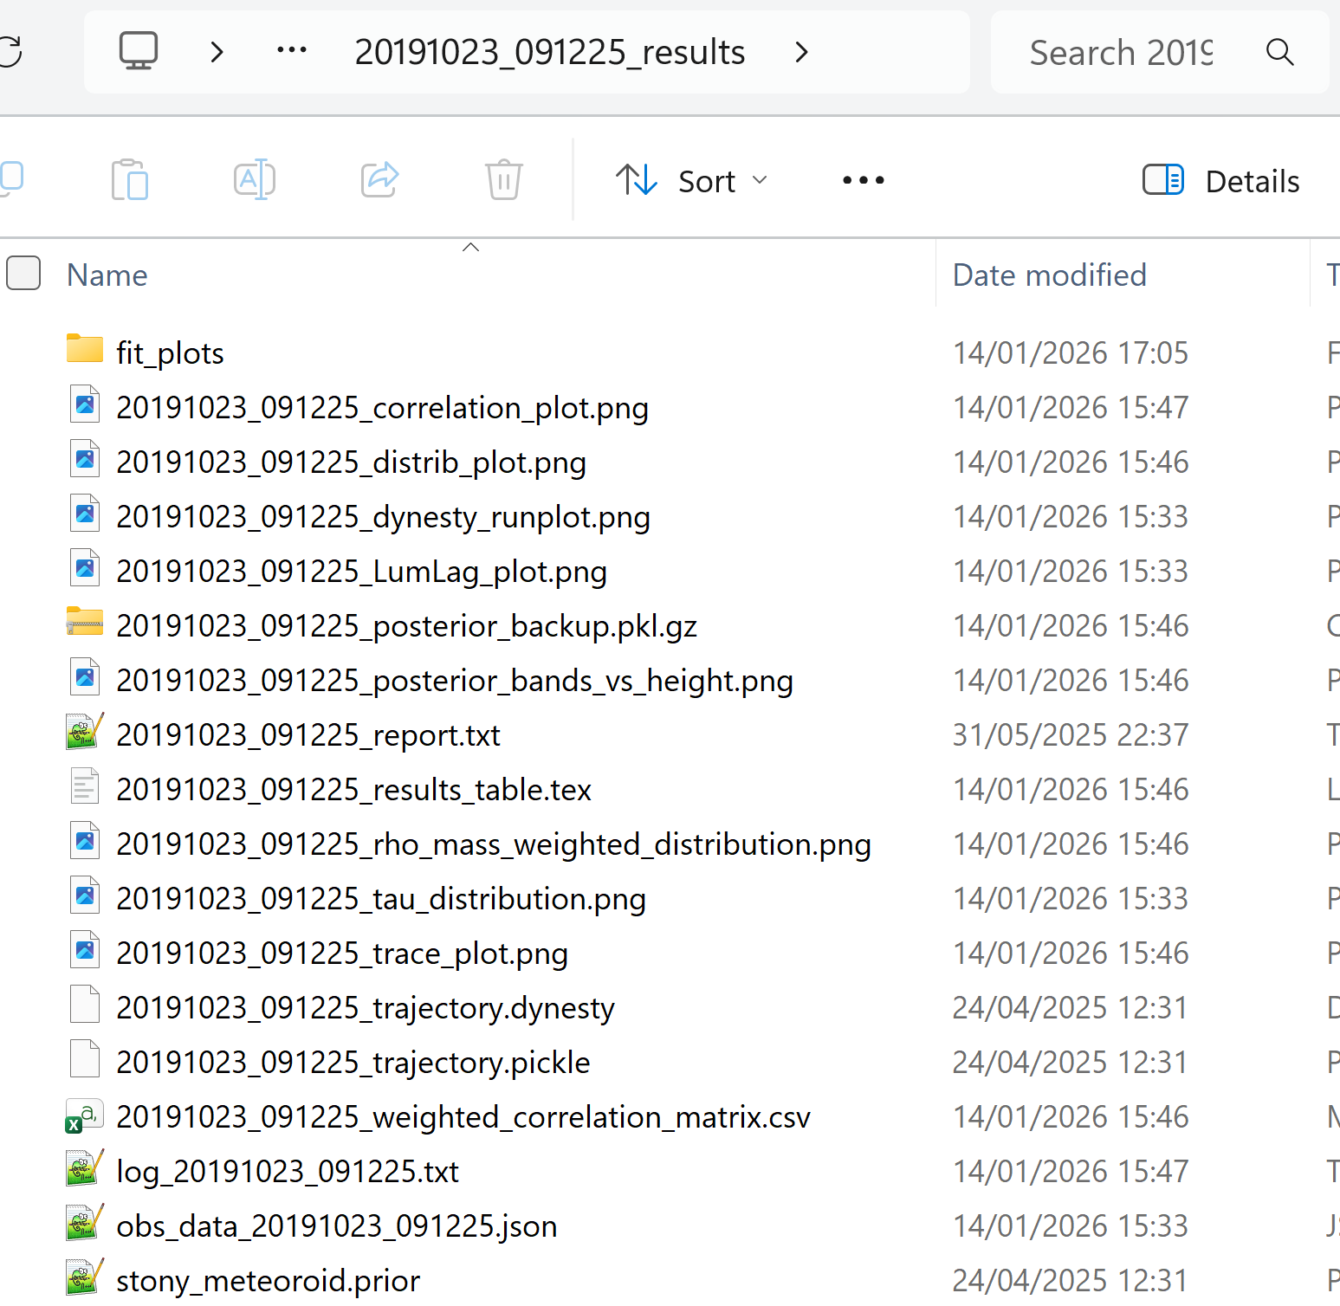
Most of the plots are self-explanatory or explain by dynesty documentation. The posterior bands plots show the range where most of the solutions are, the rho_mass_weighted is only useful when you have multiple fragmentation with different rho as it shows the mass weighted value of rho, the tau_distribution inverts from the photometric mass found in the posterior the tau value useful incase you o not have a fix tau and you do not have a value for it.
log_ : file shows the prior range, how to interpret the “Summary” is describe in dynasty documentation, the tau value base on the mass in order to inverted from the photometric mass formula tau = 2 E_rad / (m_init v0^2), the approx. and real weighted rho are important if you have 2 rho because of the erosion height change, while the best fit section shows the noise its values and the logl and how much it take to run the code
fit_plots: All the image in the fit_plot folder show how the best fit mode etc… while the .json are readable by the .GUI and are solution from the results. Remember that respect to the GUI the result have different reference point for the lag as they consider the initial median velocity and not the first point of lag like in the GUI, while consider that the fit on luminosity is done on the integrated light curve so there might be mismatch especially for fast meteors.
posterior_backup.pkl.gz: is storing all the other information from all the simulated events other than the samples values and weight there is also the best guess values and all the bands shown in posterior_bands plot, the data in const_backups also contains data the erosion begin mass the dynamic pressure at the erosion and other parameters that are save in each .json simulations by default

posterior_backup.pkl.gz
Here is the data and how is stored:
# save the backup_data to a json file
backup_small = {
"dynesty": {
"file_name": file_name,
"samples_eq": backup_data["samples_eq"].tolist(),
"weights": backup_data["weights"].tolist(),
"variables": variables,
"flags_dict": flags_dict,
"fixed_values": fixed_values,
"const_backups": backup_data["const_backups"],
"rho_array": backup_data["rho_array"],
"rho_mass_weighted_estimate": {k: float(v) for k, v in backup_data["rho_mass_weighted_estimate"].items()}
},

"best_guess": {
k: np.asarray(v, dtype=np.float32)
for k, v in backup_data["best_guess"].items()
},

"bands": {
k: {q: v.astype(np.float32) for q, v in backup_data["bands"][k].items()}
for k in ("lum", "mag", "vel", "lag")
},
}

Here that is saved in the const_backups for each simulated case:
const_backup = {
"rho_mass_weighted": rho_mass_weighted,
"rho_volume_weighted": rho_volume_weighted,
"erosion_beg_vel": const_saved.erosion_beg_vel if hasattr(const_saved, 'erosion_beg_vel') else None,
"erosion_beg_mas": const_saved.erosion_beg_mas if hasattr(const_saved, 'erosion_beg_mas') else None,
"erosion_beg_dyn_press": const_saved.erosion_beg_dyn_press if hasattr(const_saved, 'erosion_beg_dyn_press') else None,
"mass_at_erosion_change": const_saved.mass_at_erosion_change if hasattr(const_saved, 'mass_at_erosion_change') else None,
"dyn_press_at_erosion_change": erosion_dyn_press_change,
"energy_per_cs_before_erosion": const_saved.energy_per_cs_before_erosion if hasattr(const_saved, 'energy_per_cs_before_erosion') else None,
"energy_per_mass_before_erosion": const_saved.energy_per_mass_before_erosion if hasattr(const_saved, 'energy_per_mass_before_erosion') else None,
"main_mass_exhaustion_ht": const_saved.main_mass_exhaustion_ht if hasattr(const_saved, 'main_mass_exhaustion_ht') else None,
"main_bottom_ht": const_saved.main_bottom_ht if hasattr(const_saved, 'main_bottom_ht') else None
}

You can simply an accessing the data by opening by doing just this:
if name.endswith("_posterior_backup.pkl.gz"):
backup_file = name
print(f"Using backup file: {backup_file}")
with gzip.open(os.path.join(output_dir, backup_file), "rb") as f:
backup_small = pickle.load(f)
break

For instance here is how to access the real density:
x_valid_rho = backup_small['dynesty']['rho_array']
rho, rho_lo, rho_hi = backup_small['dynesty']['rho_mass_weighted_estimate']['median'], backup_small['dynesty']['rho_mass_weighted_estimate']['low95'], backup_small['dynesty']['rho_mass_weighted_estimate']['high95']
I am sorry if you have to go in and edit my spaghetti code… (sorry, I am Italian and I like spaghetti)

