Changing Screen Name

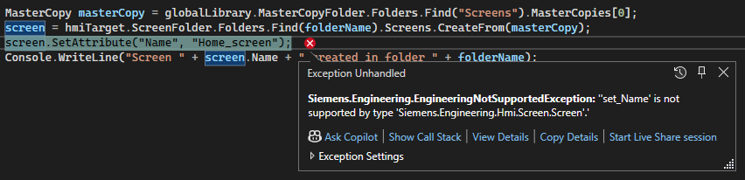It’s not possible to change the “Name” property of a screen, it is read only.

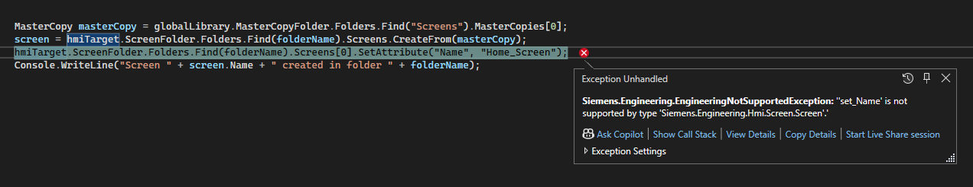

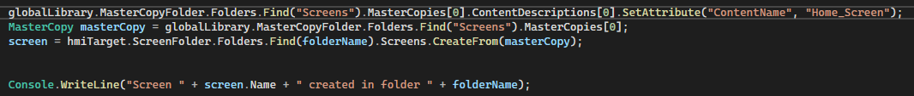Aswell as the “ContentName” attribute of a MasterCopy.



Getting HMI Software

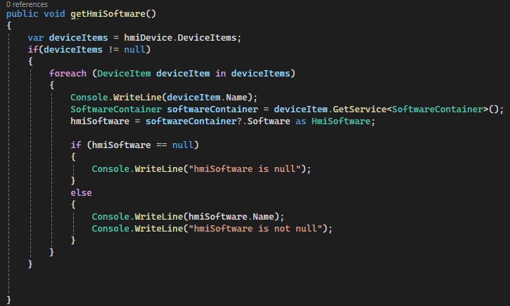Code similar to the one in the manual to get HMI Software. Result:

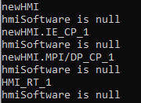

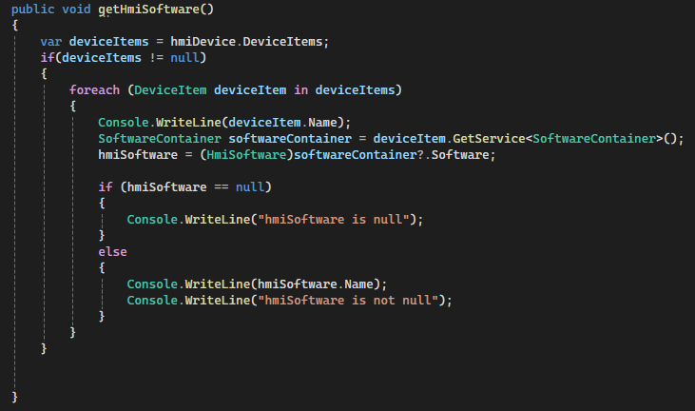Another Code:

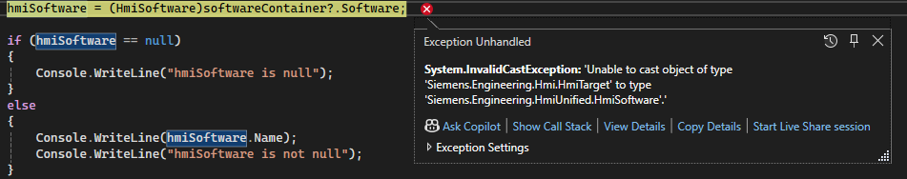Result:

Faceplates

Can’t Find a Method to work with faceplates directly. Need to use a number of existing Faceplates in a library but there is no method like “CreateFrom()” like in Function-Blocks, UDT’s, Screens etc. or a way to import a number of faceplates to one screen.