**Toast or be toasted**

Android application

This game is intended for everyone over the age of 10

This game is rated ​ **‘E’’**

DevTeam:Dylan,Dean,Alex

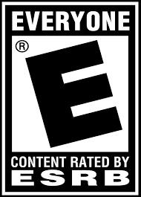

Side Scroller

# Game story summary

A sidescroller controlled using swipes up and down while moving in a 2D enviornment. Play as a sentient piece of toast on a kitchen top trying to avoid all obstacles and enemies that can harm you. The player controls the toast by moving up and down to the different lanes that's the level is comprised of as the toast moves on its on horizontally across the table.

# Unique selling points

* ” Find out what side your toast is buttered on”
* “Navigate the most dangerous place in the house...the Kitchen”
* “Avoid scathing hot Jalepenos, Bully Burritos, Peckish Pizza”
* “Be the best toast you can be!”

# Competitive products

Temple run’s style of gameplay is very similar to the inspiration of this game, while the perspective and graphical style is similar to the style of the NES classic Excitebike.