Process to recover a password on Cisco router.

To recover or reset the enable password on the Cisco 1900 series router, complete the following steps:
- Establish a terminal connection with the Ctrl + BREAK
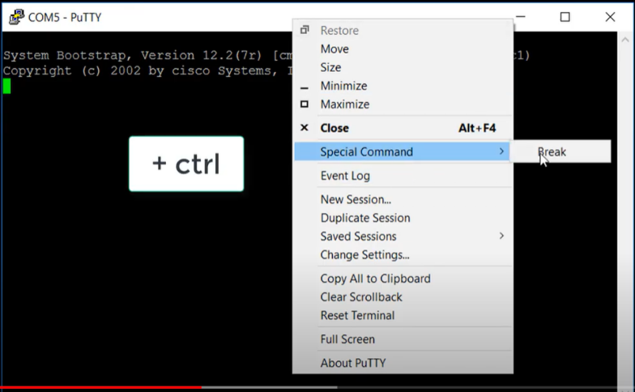
2. Začnš bootovat a vypíše se prompt.
3. Type confreg 0x2142 at the rommon prompt.
4. Type reset at the next rommon prompt.
5. Type no at the initial configuration dialog.
6. Type at the router prompt.
7. Type copy startup-config running-config to load the startup configuration.
8. Type configure terminal.
9. Record an unencrypted enable password. Reset an encrypted enable password.
10. In configuration mode, type config-register 0x2102.
11. In privilege mode, type copy running-config startup-config to save configuration.
12. Use the show version command to verity configuration register settings.

