Приклад простого проєкта
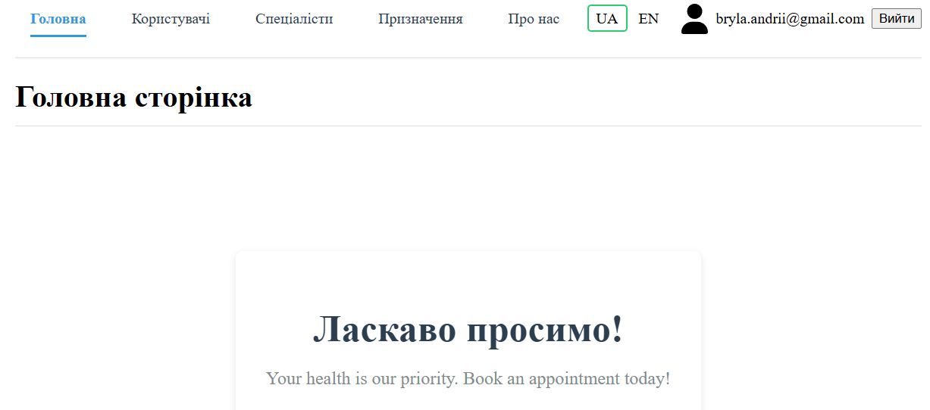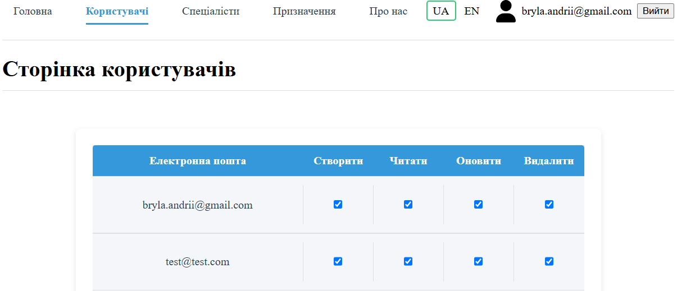
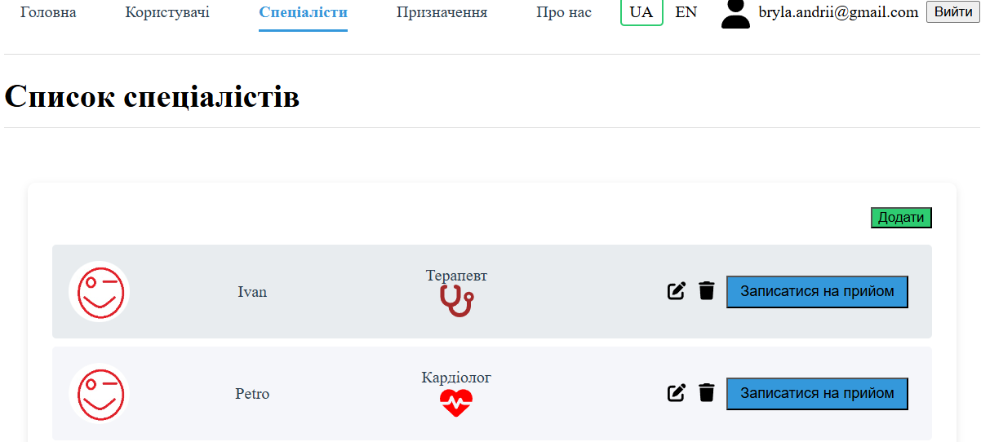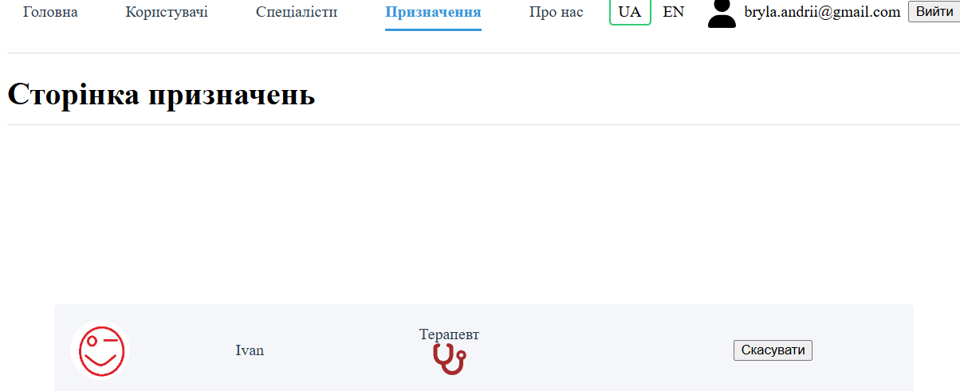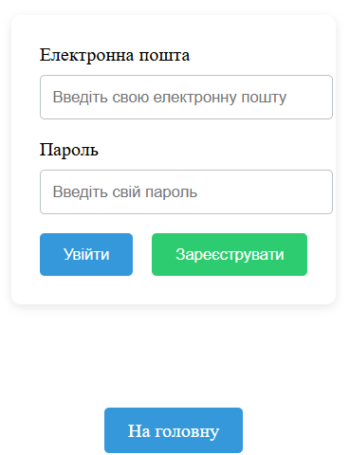

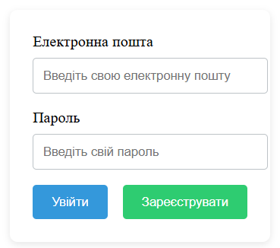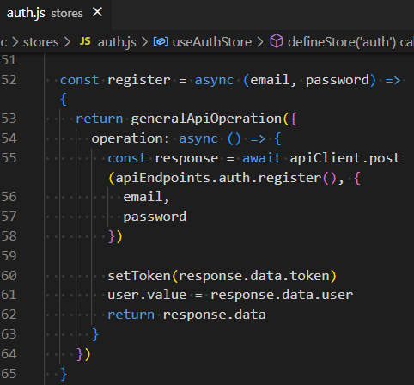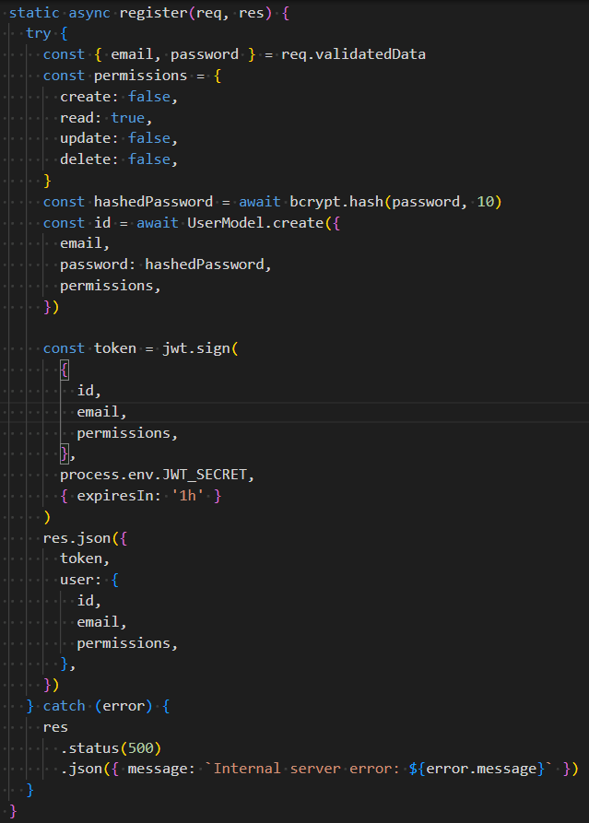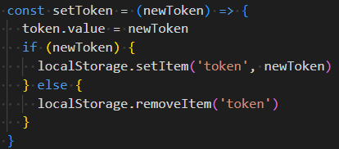
FRONT
BACK
Формується токен і надсилається на фронтенд
Отриманий токен зберіраємо для подальшого використання (буде додаватись у подальшні запити для індетифікації користувача)
РеєстраціяRONT
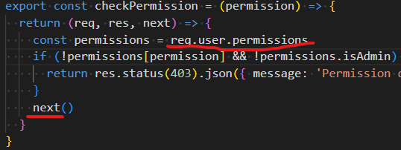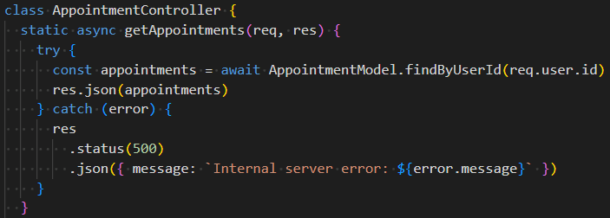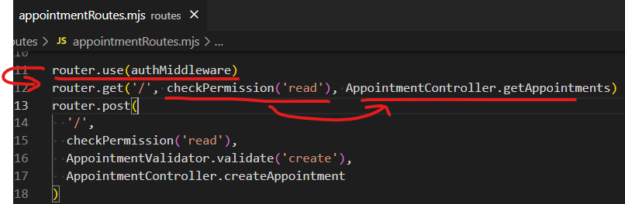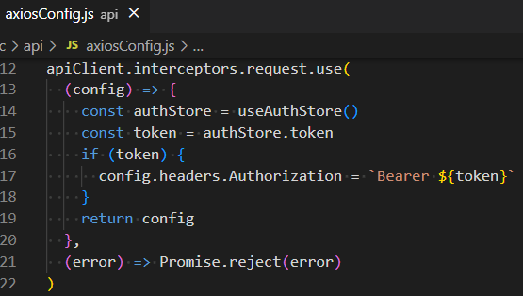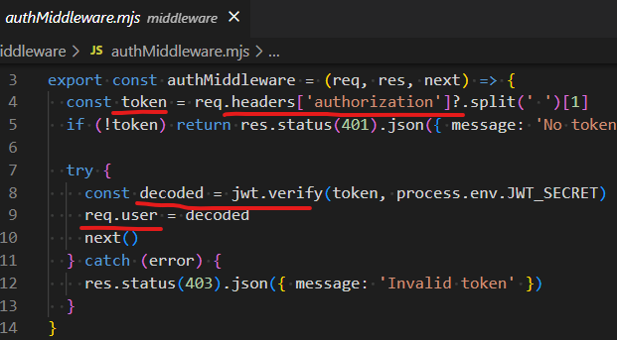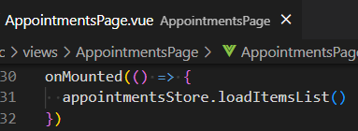
Запит з токеном
BACK
FRONT
У запит додається токен

Бекенд частина

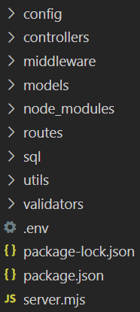

Скрипт для створення таблиць бази даних  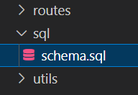 | =======================================  CREATE DATABASE healthcare_db;  USE healthcare_db;  CREATE TABLE users (  id INT AUTO_INCREMENT PRIMARY KEY,  email VARCHAR(255) UNIQUE NOT NULL,  password VARCHAR(255) NOT NULL,  permissions JSON NOT NULL,  created_at TIMESTAMP DEFAULT CURRENT_TIMESTAMP,  updated_at TIMESTAMP DEFAULT CURRENT_TIMESTAMP ON UPDATE CURRENT_TIMESTAMP  );  CREATE TABLE specialists (  id INT AUTO_INCREMENT PRIMARY KEY,  title VARCHAR(255) NOT NULL,  img TEXT, -- Змінено на TEXT для зберігання Base64  category VARCHAR(50) NOT NULL,  rating FLOAT,  created_at TIMESTAMP DEFAULT CURRENT_TIMESTAMP,  updated_at TIMESTAMP DEFAULT CURRENT_TIMESTAMP ON UPDATE CURRENT_TIMESTAMP  );  CREATE TABLE appointments (  id INT AUTO_INCREMENT PRIMARY KEY,  user_id INT NOT NULL,  specialist_id INT NOT NULL,  created_at TIMESTAMP DEFAULT CURRENT_TIMESTAMP,  FOREIGN KEY (user_id) REFERENCES users(id) ON DELETE CASCADE,  FOREIGN KEY (specialist_id) REFERENCES specialists(id) ON DELETE CASCADE  );
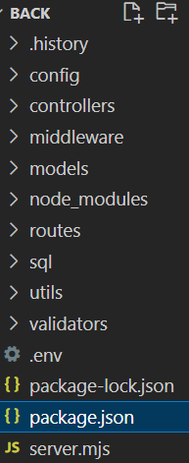 | {  "name": "backend",  "version": "1.0.0",  "main": "server.mjs",  "type": "module",  "scripts": {  "start": "node server.mjs",  "dev": "nodemon server.mjs"  },  "dependencies": {  "bcryptjs": "^2.4.3",  "cors": "^2.8.5",  "dotenv": "^16.0.3",  "express": "^4.18.2",  "helmet": "^7.0.0",  "joi": "^17.13.1",  "jsonwebtoken": "^9.0.0",  "mysql2": "^3.6.0"  },  "devDependencies": {  "nodemon": "^3.0.1"  }  }
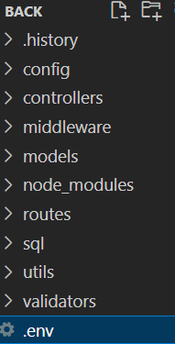 | DB_HOST='127.0.0.1'  DB_USER=root  DB_PASSWORD=''  DB_NAME='healthcare_db'  JWT_SECRET=your_jwt_secret  PORT=5000
Налаштування модуля mysql2  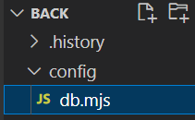 | import mysql from 'mysql2/promise'  import 'dotenv/config'  const pool = mysql.createPool({  host: process.env.DB_HOST,  user: process.env.DB_USER,  password: process.env.DB_PASSWORD,  database: process.env.DB_NAME,  waitForConnections: true,  connectionLimit: 10,  queueLimit: 0,  })  export default pool
Моделі даних
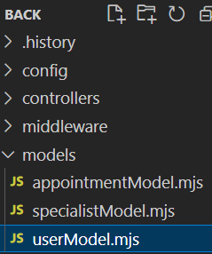 | import db from '../config/db.mjs'  class UserModel {  static async create({ email, password }) {  try {  const [result] = await db.query(  'INSERT INTO users (email, password, permissions) VALUES (?, ?, ?)',  [  email,  password,  JSON.stringify({  create: false,  read: true,  update: false,  delete: false,  isAdmin: false,  }),  ]  )  return result.insertId  } catch (error) {  throw new Error(`Failed to create user: ${error.message}`)  }  }  static async findByEmail(email) {  try {  const [rows] = await db.query('SELECT * FROM users WHERE email = ?', [  email,  ])  return rows[0]  } catch (error) {  throw new Error(`Failed to find user by email: ${error.message}`)  }  }  static async findById(id) {  try {  const [rows] = await db.query('SELECT * FROM users WHERE id = ?', [id])  return rows[0]  } catch (error) {  throw new Error(`Failed to find user by ID: ${error.message}`)  }  }  static async update(id, data) {  try {  const [result] = await db.query('UPDATE users SET ? WHERE id = ?', [  data,  id,  ])  if (result.affectedRows === 0) throw new Error('User not found')  return true  } catch (error) {  throw new Error(`Failed to update user: ${error.message}`)  }  }  static async delete(id) {  try {  const [result] = await db.query('DELETE FROM users WHERE id = ?', [id])  if (result.affectedRows === 0) throw new Error('User not found')  return true  } catch (error) {  throw new Error(`Failed to delete user: ${error.message}`)  }  }  static async getAll() {  try {  const [rows] = await db.query('SELECT * FROM users')  return rows  } catch (error) {  throw new Error(`Failed to fetch users: ${error.message}`)  }  }  }  export default UserModel
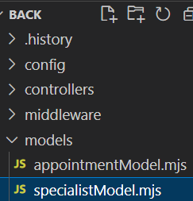 | import db from '../config/db.mjs'  class SpecialistModel {  static async create({ title, img, category, rating }) {  try {  const [result] = await db.query(  'INSERT INTO specialists (title, img, category, rating) VALUES (?, ?, ?, ?)',  [title, img, category, rating || null]  )  return result.insertId  } catch (error) {  throw new Error(`Failed to create specialist: ${error.message}`)  }  }  static async findById(id) {  try {  const [rows] = await db.query('SELECT * FROM specialists WHERE id = ?', [  id,  ])  if (!rows[0]) throw new Error('Specialist not found')  return rows[0]  } catch (error) {  throw new Error(`Failed to find specialist by ID: ${error.message}`)  }  }  static async getAll() {  try {  const [rows] = await db.query('SELECT * FROM specialists')  return rows  } catch (error) {  throw new Error(`Failed to fetch specialists: ${error.message}`)  }  }  static async update(id, data) {  try {  const [result] = await db.query('UPDATE specialists SET ? WHERE id = ?', [  data,  id,  ])  if (result.affectedRows === 0) throw new Error('Specialist not found')  return true  } catch (error) {  throw new Error(`Failed to update specialist: ${error.message}`)  }  }  static async delete(id) {  try {  const [result] = await db.query('DELETE FROM specialists WHERE id = ?', [  id,  ])  if (result.affectedRows === 0) throw new Error('Specialist not found')  return true  } catch (error) {  throw new Error(`Failed to delete specialist: ${error.message}`)  }  }  }  export default SpecialistModel
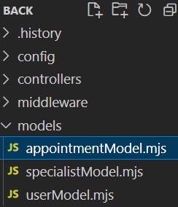 | import db from '../config/db.mjs'  class AppointmentModel {  static async create({ userId, specialistId }) {  try {  const [result] = await db.query(  'INSERT INTO appointments (user_id, specialist_id) VALUES (?, ?)',  [userId, specialistId]  )  return result.insertId  } catch (error) {  throw new Error(`Failed to create appointment: ${error.message}`)  }  }  static async findByUserId(userId) {  try {  const [rows] = await db.query(  `SELECT  appointments.id,  specialists.id as specialists_id,  specialists.title,  specialists.category,  specialists.img,  specialists.rating  FROM appointments  LEFT JOIN specialists ON appointments.specialist_id = specialists.id  WHERE appointments.user_id = ?  `,  [userId]  )  return rows  } catch (error) {  throw new Error(`Failed to fetch appointments: ${error.message}`)  }  }  static async delete(userId, appointmentId) {  try {  const [result] = await db.query(  'DELETE FROM appointments WHERE user_id = ? AND id = ?',  [userId, appointmentId]  )  if (result.affectedRows === 0) throw new Error('Appointment not found')  return true  } catch (error) {  throw new Error(`Failed to delete appointment: ${error.message}`)  }  }  }  export default AppointmentModel
Контролери
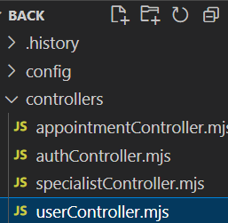 | import bcrypt from 'bcryptjs'  import UserModel from '../models/userModel.mjs'  class UserController {  static async getUsers(req, res) {  try {  const users = await UserModel.getAll()  res.json(  users.map((user) => ({  ...user,  permissions: JSON.parse(user.permissions),  }))  )  } catch (error) {  res  .status(500)  .json({ message: `Internal server error: ${error.message}` })  }  }  static async getUserById(req, res) {  try {  const user = await UserModel.findById(req.params.id)  if (!user) return res.status(404).json({ message: 'User not found' })  res.json({ ...user, permissions: JSON.parse(user.permissions) })  } catch (error) {  res  .status(500)  .json({ message: `Internal server error: ${error.message}` })  }  }  static async createUser(req, res) {  try {  const data = req.validatedData  console.log(data)  if (data.password) data.password = await bcrypt.hash(data.password, 10)  await UserModel.create(data)  res.json({ message: 'User updated' })  } catch (error) {  res  .status(500)  .json({ message: `Internal server error: ${error.message}` })  }  }  static async updateUser(req, res) {  try {  const data = req.validatedData  if (data.permissions) data.permissions = JSON.stringify(data.permissions)  if (data.password) data.password = await bcrypt.hash(data.password, 10)  await UserModel.update(req.params.id, data)  res.json({ message: 'User updated' })  } catch (error) {  res  .status(500)  .json({ message: `Internal server error: ${error.message}` })  }  }  static async deleteUser(req, res) {  try {  await UserModel.delete(req.params.id)  res.json({ message: 'User deleted' })  } catch (error) {  res  .status(500)  .json({ message: `Internal server error: ${error.message}` })  }  }  }  export default UserController
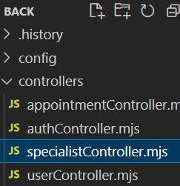 | import SpecialistModel from '../models/specialistModel.mjs'  class SpecialistController {  static async getSpecialists(req, res) {  try {  const specialists = await SpecialistModel.getAll()  res.json(specialists)  } catch (error) {  res  .status(500)  .json({ message: `Internal server error: ${error.message}` })  }  }  static async getSpecialistById(req, res) {  try {  const specialist = await SpecialistModel.findById(req.params.id)  res.json(specialist)  } catch (error) {  res  .status(500)  .json({ message: `Internal server error: ${error.message}` })  }  }  static async createSpecialist(req, res) {  try {  const data = req.validatedData  const id = await SpecialistModel.create(data)  res.status(201).json({ id, ...data })  } catch (error) {  res  .status(500)  .json({ message: `Internal server error: ${error.message}` })  }  }  static async updateSpecialist(req, res) {  try {  const data = req.validatedData  await SpecialistModel.update(req.params.id, data)  res.json({ message: 'Specialist updated' })  } catch (error) {  res  .status(500)  .json({ message: `Internal server error: ${error.message}` })  }  }  static async deleteSpecialist(req, res) {  try {  await SpecialistModel.delete(req.params.id)  res.json({ message: 'Specialist deleted' })  } catch (error) {  res  .status(500)  .json({ message: `Internal server error: ${error.message}` })  }  }  }  export default SpecialistController
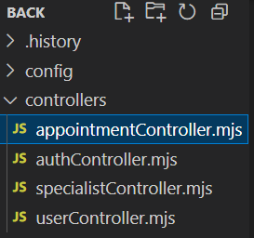 | import AppointmentModel from '../models/appointmentModel.mjs'  import SpecialistModel from '../models/specialistModel.mjs'  class AppointmentController {  static async getAppointments(req, res) {  try {  const appointments = await AppointmentModel.findByUserId(req.user.id)  res.json(appointments)  } catch (error) {  res  .status(500)  .json({ message: `Internal server error: ${error.message}` })  }  }  static async createAppointment(req, res) {  try {  const { specialistId } = req.validatedData  const id = await AppointmentModel.create({  userId: req.user.id,  specialistId,  })  res.status(201).json({ id, userId: req.user.id, specialistId })  } catch (error) {  res  .status(500)  .json({ message: `Internal server error: ${error.message}` })  }  }  static async deleteAppointment(req, res) {  try {  await AppointmentModel.delete(req.user.id, req.params.appointmentId)  res.json({ message: 'Appointment deleted' })  } catch (error) {  res  .status(500)  .json({ message: `Internal server error: ${error.message}` })  }  }  }  export default AppointmentController
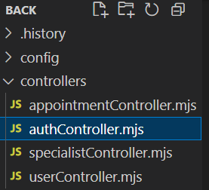 | import bcrypt from 'bcryptjs'  import jwt from 'jsonwebtoken'  import UserModel from '../models/userModel.mjs'  class AuthController {  static async login(req, res) {  try {  const { email, password } = req.validatedData  const user = await UserModel.findByEmail(email)  if (!user || !(await bcrypt.compare(password, user.password))) {  return res.status(401).json({ message: 'Invalid credentials' })  }  const token = jwt.sign(  {  id: user.id,  email: user.email,  permissions: JSON.parse(user.permissions),  },  process.env.JWT_SECRET,  { expiresIn: '1h' }  )  res.json({  token,  user: {  id: user.id,  email: user.email,  permissions: JSON.parse(user.permissions),  },  })  } catch (error) {  res  .status(500)  .json({ message: `Internal server error: ${error.message}` })  }  }  static async register(req, res) {  try {  const { email, password } = req.validatedData  const permissions = {  create: false,  read: true,  update: false,  delete: false,  }  const hashedPassword = await bcrypt.hash(password, 10)  const id = await UserModel.create({  email,  password: hashedPassword,  permissions,  })  const token = jwt.sign(  {  id,  email,  permissions,  },  process.env.JWT_SECRET,  { expiresIn: '1h' }  )  res.json({  token,  user: {  id,  email,  permissions,  },  })  } catch (error) {  res  .status(500)  .json({ message: `Internal server error: ${error.message}` })  }  }  static async getProfile(req, res) {  try {  const { email } = req.user  const user = await UserModel.findByEmail(email)  if (!user) {  return res.status(401).json({ message: 'Invalid credentials' })  }  const token = jwt.sign(  {  id: user.id,  email: user.email,  permissions: JSON.parse(user.permissions),  },  process.env.JWT_SECRET,  { expiresIn: '1h' }  )  res.json({  token,  user: {  id: user.id,  email: user.email,  permissions: JSON.parse(user.permissions),  },  })  } catch (error) {  res  .status(500)  .json({ message: `Internal server error: ${error.message}` })  }  }  }  export default AuthController
middleware
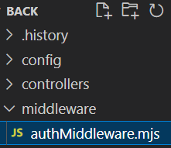 | import jwt from 'jsonwebtoken'  export const authMiddleware = (req, res, next) => {  const token = req.headers['authorization']?.split(' ')[1]  if (!token) return res.status(401).json({ message: 'No token provided' })  try {  const decoded = jwt.verify(token, process.env.JWT_SECRET)  req.user = decoded  next()  } catch (error) {  res.status(403).json({ message: 'Invalid token' })  }  }  export const checkPermission = (permission) => {  return (req, res, next) => {  const permissions = req.user.permissions  if (!permissions[permission] && !permissions.isAdmin) {  return res.status(403).json({ message: 'Permission denied' })  }  next()  }  }
Валідатори
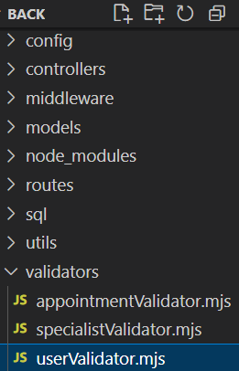 | import Joi from 'joi'  class UserValidator {  static schemas = {  create: Joi.object({  email: Joi.string().email().required().messages({  'string.email': 'Invalid email format',  'any.required': 'Email is required',  }),  password: Joi.string().min(2).required().messages({  'string.min': 'Password must be at least 6 characters',  'any.required': 'Password is required',  }),  }),  update: Joi.object({  email: Joi.string().email().optional(),  password: Joi.string().min(2).optional(),  permissions: Joi.object({  create: Joi.boolean(),  read: Joi.boolean(),  update: Joi.boolean(),  delete: Joi.boolean(),  isAdmin: Joi.boolean(),  }).optional(),  }),  login: Joi.object({  email: Joi.string().email().required().messages({  'string.email': 'Invalid email format',  'any.required': 'Email is required',  }),  password: Joi.string().min(2).required().messages({  'string.min': 'Password must be at least 6 characters',  'any.required': 'Password is required',  }),  }),  }  static validate(schemaName) {  return async (req, res, next) => {  try {  const schema = this.schemas[schemaName]  const { error, value } = schema.validate(req.body, {  abortEarly: false,  })  if (error) {  return res.status(400).json({  message: 'Validation failed',  errors: error.details.map((detail) => detail.message),  })  }  req.validatedData = value  next()  } catch (error) {  res  .status(500)  .json({ message: `Internal validation error: ${error.message}` })  }  }  }  }  export default UserValidator
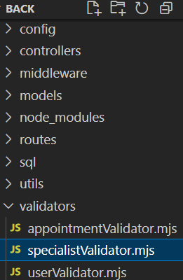 | import Joi from 'joi'  class SpecialistValidator {  static schemas = {  create: Joi.object({  title: Joi.string().required().messages({  'any.required': 'Title is required',  }),  img: Joi.string().optional(),  category: Joi.string().required().messages({  'any.required': 'Category is required',  }),  rating: Joi.number().min(0).max(5).optional(),  }),  update: Joi.object({  title: Joi.string().optional(),  img: Joi.string().optional(),  category: Joi.string().optional(),  rating: Joi.number().min(0).max(5).optional(),  }),  }  static validate(schemaName) {  return async (req, res, next) => {  try {  const schema = this.schemas[schemaName]  const { error, value } = schema.validate(req.body, {  abortEarly: false,  })  if (error) {  return res.status(400).json({  message: 'Validation failed',  errors: error.details.map((detail) => detail.message),  })  }  req.validatedData = value  next()  } catch (error) {  res  .status(500)  .json({ message: `Internal validation error: ${error.message}` })  }  }  }  }  export default SpecialistValidator
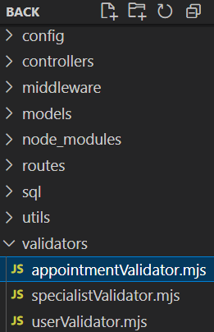 | import Joi from 'joi'  class AppointmentValidator {  static schemas = {  create: Joi.object({  specialistId: Joi.number().integer().required().messages({  'any.required': 'Specialist ID is required',  'number.base': 'Specialist ID must be a number',  }),  }),  }  static validate(schemaName) {  return async (req, res, next) => {  try {  const schema = this.schemas[schemaName]  const { error, value } = schema.validate(req.body, {  abortEarly: false,  })  if (error) {  return res.status(400).json({  message: 'Validation failed',  errors: error.details.map((detail) => detail.message),  })  }  req.validatedData = value  next()  } catch (error) {  res  .status(500)  .json({ message: `Internal validation error: ${error.message}` })  }  }  }  }  export default AppointmentValidator
Роутери
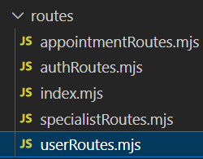 | import express from 'express'  import UserController from '../controllers/userController.mjs'  import UserValidator from '../validators/userValidator.mjs'  import {  authMiddleware,  checkPermission,  } from '../middleware/authMiddleware.mjs'  const router = express.Router()  router.use(authMiddleware)  router.get('/', checkPermission('read'), UserController.getUsers)  router.get('/:id', checkPermission('read'), UserController.getUserById)  router.post(  '/',  UserValidator.validate('create'),  checkPermission('isAdmin'),  UserController.createUser  )  router.put(  '/:id',  checkPermission('isAdmin'),  UserValidator.validate('update'),  UserController.updateUser  )  router.delete('/:id', checkPermission('isAdmin'), UserController.deleteUser)  export default router
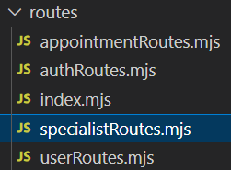 | import express from 'express'  import SpecialistController from '../controllers/specialistController.mjs'  import SpecialistValidator from '../validators/specialistValidator.mjs'  import {  authMiddleware,  checkPermission,  } from '../middleware/authMiddleware.mjs'  const router = express.Router()  router.get('/', SpecialistController.getSpecialists)  router.get('/:id', SpecialistController.getSpecialistById)  router.post(  '/',  authMiddleware,  checkPermission('create'),  SpecialistValidator.validate('create'),  SpecialistController.createSpecialist  )  router.put(  '/:id',  authMiddleware,  checkPermission('update'),  SpecialistValidator.validate('update'),  SpecialistController.updateSpecialist  )  router.delete(  '/:id',  authMiddleware,  checkPermission('delete'),  SpecialistController.deleteSpecialist  )  export default router
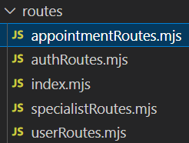 | import express from 'express'  import AppointmentController from '../controllers/appointmentController.mjs'  import AppointmentValidator from '../validators/appointmentValidator.mjs'  import {  authMiddleware,  checkPermission,  } from '../middleware/authMiddleware.mjs'  const router = express.Router()  router.use(authMiddleware)  router.get('/', checkPermission('read'), AppointmentController.getAppointments)  router.post(  '/',  checkPermission('read'),  AppointmentValidator.validate('create'),  AppointmentController.createAppointment  )  router.delete(  '/:appointmentId',  checkPermission('read'),  AppointmentController.deleteAppointment  )  export default router
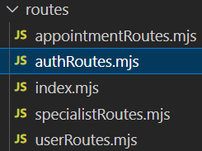 | import express from 'express'  import AuthController from '../controllers/authController.mjs'  import UserValidator from '../validators/userValidator.mjs'  import {  authMiddleware,  checkPermission,  } from '../middleware/authMiddleware.mjs'  const router = express.Router()  router.post('/login', UserValidator.validate('login'), AuthController.login)  router.post(  '/register',  UserValidator.validate('create'),  AuthController.register  )  router.get(  '/profile',  authMiddleware,  checkPermission('read'),  AuthController.getProfile  )  export default router
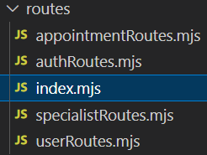 | import express from 'express'  import authRoutes from './authRoutes.mjs'  import userRoutes from './userRoutes.mjs'  import specialistRoutes from './specialistRoutes.mjs'  import appointmentRoutes from './appointmentRoutes.mjs'  const router = express.Router()  // Підключення всіх маршрутів  router.use('/auth', authRoutes)  router.use('/users', userRoutes)  router.use('/specialists', specialistRoutes)  router.use('/appointments', appointmentRoutes)  export default router
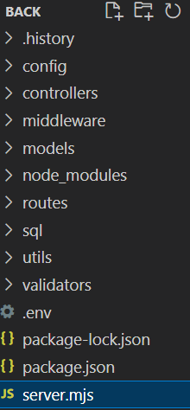 | import express from 'express'  import cors from 'cors'  import helmet from 'helmet'  import apiRoutes from './routes/index.mjs' // Підключаємо лише об'єднаний файл маршрутів  const app = express()  app.use(helmet())  app.use(cors())  app.use(express.json())  // Використовуємо об'єднаний роутер з префіксом /api  app.use('/api', apiRoutes)  app.use((err, req, res, next) => {  console.error(err.stack)  res.status(500).json({ message: `Internal server error: ${err.message}` })  })  const PORT = process.env.PORT || 5000  app.listen(PORT, () => console.log(`Server running on port ${PORT}`))

ФРОНТЕНД ЧАСТИНА
Приклад покрокового створення додатку
Створення додатку
Composition API
Встановлення (is based on Vite)  https://vuejs.org/guide/quick-start.html | npm create vue@latest
 | 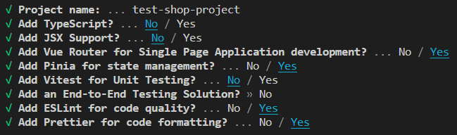
Інтернаціоналізація. Модуль i18n
1. Встановлюємо бібліотеку  https://vue-i18n.intlify.dev/ | npm install vue-i18n@9
Створюємо файли з перекладами | 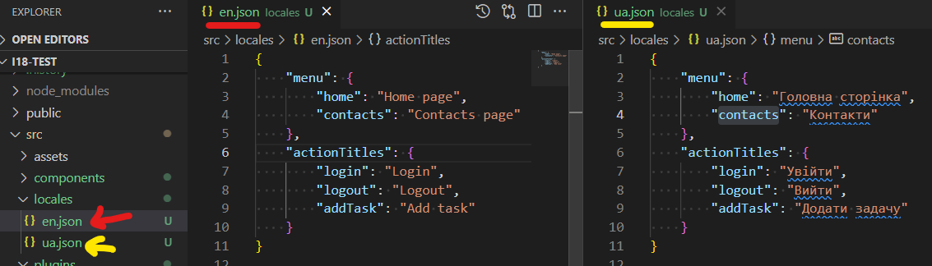
en | {  "buttons": {  "edit": "Edit",  "create": "Create",  "add": "Add",  "save": "Save",  "cancel": "Cancel",  "login": "Login",  "logout": "Logout"  },  "categories": {  "therapist": "Therapist",  "cardiologist": "Cardiologist",  "urologist": "Urologist",  "psychologist": "Psychologist",  "dentist": "Dentist"  },  "pages": {  "home": {  "title": {  "menu": "Home",  "page": "Home page"  },  "messages": {  "welcome": "Welcome!"  }  },  "appointments": {  "title": {  "menu": "Appointments",  "page": "Appointments page"  },  "buttons": {  "edit": "Config"  },  "messages": {  "empty-list": "No visits"  }  },  "specialists": {  "title": {  "menu": "Specialists",  "page": "Specialists list",  "edit": "Edit specialist data",  "create": "Add specialist data"  },  "messages": {  "empty-list": "List is empty"  },  "buttons": {  "make-appointment": "Make an appointment",  "cancel-appointment": "Cancel appointment"  },  "fields": {  "name": {  "label": "Name",  "placeholder": "Input name"  },  "image": {  "label": "Select an image",  "placeholder": "Input title"  },  "category": {  "label": "Category",  "placeholder": "Input category"  },  "rating": {  "label": "Rating"  }  }  },  "specialistsConfig": {  "title": {  "page": "Edit specialist page"  }  },  "login": {  "title": {  "menu": "Login",  "page": "Login page"  },  "buttons": {  "toHome": "Home"  },  "fields": {  "email": {  "label": "Email",  "placeholder": "Input your email"  },  "password": {  "label": "Password",  "placeholder": "Input your password"  },  "phone": {  "label": "Phone",  "placeholder": "Input your phone"  }  }  },  "users": {  "title": {  "menu": "Users",  "page": "Users page"  },  "fields": {  "email": "Email",  "create": "Crteate",  "read": "Read",  "update": "Update",  "delete": "Delete"  }  },  "edit": {  "title": {  "menu": "About",  "page": {  "edit": "Edit product",  "create": "Create a product"  }  },  "fields": {  "title": {  "label": "Title",  "placeholder": "Input title"  },  "image": {  "label": "Select an image",  "placeholder": "Input title"  },  "price": {  "label": "Price",  "placeholder": "Input title"  }  },  "button": {  "edit": "Save",  "create": "Create"  }  },  "about": {  "title": {  "menu": "About",  "page": "About page"  },  "messages": {  "text": "This is an about page"  }  },  "error": {  "title": {  "page": "Error page"  },  "messages": {  "smth_wrong": "Something went wrong!"  }  }  },  "messages": {  "welcome": "Welcome",  "currentLanguage": "Current language"  },  "actionTitles": {  "login": "Login",  "logout": "Logout",  "addTask": "Add task"  }  }
ua | {  "buttons": {  "edit": "Редагувати",  "create": "Створити",  "add": "Додати",  "save": "Зберегти",  "cancel": "Скасувати",  "login": "Увійти",  "logout": "Вийти"  },  "categories": {  "therapist": "Терапевт",  "cardiologist": "Кардіолог",  "urologist": "Уролог",  "psychologist": "Психолог",  "dentist": "Стоматолог"  },  "pages": {  "home": {  "title": {  "menu": "Головна",  "page": "Головна сторінка"  },  "messages": {  "welcome": "Ласкаво просимо!"  }  },  "appointments": {  "title": {  "menu": "Призначення",  "page": "Сторінка призначень"  },  "buttons": {  "edit": "Налаштування"  },  "messages": {  "empty-list": "Немає візитів"  }  },  "specialists": {  "title": {  "menu": "Спеціалісти",  "page": "Список спеціалістів",  "edit": "Редагування даних спеціаліста",  "create": "Додавання нового спеціаліста"  },  "messages": {  "empty-list": "Список порожній"  },  "buttons": {  "make-appointment": "Записатися на прийом",  "cancel-appointment": "Скасувати призначення"  },  "fields": {  "name": {  "label": "Ім'я",  "placeholder": "Введіть ім'я"  },  "image": {  "label": "Виберіть зображення",  "placeholder": "Введіть заголовок"  },  "category": {  "label": "Категорія",  "placeholder": "Введіть категорію"  },  "rating": {  "label": "Рейтинг"  }  }  },  "specialistsConfig": {  "title": {  "page": "Сторінка редагування користувачів"  }  },  "login": {  "title": {  "menu": "Увійти",  "page": "Сторінка входу"  },  "buttons": {  "toHome": "На головну"  },  "fields": {  "email": {  "label": "Електронна пошта",  "placeholder": "Введіть свою електронну пошту"  },  "password": {  "label": "Пароль",  "placeholder": "Введіть свій пароль"  },  "phone": {  "label": "Телефон",  "placeholder": "Введіть свій телефон"  }  }  },  "users": {  "title": {  "menu": "Користувачі",  "page": "Сторінка користувачів"  },  "fields": {  "email": "Електронна пошта",  "create": "Створити",  "read": "Читати",  "update": "Оновити",  "delete": "Видалити"  }  },  "edit": {  "title": {  "menu": "Про нас",  "page": {  "edit": "Редагувати продукт",  "create": "Створити продукт"  }  },  "fields": {  "title": {  "label": "Заголовок",  "placeholder": "Введіть заголовок"  },  "image": {  "label": "Виберіть зображення",  "placeholder": "Введіть заголовок"  },  "price": {  "label": "Ціна",  "placeholder": "Введіть ціну"  }  },  "button": {  "edit": "Зберегти",  "create": "Створити"  }  },  "about": {  "title": {  "menu": "Про нас",  "page": "Сторінка про нас"  },  "messages": {  "text": "Це сторінка про нас"  }  },  "error": {  "title": {  "page": "Сторінка помилки"  },  "messages": {  "smth_wrong": "Щось пішло не так!"  }  }  },  "messages": {  "welcome": "Ласкаво просимо",  "currentLanguage": "Поточна мова"  },  "actionTitles": {  "login": "Увійти",  "logout": "Вийти",  "addTask": "Додати завдання"  }  }
Створюємо папку plugins->i18n.js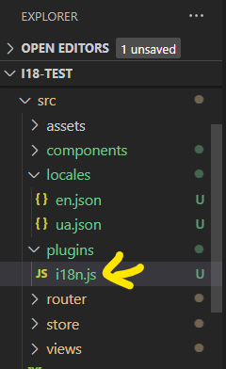  «process» => «import.meta» | import { createI18n } from 'vue-i18n'  import localesEN from '@/locales/en.json'  import localesUA from '@/locales/ua.json'  const i18n = createI18n({  legacy: false, //for Composition API  locale: localStorage.getItem('lastLocale') || import.meta.env.VITE_I18N_LOCALE || 'ua',  fallbackLocale: import.meta.env.VITE_I18N_FALLBACK_LOCALE || 'ua',  messages: {  en: localesEN,  ua: localesUA  },  globalInjection: true  })  export default i18n
Підключаємо i18n у main.js  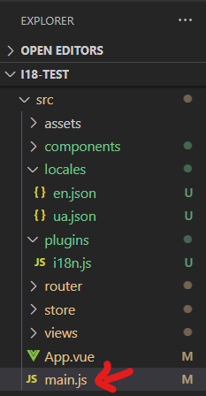 | 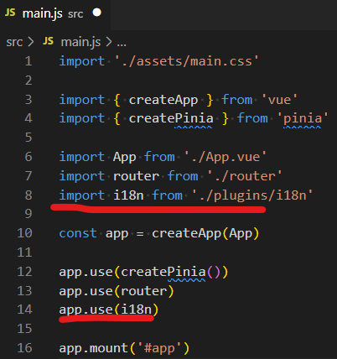  //------------------------- текст файлу  import './assets/main.css'  import { createApp } from 'vue'  import { createPinia } from 'pinia'  import App from './App.vue'  import router from './router'  import i18n from './plugins/i18n'  const app = createApp(App)  app.use(createPinia())  app.use(router)  app.use(i18n)  app.mount('#app')
Загальні стилі  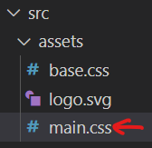 | /* Визначаємо перемінні для світлої теми за замовчуванням */  :root {  --background-color: #ecf0f1;  --card-background: #fff;  --text-color: #2c3e50;  --secondary-text-color: #7f8c8d;  --primary-color: #3498db;  --primary-hover: #2980b9;  --success-color: #2ecc71;  --success-hover: #27ae60;  --error-color: #e74c3c;  --error-hover: #c0392b;  --border-color: #bdc3c7;  --shadow-color: rgba(0, 0, 0, 0.1);  --hover-background: #f5f6fa;  }  /* Темна тема */  [data-theme='dark'] {  --background-color: #2c3e50;  --card-background: #34495e;  --text-color: #ecf0f1;  --secondary-text-color: #bdc3c7;  --primary-color: #3498db;  --primary-hover: #5dade2;  --success-color: #2ecc71;  --success-hover: #27ae60;  --error-color: #e74c3c;  --error-hover: #c0392b;  --border-color: #7f8c8d;  --shadow-color: rgba(0, 0, 0, 0.3);  --hover-background: #3e5a74;  }  /* Застосовуємо перемінні до основних стилів */  body {  background-color: var(--background-color);  color: var(--text-color);  font-family: 'Roboto', sans-serif;  line-height: 1.6;  }  /* Контейнер */  .container {  max-width: 1200px;  margin: 0 auto;  padding: 16px;  }  /* Заголовки */  h1,  h2,  h3 {  font-weight: 500;  margin-bottom: 16px;  color: var(--text-color);  }  h1 {  font-size: 2rem;  }  h2 {  font-size: 1.5rem;  }  h3 {  font-size: 1.25rem;  }  /* Кнопки */  button {  background-color: var(--primary-color);  color: var(--card-background);  border: none;  padding: 10px 20px;  border-radius: 4px;  cursor: pointer;  font-size: 1rem;  transition: background-color 0.3s ease;  }  button:hover {  background-color: var(--primary-hover);  }  button:disabled {  background-color: var(--border-color);  cursor: not-allowed;  }  /* Поля введення */  input,  select {  width: 100%;  padding: 10px;  margin-top: 8px;  border: 1px solid var(--border-color);  border-radius: 4px;  font-size: 1rem;  background-color: var(--card-background);  color: var(--text-color);  transition: border-color 0.3s ease;  }  input:focus,  select:focus {  border-color: var(--primary-color);  outline: none;  }  /* Повідомлення */  .error {  color: var(--error-color);  font-weight: 500;  }  .success {  color: var(--success-color);  font-weight: 500;  }  /* Адаптивність */  @media (max-width: 768px) {  .container {  padding: 8px;  }  h1 {  font-size: 1.5rem;  }  button {  padding: 8px 16px;  }  }
Створюємо файл з змінними середовища.  Усі змінні повинні починатись з префіксу  «VITE_» !!!!  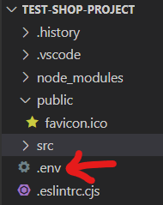 | //------------------------------------------- текст файлу  VITE_I18N_LOCALE=en  VITE_I18N_FALLBACK_LOCALE=en  VITE_SAVE_CREDENTIALS_IN_LOCAL_STORE=true
Створюємо модуль для полегшення взаємодії з модулем i18n  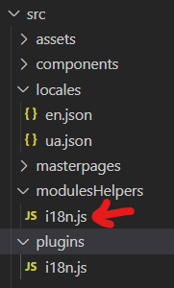 | import { useI18n } from 'vue-i18n'  import { useRouter } from 'vue-router'  export function useLocales() {  const { t, locale } = useI18n({ useScope: 'global' })  function setLocale(lang) {  locale.value = lang  localStorage.setItem('lastLocale', lang)  }  function checkLocale() {  const lastLocale = localStorage.getItem('lastLocale')  if (lastLocale && lastLocale !== locale.value) {  setLocale(localStorage.getItem('lastLocale'))  useRouter().go()  }  }  window.addEventListener('storage', () => checkLocale())  return {  locale,  t,  setLocale,  checkLocale  }  }
Встановлення Font Awesome через npm
https://fontawesome.com/docs/web/use-with/vue/
Встановлюємо модуль | npm i --save @fortawesome/fontawesome-svg-core
Встановити пакети іконок | npm i --save @fortawesome/free-solid-svg-icons  npm i --save @fortawesome/free-regular-svg-icons  npm i --save @fortawesome/free-brands-svg-icons
Встановлюємо відповідний Vue Component | npm i --save @fortawesome/vue-fontawesome@latest-3
Підключаємо бібліотеку Font Awesome у main.js  https://fontawesome.com/docs/web/use-with/vue/add-icons  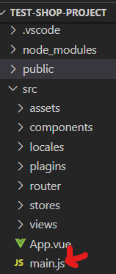  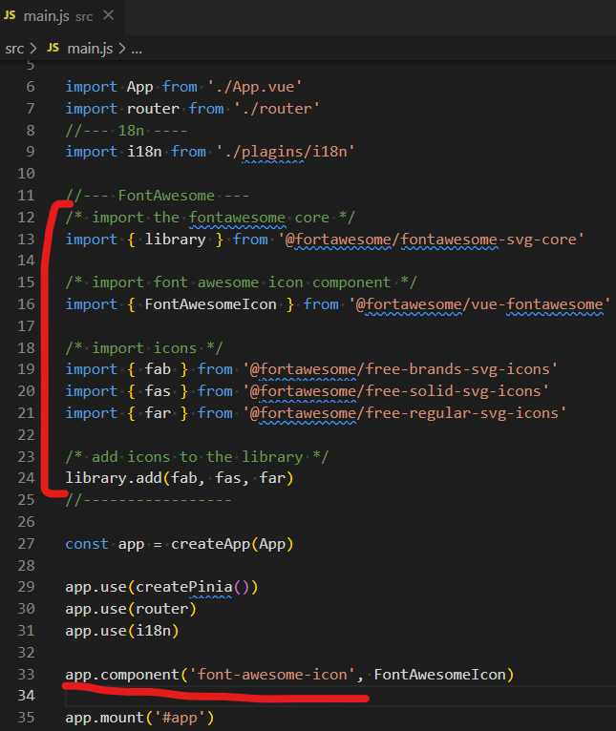  Тепер можемо використовувати іконки на зразок  <font-awesome-icon :icon="['fas', 'user']" /> | // import './assets/main.css'  import { createApp } from 'vue'  import { createPinia } from 'pinia'  import App from './App.vue'  import router from './router'  //--- 18n ----  import i18n from './plugins/i18n'  // import { useI18n } from 'vue-i18n'  //--- FontAwesome ---  /* import the fontawesome core */  import { library } from '@fortawesome/fontawesome-svg-core'  /* import font awesome icon component */  import { FontAwesomeIcon } from '@fortawesome/vue-fontawesome'  /* import icons */  import { fab } from '@fortawesome/free-brands-svg-icons'  import { fas } from '@fortawesome/free-solid-svg-icons'  import { far } from '@fortawesome/free-regular-svg-icons'  /* add icons to the library */  library.add(fab, fas, far)  //-----------------  const app = createApp(App)  app.use(createPinia())  app.use(i18n)  app.use(router)  app.component('font-awesome-icon', FontAwesomeIcon)  app.mount('#app')
Створюємо файл .env  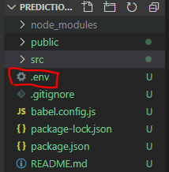 | Додаємо наш додаток в Firebase проект  Для багатомовності  VITE_I18N_LOCALE=en  VITE_I18N_FALLBACK_LOCALE=en  VITE_SAVE_CREDENTIALS_IN_LOCAL_STORE=true  Шлях до беккнда  VITE_API_URL=http://localhost:5000/api
Шляхи для взаємодії з бекнедом  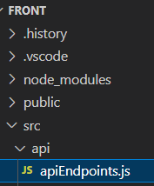 | const API_URL = import.meta.env.VITE_API_URL || 'http://localhost:5000/api'  // Об'єкти для кожної сутності  const apiEndpoints = {  auth: {  login: () => `${API_URL}/auth/login`,  register: () => `${API_URL}/auth/register`,  profileByToken: () => `${API_URL}/auth/profile`  },  users: {  getAll: () => `${API_URL}/users`,  getById: (id) => `${API_URL}/users/${id}`,  update: (id) => `${API_URL}/users/${id}`,  delete: (id) => `${API_URL}/users/${id}`  },  specialists: {  getAll: () => `${API_URL}/specialists`,  getById: (id) => `${API_URL}/specialists/${id}`,  create: () => `${API_URL}/specialists`,  update: (id) => `${API_URL}/specialists/${id}`,  delete: (id) => `${API_URL}/specialists/${id}`  },  appointments: {  getAll: () => `${API_URL}/appointments`,  create: () => `${API_URL}/appointments`,  delete: (specialistId) => `${API_URL}/appointments/${specialistId}`  }  }  export default apiEndpoints
Створюємо файл налаштувань axios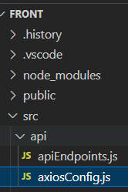 | import axios from 'axios'  import { useAuthStore } from '@/stores/auth'  const apiClient = axios.create({  baseURL: import.meta.env.VITE_API_URL || 'http://localhost:5000/api',  headers: {  'Content-Type': 'application/json'  }  })  // Інтерсептор для додавання токена до кожного запиту  apiClient.interceptors.request.use(  (config) => {  const authStore = useAuthStore()  const token = authStore.token  if (token) {  config.headers.Authorization = `Bearer ${token}`  }  return config  },  (error) => Promise.reject(error)  )  // Інтерсептор для обробки помилок відповіді (наприклад, 401)  apiClient.interceptors.response.use(  (response) => response,  (error) => {  if (error.response?.status === 401) {  const authStore = useAuthStore()  authStore.logout() // Очищаємо авторизацію при 401  }  return Promise.reject(error)  }  )  export default apiClient
Створюємо модуль, у якому будемо зберігати загальні для усіх операцій дані та методи  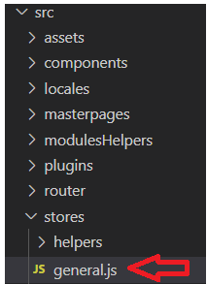 | import { ref, computed } from 'vue'  import { defineStore } from 'pinia'  export const useGeneralStore = defineStore('general', () => {  const loading = ref(null)  const error = ref(null)  const isLoading = computed(() => loading.value)  const hasError = computed(() => error.value)  function setLoading(val) {  loading.value = val  }  function setError(val) {  error.value = val  }  function startLoading() {  setLoading(true)  setError(null)  }  async function generalApiOperation({ operation, successCallback, errorCallBack }) {  startLoading()  try {  const res = await operation()  if (successCallback) successCallback(res)  return res  } catch (error) {  setError(error)  if (errorCallBack) errorCallBack(error)  } finally {  setLoading(false)  }  }  return { isLoading, hasError, setLoading, setError, startLoading, generalApiOperation }  })
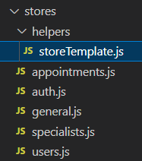 | import { ref } from 'vue'  import apiClient from '@/api/axiosConfig'  import apiEndpoints from '@/api/apiEndpoints'  import { useGeneralStore } from '../general'  export default function getStoreTemplate(entity) {  const generalStore = useGeneralStore()  const { generalApiOperation } = generalStore  const itemsList = ref([])  const currentItem = ref(null)  const endpoints = apiEndpoints[entity]  const loadItemsList = async () => {  itemsList.value = await generalApiOperation({  operation: async () => {  const response = await apiClient.get(endpoints.getAll())  itemsList.value = response.data  return response.data  }  })  }  const loadItemById = async (itemId) => {  currentItem.value = await generalApiOperation({  operation: async () => {  const response = await apiClient.get(endpoints.getById(itemId))  return response.data  }  })  return currentItem.value  }  const addItem = async (itemData) => {  const newItem = await generalApiOperation({  operation: async () => {  const response = await apiClient.post(endpoints.create(), itemData)  return response.data  }  })  // itemsList.value.push(newItem)  return newItem  }  const updateItem = async (id, data) => {  await generalApiOperation({  operation: async () => {  const response = await apiClient.put(endpoints.update(id), data)  const index = itemsList.value.findIndex((item) => item.id === id)  if (index !== -1) itemsList.value[index] = { ...itemsList.value[index], ...data }  if (currentItem.value?.id === id) currentItem.value = { ...currentItem.value, ...data }  return response.data  }  })  }  const deleteItem = async (itemId) => {  await generalApiOperation({  operation: async () => {  const response = await apiClient.delete(endpoints.delete(itemId))  itemsList.value = itemsList.value.filter((item) => item.id !== itemId)  return response.data  }  })  }  return {  itemsList,  currentItem,  loadItemsList,  loadItemById,  addItem,  updateItem,  deleteItem  }  }
Cтворюємо модуль для зберігання даних про користувачів  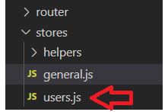 | import { defineStore } from 'pinia'  import getStoreTemplate from './helpers/storeTemplate'  // import { useAuthStore } from './auth'  export const useUsersStore = defineStore('users', () => {  // const authStore = useAuthStore()  const template = getStoreTemplate('users')  return {  ...template  }  })
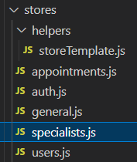 | import { defineStore } from 'pinia'  import getStoreTemplate from './helpers/storeTemplate'  export const useSpecialistsStore = defineStore('specialists', () => {  return getStoreTemplate('specialists')  })
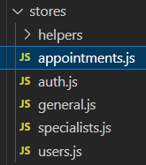 | import { defineStore } from 'pinia'  import getStoreTemplate from './helpers/storeTemplate'  export const useAppointmentsStore = defineStore('appointments', () => {  const template = getStoreTemplate('appointments')  return {  ...template  }  })
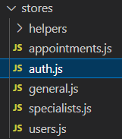 | import { defineStore } from 'pinia'  import { ref, computed } from 'vue'  import apiClient from '@/api/axiosConfig'  import apiEndpoints from '@/api/apiEndpoints'  import { useGeneralStore } from './general'  import { useUsersStore } from './users'  export const useAuthStore = defineStore('auth', () => {  const generalStore = useGeneralStore()  const usersStore = useUsersStore()  const { generalApiOperation } = generalStore  const user = ref(null)  const token = ref(localStorage.getItem('token') || null)  const getCurrentUserPermissions = computed(() => user.value?.permissions || {})  const setToken = (newToken) => {  token.value = newToken  if (newToken) {  localStorage.setItem('token', newToken)  } else {  localStorage.removeItem('token')  }  }  const login = async (email, password) => {  return generalApiOperation({  operation: async () => {  const response = await apiClient.post(apiEndpoints.auth.login(), { email, password })  setToken(response.data.token)  user.value = response.data.user  return response.data.user  }  })  }  const getUserProfileByToken = async () => {  const currentToken = localStorage.getItem('token')  if (!currentToken) return null  return generalApiOperation({  operation: async () => {  const response = await apiClient.get(apiEndpoints.auth.profileByToken())  setToken(response.data.token)  user.value = response.data.user  return response.data.user  }  })  }  const register = async (email, password) => {  return generalApiOperation({  operation: async () => {  const response = await apiClient.post(apiEndpoints.auth.register(), {  email,  password  })  setToken(response.data.token)  user.value = response.data.user  return response.data  }  })  }  const logout = () => {  setToken(null)  user.value = null  }  return { user, token, getUserProfileByToken, getCurrentUserPermissions, login, register, logout }  })
Створюємо шаблони сторінок
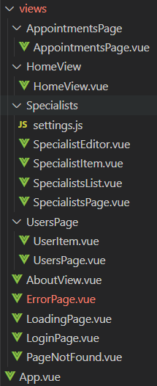
Створюємо компонент для відображення процесу звантаження  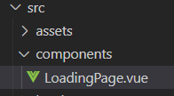 | <template>  <div class="loading-container">  <font-awesome-icon :icon="['fas', 'spinner']" size="6x" spin class="icon" />  </div>  </template>  <script setup></script>  <style lang="scss" scoped>  .mt-16 {  margin-top: 16px;  }  .ml-16 {  margin-left: 16px;  }  label {  display: block;  font-weight: 500;  }  button {  margin-right: 8px; /* Додаємо відстань між кнопками */  }  button:nth-child(3) {  /* Стилі для кнопки Google */  background-color: #fff;  color: #2c3e50;  border: 1px solid #bdc3c7;  display: flex;  align-items: center;  gap: 8px;  &:hover {  background-color: #f5f6fa;  }  }  </style>
Створюємо компонент для відображення статусу помилки  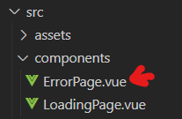 | <template>  <div class="container">  <h2>  {{ $t('pages.error.messages.smth_wrong') }}  </h2>  <font-awesome-icon :icon="['fas', 'triangle-exclamation']" size="6x" class="icon" />  </div>  </template>  <style lang="scss" scoped>  .container {  text-align: center;  padding: 32px;  h2 {  margin-bottom: 16px;  }  .icon {  color: #e74c3c;  }  }  </style>
Створюємо домоміжний файл для роутера  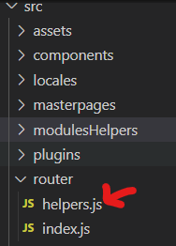 | import { useAuthStore } from '@/stores/auth'  import { storeToRefs } from 'pinia'  export function isAuthenticated() {  return useAuthStore().getUser  }  export function isRouteAvailable(routeItem) {  const { getCurrentUserPermissions, user } = storeToRefs(useAuthStore())  return (  !routeItem.meta?.requireAuth ||  (routeItem.meta?.hasAccess && routeItem.meta.hasAccess(getCurrentUserPermissions.value)) ||  (!routeItem.meta?.hasAccess && user.value)  )  }
Змінюємо файл налаштувань роутера (роутер вже встановлений при створенні проєкта)  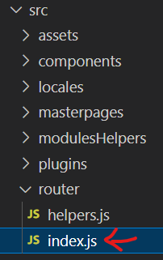 | import { createRouter, createWebHistory } from 'vue-router'  import HomeView from '@/views/HomeView/HomeView.vue'  import LoginPage from '@/views/LoginPage.vue'  import { useAuthStore } from '@/stores/auth'  export const routes = [  { path: '/', name: 'home', meta: { requireAuth: false, useInMenu: true }, component: HomeView },  {  path: '/login',  name: 'login',  meta: { requireAuth: false, useInMenu: false },  component: LoginPage  },  {  path: '/users',  name: 'users',  meta: { requireAuth: true, hasAccess: (permissions) => permissions?.isAdmin, useInMenu: true },  component: () => import('../views/UsersPage/UsersPage.vue')  },  {  path: '/specialists',  children: [  {  path: '',  name: 'specialists',  meta: { requireAuth: false, useInMenu: true },  component: () => import('../views/Specialists/SpecialistsPage.vue')  },  {  path: '/config/:id?',  name: 'specialistsConfig',  meta: { requireAuth: true, hasAccess: (permissions) => permissions.update },  component: () => import('../views/Specialists/SpecialistEditor.vue')  }  ]  },  {  path: '/appointments',  name: 'appointments',  meta: { requireAuth: true, hasAccess: (permissions) => permissions?.read, useInMenu: true },  component: () => import('../views/AppointmentsPage/AppointmentsPage.vue')  },  {  path: '/about',  name: 'about',  meta: { requireAuth: false, useInMenu: true },  component: () => import('../views/AboutView.vue')  },  {  path: '/:path(.*)*',  name: 'page-not-found',  meta: { requireAuth: false },  component: () => import('../views/PageNotFound.vue')  }  ]  const router = createRouter({  history: createWebHistory(import.meta.env.BASE_URL),  routes  })  router.beforeEach(async (to) => {  const authStore = useAuthStore()  if (!authStore.user) {  await authStore.getUserProfileByToken()  if (to.meta?.requireAuth) {  if (!authStore.user) return { name: 'login', query: { redirect: to.fullPath } } // Перенаправлення на логін із збереженням URL  }  const permissions = authStore.getCurrentUserPermissions ?? {}  if (to.meta?.hasAccess && !to.meta.hasAccess(permissions)) {  return { name: 'page-not-found' }  }  }  })  export default router
Створюємо шаблон (masterpage/layouts) допоміжних сторінок (наприклад, логіна)  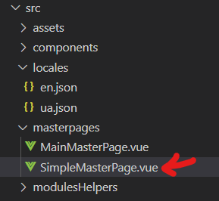 | <template>  <div class="container">  <div class="header">  <slot name="header"> </slot>  </div>  <div class="main">  <div class="content">  <slot></slot>  </div>  </div>  <div class="footer">  <slot name="footer">  <router-link  :to="{  name: 'home'  }"  class="home-link"  >  {{ $t('pages.login.buttons.toHome') }}  </router-link>  </slot>  </div>  </div>  </template>  <script setup></script>  <style lang="scss" scoped>  .container {  height: 100vh;  display: flex;  flex-direction: column;  align-items: center;  justify-content: center;  .header {  height: 80px;  }  .main {  flex-grow: 1;  display: flex;  align-items: center;  justify-content: center;  }  .footer {  height: 80px;  }  .home-link {  display: inline-block;  padding: 10px 20px;  background-color: #3498db;  color: white;  text-decoration: none;  border-radius: 4px;  transition: background-color 0.3s ease;  &:hover {  background-color: #2980b9;  }  }  }  </style>
Комопонент для перемикання мови  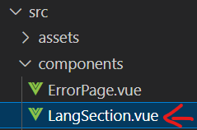 | <template>  <div class="lang">  <span  :class="{  selected: locale == 'ua'  }"  @click="setLocale('ua')"  >UA</span  >  <span  :class="{  selected: locale == 'en'  }"  @click="setLocale('en')"  >  EN</span  >  </div>  </template>  <script setup>  import { useLocales } from '@/modulesHelpers/i18n.js'  const { locale, setLocale } = useLocales()  </script>  <style lang="scss" scoped>  .lang {  span {  cursor: pointer;  padding: 4px 8px;  border-radius: 4px;  &.selected {  border: 2px solid #2ecc71;  }  }  }  </style>
Компонент для відображення даних поточного користувача  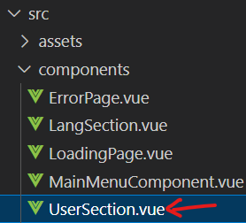 | <template>  <div>  <div v-if="user" class="user-section">  <img v-if="user.photoURL" :src="user.photoURL" class="ml-16" />  <font-awesome-icon v-else :icon="['fas', 'user']" size="2x" class="ml-16" />  <span class="ml-16">{{ user.displayName ?? user.email }}</span>  <button class="ml-16" @click="onLogout">{{ $t('buttons.logout') }}</button>  </div>  <button v-else @click="onLogin">{{ $t('buttons.login') }}</button>  </div>  </template>  <script setup>  import { computed } from 'vue'  import { useAuthStore } from '@/stores/auth'  const authStore = useAuthStore()  const { user } = storeToRefs(authStore)  import { useRouter } from 'vue-router'  import { storeToRefs } from 'pinia'  const router = useRouter()  function onLogin() {  router.push({  name: 'login'  })  }  function onLogout() {  authStore.logout()  router.push({  name: 'login'  })  }  </script>  <style lang="scss" scoped>  .user-section {  display: flex;  align-items: center;  gap: 8px;  img {  height: 40px;  border-radius: 50%;  }  }  </style>
Створюємо компонент для створення головного меню  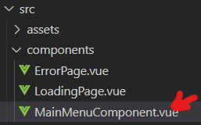 | <template>  <nav>  <router-link  v-for="routeItem in visibleMenuItems"  :key="routeItem.name"  :to="{ name: routeItem.name }"  class="menu-link"  active-class="active"  >  {{ $t(`pages.${routeItem.name}.title.menu`) }}  </router-link>  </nav>  </template>  <script setup>  import { computed } from 'vue'  import { routes } from '@/router'  import { isRouteAvailable } from '@/router/helpers.js'  function checkRoutesList(routeItems, menuItemsRoutes) {  for (const routeItem of routeItems) {  if (routeItem.children) checkRoutesList(routeItem.children, menuItemsRoutes)  else if (routeItem.meta?.useInMenu && isRouteAvailable(routeItem)) {  menuItemsRoutes.push({  name: routeItem.name  })  }  }  }  const visibleMenuItems = computed(() => {  const menuItemsRoutes = []  checkRoutesList(routes, menuItemsRoutes)  return menuItemsRoutes  })  </script>  <style lang="scss" scoped>  nav {  display: flex;  align-items: center;  gap: 16px;  padding: 8px 0;  .menu-link {  text-decoration: none;  color: #2c3e50;  font-weight: 500;  font-size: 1rem;  padding: 8px 16px;  position: relative;  transition: color 0.3s ease;  &:hover {  color: #3498db;  }  &.active {  color: #3498db;  font-weight: 600;  &::after {  content: '';  position: absolute;  bottom: -2px; /* Вирівнюємо підкреслення з нижньою межею */  left: 16px;  right: 16px;  height: 2px;  background-color: #3498db;  }  }  }  @media (max-width: 768px) {  flex-wrap: wrap;  justify-content: center;  gap: 8px;  .menu-link {  padding: 8px 12px;  font-size: 0.9rem;  }  }  @media (max-width: 600px) {  flex-direction: column;  align-items: center;  gap: 12px;  .menu-link {  padding: 8px;  font-size: 1rem;  }  }  }  </style>
Створюємо головний шаблон (masterpage)  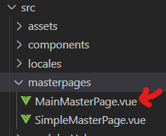 | <template>  <div class="container">  <div class="header">  <slot name="header">  <div>  <main-menu-component />  </div>  <div class="right-section">  <lang-section />  <user-section />  </div>  </slot>  </div>  <h1 class="page-title">{{ $t(`pages.${currentRoute.name}.title.page`) }}</h1>  <div>  <slot name="title"></slot>  </div>  <div class="main">  <loading-page v-if="isLoading" />  <error-page v-else-if="hasError" />  <template v-if="!isLoading && !hasError">  <slot></slot>  </template>  </div>  <div class="footer">  <slot name="footer"> </slot>  </div>  </div>  </template>  <script setup>  import MainMenuComponent from '@/components/MainMenuComponent.vue'  import LoadingPage from '@/components/LoadingPage.vue'  import ErrorPage from '@/components/ErrorPage.vue'  import LangSection from '@/components/LangSection.vue'  import UserSection from '@/components/UserSection.vue'  import { computed } from 'vue'  import { useGeneralStore } from '@/stores/general'  import { storeToRefs } from 'pinia'  const generalStore = useGeneralStore()  const { isLoading, hasError } = storeToRefs(generalStore)  import { useRoute } from 'vue-router'  const currentRoute = computed(() => useRoute())  </script>  <style lang="scss" scoped>  .container {  padding: 16px;  min-height: 100vh;  display: flex;  flex-direction: column;  .header {  display: flex;  align-items: center;  justify-content: space-between;  padding-bottom: 16px;  border-bottom: 1px solid #ddd;  .menu-link {  margin: 0 16px;  text-decoration: none;  color: #2c3e50;  font-weight: 500;  &:hover {  color: #3498db;  }  }  .right-section {  display: flex;  align-items: center;  gap: 16px;  }  }  .page-title {  padding-bottom: 12px;  border-bottom: 1px solid #e0e0e0;  }  .main {  flex-grow: 1;  display: flex;  justify-content: center;  align-items: center;  }  }  </style>
Головна сторінка  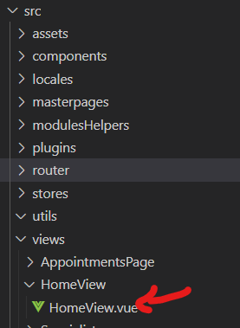 | <template>  <main-master-page>  <div class="home-container">  <h1>{{ $t('pages.home.messages.welcome') }}</h1>  <p class="subtitle">Your health is our priority. Book an appointment today!</p>  </div>  </main-master-page>  </template>  <script setup>  import MainMasterPage from '@/masterpages/MainMasterPage.vue'  </script>  <style lang="scss" scoped>  .home-container {  text-align: center;  padding: 32px;  background-color: #fff;  border-radius: 8px;  box-shadow: 0 2px 8px rgba(0, 0, 0, 0.1);  max-width: 600px;  margin: 0 auto;  h1 {  color: #2c3e50;  font-size: 2.5rem;  margin-bottom: 16px;  }  .subtitle {  font-size: 1.2rem;  color: #7f8c8d;  }  @media (max-width: 768px) {  padding: 16px;  h1 {  font-size: 2rem;  }  .subtitle {  font-size: 1rem;  }  }  }  </style>
Сторінка About  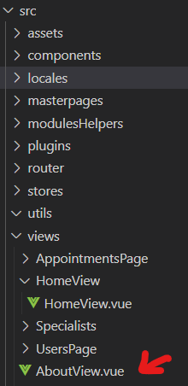 | <template>  <main-master-page>  <div class="about">  <h1>{{ $t('pages.about.messages.text') }}</h1>  </div>  </main-master-page>  </template>  <script setup>  import MainMasterPage from '@/masterpages/MainMasterPage.vue'  </script>  <style>  @media (min-width: 1024px) {  .about {  min-height: 100vh;  display: flex;  align-items: center;  }  }  </style>
Cторінка PageNotFound  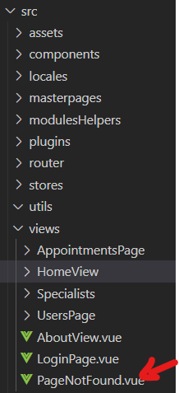 | <template>  <simple-master-page>  <div class="not-found">  <h2>Page Not Found</h2>  <font-awesome-icon :icon="['fas', 'exclamation-circle']" size="4x" class="icon" />  <p>The page you are looking for doesn't exist.</p>  </div>  </simple-master-page>  </template>  <script setup>  import SimpleMasterPage from '@/masterpages/SimpleMasterPage.vue'  </script>  <style lang="scss" scoped>  .not-found {  text-align: center;  padding: 32px;  background-color: #fff;  border-radius: 8px;  box-shadow: 0 2px 8px rgba(0, 0, 0, 0.1);  h2 {  color: #e74c3c;  font-size: 2rem;  margin-bottom: 16px;  }  .icon {  color: #e74c3c;  margin-bottom: 16px;  }  p {  color: #7f8c8d;  font-size: 1.1rem;  margin-bottom: 24px;  }  .home-link {  display: inline-block;  padding: 10px 20px;  background-color: #3498db;  color: white;  text-decoration: none;  border-radius: 4px;  transition: background-color 0.3s ease;  &:hover {  background-color: #2980b9;  }  }  @media (max-width: 768px) {  padding: 16px;  h2 {  font-size: 1.5rem;  }  p {  font-size: 1rem;  }  }  }  </style>
Сторінка налштувань одного користувача  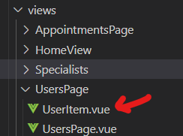 | <template>  <tr>  <td>{{ user.email }}</td>  <td v-for="ruleId in permissionsList" :key="ruleId">  <input v-model="userObj.permissions[ruleId]" type="checkbox" class="checkbox" />  </td>  </tr>  </template>  <script setup>  import { reactive, watch } from 'vue'  import { useUsersStore } from '@/stores/users'  const userStore = useUsersStore()  import { permissionsList } from './settings'  const props = defineProps({  user: {  type: Object,  required: true  }  })  const userObj = reactive({ ...props.user })  const editablePermissions = ['read', 'create', 'update', 'delete']  function editablePermissionsList() {  const obj = {}  for (const ruleId of editablePermissions) {  obj[ruleId] = userObj.permissions[ruleId]  }  return obj  }  watch(userObj, (newUserObj) => {  userStore.updateItem(newUserObj.id, {  email: newUserObj.email,  permissions: newUserObj.permissions  })  })  </script>  <style lang="scss" scoped>  tr {  display: grid;  grid-template-columns: 300px repeat(4, 100px); /* Точно відповідає grid-header */  align-items: center;  padding: 12px 0; /* Прибираємо горизонтальний padding для точного вирівнювання */  background-color: #f5f6fa;  border-radius: 0;  transition: background-color 0.3s ease;  &:hover {  background-color: #e8ecef;  }  td {  text-align: center;  font-weight: 500;  color: #2c3e50;  border-right: 1px solid #e0e0e0;  padding: 8px 0; /* Прибираємо горизонтальний padding */  display: flex;  justify-content: center;  align-items: center;  min-height: 40px; /* Для однакової висоти рядків */  &:last-child {  border-right: none;  }  &.permissions {  display: flex;  justify-content: center;  align-items: center;  gap: 16px;  .checkbox {  width: 16px;  height: 16px;  cursor: pointer;  accent-color: #3498db;  }  }  }  }  @media (max-width: 768px) {  tr {  grid-template-columns: 200px repeat(4, 80px);  font-size: 0.9rem;  td.permissions {  gap: 8px;  }  }  }  @media (max-width: 600px) {  tr {  display: flex;  flex-direction: column;  align-items: center;  gap: 8px;  padding: 16px;  td {  border-right: none;  border-bottom: 1px solid #e0e0e0;  padding: 8px 0;  width: 100%;  &:last-child {  border-bottom: none;  }  &.permissions {  flex-direction: column;  align-items: center;  }  }  }  }  </style>
Сторінка наштування користувачів  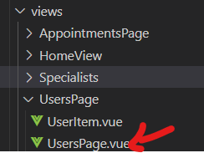 | <template>  <main-master-page>  <div class="users-container">  <table v-if="usersList?.length" class="users-table">  <tr class="grid-header">  <th>{{ $t('pages.users.fields.email') }}</th>  <th v-for="ruleId in permissionsList" :key="ruleId">  {{ $t(`pages.users.fields.${ruleId}`) }}  </th>  </tr>  <user-item v-for="user in usersList" :key="user.id" :user="user" />  </table>  <div v-else class="empty-message">No users found</div>  </div>  </main-master-page>  </template>  <script setup>  import MainMasterPage from '@/masterpages/MainMasterPage.vue'  import { onMounted } from 'vue'  import { useUsersStore } from '@/stores/users'  import { storeToRefs } from 'pinia'  const usersStore = useUsersStore()  const { itemsList: usersList } = storeToRefs(usersStore)  const { loadItemsList: loadUsersList } = usersStore  import { permissionsList } from './settings'  onMounted(() => {  loadUsersList()  })  import UserItem from './UserItem.vue'  </script>  <style lang="scss" scoped>  .users-container {  max-width: 1200px;  margin: 32px auto;  padding: 24px;  background-color: #fff;  border-radius: 8px;  box-shadow: 0 2px 8px rgba(0, 0, 0, 0.1);  h1 {  color: #2c3e50;  font-size: 2rem;  margin-bottom: 24px;  }  .users-table {  display: flex;  flex-direction: column;  gap: 1px; /* Відстань між рядками */  background-color: #e0e0e0; /* Фон для імітації меж між рядками */  }  .grid-header {  display: grid;  grid-template-columns: 300px repeat(4, 100px); /* Точно відповідає UserItem.vue */  background-color: #3498db;  color: white;  padding: 12px 0; /* Прибираємо горизонтальний padding для точного вирівнювання */  border-radius: 4px 4px 0 0;  font-weight: 500;  tr {  display: grid;  grid-template-columns: 300px repeat(4, 100px); /* Точно відповідає grid-header */  th {  text-align: center;  border-right: 1px solid rgba(255, 255, 255, 0.3);  padding: 0; /* Прибираємо padding, щоб стовпці вирівнялися */  padding: 8px 0; /* Прибираємо горизонтальний padding */  display: flex;  justify-content: center;  align-items: center;  min-height: 40px;  line-height: 1.5; /* Для кращого вирівнювання тексту */  &:last-child {  border-right: none;  }  }  }  }  .empty-message {  text-align: center;  color: #7f8c8d;  font-size: 1.2rem;  padding: 16px;  }  @media (max-width: 768px) {  margin: 16px;  padding: 16px;  h1 {  font-size: 1.5rem;  }  .grid-header {  grid-template-columns: 200px repeat(4, 80px);  font-size: 0.9rem;  }  }  @media (max-width: 600px) {  .grid-header {  display: none;  }  }  }  </style>
Файл даних-наштувань спеціальностей лікарів  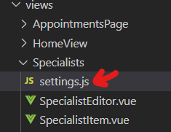 | export const categories = {  therapist: { icon: ['fas', 'fa-stethoscope'], color: 'brown' },  cardiologist: { icon: ['fas', 'fa-heartbeat'], color: 'red' },  urologist: { icon: ['fas', 'fa-user-md'], color: 'orange' },  psychologist: { icon: ['fas', 'fa-brain'], color: 'green' },  dentist: {  icon: ['fas', 'fa-tooth'],  color: 'blue'  }  }
Компонент для створення/редагування лікаря  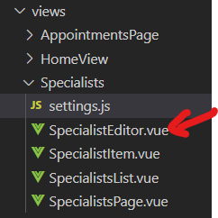 | <template>  <main-master-page>  <div class="editor-container">  <h1>  {{  specialistId ? $t('pages.specialists.title.edit') : $t('pages.specialists.title.create')  }}  </h1>  <Form :validation-schema="schema" :initial-values="form" @submit="onSubmit">  <div class="form-group">  <label>{{ $t('pages.specialists.fields.name.label') }}</label>  <Field  name="title"  v-model="form.title"  type="text"  :placeholder="$t('pages.specialists.fields.name.placeholder')"  />  <ErrorMessage name="title" class="error" />  </div>  <div class="form-group image">  <div class="image-preview">  <img v-if="form.img" :src="form.img" class="img" />  <font-awesome-icon v-else :icon="['fas', 'user']" size="4x" class="icon" />  </div>  <label>{{ $t('pages.specialists.fields.image.label') }}</label>  <input type="file" @change="loadImage" />  </div>  <div class="form-group">  <label>{{ $t('pages.specialists.fields.category.label') }}</label>  <Field name="category" as="select" v-model="form.category">  <option value="" disabled>  {{ $t('pages.specialists.fields.category.placeholder') }}  </option>  <option v-for="categoryId in categoriesList" :key="categoryId" :value="categoryId">  {{ $t(`categories.${categoryId}`) }}  </option>  </Field>  <ErrorMessage name="category" class="error" />  </div>  <div class="actions">  <button type="submit" :disabled="isSubmitting">{{ btnTitle }}</button>  </div>  </Form>  </div>  </main-master-page>  </template>  <script setup>  import { Form, Field, ErrorMessage, useForm } from 'vee-validate'  import * as yup from 'yup'  import { ref, computed, onMounted } from 'vue'  import { useRoute, useRouter } from 'vue-router'  import { useSpecialistsStore } from '@/stores/specialists'  import MainMasterPage from '@/masterpages/MainMasterPage.vue'  import { categories } from './settings'  import { useI18n } from 'vue-i18n'  const { t } = useI18n({ useScope: 'global' })  const route = useRoute()  const router = useRouter()  const specialistsStore = useSpecialistsStore()  const specialistId = computed(() => route.params.id)  const categoriesList = computed(() => Object.keys(categories))  // Ініціалізація форми  const form = ref({  title: '',  img: '',  category: ''  })  // Схема валідації  const schema = yup.object({  title: yup.string().required('Name is required'),  category: yup.string().required('Category is required')  })  // Налаштування vee-validate форми  const { setValues } = useForm({  initialValues: form.value,  validationSchema: schema  })  // Стан відправки  const isSubmitting = computed(() => specialistsStore.isLoading || false)  onMounted(async () => {  if (specialistId.value) {  const specialist = await specialistsStore.loadItemById(specialistId.value)  form.value = { ...specialist } // Оновлюємо ref  setValues({ ...specialist }) // Оновлюємо стан форми vee-validate  }  })  const loadImage = (event) => {  const file = event.target.files[0]  if (file) {  const reader = new FileReader()  reader.onload = (e) => {  form.value.img = e.target.result  setValues({ ...form.value }) // Оновлюємо форму після зміни зображення  }  reader.readAsDataURL(file)  }  }  const btnTitle = computed(() => (specialistId.value ? t('buttons.save') : t('buttons.create')))  const onSubmit = async (values) => {  try {  const payload = { ...values, img: form.value.img }  if (specialistId.value) {  await specialistsStore.updateItem(specialistId.value, payload)  } else {  await specialistsStore.addItem(payload)  }  router.push({ name: 'specialists' })  } catch (error) {  console.error('Submission failed:', error.message)  }  }  </script>  <style lang="scss" scoped>  /* Стилі залишилися без змін */  </style>
Компонент для відображення одного лікаля  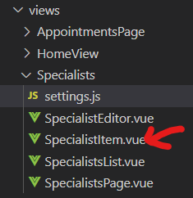 | <template>  <div class="container">  <div class="image-container">  <img v-if="specialist.img" :src="specialist.img" />  <font-awesome-icon v-else :icon="['fas', 'user']" class="icon" />  </div>  <div class="text">{{ specialist.title }}</div>  <div class="text">  <div class="category">{{ $t(`categories.${specialist.category}`) }}</div>  <div>  <font-awesome-icon  :icon="categoriesList[specialist.category].icon"  size="2x"  :style="{  color: categoriesList[specialist.category].color  }"  />  </div>  </div>  <div class="text">{{ specialist.rating }}</div>  <div class="action">  <slot name="action">  <div>  <font-awesome-icon  v-if="getCurrentUserPermissions.update"  :icon="['fas', 'pen-to-square']"  @click="onEdit"  class="icon"  />  </div>  <div>  <font-awesome-icon  v-if="getCurrentUserPermissions.delete"  :icon="['fas', 'trash']"  class="icon"  @click="onDelete"  />  </div>  <button  @click="makeAppointment"  :disabled="!getCurrentUserPermissions.read"  :title="!getCurrentUserPermissions.read ? 'Please login' : ''"  >  {{ $t('pages.specialists.buttons.make-appointment') }}  </button>  </slot>  </div>  </div>  </template>  <script setup>  import { categories } from './settings'  const categoriesList = computed(() => categories)  import { useAuthStore } from '@/stores/auth'  const authStore = useAuthStore()  const { user, getCurrentUserPermissions } = storeToRefs(authStore)  import { useRouter } from 'vue-router'  import { computed } from 'vue'  const router = useRouter()  // import { useUsersStore } from '@/stores/users'  // const { getCurrentUserPermissions } = storeToRefs(useUsersStore())  import { useSpecialistsStore } from '@/stores/specialists'  const specStore = useSpecialistsStore()  import { useAppointmentsStore } from '@/stores/appointments'  import { storeToRefs } from 'pinia'  const appointmentsStore = useAppointmentsStore()  // props  const props = defineProps({  specialist: {  type: Object,  required: true  }  })  function onEdit() {  router.push({  name: 'specialistsConfig',  params: {  id: props['specialist'].id  }  })  }  function onDelete() {  specStore.deleteItem(props.specialist.id)  }  function makeAppointment() {  // appointmentsStore.addItemToArray(user.value.uid, 'appointments', props.specialist.id)  appointmentsStore.addItem({ specialistId: props.specialist.id })  }  </script>  <style lang="scss" scoped>  .container {  display: grid;  grid-template-columns: 80px 200px 200px 100px 250px;  align-items: center;  padding: 16px;  background-color: #f5f6fa;  border-radius: 4px;  margin-bottom: 8px;  transition: background-color 0.3s ease;  &:hover {  background-color: #e8ecef;  }  > div {  text-align: center;  }  .image-container {  display: flex;  align-items: center;  justify-content: center;  max-width: 60px;  height: 60px;  background-color: #ecf0f1;  border-radius: 50%;  overflow: hidden;  img {  width: 100%;  height: 100%;  object-fit: cover; /* Зображення масштабується, зберігаючи пропорції */  }  .icon {  font-size: 30px;  color: #7f8c8d;  }  }  .text {  font-weight: 500;  color: #2c3e50;  &.category {  display: flex;  align-items: center;  justify-content: center;  gap: 8px;  color: #7f8c8d;  }  &.rating {  color: #3498db;  }  }  .action {  display: flex;  justify-content: center;  gap: 12px;  align-items: center;  .icon {  font-size: 18px;  cursor: pointer;  transition: color 0.3s ease;  &:hover {  color: #3498db; /* Колір для іконки редагування */  }  &:last-child:hover {  color: #e74c3c; /* Колір для іконки видалення */  }  }  button {  background-color: #3498db;  padding: 6px 12px;  font-size: 0.9rem;  &:hover {  background-color: #2980b9;  }  &:disabled {  background-color: #bdc3c7;  }  }  }  }  @media (max-width: 768px) {  .container {  grid-template-columns: 60px 150px 150px 80px 200px;  font-size: 0.9rem;  .image-container {  width: 50px;  height: 50px;  img {  width: 100%;  height: 100%;  }  .icon {  font-size: 24px;  }  }  .action {  button {  padding: 4px 8px;  font-size: 0.8rem;  }  }  }  }  @media (max-width: 600px) {  .container {  display: flex;  flex-direction: column;  align-items: center;  gap: 8px;  padding: 16px;  .image-container {  width: 60px;  height: 60px;  img {  width: 100%;  height: 100%;  }  .icon {  font-size: 30px;  }  }  }  }  </style>
Компоенент для відображення списку лікарів  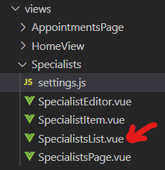 | <template>  <h3 v-if="itemsList.length === 0">  {{ $t('pages.specialists.messages.empty-list') }}  </h3>  <template v-else>  <div>  <specialist-item  v-for="specialist in itemsList"  :key="specialist.id"  :specialist="specialist"  />  </div>  </template>  </template>  <script setup>  import SpecialistItem from './SpecialistItem.vue'  import { computed } from 'vue'  import { storeToRefs } from 'pinia'  import { useSpecialistsStore } from '@/stores/specialists'  const specialistsStore = useSpecialistsStore()  const { itemsList } = storeToRefs(specialistsStore)  </script>  <style lang="scss" scoped></style>
Сторінка (компонент) лікарів  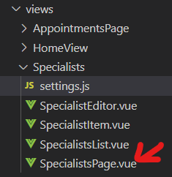 | <template>  <main-master-page>  <div class="specialists-container">  <div v-if="getCurrentUserPermissions.create" class="actions">  <button @click="onAdd">{{ $t('buttons.add') }}</button>  </div>  <specialists-list />  </div>  </main-master-page>  </template>  <script setup>  import SpecialistsList from './SpecialistsList.vue'  import MainMasterPage from '@/masterpages/MainMasterPage.vue'  import { useRouter } from 'vue-router'  import { storeToRefs } from 'pinia'  const router = useRouter()  import { onMounted } from 'vue'  import { useSpecialistsStore } from '@/stores/specialists'  const specialistsStore = useSpecialistsStore()  import { useAuthStore } from '@/stores/auth'  const { getCurrentUserPermissions } = storeToRefs(useAuthStore())  onMounted(() => {  specialistsStore.loadItemsList()  })  function onAdd() {  router.push({  name: 'specialistsConfig'  })  }  </script>  <style lang="scss" scoped>  .specialists-container {  max-width: 1000px;  margin: 32px auto;  padding: 24px;  background-color: #fff;  border-radius: 8px;  box-shadow: 0 2px 8px rgba(0, 0, 0, 0.1);  h1 {  color: #2c3e50;  font-size: 2rem;  margin-bottom: 24px;  }  .actions {  display: flex;  justify-content: flex-end;  margin-bottom: 16px;  button {  background-color: #2ecc71;  &:hover {  background-color: #27ae60;  }  }  }  @media (max-width: 768px) {  margin: 16px;  padding: 16px;  h1 {  font-size: 1.5rem;  }  }  }  </style>
Сторінка для відображення призначених зустрічей  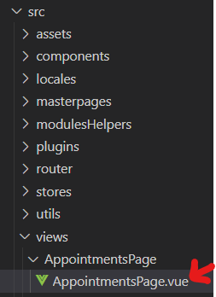 | <template>  <main-master-page>  <div class="appointments-container">  <div v-if="itemsList.length" class="appointments-list">  <specialist-item v-for="item in itemsList" :key="item.id" :specialist="item">  <template #action>  <button @click="onCancel(item.id)" class="cancel-btn">  {{ $t('buttons.cancel') }}  </button>  </template>  </specialist-item>  </div>  <div v-else class="empty-message">  {{ $t('pages.appointments.messages.empty-list') }}  </div>  </div>  </main-master-page>  </template>  <script setup>  import { onMounted } from 'vue'  import MainMasterPage from '@/masterpages/MainMasterPage.vue'  import SpecialistItem from '@/views/Specialists/SpecialistItem.vue'  import { useAppointmentsStore } from '@/stores/appointments'  import { storeToRefs } from 'pinia'  const appointmentsStore = useAppointmentsStore()  const { itemsList } = storeToRefs(appointmentsStore)  onMounted(() => {  appointmentsStore.loadItemsList()  })  const onCancel = (specialistId) => {  appointmentsStore.deleteItem(specialistId)  }  </script>  <style lang="scss" scoped>  /* Стилі залишилися без змін */  </style>
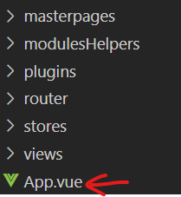 | <script setup>  import { RouterView } from 'vue-router'  import { useLocales } from './modulesHelpers/i18n'  const { checkLocale } = useLocales()  checkLocale()  </script>  <template>  <RouterView />  </template>  <style scoped></style>
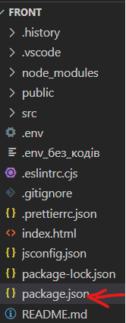 | {  "name": "frontend",  "version": "0.0.0",  "type": "module",  "scripts": {  "dev": "vite",  "build": "vite build",  "serve": "vite preview"  },  "dependencies": {  "vue": "^3.2.47",  "pinia": "^2.0.33",  "vue-router": "^4.1.6",  "vue-i18n": "^9.2.2",  "@fortawesome/fontawesome-svg-core": "^6.2.1",  "@fortawesome/free-solid-svg-icons": "^6.2.1",  "@fortawesome/free-regular-svg-icons": "^6.2.1",  "@fortawesome/free-brands-svg-icons": "^6.2.1",  "@fortawesome/vue-fontawesome": "^3.0.3",  "vee-validate": "^4.7.3",  "yup": "^1.0.0",  "axios": "^1.6.0"  },  "devDependencies": {  "@vitejs/plugin-vue": "^4.1.0",  "vite": "^4.3.9"  }  }

