## PR:Microsoft Web Technologies – Mid-Term Exam

You are working on contracts for night clubs. Each contract is between a club and a group for a stated number of performances at an agreed rate per performance. The contracts also show the start date and the total price of the contract.

1. You have an ASP.NET Core MVC project called ***Clubs*** and an SQL script called ***Clubs.sql*** on the exam account’s G: drive. **Only what is saved to the exam account’s G: drive will be marked.**
   1. Use SQL Server 2014 Management Studio to generate the Clubs database from the SQL script.
   2. You can work on the project on either the G: drive or the C: drive. If working on the C: drive, i**t is your responsibility to periodically copy the project folder to G:**

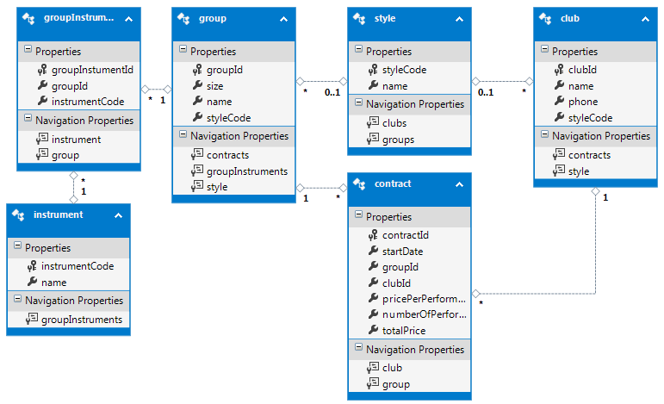

1. Modify the main layout, ***_layout.cshtml***:
   1. Add a link to the ***Club*** controller in the menu
   2. Move the *About* and *Contact* menu items to the right side of the footer, aligned horizontally as shown.
   3. Display the TempData variable *message*, bold and red, before the main body of the guest page.
   4. Put your name and section in the footer, as an e-mail hyperlink to your college address.

### Club Controller

1. Generate the ***Club*** controller with full CRUD support for the *Club* table. Modify its listing of clubs to be similar to the one shown below (your list should be longer) …
   1. The browser title and the page heading should be “Club Listing”.
   2. Order the clubs by style name and then by club name
   3. Show only the columns in the example
   4. Add a hyperlink to each row to pass its *clubId* to the default page of the ***Contract*** controller.

This page intentionally left blank

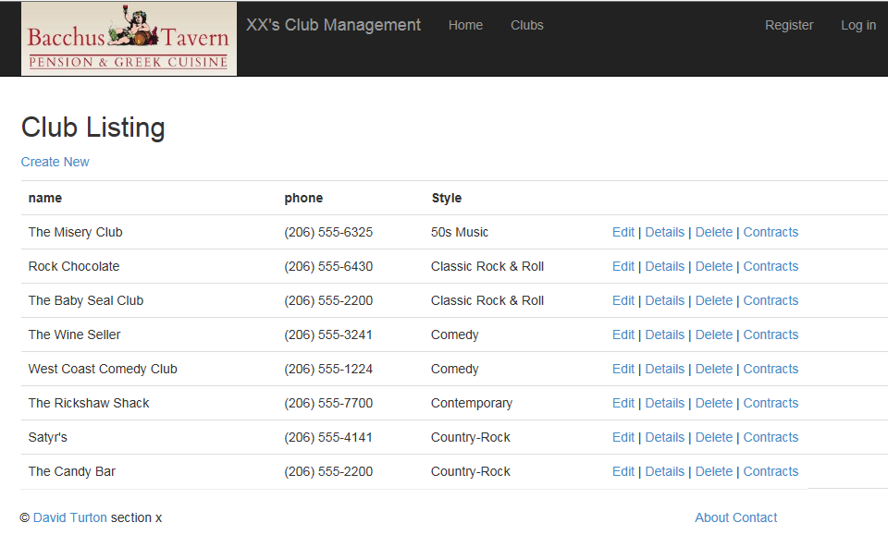

### *Contract* controller

1. Generate the ***Contract*** controller with full CRUD support for the *contract* table.
2. For the *Index* action and its view:
   1. If the *clubId* has been passed in the URL or QueryString, save it to a cookie or session variable
   2. If the *clubId* is not in the QueryString or URL, look for it in a cookie or session variable … if it’s not there either, go back to the club listing and display a message requesting they select a club.
   3. Limit the listing of *contract* records to the given *clubId*, in sequence by start date, most current first.
   4. On the view:
      1. Change the page title and heading to “Contract Listing:” and the selected club’s name.
      2. Modify the view’s fields to those shown on the sample below.

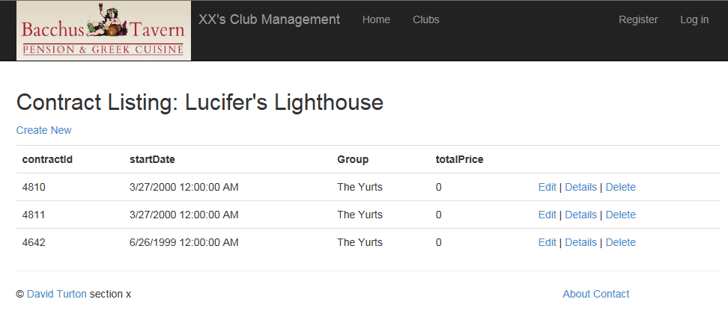

1. For the Create actions and their view:
   1. Modify the view’s fields to those shown on the sample below.
      1. Order the drop-down by group name and only show groups whose style matches the club’s style (there are no groups for 50’s and comedy, in case you're wondering what’s wrong).
   2. Change the browser title and heading to “New Contract:” plus the selected club’s name.
   3. When the user clicks *Create*:

…continued next page…

* + 1. Compute the total price of the contract and add that to the record before saving.
    2. Remember to place the current *clubId* into the record.
    3. If the save works, put a message to that effect in TempData and display it on the listing of contracts for this club so the manager can see the total price of the contract.

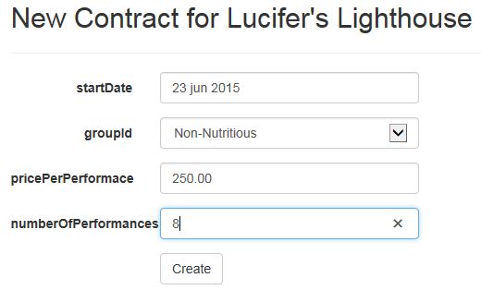

|  |  |
| --- | --- |
| **_layout**   * TempData variable displayed before guest page, red & bold * Student name & section in footer invokes e-mail client to college account * Contact and About hyperlinks moved to right side of footer, still aligned horizontally * Menu link sends browser to index page of ClubController | ________/ 2  ________/ 2  ________/ 2  ________/ 1 |
| **Club Listing**   * Browser title & page heading correct * Listing shows all clubs, sequenced by name within style name * View shows only fields specified * Hyperlink on each line redirects user to contract listing   + Link passes clubId | ________/ 1  ________/ 2  ________/ 2  ________/ 1  ________/ 1 |
| **Contract Listing**   * Check made for *clubId* in URL or a QueryString   + If found, is persisted to a cookie or session variable   + Otherwise, checks for a cookie or session variable with *clubId* & uses that     - If not found, returns to club listing & displays message to pick a club * Browser title & page heading correct, include the club name * View shows only contracts for requested club, sequenced by date: most current first * View shows only fields specified | ________/ 1  ________/ 1  ________/ 1  ________/ 2  ________/ 2  ________/ 2  ________/ 2 |
| **Contract Create**   * Browser title & page heading correct, include the club name * View shows only fields specified * Groups drop-down shows sorted group name, only shows groups with same style as club * On save:   + Total price computed correctly   + Total price and clubId added to record before writing   + Record saves correctly   + Message displayed on contract listing after successful add | ________/ 2  ________/ 1  ________/ 3  ________/ 2  ________/ 2  ________/ 1  ________/ 1 |
| **Base Mark**  **Fixes for: build errors run errors @1/fix**  **Final Mark** | ________/ 37  - _______  ________/ 37 |