**4Notes Recommended System Requirements:**

* Windows OS
* Visual Studio with Blazor 2022
* PostgreSQL16
* Google Chrome

**Recommended Setup:**

1. Launch Notes.sin project
2. Open Package Manager Console, select Infrastructure as default project and enter Update-Database
3. Run Web project on https

**Web application description:**

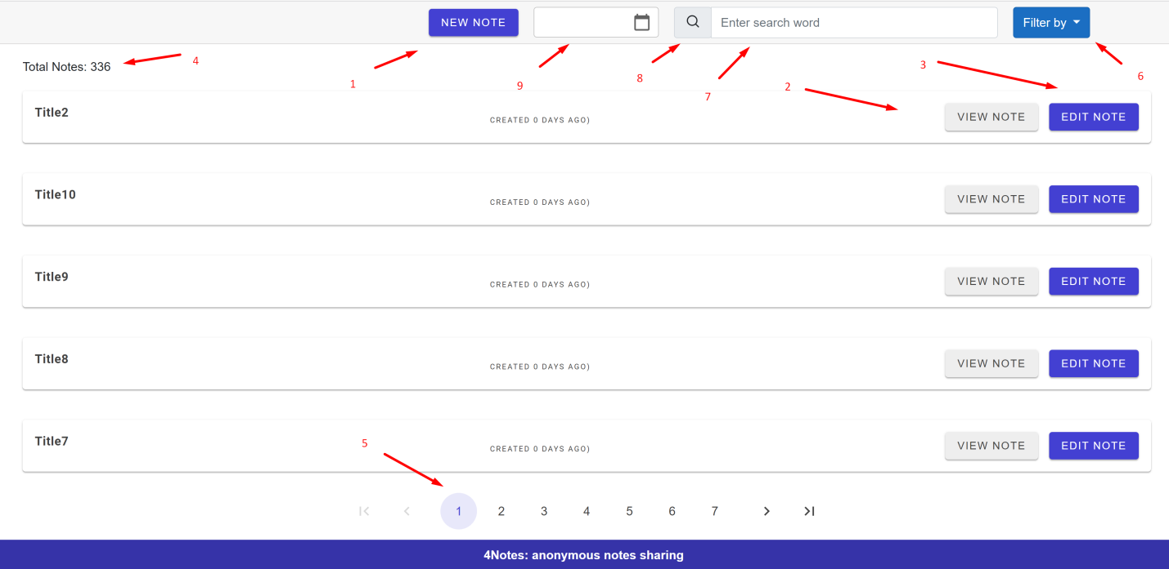  
1. You can create a new Note with Title and Note content which will be shared to all site visitors. There are possible to create a note without content but title is required by default. The note’s content max length is 5000 chars.

2. After note creating you can see it on the page in row format with title, information how long it was created and two buttons: first one is “View Note” allows you to view note content and precise creation date.

3. The second button “Edit note” allows you to edit note’s title or content. All constraints works as well as in note’s creation.

4. In the left and top of the page you can see total count of notes.

5. Page pagination allows you to view partial content of total notes which were created. You can navigate by pages and view 5 notes on each page.

6. You can filter notes by title which is default and note content. Click on button “Filter by” to choose type.

7. Then put a search keyword to input.

8. Click on search button to filter data or press “Enter” on keyboard.

9. Also there is a date filter to see notes by specified creation date or day, you can select only past days.  
  
All notes’ updates on site show in real time. (You needn’t to refresh the page to see notes updates from another visitor).

**Project architecture**:

The project has a “Clean Architecture” structure with “User Interface”, “Infrastructure”, “Domains”, “Tests” layers.

“Web” – User Interface is Blazor pages which depends from different “Domains”.  
“Domains” or ”Application Cores” – There is only one domain called NotesDomain which consist all business logic of notes like CRUD operations or paging with filters.

“Infrastructure” – include dbContext with EFCore.

“Tests” – unit and integration tests.