Air Watcher – Introduction Document

*Sense it, process it, breathe it*

1. Introduction

Air quality has been a big matter of concerns since the last century. These days, various government agencies are tracking with caution the content and the quality of their air for the safety of their people.

To pursue these goals, the newly created Belizean Air Agency tasked our team to develop an applet to process and visualize the air quality of its country based on its sensors dispatched all over the territory.

Our team, the AirGeneers, will create an app with C++ complying with these requirements named Air Watcher. Air Watcher will allow its users to access the sensors’ data with statistics, to compare them and to calculate the air quality index. Finally, Air Watcher will be implemented along with a net of air cleaners in the country. The app will need to observe and validate the impact of these cleaners all around the country.

This project will be realized in approximately 20 hours, including conception, realization, and presentation.

1. Human Resources
   1. The AirGeneers team

### 

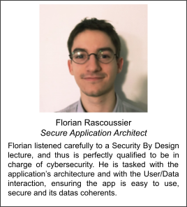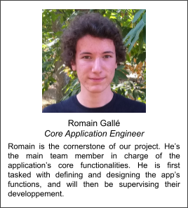

* 1. Task organization and Gantt Diagram

Work will be divided among all team members; our goal is to maximize parallel tasking to use our time at its maximum potential. Our developing process is incremental, we are advancing features by features, with an intermediate testing and security reviewing session.

We are planning more than two features for our app. We actually plan to be flexible, and to go as far as we can by the number of features developed by the team, while making sure our app is functional at each step.

The following Gantt Diagram presents the provisional Task Repartition, defined during the 1rst Lab Sequence.

