**Web Scrapper**

1. **Statement of Goal:**

This is a web based application which copies the content of a web page provided by a user and displays it in an XML format. It is intended for use by anyone who finds this functionality beneficial.

1. **Functional Description:**

* The application shall display the “first level-content” of a web page from a URL provided by the user.
* The application shall display any failures that might occur during this operation.

1. **Wire Frames:**

State 1: Landing Page:

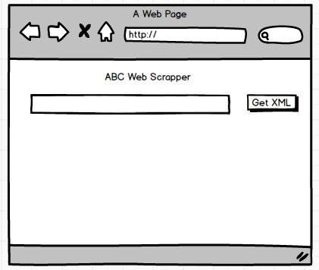

State 2: XML Display State

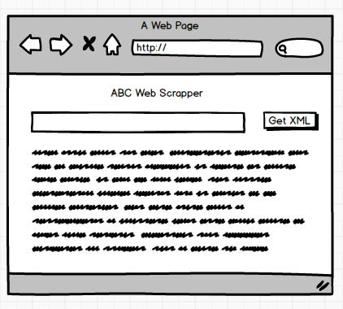

1. **Milestones:**

M1: Application is able to display error messages for all invalid URLs entered by the user.

M2. Application is able to scrape text from webpage

M3. Application is able to display scraped text as XML to the user