**README FILE WITH INSTRUCTIONS**

**Instructions in successfully running my Code in the following steps**

1: In my Zip file I have provided a Client and Server Folder

2: Open the Client and Server in Separately in visual studio

3: Clean and Build just to ensure it runs smoothly

4: After build, First run the SERVER code …. Should something like this

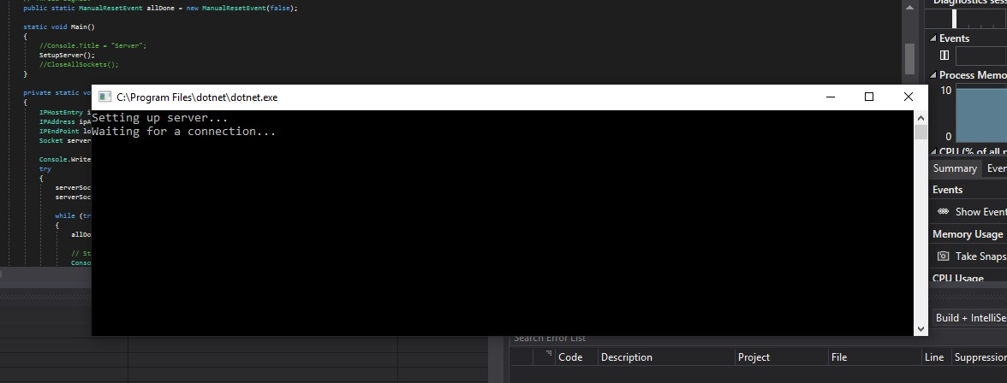

5:

Then follow by running the Client

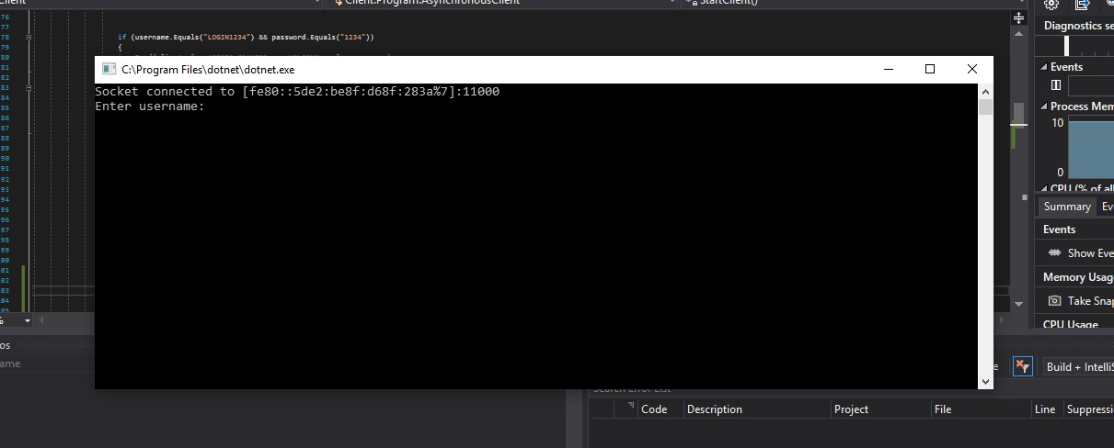

6: Then the client should ask for “USERNAME” and “PASSWORD” which I have provided in the client Folder called “LOGIN DETAILS.txt ”

7: After successfully you Login it should look like this stating that your Access has been granted

Without the exact login “username: LOGIN1234” & “password: 1234” access will certainly be denied

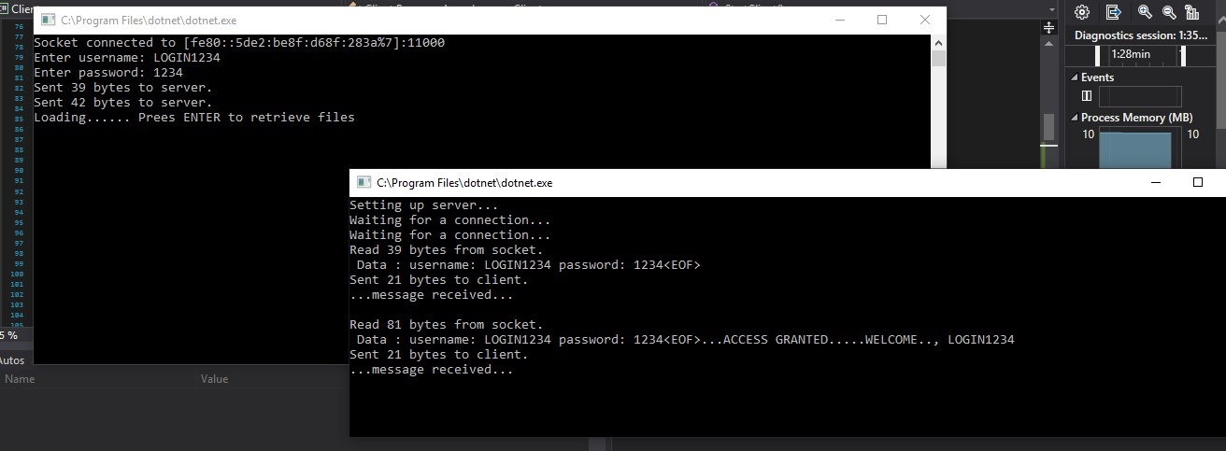

8: After this client starts loading the files in the server and in order to retrieve the files you press

“ENTER” which then successfully Obtains the files from server

9: After files have been obtain simply press “ENTER” to open file in server which should look like the following…

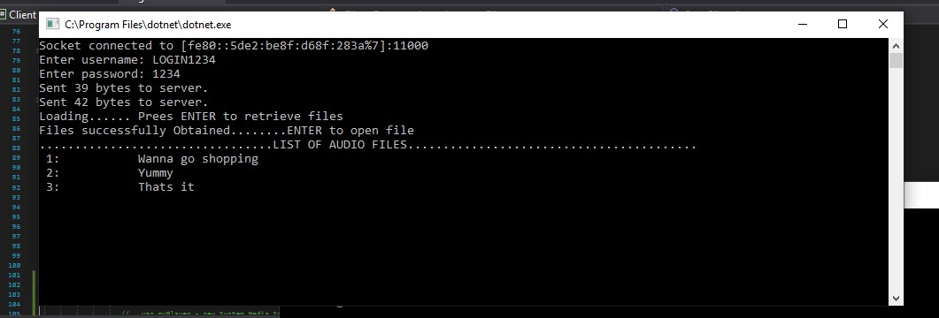

10: After this my program should then ask for another request where you can either insert “Play” (which at the moment it plays my default file “wanna-go-shopping” this can easily be changed in the client and “Stop” command while audio is playing in order to stop.

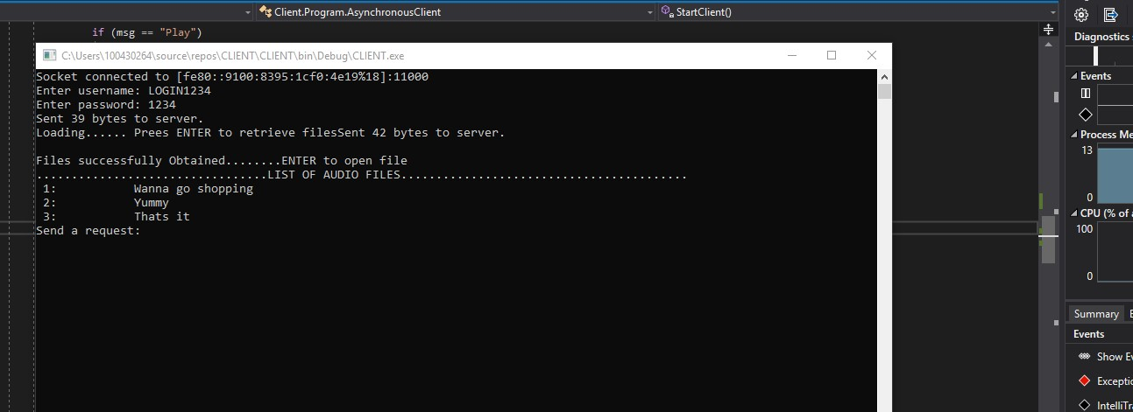

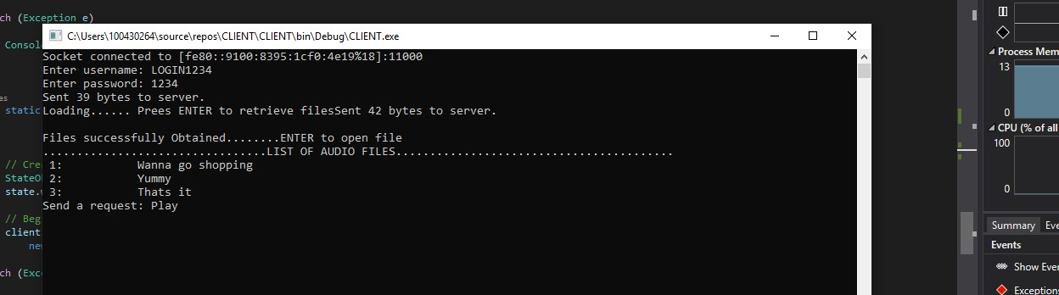

12: The wav file can be changed in the client program.

